BRIEFING: THE DWP’S JSA/ESA SANCTIONS STATISTICS RELEASE, 13 May 2015

SUMMARY

The number of JSA claimants halved between February 2013 and December 2014, and total JSA sanctions have fallen to reflect this. In 2014 there were an estimated 702,000 JSA sanctions before challenges and 605,595 after. Sanctions as a percentage of JSA claimants have fallen from peaks of 6.77% per month before challenges and 5.83% after in the 12 months to March 2014, to 5.94% and 5.12% respectively in 2014. These figures do not include jobseeker sanctions under Universal Credit, which probably reached almost 1,000 per month by December 2014. Before the Coalition, the highest monthly rates for JSA sanctions in any 12-month period were 3.81% and 3.51% in the year to July 2008, and both figures were usually well under 3%.

ESA sanctions in 2014 after challenges were at an all-time high for any 12-month period of 36,808, and before challenges were almost at an all-time high, at about 48,700. They are stabilising, having approximately tripled since 2012. As a percentage of ESA Work Related Activity Group claimants, sanctions in 2014 were 0.78% before and 0.59% after challenges.

An estimated 108,300 JSA or ESA sanctions were overturned following challenge in 2014. In all these cases the claimant’s payments will have been stopped for weeks or months only to be refunded later. This figure peaked at 153,500 in the year to March 2014.

The commonest reason for JSA sanction remains ‘not actively seeking work’, followed by non-participation in the Work Programme and then failure to attend an interview. The alleged ‘failures’ are often trivial or non-existent. Almost 90% of ESA sanctions are for ‘non-participation in work-related activity’.

For JSA claimants, Mandatory Reconsideration (MR) has cut the proportion of sanctions which are challenged, but increased the success rate of challenges, with the net result that the proportion of sanctions overturned remains at about 13%. For ESA claimants, MR has cut the success rate of ESA challenges, from 60% to 40%, with the result that the proportion of sanctions overturned has fallen from about 35% to about 20%. The fall in the success rate of ESA claimants’ challenges under MR may be due to their medical condition rendering them unable to cope effectively with the phone calls they receive from DWP officials.

Up to December 2014 there were almost twice as many JSA Work Programme sanctions before challenges as JSA Work Programme job outcomes: 734,774 sanctions compared to 376,020 job outcomes. There were 596,022 Work Programme sanctions after challenges.

The most important recent non-statistical event in relation to sanctions has been publication of the highly critical House of Commons Work and Pensions Committee report Benefit Sanctions Policy beyond the Oakley Review on 24 March. Its recommendations fall to be taken forward in the new Parliament.
BRIEFING: THE DWP’S JSA/ESA SANCTIONS STATISTICS RELEASE, 13 May 2015

Introduction

This briefing deals with the statistics on Jobseekers Allowance (JSA) and Employment and Support Allowance (ESA) sanctions released by the DWP on 13 May 2015, which include figures for the further three months October to December 2014. Excel spreadsheet summaries of the DWP’s statistics are available at https://www.gov.uk/government/collections/jobseekers-allowance-sanctions and the full dataset is in the Stat-Xplore database at https://stat-xplore.dwp.gov.uk/default.aspx.

All statistics relate to Great Britain. They all relate to the former Coalition government. Statistics on the re-elected Conservative government’s use of sanctions will not begin to be published until November.

Mandatory Reconsideration

The figures here fully incorporate information on ‘mandatory reconsiderations’. The Mandatory Reconsideration (MR) regime introduced on 28 October 2013 was discussed in the previous Briefing, which included the results of mandatory reconsiderations for the first time.

Reviews, reconsiderations and appeals

The DWP’s database only shows sanctions after any reviews, reconsiderations and appeals that have taken place by the time the data is published. But numbers of sanctions before the results of these challenges are important since they show all the cases in which claimants have had their money stopped. Although a successful challenge should result in a refund, this is only after weeks or months by which time serious damage is often done. Figures for sanctions before reconsideration or appeal are therefore given here but although reliable for longer time periods, they are not fully accurate for individual months, as explained in earlier Briefings. The earlier Briefings also have methodological notes on other topics.

Universal Credit sanctions

The number of jobseekers receiving Universal Credit (UC) instead of JSA is now starting to become significant. On a seasonally adjusted basis it has risen from 10,200 in September 2014 to 17,900 in December 2014 and 30,100 in March 2015. The DWP intends to publish statistics on UC sanctions but has not done so yet and has not fixed a date for doing so. This means that the numbers of jobseeker sanctions are being understated in the published statistics.

If the rate of sanction under UC were the same as under JSA, then there would have been about 950 UC jobseeker sanctions in December 2014 before reviews/reconsiderations/appeals and 850 after, equating to annual rates of 11,000 and 10,000 respectively.

Other factors influencing the figures

The figures must be read in the light of the falling numbers of JSA and ESA Work Related Activity Group (WRAG) claimants. The number of JSA claimants halved from 1.548m in February 2013 to 0.775m in December 2014 (it subsequently rose again to 0.811m in February 2015 before falling further to 0.752m in April 2015). The parallel fall in the official (ILO) unemployment rate shows that this is mainly due to an improving labour market. However, transfer of claimants to UC (as noted above) and the effect of sanctions in driving claimants off JSA altogether (Loopstra et al. 2015a) will also have contributed to the fall.

The ESA WRAG peaked at 0.563m in August 2013 but has since fallen every quarter until reaching 0.492m in November 2014 and an estimated 0.486m in December 2014. This is not due to any fall in claimants of ESA. In fact their total has continued to rise, to an all-time high of 2.275m in November 2014. What has happened is that an increasing proportion of claimants are being put into the Support Group rather than the WRAG. In addition, administrative delays have increased the proportion in the Assessment Phase. Under the Coalition from May 2010 to November 2014, the total number of claimants of disability benefits (ESA, Incapacity Benefit and Severe Disability Allowance) has fallen by only 92,830, from 2.613m to 2.520m.

At the end of this briefing there are notes on some additional recent developments in relation to sanctions.

Terminology

The terms used here in relation to reviews, reconsiderations and appeals are as follows:

Mandatory Reconsideration, with initial capitals, and its abbreviation MR, means the whole new appeal system introduced on 28 October 2013

‘mandatory reconsideration’, without initial capitals, and never abbreviated, means the formal reconsideration of a sanction decision undertaken by the DWP’s Disputes Resolution Team.

‘decision review’ means the informal process of reconsideration now undertaken by the original Decision Maker (but previously undertaken by a different Decision Maker) when a claimant first challenges a sanction

‘internal review’ is a term embracing both ‘decision review’ and ‘mandatory reconsideration’

‘appeal’ means a formal appeal to a Tribunal

‘challenge’ means any challenge to a sanction decision, i.e. it embraces ‘decision reviews’, ‘mandatory reconsiderations’ and Tribunal appeals.

Numbers and rates of JSA sanctions

In 2014 there were 702,000 JSA sanctions before challenges and 605,595 after (Figure 1). They have fallen back by one third from their peaks of 1,037,000 before challenges and 902,016 after in the 12 months ending October 2013. The main reason for this is that the average number of JSA claimants fell by almost as much (31%) over the same period.

JSA sanctions as a percentage of JSA claimants have fallen only modestly, from peaks of 6.77% per month before challenges and 5.83% after in the 12 months to March 2014, to 5.94% and 5.12% respectively in the 12 months to December 2014 (Figure 2). The monthly figures (Figure 6) suggest that there may be a continuing trend for the intensity of JSA sanctioning to decline, but it is too early to be sure of this. Before the Coalition came in, the highest figures for JSA sanctions ever seen in any 12-month period were 3.81% and 3.51% respectively in the year to July 2008, and both figures were usually well under 3%.

The DWP press release of 13 May claimed ‘As claimants fulfil their commitments to look for work and take up the offer of employment support, the number of benefit sanctions has gone down’. There is no evidence to support this statement. It is clear that the main reason for the fall in sanctions is the fall in claimants.

Numbers and rates of ESA sanctions

ESA sanctions in 2014 after challenges were at an all-time high for any 12-month period of 36,808, and before challenges were almost at an all-time high, at about 48,700. They are stabilising at these levels, having approximately tripled since 2012 (Figure 3).

As a percentage of ESA WRAG claimants, sanctions in 2014 were at their highest since 2011 both before and after challenges, at 0.78% and 0.59% per month respectively (Figure 4). The 12-month trend still seems to be upward, but the increase has slowed down. The monthly figures (Figure 6) show that the really big increase took place between spring/summer 2013 and spring/summer 2014.

Sanctions overturned following challenge

An estimated 96,400 JSA sanctions and 11,900 ESA sanctions were overturned in 2014 via reviews, reconsiderations or appeals. This is a total of 108,300 cases where the claimant’s payments will have been stopped for weeks or months only to be refunded later. This figure peaked at 153,500 in the year to March 2014.

The difference between the numbers of sanctions before and after challenges is much greater for ESA than for JSA sanctions. It also appears that challenges to ESA sanctions are taking a particularly long time to resolve. Figure 5 compares the figures for total ESA sanctions published each quarter since November 2013. As the numbers of sanctions escalated in 2013, so the scale of revisions increased. The figure originally given (in August 2014) for March 2014 was 7,507, but this was then revised down to 4,266 in November 2014 and then further down to 3,810 in February 2015 and to 3,724 in May 2015. Since these sanction decisions were already 5 months old when the first figure was published, this implies that claimants are having to wait many months and in some cases over a year to have their sanction rescinded and their money returned.
Referrals and Decisions

The number of sanctions imposed depends initially on the number of referrals for sanction made by advisers or programme contractors, and then on the proportion of decisions on those referrals that are adverse to the claimant. Figure 7 shows how the monthly totals of JSA and ESA referrals have changed. The Coalition inherited a level of monthly JSA referrals of around 6%, but then drove it up enormously to peak at over 16% in September 2013. Since then there has been a clear downward trend, to around 9% in the final quarter of 2014. However, actual sanctions have not fallen correspondingly, because as Figure 8 shows, the proportion of referrals with an adverse decision has risen. The Coalition inherited a proportion of about 63%, but from early 2011 began driving it up, to reach a steady level of about 81% from the beginning of 2014.

The obvious interpretation of the JSA figures is that in 2014 the Coalition has placed less pressure on advisers to refer claimants for sanction, but more pressure on decision-makers to find claimants guilty of ‘failures’.

For ESA, the Coalition inherited a situation where the only sanction referrals were for non-attendance at interviews. They were falling fast, and continued down to 0.1% in summer 2011. After that, the Coalition introduced referrals for non-participation in work-related activity and total ESA referrals rose rapidly to a peak of over 2% in summer 2014. In the second half of 2014 there has been a modest decline, to 1.5% per month (Figure 7; see also Figure 12 below). The Coalition inherited a proportion of adverse decisions on referrals which was fluctuating but was around 80%. This then fell to around 60% to 70%, probably because the issues involved in non-participation in work-related activity are different from those relating to non-attendance at interviews. However, at the end of 2013 there was a sharp rise to over 70%, almost at the same time as the sharp rise for JSA (Figure 8). The government has always protested that it does not have ‘targets’, but the sharp rises in the proportion of adverse decisions, to new stable levels and at almost the same time, for both JSA and ESA, certainly look as though they reflect administratively imposed targets.

The proportion of claimants who are sanctioned

The DWP's press release of 13 May stated that 'Sanctions are only used as a last resort in a small percentage of cases, with over 94% of JSA claimants and 99% of Employment and Support Allowance (ESA) claimants not being sanctioned’. Since all other numbers quoted in the press release were annual figures for 2014, these percentages were bound to be read as annual also. But they actually show the percentages of claimants who were not sanctioned in any given month. Obviously, if 6% of JSA claimants are sanctioned each month, then over 12 months the percentage will be much higher. During the financial year 2013/14 the mean percentage of claimants sanctioned each month (after challenges) was 5.12%, but the DWP's FoI response 2014-4972 disclosed that of all those who claimed JSA during the financial year, 18.4% were sanctioned (after challenges). Over the five year period 2009/10 to 2013/14 inclusive, the percentage of JSA claimants sanctioned (after challenges) was even greater, at 22.3%. The proportion before challenges will have been higher still, at about one quarter.

Quotation of the monthly figures in such a way as to imply that they refer to the percentage of claimants ever sanctioned is a habitual practice by the DWP, and it has led to widespread misunderstanding. A case in point is that of Margot James, the Conservative MP for Stourbridge. In the Westminster Hall debate on poverty on 4 February 2015 she said (col.105WH): ‘The last time I checked with my jobcentre, just before Christmas, fewer than 5% of all the people seen there had been sanctioned over the previous 12 months. We are talking about a minority, and she’ (Lisa Nandy MP, who in the preceding speech had criticised abusive sanctions leading to resort to food banks) ‘is talking about a very tiny minority of an already small minority’.

While the rate of JSA sanctions at Stourbridge Jobcentre is indeed somewhat below the national average, the ‘fewer than 5%’ figure quoted by Ms James is of course per month, not per year. The figure for the whole year 2014, after challenges, will have been not much below the GB figure of around 18%.

I took this up with Margot James and I am pleased to report that she has responded as follows: ‘I have looked into this issue and I was mistaken to say in the debate last month that less than 5% of people were sanctioned per annum. The (figure) I gave actually refers to the average monthly sanction rate for Stourbridge Jobcentre over the last year, which is in fact less than 5% of claimants in any one month. I understand that annual sanction rates are not routinely published by the Department for Work and Pensions. Thank you again for taking the time to email me, I will amend my statements on this matter in future to stress the point that I am talking about fewer than 5% of claimants in any one month.’

Repeat sanctions

Stat-Xplore shows that in the 114-week period of the new regime from 22 October 2012 to 30 December 2014, 930,287 individuals received 1,663,215 JSA sanctions, after challenges. This is an average of 1.79 each.

During the whole of the ESA sanctions regime from October 2008 to December 2014, 87,916 individuals received 124,629 sanctions after challenges, an average of 1.42 each. Of the sanctioned ESA claimants, 21.6% received more than one sanction, and 8.1% received three or more.

Figures on repeat sanctions before challenges are not available.

Three-year sanctions

The DWP does not publish any information on the number of people receiving the lengthier sanctions that are imposed for repeated ‘failures’.

No response has yet been received to the challenge (mentioned in the previous briefing) to DWP’s response to FoI request 2014-4972 that it would be too expensive for them to find out how many people have been subjected to three-year sanctions. This number cannot be greater than 2,291 and is probably substantially less. This is the number of people who have received three or more ‘high level’ sanctions since October 2012, a period of 26 months. Three-year sanctions apply to those with three ‘high level’ ‘failures’ within 12 months.

Reasons for JSA sanctions

Figures 9, 10 and 11 show the different reasons for sanctions for the calendar years 1997, 2003, 2009, 2013 and 2014. These are respectively the first full year of JSA, the lowest point of sanctions under the previous Labour government, the last full year of the Labour government, and the most recent two years of the Coalition.

Figure 9 simply shows the number of sanctions for each reason. All types of sanction have fallen in 2014 compared to 2013 due to the fall in the claimant count, as discussed earlier. The commonest reason for sanction remains ‘not actively seeking work’, closely followed by non-participation in the Work Programme and then failure to attend an interview. As noted in previous briefings, all of these are misnomers. ‘Not actively seeking work’ usually means that the claimant is actively seeking work but has not done exactly what they have been instructed by the Jobcentre, for instance in the way they fill in their job search record. ‘Non-participation in the Work Programme’ usually means missing a single interview with the contractor. ‘Failure to attend an interview’ often means being slightly late.

Figure 10 gives sanctions as a percentage of the average number of JSA claimants during the year, showing the intensity of sanctioning for each reason. The intensity of sanctioning for voluntarily leaving a job or losing it through misconduct, and for refusing employment or an employment opportunity, actually increased in 2014. The intensity of sanctioning for all other reasons fell, particularly for ‘not actively seeking work’. Sanctioning for ‘not actively seeking work’, ‘non-partipation’ in training or employment schemes and not complying with a Jobseeker’s Direction remains far above the levels inherited from the previous Labour government, while sanctioning for other reasons is at a similar level. Non-participation in Mandatory Work Activity and Work Experience are new reasons for sanctioning introduced by the Coalition.

Figure 11 shows the proportion of total sanctions accounted for by each reason. This particularly highlights the long-term decline in the use of sanctions for voluntary leaving or misconduct, and to a lesser extent non-availability for employment. However the intensity of sanctioning for voluntary leaving/misconduct has been increasing. As noted in earlier briefings, this is because during the recovery from a recession, people become more willing to give up a job because they know it will be easier to get another. The number of people changing employers each quarter fell by about one third during the downturn, but has been rising since 2012 and is now approaching pre-crisis levels.

The Coalition introduced a new reason for JSA sanction on 6 October 2014: ‘Failure to participate in the Supervised Jobsearch Pilot Scheme’. This produced 385 sanctions during the quarter.

Reasons for ESA sanctions

Figure 12 updates the reasons for ESA sanctions, after challenges. The big surge in ESA sanctions since mid-2013 has been entirely due to ‘failure to participate in work related activity’. This reason now accounts for just under 90% of ESA sanctions.

The ‘Mandatory Reconsideration’ Process

The new process for appeal against sanctions introduced on 28 October 2013 was fully described in the previous Briefing, on the statistics release of 18 February 2015. The claimant now has first to make an informal request for reconsideration (there is no form). The next step is for them to be phoned by the original decision-maker who gives them an ‘explanation’ of the reason(s) for the sanction. If the claimant accepts this, the matter ends there. If the claimant persists, the decision-maker will consider what they have to say, including any new evidence or points they make. The decision-maker may decide to change their decision at this point, and if so, the new decision will appear in the statistics as a ‘non-adverse decision review’. If the decision maker considers arguments from the claimant but does not change their decision, there will not necessarily be an entry in the statistics of an ‘adverse decision review’. If at the end of the ‘decision review’ stage the decision has not been changed and the claimant insists on pursuing their challenge, the decision-maker (not the claimant) will complete a MR1 form to trigger a formal ‘mandatory reconsideration’. This will also occur if the decision-maker has been unable to contact the claimant on the phone after three attempts and the claimant has made it clear that they wish to challenge the decision. But if it appears that the claimant has merely queried the decision, and they cannot be contacted, then the matter will lapse.

The actual process of ‘mandatory reconsideration’ is undertaken by a set of new, remotely located ‘Dispute Resolution Teams’. They also make efforts to discuss the case with the claimant. It appears that a result from this process, whether favourable or otherwise, is always recorded in the statistics.

The DWP’s press release of 13 May stated: ‘If someone disagrees with a sanction, they can ask for a reconsideration or appeal to an independent tribunal’. This is misleading since a Tribunal can now only be reached after the claimant has asked for internal reconsideration, has maintained their objection to the sanction after what will usually be three phone calls from the DWP, has received formal notice of DWP’s refusal of their request for revocation of the sanction, and has thereafter sent in a form to the Tribunals service requesting a Tribunal hearing.

JSA and ESA Sanction Challenges

Numbers of Decision Reviews, Mandatory Reconsiderations and Tribunal Appeals

Figures 13 and 14 show updated figures for the impact of the new Mandatory Reconsideration system on the numbers of the different types of challenge to JSA and ESA sanctions. The fall in JSA challenges is partly due to the fall in the numbers of JSA sanctions discussed earlier. However, for both benefits, the figures confirm the collapse in both internal reviews/reconsiderations and Tribunal appeals brought about by the Mandatory Reconsideration system. There was a small uptick in JSA Tribunal appeals in the Oct-Dec quarter 2014, with 405 compared to 244 in the previous quarter; but this compares with 8,830 in the Oct-Dec quarter of 2013. There were 6 ESA Tribunal appeals in the Oct-Dec quarter 2014, compared to nil in Jul-Sep and 206 in Oct-Dec 2013.

In the case of JSA (Figure 13), there are now twice as many ‘decision reviews’ as ‘mandatory reconsiderations’. For ESA (Figure 14), there are more than ten times as many. In other words, few claimants are getting as far as internal ‘mandatory reconsideration’, let alone Tribunal appeal.

The propensity to challenge sanctions

Figures 15 and 16 show what has happened to the propensity for claimants to challenge sanctions, by plotting internal reviews and Tribunal appeals as percentages of initial sanction decisions. For both benefits, MR has caused a sharp fall in challenges through the internal DWP process, and a collapse in appeals to Tribunal.

JSA challenges through internal review had risen to about one third of initial adverse decisions in summer 2013, but they have now fallen to one fifth. JSA Tribunal appeals had risen to over 4% in the summer of 2013, but they are now running at only 0.32%, although this is slightly more than the trough of 0.15% in the third quarter of 2014. (Figure 15).

At the time of introduction of MR, challenges to ESA sanctions through internal review had risen to 50%. They then continued rising but have now fallen back to 45% in December 2014. ESA Tribunal appeals had risen to over 2% in late 2013, but have now fallen to almost nothing (Figure 16).

Claimants’ success rate in challenges

In the case of JSA, the fall in the number of challenges under MR has been considerably offset by sharp increases in claimants’ success rate. Figure 17 shows that while the success rate in formal ‘mandatory reconsiderations’ is lower than it was in decision reviews prior to MR, the success rate in decision reviews under MR has risen to 90%. This latter rise is probably mainly due to Decision Makers not recording most ‘decision reviews’ unless they change the original decision. Nevertheless, the overall success rate in internal reviews has risen from just over two-fifths to about two-thirds, exceeding its previous high reached in 2010-11. The Tribunal success rate also remains high, at 38% in the quarter to December 2014, compared to a long-term level of 10%.

For ESA claimants, MR has lowered the success rate of challenges, from just over 60% down to under 40%. (Figure 18). This is mainly due to a sharp fall in the success rate for decision reviews. Very few sanctioned ESA claimants are getting through to the formal mandatory reconsideration stage, and almost none to Tribunals.

Overall impact of the Mandatory Reconsideration system

Figures 19 and 20 summarise the overall impact on claimants of the Mandatory Reconsideration system to date. The conclusions remain as in the previous briefing. For JSA claimants, MR has cut the proportion of sanctions which are challenged, but increased the success rate of challenges, with the net result that there has been no significant effect on the proportion of sanctions overturned, which remains at about 13% (Figure 19). For ESA claimants, MR initially did not halt the rise in the proportion of sanctions being challenged, but has now brought it back down to where it was before MR. MR has also drastically cut the success rate of ESA challenges, from 60% to 40%, with the result that the proportion of sanctions overturned has fallen from about 35% to about 20% (Figure 20).

The previous briefing included a commentary on the implications of the statistical evidence on the functioning of Mandatory Reconsideration. In particular, it appears likely that the sharp fall in the success rate of ESA claimants at the internal review stage under MR is due to their medical condition (which in over half of cases is mental or behavioural) rendering them unable to cope effectively with the phone calls from DWP officials.

The Work Programme: Still more sanctions than job outcomes

On a monthly basis, the number of job outcomes from the Work Programme now slightly exceeds the number of sanctions after challenges, with 31,200 job outcomes in the quarter to December 2014 compared to 25,862 sanctions. However, sanctions before challenges, at 33,187, still exceed job outcomes. On a cumulative basis, up to 31 December 2014 there had been almost twice as many JSA Work Programme sanctions before challenges as there had been JSA Work Programme job outcomes: about 735,000 sanctions compared to 376,020 job outcomes. There had been a cumulative 596,022 sanctions after challenges (Figure 21).

A similar comparison cannot be made accurately for ESA claimants.

SANCTIONS - OTHER DEVELOPMENTS

House of Commons Work and Pensions Committee sanctions report

The Work and Pensions Committee report into Benefit Sanctions Policy beyond the Oakley Review was published on 24 March. It is extremely critical of the sanctions regime. It has once again reiterated its call for a comprehensive independent review, to cover both the application of sanctions and the coherence of the legislative framework on which they are based. It calls for full implementation of the Oakley review’s recommendations, in particular to resolve the problem of conflicting demands on claimants by Jobcentre Plus and Work Programme contractors, to allow contractors to take a common sense view on good reasons for non-compliance, and to pilot pre-sanction written warnings and non-financial sanctions. It says that sanctioned claimants should receive additional, tailored support. It has concluded that there is no evidence to support the longer sanction periods of the post-October 2012 regime, and generally little evidence to support financial sanctions as opposed to other elements of conditionality. It expresses concern about the movement of sanctioned claimants off benefit but not into work, and calls for tracking of this group. It calls for urgent review of the appropriateness of conditions being imposed on claimants via the Claimant Commitment, of the adequacy of claimants’ involvement in setting them, and of the relationship between the Claimant Commitment and Jobseeker Directions. It suggests that DWP staff are not properly applying the flexibilities applicable to lone parents under JSA and says that Universal Credit rules for lone parents should be reviewed to ensure no worsening compared to JSA. It challenges the universal application of benefit sanctions and proposes that DWP should confine the regime to identified claimants whose attitudes it seeks to change. It criticises the blanket use of sanctions for ‘not actively seeking work’ against claimants who are seeking work but are merely not doing exactly what they are instructed by the Jobcentre; and it also criticises the immediate suspension of benefit in ‘not actively seeking work’ cases, before the claimant has had an opportunity to offer a ‘good reason’. It expresses particular concern about the rapid increase in ESA sanctions, notes the absence of evidence on their efficacy, doubts that these claimants receive sufficient support, and calls for specific review of the use of sanctions for this group as compared to alternative approaches. It recommends that non-‘vulnerable’ sanctioned claimants should be allowed to apply for hardship payments from day one, instead of after two weeks as at present. It also recommends that where a claimant is vulnerable or has children, the DWP itself should initiate the hardship payment process prior to the sanction decision. It criticises the lack of published information about hardship payments. It calls for external, independent review of cases where claimants die. It also points out that there is no evidence to support the application of sanctions under Universal Credit to people in part-time work who are considered not to be doing enough to increase their hours, and urges that these sanctions should not be implemented unless such evidence materialises.

The government normally produces a response to House of Commons Committee reports. There was no time for this before the general election but there should be a response soon.

Of the eleven members of the Committee, three, including the chair Anne Begg, lost their seats at the general election, and one retired.

Deaths of claimants following sanctions

The DWP has now been forced to reveal how many of the claimants whose deaths have resulted in ‘peer reviews’ had been sanctioned. The answer is ten out of 49. See
https://www.whatdotheyknow.com/request/252562/response/650114/attach/2/VTR501%20Bellows.pdf and also http://www.disabilitynewsservice.com/one-in-five-benefit-related-deaths-involved-sanctions-admits-dwp/

DWP Vulnerability Guidance

The DWP’s document Vulnerability Guidance – Additional Support for Individuals has now been published at
https://www.whatdotheyknow.com/request/259586/response/635763/attach/4/Vulnerability%20guidance.pdf

Low Commission Follow-Up Report

The independent Low Commission on the Future of Advice and Legal Support, funded by the Baring Foundation, Lankelly Chase Foundation, Barrow Cadbury Trust, Esmee Fairbairn Foundation and Trust for London, has published a follow-up report Getting it Right in Social Welfare Law (March 2015), available at http://www.lowcommission.org.uk/ This follows their earlier report Tackling the Advice Deficit (January 2014). The new report is based on a survey of 436 welfare rights advisers and among other things considers the impact of Mandatory Reconsideration. Almost two-thirds of advisers (65%) thought that MR had made it less likely that claimants would receive the right outcome without having to make a formal appeal.

Loopstra et al. on sanctions and food banks

A new paper from the Oxford University Sociology Department, with colleagues, was published in April (Loopstra et al. 2015b). Among their findings in a study across British local authorities was that each 1% increase in the rate of benefit sanctions was associated with a significant increase of 0.09 percentage points in the prevalence of food parcel distribution. In some of the most deprived areas of England, such as Derby, this equates to a substantial rise in food parcel distribution, to an additional one parcel for every 100 persons living in the area.

DWP statistical Freedom of Information responses

A number of particularly useful statistical FoI responses have been published recently at https://www.gov.uk/government/collections/dwp-statistical-foi-releases. These include JSA sanctions and numbers of JSA claimants on the basis of the same Jobcentre boundaries, to enable calculation of rates; referrals of JSA claimants for sanction by Work Programme contractors by contract; jobseekers reclaiming JSA within 6 months; ESA sanctions by claimant’s disease category (ICD); and time taken to assess ESA claimants.

Nick Boles MP – Grantham and Stamford

On 28 February the Grantham Journal at http://www.granthamjournal.co.uk/news/local/special-report-benefit-sanctions-criticised-by-mp-nick-boles-during-grantham-passage-visit-1-6605597 reported that the local Conservative MP, Nick Boles, had visited a local homeless charity and had been concerned at the evidence he had been given of abusive sanctions. He was reported as saying ‘With some of these cases it seems to me that there is an inhuman inflexibility that is imposed on them ..... The sanctions are a worry, and do need to be looked at ..... In the run-up to the election there is not a lot we can do, but we can get the case studies together where the sanctions seem to be most unreasonable ...... The beginning of a parliamentary term, when people are looking at things afresh, is the best time to make a change.’ The BBC subsequently reported on 3 March at
http://www.bbc.co.uk/news/uk-politics-31716210 that the Prime Minister’s official spokesman and the Conservative Chief Whip both claimed to know that Mr Boles had not meant what he said. David Cameron’s official spokesman said ‘What I believe Nick Boles has said today is that he is a “strong supporter of benefit sanctions both in principle and practice - those who can work, should work”. The prime minister entirely agrees with that.’ Michael Gove ‘acknowledged that the use of the term "inhuman" was "provocative"’. But he told LBC Radio: "I don't think Nick's intention was to provoke and I think all of us can, from time to time, occasionally as we reach for the right word in order to show that we don't necessarily approve or support every aspect of a particular policy, we can sometimes make a verbal slip."’ This is the first time that David Cameron has been personally implicated in defending his government’s abuses of the sanctions system.

Ruth Davidson MSP - Leaders’ Election Debate – Scotland, 3 May 2015

In the Scottish Leaders’ General Election Debate on BBC-2 TV on 3 May 2015, the Conservative leader Ruth Davidson accused Labour leader Jim Murphy of lying when he criticised the Coalition’s abuses of sanctions. The full sequence is at http://www.bbc.co.uk/iplayer/episode/b05tv6dm/the-leaders-debate, starting at 14’14’’, and will be available on BBC i-Player until 3 April 2016. The episode was replayed in part in subsequent TV news programmes and reported in print media.

Jim Murphy said ‘I’m angry that under your government, it’s a deliberate policy ..... there’s a deliberate target that no matter what your behaviour, you will get sanctioned by the Jobcentre. You don’t then find out about it until you go to the hole in the wall or the bank ...... to get your money out. You’ve got no money. You go to a high street moneylender that you can’t afford or you go to a food bank because you can’t feed your kids. It’s utterly unacceptable.’ ....... Davidson: ‘It’s also not true. I’ve heard Jim use that line before. Now I love the cut and thrust of debate and but I always try and be respectful in it and I always try and use parliamentary language and I’m sorry that I’m going to have to use unparliamentary language, because that is an outright lie. It is a falsehood. It is made up. He is peddling a falsehood ....... I went and checked after you first started talking about this because I’d never heard about this before, and it turns out it’s utter nonsense. ....... (Murphy attempts to respond, Davidson continues) ....... Chair to Davidson: ‘ ....... Let him respond to the accusation.’ Murphy: ‘How dare you call me a liar. How dare you deal in that sort of way (audience applause). Your government has sanctioned tens of thousands of Scots who are doing their best to find work. A man came to see me at my advice surgery...... who got his benefit stopped ....... because he went for a job interview......’ Davidson: ‘Well I’ve got the figures here, so let’s talk about that. ...... There were 170,000 fewer benefit sanctions this year than last year. He is making this up and I have to challenge it when he says .........’ (words unclear).

The following is the most relevant evidence on these assertions.

(Davidson) There were 170,000 fewer benefit sanctions this year than last year. Stat-Xplore (Feb 2015) showed that after challenges, JSA sanctions were indeed 170,219 or 19.0% lower in the year to 30 Sept 2014 than in the year to 30 Sept 2013. However, the JSA claimant count was on average 366,000 or 25.5% lower. Therefore the intensity of sanctioning actually increased: the average percentage of JSA claimants sanctioned per month rose from 5.23% in the year to 30 Sept 2013 to 5.62% in the year to 30 Sept 2014. ESA sanctions after challenges more than doubled, from 18,983 to 38,755, between the years ending Sept 2013 and Sept 2014.

(Murphy) A man ..... got his benefit stopped ....... because he went for a job interview. There are frequent reports of claimants being sanctioned because of a clash of appointment times between the Jobcentre/Work Programme contractor and a potential employer, or between the Jobcentre and the Work Programme contractor. Many examples are cited in the evidence to the government’s own Oakley review at http://www.cpag.org.uk/content/oakley-sanctions-review-responses-other-organisations and to the House of Commons Work and Pensions Committee at http://www.parliament.uk/business/committees/committees-a-z/commons-select/work-and-pensions-committee/inquiries/parliament-2010/benefit-sanctions/?type=Written#pnlPublicationFilter The Daily Mail published an exactly similar case on 24 June 2013 at http://www.dailymail.co.uk/news/article-2347281/Unemployed-graduate-benefits-stopped-missing-job-centre-appointment-INTERVIEW.html

(Murphy) Your government has sanctioned tens of thousands of Scots who are doing their best to find work. The total number of JSA sanctions in Scotland under the Coalition from May 2010 to September 2014 was 294,000. Given the scale of misapplied sanctions as indicated for instance by the House of Commons resolution of 3 April 2014, or the Scottish Government’s conclusion (2013) that ‘Research shows that claimants who face sanction are often unable to comply with conditions rather than unwilling’, ‘tens of thousands’ is a very fair estimate. Another way of looking at it is to consider that 22.3% of the 8,232,560 individuals in Great Britain who claimed JSA in the period April 2009 to March 2014 were sanctioned, after challenges (DWP FoI response 2014-4972). This was 1,833,035 people. This is a much higher proportion than is indicated by the frequent declarations by ministers and officials that only ‘a tiny minority’ or ‘a small minority’ of claimants do not fulfil their responsibilities to try to get work, implying that a substantial proportion must have been wrongly sanctioned. Of the 1,833,035 sanctioned claimants, about 10% (183,000) will have been in Scotland. Again, the estimate of ‘tens of thousands’ is very reasonable.

(Murphy) You go to a high street moneylender that you can’t afford Use of payday lenders by sanctioned claimants is frequently mentioned in voluntary sector reports, for instance Manchester CAB Service (2013 p.15), reporting a survey which found 9% of sanctioned claimants using payday lenders.

(Murphy) or you go to a food bank because you can’t feed your kids. My own submission to the All-Party Parliamentary Inquiry into Hunger in the United Kingdom, available at http://www.cpag.org.uk/david-webster , contained a thorough review of the survey evidence, which shows that around 25% of food bank usage is due to benefit sanctions. As noted above, Loopstra et al. (2015b) have shown a direct link between benefit sanctions and food parcel distribution. My February 2015 Briefing (p.7) showed that one dependant child is affected for approximately every six JSA claimants who are sanctioned.

(Murphy) You don’t ... find out about it until you go to the hole in the wall or the bank ...... to get your money out. This problem was highlighted in the government’s own Oakley report (July 2014, pp.45-6 and Recommendation 17) and in its response (p.17) the government undertook to change its internal guidance to ensure that it does not happen. However, at the House of Commons Work and Pensions Committee hearing on 21 January, Lois Race of Derbyshire County Council said that the situation had not changed on the ground.

(Murphy) it’s a deliberate policy ..... there’s a deliberate target that no matter what your behaviour, you will get sanctioned by the Jobcentre. The Coalition government has clearly had a deliberate policy of driving up sanctions. There is no other plausible explanation for the fact that it has more than doubled the rate of sanctions that it inherited. This is also borne out by a large volume of ‘whistleblower’ evidence, for instance by the PCS union at http://www.parliament.uk/documents/PCS%20%28SAN0161%29%20300115.pdf and in individual statements by Jobcentre Plus officials John Longden at http://data.parliament.uk/writtenevidence/committeeevidence.svc/evidencedocument/work-and-pensions-committee/benefit-sanctions-policy-beyond-the-oakley-review/written/16165.html and Ian Wright at http://data.parliament.uk/writtenevidence/committeeevidence.svc/evidencedocument/work-and-pensions-committee/benefit-sanctions-policy-beyond-the-oakley-review/written/15855.html as well as much other ‘whistleblower’ evidence in the media and on the web.

The Coalition has always denied that it has ‘targets’ for sanctions. This is for a legal reason. A ‘target’ would imply that some individual sanction decisions were not being made on their merits, and according to well-established legal principles such a policy would be set aside on judicial review. A previous Conservative government did set explicit targets for sanctions, in the early 1990s, but they were for referrals to the then independent Adjudication Service; since the actual decisions remained with the Adjudication Service, which did not have targets, this policy escaped judicial review – but of course it did drive up sanctions since a claimant is much more likely to be sanctioned if they are referred for sanction than if they are not. Instead of setting ‘targets’, the Coalition has adopted the different approach of driving up sanctions by setting ‘expectations’ and continuously reviewing performance. But there is no practical difference between these devices and ‘targets’. Both drive up sanctions compared to what they would be if officials were to apply the law in good faith.

I challenged Ruth Davidson on her use of the words ‘outright lie’, ‘falsehood’, ‘made up’ and ‘utter nonsense’. She replied as follows:

‘Thank you for your email and attached documents. My exchange with Jim Murphy related to a very specific point. He claimed that within the Department of Work and Pensions there is a targeting regime; in other words, members of the public are facing benefits sanctions (regardless of the merits of their case) in order to meet a quota. This is simply not true. I have contacted the DWP and they confirmed that no such targets exist for benefits sanctions. Given this, I felt it imperative that Mr Murphy was challenged on the issue. I make no apology for doing so and stand by my comments that evening. I trust this clarifies matters.’

28 May 2015

Dr David Webster
Honorary Senior Research Fellow
Urban Studies
University of Glasgow

Email david.webster@glasgow.ac.uk

Webpages: http://www.gla.ac.uk/schools/socialpolitical/staff/davidwebster/
http://www.cpag.org.uk/david-webster

REFERENCES

House of Commons Work and Pensions Committee (2015) Benefit sanctions policy beyond the Oakley Review, Fifth Report of Session 2014–15, HC 814, 24 March, at http://www.publications.parliament.uk/pa/cm201415/cmselect/cmworpen/814/814.pdf

Loopstra, Rachel, Aaron Reeves, Martin McKee & David Stuckler (2015a) Do punitive approaches to unemployment benefit recipients increase welfare exit and employment? A cross-area analysis of UK sanctioning reforms, Oxford University Department of Sociology,
Sociology Working Paper No. 2015-01, January, at http://www.sociology.ox.ac.uk/materials/papers/sanction120115-2.pdf

Loopstra, Rachel, Aaron Reeves, David Taylor-Robinson, Ben Barr, Martin McKee & David Stuckler (2015b) ‘Austerity, sanctions, and the rise of food banks in the UK’, British Medical Journal, 360:h1775, 8 April, at http://dx.doi.org/10.1136/bmj.h1775

Low Commission on the Future of Advice and Legal Support (2015) Getting it Right in Social Welfare Law, March, available at http://www.lowcommission.org.uk/

Manchester CAB Service (2013) Punishing Poverty? A review of benefits sanctions and their impacts on clients and claimants, October

Scottish Government (2013) The potential impacts of benefit sanctions on individuals and
households: Welfare Analysis, December, available at
http://www.scotland.gov.uk/Topics/People/welfarereform/analysis/analysisonsanctions

Figure 1
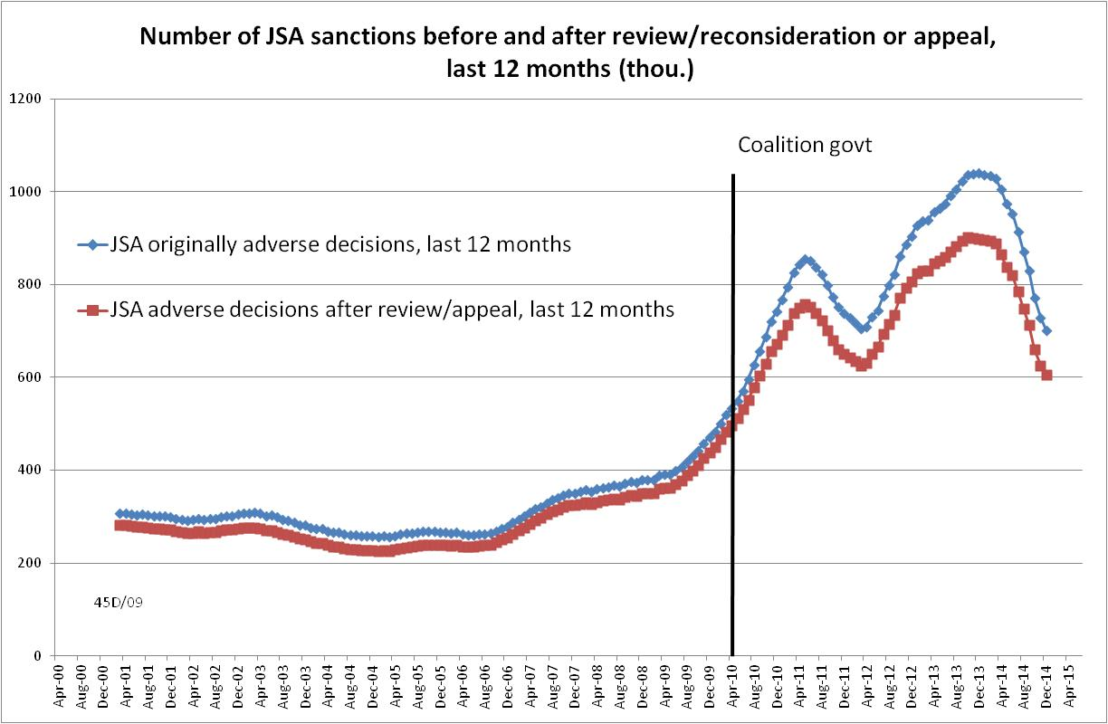

Figure 2
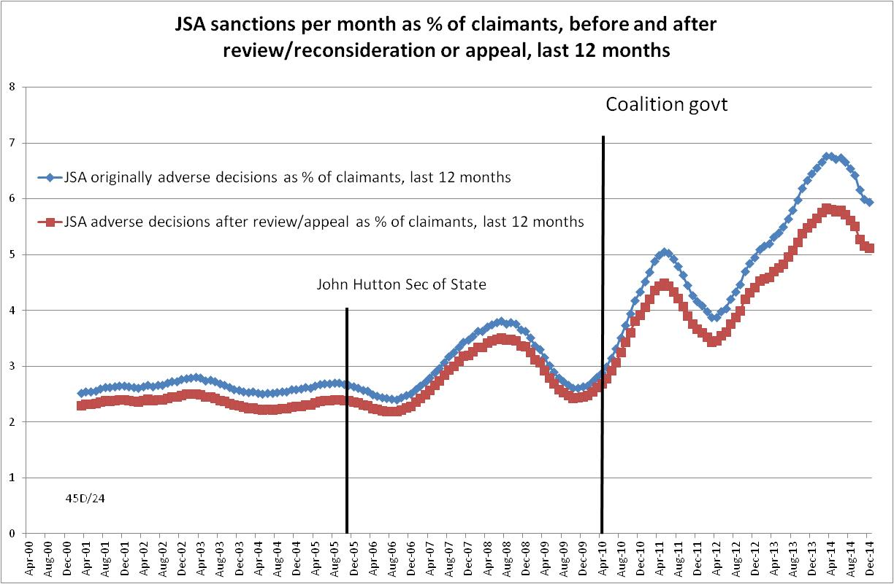

Figure 3
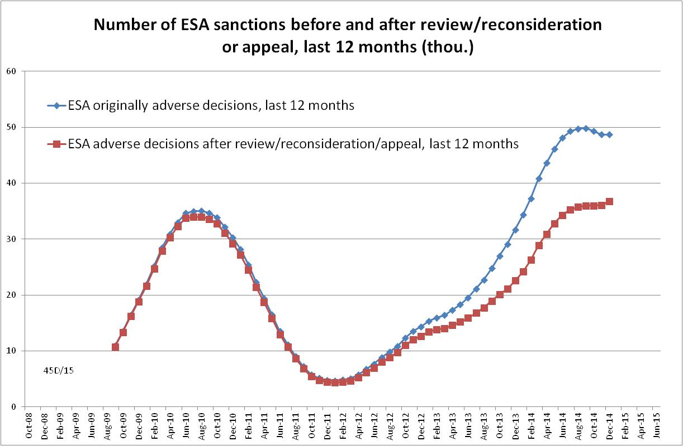
Figure 4
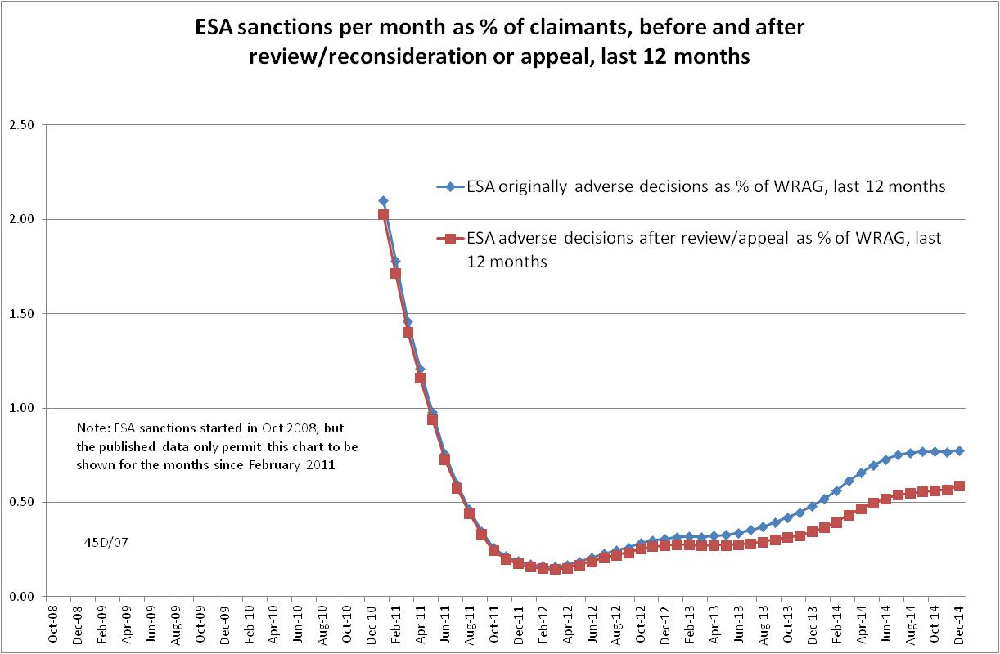

Figure 5
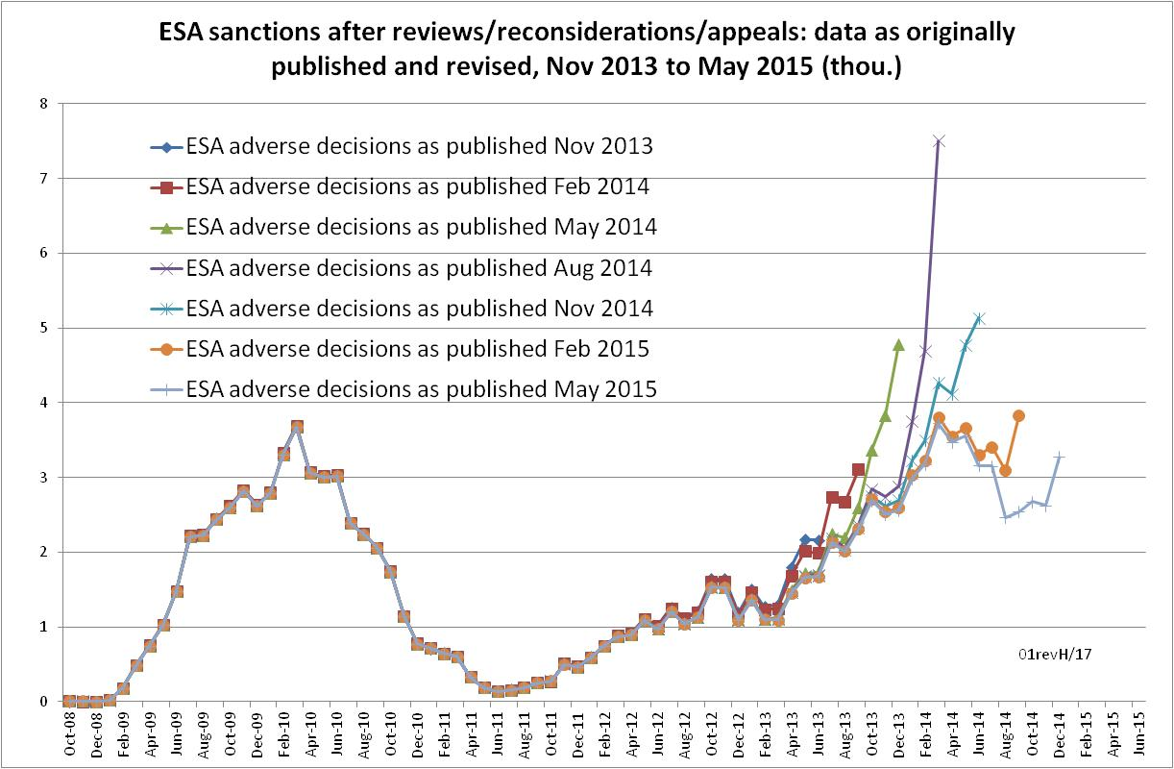
Figure 6
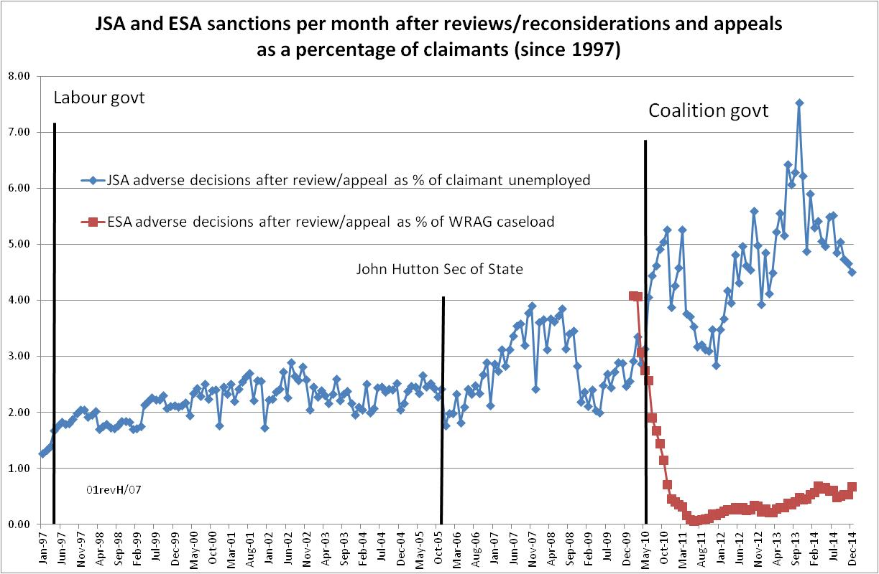

Figure 7
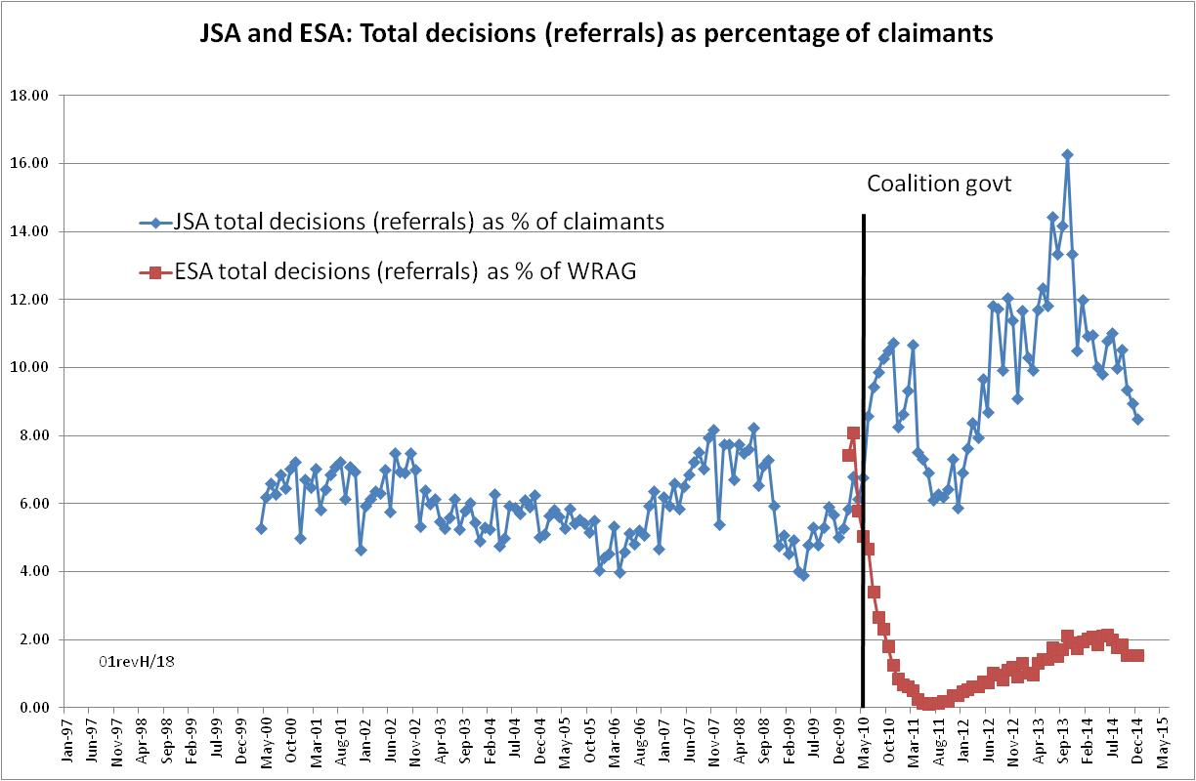
Figure 8
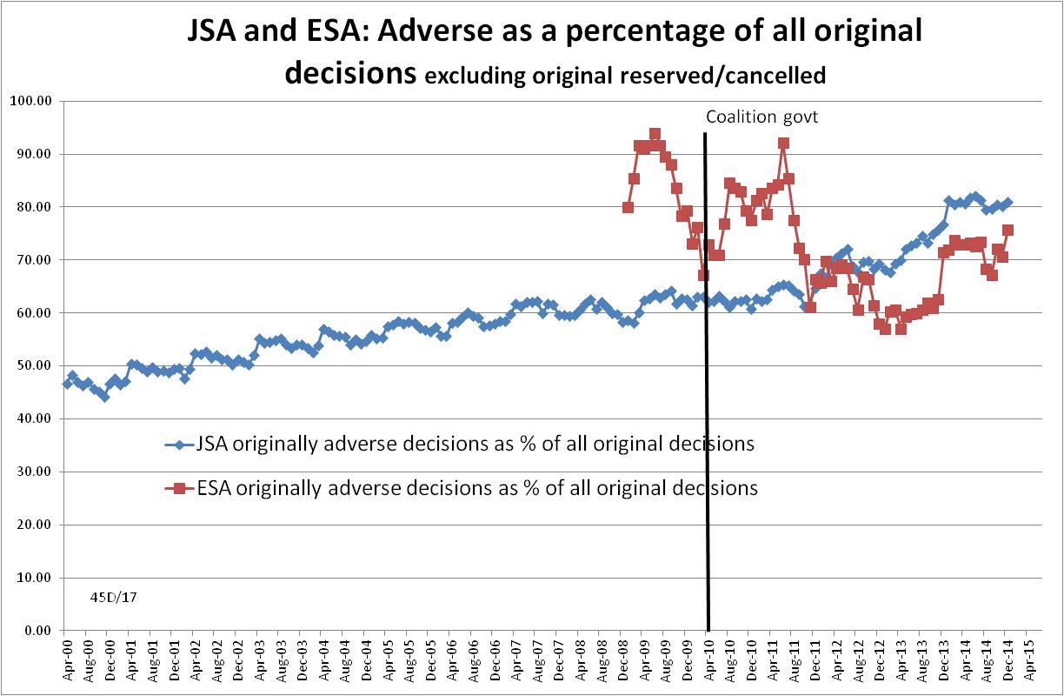

Figure 9

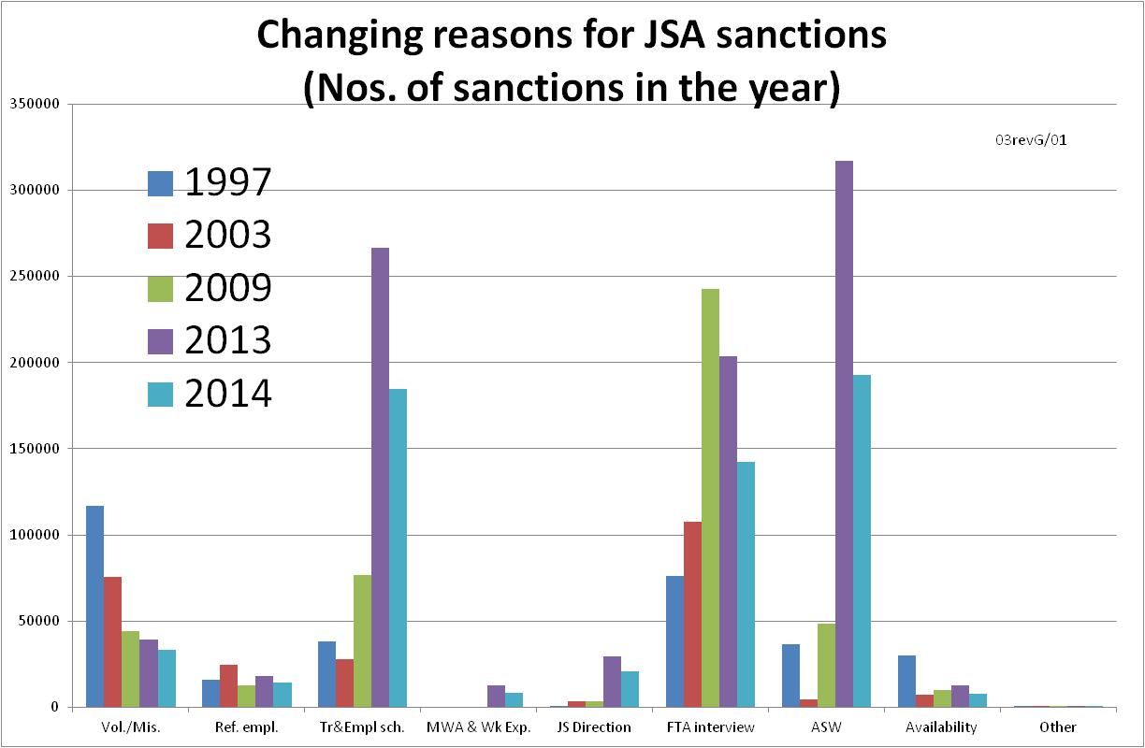
Figure 10
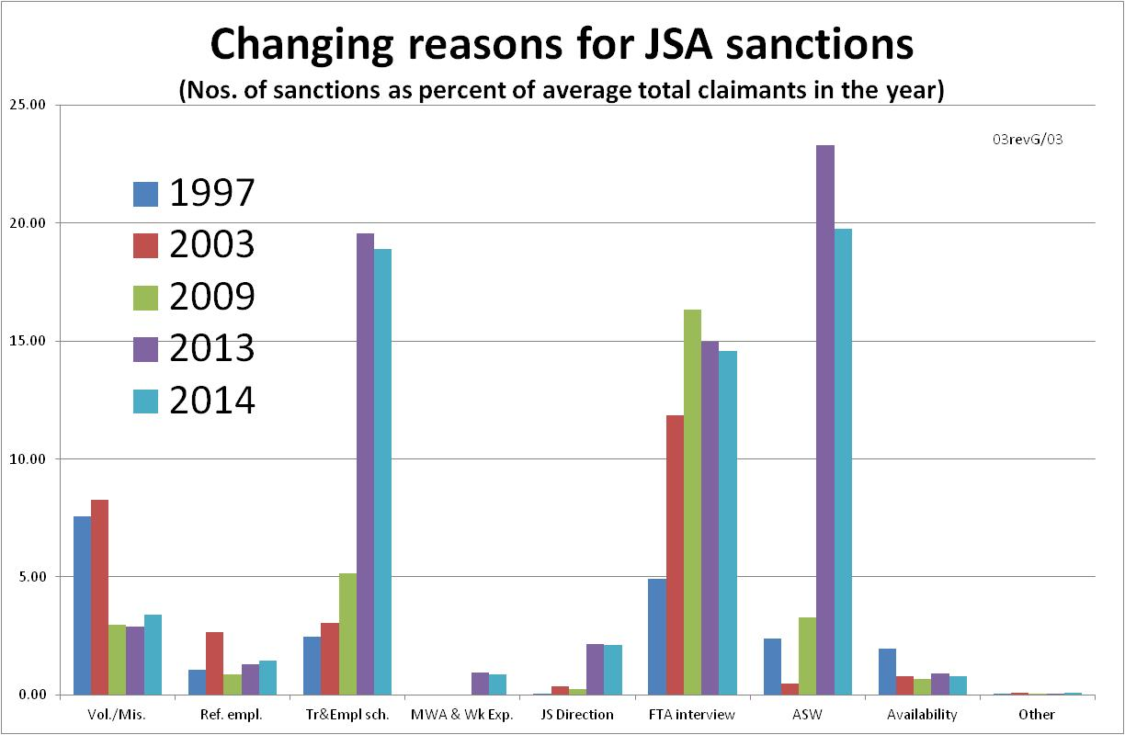
Figure 11
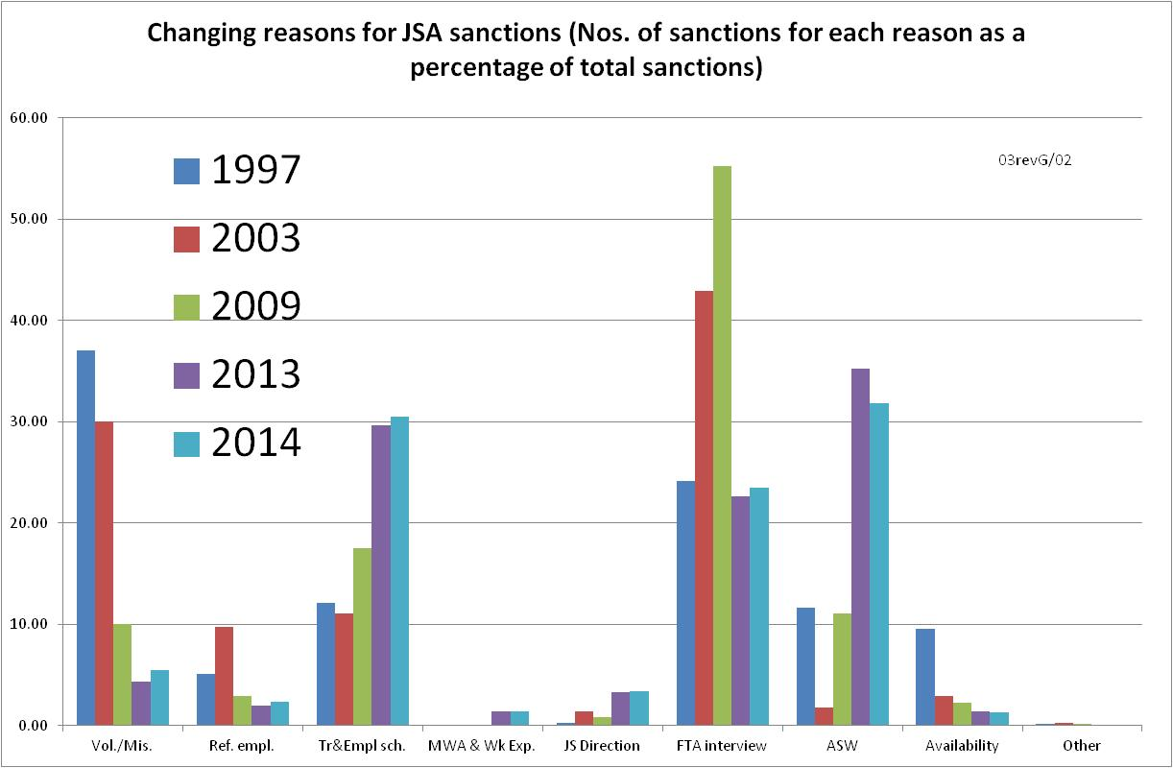
Figure 12
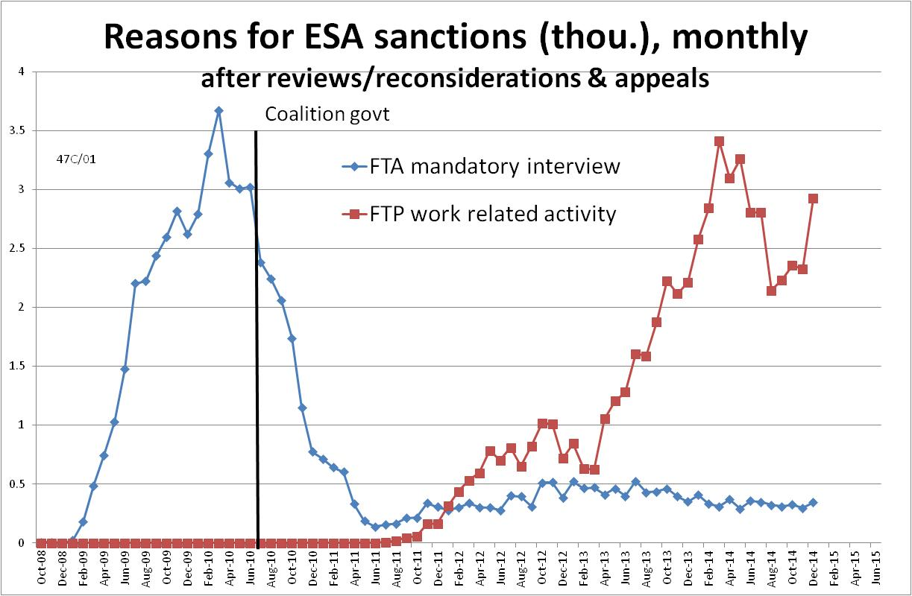

Figure 13
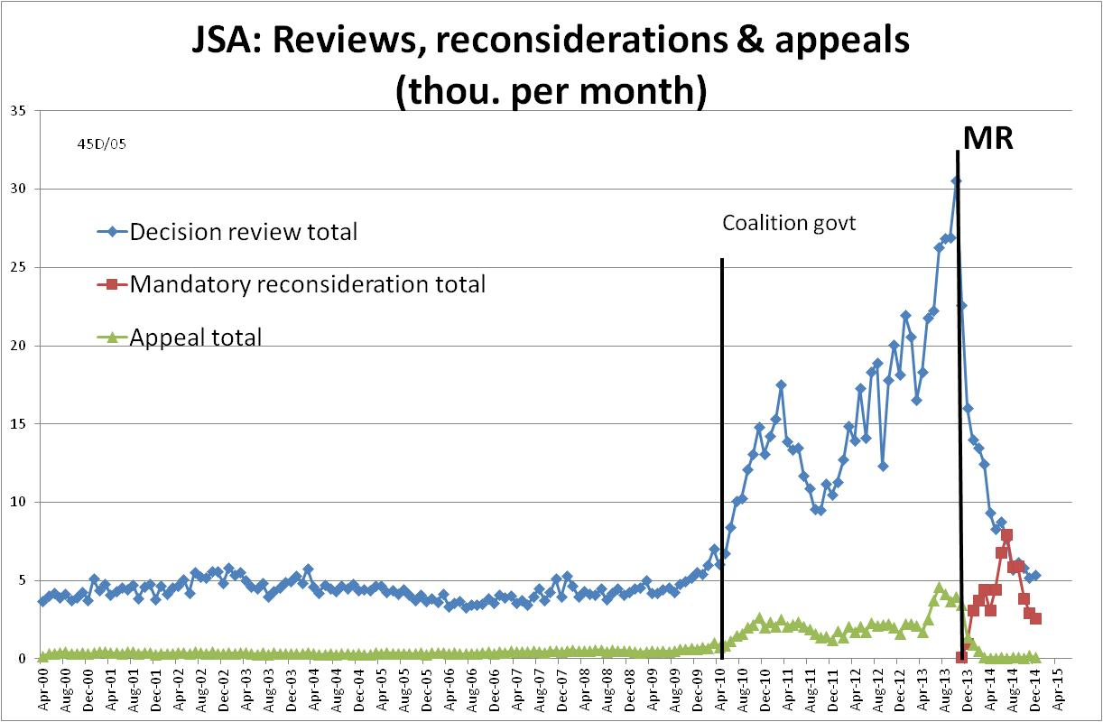

Figure 14
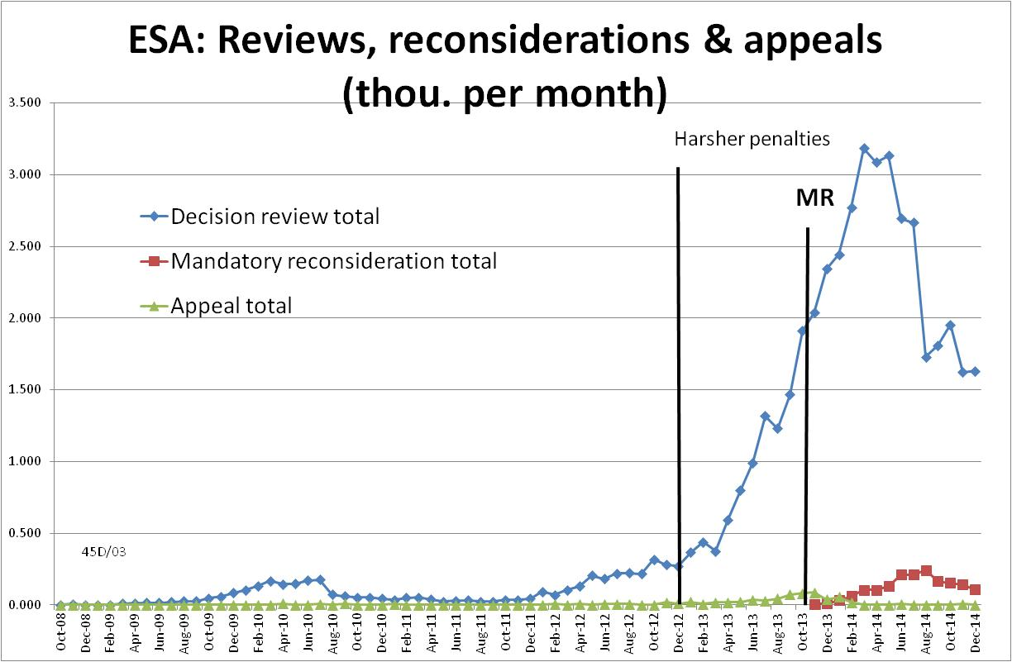

Figure 15
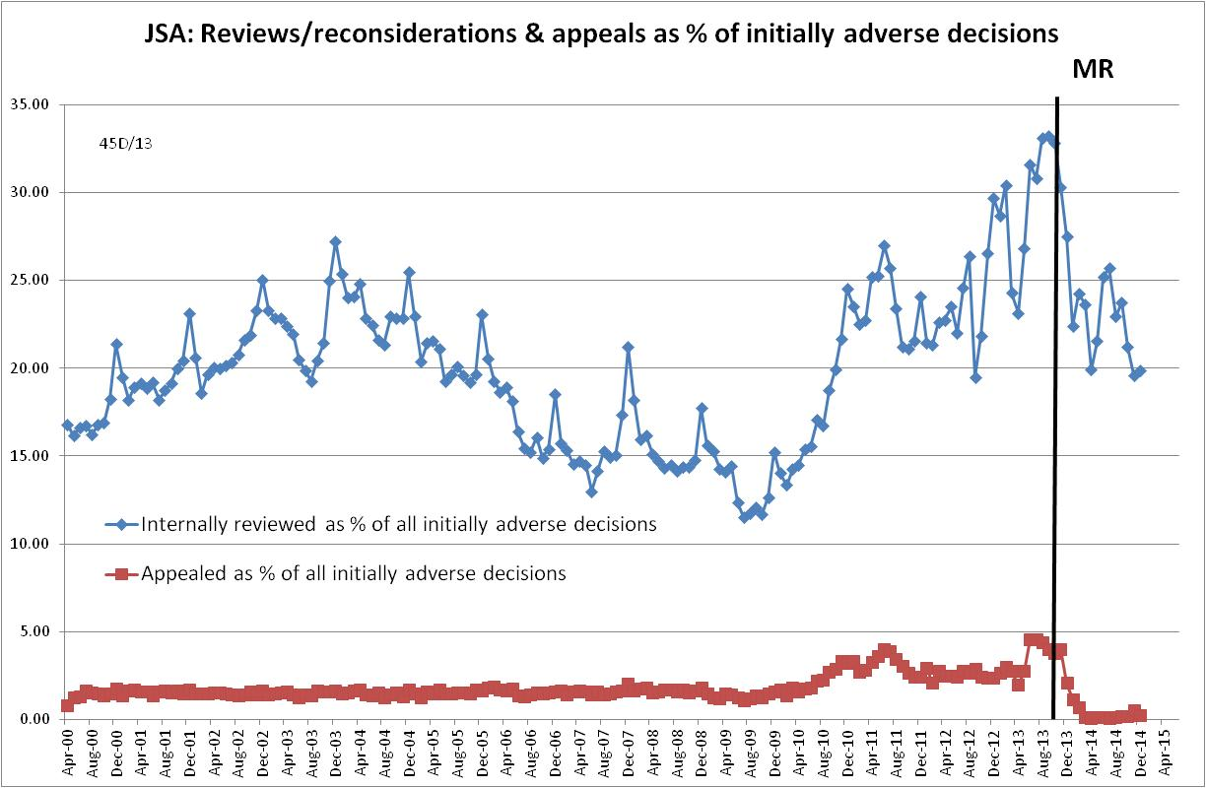
Figure 16
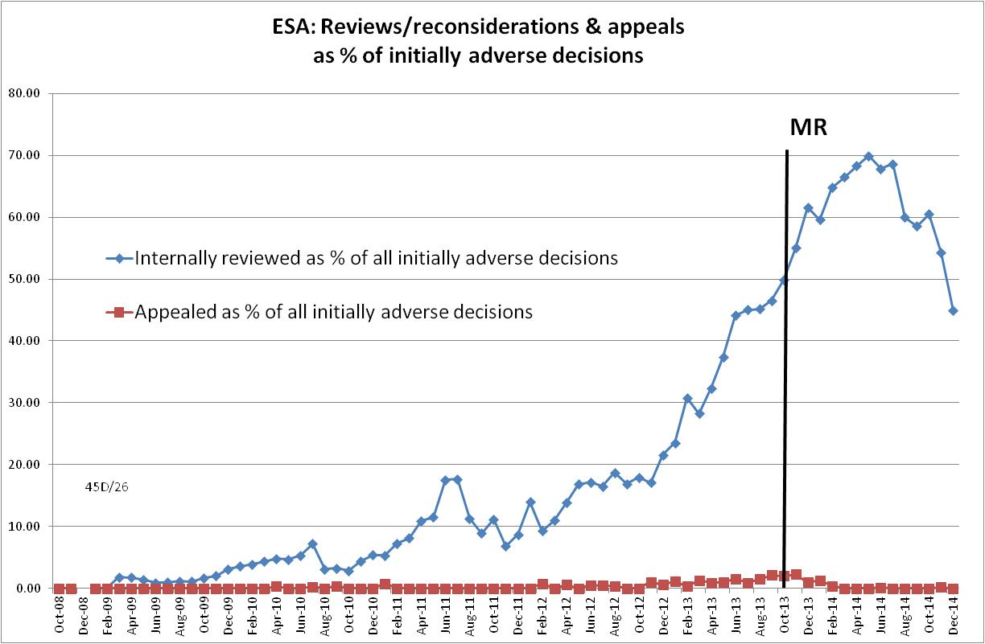

Figure 17
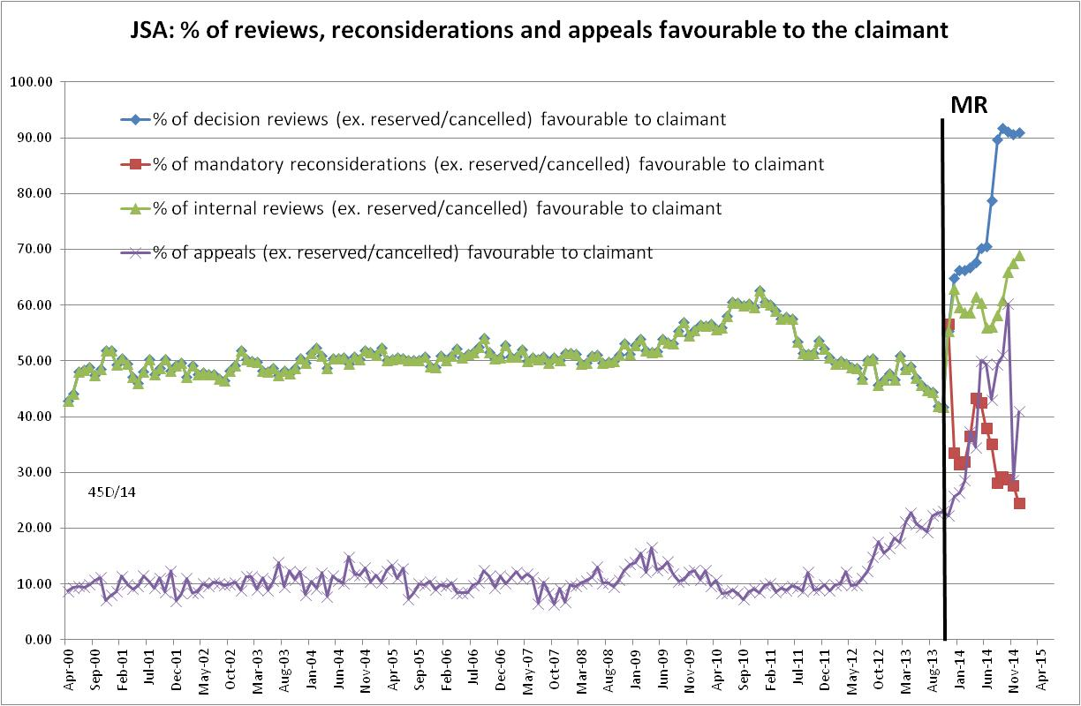
Figure 18
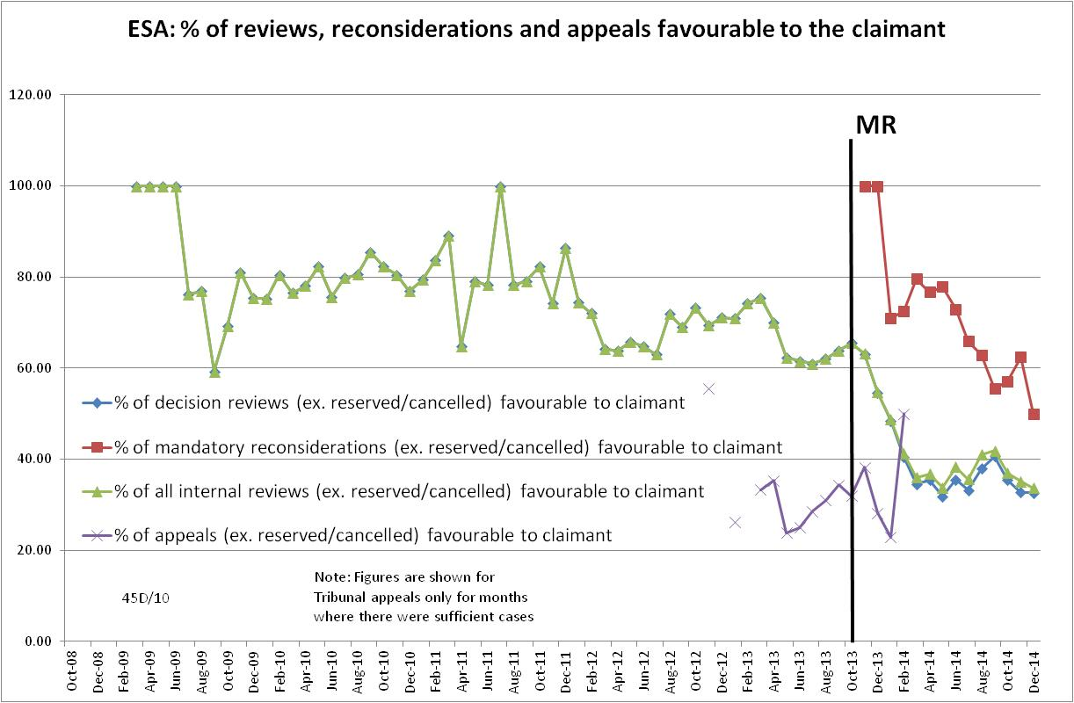

Figure 19
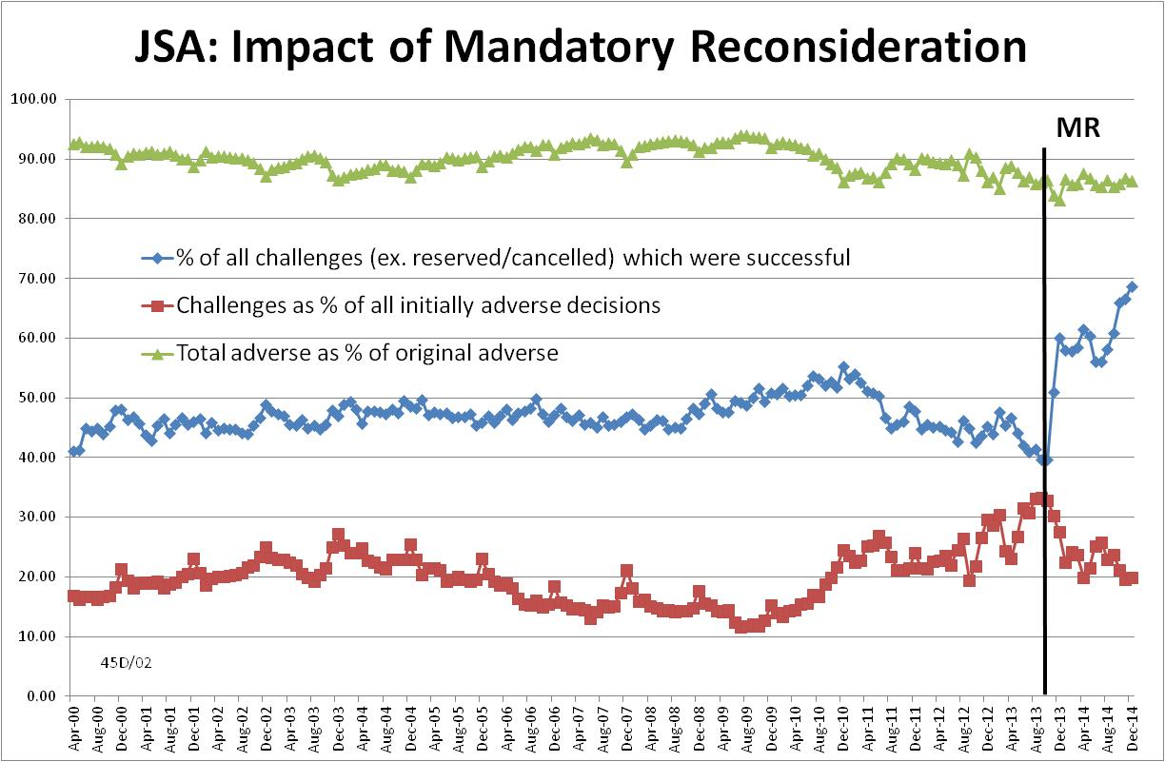
Figure 20
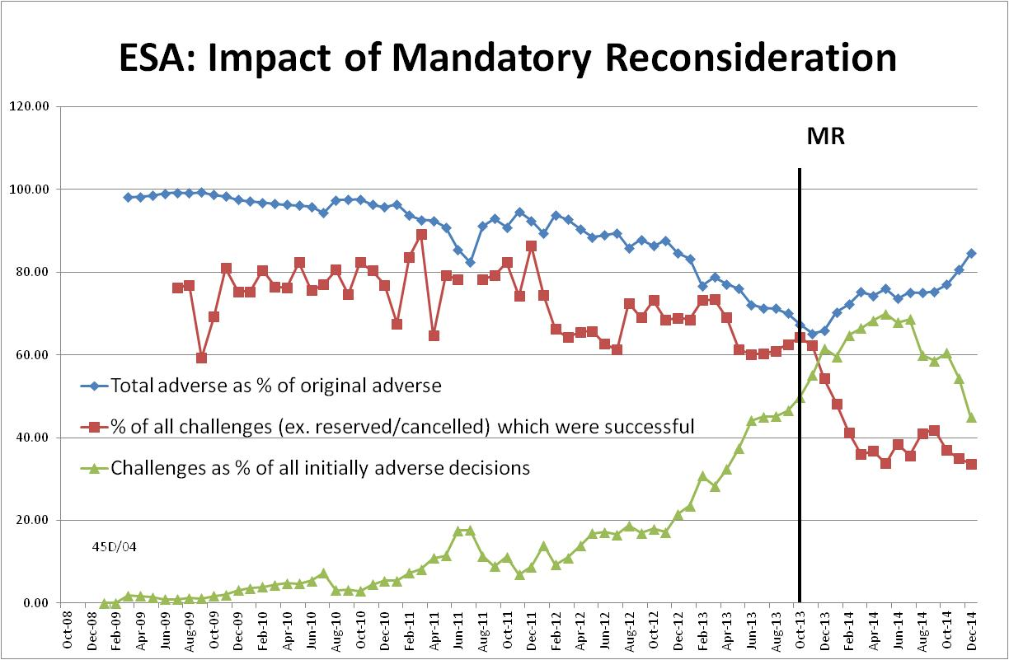

Figure 21
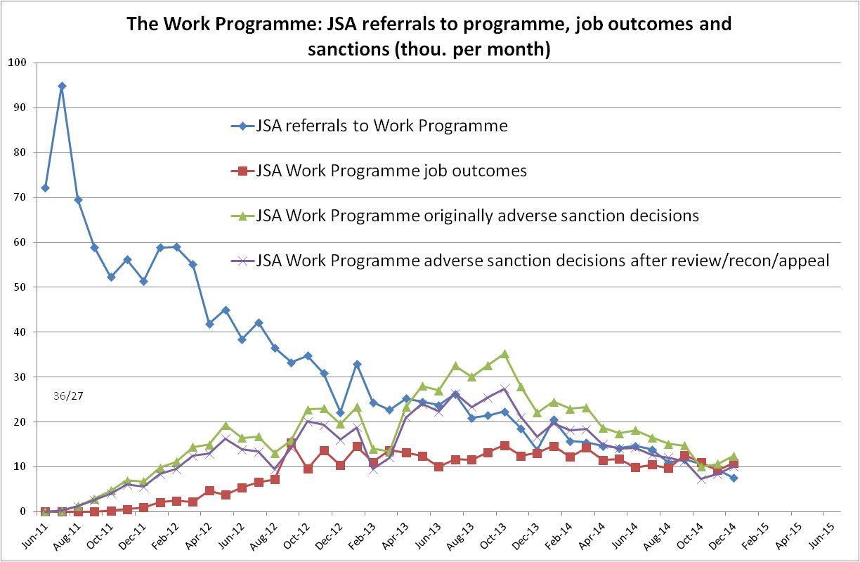

This is the seventh in a series of briefings on the DWP’s statistics on Jobseeker’s Allowance (JSA) and Employment and Support Allowance (ESA) sanctions. Earlier briefings were produced for the figures released in February 2015, November 2014, August 2014, May 2014, February 2014 and November 2013. They should be read in the light of the DWP’s statistical revisions, because some of their conclusions are no longer valid. However, much of the data and discussion remains useful, as noted in the present briefing. All the briefings are available at http://www.cpag.org.uk/david-webster
See the ONS table CLA03 available at http://www.ons.gov.uk/ons/publications/re-reference-tables.html?edition=tcm%3A77-363535 and the accompanying ONS notes Indicative Representation of the Claimant Count Including Universal Credit Caseload: Guidance Document and List of Jobcentre Plus Offices under Universal Credit, which can be found by web search. Experimental statistics on Universal Credit claims to May 2015 are at https://www.gov.uk/government/statistics/universal-credit-apr-2013-to-may-2015
DWP Freedom of Information response 2014-3800 (2 April 2015) showed that for ESA claims made in November 2013, the time to assessment was 32 weeks, compared to a target of 13 weeks.
https://www.gov.uk/government/uploads/system/uploads/attachment_data/file/426815/dwp-stats-summary-may-2015.pdf, Table 1.3a
https://www.gov.uk/government/news/benefit-sanctions-down-as-more-people-helped-into-work
The reason why ESA sanctions as a percentage of claimants may still be on an upward trend when the total number of sanctions has stabilised is that the WRAG is shrinking.
Because the DWP’s database attributes each sanction case to the latest month in which there has been a decision on it, the series shown in Figure 7 strictly speaking shows decisions, not referrals. However, provided too much weight is not put on the figures for individual months, for practical purposes the figures are equivalent to total referrals.
Figure 8 shows originally adverse decisions as a percentage of all decisions originally made. As for Figure 7, too much weight should not be put on the figures for individual months as the DWP’s database does not show the original month of decision except for decisions which have never been subject to any subsequent decision review, mandatory reconsideration or Tribunal appeal.
More detail is given in the previous Briefing of 2 March 2015 at http://www.cpag.org.uk/david-webster.
ONS ad hoc table Job-to-job employee moves each quarter, by reason for leaving job, occupational grouping, and whether a different industry was entered, 003934, 13 March 2015, at http://www.ons.gov.uk/ons/about-ons/business-transparency/freedom-of-information/what-can-i-request/published-ad-hoc-data/labour/march-2015/index.html
Memo DMG 23/14, JSA Supervised Jobsearch Pilot Scheme, October 2014, at https://www.gov.uk/government/uploads/system/uploads/attachment_data/file/361090/m-23-14.pdf
It should be noted that the large revisions to the ESA sanctions data shown in Figure 5 also have a substantial effect on the recent monthly figures for ESA challenges.
Readers may wonder how the overall success rate for internal reviews can have risen in the latest quarter when it has fallen for mandatory reconsiderations and stayed the same for decision reviews. This is because there has been a fall in mandatory reconsiderations, which have a much lower success rate than decision reviews.

