BRIEFING:

The DWP’s JSA/ESA Sanctions Statistics Release, 17 August 2016

31 August 2016

Dr David Webster
Honorary Senior Research Fellow
Urban Studies
University of Glasgow

Email david.webster@glasgow.ac.uk

Webpages: http://www.gla.ac.uk/schools/socialpolitical/staff/davidwebster/
http://www.cpag.org.uk/david-webster

SUMMARY

This Briefing deals with JSA and ESA sanctions up to the end of March 2016. There is no significant change in the picture shown by earlier editions of this Briefing. The numbers and rates of JSA and ESA sanctions are both continuing their long decline.

The DWP has yet to publish any data on sanctions on claimants of Universal Credit (UC), but the best estimate of the total number of sanctions before challenges on unemployed people claiming either JSA or UC in the year to 30 March 2016 is 310,000. This compares with only 219,169 JSA sanctions after challenges reported in Stat-Xplore but is much lower than the peak of 1,041,000 JSA sanctions before challenges in 2014. The main reason for the continous fall in JSA sanctions since November 2013 is the fall in the number of JSA claimants, but the rate of sanctions on JSA claimants has also been steadily falling. The monthly averages for the latest quarter are 3.04% before and 2.52% after challenges. These rates are similar to those inherited by the Coalition government in May 2010. Since October 2012, sanctions are much more severe and so the total loss of benefits imposed on the unemployed remains very much greater than suggested by the numbers of sanctions alone. The DWP has never offered any credible explanation for the huge rise and then fall in the rate of JSA sanctions. It must have been the result of decisions by the DWP ministerial team.

Total ESA sanctions have now also fallen, to 20,200 before challenges and 14,523 after in the year to end-March 2016. This compares with peaks of 49,400 before challenges in the year to August 2014 and 35,516 after challenges in the year to September 2014. The fall partly reflects the continuing shrinkage of the Work Related Activity Group, but as a percentage of ESA WRAG claimants, sanctions have also declined, both before and after challenges. These figures peaked at 0.76% in August to October 2014 and 0.55% in September to December 2014. In the year to March 2016 the average monthly rate was 0.36% before challenges and 0.26% after. The rise and fall in ESA sanctions appears to be satisfactorily explained by changes in referrals to the Work Programme.

An estimated 43,800 JSA sanctions and 5,700 ESA sanctions were overturned in the year to March 2016 via reviews, reconsiderations or appeals.

Currently, three-quarters of challenges to JSA sanctions are successful, but only one quarter of sanctioned JSA claimants make any sort of challenge. Consequently the proportion of JSA sanctions overturned is only about one fifth. Far more claimants should appeal. A higher proportion of sanctioned ESA claimants – about one half – challenge their sanction, but their success rate is lower, also at about one half, so that about one quarter of ESA sanctions are overturned.

The reader is referred to earlier editions of this Briefing, at www.cpag.org.uk/david-webster, for various special analyses which are not repeated in this issue.

A news section at the end of the Briefing gives information about other developments relating to sanctions. Particularly notable was the publication in May of a major critique of the Waddell-Aylward ‘biopsychosocial’ model of disability, which lay behind the design of the ESA system.
BRIEFING: The DWP’s JSA/ESA Sanctions
Statistics Release, 17 August 2016

Introduction

This briefing deals with the regular quarterly Jobseekers Allowance (JSA) and Employment and Support Allowance (ESA) sanctions data released on 17 August, which include figures for the further three months January to March 2016. Excel spreadsheet summaries of these statistics are available at https://www.gov.uk/government/collections/jobseekers-allowance-sanctions and the full dataset is in the Stat-Xplore database at https://stat-xplore.dwp.gov.uk/default.aspx. DWP provides some commentary on the figures in its Quarterly Statistical Summary at https://www.gov.uk/government/statistics/dwp-statistical-summaries-2016

All statistics relate to Great Britain.

Sanctions before and after reviews, reconsiderations and appeals

The DWP’s database only shows sanctions after any reviews, reconsiderations and appeals that have taken place by the time the data are published., But numbers of sanctions before the results of these challenges are important since they show all the cases in which claimants have had their money stopped. Although a successful challenge should result in a refund, this is only after weeks or months by which time serious damage is often done. Estimates of sanctions before challenges are therefore given here but although reliable for longer time periods, they are not fully accurate for individual months. Figures for sanctions before challenges are currently higher than the ‘after challenge’ figures by about 20% for JSA and 39% for ESA.

Universal Credit and Universal Credit sanctions

All new single claimants of unemployment benefits are now put on to Universal Credit (UC) instead of JSA, together with, since January 2015, claimants with families in the north west region. Statistics for UC on claims, starts and numbers claiming now appear on Stat-Xplore and summaries are at https://www.gov.uk/government/collections/universal-credit-statistics . But no statistics have been published on UC sanctions, and no date has been given for them. This has a significant distorting effect on the analysis of JSA sanctions, because the number of claimants at risk of JSA sanctions is being reduced. The distortion is amplified because single claimants are disproportionately young, and young people are sanctioned at double the rate of other people.

A full assessment of the distortion was contained in the November 2015 Briefing, and will be updated in a future Briefing. The present briefing includes approximate estimates of the scale of the distortion. The figures for ESA sanctions are unaffected since no ESA claimants have been transferred to UC.

The UC regime has similar lengths of sanction to those of JSA for the various ‘failures’, but there are some critical differences. Sanctions are lengthened by being made consecutive, not concurrent. Hardship payments become repayable. Given that repayments are made at the rate of 40% of benefit – the same as the amount by which a hardship payment is lower than the benefit – this means that for claimants receiving hardship payments, UC sanctions are in effect 2½ times as long as their nominal length. All sanctioned UC claimants must also demonstrate ‘compliance’ for 7 days before applying for hardship payments, and must reapply for each 4-week period. The 80% hardship rate for ‘vulnerable’ claimants is abolished.

Impact of declining numbers of claimants

A fall in the number of claimants means a fall in the number of sanctions, other things being equal. The number of JSA claimants has been falling because of the labour market recovery and transfers to UC. By March 2016 it had fallen to 608,056, a slight increase from the 591,892 of December 2015 but a large reduction from the monthly peak of 1,547,585 in February 2013. At March 2016 the number of unemployed people on UC according to NOMIS was 156,259. The total of unemployed claimants of either JSA or UC at March 2016 was therefore 764,315, of whom around one in five was not having any sanctions reported in any statistical system.

The number of ESA claimants exposed to sanctions – those in the Work Related Activity Group (WRAG) – is also continuing its long decline. The WRAG peaked at 0.563m in August 2013 but has since fallen every quarter until reaching 0.449m in February 2016 and an estimated 0.447m in March 2016. The fall is mainly because an increasing proportion of ESA claimants are being put into the Support Group rather than the WRAG: the proportion of put into the ‘support group’ has increased from 18% to 74% following successive reviews of the WCA since February 2010. It is worth noting that there has recently been a very large reduction in the number of people in the ‘assessment’ phase of an ESA claim. A growing backlog had caused this figure to peak at 0.546m in August 2014, but by February 2016 it had fallen to 0.316m, the lowest since these statistics began in February 2010.

‘In-work’ sanctions for Universal Credit claimants

The Universal Credit regime has introduced sanctions for claimants who are in work but who do not earn the equivalent of the national minimum wage for a 35-hour week. They are required to attempt to increase their earnings through higher pay or more hours. This regime is currently being operated only in pilot areas. The DWP has published no statistics on these sanctions. However, Stat-Xplore shows that by July 2016 there were 53,663 UC claimants subject to ‘in-work’ conditionality.

UK Statistics Authority recommendations to DWP on sanctions statistics

The present suite of DWP sanctions statistics has important gaps and is seriously misleading in various respects. As explained in previous briefings, the UK Statistics Authority (UKSA) in August 2015 made recommendations to the DWP for improvements to the sanctions statistics. The May 2016 Briefing contained an assessment of the DWP’s updated Benefit Sanction Statistics Publication Strategy in relation to these recommendations. There has been no further progress.

The DWP is still inviting comments on its Benefit Sanction Statistics Publication Strategy, to be sent to Stats-consultation@dwp.gsi.gov.uk.

The UKSA’s recommendations were as follows:

- Provide users with benefit sanction statistics based on the actual number of sanctions applied, making clear the numbers of reviews, reconsiderations and appeals.
- Make clear the limitations associated with the statistics. Include in the quarterly benefit statistics bulletin a statement of the proportion of JSA claims subject to a sanction, as well as the proportions of claimants who have been sanctioned during the most recent one-year and five-year periods, and the numbers on which these proportions are based.
- Ensure all statements made using the official statistics are objective and impartial and appropriately apply the definitions of the variables underpinning the data, including ‘actively seeking work’.
- Extend the range of benefit sanction data available by addressing the gaps in information on repeat sanctions and hardship payments, alongside the development of sanction data from the Universal Credit system.

I have written a blog about sanctions statistics and the UK Statistics Authority at http://www.welfareconditionality.ac.uk/2016/04/guest-blog-tackling-britains-misleading-benefit-sanctions-statistics/
Numbers and rates of sanctions against unemployed people (JSA and Universal Credit)

The estimated total number of JSA sanctions before challenges in the 12 months to end-March 2016 was 263,000. This is a fall of 75% from the peak of 1,041,000 in the calendar year 2013. If Universal Credit sanctions against unemployed people are running at the same rate as for JSA, they would add approximately a further 47,000, making an estimated total of 310,000 for the year to March 2016. This compares with only 219,169 JSA sanctions after challenges reported for the same period in Stat-Xplore.

The main reason for the fall in JSA sanctions is the fall in JSA claimants, of 52% between the averages for 2013 and for the year to March 2016. But there has also been a large fall in JSA sanctions as a percentage of unemployed claimants. On an annual basis, the rate of JSA sanctions has halved from peaks of 6.76% per month before challenges and 5.83% after in the 12 months to March 2014, to 3.34% and 2.78% respectively in the 12 months to March 2016 (Figure 1). The monthly data (Figure 2) show averages of 3.04% and 2.52% respectively for the latest 3 months. The monthly rate of sanctions before challenges is now similar to that inherited by the Coalition government in May 2010, and below the annual peak (3.81%) reached during the sanctions drive initiated by John Hutton as Secretary of State as part of the JSA ‘relaunch’ of April 2006. However, sanctions have usually run at below this rate; the average before challenges for the whole period from 2000 to 2010 under the Labour government was 2.81%. Since 2012, sanctions are of course much more severe and so the total loss of benefits imposed on the unemployed remains very much greater than suggested by the numbers of sanctions alone.

The DWP has never offered any credible explanation for the huge rise and then fall in the rate of sanctions shown in Figures 1 and 2. The latest Quarterly Statistical Summary (p.8) states that ‘The number of sanction decisions reflects the number of JSA claimants. As such, over the last year the number of decisions per month has been declining. DWP are looking to enhance the information we make available on the relationship between these two volumes.
The recent fall in JSA sanction decisions coincides with lower numbers of JSA claimants joining the Work Programme.’ The effect of the decline in JSA claimants has already been removed from Figures 1 and 2, which express sanctions as a percentage of claimants. The DWP’s point about the Work Programme is clearly incorrect, as all the main categories of sanction have declined since November 2013 and indeed Figure 5 in the May Briefing shows that Work Programme sanctions actually increased as a percentage of the total between 2013 and 2015.

The rise and fall of JSA sanctions must have been the result of decisions by the DWP ministerial team; such large and unprecedented changes could not have been caused by claimant behaviour. There has never been any announcement of these changes of policy, either on the way up or on the way down. The Social Security Act 1998 abolished independent adjudication and allows ministers to make these decisions in secret.

Reasons for JSA sanctions

An analysis of reasons for JSA sanctions for 2015 and earlier years was included in the May 2016 Briefing. This showed that the three main reasons for sanction are currently non-participation in the Work Programme, ‘not actively seeking work’ (which actually means not seeking work in the way instructed by Jobcentre Plus), and not attending an interview, in that order. Figures for the half year to June 2016 will be in the next Briefing.

Numbers, rates and reasons for ESA sanctions

ESA sanctions are not affected by any of the estimation problems relating to Universal Credit, since no ESA claimants have been transferred to UC. Total ESA sanctions have now also fallen, to 20,200 before challenges and 14,523 after in the 12 months to end-March 2016 (Figure 3). This compares with peaks of 49,400 before challenges in the 12 months to August 2014 and 35,516 after challenges in the 12 months to September 2014. The fall partly reflects the continuing decline in the WRAG, but as a percentage of ESA WRAG claimants, sanctions before challenges have also declined, both before and after challenges (Figure 4). These figures peaked at 0.76% in August to October 2014 and 0.55% in September to December 2014. In the 12 months to March 2016 the average monthly rate was 0.36% before challenges and 0.26% after.

Figure 5 splits ESA sanctions after challenges by the reasons for them. The big rise and subsequent fall in ESA sanctions since the spring of 2013 have been due to changes in sanctions for ‘failure to participate in work related activity’, while sanctions for not attending work-focused interviews have been gently and steadily declining. In contrast to the position for JSA, DWP has offered a credible explanation for the rise and fall in ESA sanctions, namely changes in referrals to the Work Programme (Quarterly Statistical Summary, August 2016, p.10).

As noted in previous Briefings, the upturn in sanctions for ‘failure to participate in work related activity’ in the latest two months is probably not significant. Challenges to sanctions for this reason appear to take a particularly long time to be settled, so that even though the most recent sanctions were imposed 5 months prior to publication of the statistics, there are still many cases included in the ‘adverse’ category for the most recent months which will appear as ‘non-adverse’ in the next set of statistics.

Sanctions overturned following challenge

An estimated 43,800 JSA sanctions and 5,700 ESA sanctions were overturned in the 12 months to March 2016 via reviews, reconsiderations or appeals. This is a total of 49,500 cases where the claimant’s payments will have been stopped for weeks or months only to be refunded later. This figure peaked at 153,700 in the year to March 2014.

The proportion of JSA and ESA claimants who are sanctioned

No update is available on the proportion of claimants who are sanctioned during a given period. Freedom of Information response 2015-2187 of 16 February 2016 showed that in the 12 months to 30 June 2015, excluding sanctions successfully challenged, 284,436 individuals were sanctioned out of 2,206,160 individuals who claimed JSA at any time during the year. This is 12.9%. A full series of figures back to 2007/08 was given in the February 2016 Briefing.

FoI response 2015-2187 also revealed that during the 12 months to 30 June 2015 the number of individual ESA claimants sanctioned, after challenges, was 15,949, out of 544,770 individuals who were in the WRAG at any point during the year. This is 2.9%.

If sanctions imposed but subsequently overturned were included, all the above figures would be higher.

Repeat sanctions – JSA and ESA

Figures in the May briefing showed that under Conservative ministers, sanctions have come to be concentrated much more on a group of repeatedly sanctioned individuals.

JSA and ESA hardship payments

The ad hoc statistics on hardship payments released by DWP on 18 November 2015 were fully analysed in the November 2015 Briefing. No further information is available.

JSA and ESA sanction challenges

Figures 6 and 7 update earlier summaries of the changing performance of the appeal system.

JSA challenges Earlier Briefings noted that the impact of Mandatory Reconsideration, introduced from 28 October 2013, had been to reduce the proportion of JSA sanctions that are challenged, but to increase the proportion of challenges which are successful, leaving the overall proportion of sanctions which are overturned more or less unchanged. The latest figures (Figure 6) show that the proportion of sanctions challenged remains at just under one quarter, while the proportion of challenges which are successful is at a historically high level of three-quarters. The proportion of JSA sanctions overturned is just under one in five.

There has been a slight increase in JSA sanction Tribunal appeals, to 230 in the latest quarter, from a restated 204 in the last quarter of 2015. But this compares with a peak of 12,722 in the three months ending August 2013. The success rate of Tribunal appeals remains historically high at 46%, although still lower than the success rate in internal reviews.

JSA ‘decision reviews’ continue to far outstrip formal ‘mandatory reconsiderations’, with 9,694 and 2,900 respectively in the quarter to March 2016.

As noted before, far more JSA claimants ought to challenge their sanctions. Not only are their chances of success around 75%, but they are unlikely to have to bother to go beyond the informal review stage to get a positive result.

ESA challenges The impact of Mandatory Reconsideration on ESA sanctions has been that what was a rise in the proportion of sanctions challenged has been halted, while the proportion of challenges which are successful has fallen sharply, the net effect being to lower the proportion of sanctions which are overturned. The latest data (Figure 7) show no real change to this picture. In round terms, the proportion of sanctions challenged is around 50%, the proportion of challenges which are successful is just over 50%, and the proportion of sanctions overturned is about one quarter, slightly more than for JSA.

Six ESA sanction appeal cases went to Tribunals in the first quarter of 2016. Stat-Xplore now shows 25 ESA sanction Tribunal decisions for 2015, rather than the 19 reported in the previous briefing. For ESA, like JSA, decision reviews continue to far outstrip formal mandatory reconsiderations, with 2,584 and 103 respectively in the quarter to March.

SANCTIONS - OTHER DEVELOPMENTS

Work and Pensions Committee report on In-Work Progression: Government response

On 21 July the government published its response to the House of Commons Work and Pensions Committee report on In-work Progression in Universal Credit. The response is at http://www.publications.parliament.uk/pa/cm201617/cmselect/cmworpen/585/585.pdf

The government states that the final report of the In-work Progression Randomised Control Trial (RCT) is due in early 2018, and will include data on sanctions imposed within the trial. ‘Headline’ information about sanctions will be included in the interim report in early 2017 (para.28). There is no further commitment to any timescale for publication of information on Universal Credit sanctions: ‘DWP analysts plan to release further information on Universal Credit, including sanctions, once there is sufficient information available and it has been thoroughly quality assured’ (para.29).

Final stage in the ‘Poundland’ case

The DWP’s appeal against the finding of the Court of Appeal in April that the retrospective Jobseekers (Back to Work Schemes) Act 2013 is incompatible with human rights law went to the Supreme Court on 1 August. Judgment is expected in the autumn.

National Audit Office Report on the DWP’s Investigations into Misuse of the Flexible Support Fund in Plaistow

On 8 July the NAO published a report on misuse of the Flexible Support Fund in the Plaistow Jobcentre. The Fund was introduced in 2011-12 and finances support to help people into work which is not otherwise provided for. The NAO’s report investigates not the misuse itself, but the DWP’s investigations of the misuse and action taken. A good deal of reading between the lines is required. Various issues relevant to sanctions are raised in the report, in particular the way that targets, such as the DWP’s ‘off-flow’ targets for JSA, lead to abuse. A report by HR & Charity News at http://hrnews.co.uk/job-centre-misused-funds-skew-performance-figures/ helps to explain the issues.

National Audit Office study of the DWP's benefit sanctions regime

The report of this study is now expected in November. The NAO website at https://www.nao.org.uk/work-in-progress/benefit-sanctions/ is still inviting evidence.

Universal Credit for those in or out of work: full work search requirements while on holiday

A letter from David Freud on 8 June replying to a constituent of James Berry MP has confirmed that Universal Credit claimants, whether out of work or in low paid or part time work, are allowed to go on holiday but must carry out their full work search requirements while on holiday. Freud argues that ‘Policy on work-related requirements does not contravene Directive 2003/88/ED (“the working time directive”). The Directive makes provision to protect workers including an entitlement to a certain period of annual leave from work but the entitlement does not extend to activities a person is required to do in consequence of receiving benefit such as work search and work availability requirements. These circumstances are not covered by the directive.’ On the same day, the then Minister for Employment, Priti Patel, gave a written House of Commons answer (39225) stating ‘If a claimant chooses to go on holiday in Great Britain or abroad they must continue to carry out work-related requirements as set out on their Claimant Commitment. No allowances have been made within the conditionality regime for holidays. Therefore claimants must do all they reasonably can to look for work in each week, including continuing to attend their normal appointments, be available to attend job interviews or take up offers of employment, even if this means cutting short a holiday.’ This is at http://www.parliament.uk/business/publications/written-questions-answers-statements/written-question/Commons/2016-06-03/39225/

There is a discussion of this Dickensian provision on the RightsNet website at
http://www.rightsnet.org.uk/forums/viewthread/8887/

Important critique of the biopsychosocial model of disability published in May

The theories of Gordon Waddell and Mansel Aylward, particularly as set out in their DWP-sponsored The scientific and conceptual basis of incapacity benefits (London, The Stationery Office 2005), played a key role in the formulation of the policy of ‘activation’ of sick and disabled claimants embodied in Employment and Support Allowance. Generalising from earlier studies of the management of back pain, to which the theories do appear to be relevant, Mansell and Aylward argued that physical ill-health (the ‘bio’ part) only partly determines whether people are able to work or not; equally important are the subjective attitudes of the person to their condition (the ‘psycho’ part) and social and institutional definitions of the situation (the ‘social’ part); public policy should therefore focus on the psychosocial as well as health aspects and in particular the person’s own healthcare professionals should be removed from any decision-making because they are too close to the person’s own view. Waddell & Aylward explicitly supported imposing benefit sanctions on sick and disabled people, although they did argue against the stricter Work Capability Assessment introduced in 2008.

A group of academics at Glasgow and Norwich – Tom Shakespeare, Nicholas Watson and Ola Abu Alghaib - have now published the first extended critique of Waddell and Aylward’s work, in Critical Social Policy. The abstract is available at http://csp.sagepub.com/content/early/2016/05/25/0261018316649120.abstract They particularly note the weakness of the evidence base for generalisation of the approach beyond its original application to back pain.

An earlier critique (2006) by Alison Ravetz of the Centre for Disability Studies at the University of Leeds is still well worth reading. It is available at http://disability-studies.leeds.ac.uk/files/library/ravetz-Green-Paper-IB-critique.pdf

Jon Hume on area bias in the Work Capability Assessment

The Guardian on 9 August at
https://www.theguardian.com/society/2016/aug/09/biased-fit-for-work-tests-poorer-disabled-people reported research by Jon Hume which found that the WCA disproportionately removes benefits from people in more deprived regions, and that claimants in wealthier areas are more likely to retain their sickness benefits and to be placed in the ESA support group, in which claimants are not required to undertake any form of work preparation and receive the highest benefit rate. The study analyses government data from over 300 local authorities between 2007 and 2015. It was due to be published in the journal Radical Statistics but at the time of writing was not available on the website http://www.radstats.org.uk/

Joseph Rowntree Foundation on the Cost of UK Poverty

A report from JRF Counting the cost of UK poverty (Bramley et al. 2016), published in August, sets out to estimate the scale of the cost of poverty to the public purse in order to show the kinds of savings that a sustained reduction in poverty could bring. It also looks at longer-term consequences in terms of reduced revenues and increased benefit payments to people whose earnings potential will be damaged in the future by the experience of poverty today. The report estimates a total cost of poverty in the UK of around £78 billion per year, and concludes that about £1 in every £5 spent on public services is making up for the way that poverty damages people’s lives.

List of organizations providing places for Mandatory Work Activity published

The Mandatory Work Activity programme, the British version of ‘workfare’, has now been scrapped. During its application the government was very keen to keep secret the identity of the organizations which had agreed to provide places for the scheme. However, after a four-year legal struggle under Freedom of Information, a list these organizations covering the period July 2011 to January 2012 has now been published, at https://www.whatdotheyknow.com/request/348484/response/845583/attach/3/326%202012%20Info.pdf Further information is available at http://www.boycottworkfare.org/?p=6675

Scottish Greens’ report Scotland Against Sanctions, 19 August

The Scottish Green Party has published a critical report on benefit sanctions by Dan Heap, available at
https://greens.scot/files/sanctions-report-for-scottish-green-mspspdf Drawing on a review of the weakness of the evidence supporting use of compulsion in training and employment schemes and on the stronger evidence on the negative effects of compulsion, it argues that when the Scottish Government takes over responsibility for employment programmes in April 2017 they should be voluntary.

Dr Heap proposes that the Scottish Government should put a stop to benefit sanctions in its employment programmes by using its control over the contracts with external providers to prevent information about alleged ‘failures’ being passed to the DWP. He does not discuss the legal position in any detail, but cites what appear to be relevant precedents in the UK government’s Skills Conditionality and Sector Based Work Academies programmes as applied in Scotland and Wales. As argued in my Guide to the Oakley Report, it does seem that at the very least the Scottish Government could prevent the waste pointed out by Oakley in reporting claimants for potential sanction when the provider knows perfectly well that they had good reason for not complying with some requirement.

Scottish Green Party views on the proposal are at https://greens.scot/scotland-against-sanctions

Michael Adler on benefit sanctions as a system of administrative justice

A paper by Professor Michael Adler of Edinburgh University on ‘A New Leviathan: Benefit Sanctions in the Twenty-first Century’ was published in the June issue of the Journal of Law and Society. It compares benefit sanctions with parking and court fines as systems of administrative justice and concludes that sanctions are particularly problematic because their severity causes great and disproportionate hardship, and because, in addition to punishing offenders, they also attempt to discipline them by managing their behaviour. It points out that there are numerous ways in which the hardship caused by benefit sanctions could be ameliorated, for example by reducing the severity of benefit sanctions; limiting the circumstances in which they can be imposed; giving claimants a warning before imposing a sanction; presenting the evidence on which the case for imposing a sanction is based and allowing claimants to challenge it; giving Jobcentre Plus staff some scope to exercise discretion (by using their common sense) in determining whether a sanction should be imposed; giving claimants an opportunity to attend a tribunal hearing before a sanction is imposed; allowing claimants to appeal directly to a tribunal when a sanction is imposed; and/or developing non-financial alternatives to the existing benefit sanctions for minor misdemeanours.

Citizens Advice Scotland report Living at the Sharp End: CAB Clients in Crisis, July 2016

This report found that sanctions, especially of JSA, are one of five main causes of Scottish CAB clients experiencing a gap in benefit payments resulting in the need for crisis support. Of the 578 CAB clients who sought advice regarding food banks during November
2014, 1 in every 15 had been sanctioned. During 2014/15, 3,283 instances of advice regarding sanctions were recorded and, during the same period, 1,558 instances of advice regarding hardship payments. CAB clients needing advice about food parcels in Scotland are younger than the average CAB client, and 26% more likely to be male. Young men are of course the most frequently sanctioned JSA claimants and the Rowntree study reported in the May Briefing found that they are the most likely to experience destitution. The CAS report notes continuing difficulties with hardship payments and includes a case history of a claimant who had been sanctioned and had to travel to Inverness (a 60 mile round trip costing £14) to make an application for a hardship payment; they would not find out for a further five days whether the application was successful and in the meantime had no money or food.

Among other things, the CAS report calls for:
- A statutory time limit for Mandatory Reconsideration decisions
- A full scale independent review of the sanctions regime. This review should consider the effectiveness of the sanctions regime in getting people back to work and the impact that it has on individuals, families and services. In particular, the impact of sanctions on ESA claimants and JSA claimants with disabilities and health conditions should be taken into account.
- The DWP should ensure that it identifies people in vulnerable situations, and that any relevant personal circumstances such as mental and physical health issues and care responsibilities are identified as early as possible when the Claimant Commitment is initially being drafted.

The report is available at http://www.cas.org.uk/publications/living-sharp-end

Some jobseekers spend 15% of their income getting to the Jobcentre

A report Round the Bend: A review of local bus provision by Scottish Citizens Advice Bureaux (June), at http://www.cas.org.uk/publications/round-bend, found that some jobseekers were having to spend as much as 15% of their income on one return journey to the nearest job centre.

UK and Greece had worst fall in real wages in the entire OECD 2007-2015
The TUC reported on 27 July that UK workers have suffered the biggest fall in real wages among the leading OECD countries. Between 2007 and 2015, real wages in the UK fell by 10.4% – a drop equalled only by Greece. By contrast, over the same eight-year period, real wages grew in Poland by 23%, in Germany by 14%, and in France by 11%. Across the OECD, real wages increased by an average of 6.7%. The UK, Greece and Portugal were the only three OECD countries which saw real wages fall. The analysis also shows that while the UK has increased employment rates since the economic crisis, countries such as Germany, Hungary and Poland have increased employment rates significantly more, while raising real wages at the same time.
The February and May Briefings reported on the UK’s poor performance on productivity, which is a key determinant of real wages.
In this author’s view, JSA sanctions have contributed significantly to the UK’s poor recent performance on both wages and productivity, by driving people into unsuitable jobs with low wages and bad conditions. The statements coming out of the DWP have focused one-sidedly on the apparently good employment performance, while ignoring the downside in terms of low pay, bad conditions and low productivity.
The TUC report is at https://www.tuc.org.uk/economic-issues/labour-market/uk-workers-experienced-sharpest-wage-fall-any-leading-economy-tuc

Social Security Advisory Committee Occasional Paper 18: Decision making and mandatory reconsideration, 21 July

The SSAC’s report is available at https://www.gov.uk/government/publications/ssac-occasional-paper-18-decision-making-and-mandatory-reconsideration It considers many questions of detail but does not address fundamentals. The report lists 53 organizations that submitted evidence and notes that there were 30 individuals including claimants, academics and members of the judiciary who also submitted evidence but are not named. These included the present author, none of whose points are taken up in the report. None of the evidence has been published unless those submitting it have done so themselves. A useful brief critique of the report by Paul Spicker is at http://blog.spicker.uk/the-ssac-review-of-mandatory-reconsideration/

Matthew Oakley has retired from the SSAC and his place has been taken by Charlotte Pickles, also of the Policy Exchange - https://www.gov.uk/government/news/social-security-advisory-committee-announces-membership-changes

I, Daniel Blake release date

Ken Loach's film I, Daniel Blake, which features the UK benefit sanctions system, is scheduled for UK release on 21 October.

Implications of the Rowntree destitution for the effectiveness of hardship payment procedures

The Joseph Rowntree Trust study of destitution in the UK (Fitzpatrick et al. 2016) was reported in the May Briefing, where it was noted that the often-reported ineffectiveness of the DWP’s ‘hardship payment’ system is confirmed by the finding that none of the 80 sanctioned interviewees in the study reported receiving a hardship payment, and in only two cases had the possibility of such a payment been raised with them. The technical report of the study has now been published at https://pureapps2.hw.ac.uk/portal/files/10667077/DESTITUTION_TECHNICAL_REPORT_FINAL.pdf. This states that the 80 interviews were carried out in summer 2015. The DWP’s claimed improvement in hardship payment procedures was to start in August 2014 (DWP 2014, p.12). The Rowntree study does therefore appear to cast doubt on the effectiveness of the improvement in DWP procedures.

REFERENCES

Bramley, Glen, Donald Hirsch, Mandy Littlewood and David Watkins (2016) Counting the cost of UK poverty, Joseph Rowntree Foundation, August, available at https://www.jrf.org.uk/report/counting-cost-uk-poverty

DWP (2014) Government’s response to the Independent review of the operation of Jobseeker’s Allowance sanctions validated by the Jobseekers Act 2013, Cm 8904, July, available at https://www.gov.uk/government/uploads/system/uploads/attachment_data/file/332137/jsa-sanctions-independent-review-government-response.pdf

Fitzpatrick, Suzanne, Glen Bramley, Filip Sosenko, Janice Blenkinsopp, Sarah Johnsen,
Mandy Littlewood, Gina Netto and Beth Watts (2016) Destitution in the UK, Joseph Rowntree Foundation, April, at https://www.jrf.org.uk/report/destitution-uk

Heap, Dan (2016) Sanction-free Scotland: The case for voluntary employability programmes, A report for the Green MSPs, August, Scottish Green Party, available at https://greens.scot/sites/default/files/Policy/Sanctions%20Report%20for%20Scottish%20Green%20MSPs.pdf

National Audit Office (2016) Department for Work & Pensions: Investigation into misuse
of the Flexible Support Fund in Plaistow, HC 509 Session 2016-17, 8 July

Shakespeare, Tom, Nicholas Watson & Ola Abu Alghaib (2016) ‘Blaming the victim, all over again: Waddell and Aylward’s biopsychosocial (BPS) model of disability’, Critical Social Policy published online before print May 25, 2016, doi: 10.1177/0261018316649120

Webster, David (2014) JSA Sanctions: A Guide to the Oakley Report and the Government’s Response, updated 14 September 2014, available at
http://www.cpag.org.uk/sites/default/files/uploads/CPAG-Oakley-Report-Guide-DW-rev-14-Sept-2014.pdf

Figure 1

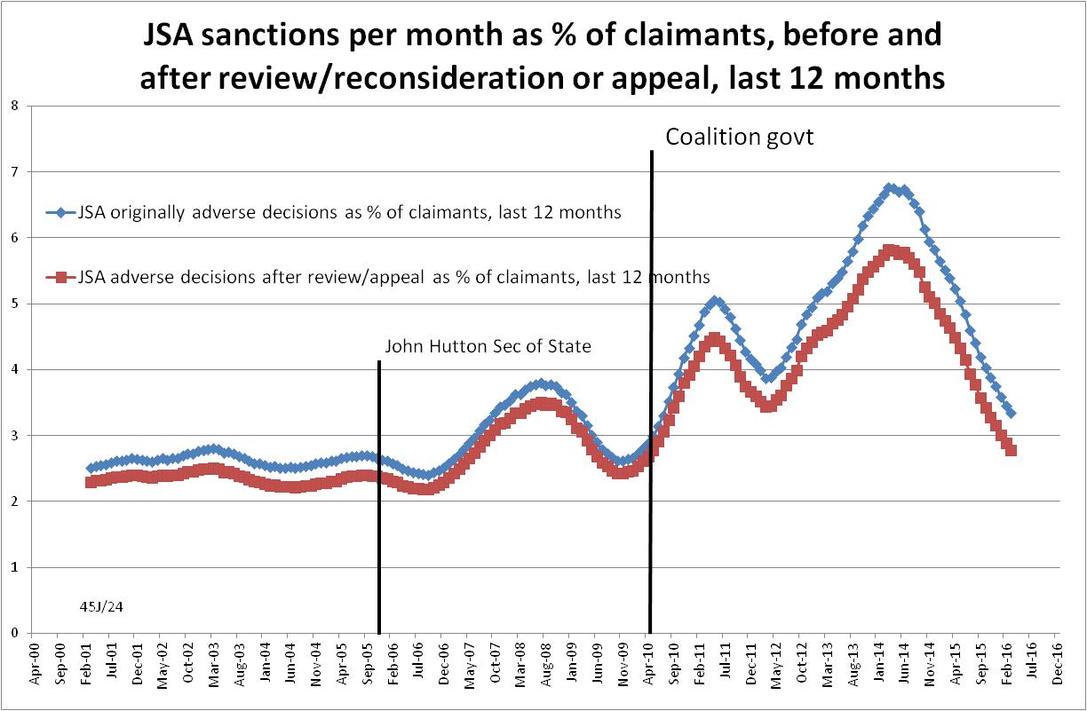

Figure 2
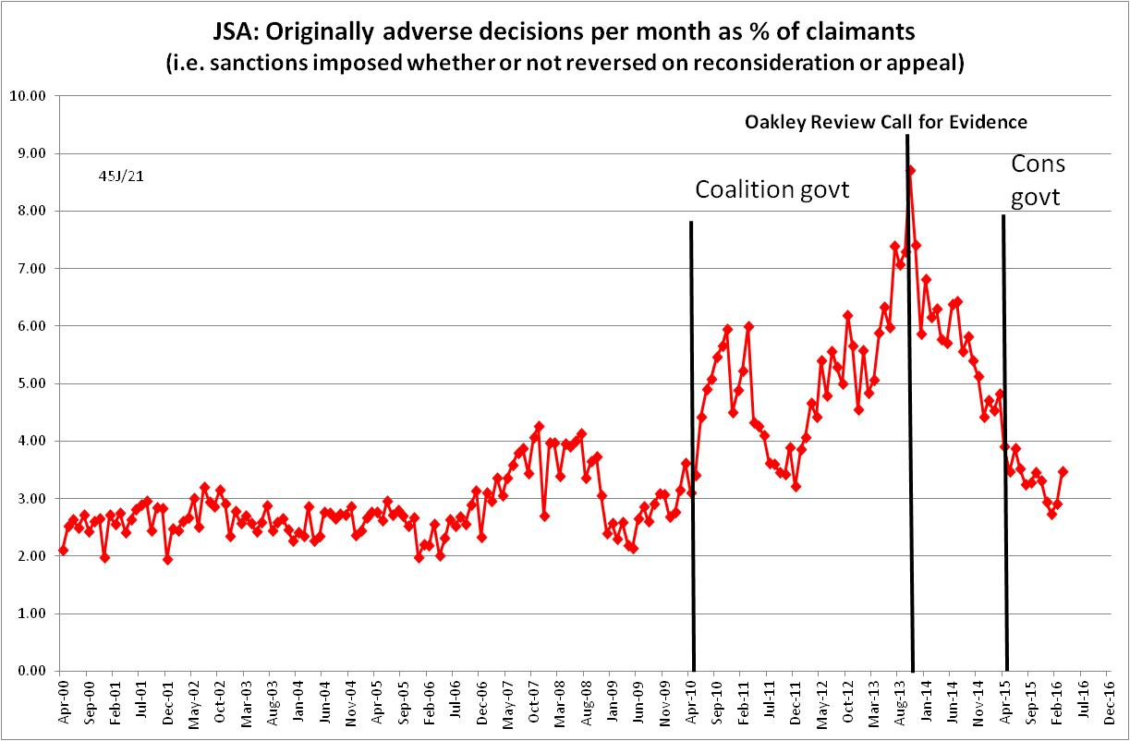
Figure 3
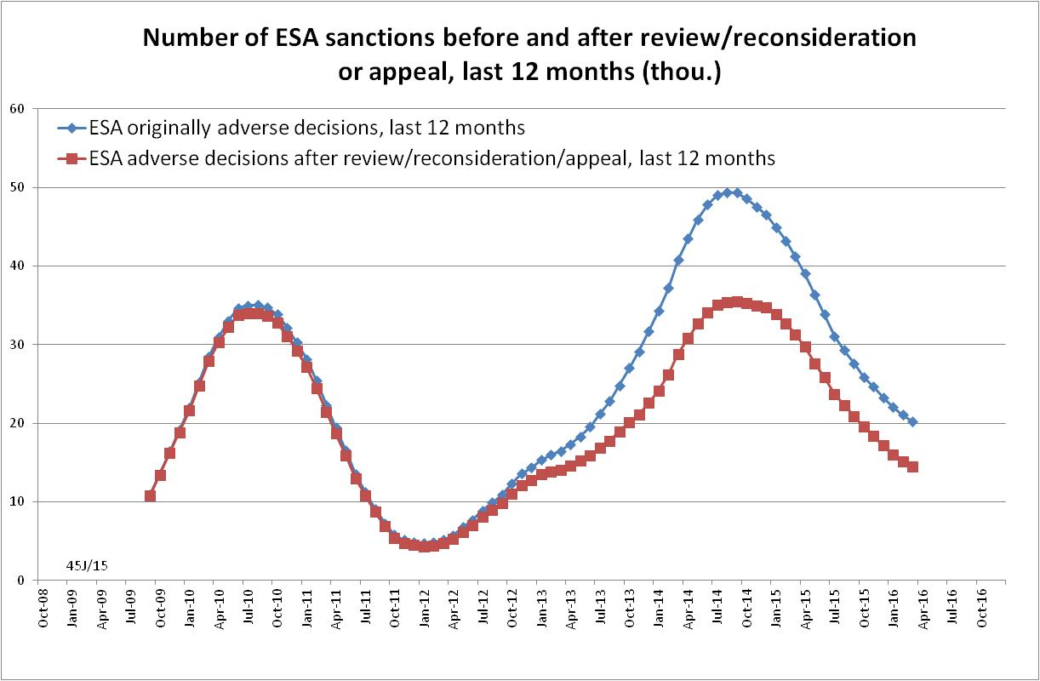
Figure 4
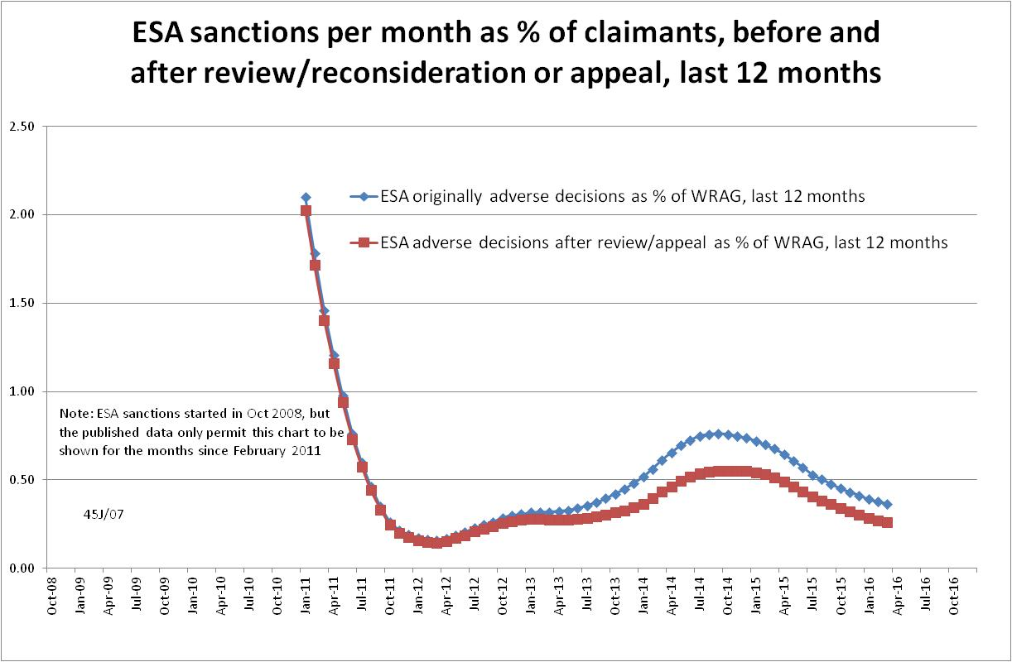
Figure 5
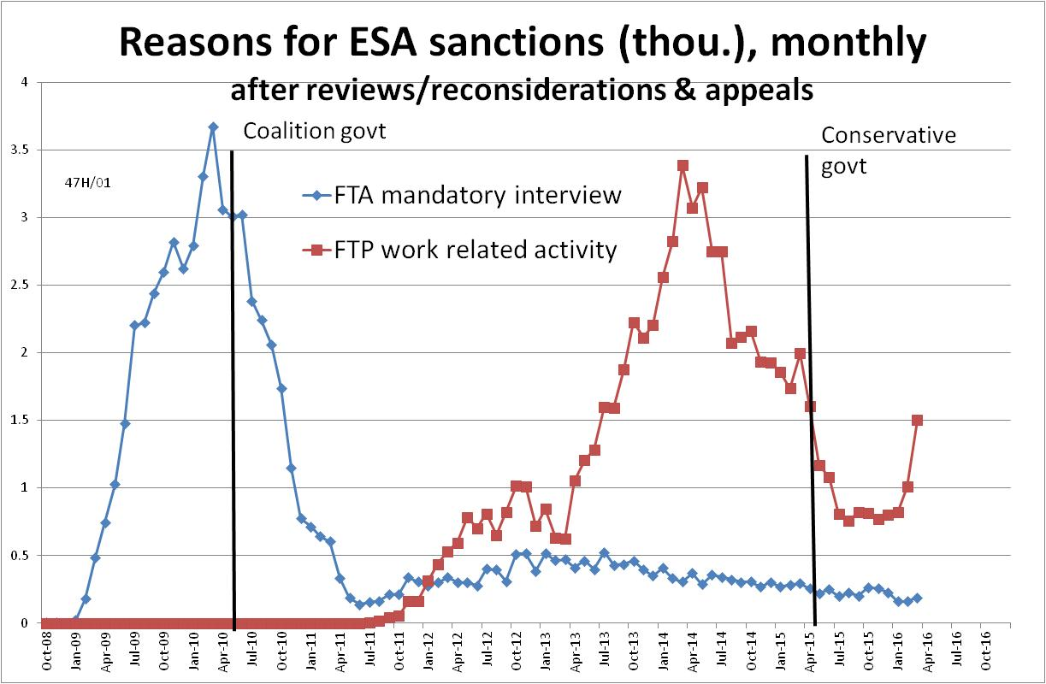
Figure 6
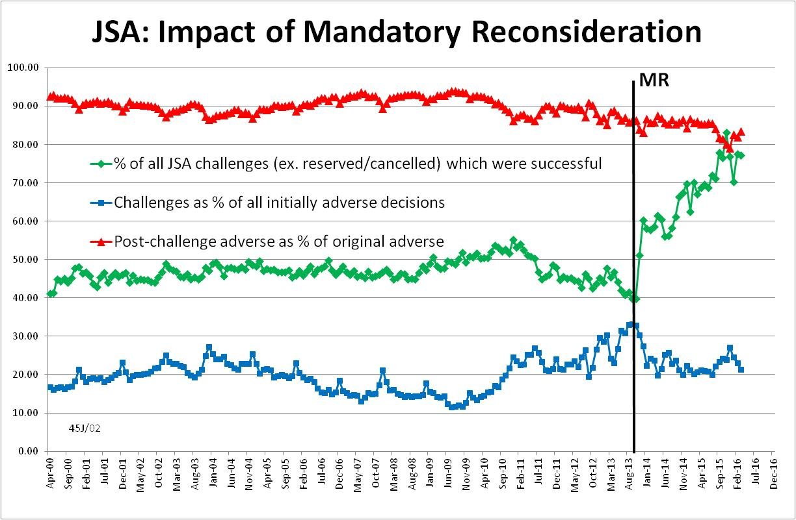

Figure 7
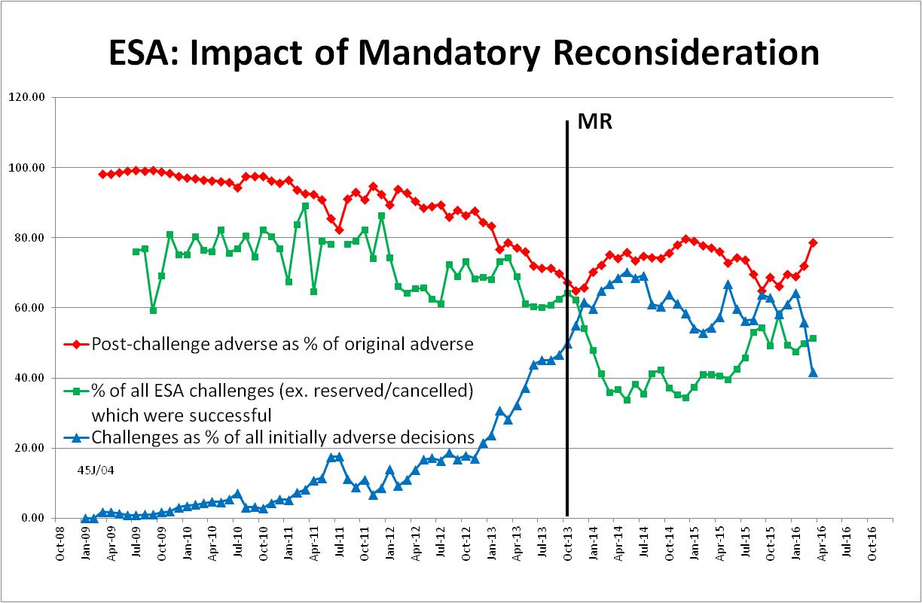

NOTES

This is the twelfth in a series of briefings on the DWP’s statistics on Jobseeker’s Allowance (JSA) and Employment and Support Allowance (ESA) sanctions. All the briefings are available at http://www.cpag.org.uk/david-webster. Earlier briefings contain various analyses not included in the present briefing. In reading earlier issues of the Briefing it should be remembered that the DWP may have made subsequent statistical revisions.
The basic concept of the DWP’s sanctions database is that each sanction case appears only once, and is given its latest status and attributed to the month of the latest decision on the case. So, for instance, if a decision is made in January 2014 to sanction someone, this decision is reviewed in March 2014 with an outcome unfavourable to the claimant, reconsidered in a ‘mandatory reconsideration’ in May 2014 again with an unfavourable outcome, and is heard on appeal by a Tribunal in October 2014 with a decision favourable to the claimant, then: - it appears in the statistics for the first time in January 2014 as an adverse ‘original’ decision - in March 2014 it changes its status to a ‘reviewed’ adverse decision and moves month to be with all the other cases where the latest decision has been made in March 2014 - in May 2014 it changes its status to a ‘reconsidered’ adverse decision and moves month to be with all the other cases where the latest decision has been made in May 2014 - in October 2014 it changes its status again to an appealed non-adverse decision, and moves month again to be with all the other cases where the latest decision has been made in October 2014.
The terms used here in relation to reviews, reconsiderations and appeals are as follows: Mandatory Reconsideration, with initial capitals, and its abbreviation MR, means the whole new appeal system introduced on 28 October 2013 ‘mandatory reconsideration’, without initial capitals, and never abbreviated, means the formal reconsideration of a sanction decision undertaken by the DWP’s Disputes Resolution Team. ‘decision review’ means the informal process of reconsideration now undertaken by the original Decision Maker (but previously undertaken by a different Decision Maker) when a claimant first challenges a sanction ‘internal review’ is a term embracing both ‘decision review’ and ‘mandatory reconsideration’ ‘appeal’ means a formal appeal to a Tribunal ‘challenge’ means any challenge to a sanction decision, i.e. it embraces ‘decision reviews’, ‘mandatory reconsiderations’ and Tribunal appeals.
DWP published an updated version of its UC statistics release strategy on 18 May at https://www.gov.uk/government/publications/universal-credit-statistics-background-information/universal-credit-statistics-background-information It still says nothing about statistics on Universal Credit sanctions. A note on Universal Credit statistics background and methodology (March 2016) is at https://www.gov.uk/government/uploads/system/uploads/attachment_data/file/523595/universal-credit-background-methodology.pdf
The previous three issues of the Briefing have incorrectly stated that UC sanctions are in effect 3½ rather than 2½ times as long as their nominal length. Repayment is suspended for any month when the claimant earns more than their threshold, and any remaining debt is written off if the earnings threshold has been met for 26 weeks, whether continuous or not.
The Universal Credit figures published by DWP exclude some claimants. The NOMIS figures are understood to correct for this and are preferred here.
‘In-work’ conditionality has been taken to apply to claimants in the statistical categories 'searching for work', 'working - with requirements', 'planning for work' and 'preparing for work’.
The documentation is in correspondence between Jonathan Portes (NIESR) and myself and the UKSA Chair Sir Andrew Dilnot, on the UKSA website at http://www.statisticsauthority.gov.uk/reports---correspondence/correspondence
Available at https://www.gov.uk/government/publications/benefit-sanction-statistics-publication-strategy/benefit-sanction-statistics-publication-strategy
The estimate of sanctions before challenges has been derived by adding the monthly total of ‘non-adverse’, ‘reserved’ and ‘cancelled’ decisions shown as being the result of reviews, mandatory reconsiderations and tribunal appeals, to the monthly total of adverse ‘original’ decisions.
Universal Credit sanctions have been estimated by assuming that their monthly rate is the same as for JSA, and increasing the resulting number by 37.7% in line with the result of the detailed calculation using age-specific JSA sanction rates reported in the November 2015 Briefing.
https://www.gov.uk/government/statistics/dwp-statistical-summaries-2016
Relevant DWP ministers since May 2010 have been the Secretary of State Iain Duncan Smith, in post throughout until 18 March 2016; David Freud, Minister for Welfare Reform throughout and still in post; and the Ministers of State for Employment, who have been Chris Grayling (May 2010 - Sept 2012), Mark Hoban (Sept 2012 – Oct 2013), Esther McVey (Oct 2013 - May 2015) and Priti Patel (May 2015 – July 2016).
In FoI response 2015-2187, DWP has supplied a denominator, namely the number of individuals who claimed ESA at any point in the year, which is not quite correct as it is for 1 June 2014 to 31 May 2015. This does not make a significant difference.

