BRIEFING

Benefit Sanctions Statistics

May 2019

4 June 2019

Dr David Webster
Honorary Senior Research Fellow
Urban Studies
University of Glasgow

Email david.webster@glasgow.ac.uk

Webpages: http://www.gla.ac.uk/schools/socialpolitical/staff/davidwebster/
http://www.cpag.org.uk/david-webster
SUMMARY

Publication by DWP in its 14 May statistical release of the first figures for the numbers of Universal Credit (UC) Full Service sanctions changes the picture from that presented in previous Briefings. When Full Service and Live Service UC sanctions are put together it emerges that there has been a decline in the overall monthly rate of UC sanctions before challenges as a proportion of claimants subject to conditionality from around 9% in 2015 to around 3% by January 2019. In the 12 months to January 2019 there were a total of approximately 228,000 sanctions on all benefits taken together, comprising 198,000 UC Full plus Live Service sanctions, 20,000 JSA, 1,800 ESA and 7,900 IS sanctions. The total number of sanctions on all benefits for 2018 at 246,000 was the lowest for a calendar year since this statistical system began in 2000. Therefore while the rate of sanctions on UC started very high by historical standards, it is now at a level comparable to that seen on JSA in the earliest years of the century, although sanctions are now more severe. Within the UC total, the rate for unemployed people is higher than for other claimants, but DWP has not released the figures necessary to establish by how much. The UC monthly sanction rate also remains much higher than the current rates for JSA, ESA and Income Support (IS).

DWP has also released new figures on the reasons for UC sanctions. In the year to January 2019 missed interviews were the main reason for UC (81%) and almost the only reason for IS sanctions. For JSA, missed interviews and non-availability for work/not actively seeking work were almost equally important at 28%, followed by non-participation in employment programmes at 26.5%, with voluntary leaving/misconduct at 17%. For ESA, non-performance of work related activity was at 60% of sanctions and missed interviews at 40%.

The DWP’s estimates of the proportion of claimants under sanction at any one time show that unemployed people continue to be treated more harshly than other groups within UC, with well over 3% under sanction in the latest quarter compared to under 1% for the other groups. One of the strongly criticised features of UC is that sanctions are continued even if the claimant moves into a different group which has no conditionality. In January 2019 there were a total of 2,012 claimants in this position, comprising 860 in the ‘working – with requirements’ group (which currently has no conditionality), 760 in ‘no work requirements’ and 392 in ‘working – no requirements’.

By April 2019 the number of claimants on UC had reached almost two million (1.96m), of whom just over half (50.9%) were in practice subject to conditionality. The total of claimant unemployed on UC or JSA has risen above one million for the first time since June 2014.

Ruth George MP has continued to elicit information from DWP about deductions from UC via parliamentary questions. This shows very substantial indebtedness to DWP among UC claimants, many of whom are living on incomes well below the official benefit scales as a result. Currently around 850,000 claimants (approaching half of all current UC claimants) have a UC advance repayment in place. Of these, over half (440,000 or 52%) also have at least one other debt relating to benefit overpayments, social fund loans or previous advances. The amount deducted from total UC entitlements for the various debts has increased from £9m out of £140m (7%) in April 2017 to £39m out of £410m (10%) in October 2018.

A news digest at the end of the Briefing reports on recent sanctions developments, including the announced scrapping of 3-year sanctions by the end of 2019 and the DWP’s public relations campaign on Universal Credit.
BRIEFING: Benefit Sanctions Statistics
May 2019

INTRODUCTION

The latest quarterly benefit sanctions statistics were released by DWP on 14 May, giving data to the end of January or February 2019. The new data are summarised by DWP in the publication Benefit Sanctions Statistics, available along with methodological notes at https://www.gov.uk/government/collections/jobseekers-allowance-sanctions with an associated spreadsheet with summary tables. The full figures for most aspects of the data are on the DWP’s Stat-Xplore database at https://stat-xplore.dwp.gov.uk/webapi/jsf/login.xhtml

New this quarter: The DWP for the first time has released data giving basic numbers of Universal Credit (UC) sanctions and reasons for them. These are in Benefit Sanctions Statistics or the accompanying spreadsheet but not on Stat-Xplore. They change the picture previously given in the Briefing, as explained below.

All statistics presented here relate to Great Britain.

Groups of claimants exposed to sanctions:
Universal Credit, JSA, ESA and Income Support

At January 2019, a total of about 1.83m claimants were exposed to the risk of sanctions, with varying frequency and severity. They were split between Universal Credit (UC), Jobseekers Allowance (JSA), Employment and Support Allowance (ESA) and Income Support (IS). The total of those exposed to sanctions is lower than given in previous Briefings, because of a change by the Briefing in the treatment of claimants in the UC ‘working – with requirements’ group to reflect the reality that they are not currently subject to conditionality.

Figure 1 shows that by April 2019 the number of claimants on UC had reached almost two million (1.96m). Figure 1 also shows how the numbers of claimants on UC have increased for each conditionality regime. At April 2019 there were 856,642 unemployed people in the full conditionality ‘searching for work’ group. There were 88,688 people ‘preparing for work’ and 52,662 ‘planning for work’. The DWP classifies the 272,782 people in the ‘working – with requirements’ group as being subject to conditionality, but since the end of the ‘In-Work Progression Randomised Control Trial’ on 31 March 2018, no conditionality has been applied to them in practice. Therefore in total just over half of UC claimants (997,972 or 50.9%) were in practice subject to conditionality at April 2019, and almost half (961,084 or 49.1%) were not.

Unemployed claimants (i.e. looking for work)

The total of people classified as unemployed in the ‘claimant count’ continues to rise, due to UC imposing work search and availability requirements on previously exempt people. Figure 2 shows that at April 2019 the number of JSA claimants had fallen to 230,234, but the combined total of unemployed people on UC or JSA had risen to 1,085,265. This is the first time since June 2014 that the unemployed claimant count has risen above one million. Over three-quarters (78.8%) of unemployed claimants are now on UC rather than JSA. A fuller analysis of unemployment was given in the February 2019 Briefing (pp.3-4).

Others subject to conditionality

To establish the number of claimants on grounds of sickness and disability who are subject to sanctions it is necessary to add to the total of claimants in the ESA Work Related Activity Group (WRAG) the number of UC claimants claiming on grounds of sickness or disability and subject to ‘preparing for work’ requirements. This is not published by DWP. The 88,688 UC claimants ‘preparing for work’ at April 2019 include these people but they also include some people who are not sick or disabled and would previously have claimed IS. The number of ESA WRAG claimants however is known. Their number peaked at 562,620 in August 2013 and has fallen since. There is a continuing gentle decline, with 364,800 at November 2018 and an estimated 351,000 at January 2019.

The number in the ESA Assessment Phase (which has no conditionality) is falling very sharply, to 111,490 in November 2018 from a peak of 546,030 in August 2014. This is because new claimants are being put on to UC. UC does not have an assessment phase; the ‘Job Coach’ has discretion on what conditions to impose pending the Work Capability Assessment.

The number of IS claimants is also falling due to movement of new claimants on to UC.There were an estimated 403,000 claimants on IS and subject to sanctions at January 2019. The largest group among these was an estimated 235,000 lone parents with a youngest child aged between one and five. There were also an estimated 157,000 carers and 11,000 other IS claimants.

The Universal Credit sanctions regime

A full description of the UC sanctions regime was given in the February issue of the Briefing, pp.5-6.

Sanctions before and after reviews, reconsiderations and appeals

Except for the new UC data, the DWP’s Benefit Sanctions Statistics publication and Stat-Xplore database only show sanctions after any reviews, reconsiderations and appeals that have taken place by the time the data are published. But numbers of sanctions before the results of these challenges are important since they show all the cases in which claimants have had their money stopped. Although a successful challenge should result in a refund, this is only paid after weeks or months by which time serious damage is often done. Estimates of sanctions before challenges are therefore given here but although reliable for longer time periods, they are not fully accurate for individual months. For JSA and ESA, figures for sanctions before challenges are typically higher than the ‘after challenge’ figures by very large amounts, namely about 20%. and 40% respectively. For UC ‘live service’ (the only figures currently available for the UC appeal process) and for IS, the proportion of sanctions overturned is much smaller at around 5% and 1% respectively. So for these types of sanction there is much less difference between the pre-and post-challenge figures. Wherever possible, this Briefing shows estimated pre-challenge sanctions figures.

NUMBERS OF SANCTIONS ON ALL BENEFITS BEFORE CHALLENGES

On its introduction, Universal Credit was delivered via ‘Live Service’. A programme to transfer Jobcentres to the more sophisticated ‘Full Service’ was started in May 2016 and completed in December 2018. Figure 2 of the November 2018 Briefing presented estimates of how the numbers of UC claimants on each of Live Service and Full Service have changed over time. By October 2018 it was estimated that 94% of UC claimants subject to conditionality were on Full Service and the latest Benefits Sanctions Statistics (p.4) states that by March 2019, 99.6% of Live Service claimants had transferred on to Full Service. Live Service figures by themselves are therefore now of little value.

Fortunately, DWP has now at last published some figures on UC Full Service sanctions, although these cover only original adverse decisions and reasons for them. This means that for the first time since 2016 it is now possible to say more or less exactly how many sanctions have been imposed.

In the 12 months to January 2019 there were a total of approximately 228,000 sanctions on all benefits taken together, comprising 198,000 UC Full plus Live Service sanctions, 20,000 JSA, 1,800 ESA and 7,900 IS sanctions.

Figure 3 shows how the annual total number of sanctions before challenges on all benefits has changed since April 2000. (The pre-2016 figures for IS are not reliable, but they make little difference to the picture.) The main feature is that the huge escalation of sanctions under the Coalition government, with a peak of 1,113,000 in 2013, has been decisively reversed. The total for 2018 at 246,000 was the lowest for a calendar year since this statistical system began. Figure 4 shows the monthly number of sanctions for each individual benefit; this picture is dominated by the huge surge in JSA sanctions under the Coalition government in 2010-15.

MONTHLY NUMBERS AND RATES OF SANCTIONS BEFORE CHALLENGES FOR THE FOUR BENEFITS

Monthly number and rate of Universal Credit sanctions

Figure 5 shows the newly published data on the monthly number of Full Service sanctions, together with the monthly number of Live Service sanctions, both since August 2015 when the national rollout of Full Service began. The DWP’s Full Service data shows ‘before challenge’ figures, but DWP continues to publish Live Service sanctions only on an ‘after challenge’ basis. So here, ‘before challenge’ figures have been estimated for Live Service in the usual way. The chart shows Full Service sanctions replacing Live Service sanctions, particularly during 2018 when it appears that Full Service sanctioning lagged behind the transfer of cases early in the year, and there was a sudden catch-up in the summer. The overall total of UC sanctions on Live and Full Service taken together has remained roughly steady since the end of the DWP’s catch-up blitz of winter 2016-17, at around 15,000-20,000 per month.

Figure 6 shows estimated monthly Full plus Live Service UC sanctions as a percentage of claimants subject to conditionality. The exact number of claimants subject to conditionality is not available for the period April 2015 to March 2018, when a proportion of people in the ‘working – with requirements’ group were enrolled in the In-Work Progression Trial. Here, it has been assumed that everyone in this group was subject to conditionality for the whole period up to March 2018, but no one since then. This will produce an overestimate of the total number of UC claimants subject to conditionality for the period up to March 2018, which will slightly lower the resulting sanction rates for this period. For comparison, Figure 6 also shows the estimated rate of sanctions for Live Service only as previously published in the Briefing.

The most important finding is that there has been a fairly steady decline in the overall rate of UC sanctions before challenges as a proportion of claimants subject to conditionality since the end of the catch-up blitz in 2017, from around 6% per month to around 3%. If the fluctuation associated with the catch-up is disregarded, the longer term decline has been from around 9% in 2015 to around 3% by 2019.

The comparison with the previously published Live Service only figures shows that the Live Service figures became increasingly misleading from the end of 2017 onwards.

The DWP has not broken down its new UC sanctions figures between conditionality groups. However, the estimates of the proportion of claimants under sanction at a point in time (see Figure 10 below) indicate that the rate of sanction is much higher for unemployed claimants than for other claimants.

Monthly rate of sanctions: Universal Credit compared to ‘legacy’ benefits

Figure 7 gives the monthly rates of sanction before challenges for all four benefits. Inclusion of the newly published figures for UC Full Service radically changes the picture from that presented in Figure 5 of the February 2019 Briefing, where UC Live Service sanction rates were shown as staying at a level similar to the highest rates seen for JSA under the Coalition. The revised picture, for Full and Live Service together, indicates that while UC sanction rates were at this level at the outset, they have subsequently declined to reach a level of around 3% per month, similar to that seen in the earliest years of the century. However the UC sanction rate remains much higher than the rates of well under 1% currently seen for JSA, ESA and IS.

REASONS FOR SANCTIONS

The Briefing last looked at the reasons for sanctions in May 2017. With DWP’s publication of data on the reasons for UC Full Service sanctions, it is now worth looking at them again.

DWP has published UC Full Service data only for the year and quarter to 31 January 2019, and only for its summary classification of reasons. The DWP’s summary classification is unsatisfactory because it puts unrelated reasons together. In particular, it includes ‘actively seeking work’ or ‘work search’ under ‘availability’, which is an entirely different issue. However, there is no choice but to use it. To enable comparison, Figure 8 shows the summary reasons for sanctions for the year to January 2019 for the combined UC Full and Live Service and for the other three benefits, with all figures on a ‘before challenge’ basis, estimated where necessary.

The 161,000 UC sanctions for ‘failure to attend’ (FTA) interviews dominate the figures, far exceeding the next largest category which is UC sanctions for non-availability for work (which as noted includes work search) at 25,000. Other reasons account for relatively small numbers of sanctions.

Figure 9 presents the figures in terms of the percentage of sanctions for each benefit which were imposed for each reason. Missed interviews are the main reason for UC (81%) and almost the only reason for IS. For JSA, missed interviews and non-availability for work/actively seeking work are almost equally important at 28%, closely followed by non-participation in employment programmes at 26.5%, with voluntary leaving/misconduct at 17%. For ESA, non-performance of work related activity is at 60% and interviews at 40%.

The extreme predominance of missed interviews in UC sanctions is something of a mystery.

PROPORTION OF CLAIMANTS UNDER SANCTION AT A POINT IN TIME

The DWP’s preferred measure of sanctions ‘rate’ is the number and proportion of claimants who are serving a sanction at a point in time. Their published figures have always covered both Live and Full service, but there are various problems with this measure, which were discussed in the November 2017 Briefing (pp.6-10). In particular, it does not show people who stop claiming because of the sanction, or people who resume a sanction on returning to benefit, or those on UC who still have reduced benefits as a result of repaying hardship payments. This measure also gives no idea of the total number of people who have been subjected to sanctions over a given period such as a year, which is a serious weakness given that the effects of a sanction often last a long time. There are also particular problems with the JSA estimates, which do not appear credible at all. However, the figures do have the advantage that in respect of UC, they show the differing prevalence of sanctions for the different conditionality groups, and any trends will at least to some extent reflect similar trends in the numbers of sanctions being imposed.

Figures allowing calculation of the percentage of UC claimants under sanction at a point in time by conditionality group were first published by DWP in May 2018. Figure 10 updates these figures. After a levelling off during 2018, there has been a slight downward trend in all the groups in the latest quarter. The unemployed are treated much more harshly than the other groups, with well over 3% under sanction in the latest quarter, whereas the others are all below 1%. The ‘working – with requirements’ group previously came second, but ending of the DWP’s in-work conditionality trial in March 2018 has meant that they have now been overtaken by the ‘preparing for work’ group of mainly sick and disabled people.

One of the strongly criticised features of Universal Credit is that sanctions are continued even if the claimant moves into a different group which has no conditionality. The Work and Pensions Committee (2018) condemned this as pointless. To examine the scale of this problem, Figure 11 shows the numbers (not proportions) of people in each no-conditionality group who have been under sanction in each quarter since August 2015. In January 2019 there were a total of 2,012 claimants in this position, comprising 860 in the ‘working – with requirements’ group (which currently has no conditionality), 760 ‘no work requirements’ and 392 ‘working – no requirements’. The number in the ‘No work requirements’ group has been steadily rising, presumably because of the increase in UC claimants. All three groups saw big increases associated with the DWP’s sanctions catch-up blitz of 2016-17.

DEDUCTIONS FROM UNIVERSAL CREDIT

Ruth George MP has continued to elicit information from DWP about deductions from UC via parliamentary questions. This shows very substantial indebtedness to DWP among UC claimants, many of whom are living on incomes well below the official benefit scales as a result.

A Written Answer on 8 May 2019 (249941) revealed that currently there are around 850,000 claimants who have a UC advance repayment in place. This is approaching half of all current UC claimants. Of these claimants, over half (440,000 or 52%) also have at least one other debt relating to benefit overpayments, social fund loans or previous advances. These break down as follows (figures rounded to nearest ten thousand):

Tax Credits only 120,000
Social Fund only 80,000
Other combinations inc. Social Fund 62,000
Other combinations 40,000
UC overpayment only 22,000
Other Combinations inc. UC 20,000
Other Combinations inc. Leg OP & SF 18,000
Legacy Benefit overpayment only 18,000
Other Combinations inc. Legacy 17,000
UC Recoverable Hardship Payment 10,000
Legacy Benefit overpayment & Social Fund 10,000
Housing Benefit only 10,000
Tax Credits & Housing Benefit 9,000
Housing Benefit & Social Fund 5,000
______
TOTAL 440,000

The above data do not include other third party debts, for example arrears, utility bills or other borrowing. Note that the figures also do not show the number of claimants making non-advance repayments who are not making advance repayments.

A Written Answer on 15 May 2019 (224493) established that the amount deducted from UC for the various debts has increased from £9m out of £140m (7%) in April 2017 to £39m out of £410m (10%) in October 2018. The increase in the proportion is attributed to greater awareness of the availability of advance payments and resulting increased requests for them. Around 60% of new claimants to Universal Credit in October 2018 received an advance.

A Written Answer on 13 February established that at September 2018, 60,000 Full Service claims (7%) had deductions at 40% of the standard allowance and 5,000 (0.6%) had deductions that exceeded the normal 40% maximum deduction rate. These deductions of over 40% are due to ‘last resort’ deductions which are applied to help prevent disconnection or eviction (for example, service charges, rent, gas or electricity arrears). DWP has not included sanctions or fraud penalties in these figures on the basis that they are ‘reductions’ of benefit rather than ‘deductions’.

Fraud and sanction hardship payment repayments can be deducted at 40%. A Written Answer of 27 February 2019 (224831) stated that ‘Our current internal data shows that there are around 8,500 Universal Credit claimants with an overpayment classified as fraud. Other factors, such as higher priority deductions, may mean that DWP is unable to deduct at 40% for the recovery of a benefit overpayment.’

Some fragmentary data on repayment of UC hardship payments were discussed in the February 2019 Briefing, pp.10-11. The rules for deductions were discussed in the November 2018 Briefing, pp.18-19.

A news story in the Independent on 19 May at https://www.independent.co.uk/news/uk/home-news/universal-credit-dwp-deductions-benefit-families-claimants-a8916921.html said that Ruth George ‘cited separate figures showing two-thirds of universal credit claimants who have transferred from tax credits have an overpayment to repay, averaging £1,500 per person’. I have not been able to find the original source of these figures.

ANALYSES NOT INCLUDED IN THIS ISSUE

Readers are referred to earlier numbers of the Briefing for analyses of issues not discussed in the present issue. Figures on durations of sanctions were discussed in detail in February 2019; claimants with earnings following a sanction were covered in November 2018; ethnicity and gender in July 2018; benefit destinations in February 2018; challenges to sanctions in February 2018 and May 2017; JSA benefit suspensions not followed by sanction, and ESA sanctions by medical condition in August 2017; and hardship payments in February 2019 and November 2015. Longer period analyses were included in the author’s written evidence to the Work and Pensions Committee (Webster 2018a) and in a presentation to the Welfare Conditionality conference at York in June 2018 (Webster 2018b). These analyses will be updated in future numbers.

SANCTIONS - OTHER DEVELOPMENTS

Abolition of 3-year sanctions ‘by the end of the year’

In a Parliamentary Written Statement on 9 May, col.34WS, Amber Rudd announced her intention to abolish the three-year sanctions which were introduced for JSA and UC in 2012, ‘by the end of the year’. This was followed by a speech on 10 May, at
https://www.gov.uk/government/speeches/the-future-of-the-labour-market
and an accompanying press release at
https://www.gov.uk/government/news/record-employment-is-not-enough-jobseekers-need-the-chance-of-better-work New Regulations will be required to bring this into effect. As indicated in its response to the Work and Pensions Committee (House of Commons Work and Pensions Committee 2019), the government’s review of sanctions is continuing, and there may be further announcements. A commentary on the government response (Webster 2019) is available at www.cpag.org.uk/david-webster

Three year sanctions are incurred for 3 high level 'failures' within 12 months. However for JSA the DWP has never recorded the date of the failure in its computer systems. It only records the date of the sanction decision. So it is possible only to put an upper limit on the number of people who could have been subject to a 3-year sanction. For JSA, this upper limit is 2,904. This is the number of individuals who have had three or more high level sanctions during the whole period since the start of the current regime in October 2012. It seems unlikely that many of these people will have had three or more sanctionable 'failures' within any twelve month period so the number of JSA claimants given 3-year sanctions to date is likely to have been only in the hundreds. For UC, the upper limit is 121, on the same basis except that this figure refers only to Live Service, not Full Service, and only covers the period since August 2015 when the current statistics started (there were small numbers of people on UC in pilot areas before this). The upshot is that it seems unlikely that the number of people given 3-year sanctions to date will have been far into four figures, even if it has reached them.

It should be remembered that for 73 years from the start of National Insurance in 1913 up to 1986, the maximum length of a disqualification/sanction was 6 weeks. The new upper limit of 6 months is seven times as long.

It remains to be seen whether the government will really reduce the effective maximum sanction length to 6 months. Because of the ‘until compliance’ feature in ESA and the consecutive application of sanctions under UC, the DWP’s own data as at February 2019 showed 21% of ESA sanctions lasting over 6 months, and 5% of UC sanctions.

DWP public relations campaign on Universal Credit

The DWP has launched a public relations campaign about Universal Credit to counter the criticisms it has received and to promote its own claims about the system. The campaign was described in a DWP memo to the ‘staff side’ reported in the Guardian on 14 and 16 May, at
https://www.theguardian.com/commentisfree/2019/may/14/universal-credit-department-work-pensions-pr and at
https://www.theguardian.com/society/2019/may/16/mps-demand-details-of-dwps-universal-credit-advertorials The Guardian story of 16 May has a facsimile of the memo.

The DWP campaign has three components.

First, a wrap-around ‘advertorial’ supplement to the Metro free newspaper (which is owned by the Daily Mail), spread over 9 weeks starting on 22 May, together with a dedicated Daily Mail/Metro website with videos at https://creative.dailymail.co.uk/universalcredit/uc-uncovered/index.html. This website in turn links to an apparently redesigned conventional government information website at https://www.understandinguniversalcredit.gov.uk/ Of the Metro material, the memo says “the features won’t look or feel like DWP or UC – you won’t see our branding … We want to grab the readers’ attention and make them wonder who has done this ‘UC uncovered’ investigation.” The New Statesman printed a facsimile of the Metro material of 22 May at https://www.newstatesman.com/politics/welfare/2019/05/dwp-s-universal-credit-uncovered-newspaper-advert-backfires

Second, promotion of sympathetic editorial coverage in provincial media owned by the Reach group, notably in the Leicester Mercury on 14 May at https://www.leicestermercury.co.uk/news/leicester-news/man-thinks-universal-credit-great-2862272 This feature was republished on 15 May in the Newcastle Chronicle at https://www.chroniclelive.co.uk/news/uk-news/universal-credit-why-actually-great-16279017 and in Wales Online at https://www.walesonline.co.uk/news/world-news/universal-credit-why-actually-great-16279017, and apparently also in Kent.

The third element of the campaign will be a BBC2 documentary series, which according to the memo is “looking to intelligently explore UC” by filming inside three jobcentres. “This is a fantastic opportunity for us” (i.e. DWP) “– we’ve been involved in the process from the outset, and we continue working closely with the BBC to ensure a balanced and insightful piece of television.”

The House of Commons Work and Pensions Committee has written to Amber Rudd raising various questions about the PR campaign. The Chair’s letter is at https://www.parliament.uk/documents/commons-committees/work-and-pensions/Correspondence/Letter%20from%20FF-to-Amber-Rudd.pdf

The Metro feature on 22 May highlighted the statement ‘Fewer than 3 in every 100 Universal Credit claimants are having payments reduced by sanctions’. The Employment Minister Alok Sharma made a similar statement in response to an oral question in the House on 13 May, col.13: ‘Right now less than 3% of those who are on universal credit and under conditionality are getting a sanction’. Both of these statements are in breach of the official Code of Practice for Statistics, para.V3.1 ‘Statistics, data and explanatory material should be relevant and presented in a clear, unambiguous way that supports and promotes use by all types of users’ and V3.2 ‘Statistics should be accompanied by a clear description of the main statistical messages that explains the relevance and meaning of the statistics in a way that is not materially misleading.......’ (emphasis added). The ‘less than 3%’ figure refers to the DWP’s estimates (themselves disputable) on the proportion of claimants who are serving a sanction at any one point in time. But the statements as they stand can imply that less than 3% of UC claimants get a sanction at any time, and therefore that the chance of any individual person getting a sanction if they claim UC is less than 3 in 100. This is not the case. With about 3% of claimants receiving a sanction each month (see above, p.6), the proportion receiving a sanction over a longer period such as a year or five years will be much higher. This point has been discussed in earlier Briefings, most recently in February 2017 pp.7-8, May 2017 pp.6-7 and July 2018 p.9.

Work and Pensions Committee on ‘survival sex’

The House of Commons Work and Pensions Committee is investigating the recurrent allegations that ‘welfare reform’ including the sanctions regime has led to prostitution. It held an evidence session on 22 May at http://data.parliament.uk/writtenevidence/committeeevidence.svc/evidencedocument/work-and-pensions-committee/universal-credit-and-survival-sex/oral/102450.pdf
Papers about the inquiry are at
https://www.parliament.uk/business/committees/committees-a-z/commons-select/work-and-pensions-committee/inquiries/parliament-2017/universal-credit-survival-sex-inquiry-17-19/publications/

Report on the UK Visit of the UN Special Rapporteur on Extreme Poverty and Human Rights

Following his initial statement on 16 November, the UN Special Rapporteur has now published his official report, on 22 May at https://undocs.org/en/A/HRC/41/39/Add.1, with a press release at https://www.ohchr.org/EN/NewsEvents/Pages/DisplayNews.aspx?NewsID=24636&LangID=E

His comments and recommendations are similar to those of his Statement of 16 November, reproduced in the November 2018 Briefing, p.10. He summarises the position as follows: ‘British compassion has been replaced by a punitive, mean-spirited and often callous approach apparently designed to impose a rigid order on the lives of those least capable of coping, and elevate the goal of enforcing blind compliance over a genuine concern to improve the well-being of those at the lowest economic levels of British society. It might seem to some observers that the Department of Work and Pensions has been tasked with designing a digital and sanitized version of the nineteenth century workhouse, made infamous by Charles Dickens, rather than seeking to respond creatively and compassionately to the real needs of those facing widespread economic insecurity in an age of deep and rapid transformation brought about by automation, zero-hour contracts and rapidly growing inequality’

Bailiffs – Enforcement of debt – House of Commons Justice Committee

This report (House of Commons Justice Committee 2019) notes widespread malpractice by bailiffs, the majority of whose work relates to local authority debt. It says ‘We are surprised that bailiffs are apparently so under-regulated compared with other sectors, especially given that they deal with some of the most vulnerable people in society’, and that reforms introduced in 2014 have not worked’. It calls for a new regulator, which should be able to stop unfit enforcement agents and companies from practising.

The UK’s debt crisis - shifting to basics, not overspending

The Financial Times on 27 April ran a major article (Barrett 2019) on the work of PayPlan, one of the UK’s largest providers of free debt advice. It highlighted the fact that the nature of problem debt has shifted over the past decade. Before the financial crisis of 2008, it was typically due to overspending. Now, PayPlan’s service users have lower debt levels and lower incomes, and their debts have typically been incurred through spending on everyday things. The typical debt is £15,000 and typical income less than £2,000 per month. Nearly a quarter of people who attempted suicide last year were in problem debt. Problem debts are now more likely to be owed to government organizations – Citizens Advice reported that this proportion doubled from 21 to 40 per cent in the five years to 2017-18, while those reporting consumer debt problems fell from 52 to 33 per cent. Benefit issues, including deductions, are now common, and public sector debt collection methods are a particular problem. The Financial Conduct Authority has a remit to protect people in problem debt, but it does not extend to the public sector.

Lack of minimum wage enforcement

The Financial Times on 15 April carried a lengthy interview (Wright 2019) with Professor David Metcalf, the Director of Labour Market Enforcement. He is very critical of HMRC for focusing on the comparatively easy target of large retailers rather than the areas of particularly serious breach of minimum wage legislation which include agriculture, shellfish production, nail bars, car washes, some areas of construction, social care and the hotel and hospitality industry. The enforcement bodies together employ only one inspector for every 20,000 workers.

CRISIS Homelessness Monitors 2019 – England and Scotland

The annual CRISIS Homeless Monitors have been published for Scotland on 25 February and for England on 15 May, at https://www.crisis.org.uk/ending-homelessness/homelessness-knowledge-hub/homelessness-monitor/ Both discuss the role of benefit sanctions.

Reform of Jobcentre Plus – Views of the Shadow Employment Secretary

The Fabian Society is currently running a project Poverty and social security: where next?, details at https://fabians.org.uk/about-us/our-projects/poverty-and-social-security-where-next/ In a contribution on 2 April at https://fabians.org.uk/hard-truths/ the Shadow Minister for Employment Mike Amesbury MP set out his views on reform of Jobcentre Plus. ‘ “Nobody chooses to go into a jobcentre because they think that’s where they’ll find a job – they’re not job centres – they’re sanctions centres.” That was the view of a former Jobcentre Plus work coach I spoke to on his experience of how our network of jobcentres are perceived and run under this Conservative government...... I want to see a jobcentre approach that focuses on real support, delivered in locations that people can access easily, that are real, genuine community hubs, supporting people throughout their working and non-working life...... We need a radical cultural shift for jobcentres, from being places of punitive administration to centres that offer professional, impartial careers advice whilst providing compassionate support to those most in need...... Under a Labour government, we will work with partners to radically overhaul our social security system so that it supports people instead of punishing them.’

Trussell Trust statistics on Food Bank usage 2018/19

The Trussell Trust’s annual statistics on food bank usage were published on 25 April at
https://www.trusselltrust.org/news-and-blog/latest-stats/end-year-stats/ The main issue highlighted is the 5-week delay in the first payment under Universal Credit. It is not clear how large a role is currently being played by benefit sanctions. However, an article in the New Statesman on 25 April by Anoosh Chakelian at https://www.newstatesman.com/politics/welfare/2019/04/universal-credit-designed-make-you-fail-why-foodbank-use-record-high about a visit to a food bank in Brixton quotes a benefits adviser as saying ‘For most cases, it’s problems with benefits – delayed payments, sanctions...... If they’re unwell, they miss an appointment, they’re sanctioned straight away.’

Food insecurity in the UK – new study

This study (Loopstra et al. 2019), published on 29 April, concludes that vulnerability to food insecurity has worsened among low-income adults in the UK since 2004, particularly among those with disabilities.

Right to Food – Scottish Human Rights Commission

The Scottish Human Rights Commission has urged that the human right to food should be put into law in Scotland to protect people from rising food insecurity and the impacts of Brexit. It comments that ‘The statistics bear out that there is a causal link between the implementation of social security and the food insecurity. ‘ Details are at
http://www.scottishhumanrights.com/news/change-the-law-to-protect-the-right-to-food-for-all/

Labour Hunger Campaign

Labour Party activists have launched a Labour Hunger Campaign at https://labourhunger.wordpress.com/. It includes a proposed Charter on Hunger with the commitment to ‘abolish sanctions on sick or disabled people, people in work, and all sanctions on the unemployed except those related to traditional insurance conditions (such as leaving a job voluntarily without good reason, or refusing to accept a suitable job). Even then, people must still be entitled to an income sufficient to prevent destitution.’

New book from the Welfare Conditionality project

A new book has been published from the ESRC-funded Welfare Conditionality project: Dealing with Welfare Conditionality: Implementation and Effects, edited by Peter Dwyer. Details are at
https://policy.bristoluniversitypress.co.uk/dealing-with-welfare-conditionality

NAO report on penalty charge notices in healthcare

The report of this investigation was published on 14 May at https://www.nao.org.uk/report/investigation-into-healthcare-penalty-charge-notices/ The NAO has concluded that ‘Free prescriptions and dental treatment are a significant cost to the NHS, so it is important that it can reclaim funds from people who are not exempt from charges and deter fraud. However, eligibility rules under the current system are complicated and difficult for people to understand, and NHS Business Services Authority still issues a significant number of PCNs (Penalty Charge Notices) that are later successfully challenged. Since 2014, NHSBSA has significantly increased the number of checks it carries out and the number of PCNs it issues but has only recently started taking commensurate steps to improve public awareness of the rules. A simpler system or better real-time checking will be important going forward in deterring fraud but not disadvantaging vulnerable people.’ There are obvious parallels with the experience of benefit sanctions since 2010.

INTERNATIONAL

Australian controversy on benefit sanctions

The Guardian on 8 January at https://www.theguardian.com/australia-news/2019/jan/08/labor-says-jobactive-system-is-failing-job-seekers-and-businesses reported on plans by the Australian Labour Party to reform the benefit conditionality system for unemployed people, in particular the requirement to make 20 job applications per month. Peter Strong, the chief executive of the Council of Small Business of Australia, has said this requirement is particularly hated by business. The Liberal former Prime Minister Tony Abbott responded by claiming that ‘These proposed changes show Labor is now the welfare class party not the working class one.’

This dichotomisation is familiar from British controversy. Writing in the Social Policy Association’s 50th Anniversary blog series on 9 April at http://www.social-policy.org.uk/50-for-50/australia-welfare/ , Peter Whiteford of the Australian National University rehearsed the lack of evidence for it, concluding that ‘The prevalence of risks means that even in Australia with the most targeted benefit system in the OECD, the social security system is not “residual”, but is among the core institutions of contemporary society, and is one of the main levers not just of social policy but also of economic policy in dealing with risks. The evidence is overwhelming that Australian welfare, like the British welfare state, is not simply a matter of “them” versus “us”. We are all in it together.’ However, the Australian Labour Party did not win the general election held on 18 May.

The Australian ‘jobactive’ employment service is described at https://www.jobs.gov.au/jobactive and the ‘Mutual Obligation’ requirements on unemployed claimants are described at
https://www.humanservices.gov.au/individuals/topics/mutual-obligation-requirements/29751

REFERENCES

Barrett, Claer (2019) ‘On the frontline with those tackling the UK’s debt crisis’, Financial Times, 27 April

House of Commons Justice Committee (2019) Bailiffs: Enforcement of debt, Seventeenth Report of Session 2017–19, HC 1836, 11 April, at
https://publications.parliament.uk/pa/cm201719/cmselect/cmjust/1836/1836.pdf

House of Commons Work and Pensions Committee (2018) Benefit Sanctions, Nineteenth Report of Session 2017-19, HC 955, 6 November, at
https://publications.parliament.uk/pa/cm201719/cmselect/cmworpen/955/955.pdf

House of Commons Work and Pensions Committee (2019) Benefit Sanctions: Government Response to the Committee’s Nineteenth Report of Session 2017-19, HC 1949, 11 February, at https://publications.parliament.uk/pa/cm201719/cmselect/cmworpen/1949/1949.pdf

Loopstra, Rachel, Aaron Reeves and Valerie Tarasuk (2019) ‘The rise of hunger among low-income households: an analysis of the risks of food insecurity between 2004 and 2016 in a population-based study of UK adults’, Journal of Epidemiology and Community Health, doi:10.1136/jech-2018-211194

Webster, David (2018a) Written evidence to the House of Commons Work and Pensions Committee inquiry into Benefit Sanctions, at
http://data.parliament.uk/writtenevidence/committeeevidence.svc/evidencedocument/work-and-pensions-committee/benefit-sanctions/written/82601.pdf
Webster, David (2018b) The great benefit sanctions drive 2010-16 in historical perspective, presentation to the conference Welfare Conditionality: Principles, Practice and Perspectives, University of York, Wednesday 27 June 2018, at http://eprints.gla.ac.uk/183161/

Webster, David (2019) Government Response to the Work and Pensions Committee Report on Benefit Sanctions: Commentary, 1 April, at www.cpag.org.uk/david-webster

Wright, Robert (2019) ‘Minimum wage enforcers urged to focus on worst offenders’, Financial Times, 15 April

Figure 1
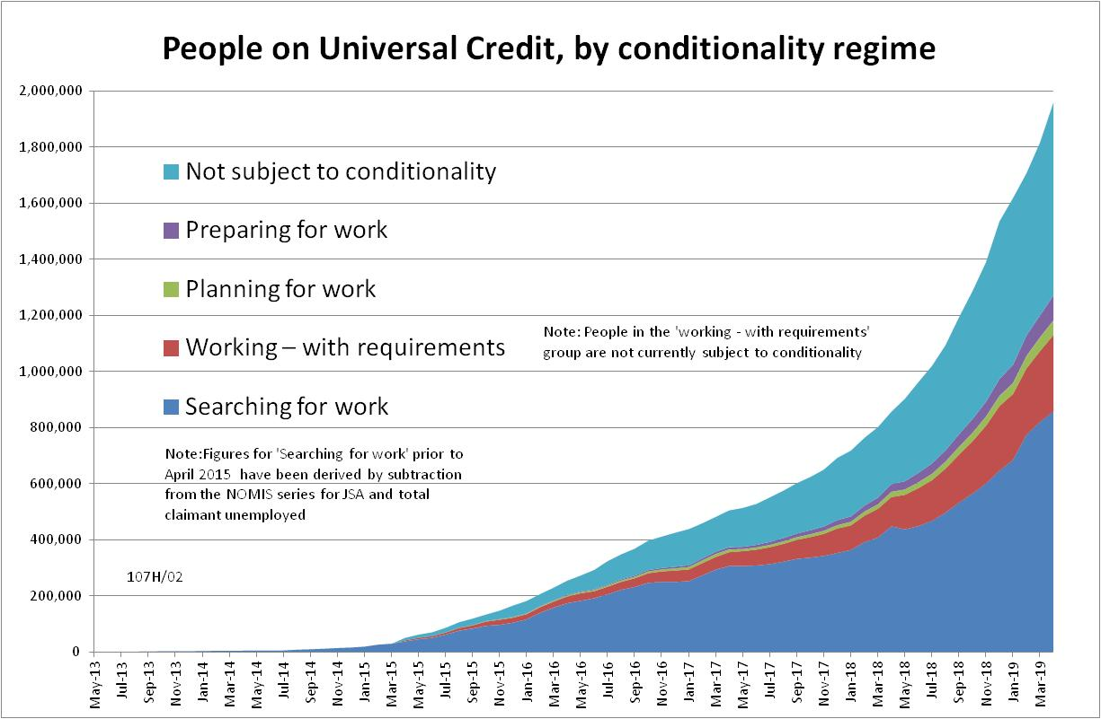

Figure 2
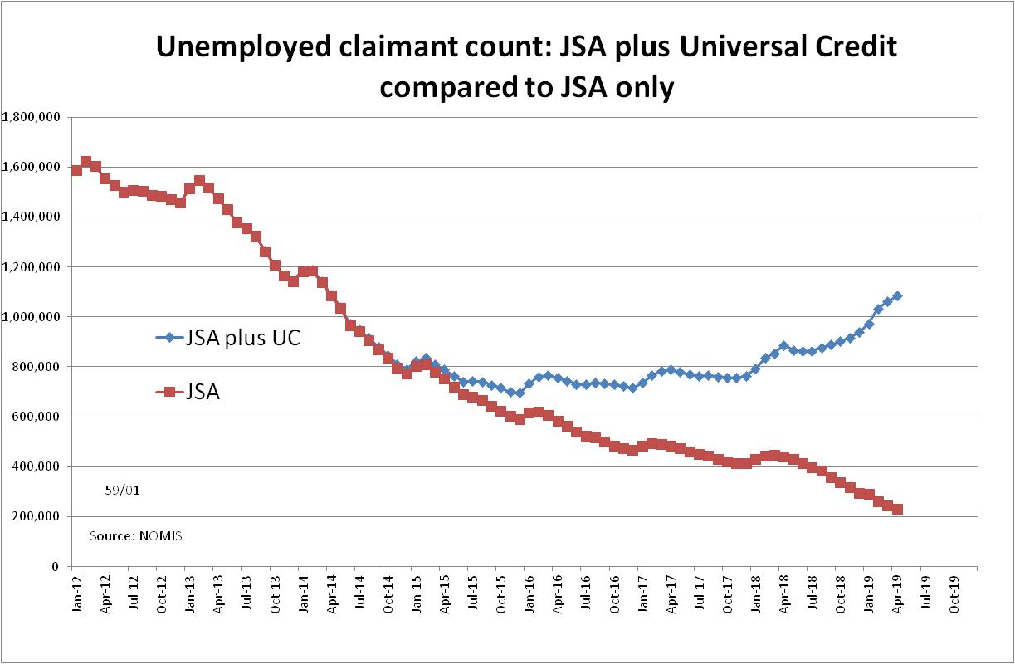
Figure 3
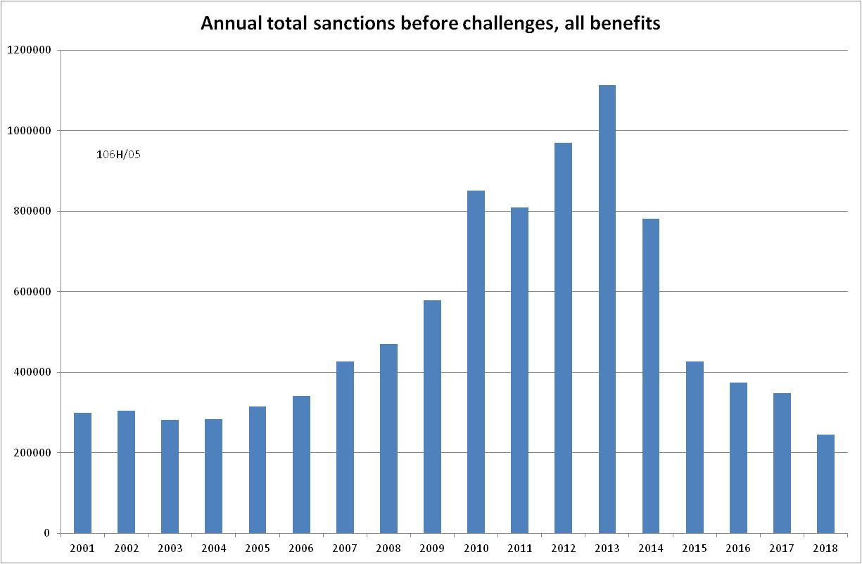

Figure 4
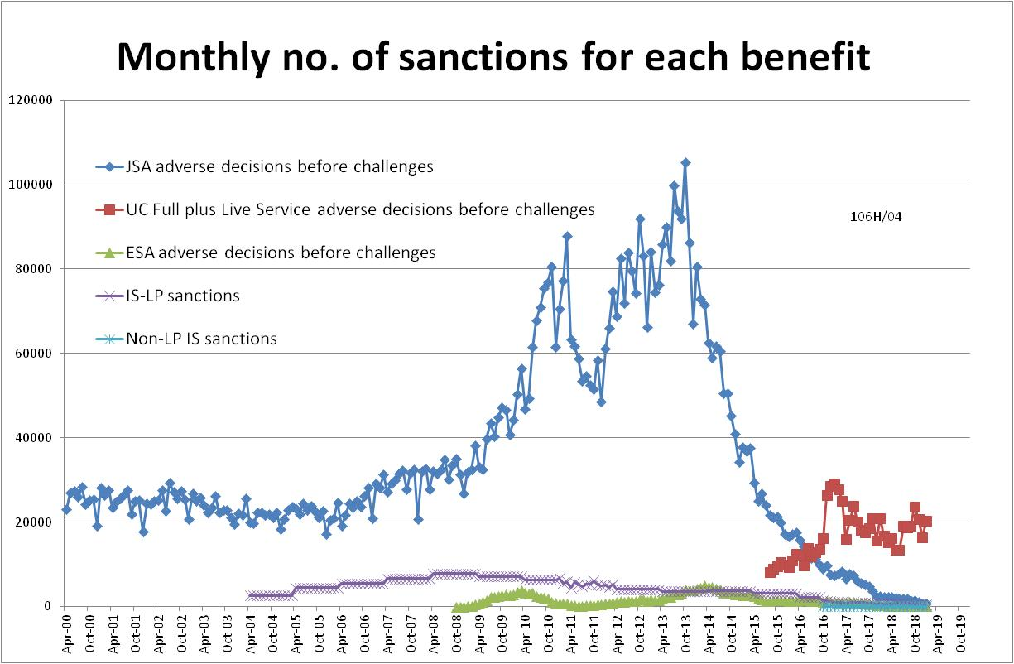
Figure 5
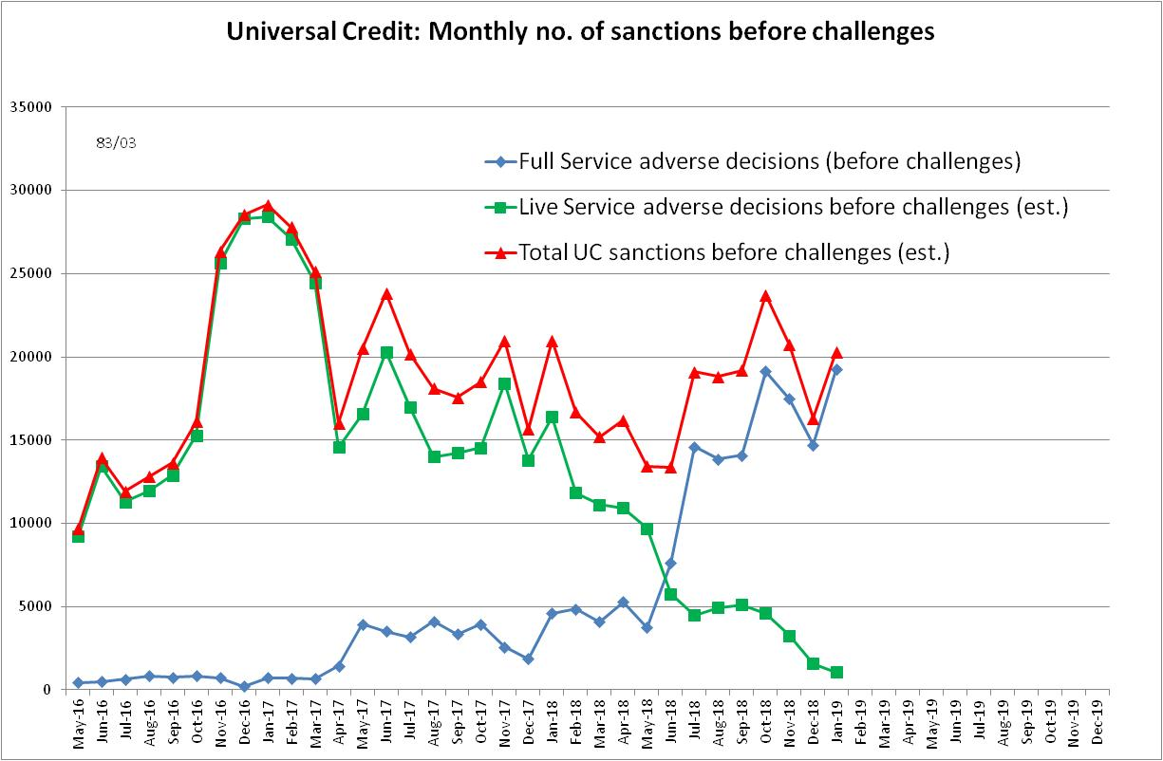
Figure 6
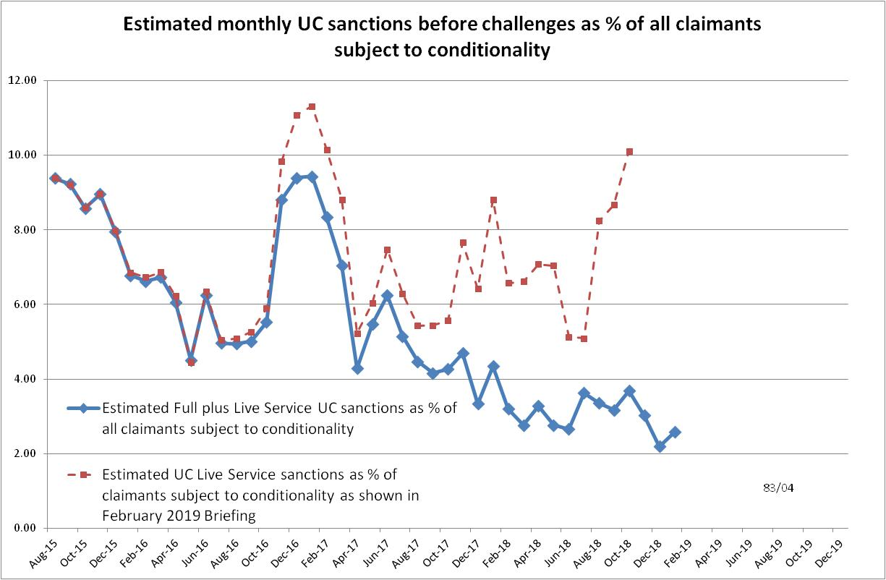

Figure 7
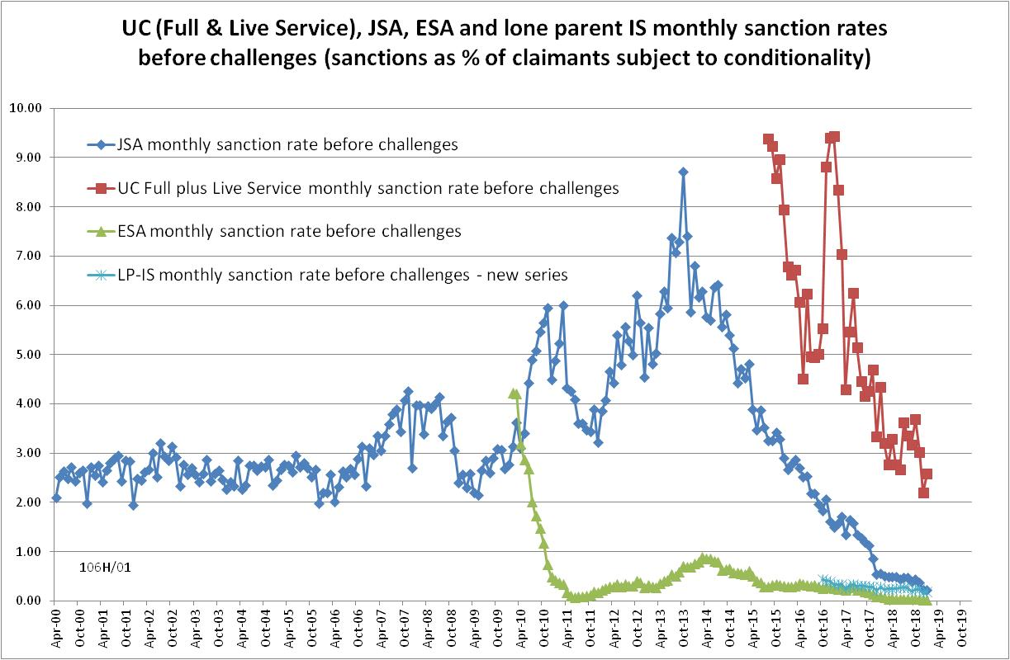

Figure 8
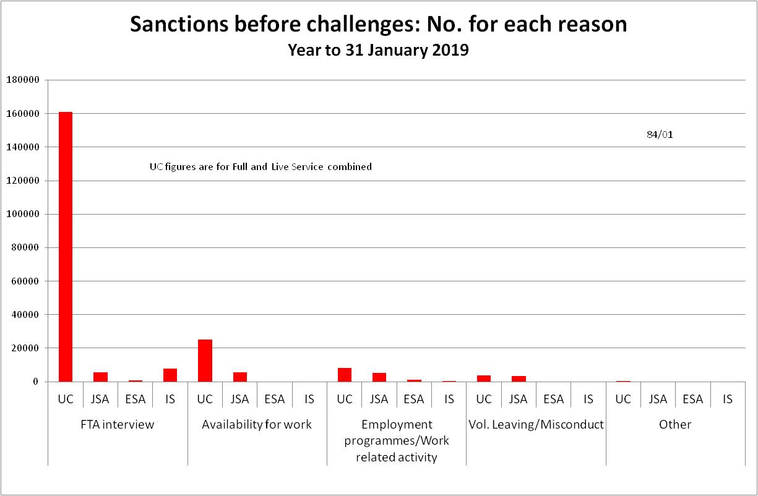

Figure 9
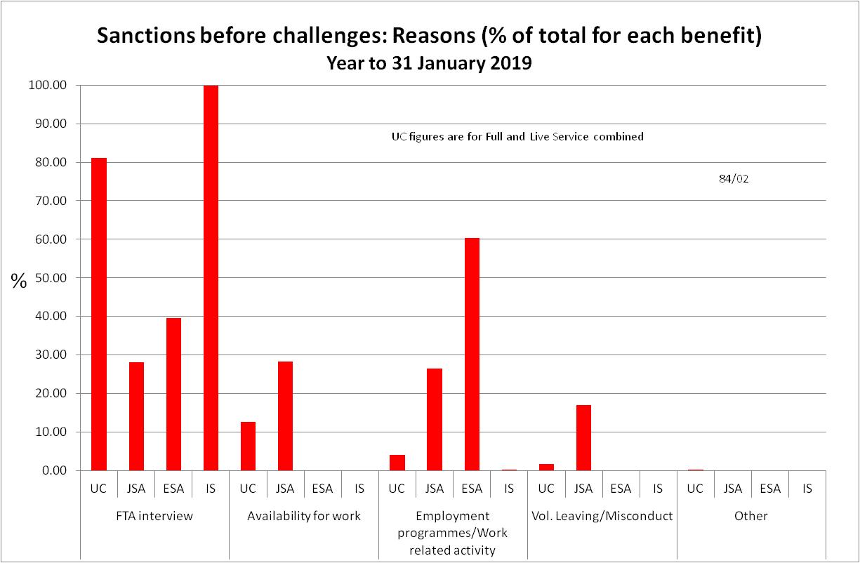
Figure 10
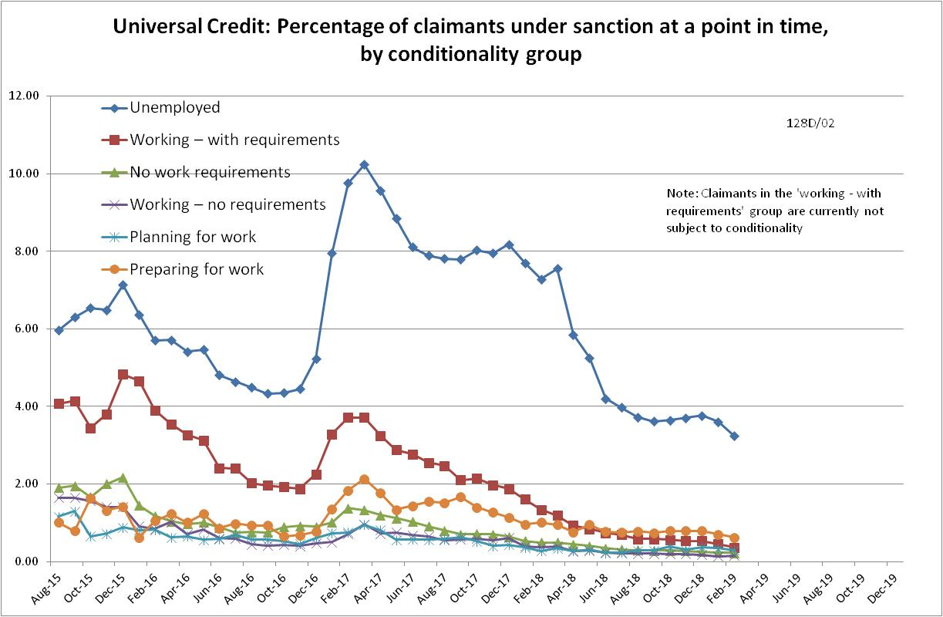

Figure 11
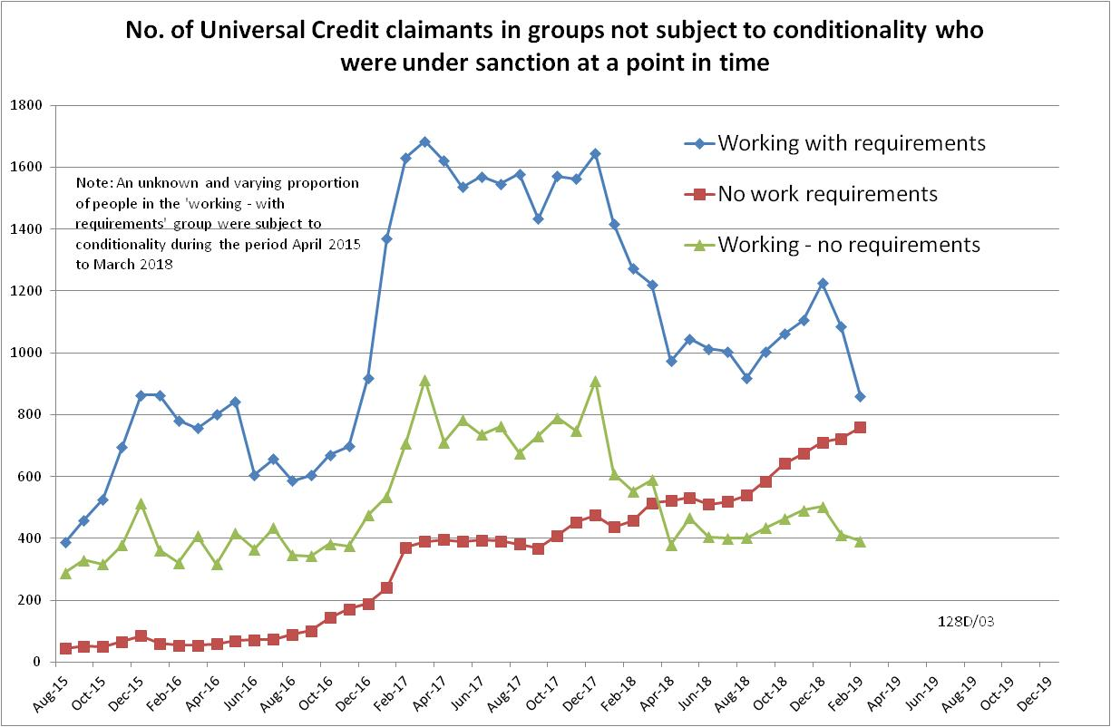

NOTES

Previous briefings are available at http://www.cpag.org.uk/david-webster. They include many analyses that are not repeated here but remain valid. However it should be remembered that the DWP may have made subsequent revisions to the data reported in earlier briefings. These revisions will generally not be major although there may be substantial changes in some figures for the most recent few months.
The total number of people subject to sanctions cannot be stated exactly, because there are some categories of Income Support claimants other than lone parents with a child under one who are not subject to sanctions, and there are no data on their numbers. However, they are likely to number in the low tens of thousands.
The UC claimants in the ‘working – with requirements’ group are low paid or part-time workers . Those ‘planning for work’ are mainly lone parents with a child aged 1, while those ‘preparing for work’ are people who would have been in the ESA Work Related Activity Group, and lone parents with a child aged 2 but under 5. The statistical categories for conditionality regime used in Stat-Xplore are explained in the ‘i’ feature next to the variable name in Stat-Xplore and also in the Universal Credit Statistics methodology document at https://www.gov.uk/government/publications/universal-credit-statistics-background-information-and-methodology
Lone parents with youngest child aged one to five have been estimated simply as four fifths of the total with youngest child aged 0 to five.
The basic concept of the DWP’s sanctions database is that each sanction case appears only once, and is given its latest status and attributed to the month of the latest decision on the case. So, for instance, if a decision is made in January 2014 to sanction someone, this decision is reviewed in March 2014 with an outcome unfavourable to the claimant, reconsidered in a ‘mandatory reconsideration’ in May 2014 again with an unfavourable outcome, and is heard on appeal by a Tribunal in October 2014 with a decision favourable to the claimant, then: - it appears in the statistics for the first time in January 2014 as an adverse ‘original’ decision - in March 2014 it changes its status to a ‘reviewed’ adverse decision and moves month to be with all the other cases where the latest decision has been made in March 2014 - in May 2014 it changes its status to a ‘reconsidered’ adverse decision and moves month to be with all the other cases where the latest decision has been made in May 2014 - in October 2014 it changes its status again to an appealed non-adverse decision, and moves month again to be with all the other cases where the latest decision has been made in October 2014.
The estimates of sanctions before challenges have been derived by adding the monthly total of ‘non-adverse’, ‘reserved’ and ‘cancelled’ decisions shown as being the result of reviews, mandatory reconsiderations and tribunal appeals, to the monthly total of adverse ‘original’ decisions. This produces only an approximate estimate for each individual month, since decisions altered following challenge are not attributed to the correct month. It will be particularly unreliable for months affected by a DWP catch-up of a backlog of decisions. But the estimates are reliable for longer periods.
This estimate was made using the March 2018 edition of the DWP’s Universal Credit Transition Rollout Schedule, which shows when each Jobcentre was to transfer to Full Service. DWP kindly supplied dates (October 2018 and October 2017 respectively) for Leeds Eastgate and Manchester Longsight which are missing from the Schedule. DWP has published revisions to the Jobcentre level figures for people on UC back to January 2016, and the numbers on full and live service have been recalculated for the purposes of this Briefing. The recalculation shows that the revisions are small and make little difference to the GB estimates of numbers on live and full service. It is assumed that when each Jobcentre transferred to Full Service, all existing UC claimants moved on to Full Service by the middle of the following month. Varying this assumption would be unlikely to make much difference to the estimates.
The In-work Progression conditionality trial started in 10 Jobcentres in April 2015 and began rollout across the whole country in December 2015, in both Full and Live Service. The trial finished on 31 March 2018. 30,709 claimants passed through the trial. About two-thirds ('frequent' & 'moderate' support) were in the trial for at least a year, the other one third for at least 2 months. The total number of people in the ‘working – with requirements’ group rose from 4,000 in April 2015 to 103,000 in March 2018. We therefore know that a substantial proportion of the group were in the trial at any one time, but we do not know how many.
Pre-October 2016 data for IS are omitted from Figure 7 because they are not comparable with the current data.
Note that previous analyses of reasons in the Briefing have always been on an ‘after challenge’ basis, and have used a different summary classification.

