BRIEFING

Benefit Sanctions Statistics

August 2021

25 August 2021

Dr David Webster
Honorary Senior Research Fellow
Urban Studies
University of Glasgow

Email david.webster@glasgow.ac.uk

Webpages: http://www.gla.ac.uk/schools/socialpolitical/staff/davidwebster/
http://www.cpag.org.uk/david-webster

SUMMARY

This Briefing deals with the quarterly benefit sanctions statistics released by DWP on 17 August, taking sanctions data up to the end of April 2021.

Almost all new sanctions were officially suspended from March until 1 July 2020 due to the coronavirus pandemic. In spite of the official end of the suspension, up to the end of April 2021 there have still been no new sanctions on Jobseeker’s Allowance (JSA), Employment and Support Allowance (ESA) or Income Support (IS).

Universal Credit (UC) sanctions are however continuing to creep up, while still at a historically very low level. From 489 in January and 488 in February, they rose to 959 in March and 1,056 in April. The March-April figures imply an annual rate of 4,000. This is far below the annual rate before the suspension, which was approximately 237,000 for all benefits. These numbers are for sanctions before any challenges. The number of UC sanction referrals will be higher, but DWP is not currently reporting it

The main reason for UC sanctions continues to be non-attendance at interviews (95.7% in the latest quarter). Among the approximately 3,000 claimants sanctioned since the end of the moratorium, there appears to be a greater proportion of males than before the pandemic (83% compared to 72%), but it is too early to say whether this difference will continue.

Data released by DWP now make it possible to produce a useful analysis of repeat UC sanctions for the last complete 12 months before the moratorium, i.e. February 2019 to January 2020 inclusive. The proportion of total sanctions which were repeats during this single year was 22.6%, and third or subsequent sanctions on the same individual accounted for more than one in ten (11.1%).

In the latest quarter, the number of UC claimants under sanction at a point in time stopped declining, because the rising number of claimants newly sanctioned since the moratorium has counterbalanced the number coming to the end of sanctions imposed before it. On DWP’s estimates, this number was approximately 3,900 throughout February to May 2021. This measure can now be expected to rise.

At July 2021 there were just under six million (5.924m) claimants of UC; on DWP’s latest figures this measure has been at approximately the same level since the beginning of 2021. Of the 5.924m claimants in July, 2.430m or 41.0% were subject to conditionality. JSA claimants have fallen sharply from the 236,000 in April 2021 reported in the previous Briefing to 164,000 in July, and the total of claimant unemployed (whether on JSA or UC) has fallen even more sharply, from 2.573m in April to 2.218m in July. For claimants in the Work Related Activity Group (WRAG) of ESA, and of IS, the latest available figures are for February 2021. In that month there were 207,500 in the ESA WRAG and 220,000 claimants of IS normally subject to conditionality.

The news section at the end of the Briefing reports on the DWP’s new Green Paper on policy for people with disabilities, and on the new book by David Freud about his time in government working on benefit issues. The Green Paper consultation closes on 11 October.
BRIEFING: Benefit Sanctions Statistics
August 2021

The DWP released its latest quarterly benefit sanctions statistics on 17 August, taking sanctions data up to the end of April 2021.The new data are summarised by DWP in the publication Benefit Sanctions Statistics, available along with methodological notes at https://www.gov.uk/government/collections/jobseekers-allowance-sanctions together with a spreadsheet with summary tables. The full figures for many aspects of the data are on the DWP’s Stat-Xplore database at https://stat-xplore.dwp.gov.uk/webapi/jsf/login.xhtml All statistics presented here relate to Great Britain.

There continues to be little new information. Fuller information is in previous Briefings, available at http://www.cpag.org.uk/david-webster .

Universal Credit sanctions are continuing to creep up although so far remaining at a historically very low level

Almost all new sanctions were officially suspended from March until 1 July 2020 due to the coronavirus pandemic.

Up to the end of April 2021, there have still been no new sanctions on Jobseeker’s Allowance (JSA), Employment and Support Allowance (ESA) or Income Support (IS) since the beginning of the pandemic. There were 5 referrals for sanction for JSA claimants in April 2021 but all were cancelled.

Universal Credit (UC) sanctions are however continuing to creep up, while remaining at a historically very low level. From 489 in January and 488 in February, they rose to 959 in March and 1,056 in April. The March-April figures imply an annual rate of 4,000. This is far below the annual rate before the suspension, which was approximately 237,000 for all benefits. These numbers are for sanctions before any challenges. The number of UC sanction referrals will be higher, but DWP is not currently reporting it, so we do not know how many UC sanction proceedings have been initiated since the end of the suspension.

Reasons for Universal Credit sanctions

The reasons for sanctions in the latest quarter are almost identical to those for the previous quarter. Benefit Sanctions Statistics states that of the 2,490 new UC sanctions imposed in February to April 2021 inclusive, 2,390 or 95.7% were for non-attendance at interviews, with 70 for non-availability for work and 30 for leaving a job voluntarily or losing it as a result of misconduct. In the previous quarter, missed interviews accounted for 94.7%.

Gender and age breakdown of those newly sanctioned since the moratorium

Each issue of Benefit Sanctions Statistics shows the cumulative number of UC claimants sanctioned since 1 May 2016. By comparing successive issues, it is possible to derive the approximate number of UC claimants of each gender and age group who have been sanctioned for the first time since that date during each quarter. This analysis for the approximately 3,000 claimants newly sanctioned since the end of the moratorium shows that 83% were male, and half (49.5%) were aged 18-24, with almost nine in ten (86.8%) aged 18-39. For age, this is a very similar pattern to that shown in the analysis for the period before the moratorium reported in the February 2020 Briefing, p.9 and Figures 10 and 11. For gender, there appears now to be a stronger concentration of sanctions on males (83% compared to 72%), but the numbers since the moratorium remain small and it is too early to say whether this difference will continue.

Repeat Universal Credit sanctions

The May 2021 issue of the Briefing explained the issues created by the DWP having misdescribed the repeat UC sanctions figures previously published in Benefit Sanctions Statistics. DWP had said that they showed the number of individuals receiving repeat sanctions within the last 12 months, when in fact they referred to repeats during the whole period since May 2016. Using the correct description, the May 2021 Briefing (pp.4-5 and Figure 1) presented an analysis of repeat UC sanctions for the period May 2016 to October 2020. This analysis for a four and a half year period remains correct, although the figures on which it is based are no longer available on the DWP’s website.

DWP has now put all its published figures for repeat UC sanctions on to the basis of the latest 12 months, replacing the previously published issues of Benefit Sanctions Statistics with revised documents on its website where necessary.

Analysis for the most recent 12 months to 30 April 2021 is of no value since there were virtually no sanctions at all in the earlier part of the period, meaning that there cannot have been many repeats. However, it is now possible to produce a useful analysis of repeat UC sanctions for the last complete 12 months before the moratorium, i.e. February 2019 to January 2020 inclusive. This is shown in Figure 1. As would be expected, the proportion of total sanctions which were repeats during this single year was much smaller than for the four and a half year period analysed in the May 2021 Briefing: 22.6% as against 32.9%. None of the difference is accounted for by sanctions on individuals who had just one repeat: these were 11.5% in both cases. The difference was in multiple repeats on the same individual, which were much lower for the 12-month period. Nevertheless the numbers of multiple repeats were still quite high: third or subsequent sanctions on the same individual accounted for more than one in ten (11.1%) of all UC sanctions over the 12 months.

The level of repeats matters for two main reasons. First, under UC the length of sanctions escalates harshly with repeated ‘failures’, and sanctions are served consecutively, not concurrently so that many people spend very long periods without benefits. This makes nugatory Amber Rudd’s reduction of the maximum individual sanction to 6 months. Second, repeated sanctions are seen by many as an indication of failure of the sanctions system itself.

Number and proportion of Universal Credit claimants under sanction at a point in time

The DWP’s preferred measure of the scale of sanctions is the proportion of claimants serving a sanction at a point in time (what it calls the ‘rate’). The Briefing has always expressed reservations about this measure, which were explained in the November 2017 issue, pp.6-10. In November 2020, DWP withdrew the UC ‘rate’ data for all months prior to April 2019, pending revision of the figures for Live Service. These figures remain withdrawn. In addition, in the February 2021 release DWP made significant revisions to the figures for April 2019 onwards (which are for Full Service only, there being no one left on Live Service). These were fully discussed in the February 2021 Briefing.

In the latest quarter, the number of UC claimants under sanction at a point in time stopped declining. This number was approximately 3,900 throughout February to May 2021. The stabilisation is because the rising number of claimants newly sanctioned since the moratorium has counterbalanced the number coming to the end of sanctions imposed before it. This measure can now be expected to rise.

The figure for the overall proportion of UC claimants under sanction at a point in time is not of much value, because the treatment of the various conditionality groups is so different, with those in the ‘searching for work’ group treated much more harshly than the others. The Briefing has never emphasised this measure and has rarely reported it, preferring to focus on the actual numbers and on the separate proportions for each of the conditionality groups. However, the DWP does emphasise it, and an issue has therefore arisen in relation to the ‘working – with requirements’ conditionality group.

In practice, claimants in this group are not currently bound by any work search conditionality requirements, and never have been, apart from some trials, which mainly if not completely ended in April 2018. In-work conditionality was planned as part of UC but it has been controversial and the trials have not produced evidence in its favour (see the November 2019 Briefing, pp.10-11). No decision has been taken to introduce it on a general basis. The Briefing has treated the ‘working – with requirements’ group as being subject to conditionality up to March 2018 and as not being subject to conditionality thereafter. DWP however has continued to classify this group as subject to conditionality. This has pushed down its measure of the overall proportion of UC claimants subject to conditionality who are actually under sanction, because the ‘working – with requirements’ group, which is large, has been added to the denominator in calculating the ‘rate’. DWP has now announced that it intends to change this methodology from the November 2021 release, and will count ‘working – with requirements’ as not subject to conditionality. This will raise the ‘rate’.

Suspension of Universal Credit sanctions duration statistics

Data on the duration of UC Full and Live Service sanctions remain suspended while DWP addresses problems with the methodology.

Groups of claimants exposed to sanctions:
Universal Credit, JSA, ESA and Income Support

At July 2021 there were just under six million (5.924m) claimants of UC; on DWP’s latest figures this measure has been at approximately the same level since the beginning of 2021. Of the 5.924m claimants in July, 2.430m or 41.0% were subject to conditionality (counting the ‘working – with requirements’ group as not subject to conditionality). JSA claimants have fallen sharply from the 236,000 in April 2021 reported in the previous Briefing to 164,000 in July. While this fall will partly be due to people who claimed ‘New style’ contribution-based JSA early in the pandemic exhausting their 12 months’ entitlement, the total of claimant unemployed (whether on JSA or UC) has fallen even more sharply, from 2.573m in April to 2.218m in July. For claimants in the Work Related Activity Group (WRAG) of ESA, and of IS, the latest available figures are for February 2021. In that month there were 207,500 in the ESA WRAG and 220,000 claimants of IS normally subject to conditionality.
SANCTIONS - OTHER DEVELOPMENTS

Shaping Future Support – Health & Disability Green Paper and consultation, published 20 July

Following the Improving Lives Green Paper five years ago (DWP/Dept of Health 2016), the government is continuing its slow development of policy towards people with disabilities, with the publication on 20 July of a further Green Paper, Shaping Future Support (DWP 2021). The associated consultation closes on 11 October.

On sanctions, the new Green Paper’s Chapter 2 (para.112) acknowledges evidence that sanctions actually discourage some disabled people and people with health conditions from taking part in employment support or starting work. It sets out what it says is a ‘new approach’ to conditionality for people in the ESA WRAG, UC claimants who have been found to have limited capability for work (LCW), and those who are claiming UC or ESA, ahead of their Work Capability Assessment (WCA). The paper says:

In September 2019, we started testing whether changing how activities are agreed can improve the relationship between a person and their work coach. The aim of the approach is to enable an honest and open conversation about what a person can do. We want people to feel engaged in their activity, understand why it is worthwhile and carry it out to the best of their ability, so people are more likely to move towards work, and into work, where possible.

Work coaches have the option of applying no mandatory requirements if they feel this is appropriate for the person’s individual circumstances, but instead are encouraged to set voluntary steps the person could take to move towards or into work. These could include, for example, developing a CV or looking for suitable jobs online. Using their discretion, work coaches apply mandatory requirements only if and when they are needed.

One of the reasons why this approach to conditionality was shown to be effective in testing was because work coaches were able to apply more tailored activities to help people prepare for and progress in work. Work coaches felt they were able to develop a better understanding of how best to support people through the new approach. They were able to make the best use of voluntary activities to stretch and encourage people, while introducing mandatory activities if necessary to ensure people remained engaged with their employment support. This new approach also reduced the risk of sanctions. We have now rolled this approach out nationally, subject to ongoing evaluation. We will continue to refine our approach on the basis of these findings.

This does raise the question how DWP could ever have thought that a more rigid approach could be justified.

David Freud: Clashing Agendas, published 21 June

David Freud was an important figure in British welfare policy for a decade. His involvement began with his report Reducing dependency, increasing opportunity: options for the future of welfare to work (Freud 2007) commissioned by the last Labour government, which also gave him a peerage in 2009. He then worked with the Conservatives both in opposition and, mainly, as Minister for Welfare Reform at DWP, appointed in May 2010 and serving until his retirement at the end of 2016. The great bulk of his new book Clashing Agendas: Inside the Welfare Trap (Freud 2021) is about his experiences in promoting the introduction of Universal Credit, including arguments on policy, dealing with administrative issues, project management, infighting between departments, and getting legislation through Parliament. The ‘clashing agendas’ of the title are on the one hand Freud’s primary aim of changing the benefit system to more strongly incentivise and make easier the transition to work, and on the other, George Osborne’s aim of shrinking the state, which led to massive cuts in the planned levels of Universal Credit and to the resignation of Iain Duncan Smith as Secretary of State.

The book provides many insights into the working of the state machine. However it offers very little indeed about benefit conditionality and nothing at all about the decisions first to mount and then to unwind the great sanctions drive of 2010 to 2015, in which sanctions peaked at 1.1m in 2013, and to make the sanctions regime much harsher from 2012. Freud will know a great deal about these decisions, which he has not cared to disclose. However he does admit (p.206) that, although he himself put it through the House of Lords, the government was not justified in introducing the retrospective Jobseekers (Back to Work Schemes) Act 2013 to avoid repaying the money deducted in sanctions ruled unlawful by the Court of Appeal. The book (pp.236-7) also touches on the issue of the higher rate of sanctions under UC than JSA, but only perfunctorily. A better source on this is the House of Commons Library paper (Keen 2018).

Tom Boland & Ray Griffin: Ideological roots of benefit conditionality

Tom Boland of University College Cork and Ray Griffin of Waterford Institute of Technology have expanded their studies of benefit conditionality to examine its ideological roots, taking a very broad historical perspective and looking in particular at religious ideas of redemption. ‘The contemporary confession box is JobCentre Plus. You arrive as a penitent, admitting your need for transformation, and are directed to examine your life, your conduct, and embark on reforming yourself. Like a novitiate monk, you must obey the abbot, and comply with their directions – work, prayer, reflection, penitence. It is a continuous process, both of examining one’s own faults – perhaps idleness, pride or avarice – and professing one’s faith – in the labour market, where the ‘hand of God’ will redeem you, temporarily at least, with work.’

The authors comment that ‘Recognising these elements as part of our cultural and policy landscape is a first step towards rethinking how welfare and the low-pay economy should be governed in the age of pandemics, climate change and technological disruptions. Rather than reforming people to transform them into workers, we need to recover the idea of accepting and supporting them as citizens.’

The authors have published blogs on the themes of the book at https://www.thesociologicalreview.org/magazine/june-2021/sociological-theories/working-on-ourselves/ and at
https://www.transformingsociety.co.uk/2021/06/15/citizens-first-workers-second-reforming-our-unemployment-policy/
Chapters 1 and 3 of the book are available free to view at https://library.oapen.org/handle/20.500.12657/48791

REFERENCES

Boland, Tom & Griffin, Ray (2021) The Reformation of Welfare: The New Faith of the Labour Market, Bristol University Press

DWP (2021) Shaping Future Support: The Health and Disability Green Paper, CP 470, July, at
https://www.gov.uk/government/consultations/shaping-future-support-the-health-and-disability-green-paper

DWP/Department of Health (2016) Improving Lives: The Work, Health and Disability Green Paper, October, available at: https://assets.publishing.service.gov.uk/government/uploads/system/uploads/attachment_data/file/564038/work-and-health-green-paper-improving-lives.pdf

Freud, David (2007) Reducing dependency, increasing opportunity: options for the future of welfare to work, An independent report to the Department for Work and Pensions, Leeds, Corporate Document Services

Freud, David (2021) Clashing Agendas: Inside the Welfare Trap, London, Nine Elms Books

Keen, Richard (2018) Universal Credit: why are sanction rates higher? House of Commons Library Briefing Paper, CBP 8410, 27 September, at https://commonslibrary.parliament.uk/research-briefings/cbp-8410/

Figure 1

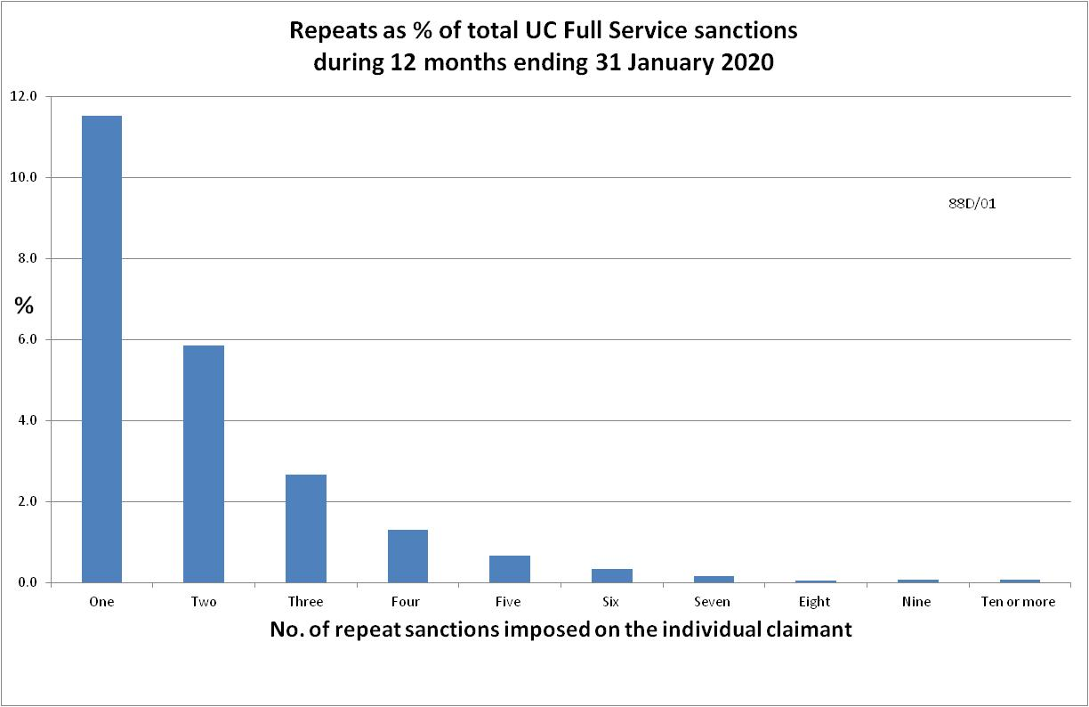

NOTES

Previous briefings include many analyses that are not repeated here but remain valid. However it should be remembered that the DWP may have made subsequent revisions to the data reported in earlier briefings. These revisions will generally not be major although there are exceptions, such as the repeat sanctions data discussed in the present Briefing. There may also often be substantial changes in some figures for the most recent few months.
Details of the sanctions suspension, including exact dates, legal basis etc. were given in the June 2020 Briefing, pp.7-8. DWP guidance on the resumption of sanctions was reported in the November 2020 Briefing, pp.3-4, and details of new sanctions procedures and staff guidance in the February 2021 Briefing, Appendix, pp.6-7.

