BRIEFING

Benefit Sanctions Statistics

February 2022

7 March 2022

Dr David Webster
Honorary Senior Research Fellow
Urban Studies
University of Glasgow

Email david.webster@glasgow.ac.uk

Webpages: http://www.gla.ac.uk/schools/socialpolitical/staff/davidwebster/
http://www.cpag.org.uk/david-webster

SUMMARY

Owing to what it says are software problems, DWP has not published any update this quarter of the figures for the the number of Universal Credit (UC) sanctions imposed, or for the other figures relating to them: reasons for UC sanctions, the demographic profile of sanctioned UC claimants and repeat UC sanctions on the same individuals. However it is clear that the rapid rise in UC sanctions which was noted in the November 2021 Briefing has continued.

The number of claimants serving a UC sanction in November 2021 was almost 50,000 (49,944). This compares with 18,144 in July and is well above the pre-pandemic peak of 36,780 in October 2019. Because there is an increased number of claimants, the percentage of UC claimants subject to conditionality who were under sanction remained well below the pre-pandemic peak, at 0.88% in November 2021 compared to 1.44% in October 2019.

By using past data, from the figures for the number of claimants serving a sanction it is possible to estimate the missing figure for the number of sanctions imposed. In November 2021 this will have been in the region of 30,000. This equates to an annual rate of 360,000 sanctions imposed. This would give the highest annual figure for total sanctions imposed on all benefits since 2016.

Although DWP has not updated the figures on the reasons for sanctions, we do know that the rapid increase in June and July 2021 was due to missed interviews and it is likely that this has continued. It is possible that in the emergence from the pandemic the figures for missed interview sanctions are being inflated by people who no longer need UC or do not qualify for it simply not informing DWP.

From the beginning of the pandemic and up to the end of October 2021, there have still been no new sanctions on claimants of Employment and Support Allowance (ESA). However, for the first time there have now been a small number of Income Support (IS) sanctions: 6 sanctions imposed on lone parents in October. Jobseeker’s Allowance (JSA) sanctions restarted in May 2021 with a total of 25 in May to July. They are showing no sign of increasing, with 6 more in August and 9 in October but none in September.

In November 2021 there were 2,473 claimants in UC non-conditionality groups who were serving a sanction imposed when they were previously in a conditionality group.

On 27 January the government announced a new initiative ‘Way to Work’, which will require jobseekers to look for work outside their chosen sectors more quickly. Use of sanctions in this way has been widely criticised. It is bound to increase the number of sanctions. The effect will start to show up in the sanctions figures for February 2022, which should be published in August 2022.

The news section summarises a number of significant recent reports and studies. It also reports on the DWP’s blocking of information on the effects of benefit sanctions, in spite of previous undertakings to release it.

BRIEFING: Benefit Sanctions Statistics
February 2022

The DWP released its latest quarterly benefit sanctions statistics on 15 February. Critically important figures have been omitted from this release, namely the number of Universal Credit (UC) sanctions imposed, and the other figures relating to them: reasons for UC sanctions, the demographic profile of sanctioned UC claimants and repeat UC sanctions on the same individuals. DWP states that this is due to software problems: ‘DWP has recently moved to a new data platform to store and process data. During our live running process an issue was identified with the availability of software required to process Universal Credit full service (UCFS) sanction decisions data. This is currently being investigated and we aim to reinstate the decisions measure as soon as possible. We will provide an update .... regarding this issue in late March 2022.’

In addition, figures on the duration of UC sanctions remain suspended due to methodological problems, and DWP has never published any data at all on mandatory reconsiderations and appeals for UC Full Service, which now handles all UC claims.

The available information is therefore very defective for UC. Figures on other benefits have been published as normal, but the numbers of people claiming them are now relatively small. However by using the information that is available, an approximate picture can be obtained of what has been going on within UC, except for the appeal processes.

The newly published data are summarised by DWP in the online publication Benefit Sanctions Statistics, available along with methodological notes at https://www.gov.uk/government/collections/jobseekers-allowance-sanctions together with a spreadsheet with summary tables. The full figures for many aspects of the data are on the DWP’s Stat-Xplore database at https://stat-xplore.dwp.gov.uk/webapi/jsf/login.xhtml All statistics presented here relate to Great Britain.

All previous Briefings are available at http://www.cpag.org.uk/david-webster .

The rapid rise in Universal Credit (UC) sanctions which was noted in the November 2021 Briefing has continued

Number of UC claimants serving a sanction at a point in time

In the absence of figures for the number of sanctions imposed (‘adverse decisions’), it is necessary to use the DWP’s figures for the number of people serving a sanction at a point in time. They are shown in Figures 1 to 3.

Figure 1 shows the number of UC claimants who were serving a sanction at the measurement date in each month. Since July and August 2021 it has increased rapidly, reaching almost 50,000 (49,944) in November 2021. This is well above the pre-pandemic peak of 36,780 in October 2019. There is only a slight indication of slackening in the pace of increase in the latest month, suggesting that the figure by now (February 2022) will be even higher.

Figure 2 shows the same data as a percentage of UC claimants subject to conditionality. Because there are now many more of these claimants (2.1m in November 2021 compared to 1.2m in October 2019), the percentage under sanction remains well below the pre-pandemic peak, at 0.88% in November 2021 compared to 1.44% in October 2019.

Number of UC sanctions being imposed per month (rough estimate)

It is possible to use these figures to produce a very rough estimate of the number of UC sanctions being imposed per month. As noted above, DWP is not currently publishing data on the duration of UC sanctions. However, figures published previously and analysed in the February 2019 Briefing (pp.8-10) indicated a mean duration of about 6 weeks and given the published tariff of sanction lengths, the actual mean has to be of a similar order. On the assumption of one sanction per claimant, this means that the figure for the total number of claimants under sanction in each month must be roughly equal to the number of newly imposed sanctions in the previous one and a half months. A total of 50,000 claimants under sanction in November therefore suggests a monthly number of sanctions imposed of around 33,000. The assumption of one sanction per claimant will not be correct, but if it is relaxed the effect will be to increase the estimate of the number of sanctions imposed per month. An alternative estimation method is to look at the last 12 months before the pandemic, i.e. April 2019 to March 2020 inclusive. During this period the monthly number of UC sanctions was fairly stable at an average of about 18,300 and the number of UC claimants serving a sanction at a point in time was also fairly stable at an average of about 32,400. This ratio of 1.77 would give a monthly number of UC sanctions imposed in November 2021 of about 28,000. It therefore seems reasonable to take 30,000 as the estimate of new UC sanctions per month. This equates to an annual rate of around 360,000. This is approaching double the annual rate of 191,000 suggested by the 15,929 sanctions imposed in July 2021. It would imply the highest annual total number of sanctions since 2016, and higher than the level of 2001-06, although still well below the extreme of 1.1m reached in 2013 (November 2021 Briefing, Figure 1).

It should be re-emphasised that this is a very rough estimation process, and the results will need to be checked against the actual figures when they are published. It is undertaken because it is important to have some idea of the number of sanctions rather than none at all.

It is possible that part of the increase in UC sanctions is due to temporary factors. For instance, abandonment of face-to-face interviews during the pandemic is likely to have increased fraulent claims. The people responsible are likely to fail to attend any interview when requested, for fear of being found out, and the first step by the Jobcentre will be to impose a sanction, before any fraud investigation is launched. Also, the pandemic brought on to UC many people who in normal times would have sufficient earnings to disqualify them from UC. If they get a well-paid job again, they might simply not bother to contact the Jobcentre to cancel a requested interview, and once again the first step would be a sanction. To the extent that these factors are in play, they will drop out of the figures as the months go by, but in the meantime it is impossible to estimate how large their effect might be.

Another factor in play might be the general reduction in public transport timetables following the pandemic. This will have made it harder for claimants to get to their interviews.

UC claimants serving a sanction at a point in time by conditionality group

Figure 3 shows the percentage of claimants subject to each individual conditionality regime who were serving a sanction at the measurement date in each month. This shows that unemployed (‘searching for work’) claimants were far more likely to be sanctioned than the other two groups subject to conditionality, with 2.72% under sanction in November 2021 compared to 0.18% for ‘planning for work’ and 0.15% for ‘preparing for work’. However, all three groups show an increase since July.

As noted in earlier Briefings, there are also people in the groups not subject to conditionality who are serving sanctions. That is because of the much-criticised feature of UC that sanctioned claimants are made to serve out the whole of their sanction even if they move into a no-conditionality group, for instance because of illness. Their numbers remain low but are increasing, to a total of 2,473 in November 2021. There were 377 people under sanction in the ‘no work requirements’ group, 1,540 in the ‘working – with requirements’ group (who are in practice not currently subject to requirements) and 556 in the ‘working – no requirements’ group.

UC sanctions for missed appointments
As noted above, DWP has not updated data on the reasons for UC sanctions. But given that in May-July 2021, 98.8% were due to missed interviews, it is reasonable to assume that this will also be the dominant reason for the continued increase. This presumably is why on 11 February Neil Couling, DWP’s Change Director General and Senior Responsible Owner Universal Credit, tweeted:
‘So you are opposed to sanctions. Interested in what the alternatives might be. What would you propose doing about 240000 people each week who fail to turn up for an appointment? (And bear in mind NAO found we were sanctioning only 3% of the total so DWP isn’t sanctioning all)’
(https://twitter.com/NeilCouling/status/1492232062937489409)
It is unreasonable to ask people outside DWP what should be done, because we simply do not have enough information. What information we do have comes almost entirely from the National Audit Office report of 2016 (NAO 2016, Appendix 3), which relates to the then dominant JSA. This in fact suggests both that the problem is not as serious as Neil Couling implies, and that DWP itself has not analysed the issue properly.

- Couling does not say what percentage of arranged appointments the 240,000 represents. But the NAO report (p.55 para.10) said that in March 2016, claimants attended 90% of JSA appointments. I understood at the time that the 10% missed included rearranged appointments. Given the many reasons why people might not turn up without fault on their part, this does not sound particularly bad.
- The NAO (p.53 para.3) said there were 1m missed JSA appointments between July and December 2015. This equates to 39,000 per week. Couling’s figure of 240,000 per week is six times as great, which is surely implausible. Taking the NAO’s percentage not missed of 90% would imply that DWP is currently arranging 62 million appointments in each six month period of which 55.8 million are successfully carried out. This is equivalent to DWP interviewing almost the whole population of Great Britain over a six month period. Couling’s 240,000 per week appears to be a mistake for 240,000 per month.
- NAO also said (p.55 para.7) that over the 6 months July to December 2015, 942,000 people stopped claiming JSA, of whom 413,000 said they had entered work. These people obviously had a very good reason for not attending what had become a redundant appointment. The NAO commented that DWP did not know how many of them accounted for missed appointments, but their numbers were in fact sufficient to account for almost all the 1m missed appointments. This factor will be in play now, and perhaps even more so, with unemployment falling as people get back to work after the pandemic.

It is difficult to draw any conclusions from this patchy information, but it is far from showing that DWP has a particularly significant problem of appointments missed by continuing claimants. DWP is not unique in having to manage ‘no-shows’: it is a problem for a wide range of customer-facing service operations, including in particular the NHS, airlines and other public transport. The first response to Neil Couling’s question ‘What would you propose doing’ must therefore be ‘Start by doing a proper operations research-style analysis of the problem, based on hard data on all the relevant issues’. It is also important to bear in mind that in any customer-facing service operation, the customer must be recognised as being a key part of the service delivery system, and it is therefore vital to understand what are their understandings, motivations and constraints. There is no sign that DWP has ever attempted this. There can be no presumption that financial penalties are an effective way of addressing the ‘no-show’ issue.

Sanctions – Other benefits

From the beginning of the pandemic and up to the end of October 2021, there have still been no new sanctions on claimants of Employment and Support Allowance (ESA). However, for the first time there have now been a small number of Income Support (IS) sanctions: 6 sanctions imposed on lone parents in October. Jobseeker’s Allowance (JSA) sanctions restarted in May 2021 with a total of 25 in May to July. They are showing no sign of increasing, with 6 more in August and 9 in October but none in September.

The DWP’s new ‘Way to Work’ programme
On 27 January the government announced a new initiative ‘Way to Work’ https://jobhelp.campaign.gov.uk/way-to-work/ , with the stated aim of getting 500,000 people into work by June 2022 and helping to fill the current record 1.2m job vacancies in the economy. It promises to offer greater support to jobseekers and more engagement between DWP and employers. These are both welcome developments. However, it will also use the threat of sanctions to force jobseekers on UC to look for work outside their chosen sectors more quickly. Traditionally, claimants have been allowed much longer (in recent times, three months) to look for jobs in their sector. Now, they will be forced to widen their search to employment fields where they lack experience or which they do not want, after just four weeks. This is bound to increase the number of sanctions. The effect will start to show up in the sanctions figures for February 2022, which should be published in August 2022.
Use of sanctions in this way has been widely criticised, mainly on the grounds that by focusing on unemployed people, it will not address the bigger problem of those who have withdrawn from the labour force; it will produce worse matches between people and jobs, damaging earnings, morale and productivity; and the sanctions will produce the usual collateral damage. A detailed critique by the present author, with extensive references, is at
https://theconversation.com/way-to-work-scheme-forcing-people-into-jobs-they-arent-suited-for-has-damaging-effects-175974
There are other critiques by Tony Wilson of the Institute for Employment Studies at
https://www.employment-studies.co.uk/news/way-work-first-step-we-can-and-must-do-better, by Stewart Lansley at
https://www.transformingsociety.co.uk/2022/02/04/intensifying-sanctions-on-claimants-is-a-mistake/ , and by Paul Waugh of The i at
https://inews.co.uk/opinion/universal-credit-claimants-victims-operation-red-meat-boris-johnson-save-job-1426467

Groups of claimants exposed to sanctions:
Universal Credit, JSA, ESA and Income Support

At January 2022 there were 5.63m claimants of UC, down from a peak of 5.972m of March 2021, although the total is now falling rather slowly and actually increased in January. Of the 5.63m claimants in January, 2.045m or 36.3% were subject to conditionality (counting the ‘working – with requirements’ group as not subject to conditionality, as the DWP itself now does). This is a fall from 45.6% in March 2021. There were 1.659m UC claimants in the unemployed (‘searching for work’) group in January 2022, down from 2.356m in March 2021. JSA claimants have also fallen sharply, from 268,000 in March 2021 to 117,000 in January 2022. The overall total of claimant unemployed (whether on JSA or UC) has fallen from 2.618m in March to 1.773m in January, meaning that just over half of the increase seen during the pandemic has now been reversed. JSA now accounts for only 6.6% of unemployed claimants, the remainder being on UC.

For claimants in the Work Related Activity Group (WRAG) of ESA, and of IS, the latest available figures are for August 2021. In that month there were 193,000 in the ESA WRAG and 194,000 claimants of IS normally subject to conditionality.

SANCTIONS - OTHER DEVELOPMENTS

DWP blocking of information on the effects of benefit sanctions

Under Secretary of State Thérèse Coffey, the DWP appears to have adopted a comprehensive policy of blocking information on the effects of benefit sanctions.

1.In response to the House of Commons Work and Pensions Committee report on Benefit Sanctions (November 2018), the government indicated that it would carry out a study into ‘the effectiveness of reforms to welfare conditionality and sanctions’, and that it was intended to publish in late Spring 2019. The promise to publish was repeated in Parliament at least three times. But in a Parliamentary Answer (HL4139) on 1 December last, the junior DWP minister Baroness Stedman-Scott stated that it was no longer intended to publish it, ‘as we were unable to assess the deterrent effect and therefore this research doesn’t present a comprehensive picture of sanctions’. The ‘deterrent effect’ is the effect of sanctions on claimants who are not themselves sanctioned. In fact the DWP study has three parts: impact on employment, impact on earnings, and ‘deterrent effect’. Lack of success in the latter part does not constitute a reason for not publishing the rest of the study. I therefore put in a Freedom of Information request to see the parts of the study not relating to the deterrent effect. This request has been refused, as reported in the Guardian on 27 January at https://www.theguardian.com/society/2022/jan/27/report-on-effectiveness-of-benefit-sanctions-blocked-by-dwp. In the first stage of challenging this I requested DWP to review their refusal. They replied on 1 March maintaining their refusal, claiming in particular that refusal ‘protects the private space within which Ministers and officials can develop policies, undertake research and conduct Department business at its own pace and on its own schedule’. I am now appealing to the Information Commissioner. The issue of non-publication of the study was raised in an oral evidence session of the Work and Pensions Committee with the Secretary of State Thérèse Coffey on 9 February (Q.87-9), where she made the same claim about ‘private space’ (‘private area’, Q.88).
2. On 2 March, the Guardian reported at https://www.theguardian.com/society/2022/mar/02/dwp-blocks-data-for-study-of-whether-benefit-sanctions-linked-to-suicide that a Glasgow University study examining whether benefit sanctions are linked to claimant ill-health, including mental illness and suicide, has been halted after ministers reneged on a longstanding promise to release sanctions data. This is contrary to recommendations by the the National Audit Office (NAO 2016, para.24a and 24b) and the House of Commons Work and Pensions Committee (House of Commons 2018, para.4 p.61). The chair of the Committee, Stephen Timms MP, has commented ‘This emerging pattern of obstruction suggests that a culture of secrecy is entrenched in DWP. It must wake up to the harm that it is doing and commit to a new spirit of openness.’
The Committee recently had to deploy rarely-used Parliamentary legal powers to force publication of a DWP-commissioned study on the experiences of people on disability benefits, as reported in the Guardian at https://www.theguardian.com/society/2022/feb/03/report-poorer-disabled-britons-mps-force-publication. It cannot use the same powers to force publication of the sanctions effectiveness study, as this is an internal DWP paper and has a different status.

Review of the international evidence on the impacts of benefit sanctions

An important survey of the international quantitative research evidence on both labour market and wider impacts of benefit sanctions has been published by a team from the University of Glasgow (Pattaro et al. 2022). It considers 94 studies. It found that labour market studies consistently report positive impacts for employment but negative impacts for job quality and stability in the longer term, along with increased transitions to non-employment or economic inactivity. Wider-outcome studies report significant associations with increased material hardship and health problems. There is also some evidence that sanctions are associated with increased child maltreatment and poorer child well-being. The review highlights the generally poor quality of the evidence base in this area, with few studies employing research methods designed to identify the causal impact of sanctions, especially in relation to wider impacts.

Administrative Justice Council/ JUSTICE report on reforming benefits decision making

Last July saw the publication of an important report (Low 2021) by the Administrative Justice Council (AJC) and JUSTICE on reform of the processes of decision-making on benefits, including the working of conditionality, sanctions and appeals. The AJC is an official body, chaired by the Senior President of Tribunals and funded by the Ministry of Justice and charitable sources, which advises ministers and the judiciary. JUSTICE is an all-party law reform and human rights organisation working to strengthen the justice system – administrative, civil and criminal – in the UK. It provides the secretariat for the AJC. The report therefore carries weight.

Among the report’s 44 recommendations, the most relevant to sanctions and conditionality are:
- Better data collection and evaluation, including on protected characteristics of claimants, the setting of claimant commitments, the use of easements and what happens following application of sanctions, e.g., do people move off benefits entirely, are they sanctioned again, do they move into work?
- Better tailoring of claimant commitments to individual circumstances and expansion of mandatory easements
- Claimants should be provided with information on the different types of easements that are available
- A warning or ‘yellow card’ should be issued for a first failure to comply with the claimant commitment. The warning should be clearly communicated to the claimant via their preferred method of communication. It should be used only in cases where the claimant would otherwise be sanctioned i.e. they do not have a good reason for failure to comply, and not as a substitute for the proper application of the good reason test
- A further pilot and evaluation of an ‘early warning system’ should be carried out. This time, claimants should be provided with more than 14 days to provide further evidence, claimants should be made aware of what a ‘good reason’ might be and what appropriate evidence might look like, and the DWP should ensure that communication with the claimant is appropriate for that particular claimant in terms of language and any disability or vulnerability
- Removal of the mandatory reconsideration stage so that claimants are able to appeal directly to the Social Security Tribunal, but with an automatic internal review required by the DWP once an appeal has been lodged.
- Streamlining the appeals process to reduce the need for appellants to repeatedly provide the same information and greater use of tribunal caseworkers to reduce adjournments.
- The wording of decision letters (and mandatory reconsideration notices whilst they are retained) should make claimants aware that if they miss the one month deadline, they may still be able to appeal if there is a good reason for the delay
- Clear structures and rules to prevent the inconsistent and unfair application of discretion, including a statutory list of ‘good reasons’ for failure to comply with the claimant commitment.
- The DWP should urgently analyse Tribunal decision notices and collect data on the reason(s) for all successful appeals in order to identify recurring issues with initial decision-making. The DWP must then use this information to make improvements in areas identified as being problematic.
- A permanent independent reviewer or regulator for welfare benefits should be established. This should be a statutory role with responsibility for assessing and reporting on standards of decision-making in relation to benefits. Their functions should also include monitoring the use of automated decision making.

Erosion of out of work benefits in relation to minimum requirements

On 30 November the Joseph Rowntree Foundation published an analysis by Donald Hirsch of Loughborough University which shows that for out-of-work families with children, there has been a serious erosion in the adequacy of incomes, falling from close to two thirds of the University’s Minimum Income Standard (MIS) to barely half. In contrast, a working couple with two jobs can now support a family at or above MIS. For a single person without children, out-of-work benefits have fallen to only a third of MIS. These stark contrasts are the result of an increased emphasis on work incentives by the present government. Increasing in-work/out-of-work differentials is in principle an alternative to sanctions, both being types of coercion. The analysis is at
https://www.jrf.org.uk/blog/families-furthest-below-mis-excluded-social-security-gains
The MIS is explained at https://www.lboro.ac.uk/research/crsp/minimum-income-standard/

Universal Credit In-Work conditionality and sanctions

As embodied in the 2012 Act, Universal Credit was intended to include conditionality for claimants who are in work but earning less than the equivalent of 35 hours a week on the national minimum wage. From April 2015 to March 2018 DWP conducted a Randomised Control Trial (RCT) to test out the impact of different approaches to applying conditionality to these claimants. The results of the trial (DWP 2018a, 2018b and 2019) suggested that this type of conditionality is ineffectual in terms of additional hours and earnings, and DWP has so far not attempted to revive conditionality for this group. An article by Wright and Dwyer (2022), based on interviews with 58 UC claimants conducted on a longitudinal basis during the RCT, now complements the DWP’s studies by looking at the impact of conditionality on in-work claimants. It includes a wealth of quotation from claimants on their experiences. It identifies three ‘mismatches’: between the severity of sanctions and the paucity of rewards (the latter of which DWP’s own work showed); between the pressure to obtain consistently greater hours and the reality of hours fluctuating beyond the claimant’s control; and between the promise to ‘make work pay’ and the reality of continuing in-work poverty. The authors conclude that conditionality for in-work claimants is largely counterproductive.

Universal Credit design inflexibility
A recent academic paper (Bennett and Millar 2022) examines the barriers to reform built into the structure of Universal Credit, which has integrated six means-tested benefits into one. It argues that core features of this integrated benefit system limit possible reforms to fulfil a range of policy goals. They focus particularly on the operation of the monthly assessment period and the insistence on UC being a single payment, with a single ‘taper rate’ in relation to the level of earnings. The single payment issue is frequently referred to by DWP in relation to sanctions for missed interviews, when they argue that the option of simply closing a claim is not available due to the need to continue paying non-sanctionable elements of UC such as those for childcare or housing. The authors argue that this rigidity is exacerbated by resistance to change due to automation – a point which was illustrated in the court case relating to monthly assessment won by lone mothers in the Court of Appeal. See https://cpag.org.uk/news-blogs/news-listings/court-appeal-finds-dwps-treatment-earnings-under-universal-credit

Covid Realities: Documenting life on a low income during the pandemic

This study (Patrick et al. 2022) is a product of Covid Realities, a collaboration between the Universities of York and Birmingham and the Child Poverty Action Group (CPAG), funded by the Nuffield Foundation. The primary source on which it is based is diaries and other inputs from 172 low income parents, together with information from CPAG’s Early Warning System fed by welfare rights advisers, and inputs from 13 other projects researching poverty in the UK. It focuses particularly on the inadequacies of the UK social security system. In relation to conditionality and sanctions it recommends:
- End the work-first ethos
- Support claimants to pursue a wider range of opportunities, including training and education
- Recognise the value and demands of unpaid care work
- Make sanctions a last resort
- Give those facing sanction an opportunity to respond before implementation

The increasingly penal character of social policy: New books

A new book by academics at University College Cork (Kiely and Swirak, November 2021) looks at the way different areas of social policy including welfare conditionality and labour market activation have increasingly taken on a penal character, intersect more deeply with crime control and in so doing, deploy troubling strategies. This follows a similar study published in February 2021 (Cummins 2021), also showing how 'tough on crime' messages have spread to other areas of social policy.

REFERENCES

Bennett, Fran and Jane Millar (2022) Inflexibility in an integrated system? Policy challenges posed by the design of Universal Credit, University of Oxford Department of Social Policy and Intervention, Working Paper 22-01, January, at
https://www.spi.ox.ac.uk/sites/default/files/spi/documents/media/inflexibility_in_an_integrated_system_policy_challenges_posed_by_the_design_of_universal_credit.pdf

Cummins, Ian (2021) Welfare and Punishment: From Thatcherism to Austerity, Bristol University Press

DWP (2018a) Universal Credit: In-Work Progression Randomised Controlled Trial: Findings from quantitative survey and qualitative research, September, at
https://assets.publishing.service.gov.uk/government/uploads/system/uploads/attachment_data/file/739775/universal-credit-in-work-progression-randomised-controlled-trial-findings-from-quantitative-survey-and-qualitative-research.pdf

DWP (2018b) Universal Credit: In-Work Progression Randomised Controlled Trial: Impact assessment, September, at
https://assets.publishing.service.gov.uk/government/uploads/system/uploads/attachment_data/file/739767/impact-assessment-universal-credit-in-work-progression-randomised-controlled-trial.pdf

DWP (2019) In-Work Progression Trial: Further Impact Assessment and Cost Benefit Analysis, Ad hoc Report 75, October, at
https://assets.publishing.service.gov.uk/government/uploads/system/uploads/attachment_data/file/838107/in-work-progression-trial-further-impact-assessment-and-cost-benefit-analysis.pdf

House of Commons Work and Pensions Committee (2018) Benefit Sanctions, Nineteenth Report of Session 2017-19, HC 955, 6 November, at
https://publications.parliament.uk/pa/cm201719/cmselect/cmworpen/955/955.pdf

Kiely, Elizabeth and Katharina Swirak (2022) The Criminalisation of Social Policy in Neoliberal Societies, Bristol University Press

Low, Lord (chair) (2021) Reforming Benefits Decision-Making: A Report by JUSTICE and the Administrative Justice Council, London, 8 July, at
https://justice.org.uk/justice-and-the-administrative-justice-council-launch-report-on-reforming-the-benefits-system/

National Audit Office (2016) Benefit Sanctions, HC 628, 30 November, at
https://www.nao.org.uk/report/benefit-sanctions/

Patrick, Ruth, Kayleigh Garthwaite, Maddy Power, Jim Kaufman, Geoff Page, Katie Pybus, Rosalie Warnock, Hannah Aldridge, Lizzie Flew, Tom Lee, and Sophie Howes (2022) Covid Realities: documenting life on a low income during the pandemic, 24 January, at
https://covidrealities.org/

Pattaro, Serena, Nick Bailey, Evan Williams, Marcia Gibson, Valerie Wells, Mark Tranmer and Chris Dibben (2022) ‘The Impacts of Benefit Sanctions: A Scoping Review of the Quantitative Research Evidence’, Journal of Social Policy, 14 February, at
https://www.cambridge.org/core/journals/journal-of-social-policy/article/impacts-of-benefit-sanctions-a-scoping-review-of-the-quantitative-research-evidence/9272BC857236795930DCD6AB7B8E04A1
DOI: 10.1017/S0047279421001069 (This is an open access article)

Wright, Sharon and Peter Dwyer (2022) ‘In-work Universal Credit: Claimant
Experiences of Conditionality Mismatches and Counterproductive Benefit Sanctions’, Journal of Social Policy, 51:1, 20-38 January, at
https://www.cambridge.org/core/journals/journal-of-social-policy/article/inwork-universal-credit-claimant-experiences-of-conditionality-mismatches-and-counterproductive-benefit-sanctions/82C05CC442F9EBA049E99E0523A9C3F0 (This is an open access article)

Figure 1
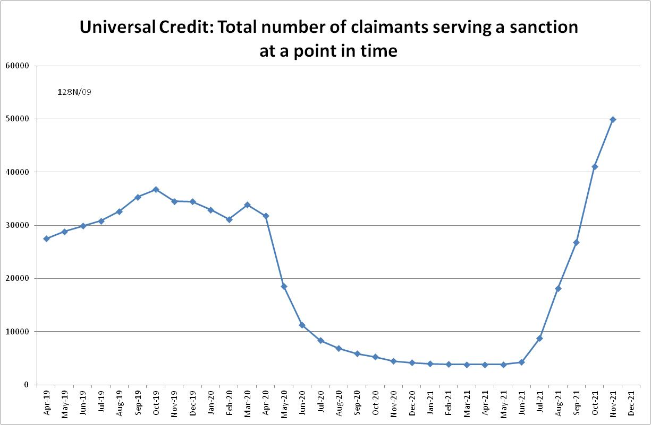
Figure 2
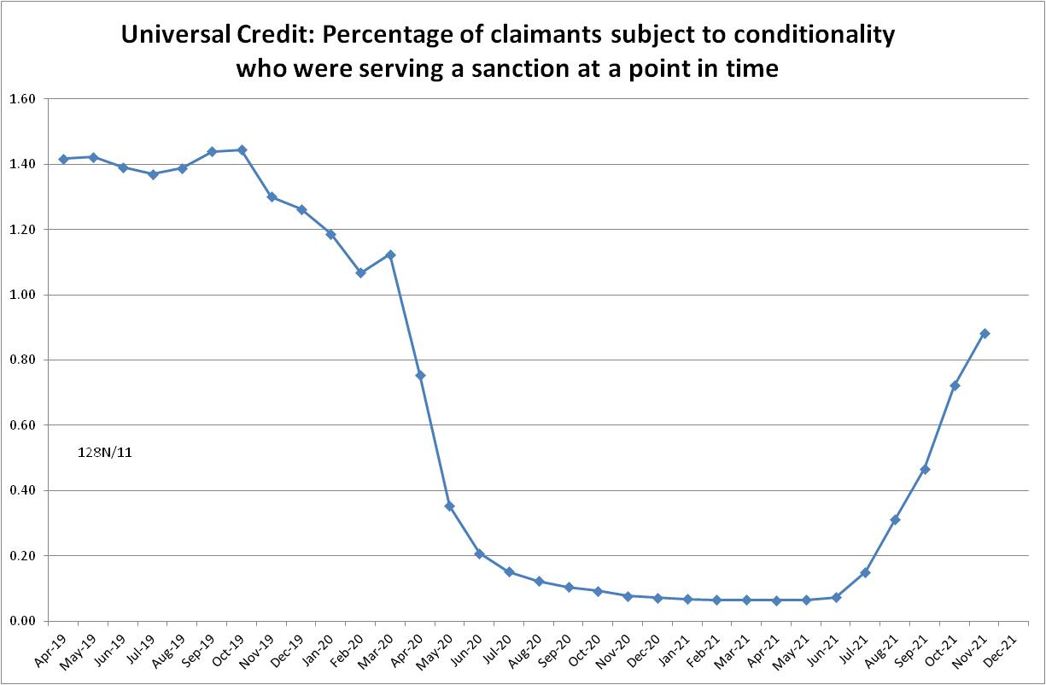
Figure 3
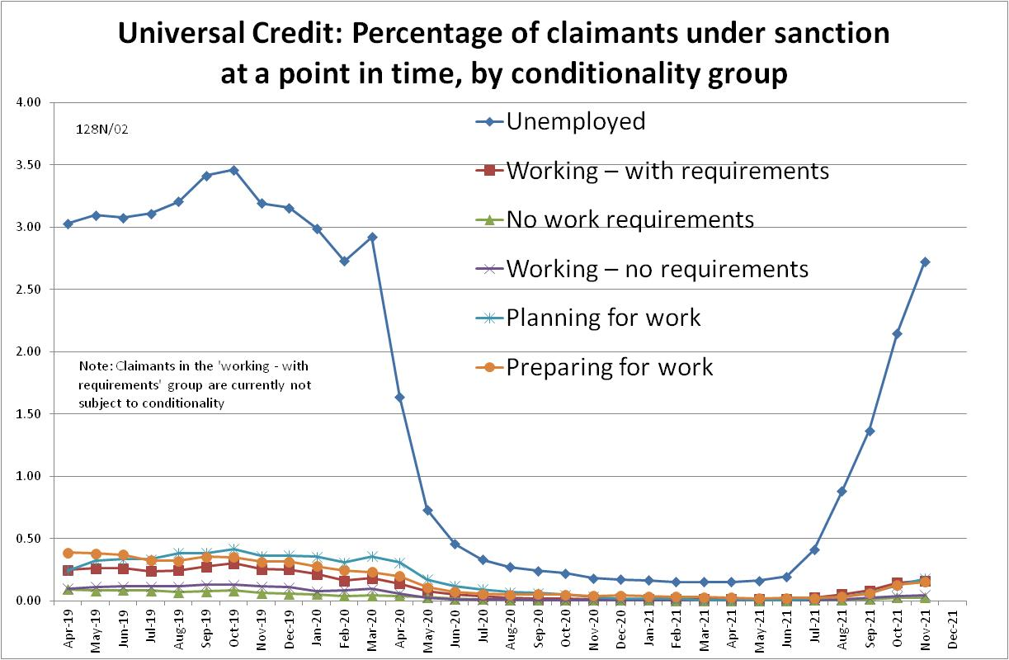

NOTES

Previous Briefings include many analyses that are not repeated here but remain valid. However it should be remembered that the DWP may have made subsequent revisions to the data reported in earlier Briefings. These revisions will generally not be major although there are exceptions. There may also often be substantial changes in some figures for the most recent few months.
The drawbacks of the ‘claimants under sanction at a point in time’ measure were discussed in the November 2017 issue of the Briefing, pp.6-10. In November 2020, DWP withdrew the UC ‘rate’ data for all months prior to April 2019, pending revision of the figures for the former ‘Live Service’. These figures remain withdrawn. In addition, in the February 2021 release DWP made significant revisions to the figures for April 2019 onwards (which are for Full Service only, there being no one left on the former Live Service). These were fully discussed in the February 2021 Briefing.

