BRIEFING

Benefit Sanctions Statistics

May 2023

31 May 2023

Dr David Webster
Honorary Senior Research Fellow
Urban Studies
University of Glasgow

Email david.webster@glasgow.ac.uk

Webpages: http://www.gla.ac.uk/schools/socialpolitical/staff/davidwebster/
http://www.cpag.org.uk/david-webster

SUMMARY

This Briefing reports on the quarterly Universal Credit (UC) sanctions statistics for Great Britain published by DWP on 16 May.

Sanctions are running at a high level. The 534,826 sanctions on all benefits imposed in 2022 were the most since 2014 and were also more than in all but six of the 22 complete calendar years since the start of the current recording system in April 2000.

In the year to end-January 2023 541,440 UC sanctions were imposed and 427,463 individual UC claimants received at least one sanction. Of these, 87,687 (20.5%) received more than one sanction, and 20,294 (4.7%) received more than two. In the last full 12 months before the pandemic there were 230,720 UC sanctions and 178,476 sanctioned individual claimants.

Monthly UC sanctions were an average of 41,838 in the latest quarter, to January 2023 (2.3% of UC claimants subject to conditionality). This is almost two-and-a-half times the average in the last full three months before the pandemic (to February 2020), which was 17,293 (1.4%).

The raising of the Administrative Earnings Threshold from 9 to 12 hours in September 2022 and from 12 to 15 hours in January 2023 should by now be having an effect on the distribution of UC claimants between conditionality groups. Since September 2022 there has been a fall of 217,000 in the ‘working – with requirements’ group, which is compatible with the government prediction of 234,000. However, only 90,000 have been added to the ‘searching for work’ group. It is possible that many of the others have stopped claiming or moved into a sick status. DWP should evaluate the effects of the raising of the AET.

The number of UC claimants serving a sanction at a point in time has stabilised, at around 115,000 – 120,000, or 6.5% of claimants subject to conditionality. This is much higher than the around 35,000 (3.1%) before the pandemic. There were 105,589 (7.55%) unemployed (‘searching for work’) claimants under sanction in February 2023 compared to 0.67% for ‘planning for work’ and 0.62% for ‘preparing for work’. This equates to one in 13 unemployed UC claimants. There were 5,267 claimants in groups not subject to conditionality who were serving a sanction in February 2023, half (2,600) of these in the ‘working – with requirements’ group.

The average duration of a UC sanction is around 2.7 months or around 11 or 12 weeks, confirming the estimate given in the previous two Briefings.

According to DWP, almost all UC sanctions (97.0% in the latest quarter to January 2023) are for ‘Failure to attend or participate in a Work-Focused Interview’. However, it seems likely that this reason is now being used to include cases where claimants have not done the work search or other activities required by their Work Coach.

The news section of the Briefing reports on the further extensions of conditionality announced in the March Budget, and on other sanctions developments.

As an Appendix I have included a copy of an unsolicited email received from a former long-time DWP job coach describing their unhappiness at the pressure they were put under to sanction claimants inappropriately, and how a supportive approach can be much more successful.

BRIEFING: Benefit Sanctions Statistics
May 2023

The DWP released its latest quarterly benefit sanctions statistics on 16 May. The newly published data are summarised by DWP in the online publication Benefit Sanctions Statistics, available along with methodological notes at https://www.gov.uk/government/collections/jobseekers-allowance-sanctions together with a spreadsheet with summary tables. Some data are on Stat-Xplore at https://stat-xplore.dwp.gov.uk/webapi/jsf/login.xhtml . All statistics presented here relate to Great Britain. All previous Briefings are available at http://www.cpag.org.uk/david-webster .

In relation to sanctions, this Briefing relates only to Universal Credit (UC). DWP no longer publishes updates to statistics on sanctions for Jobseekers Allowance (JSA), Employment and Support Allowance (ESA) and Income Support (IS). JSA and ESA are not merely legacy benefits since there are new claimants of the ‘New Style’ versions of these benefits, but we will not know about any sanctions on these benefits except via Parliamentary Questions or FoI requests. There are now very few if any JSA claimants other than on New Style.

There is still no improvement in the coverage of the UC sanctions statistics, which have never given any information on the appeal system or on the ‘levels’ of sanction for Full Service (which now covers all UC sanctions). DWP has also suspended data on duration of sanctions. However, DWP has announced that it will be publishing new quarterly statistics on the number of people on UC undergoing Work Capability Assessments (WCAs) by stage of process, giving monthly decisions and outcomes. The first release of these statistics will be on 8 June 2023.

Number of people on Universal Credit (UC) and number subject to conditionality

The total number of people on UC was a provisional 5.95m in April 2023. Within this there were 1.93m UC claimants subject to conditionality in April 2023, or 32.5% of all UC claimants.

The largest group of UC claimants subject to conditionality is those ‘searching for work’, i.e. unemployed. They were 1.47m in April 2023 (Figure 1), accounting for 94.2% of all claimant unemployed; the other 5.8% of the claimant unemployed were the 91,069 claimants on JSA.

Impact of raising of the Administrative Earnings Threshold (AET)

The raising of the Administrative Earnings Threshold in two stages, from 9 to 12 hours in September 2022 and from 12 to 15 hours in January 2023, should by now be having an effect on the distribution of UC claimants between conditionality groups. The government’s intention is to move people from the ‘working – with requirements’ group to the ‘searching for work’ group, and perhaps eventually to the ‘working – no requirements’ group. Its estimate is of 114,000 claimants moved from ‘working – with requirements’ at the first stage and 120,000 at the second stage, a total of 234,000.

Figure 1 shows the numbers in each conditionality group since January 2022 (longer period charts are available in earlier issues of the Briefing). The big change since September 2022 is a large fall of 217,000 in the ‘working – with requirements’ group. This is compatible with the government prediction of 234,000. However, only 90,000 – less than half - have been added to the ‘searching for work’ group. What has happened to the other 127,000? It is unlikely that they have moved into the ‘working – no requirements’ group as this would have required them to raise their earnings to the equivalent of 35 hours a week at the national minimum wage – effectively by moving into a full-time job. Another possibility is that they have moved into a sick status – ‘no work requirements’, although Figure 1 does not indicate any change of trend in the numbers in this group, which is rising steadily, driven at least partly by ‘managed migration’ from ESA. The remaining possibility is that these claimants have stopped claiming UC altogether. This is of course a frequently observed response to increases in conditionality. It defeats the anti-poverty objective of UC. Clearly there is a need to continue monitoring these figures closely, and for DWP to use its records to evaluate the effects of the raising of the AET. This is especially important since the Budget on 15 March announced a further planned rise in the AET to 18 hours, which is yet to be implemented.

Total claimants on all benefits subject to conditionality

Reporting on legacy benefits is less up-to-date than on UC. At January 2023 there were still an estimated 398,000 claimants on the legacy benefits subject to conditionality, comprising 166,000 in the ESA Work Related Activity Group, 140,000 on Income Support and 92,000 on JSA. Added to the 1.81m UC claimants subject to conditionality at that date, there were therefore an estimated total of 2.21m claimants on all benefits subject to conditionality.

The monthly number of Universal Credit sanctions has stabilised at a high level

After rising rapidly and continuously following the pandemic, monthly UC sanctions have clearly now stabilised, at least for the time being, both in total numbers and as a percentage of UC claimants subject to sanctions. But they are running at a higher level than before the pandemic (Figures 2 and 3).

Number of UC sanctions being imposed per month

Monthly UC sanctions reached a peak of 58,532 in March 2022 but since then have fallen back, to an average of 41,838 in the latest quarter, to January 2023 (Figure 2). This is almost two-and-a-half times the average in the last full three months before the pandemic (to February 2020), which was 17,293. A seasonal drop in December is a usual occurrence, and is particularly obvious in December 2022.

Monthly UC sanctions as a percentage of UC claimants subject to conditionality

UC sanctions have also stabilised as a percentage of UC claimants subject to conditionality (Figure 3). The monthly average of 41,838 for the latest quarter to January 2023 equates to 2.3% per month of UC claimants subject to conditionality. In the three months immediately preceding the pandemic, i.e. December 2019 to February 2020, it was 1.4% per month.

As noted in previous Briefings, the overall rate for UC puts together different categories of claimant with very different rates of sanctioning – unemployed, sick/disabled and those with caring responsibilities. The rate for unemployed claimants (‘searching for work’) is much higher than for the other conditionality groups, which have quite low rates of sanctioning.

Annual total sanctions on all benefits

Figure 4 shows the total number of sanctions on all benefits for every complete calendar year since the start of the current recording system in April 2000. The figure of 534,826 imposed in 2022 is the highest since 2014. It is also higher than in all but six of the 22 years covered by the data. The figure for 2022 assumes that sanctions on JSA, ESA and IS were negligible.

Number of Universal Credit claimants sanctioned during the year to 31 January 2023

The DWP’s Benefit Sanctions Statistics spreadsheet has a table showing the numbers of individuals who received two, three, four etc UC sanctions during the year to January 2023.
Since the total number of sanctions imposed is also shown, it is possible to calculate how many individual UC claimants were sanctioned during the year. Of the 541,440 UC sanctions imposed, 113,977 were repeat sanctions on individuals who had already received one sanction during the year. Therefore the total number of individual UC claimants who received at least one sanction during the year was 427,463. Of these, 87,687 (20.5%) received more than one sanction, and 20,294 (4.7%) received more than two. In the last full 12 months before the pandemic, to January 2020, there were 230,720 UC sanctions and 178,476 sanctioned individual claimants.

Universal Credit claimants serving a sanction at a point in time

Number of UC claimants serving a sanction at a point in time

The number of UC claimants who were serving a sanction at a point in time has stabilised, at around 115,000 – 120,000 (Figure 5). This is much higher than before the pandemic, when it was around 35,000.

Percentage of UC claimants subject to conditionality who were serving a sanction at a point in time

Figure 6 shows the same data as a percentage of UC claimants subject to conditionality. This measure has also stabilised, at around 6.5%. This percentage is more than double the pre-pandemic peak of 3.1% in October 2019 and equates to one in 15 of UC claimants subject to conditionality.
UC claimants serving a sanction at a point in time by conditionality group

Figure 7 shows the percentage of UC claimants subject to each individual conditionality regime who were serving a sanction at the measurement date in each month. As usual, unemployed (‘searching for work’) claimants were far more likely to be sanctioned than the other two groups subject to conditionality, with 105,589 or 7.55% under sanction in February 2023 compared to 0.67% for ‘planning for work’ and 0.62% for ‘preparing for work’. One in 13 unemployed UC claimants was under sanction in February 2023.

There are also people in the groups not subject to conditionality who are serving sanctions. That is because under UC, sanctioned claimants are made to serve out the whole of their sanction even if they move into a no-conditionality group, for instance because of illness. There were 5,267 of them in February 2023, half (2,600) of these in the ‘working – with requirements’ group. This group are the most likely to have recently been unemployed and therefore to have been sanctioned.

Duration of Universal Credit sanctions

DWP is not currently publishing statistics on the duration of UC sanctions. But the proportion of UC claimants under sanction has been rather stable at an average of around 6.51% since July 2022, and the proportion being given a sanction each month has also been stable at an average of around 2.4% since April 2022. It follows that the average duration of a UC sanction must be around 2.7 months or around 11 or 12 weeks, confirming the estimate given in the previous two Briefings.

Reasons for Universal Credit sanctions

According to DWP, almost all UC sanctions (97.0% in the latest quarter to January 2023) are now for ‘Failure to attend or participate in a Work-Focused Interview’. This contrasts with 87.5% in November 2019-January 2020 (the last full quarter before the pandemic). As mentioned in previous Briefings, it is difficult to credit such a high figure for sanctions for interviews. It seems likely that the reason ‘Failure to attend or participate in a Work-Focused Interview’ is now being used to include cases where claimants have not done the work search or other activities required by their Work Coach. However, as previously noted, categories of reason other than interviews have continued to increase slightly, while remaining very small, with a total of only 3,750 out of 125,510 sanctions imposed in the quarter to January 2023.

Cost of Living Payments for claimants who are sanctioned

The February 2023 Briefing, p.6, reported that claimants who are sanctioned forfeit their Cost of Living Payment if it falls due during their sanction. DWP on 17 April announced an exception to this, on the relevant webpage at https://www.gov.uk/guidance/cost-of-living-payment . It says ‘You may still be eligible for a Cost of Living Payment if ...... you had a hardship payment because you could not pay for rent, heating, food or hygiene needs’.
SANCTIONS - OTHER DEVELOPMENTS

PUBLICATION OF THE DWP’S DRAFT REPORT ON
THE IMPACT OF BENEFIT SANCTIONS ON EMPLOYMENT OUTCOMES

This report, asked for by the Work and Pensions Committee in its 2018 report on benefit sanctions, was finally published on 6 April in response to a Freedom of Information ruling by the Information Commissioner. The report found that :
- a sanction leads the average Universal Credit claimant to exit less quickly into a job (which is well proxied by PAYE earnings)
- and to earn £8 a week less
- earnings of claimants with children are affected similarly to the average
- those sanctioned for a second or third time earn £18 or £22 a week less respectively.

I wrote a commentary on the report dated 13 April which was circulated to the mailing list and is available on the web at www.cpag.org.uk/david-webster. The DWP report itself is available at https://www.gov.uk/government/publications/the-impact-of-benefit-sanctions-on-employment-outcomes-draft-report

The House of Commons Work and Pensions Committee held a special session to consider the report on 10 May, with expert witnesses Patrick Arni (University of Bristol), Serena Pattaro (University of Glasgow) and Tom Waters (Institute for Fiscal Studies). Arni and Pattaro were generally supportive of the report, while Waters was critical.

Patrick Arni drew attention to the decision of the German constitutional court in 2019 that sanctions reducing benefits by more than 30% are unconstitutional. Details (in English) are at
https://www.dw.com/en/germany-court-rules-welfare-sanctions-unconstitutional/a-51115790 and https://www.bundesverfassungsgericht.de/SharedDocs/Entscheidungen/EN/2019/11/ls20191105_1bvl000716en.html

YET MORE INCREASES IN CONDITIONALITY

Recent and forthcoming increases in UC conditionality were discussed in the November 2022 Briefing, pp. 6-11, and in the February Briefing, pp.8-9. The Budget on 15 March introduced three further measures in relation to conditionality:

1. Further raising of the AET to 18 hours, putting another 100,000 claimants into the intensive work search group. There does not yet seem to be an implementation date. A DWP equality impact assessment (DWP 2023c) of the raising of the AET from 12 to 15 hours on 30 January 2023 has some useful numbers relating to age, disability and other characteristics.

2. The Treasury Labour Market Factsheet says that, in addition, over 700,000 lead carers of children on UC will be made to look for work or increase their hours. Baroness Lister subsequently asked a PQ HL 6635 about this which received a surprisingly detailed reply on 3 April, as follows:

1) Estimate of the proportion of the 700,000 lead carers by age of youngest child
Age of youngest child | Proportion
1 | 14%
2 | 12%
3 | 11%
4 | 9%
5 | 10%
6 | 9%
7 | 8%
8 | 7%
9 | 6%
10 | 6%
11 | 5%
12 | 4%
2) Estimate of the proportion of the 700,000 lead carers by family type
Family Type | Proportion
Single, with children | 70%
Couple, with children | 30%

Details of the new requirements on lead carers:
- Lead carers of children aged 1-2 will be required to have regular work focussed conversations with a dedicated Jobcentre work coach more often.
- For lead carers of children aged 2, work coaches can offer claimants more support with work preparation activities such as job readiness workshops; help with developing a CV; practising interviewing skills; skills assessment; participating in training or employment programme.
- Lead carers of children aged 3-12 will be supported by their work coach to increase their work search and preparation activity and will be required to be available for higher paid or longer hours jobs to align with Department for Education’s 30hr free childcare offer. Work search activities could include carrying out work searches, making job applications and creating and maintaining online job profiles. The requirements will be tailored to a claimant’s circumstances (e.g., location of job, claimant eligibility for free childcare provision, availability and location of childcare provision, and transport).
The above information appears to imply that for one quarter of the lead carers (26% or 182,000 – those with youngest child 1 or 2), the new demands will in fact be less onerous than implied by the Treasury announcement.

3. Scrapping of the Work Capability Assessment (WCA) (to be implemented after the general election). This will have two major adverse impacts and many voluntary sector organizations have expressed concern. In the absence of the WCA, people who are merely sick, rather than disabled, will no longer receive additional financial support. Only those who pass the assessment for Personal Independence Payment (PIP), i.e. those with a disability, will receive any health-based supplement. Moreover, at present, claimants who are assessed by the WCA (which is always administered by some kind of health professional) as having limited capability for work or limited capability for work related activity are protected from job search requirements. Once the WCA is scrapped, claimants with health conditions who are not disabled will be subject to job search requirements at the discretion of job coaches, who have no medical qualifications.

Fuller details are given in the disability White Paper (DWP 2023b) and there is also a useful research paper by the House of Commons Library (Kennedy & Hobson 2023). Criticisms of the proposals are to be found for instance at https://www.disabilitynewsservice.com/heartless-reforms-to-disability-benefits-defy-logic/ and https://www.disabilitynewsservice.com/evidence-mounts-of-disability-benefits-white-papers-fatal-flaws/

‘IN WORK PROGRESSION OFFER’ TO BE COMPULSORY
FROM SEPTEMBER 2023

A DWP press release on 21 March at
https://www.gov.uk/government/news/government-drive-to-help-workers-on-universal-credit-boost-prospects has clarified the way in which the ‘In Work Progression Offer’ will be introduced. From March 2023 it has been available on a voluntary basis, but from September 2023 it will become compulsory. DWP estimates that around 460,000 claimants in the ‘light touch’ group, i.e. ‘working – with requirements’, will then become subject to ‘in-work conditionality’. In April 2023 there were a provisional 741,000 claimants in this group. Presumably the lower figure of 460,000 is because by September, more claimants will have been transferred into the ‘searching for work’ group as a result of the further raising of the AET.

DWP Research Report on Work Coach Provision of Employment Support: less adequate for claimants with barriers to employment

DWP has produced an evaluation report (DWP 2023d) on the quality of employment support provided to claimants by Work Coaches, carried out by Ipsos and the Institute for Employment Studies. While levels of claimant satisfaction were generally found to be high, this was often not the case for claimants with additional barriers to employment, such as health or caring responsibilities. The report suggests that for these claimants, the degree of personalisation of support was less adequate. Claimants said that interactions with the Work Coach could feel very one-sided and they could think that the Work Coach was ‘going through the motions’, following standard processes and procedures without tailoring the support offer to their particular needs. This was evident in the types of job vacancies that were suggested, which some customers judged were not relevant to their circumstances. It appeared that the lack of personalisation could sometimes be due to Work Coaches being required to meet targets for particular types of support.

These findings suggest that DWP’s treatment of disadvantaged claimants is unbalanced, with too much emphasis on punitive measures and not enough on positive support.

House of Commons Work and Pensions Committee hearings, 15 and 29 March

Apart from the hearing on the DWP report on 10 May, two other oral sessions of the Work and Pensions Committee have considered benefit sanctions: with Katy Jones (Manchester Metropolitan University) and Dan Finn (University of Portsmouth) on 15 March, with Mel Stride, Secretary of State, on 29 March.

The 15 March hearing offered a generally critical view of sanctions.

The hearing with Mel Stride revealed under questioning (Q.108) that he has never to his knowledge ever met anyone who has been sanctioned. He also stated (Q.112 & Q.113): ‘There is also a process ....... which is very measured and very proportionate and does take into account the financial situation that somebody who may be sanctioned is in. It is the case that a sanction can be waived. There is no minimum amount that is required when it comes to sanctioning. I believe there is a system there that takes into account the circumstances of the individual involved, and makes sure that a measured and proportionate approach is taken to sanctioning.’ It is untrue that account is taken of a claimant’s financial situation when a sanction is decided or that there is no minimum amount. There is a standard scale of penalties. Hardship payments are discretionary and can only be applied for after a sanction is imposed. As a follow-up to this hearing, Mel Stride wrote a letter dated 2 May at https://committees.parliament.uk/publications/39887/documents/194392/default/ which largely restates familiar DWP arguments on sanctions.

More evidence on negative effects of lone parent requirements

A new study by King’s College, London, (Avendano & Li 2023) provides more evidence of the negative effects of the requirements introduced by the ‘Lone Parent Obligation’, this time on the mental health of adolescents. The study is described at
https://www.kcl.ac.uk/news/childrens-mental-health-worsens-after-mothers-forced-to-seek-employment

Financial Times on ‘pushing people into any old job’

An article by the FT’s labour correspondent (O’Connor 2023) compared German and UK official approaches to the labour market and criticised UK policy. It commented that ‘the macroeconomy is at a point where using sticks to prod people is probably doing more harm than good’.

IPPR report on the Sanctions Surge

On 29 March the Institute for Public Policy Research published a report (Parkes 2023) drawing attention to the recent large rise in sanctions.

JRF/Trussell Trust campaign for an Essentials Guarantee

On 27 February the Joseph Rowntree Foundation and Trussell Trust published a joint report (JRF/Trussell Trust 2023) arguing that Universal Credit should be reformed to guarantee people the basic minimum income required to ensure that they can afford the essential of life. Sanctions and other deductions would not be allowed to reduce income below this level. They calculate that this would need to be at least £120 a week for a single adult and £200 for a couple. The cost would be some £22bn per year.

SSAC and DWP exchanges on issues of joint claims and escalating sanctions in relation to the introduction of sanctions on New Style JSA and ESA; unpublished data on ethnicity and disability

As noted in the February 2023 Briefing (p.3), no sanctions were imposed on New Style JSA or ESA until November 2021. Issues in relation to these sanctions arising from the Jobseeker’s Allowance and Employment and Support Allowance (Amendment) Regulations 2021 have continued to be discussed between DWP and the Social Security Advisory Committee. Relevant references are the minutes of the SSAC meetings of 8 September 2021 and 27 April 2022, and a letter from the Minister for Employment to the SSAC chair dated 6 March 2023. All are available on the SSAC website. The April 2022 minutes revealed that the SSAC has had access to analyses of sanctions data by ethnic group and disability which have not been published.

Fabian Society proposals for comprehensive reform of employment insurance

On 21 March the Fabian Society published a report (Harrop et al. 2023) calling for a complete reform of UK employment insurance. There is an accompanying article by Andrew Harrop in Prospect summarising the proposals, at
https://www.prospectmagazine.co.uk/ideas/economics/61223/why-employment-insurance-needs-an-overhaul The report points out that JSA is worth approximately 12 per cent of average earnings, statutory sick pay around 16 per cent, and maternity pay around 25 per cent. The UK is second worst in the OECD for unemployment and sickness payments, and third worst for maternity pay. The plan would return the UK to routinely providing income protection payments worth a percentage of people’s earnings, as was the case from the mid-1960s to the early-1980s. People would receive up to six months support for unemployment and 12 months for sickness, maternity or caring. Payments would typically be worth half of current or recent earnings, with a cap on the amount payable to high earners. For low-income households this would be available alongside universal credit. In the case of sick leave, workers would be paid at least 80 per cent of their earnings for up to six months. This is because existing employer practice is generally much better than the legal minimum. Large- and medium-sized employers would have to fund the new sick pay system themselves but the government would pay almost all of the cost of the other new entitlements.

Special issue of the Journal of the Institute of Employability Professionals on economic inactivity

A special March issue of the IEP Journal carries a range of articles on different aspects of the issue of economic inactivity and the role of employment support services in addressing them. All the articles are available online at https://www.myiep.uk/blogpost/1865348/The-IEP-Journal

Conditionality in the USA debt default avoidance agreement

Underlining the ideological nature of positions on conditionality, it features in the draft deal reached by President Biden and Speaker McCarthy to avoid hitting the USA’s public debt ceiling. The following is taken from the PBS website at https://www.pbs.org/newshour/politics/whats-in-and-whats-out-of-the-debt-ceiling-deal-between-biden-and-mccarthy

‘Republicans had proposed boosting work requirements for able-bodied adults without dependents in certain government assistance programs. They said it would bring more people into the workforce, who would then pay taxes and help shore up key entitlement programs, namely Social Security and Medicare.

‘Democrats had roundly criticized the proposed changes, saying they would lead to fewer people able to afford food or health care without actually increasing job participation.

‘House Republicans had passed legislation that would create new work requirements for some Medicaid recipients, but that was left out of the final agreement.

‘But the agreement would expand some work requirements for the Supplemental Nutrition Assistance Program, or SNAP, formerly known as food stamps. The agreement would raise the age for existing work requirements from 49 to 54, similar to the Republican proposal, but those changes would expire in 2030. The White House said it would at the same time reduce the number of vulnerable people at all ages who are subject to the requirements.’

APPENDIX: A JOB COACH’S TESTIMONY

This email was sent to me unsolicited after my efforts to secure release of the DWP sanctions effectiveness study were given some press publicity

I worked for the DWP for 30 years until Covid, and want to agree with your findings that sanctions do not encourage people to find work. But mainly get them into debt, and probably homeless to boot.
The main aim of advisors after encouraging people to work was to sanction people, and reduce the money they had if they did not fulfil their obligation in job search and turning up to interviews.
When you consider that there are a lot of people who have either mental health problems,
learning difficulties or some sort of autism. Drug, drink or gambling problems, this isn’t the best way
to treat these people. Many employers are not interested in taking on the long term unemployed. So they are pretty low ebb when job searching.
They are set up to fail. The advisors were tasked with sanctioning people if they did not apply for enough jobs, or attend interviews, and were questioned when they did not.
One of the young guys I saw, kept missing his appointments, and had been sanctioned lots of
times by other advisors, which meant his money was cut and then cut again. Then if he saw an advisor he could apply for a loan, which of course he was not going to be able to pay back. But meant a reduction in his benefit. Which was already cut. This had gone on for so long, he could not see a way forward, and because he was depressed with it all, he just kept missing appointments and not applying for any jobs.
When I saw him, I said, no, I am not going to sanction you, but I am not going to give you a loan either until you see a doctor, as he was obviously depressed. If he got a doctor’s note and got it backdated we could apply to have his sanctions allowed. He was not very happy with this, as got used to his routine of not attending and loans, but finally agreed to see a doctor.

My supervisor was not happy with me. But I argued my case, and to be honest, I did bend the rules, whereas most people seem to do what they were meant to do… Anyway, happy outcome in this instance, and his sanctions were lifted, and I helped him buy some clothes to get to interview, and he got a job.
But, I do feel that some advisors do follow the script, and sanction sanction sanction….. When you consider 1 in 5 or is it 1 in 4 people in work have some mental health problem. The proportion of unemployed with a mental health problem are going to be a lot higher.
I remember going to a meeting once, where the guy talking described the last of the unemployed as coffee grinds left in the cup. Hard to shift.
As an ex civil servant, I don’t suppose that I should be divulging this, the trouble being there is no easy route.
Getting employers to be more receptive maybe, and paying people to go along and help people new to jobs, training as many just haven’t got a clue. Being able to earn enough to actually pay the bills.
Incentives maybe, the stick doesn’t work well.
When UC first came out, people were able to earn £100 a month before they lost any benefit, this was reduced and it was hardly worth taking a part time job.
Some people just sign off to get away from the constant nagging.
This info is 3 years old, but don’t suppose much has changed.
Hope someone takes some notice
Kind regards

FOLLOW-UP EMAIL

Dear David,

Yes, I would be happy for you to include it in your briefing.

There are a lot of genuinely helpful advisors, don’t get me wrong. But some of the rules we are asked to follow leave us tied to using sanctions.

There are also some claimants that are good at dodging any help that they are given.

But really, I believe the way forward is encouraging employers to take on more difficult claimants, and give them rewards for doing so, as they do need a lot of help, from time keeping, to appearance, to appropriate behaviour, let alone learning the job.

Great you are taking this forward.

Best wishes
REFERENCES

DWP (2023a) Completing the move to Universal Credit: Learning from the Discovery Phase,
at https://www.gov.uk/government/publications/completing-the-move-to-universal-credit-learning-from-the-discovery-phase/completing-the-move-to-universal-credit-learning-from-the-discovery-phase

DWP (2023b) Transforming Support: The Health and Disability White Paper, CP 807, March, at https://www.gov.uk/government/publications/transforming-support-the-health-and-disability-white-paper

DWP (2023c) Equality Analysis: Raising the Administrative Earnings Threshold (January 2023 change), 17 April, at https://www.gov.uk/government/publications/changes-relating-to-in-work-progression-equality-analysis/equality-analysis-raising-the-administrative-earnings-threshold-january-2023-change

DWP (2023d) Work Coach Provision of Employment Support: A Work Coach-focused interim report from the research project ‘Cross-Cutting Evaluation of Plan for Jobs’, Ad hoc research report No.84, at
https://www.gov.uk/government/publications/work-coach-provision-of-employment-support

Harrop, Andrew, Howard Reed and Eloise Sacares (2023) In time of need: Building employment insurance for all, 21 March, at
https://fabians.org.uk/publication/in-time-of-need/

Joseph Rowntree Foundation and Trussell Trust (2023) An Essentials Guarantee: Reforming Universal Credit to ensure we can all afford the essentials in hard times, at
https://www.jrf.org.uk/report/guarantee-our-essentials

Kennedy, Steven and Frank Hobson (2023) Proposals to abolish the Work Capability Assessment, House of Commons Library Research Briefing, 18 May, at https://researchbriefings.files.parliament.uk/documents/CBP-9800/CBP-9800.pdf

Li, Liming and Mauricio Avendano (2023) ‘Lone parents’ employment policy and adolescents’ socioemotional development: Quasi-experimental evidence from a UK reform’, Social Science & Medicine, Vol. 320, March, Article 115754, at
https://www-sciencedirect-com.ezproxy.lib.gla.ac.uk/journal/social-science-and-medicine/vol/320/suppl/C (free to access)

O’Connor, Sarah (2023) ‘Now is not the time to push people into any old job’, Financial Times, 21 March p.25

Parkes, Henry (2023) The Sanctions Surge: Shining a Light on the Universal Credit Sanctions Regime, Institute for Public Policy Research, March, at https://www.ippr.org/research/publications/the-sanctions-surge

Figure 1
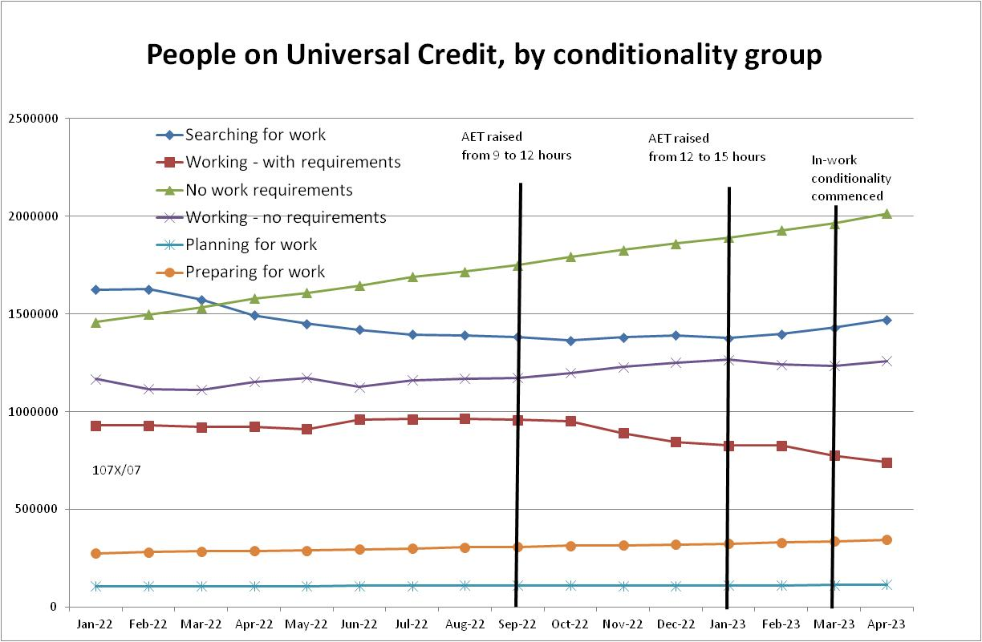

Figure 2
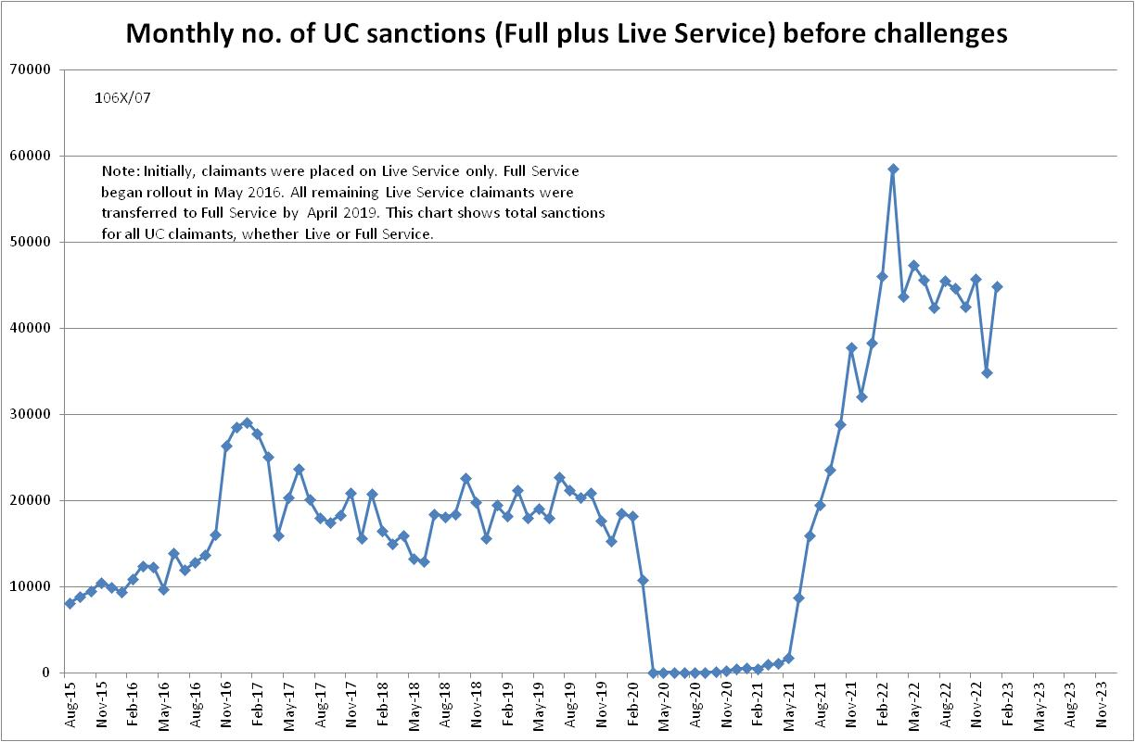

Figure 3
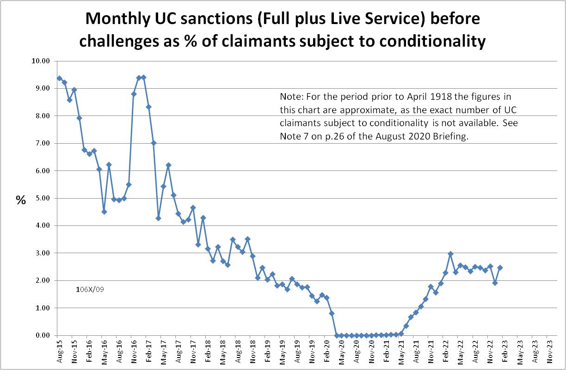
Figure 4
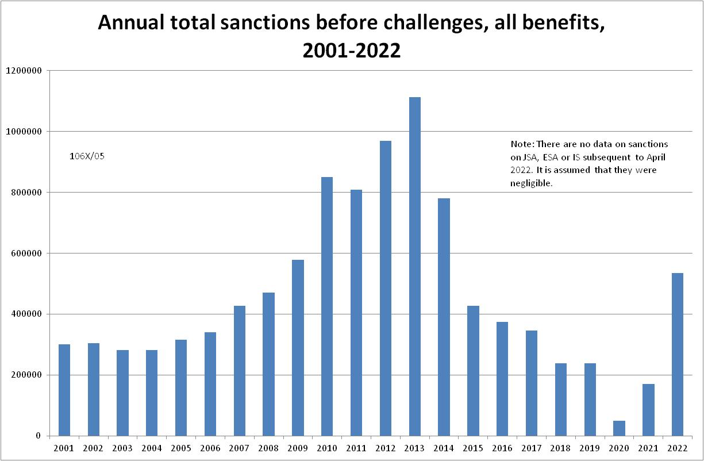

Figure 5
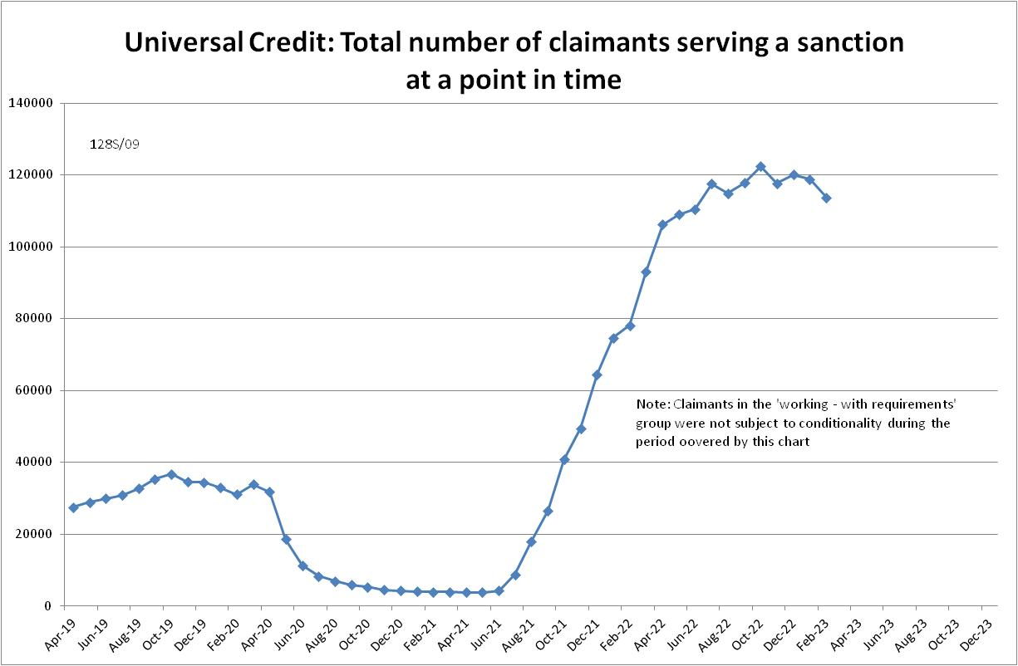

Figure 6
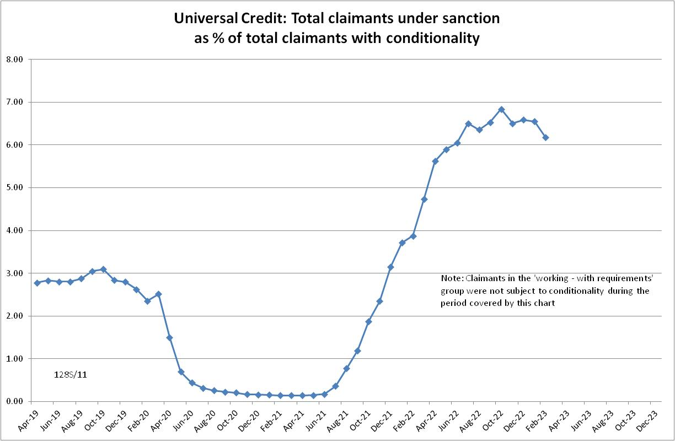

Figure 7
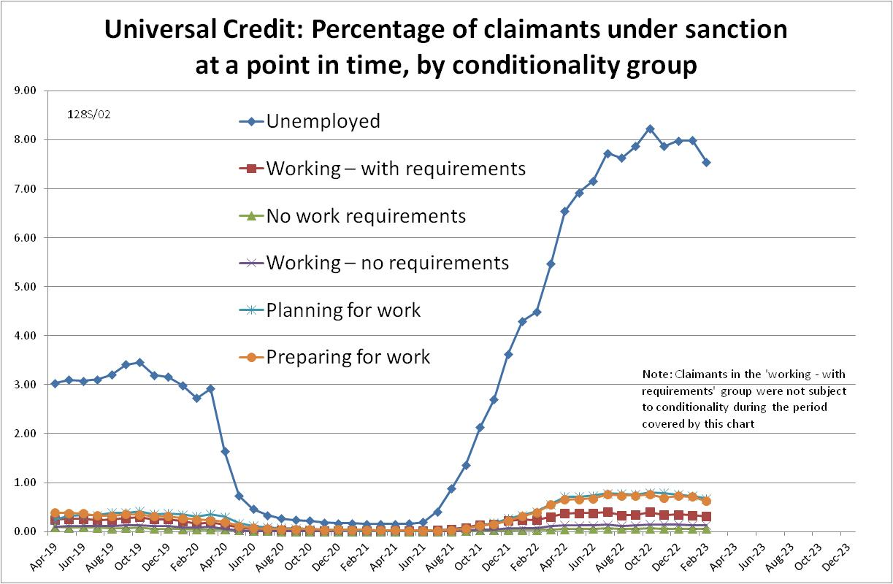

NOTES

Previous Briefings include many analyses that are not repeated here but remain valid. However it should be remembered that the DWP may have made subsequent revisions to the data reported in earlier Briefings. These revisions will generally not be major although there are exceptions. There may also often be substantial changes in some figures for the most recent few months.
A DWP report on the progress of managed migration (DWP 2023a) states that the final migration of claimants from old-style JSA to UC may not be completed before the end of 2024/25. Old-style JSA is already closed to new claimants.
The drawbacks of the ‘claimants under sanction at a point in time’ measure were discussed in the November 2017 issue of the Briefing, pp.6-10. In November 2020, DWP withdrew the UC ‘rate’ data for all months prior to April 2019, pending revision of the figures for the former ‘Live Service’. These figures remain withdrawn. In addition, in the February 2021 release DWP made significant revisions to the figures for April 2019 onwards (which are for Full Service only, there being no one left on the former Live Service). These were fully discussed in the February 2021 Briefing.
Currently available figures for the number of UC claimants under sanction only go back to April 2019 as DWP has withdrawn the figures for earlier dates. But the numbers previously published by DWP for the period before April 2019 are so far below those in 2022 that no conceivable revisions could made them higher than in 2022.

