BRIEFING: THE DWP’S JSA/ESA SANCTIONS STATISTICS RELEASE, 18 February 2015

SUMMARY

The DWP’s latest release updates the sanctions statistics to the end of September 2014. For the first time it includes the results of mandatory reconsiderations.

There were an estimated 895,000 JSA and ESA sanctions in the year to 30 September 2014, before reconsiderations and appeals. Total numbers of JSA sanctions are continuing to fall, reflecting the decline in claimant unemployment. As a proportion of claimants, they have stabilised at about 6.5% of claimants per month before reviews/reconsiderations and appeals (‘challenges’), and 5.5% after. This is double the level inherited by the Coalition. Total ESA sanctions are stabilising at an all-time high in absolute numbers, reaching an estimated 0.92% of claimants before and 0.75% after challenges in September 2014.

Almost one-fifth (18.4%) of the 3,097,630 individuals who claimed JSA during 2013/14 were sanctioned, after challenges: 568,430 people, with an average of 1.56 sanctions each. Over one-fifth (22.3%) of the 8,232,560 individuals who claimed JSA over the five years 2009/10 to 2013/14 inclusive, were sanctioned: 1,833,035 people, with an average of 1.95 sanctions each. Of the individual JSA claimants sanctioned in the year to June 2014, 30.9% were sanctioned more than once, and 12.5% three times or more. Over the six years of the ESA sanctions regime from October 2008 to September 2014, 21.0% out of a total of 85,292 sanctioned claimants received more than one sanction, and 7.6% three or more. In the year to May 2013 there were more than 93,410 children in households affected by sanctions.

The Mandatory Reconsideration system, introduced on 28 October 2013, has fundamentally changed the whole appeal process, introducing additional steps and a new Jobcentre Plus structure. MR has cut the proportion of JSA sanctions which are challenged by claimants from about one third (33%) to about 20-25%. ESA sanction challenges have returned to below their pre-MR level, at about 45%. The independent element in the system offered by Tribunals has been effectively destroyed, completely in the case of ESA and almost completely for JSA, where only 0.14% of sanction decisions are now being taken to a Tribunal. MR has had no overall impact on the proportion of JSA sanctions overturned, which remains at about 13%. But the proportion of ESA sanctions overturned has fallen from about 35% to about 20%. The most disturbing possibility is that ESA claimants’ medical conditions are rendering them unable to cope effectively with the phone calls made to them by DWP officials at home during the MR process.

The Work Programme continues to deliver far more JSA sanctions than JSA job outcomes. Up to 30 September 2014 there had been 575,399 JSA Work Programme sanctions and 345,640 JSA Work Programme job outcomes.

The author has estimated that the money directly lost to claimants through JSA sanctions imposed in 2013/14 is in the region of £328m, with ESA under £5m. This is in addition to money lost to people deterred from claiming benefits at all, which could easily be more.
BRIEFING: THE DWP’S JSA/ESA SANCTIONS STATISTICS RELEASE, 18 February 2015

Introduction

This briefing deals with the statistics on Jobseekers Allowance (JSA) and Employment and Support Allowance (ESA) sanctions released by the DWP on 18 February 2015, which include figures for the further three months July to September 2014. Excel spreadsheet summaries of the DWP’s statistics are available at https://www.gov.uk/government/collections/jobseekers-allowance-sanctions and the full dataset is in the Stat-Xplore database at https://stat-xplore.dwp.gov.uk/default.aspx.

This briefing also includes relevant material from recent DWP Freedom of Information responses, and estimates for 2013/14 of the amount of money lost to claimants through sanctions.

All statistics relate to Great Britain. No current sanctions statistics are available for Northern Ireland, which has not implemented the new regime of October 2012. The sanctions regime is one of the topics which has been subject to the recent negotiations at Stormont.

Mandatory Reconsideration

The new figures for the first time include the results of ‘mandatory reconsiderations’ back to their introduction on 28 October 2013. This Briefing is therefore able to show the impact of the new Mandatory Reconsideration (MR) regime. In the DWP’s previously published statistics, some sanctions which had actually been reversed in mandatory reconsiderations were shown as not having been reversed. As a result, the figures in the present Briefing for sanctions after (though not before) review/reconsideration/appeal since October 2013 have been revised downwards. This is in addition to the usual revisions for reviews or appeals decided subsequent to initial publication. Fuller information has become available to the author about the nature of the Mandatory Reconsideration process, and this has altered some of the conclusions drawn in the previous Briefing of November 2014. Details are given in the relevant section below.

The DWP’s database only shows sanctions after reviews, reconsiderations and appeals. But numbers of sanctions before the results of these challenges are important since they show all the cases in which claimants have had their money stopped. Although successful appellants should get their money back, this is only after weeks or months by which time serious damage is often done. However the figures for sanctions before reconsideration or appeal reported here are estimates and are not fully accurate for individual months, as explained in earlier Briefings. The earlier Briefings also have methodological notes on other topics.

Other factors influencing the figures

The figures must be read in the light of the falling numbers of JSA and ESA Work Related Activity Group (WRAG) claimants. The number of JSA claimants fell from 1.548m in February 2013 to 0.871m in September 2014 (it subsequently bottomed out at 0.775m in December and rose to 0.803m in January 2015).

Normally the DWP would already have published a figure for the number of ESA claimants who were in the WRAG in August 2014. But at the time of writing the most recently published figure is for May 2014. Consequently in this briefing it has been necessary to extrapolate figures for June to September 2014 from the figures for February and May. This will have introduced some inaccuracy into the estimates shown here of the percentage of WRAG claimants subjected to sanctions since May 2014. The published figures show that the WRAG peaked at 0.563m in August 2013 but fell back to 0.533m in May 2014. Here it is estimated that it fell to 0.509m in September 2014.

The ‘Claimant Commitment’ (requiring claimants to spend the equivalent of 35 hours a week looking for work) was rolled out across Great Britain between 14 October 2013 and spring 2014 and should have been in operation in all Jobcentres during the July-September quarter 2014.

At the end of this briefing there are notes on some additional recent developments in relation to sanctions.

Terminology

In the interests of clarity, this briefing introduces some new terms, as follows:

Mandatory Reconsideration, with initial capitals, and its abbreviation MR, means the whole new appeal system introduced on 28 October 2013

‘mandatory reconsideration’, without initial capitals, and never abbreviated, means the formal reconsideration of a sanction decision undertaken by the DWP’s Disputes Resolution Team.

‘decision review’ means the informal process of reconsideration now undertaken by the original Decision Maker (but previously undertaken by a different Decision Maker) when a claimant first challenges a sanction

‘internal review’ is a term embracing both ‘decision review’ and ‘mandatory reconsideration’

‘challenge’ means any challenge to a sanction decision, i.e. it embraces ‘decision reviews’, ‘mandatory reconsiderations’ and Tribunal appeals.

Numbers of JSA and ESA sanctions

The total numbers of JSA sanctions before and after reconsiderations and appeals are continuing to fall back, reflecting the decline in claimant unemployment. The numbers of ESA sanctions appear to be stabilising at an all-time high. They have not risen as much as was shown in the DWP statistics releases of August and November 2014.

As a proportion of claimants, JSA sanctions have stabilised during 2014 at the high level of 6.5% to 7% of claimants per month before reconsiderations and appeals, having exceeded 7% during 2013. After reconsiderations and appeals they are between 5.5% and 6.0% of claimants per month. After a rapid rise, ESA sanctions now also appear to be stabilising, at a little below 1% of claimants per month before reconsiderations and appeals and between 0.5% and 0.75% after.

Total numbers of JSA and ESA sanctions

- There were an estimated 895,000 JSA and ESA sanctions in the year to 30 September 2014, before reconsiderations and appeals (Figure 1). This compares with 564,000 in the last 12 months of the previous Labour government, but is lower than the (revised) peak of 1,073,000 reached in the year to February 2014.

- Total JSA plus ESA sanctions in the year to 30 September 2014, after reconsiderations and appeals, were 762,888. This is lower than the (revised) peak of 922,717 reached in the year to November 2013.

- An estimated 132,200 JSA or ESA sanctions were overturned in the year to 30 September 2014 via reviews, reconsiderations or appeals. In all these cases the claimant’s payments will have been stopped for weeks or months. This figure peaked at 153,300 in the year to March 2014.

JSA sanctions: Numbers and rates

- The number of JSA sanctions in the year to 30 September 2014 was 842,500 before reconsiderations and appeals and 724,141 after. This compares with 533,000 before and 496,771 after in the year to 30 April 2010, the last year of the previous Labour government.

- In the year to 30 September 2014, JSA claimants were sanctioned at the rate of 6.53% per month before reconsiderations and appeals, and 5.62% per month after. There has been a slight falling off in these figures from the peaks of 6.77% and 5.84% reached in the year to March 2014 (Figure 2). The monthly figures also suggest that the rate of JSA sanctions after reconsiderations and appeals has stabilised at around 5.5%. (Figure 4).

ESA sanctions: Numbers and rates

- There has been a rapid escalation in the numbers of ESA sanctions since mid-2013. In the year to September 2014 there were an estimated 52,600 ESA sanctions before reviews/reconsiderations and appeals (Figure 1), and 38,747 after. These are the highest figures since sanctions were introduced for ESA claimants in the Work Related Activity Group in October 2008. However total ESA sanctions appear to have stabilised at their new high level of 3,000-3,500 per month during 2014. The DWP has made very substantial downward revisions to the previously reported figures. Its August statistical release had 3,750 ESA sanctions in January 2014, 4,698 in February and 7,507 in March. These numbers – which provoked a lot of comment at the time - have now been revised down to 3,028, 3,222 and 3,810 respectively. It does not seem likely that these changes can be explained by late reviews/reconsiderations/appeals, but no other explanation has been offered.

- Although the rate of sanctions for ESA WRAG claimants is much lower than for JSA claimants, it continues to rise very fast. From a low of 0.08% of claimants per month in June 2011, before reconsiderations and appeals, and 0.07% after, it has risen to an estimated 0.92% before and 0.75% after in the month of September 2014 (Figures 3 and 4).

Government Denials

There has been a consistent pattern of denial by DWP ministers and officials that they have been driving up JSA sanctions. The latest offering has come from the Employment minister Esther McVey, appearing at the House of Commons Work and Pensions Committee on 4 February (Q.214). Her comment was not very coherent and was complicated by misquotation, but the gist of it was to take the statistics as published in November 2014 and compare post-reconsideration and appeal sanctions for June 2014 (60,219) with the same figure for June 2010 (56,394), pointing out that the difference was small. There are four things wrong with this. First, the Coalition took office in May 2010 and by June 2010 had already started to drive up sanctions; 56,394 was higher than the figure for any month prior to the Coalition. Second, in June 2010 the JSA claimant count was 1.39m, while in June 2014 it had fallen to 0.97m, so that the sanctions in the later month were being spread across fewer claimants. Third, there was a bigger gap between the estimated pre-appeal than the post-appeal figures. Fourth, comparisons of individual months are invalid anyway since there are big random fluctuations, as shown in Figure 4. The Coalition’s true impact on the JSA sanction figures is obvious from Figure 2.

In the same Work and Pensions Committee appearance, Esther McVey repeatedly quoted 0.6% as the percentage of ESA WRAG claimants sanctioned per month. This is correct for post-review/reconsideration/appeal ESA sanctions for the 12 months to September 2014, but the estimated pre-challenge figure – which is the correct measure of impact – is higher at 0.81%.

The proportion of JSA claimants who are sanctioned, and repeat JSA sanctions

DWP ministers and officials often claim that only a ‘tiny minority’ of JSA claimants are sanctioned. They support this by quoting the figures for the percentage of claimants sanctioned each month after reviews/reconsiderations and appeals. As shown above, this is about 5.6% per month. These are the only such figures available from Stat-Xplore. But of course if 5-6% of claimants are being sanctioned every month, the proportion will grow as time goes on. On 12 February, DWP published an important Freedom of Information response 2014-4972 showing the proportion of JSA claimants sanctioned and the numbers of repeat JSA sanctions.

Almost one-fifth (18.4%) of the 3,097,630 individuals who claimed JSA during 2013/14 were sanctioned: 568,430 people. During 2013/14 the maximum number of JSA claimants at any one time was 1,474,428. This gives some idea of the amount of turnover in the claimant count. We know from Stat-Xplore that there were 888,936 JSA sanctions in 2013/14, so that the average number of sanctions imposed on sanctioned claimants in 2013/14 was 1.56.

The figure of 18.4% for the proportion of JSA claimants in 2013/14 who were sanctioned is the highest recorded to date. The proportion of JSA claimants sanctioned in earlier years was:

2007/08 – 11.8 %
2008/09 – 9.8 %
2009/10 – 10.8 %
2010/11 – 15.1 %
2011/12 – 13.2 %
2012/13 – 16.0 %

It should be remembered that these figures show the proportion of claimants sanctioned after reviews/reconsiderations and appeals. The proportion sanctioned before these challenges in 2013/14 must have been about 20%.

FoI 2014-4972 also showed that between one-fifth and one-quarter (22.3%) of the 8,232,560 individuals who claimed JSA over the five year period 2009/10 to 2013/14 inclusive, were sanctioned: 1,833,035 people. Again, this is the figure after reviews/reconsiderations and appeals. The figure before these challenges will have been about 25%. Since we know from Stat-Xplore that there were 3,568,791 JSA sanctions in 2009/10-2013/14, it follows that the average number of sanctions per sanctioned claimant over those 5 years, after reviews/reconsiderations/appeals, was 1.95.

The fact that the number of people claiming JSA over 5 years is so much larger than the number claiming at any one time exposes the mendacity of the argument that claimants are getting ‘something for nothing’ unless they are made to engage in artificially imposed job search requirements, or sent on workfare schemes etc. Claimants earn their entitlement to JSA when unemployed or ESA when sick through their National Insurance contributions when they are in work.

Repeat sanctions: JSA

The FoI response 2014-4972 reveals that, disregarding any distinctions between levels of sanction, of the 539,225 individual JSA claimants sanctioned in the year to June 2014, no less than 372,461 (30.9%) were sanctioned more than once, and 67,143 (one in eight or 12.5%) were sanctioned three times or more.

Stat-Xplore shows that in the 101-week period of the new regime from 22 October 2012 to 30 September 2014, 884,479 individuals received 1,563,893 JSA sanctions, after reviews/reconsiderations and appeals. This is an average of 1.77 each.

Figure 5 updates the comparison of the number of sanctions with the number of sanctioned individuals for each month which was first included in the Briefing of November 2014. From 2000 to 2005, the gap was around 1,000. This means that at most around one thousand individuals received more than one sanction in the month. After the beginning of the recession, the Coalition inherited a figure of 3,000 per month but pushed it up to over 12,000 in October 2013. The number has now fallen back to 6,000, still double the inherited level.

Again, all of these figures on repeat sanctions show the number of sanctions after successful challenges.

Three-year sanctions

There is a serious lack of transparency in the sanctions system in that the numbers of people being subjected to the much longer sanctions for repeat ‘failures’ are not published and are not available from Stat-Xplore.

Part of FoI request 2014-4972 was for the number of people subjected to three-year sanctions, the heaviest of all. In response DWP have stated that it would be too expensive for them to find out. This does not seem credible and has been challenged. A reply is awaited. We do know that the number of people subjected to three-year sanctions since the start of the new regime in October 2012 cannot be greater than 2,048 and is probably substantially less. This is the number of people who have received three or more ‘high level’ sanctions since October 2012, a period of 23 months. Three-year sanctions apply to those with three ‘high level’ failures within 12 months.

Repeat sanctions: ESA

Less information is available about repeat ESA sanctions than about JSA repeats. However, Stat-Xplore shows that over the whole six years of the ESA sanctions regime from October 2008 to September 2014, 21.0% out of a total of 85,292 sanctioned claimants received more than one sanction, and 7.6% received three or more.

Sanctions on families with children

On 19 February the DWP published Freedom of Information response 2014-4805 giving the number of households with children in GB subjected to sanctions in the 12 months June 2012 to May 2013 inclusive. This shows that there were at least 93,410 children in households affected by sanctions, of whom at least 89,300 children in 46,160 households were affected by JSA sanctions and 4,110 children in 2,290 households by ESA sanctions. FoI 2014-4972 shows that in financial year 2012-13, which is almost the same period, the number of individual JSA claimants sanctioned was 557,858. It can be inferred that one dependant child will be affected for approximately every six JSA claimants who are sanctioned.

The ‘Mandatory Reconsideration’ Process

Statements by DWP ministers and officials have misled many people, including the present author, about the nature of the ‘Mandatory Reconsideration’ (MR) process. It has been presented as simply making mandatory what was previously a voluntary option for a sanctioned claimant to ask Jobcentre Plus to reconsider their decision prior to the claimant making an appeal to an independent Tribunal. In fact MR has fundamentally changed the whole appeal process, introducing additional steps and a new Jobcentre Plus structure. The process is described in documents published in response to DWP Freedom of Information request 2014-194 of 14 February 2014.

In the new process, the claimant is in fact not able to initiate a request for a ‘mandatory reconsideration’. The form to do this, MR1, can only be filled in by a DWP official. All the claimant is able to do is to make an informal request, by phone or in writing, for reconsideration. The next step is then for them to be phoned by the original decision-maker who gives them an ‘explanation’ of the reason(s) for the sanction. If the claimant accepts this, the matter ends there. If the claimant persists, the decision-maker will consider what they have to say, including any new evidence or points they make. The decision-maker may decide to change their decision at this point, and if so, the new decision will appear in the statistics as a ‘non-adverse decision review’. It appears that if the decision maker considers arguments from the claimant but does not change their decision, there will not necessarily be an entry in the statistics of an ‘adverse decision review’. This is because the proportion of recorded ‘decision reviews’ which are favourable to the claimant has risen from between 40% and 50% before MR to 90% now.

If at the end of the ‘decision review’ stage the decision has not been changed and the claimant insists on pursuing their challenge, the decision-maker will complete the MR1 form to trigger a formal ‘mandatory reconsideration’. This will also occur if the decision-maker has been unable to contact the claimant on the phone after three attempts and the claimant has made it clear that they wish to challenge the decision. But if it appears that the claimant has merely queried the decision, and they cannot be contacted, then the matter will lapse.

The actual process of ‘mandatory reconsideration’ is undertaken by a set of new, remotely located ‘Dispute Resolution Teams’. They also make efforts to discuss the case with the claimant. It appears that a result from this process, whether favourable or otherwise, is always recorded in the statistics.

In the previous Briefing for November 2014, the author wrongly assumed that when the DWP said that results of mandatory reconsideration were not being recorded in the statistics, this meant that the only ‘decision reviews’ included were those where a challenge had been lodged prior to 28 October 2013. In fact, ‘decision reviews’ have been recorded throughout. It is only decisions made by the Disputes Resolution Teams at the formal ‘mandatory reconsideration’ stage following completion of the MR1 which were omitted from the statistics published between February and November 2014 inclusive. Hence the discussion in the first three paragraphs on p.6 of the November 2014 Briefing, and Figure 11 in that Briefing, were incorrect.

With the MR process clarified, we can now move to consider its impact on the JSA and ESA sanctions process.

JSA and ESA Sanction Challenges:
decision reviews, mandatory reconsiderations and appeals

The Mandatory Reconsideration system has cut the proportion of JSA sanctions which are challenged by claimants from about one third (33%) to about 20-25%. In the case of ESA, a rapid increase at the time of introduction of MR has been reversed, and challenges have returned to below their pre-MR level, at about 45%. The independent element in the system offered by Tribunals has been effectively destroyed, completely in the case of ESA and almost completely for JSA, where only 0.14% of sanction cases are now getting to a Tribunal. About 50% of JSA internal reviews, but only about 8% of ESA internal reviews, are now formal ‘mandatory reconsiderations’ by the Disputes Resolution Team; the remainder of the internal reviews are ‘decision reviews’, usually by the original Decision Maker. The success rate for JSA challenges has risen, for both internal reviews and Tribunal cases, with the result that MR has had no overall impact on the proportion of JSA sanctions overturned, which remains at about 13%. But MR has cut the success rate of ESA internal reviews, from 60% to 40%, with the result that the proportion of ESA sanctions overturned has fallen from about 35% to about 20%.

Numbers of Decision Reviews, Mandatory Reconsiderations and Tribunal Appeals

Figures 6 and 7 show the impact of the new Mandatory Reconsideration system on the numbers of the different types of challenge to JSA and ESA sanctions. In the case of both benefits, Mandatory Reconsideration has brought about a sharp fall in the number of ‘decision reviews’, which has only been partly compensated by the new formal ‘mandatory reconsiderations’. Tribunal appeals have collapsed.

In the case of JSA (Figure 6), internal reviews (i.e. ‘decision reviews’ and ‘mandatory reconsiderations’ combined) fell vertiginously immediately upon the introduction of MR, more than halving from about 30,000 per month to under 15,000 per month. These internal reviews are now split half-and-half between ‘decision reviews’ and ‘mandatory reconsiderations’. Tribunal appeals fell from 3,800 per month to under 100 per month.

In the case of ESA (Figure 7), internal reviews had been rising rapidly, as a result of both the much greater harshness of the post-3 December 2012 penalties, and the fast rise in the number of sanctions from mid-2013 onwards. This impetus survived the introduction of MR until early 2014, since when the number of internal reviews has fallen back to what it was before MR, at just under 2,000 per month, 92% of these being informal ‘decision reviews’. Tribunal appeals have never been significant in relation to ESA sanctions: they peaked at 83 per month in November 2013. They have now disappeared altogether. There were no ESA sanction Tribunal decisions at all in July to September 2014.

The propensity to challenge sanctions

Figures 8 and 9 show what has happened to the propensity for claimants to challenge sanctions, by plotting internal reviews and Tribunal appeals as percentages of initial sanction decisions. For both benefits, MR has caused a sharp fall in challenges through the internal DWP process, and a collapse in appeals to Tribunal.

JSA challenges through internal review had risen to about one third of initial adverse decisions in summer 2013, but they have now fallen to 20-25%. JSA Tribunal appeals had risen to over 4% in the summer of 2013, but they have now fallen to by far the lowest level ever recorded, at 0.14%. They had never previously fallen below 1% (Figure 8).

At the time of introduction of MR, challenges to ESA sanctions through internal review had risen to 50%. As noted above, they continued rising but have now fallen back to 45% in September 2014. Tribunal appeals had risen to over 2% in late 2013, but have now fallen to nothing (Figure 9).

Claimants’ success rate in challenges

In the case of JSA, the fall in the number of challenges under MR has been considerably offset by sharp increases in claimants’ success rate. Figure 10 shows that while the success rate in formal ‘mandatory reconsiderations’ is lower than it was in decision reviews prior to MR, the success rate in decision reviews under MR has risen to 90%. This latter rise is probably mainly due to Decision Makers not recording most ‘decision reviews’ where they do not change the original decision. Nevertheless, the overall success rate in internal reviews has risen from just over 40% to 60%, now equalling its previous high reached in 2010-11. The Tribunal success rate has also continued to shoot up, now reaching over 50% from a long-term level of 10%. This presumably reflects the fact that only the most determined appellants now succeed in navigating the system through to a Tribunal.

For ESA claimants, MR has lowered the success rate of challenges, from just over 60% down to under 40%. (Figure 11). This is mainly due to a sharp fall in the success rate for decision reviews. Very few sanctioned ESA claimants are getting through to the formal mandatory reconsideration stage, and none at all to Tribunals.

Overall impact of the Mandatory Reconsideration system

Figures 12 and 13 summarise the overall impact on claimants of the Mandatory Reconsideration system to date. For JSA claimants, MR has cut the proportion of sanctions which are challenged, but increased the success rate of challenges, with the net result that there has been no significant effect on the proportion of sanctions overturned, which remains at about 13% (Figure 12). For ESA claimants, MR initially did not halt the rise in the proportion of sanctions being challenged, but has now brought it back to where it was before MR. But MR has drastically cut the success rate of ESA challenges, from 60% to 40%, with the result that the proportion of sanctions overturned has fallen from about 35% to about 20%.

The reductions in the already low rates of challenge to sanctions, and the effective ending of the independent element in appeals which has been part of the British social security system from its inception, are matters of grave concern. These are being achieved by means which are at least potentially unfair and oppressive, namely the telephoning at home of claimants by DWP officials when they do not have any adviser or representative present, and may well not have access to their documentation. Given the scale of reported abuse of claimants by Jobcentre Plus under the Coalition, it is obvious that the organization cannot be trusted to make such calls. The President of the Social Entitlement Chamber, Judge Robert Martin, commented to the House of Commons Work and Pensions Committee on 7 May 2014 (Q.96): ‘I am quite concerned that a number of claimants who may have winnable cases drop out between the mandatory reconsideration stage and deciding to make a further appeal. It seems to me to be regressive.’ In fact the situation is worse than this. Claimants are clearly dropping out at the ‘explanation’ stage, before they are allowed to get to a formal request for a mandatory reconsideration. Anecdotal evidence from advice agencies also indicates that claimants are being worn down by the delays in the system. There is no time limit for DWP to complete the process of Mandatory Reconsideration and allow the claimant to start their Tribunal appeal.

The most disturbing, but apparently quite likely, possibility is that the sharp fall in the success rate of ESA claimants at the internal review stage under MR is due to their medical condition (which in over half of cases is mental or behavioural) rendering them unable to cope effectively with the phone calls from DWP officials.

Reasons for JSA sanctions

An analysis of reasons for JSA sanctions up to the end of June 2014 is in the previous Briefing of November 2014, pp. 7-8 and Figure 14. It will be updated to the end of 2014 in the next Briefing.

Reasons for ESA sanctions

Figure 14 updates the reasons for ESA sanctions, after reviews/reconsiderations and appeals. The big surge in ESA sanctions since mid-2013 has been entirely due to ‘failure to participate in work related activity’. This reason now accounts for 90% of ESA sanctions.

The Work Programme: Still far more JSA sanctions than JSA job outcomes

The Work Programme continues to deliver far more JSA sanctions than JSA job outcomes. Up to 30 September 2014 there had been 345,640 JSA Work Programme job outcomes and 575,399 JSA Work Programme sanctions (Figure 15).

A similar comparison cannot be made accurately for ESA claimants as some work-related activity is mandated directly by Jobcentres.

Amount of money lost to claimants through sanctions

This author has previously published estimates of the net amount of money lost to JSA claimants through sanctions (Webster 2013). These estimates were:

- Calendar year 2005: £37m

- 12 months to Oct 2012 (last year of the old regime): £140m (the increase compared to 2005 being mainly the effect of increased numbers of sanctions and partly of inflation)

An estimate has now been produced for 2013/14. This uses a different methodology and as a result the estimate is for the amount of money lost to claimants through sanctions imposed in 2013/14, with some of the money being lost in later years. In effect this will be very similar to the amount of money lost in 2013/14 because some money will have been lost in that year due to sanctions imposed in earlier years. The estimate, which is approximate, is £328m. The increase compared with the year to October 2012 is due to both the huge lengthening of sanctions from 22 October 2012, and the further increase in numbers of sanctions, with inflation also having a small effect.

The amount of money lost to ESA claimants through sanctions imposed in 2013/14 is estimated at around £4.3m, on the assumption that the average ‘time to compliance’ is a week. If this was two weeks, the estimate would rise only to about £6m. There are far fewer ESA than JSA sanctions, and, setting aside the ‘time to compliance’ element, they are much shorter.

Details of all the calculations are available from the author.

These calculations relate to the direct effect of sanctions in taking money from claimants. But sanctions also have the effect of driving people off benefits altogether. Numerical estimates of JSA claimants leaving the count due to sanctions have been made by a team from Oxford University (Loopstra et al. 2014). CESI has pointed out that the proportion of unemployed young people (excluding students) not claiming JSA was 53.6% in January 2015 and had risen by over 20 percentage points since October 2012, with the sanctions regime (which was toughened in that month) an obvious possible factor. This reduction equates to about 100,000 claimants, and means a saving to the government (at the youth JSA rate) of around another £300m per year. Of course it is not only young people who are driven off benefits. Overall, it seems likely that the sanctions regime is saving the Coalition the best part of a billion pounds a year, and will be seen by ministers as making a substantial contribution to their targets for reducing social security spending.

SANCTIONS - OTHER DEVELOPMENTS

House of Commons Work and Pensions Committee Inquiry into Sanctions

The Work and Pensions Committee Inquiry into Benefit Sanctions Policy beyond the Oakley Review has received over 160 written submissions, which are available at http://www.parliament.uk/business/committees/committees-a-z/commons-select/work-and-pensions-committee/inquiries/parliament-2010/benefit-sanctions/?type=Written#pnlPublicationFilter. These submissions are an immensely valuable source of evidence on the sanctions regime, and include material from DWP ‘whistleblowers’, sanctioned claimants themselves, and a remarkable supplementary submission from the Public and Commercial Services union (SAN0161) reproducing a range of documents showing malpractice within Jobcentre Plus.

The Committee has held three oral evidence sessions and transcripts are available at http://www.parliament.uk/business/committees/committees-a-z/commons-select/work-and-pensions-committee/inquiries/parliament-2010/benefit-sanctions/

The report should be published in March.

House of Commons Debates

An adjournment debate on the amount of money withheld from claimants by sanctions promoted by the Opposition Employment spokesman Stephen Timms MP was held on 18 December. The transcript is available at
http://www.publications.parliament.uk/pa/cm201415/cmhansrd/cm141218/debtext/141218-0004.htm#14121849000003

A debate on Benefit Claimants in the North East was held on 7 January and a Westminster Hall debate on UK Poverty on 4 February. In both of these sanctions featured prominently.

New reports on sanctions

New reports on sanctions have been published by the All-Party Parliamentary Inquiry into Hunger in the United Kingdom, the Scottish Unemployed Workers’ Network, the Fawcett Society, the Poverty Alliance and the Baptist and other churches. Details are in the References below.

Paternity leave refused for unemployed claimants on work placements

The Scotsman reported on 30 November that under regulations imposed by the DWP, new fathers who are JSA claimants and sent on compulsory Mandatory Work Activity (MWA) or Community Work Placement (CWP) programmes will not be able to take paternity leave. The full report is at http://www.scotsman.com/news/uk/anger-as-workfare-fathers-denied-paternity-leave-1-3620349

2 March 2015

Dr David Webster
Honorary Senior Research Fellow
Urban Studies
University of Glasgow

Email david.webster@glasgow.ac.uk

Webpages: http://www.gla.ac.uk/schools/socialpolitical/staff/davidwebster/
http://www.cpag.org.uk/david-webster

REFERENCES

All-Party Parliamentary Inquiry into Hunger in the United Kingdom (2014) Feeding Britain: A strategy for zero hunger in England, Wales, Scotland and Northern Ireland. The report of the All-Party Parliamentary Inquiry into Hunger in the United Kingdom, December, available at https://foodpovertyinquiry.files.wordpress.com/2014/12/food-poverty-feeding-britain-final.pdf

All-Party Parliamentary Inquiry into Hunger in the United Kingdom (2014) An Evidence Review for the All-Party Parliamentary Inquiry into Hunger in the United Kingdom. Compiled and written by Andrew Forsey, Secretary to the All-Party Parliamentary Inquiry into Hunger in the United Kingdom, December, available at https://foodpovertyinquiry.files.wordpress.com/2014/12/food-poverty-appg-evidence-review-final.pdf

Ariss, Amanda, Carlene Firmin, Baroness Meacher, Sir Keir Starmer QC and Rosamund Urwin (2015) Where΄s the Benefit? An Independent Inquiry into Women and Jobseeker's Allowance, London, Fawcett Society, February, available at http://www.fawcettsociety.org.uk/wp-content/uploads/2015/02/Wheres-the-Benefit-An-Independent-Inquiry-into-Women-and-JSA.pdf

Baptist Union of Great Britain, Church Action on Poverty, The Church in Wales, Church of Scotland, Methodist Church, United Reformed Church (2015) Time to rethink benefit sanctions, March, available at http://www.jointpublicissues.org.uk/resources/rethinksanctions/

DWP (2014) Mandatory Reconsiderations, requests and decisions to October 2014, Great Britain: Experimental Official Statistics, 17 December, available at https://www.gov.uk/government/uploads/system/uploads/attachment_data/file/387871/MR_adhoc_final.pdf, with tables available at https://www.gov.uk/government/statistics/mandatory-reconsiderations-of-dwp-benefit-decisions-data-to-october-2014

Loopstra, Rachel, Aaron Reeves, Martin McKee & David Stuckler (2015) Do punitive approaches to unemployment benefit recipients increase welfare exit and employment? A cross-area analysis of UK sanctioning reforms, Oxford University Department of Sociology,
Sociology Working Paper No. 2015-01, January, at http://www.sociology.ox.ac.uk/materials/papers/sanction120115-2.pdf

MacLeod, Mary Anne (2015) Making the Connections: A study of emergency food
aid in Scotland, Glasgow, The Poverty Alliance, January

Scottish Unemployed Workers Network (2014) Sanctioned Voices: A report on the impact of the DWP sanctions regime as implemented in Dundee Job Centre, compiled by volunteers for the Scottish Unemployed Workers’ Network, December, available at http://www.scottishunemployedworkers.net/media/Sanctioned_Voices_-_final_version.pdf

Webster, D. (2013) ‘Jobseeker’s Allowance Sanctions and Disallowances’, Working Brief 233, Autumn, 6-7.

Figure 1
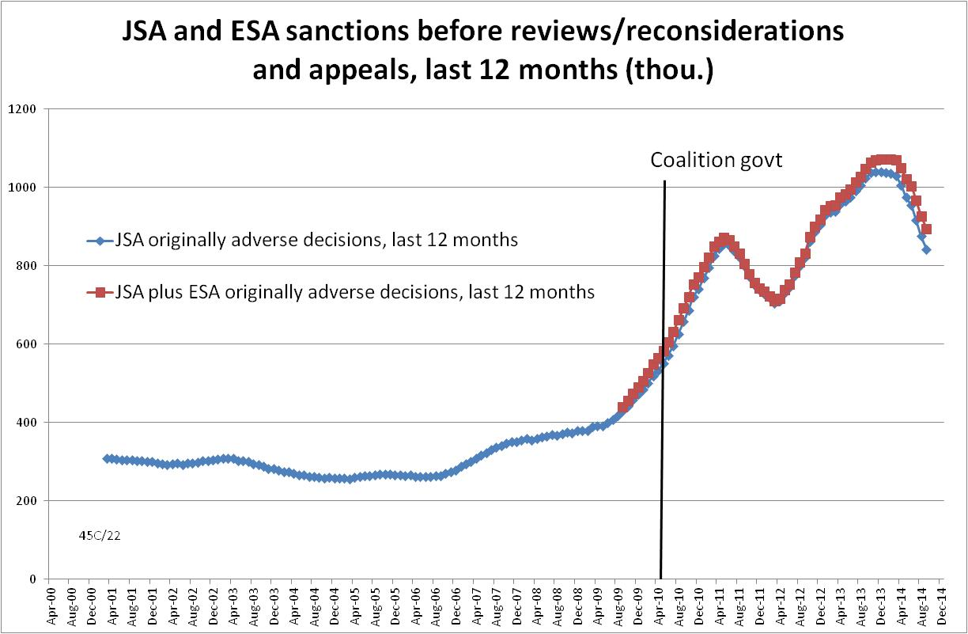

Figure 2
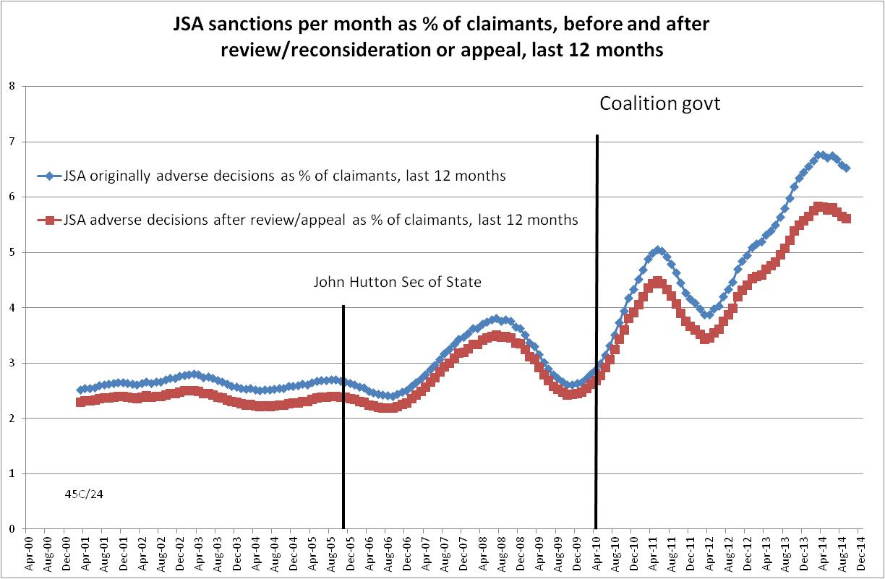

Figure 3
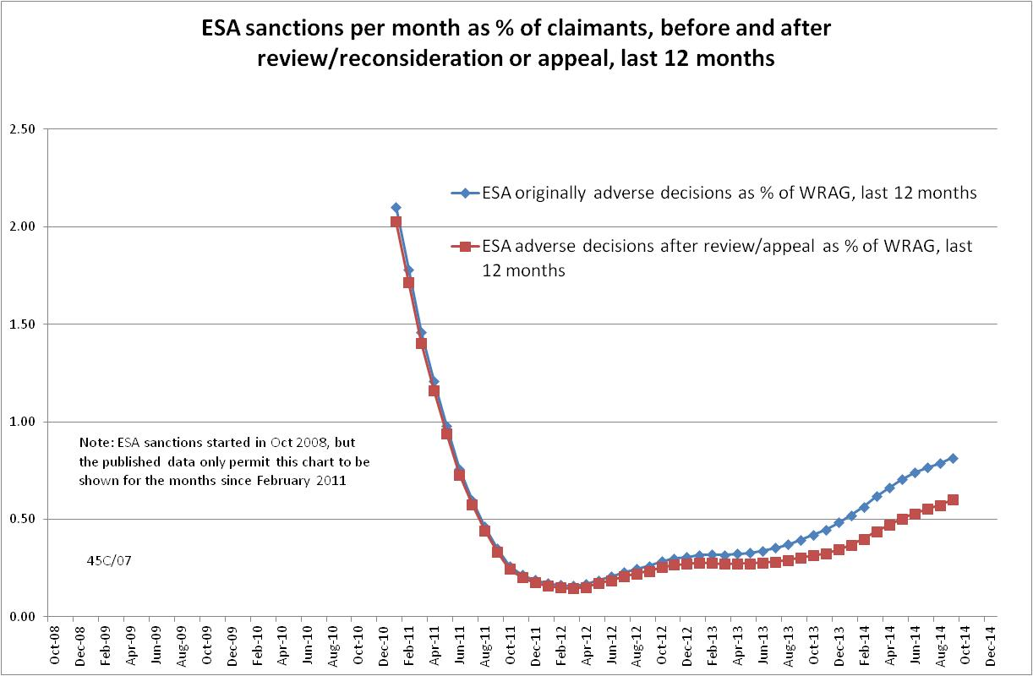
Figure 4
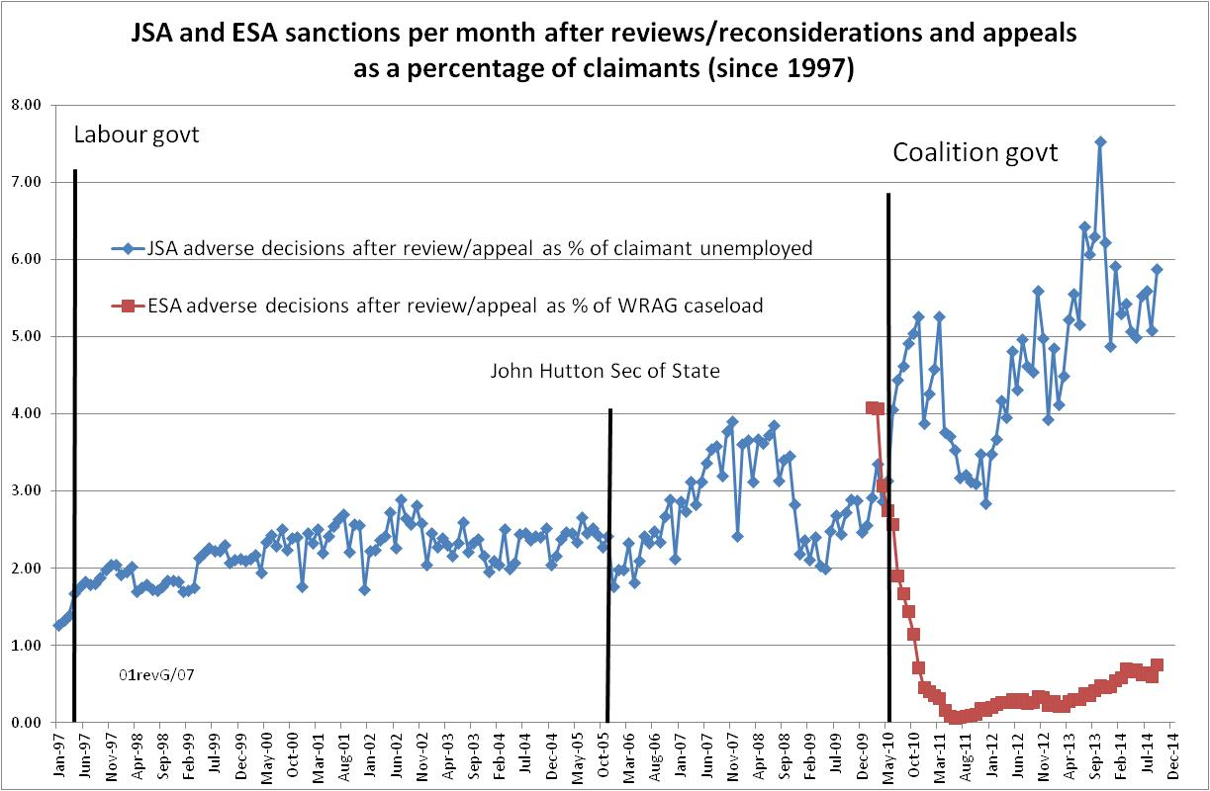

Figure 5
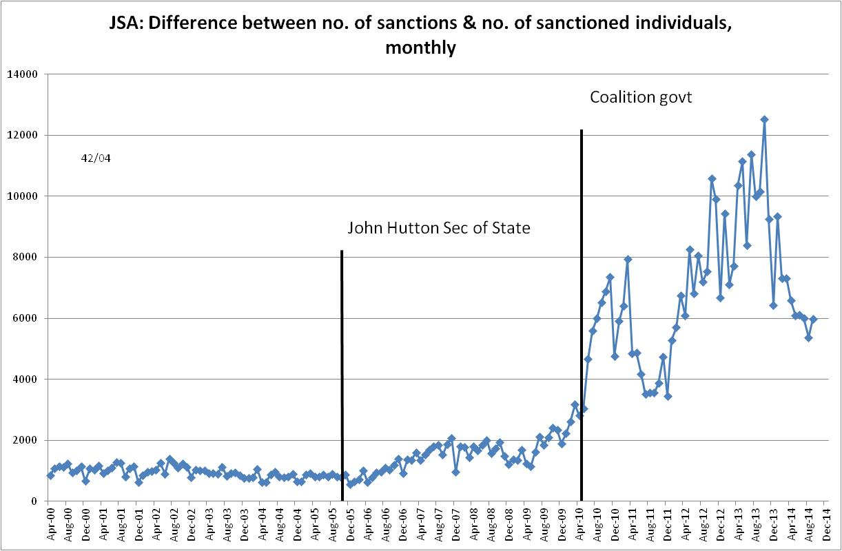

Figure 6
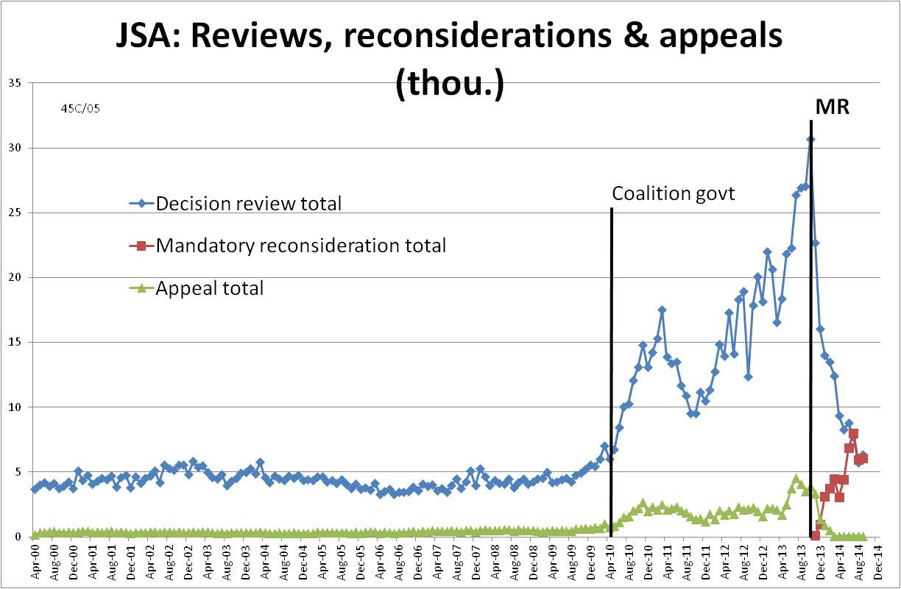

Figure 7
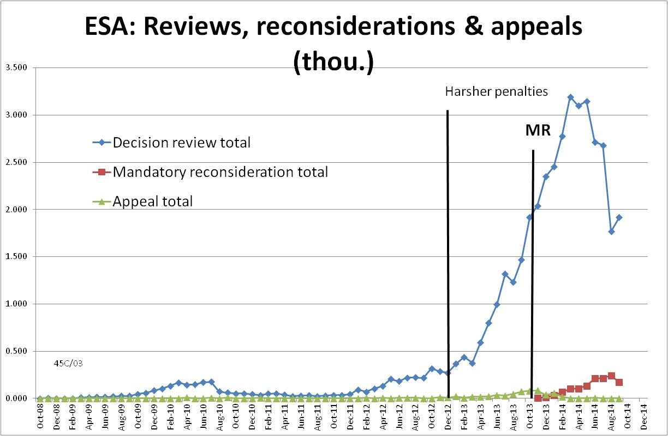

Figure 8
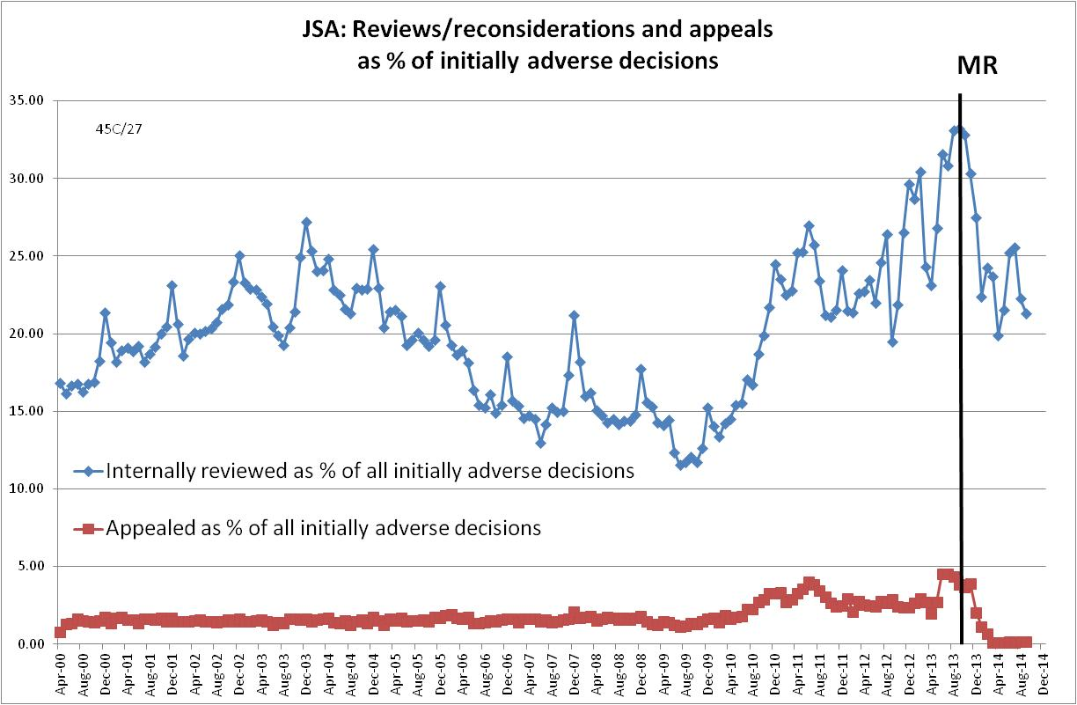
Figure 9
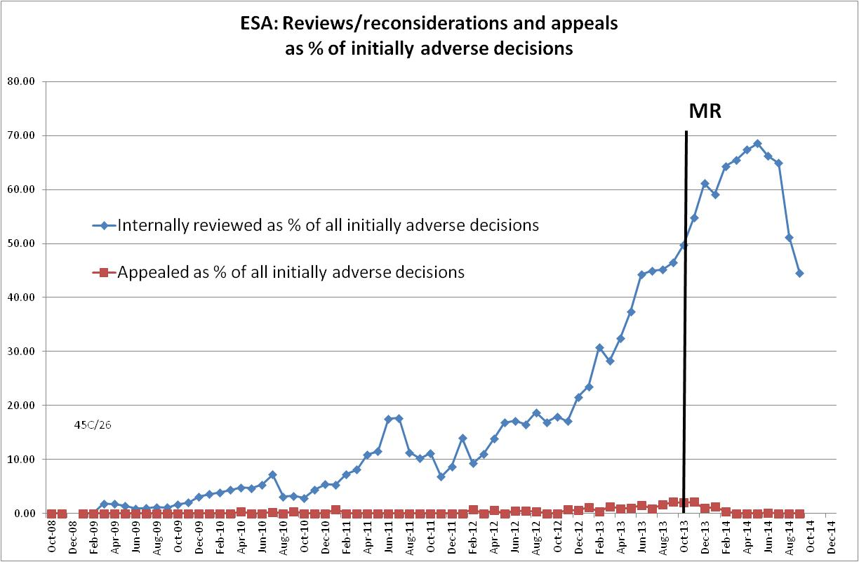

Figure 10
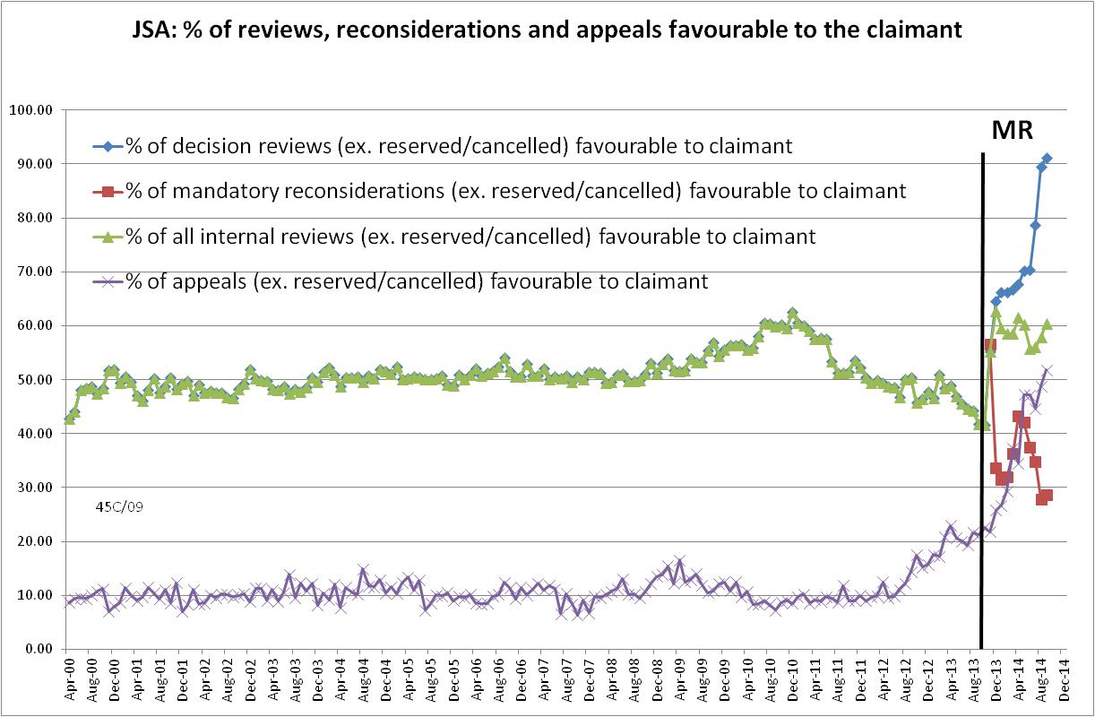
Figure 11
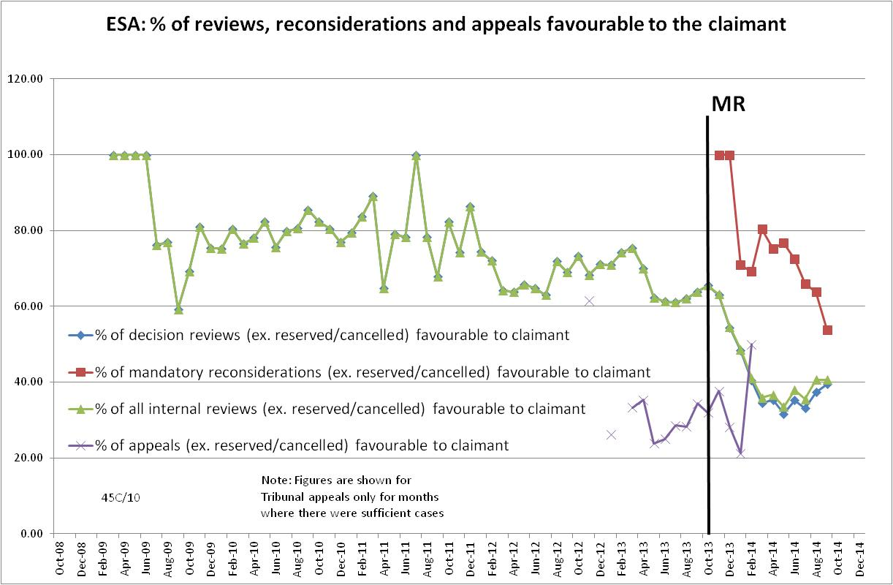

Figure 12
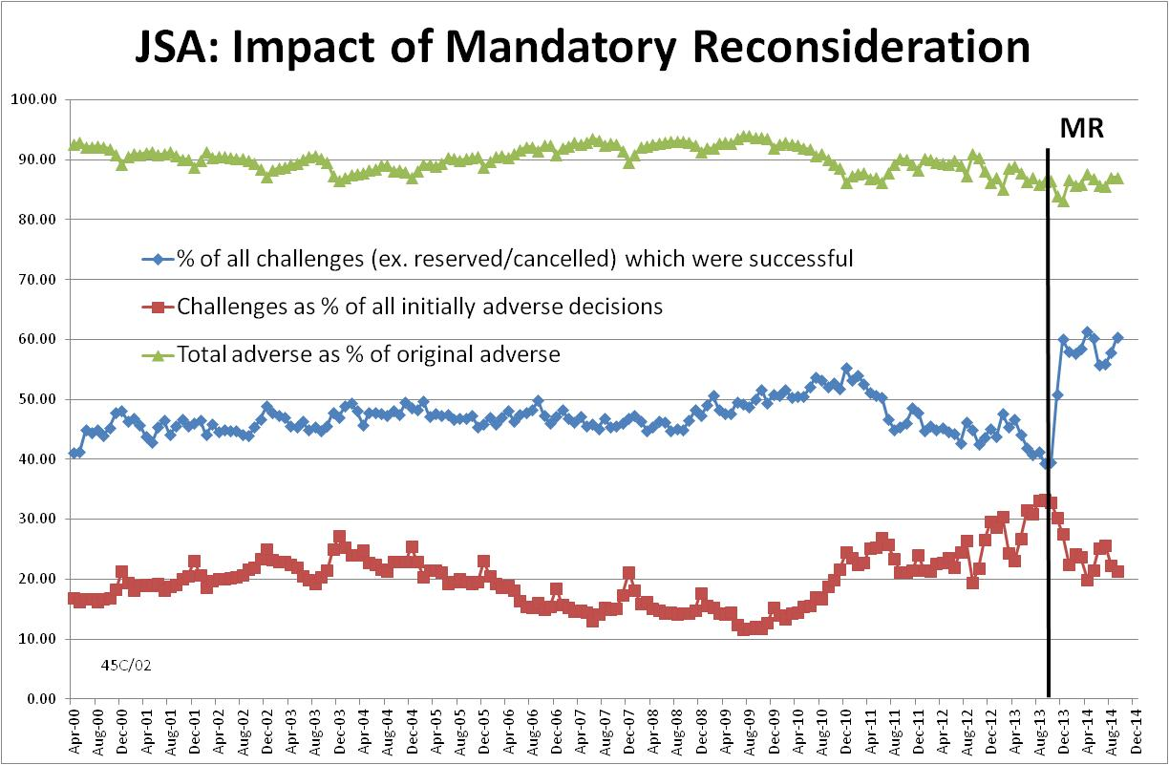
Figure 13
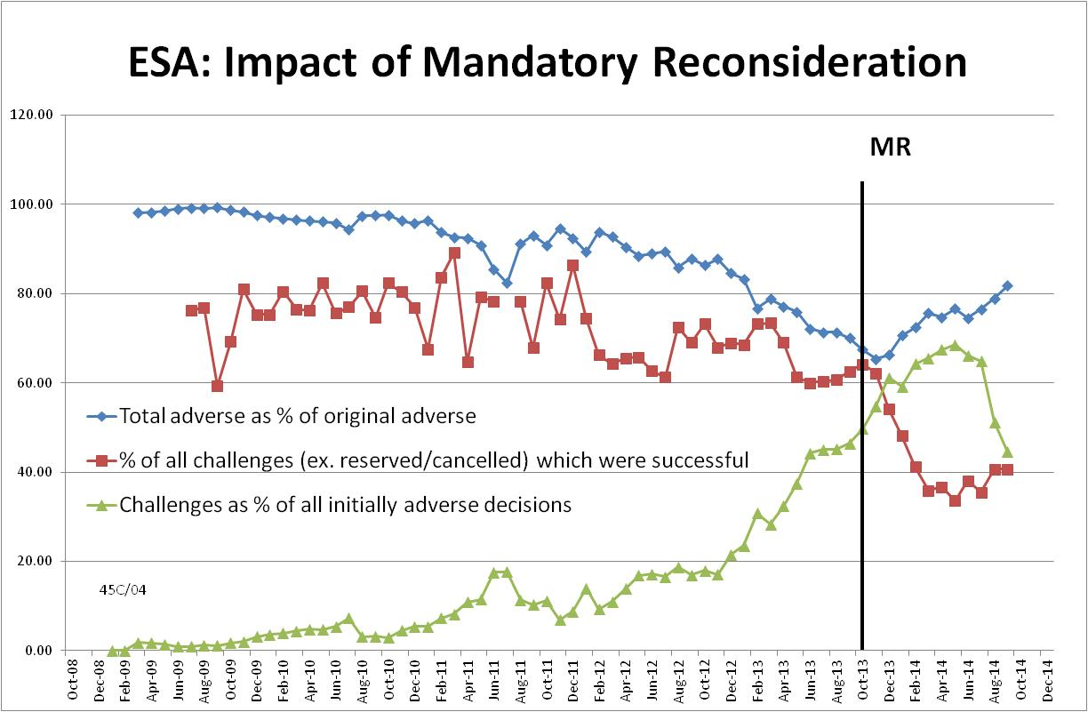

Figure 14
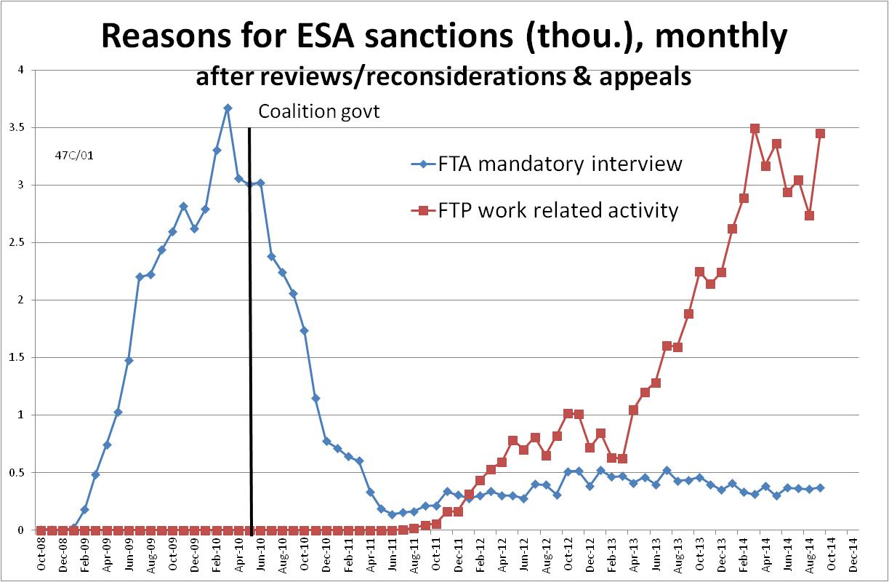

Figure 15
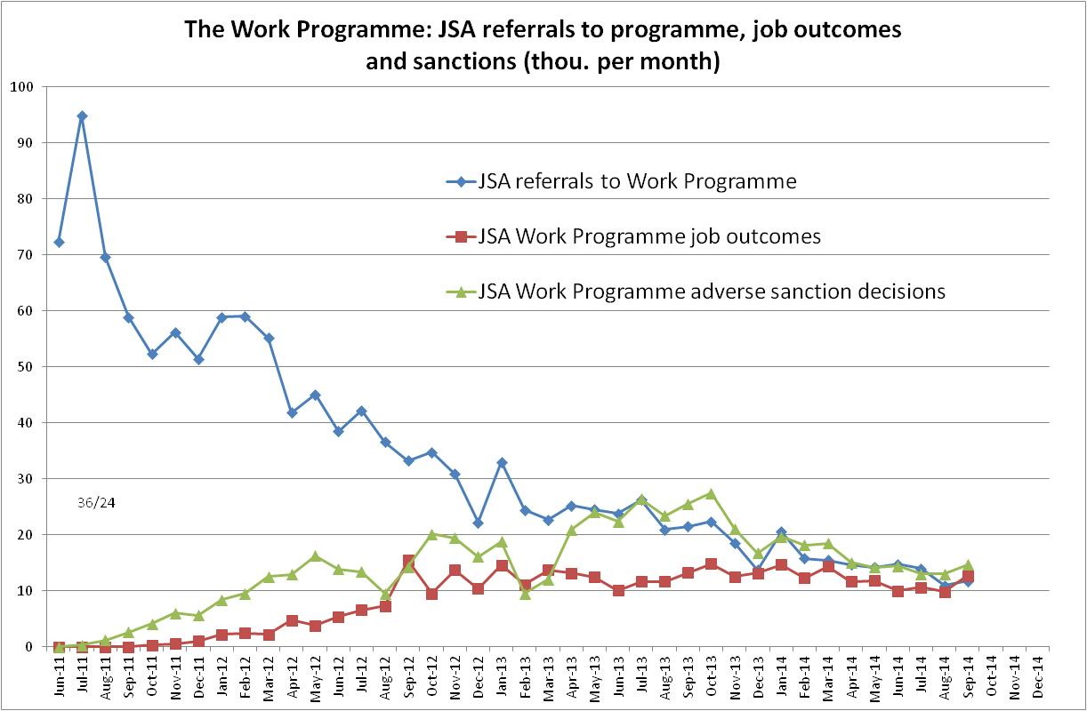

This is the sixth in a series of briefings on the DWP’s statistics on Jobseeker’s Allowance (JSA) and Employment and Support Allowance (ESA) sanctions. Earlier briefings were produced in November 2014, August 2014, June 2014 (for the May 2014 release), February 2014 and November 2013. They should be read in the light of the DWP’s statistical revisions, because some of their conclusions are no longer valid. However, much of the data and discussion remains useful, as noted in the present briefing. All the briefings are available at http://www.cpag.org.uk/david-webster
The DWP published some early statistics on the Mandatory Reconsideration process on 17 December (DWP 2014). But they did not distinguish sanctions from other aspects of JSA or ESA and therefore are not used here.
Some of the charts in this Briefing show figures for the latest 12 months, rather than for individual months, in order to show a clearer picture by smoothing out fluctuations, and to remove any misrepresentation arising from the approximation involved in estimating sanctions before reviews, reconsiderations and appeals.
The estimates for sanctions as a percentage of the WRAG will be subject to revision when updated figures on the WRAG caseload are published. The WRAG for September 2014 has been extrapolated from the figures for February and May 2014. Published figures for the number of ESA sanctions date from October 2008 whereas those for the size of the WRAG date only from February 2010. ESA sanction rates can therefore only be calculated from February 2010.
The full FoI response is available at https://www.gov.uk/government/uploads/system/uploads/attachment_data/file/402593/4972-2014.pdf Earlier FoI responses giving similar information on the proportions of claimants sanctioned were 2012-4383 of 21 December 2012, and 2012-5156 of 14 January 2013.
The full FoI response is at https://www.gov.uk/government/uploads/system/uploads/attachment_data/file/405799/4805-2014.pdf
The FoI release groups together households with five or more dependant children. Sixth and subsequent children in households with more than five children have been ignored here, so the figures for the numbers of children are underestimates.
For instance on the webpage https://www.gov.uk/social-security-child-support-tribunal/before-you-appeal and in the leaflet https://www.gov.uk/government/uploads/system/uploads/attachment_data/file/379070/jobseekers-allowance-sanctions-dwpf15.pdf published in response to the Oakley report, which is supposed to provide improved information to claimants.
The Mandatory Reconsideration process documents are available at https://www.whatdotheyknow.com/request/reconsideration_process. See in particular the Labour Market Conditions Guide, the Labour Market Decision Maker’s Guide and the Disputes Resolution Team Guide.
‘The mandatory reconsideration process will involve an outbound call from decision makers, to talk through disputed decisions with claimants and invite them to provide any additional evidence at the earliest opportunity’ (DWP 2014, p.8).
http://data.parliament.uk/writtenevidence/committeeevidence.svc/evidencedocument/work-and-pensions-committee/employment-and-support-allowance-and-work-capability-assessments/oral/9486.pdf
http://www.cesi.org.uk/statistics/labour/february-2015

