BRIEFING:

The DWP’s JSA/ESA Sanctions Statistics Release, 11 Nov 2015 and Hardship Payments Ad Hoc Statistical Release, 18 Nov 2015

30 November 2015

Dr David Webster
Honorary Senior Research Fellow
Urban Studies
University of Glasgow

Email david.webster@glasgow.ac.uk

Webpages: http://www.gla.ac.uk/schools/socialpolitical/staff/davidwebster/
http://www.cpag.org.uk/david-webster

SUMMARY

The DWP has been transferring new single claimants of unemployment benefits on to Universal Credit (UC) instead of JSA. But no statistics have been published on UC sanctions. This is starting to have a significant distorting effect on the analysis of JSA sanctions. Key figures in this briefing are adjusted to remove the distortion.

The estimated total number of sanctions on unemployed claimants before challenges, including both JSA and UC, in the 12 months to end-June 2015, is 499,000. This compares with a total for JSA alone of 482,000. The number of JSA sanctions after challenges for the same period reported in Stat-Xplore is only 414,347. The total of 499,000 before challenges for the year to end-June 2015 is less than half the peak of 1,037,000 in the 12 months ending October 2013. The main reason for this is that the number of JSA plus UC claimants fell by 41% over the same period. But there is also a downward trend in the rate of JSA sanctions as a percentage of unemployed claimants. It has fallen from a peak of 6.77% per month before challenges in the 12 months to March 2014, to 4.92% in the 12 months to June 2015. Prior to May 2010, the highest ever figure for monthly JSA sanctions before challenges in a 12-month period was 3.81%, in the year to July 2008, and it was usually well under 3%. Only one JSA sanction in 50 is for refusing a job.

ESA sanctions have also fallen, from a peak of 49,400 before challenges in the 12 months to August 2014, to 35,000 in the 12 months to June 2015. Sanctions before challenges as a percentage of ESA WRAG claimants are also now declining modestly. In the year to June 2015 the monthly rate was 0.59%. This figure peaked at 0.76% in August to October 2014.

Comparison of the figures for sanctions under the harsher regime since 2012 published in August and in November 2015 shows that a clear majority of the JSA sanctions imposed in April-June 2015, and about half of the ESA sanctions, were on claimants who had already been sanctioned within the previous two and a half years.

Before the October 2012 changes, JSA hardship awards were running at less than 10% of sanctions. But they have since risen to over 40%. ESA sanctions were running at a similar level up to 2012 but subsequently rose less. The absolute numbers of JSA and ESA hardship awards have declined since 2013 but they remain above their levels prior to the harsher 2012 regime. Altogether, there have been 749,900 JSA and about 14,500 ESA hardship payment awards over the three and a quarter years 2012-15. Since people only get a payment if they are completely cleaned out of resources, this indicates a massive scale of destitution.

The proportion of JSA sanction challenges which are successful is now over two-thirds, the highest it has ever been, but for ESA it has fallen to 40%. Because of low rates of challenge, overall only about 14% of JSA and 20% of ESA sanctions are overturned.

At the end of the Briefing there is information about other significant developments relating to sanctions, including the follow-up to the Work & Pensions Committee sanctions report, the Autumn Statement, an important Upper Tribunal case, and a private member’s bill on hardship payments. It appears that the government has reneged on its undertaking to the Work & Pensions Committee to evaluate the pilots of ‘in-work’ sanctions under Universal Credit before extending sanctions beyond the pilots.
BRIEFING: The DWP’s JSA/ESA Sanctions Statistics Release, 11 Nov 2015 and Hardship Payments Ad Hoc Statistical Release, 18 Nov 2015

Introduction

This briefing deals with two sets of statistics released by DWP in November 2015:

* The regular quarterly Jobseekers Allowance (JSA) and Employment and Support Allowance (ESA) sanctions data released on 11 November, which include figures for the further three months April to June 2015. Excel spreadsheet summaries of these statistics are available at https://www.gov.uk/government/collections/jobseekers-allowance-sanctions and the full dataset is in the Stat-Xplore database at https://stat-xplore.dwp.gov.uk/default.aspx. DWP has now made it possible for registered users to access Stat-Xplore using an application programme interface (API).
* An Ad Hoc release on 18 November giving data on JSA and ESA hardship payment awards made from April 2012 to June 2015, available at https://www.gov.uk/government/statistics/jsa-and-esa-hardship-applications-and-awards-apr-2012-to-jun-2015

All statistics relate to Great Britain. Except for the first week or so, the newly published figures for May and June for the first time show the use of sanctions by the re-elected Conservative government rather than the Coalition.

Sanctions before and after reviews, reconsiderations and appeals

The DWP’s database only shows sanctions after any reviews, reconsiderations and appeals that have taken place by the time the data are published. But numbers of sanctions before the results of these challenges are important since they show all the cases in which claimants have had their money stopped. Although a successful challenge should result in a refund, this is only after weeks or months by which time serious damage is often done. Estimates of sanctions before challenges are therefore given here but although reliable for longer time periods, they are not fully accurate for individual months, as explained in earlier Briefings.

Universal Credit and Universal Credit sanctions

The DWP has been transferring new single claimants of unemployment benefits on to Universal Credit (UC) instead of JSA. But no statistics have been published on UC sanctions, and no date has been given for them. This is starting to have a significant distorting effect on the analysis of JSA sanctions, because the number of claimants at risk of JSA sanctions is being reduced. The distortion is amplified because single claimants are disproportionately young, and young people are sanctioned at double the rate of other people. This briefing therefore introduces adjustments to estimate and where possible remove the distortion. The figures for ESA sanctions are unaffected since no ESA claimants have been transferred to UC.

NOMIS (the National Online Manpower Information System, www.nomisweb.co.uk) has started to publish two separate series for claimant unemployment, both including and excluding claimants on UC. Figure 1 shows a rapid divergence. By June 2015, the latest month reported here, the true figure for claimant unemployed was 48,544 higher, at 740,025, than that for JSA alone, which was 691,481. By October 2015 the gap had grown to 95,176.

Fortunately the DWP has started to publish within Stat-Xplore an age profile for UC claimants, which can be compared with the existing age profile for JSA claimants available from NOMIS. Figure 2 shows that UC claimants are massively different from JSA claimants. Almost half are under 25, compared with under a fifth for JSA, and only a quarter are over 34, compared to over half (56%) for JSA. By making the reasonable assumption that the rate of sanctioning is the same for each age group under UC as for JSA, it is possible to estimate the total number and rate of sanctions across the whole population of unemployed claimants, comprising both JSA and UC. This is done for the headline figures in this briefing.

The UC regime has similar lengths of sanction to those of JSA for the various ‘failures’, but there are some critical differences. Sanctions are lengthened by being made consecutive, not concurrent. Under Universal Credit hardship payments become repayable. Given that repayments are made at the rate of 40% of benefit – the same as the amount by which a hardship payment is lower than the benefit – this means that for claimants receiving hardship payments, UC sanctions are in effect 3½ times as long as their nominal length. All sanctioned UC claimants must also demonstrate ‘compliance’ for 7 days before applying for hardship payments, and must reapply for each 4-week period. The 80% hardship rate for ‘vulnerable’ claimants is abolished.

Impact of declining numbers of claimants

The falling number of unemployed claimants – whether on JSA or UC – shown in Figure 1 in itself has a downward influence on the number of sanctions. The fall in unemployed is mainly due to an improving labour market, but the effect of sanctions in driving claimants off JSA altogether (Loopstra et al. 2015) will also have contributed.

The number of ESA claimants exposed to sanctions – those in the Work Related Activity Group (WRAG) – has also been falling. The WRAG peaked at 0.563m in August 2013 but has since fallen every quarter until reaching 0.476m in May 2015 and an estimated 0.474m in June 2015. This is not due to a fall in claimants of ESA. In fact their total is continuing to rise, to an all-time high of 2.341m in May 2015, and since May 2010, the total number of claimants of disability benefits (ESA, Incapacity Benefit and Severe Disability Allowance) has fallen by only 92,000, from 2.613m to 2.521m. What has happened is that an increasing proportion of ESA claimants are being put into the Support Group rather than the WRAG.

UK Statistics Authority recommendations to DWP on sanctions statistics

As explained in the previous briefing, the UK Statistics Authority in August made recommendations to the DWP for improvements to the sanctions statistics, as follows:

- Provide users with benefit sanction statistics based on the actual number of sanctions applied, making clear the numbers of reviews, reconsiderations and appeals.
- Make clear the limitations associated with the statistics.
- Include in the quarterly benefit statistics bulletin a statement of the proportion of JSA claims subject to a sanction, as well as the proportions of claimants who have been sanctioned during the most recent one-year and five-year periods, and the numbers on which these proportions are based.
- Ensure all statements made using the official statistics are objective and impartial and appropriately apply the definitions of the variables underpinning the data, including ‘actively seeking work’.
- Extend the range of benefit sanction data available by addressing the gaps in information on repeat sanctions and hardship payments, alongside the development of sanction data from the Universal Credit system.

Of this list, the only recommendation which has been implemented to date is the publication of the hardship payment statistics discussed in this briefing.

Terminology

The terms used here in relation to reviews, reconsiderations and appeals are as follows:

Mandatory Reconsideration, with initial capitals, and its abbreviation MR, means the whole new appeal system introduced on 28 October 2013

‘mandatory reconsideration’, without initial capitals, and never abbreviated, means the formal reconsideration of a sanction decision undertaken by the DWP’s Disputes Resolution Team.

‘decision review’ means the informal process of reconsideration now undertaken by the original Decision Maker (but previously undertaken by a different Decision Maker) when a claimant first challenges a sanction

‘internal review’ is a term embracing both ‘decision review’ and ‘mandatory reconsideration’

‘appeal’ means a formal appeal to a Tribunal

‘challenge’ means any challenge to a sanction decision, i.e. it embraces ‘decision reviews’, ‘mandatory reconsiderations’ and Tribunal appeals.

Numbers and rates of sanctions on unemployed claimants
– JSA and Universal Credit

The estimated total number of sanctions on unemployed claimants before challenges, including both JSA and UC, in the 12 months to end-June 2015, is 499,000. This compares with a total for JSA alone of 482,000. The number of JSA sanctions after challenges for the same period reported in Stat-Xplore is 414,347. The adjusted figures are significantly different from those reported in Stat-Xplore, indicating how important it is that DWP should implement the UK Statistics Commission’s recommendations.

There is a strong downward trend in unemployed sanctions, even when estimated UC sanctions are added in. The total of 499,000 before challenges for the year to end-June 2015 is less than half the peak of 1,037,000 before challenges in the 12 months ending October 2013 (Figure 3). The main reason for this is that the number of JSA plus UC claimants fell by 41% over the same period.

However there is also a downward trend in unemployed claimant sanctions as a percentage of unemployed claimants. To date, it makes little difference to the 12-month figures whether there is any adjustment for UC sanctions. The rate of JSA sanctions has fallen from peaks of 6.77% per month before challenges and 5.83% after in the 12 months to March 2014, to 4.92% and 4.23% respectively in the 12 months to June 2015 (Figure 4). If estimated UC sanctions were added in, the before challenge rate in the year to June 2015 would be 4.96% rather than 4.92%, and for the three months to June 2015 it would be 4.09% rather than 4.23%. Prior to May 2010, the highest figures for monthly JSA sanctions ever seen in any 12-month period were 3.81% before challenges and 3.51% after, in the year to July 2008, and both figures were usually well under 3%.

Reasons for JSA sanctions

No information is available on the reasons for UC sanctions. Figure 5 updates the analysis of the reasons for JSA sanctions, comparing the first half of 2015 with 2014, 2013, 2009, 2003 and 1997. There is little change in the latest six months. The Coalition hugely increased sanctions for non-participation in training and employment schemes (which in its case means the Work Programme) and for ‘not actively seeking work’. These remain the top two reasons for sanction, although ‘not actively seeking work’ has fallen back to 28.4% of all sanctions while the Work Programme has risen to 32.1%. DWP ministers and officials like to refer to claimants being sanctioned for refusing a job, but this is a rarity – the modern Jobcentre Plus is not in the business of offering actual employment. In the latest 12 months, only 9,078 sanctions were imposed for refusing a job or ‘neglecting to avail of an opportunity’ of employment – about one sanction in 50. Back in 2003 it was one sanction in 10, out of a very much smaller total of sanctions (251,000). All the figures in this paragraph refer to sanctions after challenges.

Numbers, rates and reasons for ESA sanctions

ESA sanctions are not affected by any of the estimation problems relating to Universal Credit, since no ESA claimants have been transferred to UC. Total ESA sanctions have now also fallen, from peaks of 49,400 before challenges in the 12 months to August 2014 and 35,570 after challenges in the 12 months to September 2014, to 35,000 before challenges and 26,878 after in the 12 months to June 2015 (Figure 6). This partly reflects the continuing decline in the WRAG, but as a percentage of ESA WRAG claimants, sanctions before challenges are also now declining modestly, both before and after challenges (Figure 7). In the year to June 2015 the monthly rate was 0.59% before challenges and 0.45% after. These figures peaked at 0.76% in August to October 2014 and 0.55% in September to December 2014.

Figure 8 updates the reasons for ESA sanctions, after challenges. The big surge in ESA sanctions since the spring of 2013 has been entirely due to ‘failure to participate in work related activity’, while sanctions for not attending work-focused interviews have been gently declining. ‘Failure to participate in work related activity’ now accounts for 85% of ESA sanctions.

Sanctions overturned following challenge

An estimated 68,100 JSA sanctions and 8,100 ESA sanctions were overturned in the 12 months to June 2015 via reviews, reconsiderations or appeals. This is a total of 76,200 cases where the claimant’s payments will have been stopped for weeks or months only to be refunded later. This figure peaked at 153,600 in the year to March 2014.

The proportion of claimants who are sanctioned

As noted above, the UK Statistics Authority has recommended to DWP that it should include in the quarterly benefit statistics bulletin a statement of the proportion of JSA claims subject to a sanction. However, this is not yet being done and the DWP has not published any update on the figures for the financial years 2009/10 to 2013/14 contained in its Freedom of Information response 2014-4972. This showed that of all those who claimed JSA during the financial year 2013/14, 18.4% were sanctioned (after challenges). Over the five year period 2009/10 to 2013/14 inclusive, the percentage of JSA claimants sanctioned (after challenges) was even greater, at 22.3%. The proportion before challenges will have been higher still, at about one quarter.

Updated figures have been requested (by another researcher) via FoI for both JSA and ESA, but the response is overdue (the statutory time limit for response expired 5 months ago). The proportion of JSA claimants sanctioned will have fallen since 2013/14. Figures have never been published for the proportion of ESA claimants who are sanctioned. It will be substantially lower than for JSA.

Repeat sanctions

It is sometimes argued that sanctions are effective in making claimants learn to comply with requirements and that this is evidenced by the fact that most sanctioned claimants are only sanctioned once. Stat-Xplore shows that in the 140-week period of the new regime from 22 October 2012 to 3 June 2015, 999,796 individuals received 1,824,777 JSA sanctions, after challenges. This is an average of 1.83 each. Figures on repeat sanctions before challenges are not available.

In the three months April-June 2015, the number of JSA sanctions shown by Stat-Xplore as imposed since October 2012 (post-challenges) increased by 66,746 but the number of individuals sanctioned over the same period increased only by 28,448. Both of these figures are affected by revisions to the Stat-Xplore data for March 2015 due to reviews, reconsiderations or appeals. Nevertheless they imply that a clear majority of the sanctions imposed in April-June were on claimants who had already been sanctioned within the previous two and a half years.

In the slightly shorter 134-week period of the new ESA regime from 3 December 2012 to 30 June 2015, 41,357 individuals received 70,452 ESA sanctions after challenges. This is an average of 1.70 each. The increase in sanctions over the three months April-June was 3,606 while the increase in individuals sanctioned was 1,831, implying that about half of the new sanctions were on claimants who had already been sanctioned within the previous two and a half years.

JSA and ESA hardship payments

Background

Sanctions remove all of claimants’ JSA and all of the personal allowance component of ESA. Up to the late 1980s, disentitled or sanctioned unemployed claimants could claim Supplementary Benefit as of right, if they passed the normal test of resources, at the usual rate minus 40%. But in 1988, for sanctioned unemployed claimants with no contributory entitlement, Michael Portillo withdrew the new Income Support and substituted a regime of discretionary ‘hardship payments’, which have to be separately applied for. This was extended to contribution-based JSA claimants in 1996 by Portillo and Peter Lilley, and then to ESA claimants in the ‘work related activity group’ by Iain Duncan Smith in 2012. Hardship payments are paid at the rate of 60% of normal benefit except for arbitrarily defined ‘vulnerable’ claimants, who get 80%. In 1996, the rule was introduced that ‘non-vulnerable’ claimants could not even apply for hardship payments for the first two weeks of a sanction or disallowance. The official DWP Decision Makers’ Guide acknowledges that the two week wait will often damage the claimant’s health (para. 35099). The criteria for ‘hardship’ are specific to the sanctions regime and are particularly harsh – for instance, a person with cash in hand equal to their ‘applicable amount’ will be refused even if the money is owed to a payday lender (DMG para. 35198), and claimants are expected to beg or borrow money from relatives if they can. And as with any discretionary benefit, the complicated application process and lack of information given to claimants mean that many claimants never even apply for the hardship payments they ought to receive. Even when an application is made, there are often delays in payment.

Alternative ways of presenting the proportion of sanctioned claimants receiving hardship payments

There are two different ways of presenting data on hardship payments. One is to show the number of people receiving the payments and the total number of people under sanction, both at the same point in time. The other is to show the number of awards of hardship payments and the number of sanctions imposed, both over the same period. The proportion of sanctioned claimants shown by the former method as receiving a hardship payment is bound to be higher than the proportion of sanctions leading to a hardship payment shown by the latter. This is because the figure for those under sanction at a point in time includes disproportionate numbers of people serving longer sanctions, who are more likely to be included in the ‘snapshot’ Quarterly Statistical Enquiry, taken at a single point in time, from which the estimates are derived. Since people are more likely to receive a hardship payment the longer their sanction, the QSE will overestimate the proportion of sanctioned claimants who receive a hardship payment. The two methods give different answers because they are answering different questions. For JSA, the two methods are now considered in turn. For ESA, the only figures available are for the number of awards over a period. No data have yet been published on UC hardship payments.

Proportion of JSA claimants under sanction receiving a hardship payment, up to August 2012

Quarterly figures for the number of JSA claimants under sanction receiving a hardship payment were published up to February 2005, and this information was updated to August 2012 by a Freedom of Information response 2013-1443 in 2013. Figure 9 presents this information. The figures show that in 2011/12, some 25% of claimants under sanction were getting a hardship payment. Figure 10 suggests that very few indeed of those were receiving the 80% ‘vulnerable’ rate, although the number of cases for which the percentage is stated to be ‘unknown’ is so great that accurate estimates are not possible.

Proportion of JSA sanctions resulting in a hardship payment award, 2011/12 onwards

On 18 November the DWP published monthly statistics on JSA and ESA hardship payment applications and awards for April 2012 to June 2015 (DWP 2015). It had previously published an ad hoc statistical release in September 2012 (DWP 2012) giving the single figure of 64,000 as the number of JSA hardship awards made in 2011/12. It had never previously published statistics on ESA hardship payments.

Figure 11 compares the number of JSA hardship payment awards month by month with the estimated number of JSA sanctions before challenges, i.e. reviews, reconsiderations or appeals. This is the appropriate comparison since sanctioned claimants lose their money immediately and even if successful in their challenge, will only receive a refund weeks or months later.

The most striking feature is the huge increase in the number of hardship payments immediately upon Iain Duncan Smith’s introduction of the more severe sanctions regime, with longer sanctions, on 22 October 2012. Since then the gap between the number of sanctions and the number of hardship awards has continued to narrow. This is shown more clearly in Figure 12. Before the October 2012 changes, JSA hardship awards were running at less than 10% of sanctions. But they then rose steeply, to 30% by February 2013, and they have since risen further, to over 40%. If you get a hardship payment, it means that you have been completely cleaned out of resources, and exhausted all possibility of help from family and friends; the payment itself is then well below the already inadequate level of normal benefit, and under the post-October 2012 regime it will usually have to be lived on for weeks and frequently for months. The figures therefore show that the sanctions regime is creating destitution on a massive scale.

The absolute monthly number of JSA hardship awards has now declined by 62% from its peak of 33,000 per month in July to November 2013, to 12,500 in April to June 2015. This is still well over double the monthly rate of 5,300 in 2011/12, before the harsher regime. The decline will be mainly due to the fall in JSA claimants discussed earlier. From October 2013 to June 2015 this was a fall of 43%. There is no obvious explanation for the remainder of the fall.

Many of the claimants receiving a hardship award post-October 2012 would have qualified for one under the pre-October 2012 regime but for the two-week ban on application, because they will have met the hardship criteria but their sanction under the pre-October 2012 regime would have been for two weeks or less. However their situation has clearly been worsened by the lengthening of sanctions of October 2012, since the period of up to two weeks with no income which they would already have had previously is now followed by further weeks or months with their benefit reduced by 40% (sometimes, 20%).

The former minister Esther McVey told the Work and Pensions Committee on 4 February that ‘the vast, vast majority of people applying for hardship payments get them’. Figure 13 shows that this is true. Just under 90% of JSA applicants are successful. A high success rate is to be expected since reports indicated that claimants who are unlikely to succeed are discouraged by Jobcentre staff from making formal application. However it is disturbing that the success rate has risen from only about two-thirds prior to the October 2012 regime. A higher proportion of a larger number of applicants are completely destitute.

Proportion of ESA sanctions resulting in a hardship payment award, 2011/12 onwards

The newly published DWP statistics show some ESA hardship awards being made in April to November 2012, before the ESA sanction hardship payment regime was introduced on 3 December 2012 by the ESA (Sanctions) (Amendment) Regulations 2012. The DWP have explained to me that this is because the figures include hardship payments to claimants disqualified from ESA under Part 12 of the ESA Regulations 2008, mainly for not taking part in a health assessment. This is a different issue from sanctions. These ‘disqualification’ hardship payments should be removed from the total before comparing hardship payments with ESA sanctions. However the information provided by DWP does not allow this to be done. The number of ‘disqualification’ hardship awards shown for April to November 2012 is quite small, 100 or less per month, but this is enough to distort any calculations significantly, particularly in the earlier and later parts of the period.

However the figures do make it clear that although ESA hardship awards rose sharply after sanctions were made longer and more severe in 2012 (for ESA, this was from 3 December 2012), the proportion of sanctions resulting in a hardship award has never risen as high as for JSA. Figures 14 and 12 show the ESA hardship award figures without correction for ‘disqualification’ hardship awards. Figure 12 shows them rising from under 10% of ESA sanctions during 2012 to around 20% since then, with the proportion declining slightly in later months; because of the ‘disqualification’ cases, we know that these percentages are overestimates. Sanctioned ESA claimants are not quite as badly off as JSA claimants in that they currently retain the ‘work related activity component’ of about £25.75 per week, although this is being abolished from April 2017. They are also generally a less disadvantaged group than JSA claimants, in that long term sickness and disability are less concentrated among economically disadvantaged people than is unemployment. These factors probably explain why a smaller proportion of ESA than of JSA claimants receive hardship payments, and why this proportion rose less after the changes of 2012.

The proportion of ESA applicants claiming hardship payments (including both ‘disqualification’ and sanction cases) who receive them is very high, and similar to that for JSA (Figure 13).

Overall scale of destitution

Altogether, there have been 749,900 JSA hardship payment awards over the three and a quarter years covered by these statistics. The total of ESA sanction hardship payments over the same period will have been about 14,500 once the ‘disqualification’ cases are removed, making a total of about 764,000 for JSA and ESA combined. Some of these will have been repeat awards to the same people, but on the other hand these figures do not include people who should have applied but did not. This does therefore give an idea of the scale of destitution being wrought by the sanctions regime.

Further implications of the new data on hardship payments

The new data on JSA hardship payments have two important further implications:

- The fact that close to half of sanctioned JSA claimants are getting hardship payments means that the cost of extending automatic payments to everyone from day one (as in the private member’s Benefit Sanctions Regime (Entitlement to Automatic Hardship Payments) Bill) is much less than has been assumed. To estimate the cost, the correct measure of sanctions to use is actually the post-challenge figure, not the pre-challenge figure used above. This is because if a sanction is overturned, any hardship payment already made is deducted from the repayment, i.e. treated as a payment of benefit on account (DMG para.35450). The post-challenge figures raise the percentage of sanctioned JSA claimants getting hardship payments by around 6%-8%, to not far short of 50%.

- If a sanctioned JSA claimant is getting a hardship payment, then they must still be included in the JSA claimant count. Although this still leaves plenty of room for claimants to be driven off JSA by sanctions, it does put an upper limit to the possible size of this effect.

JSA and ESA Sanction Challenges

JSA and ESA reviews, reconsiderations and appeals have been extensively discussed in earlier Briefings. In the latest DWP release there are some revisions to earlier figures but no major change. Figures 15 and 16 update earlier summaries of the changing performance of the appeal system.

JSA challenges

Figure 15 confirms that Mandatory Reconsideration, introduced from 28 October 2013, has brought about a fall in the proportion of JSA sanctions that are challenged, from over 30% to only about 20%. However the proportion of challenges which are successful has risen, from a long-term rate of 40%-50% to just over two-thirds – in other words a claimant challenging a sanction has a two-to-one chance of winning. This is the highest it has ever been. The net result is that the proportion of JSA challenges which are overturned has stayed roughly the same, at about 14%. These figures are clear evidence that far more JSA claimants ought to challenge their sanctions.

However, the independent element in the appeal system has almost entirely disappeared. There were only 335 JSA sanction Tribunal appeals in the latest quarter, compared to a peak of 12,709 in the three months ending August 2013. Those appeals that do get to a Tribunal now have an unprecedentedly high success rate. In the quarter to June 2015 it was 51.6%. This was still lower than the success rate in internal reviews and reconsiderations.

JSA ‘decision reviews’ continue to far outstrip formal ‘mandatory reconsiderations’, with 12,238 and 5,005 respectively in the quarter to June.

ESA challenges

The new data from DWP indicate that the proportion of ESA sanctions which are challenged has fallen less than was previously shown (Figure 16). In the previous Briefing this proportion was shown as having fallen to 40.9% in March 2015. The revised figures show that it never fell below 50%. For the quarter ending June 2015 it was about 56%. This is still a fall from the peak of 70% reached in May 2014.

Mandatory Reconsideration has caused a major fall in the proportion of ESA sanction challenges which are successful, from over 60% to only 40%. This is historically low: prior to the introduction of MR, it was always 60% or higher. As a result, overall, MR has sharply reversed what was a rising trend in the proportion of ESA sanctions overturned. Immediately prior to MR, this had risen to one third, but it has now stabilised at just over 20%.

Tribunals are now playing virtually no role in relation to ESA sanctions. There were only 6 cases in the quarter to June. For ESA, like JSA, decision reviews continue to far outstrip formal mandatory reconsiderations, with 3,670 and 186 respectively in the quarter to June.

SANCTIONS - OTHER DEVELOPMENTS

Government Response to the House of Commons Work and Pensions Committee report Benefit Sanctions Policy beyond the Oakley Review

The Work and Pensions Committee report into Benefit Sanctions Policy beyond the Oakley Review was published on 24 March and was summarised in the May Briefing. The government response was published on 22 October. I have produced a separate briefing on the response which is available at www.cpag.org.uk/david-webster. Since the response the chair of the Committee has written a further letter to Iain Duncan Smith on 29 October asking for more detail on the content and timing of the various government proposals mentioned in its response, and also objecting further to the government’s refusal to monitor the destinations of sanctioned claimants. A fairly detailed reply from Duncan Smith dated 13 November makes some specific commitments. For instance, the trial of a two-week delay in implementing sanctions will be in Scotland from March 2016 at the latest, and automated sanction notifications were to be reintroduced from 23 November 2015.

Autumn Statement

The Autumn Statement (HM Treasury 2015, para.1.129-1.132) and the Chancellor’s accompanying speech on 25 November made some significant announcements.

In particular, the position stated in the government response to the Work and Pensions Committee concerning extension of sanctions to part-time workers under Universal Credit appears to have been quickly reneged upon. The Committee noted the lack of evidence on such a regime and urged the government not to extend sanctions beyond the existing pilots before robust evidence is available (Recommendation 8). In its response on 22 October (House of Commons Work and Pensions Committee 2015b) the government stated (p.6) ‘We agree that individuals on Universal Credit and in work will not be subject to the full range of work-related requirements and sanctions beyond existing pilots until we have fully considered the learning from those pilots. Outside of the pilots, Universal Credit claimants will continue to be subject to the current light-touch offering until we have enough evidence from the pilots to make a decision on the way forward’.
However, in his speech on 25 November, George Osborne declared ‘So today we confirm we’ll extend the same support and conditionality we currently expect of those on JSA to over 1 million more benefit claimants’. There is no sign of any report by DWP evaluating the current pilots and it seems unlikely that the DWP has ‘fully considered the learning’ from its pilots in the 34 days between the two announcements.
The Autumn Statement also says that the government will require jobseekers to attend the jobcentre weekly for the first 3 months and will ‘bring forward’ ‘the more intensive support element of the Help to Work programme currently in place for the long-term unemployed’. The Statement also has a number of other JSA- and ESA-related announcements.
Upper Tribunal decision on Jobseeker’s Agreement

There was an important Upper Tribunal judgment on 14 August on the question of ‘failure or refusal to carry out a Jobseeker’s Direction’. The appellant in the case, a 53-year old man with four children to support, had been sanctioned for being 10 minutes late for a CV-writing course. The judge found that this did not amount to ‘failure or refusal’, on the following grounds: First, the Appellant did not refuse to carry out his Jobseeker’s Direction: he was merely 10 minutes late in attending the course. As the DWP had admitted, it was inherently improbable that the Appellant would have deliberately attended late given his past record of compliance. Second, the Appellant’s late arrival was accepted by both the DWP and the tribunal to have been a genuine error (he was hard of hearing and had misheard the date of the appointment as 11.50 am as this was the time he usually signed on. He was not wearing his hearing aid as it was faulty). Third, the Appellant reported his late arrival to the Jobcentre that same day and rebooked the CV writing course which he subsequently completed. It would therefore be disproportionate to conclude that the appellant’s lateness was sufficient to amount to a failure by the Appellant to carry out his Jobseeker’s Direction.

It is interesting that the date of the appellant’s alleged ‘failure’, 30 October 2013, coincided with the all-time peak rate of JSA sanctions: 8.71% of claimants were sanctioned in that month. This will have been only one out of hundreds of thousands of unreasonable sanctions being imposed at that time. Unfortunately the lack of protection for claimants since the Social Security Act 1998 abolished independent adjudication means that very few of the victims will have had the redress secured by this claimant. This sort of case gives the lie to the DWP’s claims that sanctions are only used ‘as a last resort’. Nor does it say much for the appeal system that this obviously abusive sanction got all the way to the Upper Tribunal before being set aside.

There are not many sanctions, relatively speaking, in relation to Jobseeker Directions. There were only 3,042 such sanctions in the first half of 2015, 1.77% of the total, although at the height of the DWP’s sanctions drive, in 2013, there were 29,402 (3.3%). But the real significance of this case seems to be that the reasoning applies just as much to sanctions for 'non-participation in the Work Programme', which is the most frequent reason for sanction. Here the relevant section of the Jobseekers Act 1995 (S.17A(1)) refers to a requirement to 'participate' in a 'programme', yet claimants get sanctioned if they miss a single meeting with the contractor. But everyone knows that in commonsense terms people fully participating in a programme almost never have a 100% attendance record, no matter how keen they are.

Benefit Sanctions Regime (Entitlement to Automatic Hardship Payments) Bill

This private member’s bill promoted by Tasmina Ahmed-Sheikh (SNP) had its first reading debate in the House of Commons on 27 October 2015 (col.202). The second reading of the Bill has been postponed from 4 December to 22 January to allow more time for discussion with stakeholders on its exact terms. The text is not available at the time of writing but in the words of its promoter ‘This Bill will ensure that those who are sanctioned will automatically and immediately receive a hardship payment, and that those payments will not need to be repaid’. It will thus affect the JSA, ESA and Universal Credit sanction systems.

Apart from Ms Ahmed-Sheik herself, the sponsors are Hannah Bardell (SNP), Eilidh Whiteford (SNP), Corri Wilson (SNP), Sharon Hodgson (Lab – Washington & Sunderland W.), Naz Shah (Lab – Bradford W.), Caroline Lucas (Green – Brighton Pavilion), Margaret Ritchie (SDLP – South Down) and Liz Saville Roberts (Plaid Cymru – Dwyfor).

Scottish Parliament Welfare Reform Committee sessions on the Work Programme, 27 October & 3 November 2015

The Scottish Parliament Welfare Reform Committee returned to the subject of benefit sanctions in its ‘Your Say’ session on 27 October and ‘Future Delivery of Social Security in Scotland’ session on 3 November, both focused on the Work Programme. In the former session it interviewed claimants and in the latter, Work Programme contractors. Verbatim reports are available on the web.

In the former session, as reported in the Glasgow Herald (28 October), Jake from the East End of Glasgow described being made to ‘cold call’ long lists of companies. ‘Sometimes they make you sit on the phone from 9 to 5 each day making calls for jobs, even though you know that you are not going to get anything. It is depressing.....’ The Convener: ‘I want to come back to the phone calls that you have to make in looking for a job. Are you given a list of vacancies to follow up? What response do you get when you phone companies cold to ask whether they have any vacancies? Is it quite a curt response—“Nuh”—and that is it? How does it make you feel when you get that kind of brush-off? Jake: ‘It is going through the motions—it is a tick-box exercise.....’ The Convener: ‘What kind of jobs are you asked to phone about?’ Jake: ‘You put down your specified jobs—cleaning, catering, housekeeping and laundry are my specified areas. Your adviser checks on the computer and gives you a booklet with all these businesses in it. You then have to sit down and go through all the businesses’ phone numbers. I would phone them up and say, “Hi. My name’s Jacqueline. I’m looking to see if you have any vacancies at the moment.” You go through the rigmarole and tick “No”, “No”, “No”, “No”. ..... You go back the following week and are told to refresh the process: “Did you phone them again?” The answer is still the same.’ The Convener: ‘Dear God.’

New Ken Loach film: I, Daniel Blake

The Guardian reported on 24 November that Ken Loach is making a film about benefit sanctions, due for release in 2016. The Guardian reported Loach as saying ‘The present system is one of conscious cruelty. It bears down on those least able to bear it. The bureaucratic inefficiency is vindictive and hunger is being used as a weapon...... The situation is much worse than in the days of Cathy Come Home.’

Sheffield Hallam University report on Homeless people’s experiences of welfare conditionality and benefit sanctions

Publication of an important report on Homeless people’s experiences of welfare conditionality and benefit sanctions (Reeve et al. 2015) by the Sheffield University Centre for Regional Economic and Social Research, commissioned by CRISIS, is expected in early December. The study has used the largest sample survey of this group to date.

Rowntree Foundation Report: Young people and social security: an international review

In October the Joseph Rowntree Foundation published a study comparing the treatment of young people by the social security systems in different countries, including benefit sanction systems (Stephens & Blenkinsopp 2015). The UK is compared with Australia, Denmark, Germany, Sweden and the United States. In particular the study compares approaches to the question of when the family of origin relinquishes responsibility and the state takes over. The report points out that the UK has the highest proportion of 16-24 year olds who are NEET (not in education, employment or training) and one of the highest rates of poverty among young people. It comments that benefit sanctions in Germany and the UK are emerging as a cause of youth homelessness.

Oxford/Liverpool Study – the Work Capability Assessment

The Oxford University Sociology Department team have published a further paper in their series on the impacts of ‘welfare reform’, this time on the effects of the Work Capability Assessment on population health. They found that each additional 10,000 people reassessed in each local authority area was associated with an additional 6 suicides, 2,700 cases of reported mental health problems, and the prescribing of an additional 7,020 antidepressant items. In total, across England as a whole in 2010 to 2013, the WCA disability reassessment process was associated with an additional 590 suicides, 279,000 additional cases of self-reported mental health problems and the prescribing of an additional 725,000 antidepressant items. The reassessment process was associated with the greatest increases in these adverse mental health outcomes in the most deprived areas of the country, widening health inequalities. The authors conclude that the policy may have had serious adverse consequences for mental health in England, which could outweigh any benefits that arise from moving people off disability benefits. Putting this evidence together with personal testimonies, it is reasonable to conclude that some of the damage to mental health will have resulted from the application of ‘conditionality’ to people shifted into the WRAG or on to JSA following the WCA.

Interaction of the new Criminal Courts Charge with Benefit Sanctions in England and Wales

The August Briefing reported concern about the effects of the new mandatory Criminal Courts Charge introduced by Chris Grayling in England and Wales on 13 April before he was transferred out of the Ministry of Justice. There are two main concerns. One is that the charge creates an incentive for the innocent to plead guilty, particularly when they have no money. The other is that because the charge is mandatory and additional to any other penalty, total penalties are disproportionate, particularly for people such as sanctioned claimants who commit ‘survival crime’. The charge has caused particular concern among magistrates, some of whom have resigned as a result.

The House of Commons Justice Committee (2015) has now called for outright abolition of the charge. Written evidence from the Howard League at
http://data.parliament.uk/writtenevidence/committeeevidence.svc/evidencedocument/justice-committee/court-fees-and-charges/written/22027.pdf lists some 80 cases of the charge being levied on destitute people, giving links to the original press reports. The Lord Chief Justice has also called for re-examination of the charge (Financial Times, 18 November).

The Financial Times on 2 November (‘Tories prepare for retreat on court fees’) reported that Grayling’s successor Michael Gove has begun a review of the Criminal Courts Charge and quotes a ‘senior government figure’ as saying ‘The Ministry of Justice has decided that (the Charge) cannot stay in its current form and will be reformed or possibly scrapped entirely’.

House of Commons Work and Pensions Committee Inquiry into the Local Welfare Safety Net

The Work and Pensions Committee has launched an inquiry into local discretionary assistance schemes. Discretionary Housing Payments have existed for some time, but under the Coalition, the national Council Tax Benefit scheme has been abolished and the DWP Social Fund has been replaced by discretionary local assistance schemes. Arrangements in Scotland and Wales are different from those in England, and in effect the Committee inquiry seems to be focused on England. Local assistance schemes are often vital for sanctioned claimants, although it appears that many local authorities disqualify them. Details of the inquiry are at
http://www.parliament.uk/business/committees/committees-a-z/commons-select/work-and-pensions-committee/inquiries/parliament-2015/welfare-safety-net-15-16/
The closing date for evidence was 30 October.

Social Security Advisory Committee report Bereavement Benefit Reform

On 5 November the statutory Social Security Advisory Committee published a report Bereavement Benefit Reform (SSAC 2015). It draws attention to the issue of conditionality, i.e. sanctions, for bereaved spouses and civil partners (pp.21-23 & 32-33). Under current proposals, bereaved partners will be exempt from conditionality requirements for other benefits for six months after the death; subsequently they may be given relief at the discretion of Jobcentre staff, and in particular if they have distressed children they may be given relief for up to four months in the following two years. Respondents to a 2011 consultation argued that this is too short and that bereaved claimants, particularly parents, should receive employment support but be exempt from conditionality. The SSAC recommends that ‘It is important that Jobcentre staff are sensitive to, and take account of, the individual circumstances of bereaved families when using their discretionary powers and actively consider when an exemption would be appropriate, for example for those who are not eligible for Bereavement Support Payment but are caring for bereaved children’.

REFERENCES

Barr B., D. Taylor-Robinson, D. Stuckler, R. Loopstra, A. Reeves, M. Whitehead (2015) ‘‘First, do no harm’: are disability assessments associated with adverse trends in mental health? A longitudinal ecological study’, Journal of Epidemiology and Community Health Published Online First: 16 November 2015 doi:10.1136/jech-2015-206209

DWP (2015) JSA and ESA hardship applications and awards: Management information data for the period April 2012 to June 2015, November, available at https://www.gov.uk/government/uploads/system/uploads/attachment_data/file/477598/jsa-esa-hardship-statistics-to-jun-2015.pdf

HM Treasury (2015) Spending Review and Autumn Statement 2015, Cm 9162, November, at https://www.gov.uk/government/publications/spending-review-and-autumn-statement-2015-documents

House of Commons Justice Committee (2015) Criminal courts charge, Second Report of Session 2015–16, HC 586, 20 November, available at http://www.publications.parliament.uk/pa/cm201516/cmselect/cmjust/586/586.pdf

House of Commons Work and Pensions Committee (2015a) Benefit sanctions policy beyond the Oakley Review, Fifth Report of Session 2014–15, HC 814, 24 March, at http://www.publications.parliament.uk/pa/cm201415/cmselect/cmworpen/814/814.pdf

House of Commons Work and Pensions Committee (2015b) Benefit sanctions: Beyond the Oakley Review: Government Response to the Committee’s Fifth Report of Session 2014-15, HC 557, October, available at http://www.publications.parliament.uk/pa/cm201516/cmselect/cmworpen/557/557.pdf

Loopstra, Rachel, Aaron Reeves, Martin McKee & David Stuckler (2015) Do punitive approaches to unemployment benefit recipients increase welfare exit and employment? A cross-area analysis of UK sanctioning reforms, Oxford University Department of Sociology,
Sociology Working Paper No. 2015-01, January, at http://www.sociology.ox.ac.uk/materials/papers/sanction120115-2.pdf

Reeve, Kesia, Elaine Batty, Christina Beatty, Rionach Casey, Mike Foden & Lindsey McCarthy (forthcoming) Homeless people’s experiences of welfare conditionality and benefit sanctions, Centre for Regional Economic and Social Research, Sheffield Hallam University

Social Security Advisory Committee (2015) Bereavement Benefit Reform, A study by the Social Security Advisory Committee, Occasional Paper No. 16, October, available at https://www.gov.uk/government/publications/ssac-occasional-paper-16-bereavement-benefit-reform

Stephens, Mark & Blenkinsopp, Janice (2015) Young people and social security: an international review, Joseph Rowntree Foundation, October, at https://www.jrf.org.uk/report/young-people-and-social-security-international-review

Figure 1
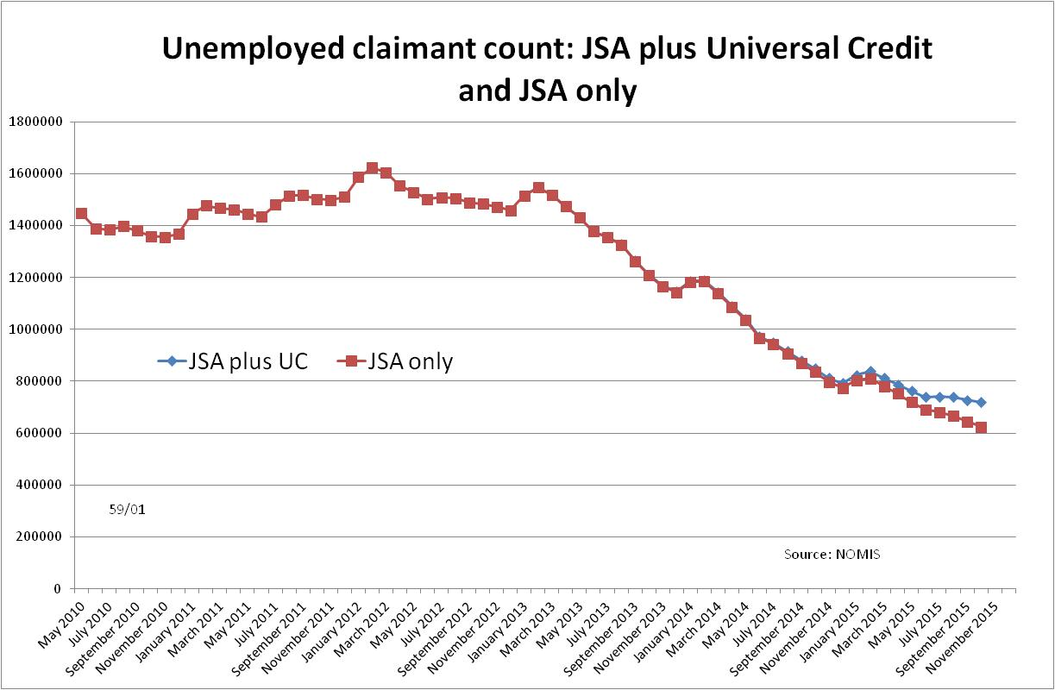
Figure 2
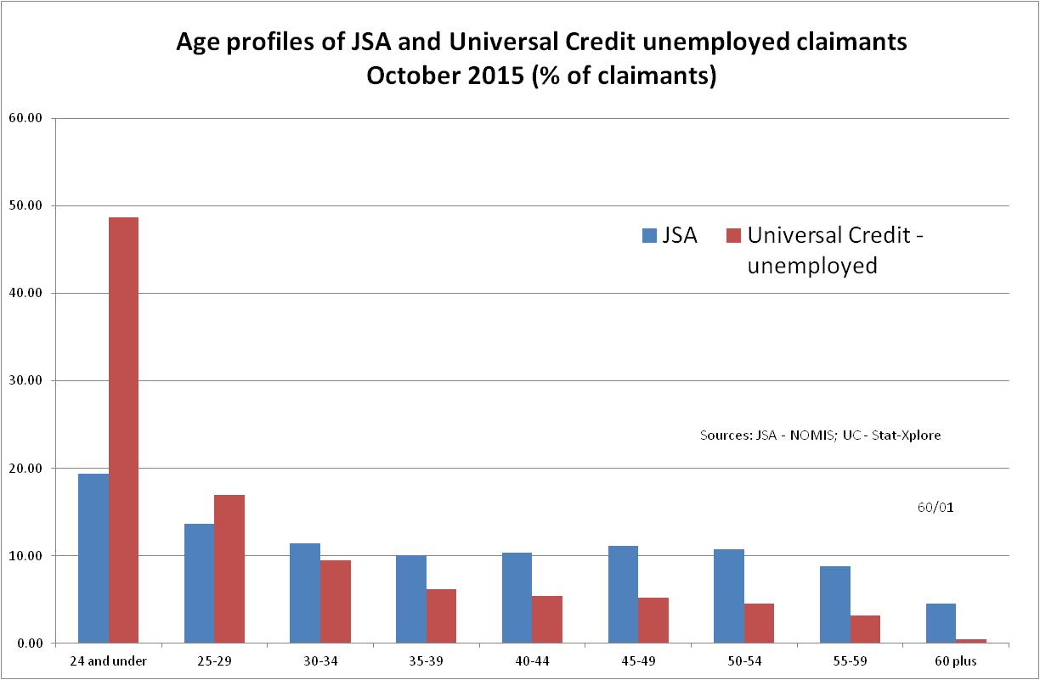

Figure 3
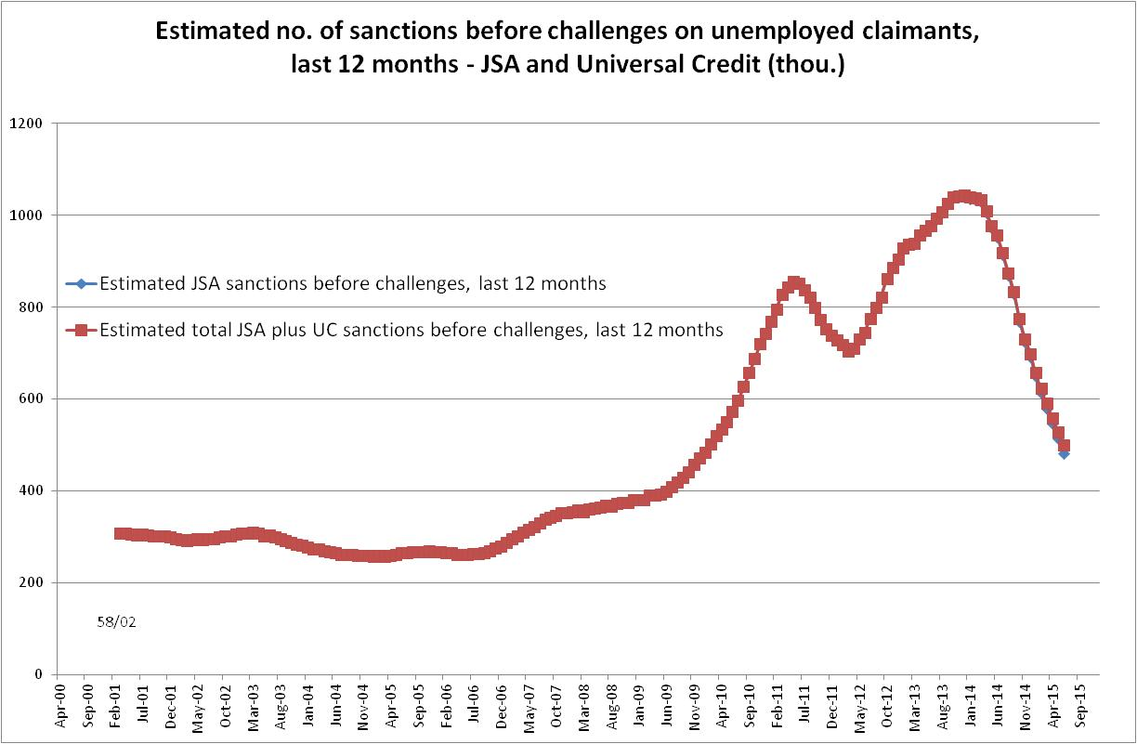

Figure 4
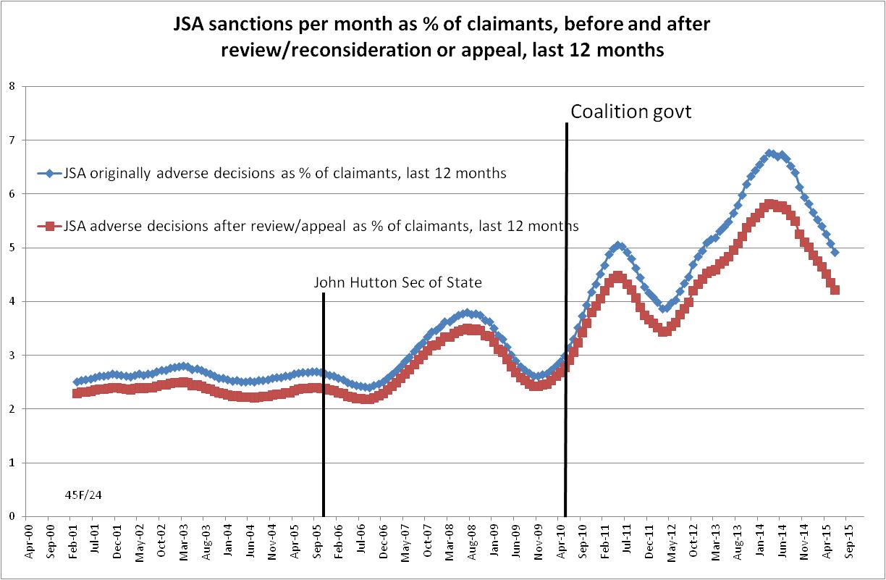

Figure 5
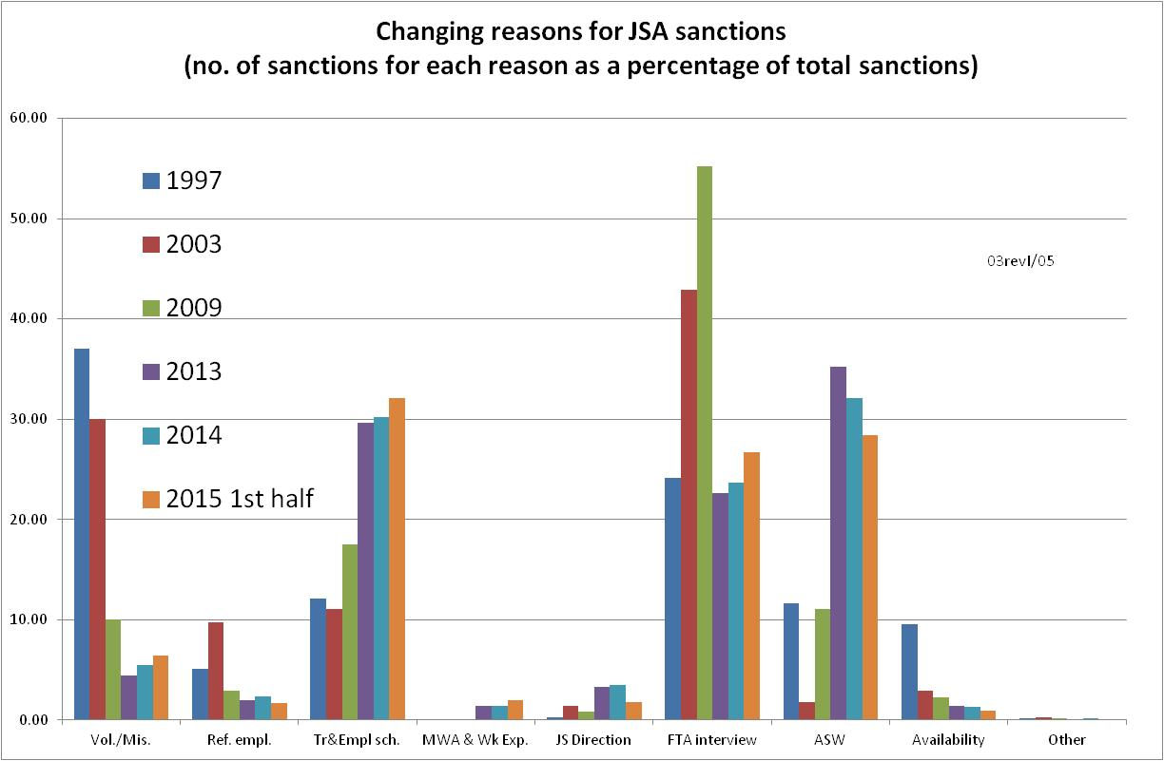

Figure 6
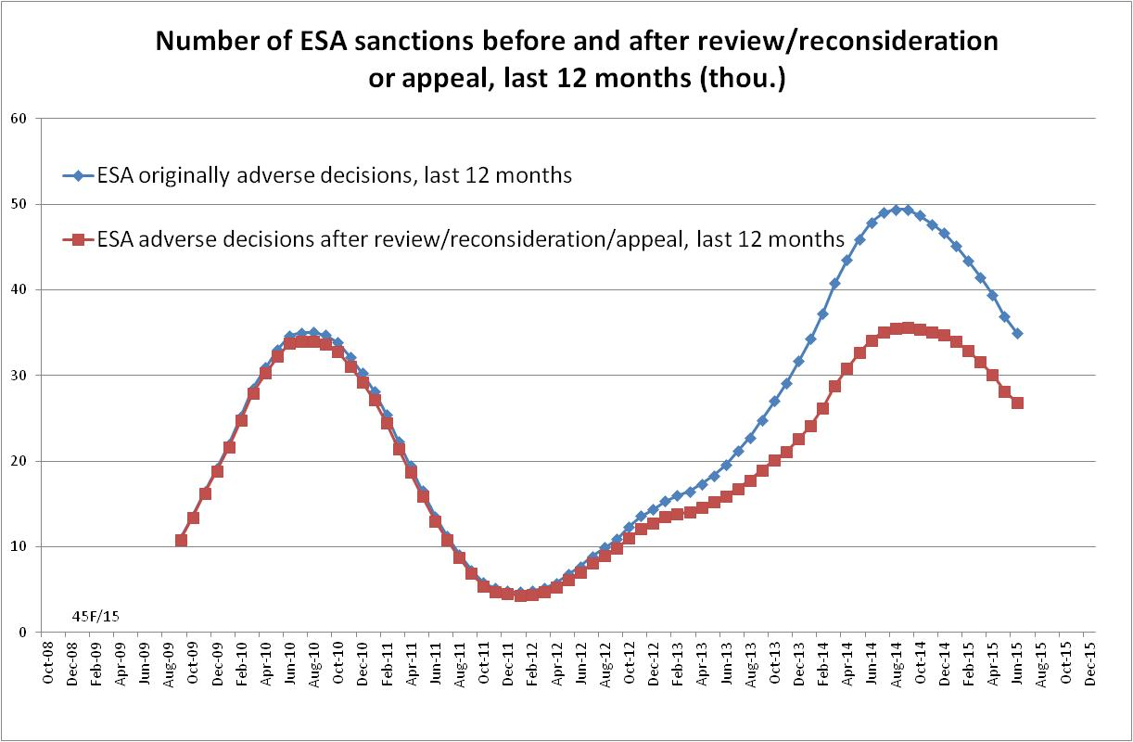
Figure 7
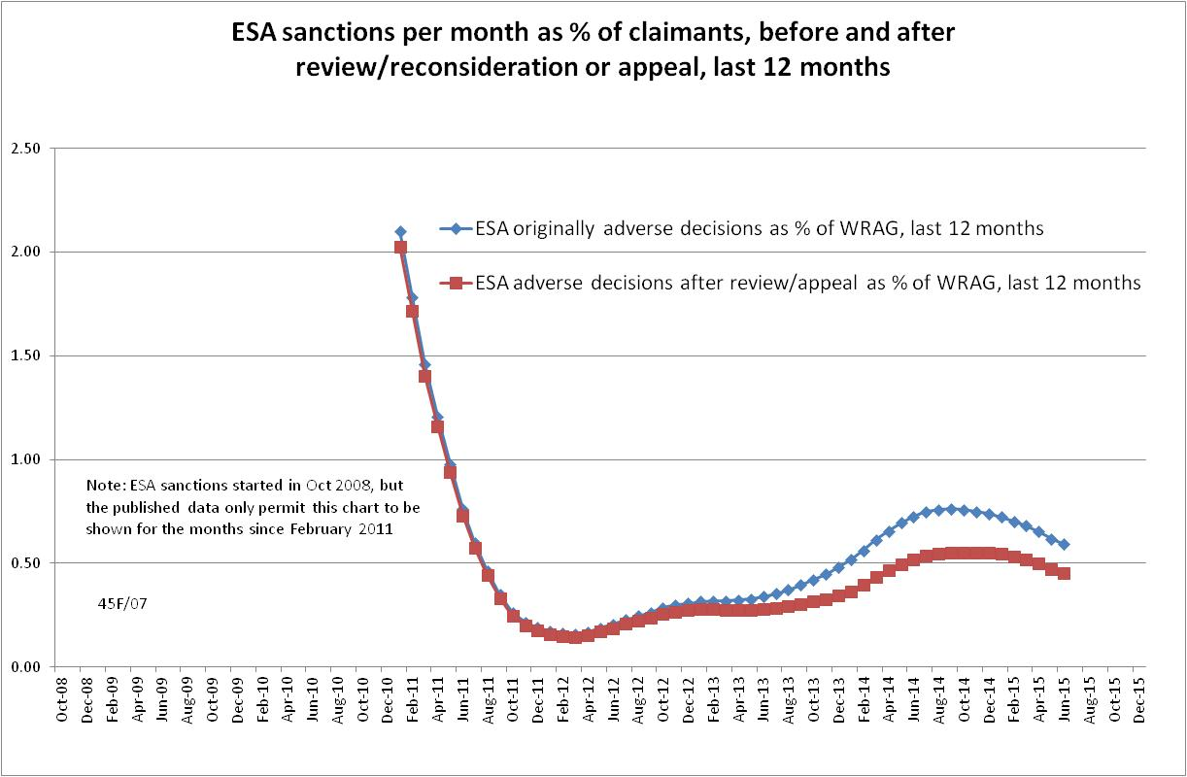
Figure 8 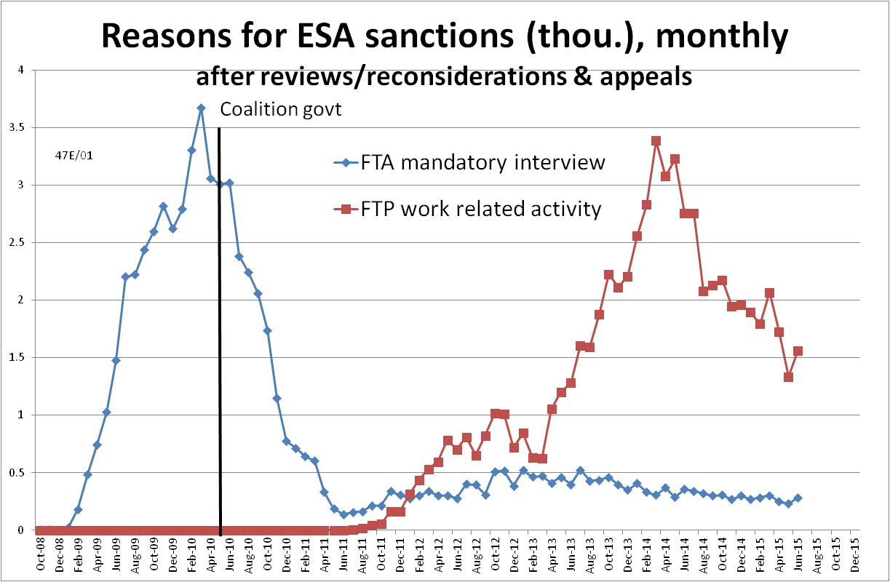
Figure 9
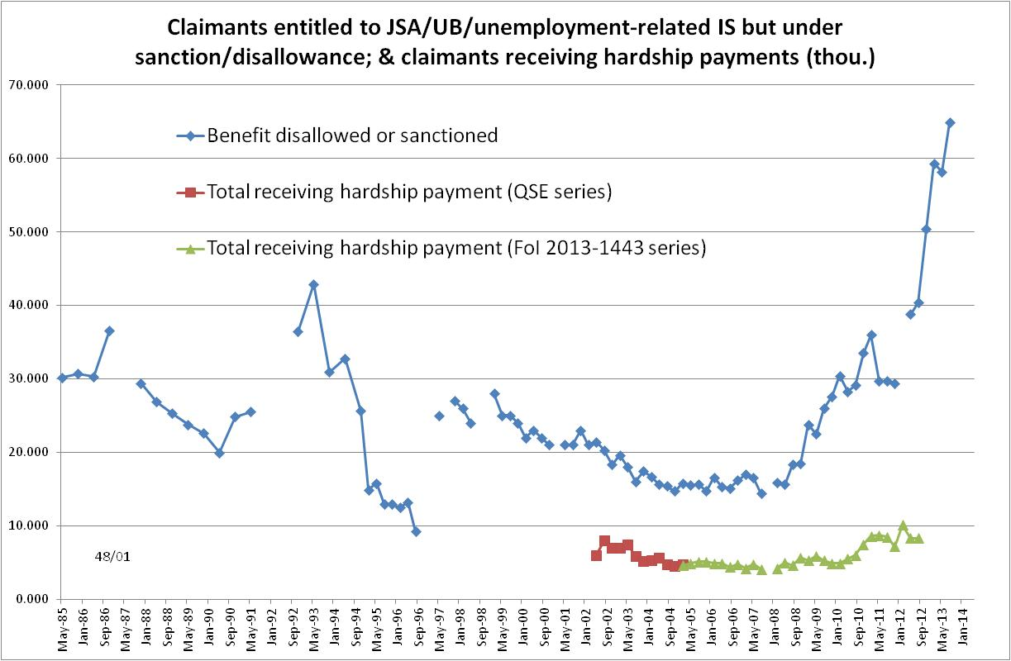
Figure 10
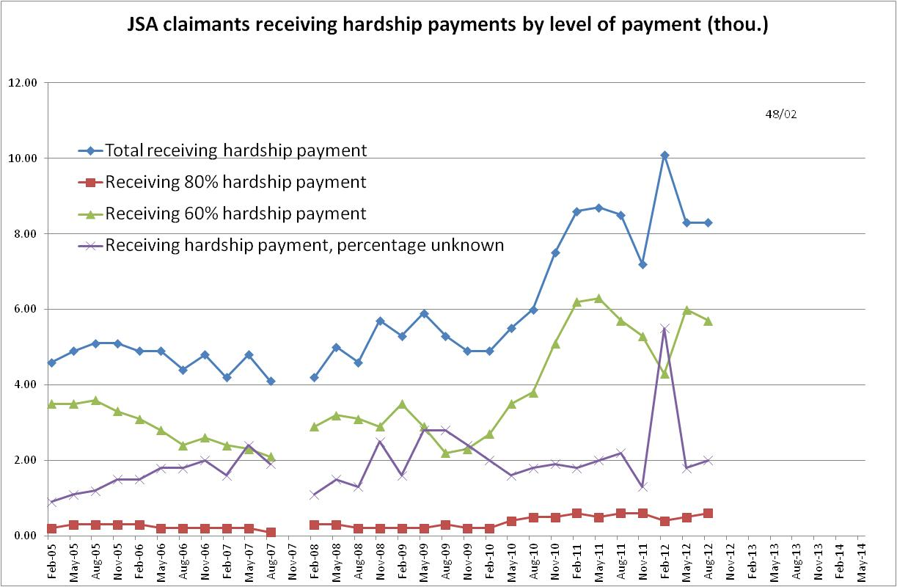

Figure 11
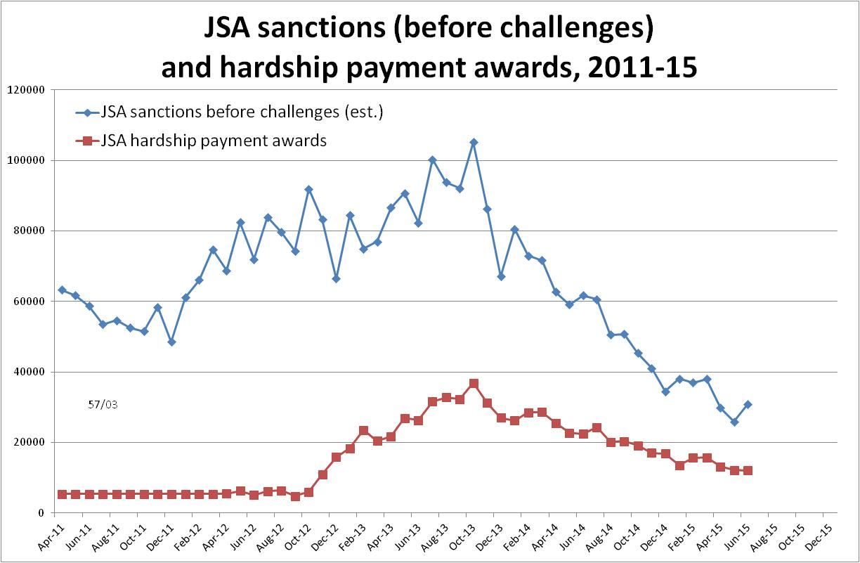

Figure 12
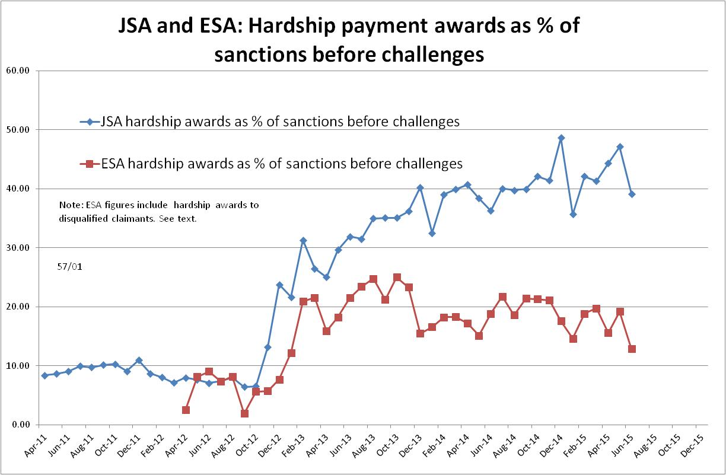

Figure 13
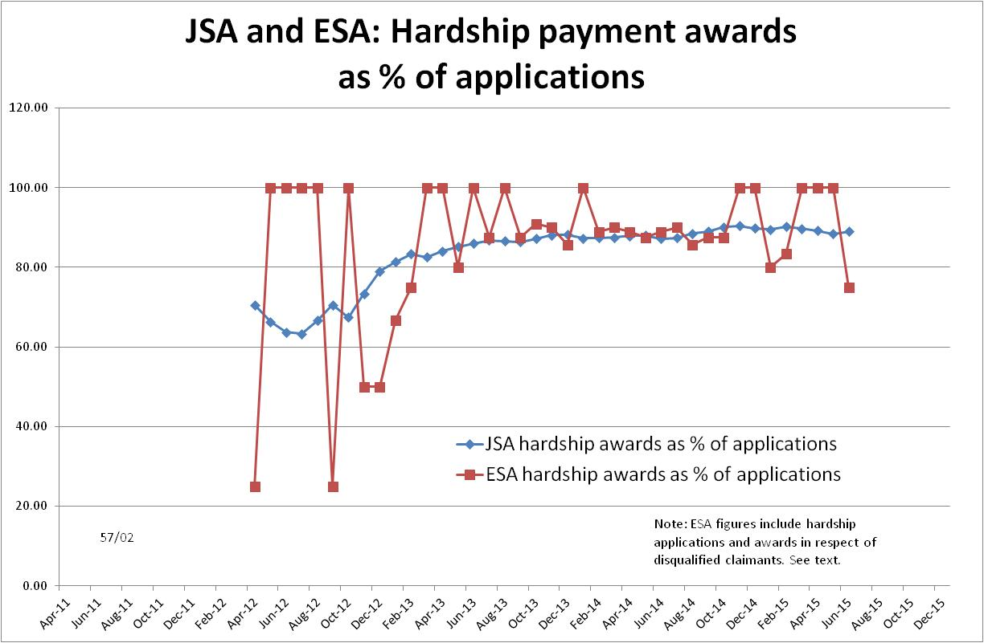

Figure 14
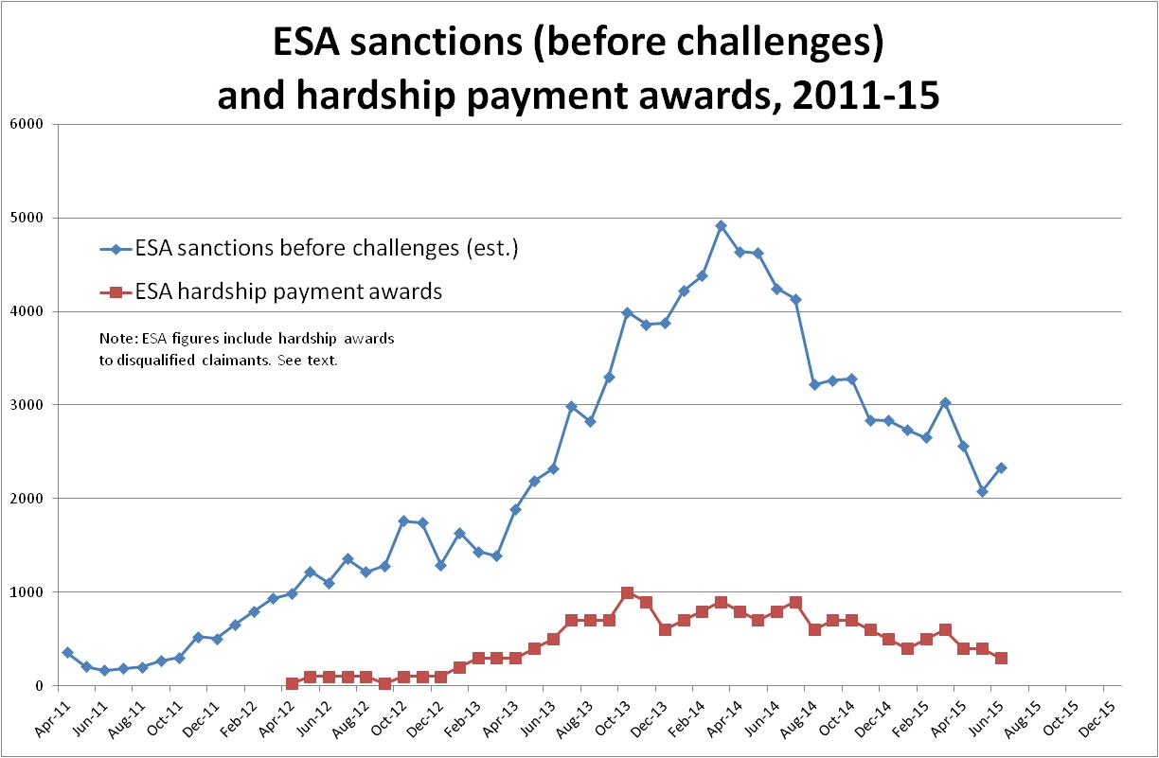
Figure 15
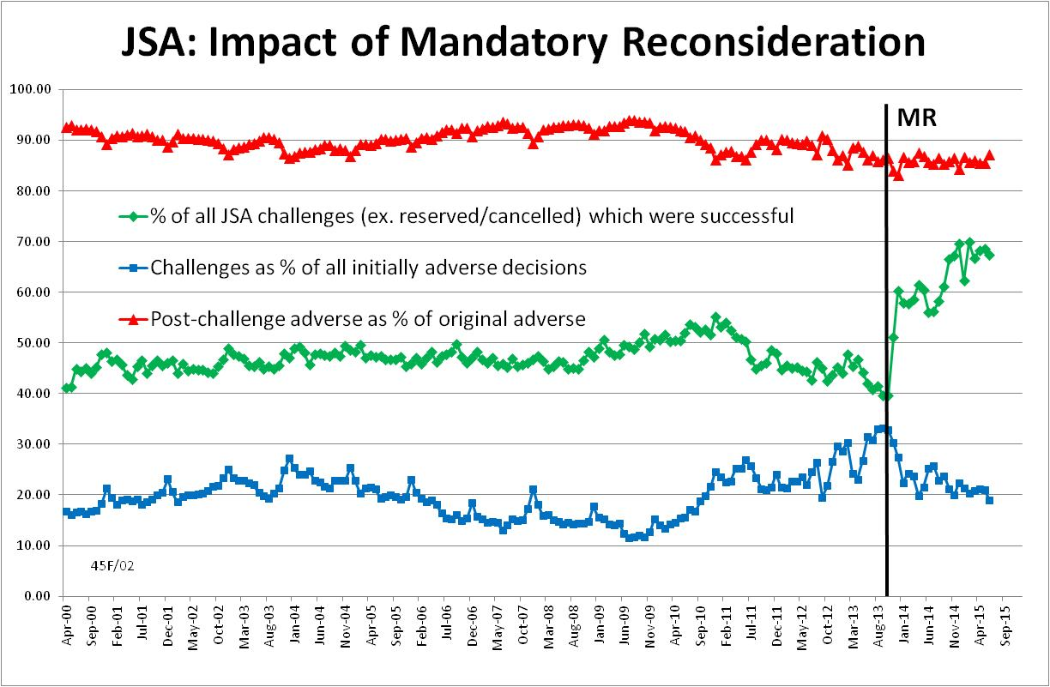
Figure 16
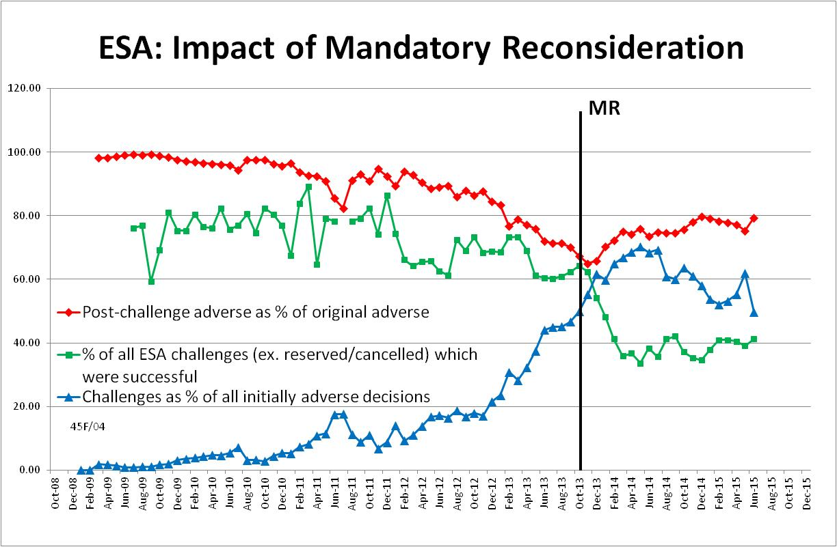

NOTES

This is the ninth in a series of briefings on the DWP’s statistics on Jobseeker’s Allowance (JSA) and Employment and Support Allowance (ESA) sanctions. All the briefings are available at http://www.cpag.org.uk/david-webster. Earlier briefings should be read in the light of the DWP’s statistical revisions, because some of their conclusions are no longer valid. However, much of the data and discussion remains useful, particularly because different briefings deal with different topics.
The basic concept of the DWP’s sanctions database is that each sanction case appears only once, and is given its latest status and attributed to the month of the latest decision on the case. So, for instance, if a decision is made in January 2014 to sanction someone, this decision is reviewed in March 2014 with an outcome unfavourable to the claimant, reconsidered in a ‘mandatory reconsideration’ in May 2014 again with an unfavourable outcome, and is heard on appeal by a Tribunal in October 2014 with a decision favourable to the claimant, then: - it appears in the statistics for the first time in January 2014 as an adverse decision - in March 2014 it changes its status to a reviewed adverse decision and moves month to be with all the other cases where the latest decision has been made in March 2014 - in May 2014 it changes its status to a reconsidered adverse decision and moves month to be with all the other cases where the latest decision has been made in May 2014 - in October 2014 it changes its status again to an appealed non-adverse decision, and moves month again to be with all the other cases where the latest decision has been made in October 2014.
Use of the age group structure of the UC claimant population may not fully capture the difference in sanction rates between the UC and JSA claimant populations. This is because the UC claimants have been selected on the basis of their single household status, not their age. However, no data are available on the sanction rates specific to single people, while age is by far the most powerful known correlate of sanction rates.
https://www.gov.uk/government/uploads/system/uploads/attachment_data/file/477328/dwp-stats-summary-nov-2015.pdf, Table 1.3a
The documentation is in correspondence between Jonathan Portes (NIESR) and myself and the UKSA Chair Sir Andrew Dilnot, on the UKSA website at http://www.statisticsauthority.gov.uk/reports---correspondence/correspondence
The estimate of sanctions before challenges has been derived by adding the monthly total of ‘non-adverse’, ‘reserved’ and ‘cancelled’ decisions shown as being the result of reviews, mandatory reconsiderations and tribunal appeals, to the monthly total of adverse ‘original’ decisions. The estimate of UC sanctions for each month has been derived by applying the age-specific pre-challenge sanction rate for each age group shown in the data for JSA sanctions to the corresponding age group in the population of UC claimants. The population for each age group of UC claimants has been derived by applying the percentage composition of the UC claimant population in October 2015 shown in Stat-Xplore to the total of UC claimants for each month shown in NOMIS.
More detail is given in the earlier Briefing of 2 March 2015 at http://www.cpag.org.uk/david-webster.
The Oakley report (2014, p.33) highlighted the fact that claimants were often not being told about hardship payments. In relation to speed of payment, the government told the Work and Pensions Committee (Report, 24 March 2015, para. 146) that it had ‘sped up’ the hardship payment process as from 14 July 2014 to ensure that claimants receive payment within three days. This implies that it was previously taking longer.
The sources for Figure 9 are as follows. For claimants under sanction: 1985-96: DSS Unemployment Benefit Statistics (various titles); Nov 1997 & Feb 1999: Social Security Statistics; May 2001 - Feb 2005: JSA Quarterly Statistical Inquiry; other data points: DWP FoI Response 2014-614, 5 March 2014. For claimants receiving hardship payments: May 2002 - Feb 2005: JSA Quarterly Statistical Enquiry; May 2005 - Aug 2012: DWP FoI Response 2013-1443, 26 April 2013.
The source for Figure 10 is DWP FoI Response 2013-1443, 26 April 2013.
DWP, The number of hardship awards in 2011/12, September 2012, available at https://www.gov.uk/government/uploads/system/uploads/attachment_data/file/222972/hardship_adhoc_2011_2012.pdf The contents of the ad hoc release of September 2012 were repeated in a Parliamentary Answer of 21 January 2015.
The figures for hardship payment show the actual month of the award. For 2011/12 the 64,000 figure for the whole year has been divided by 12 to give an estimated monthly figure. The estimated figures for sanctions before challenges are as given in the author’s regular quarterly statistical briefings. They are approximate because of the way the DWP database records cases. However this does not affect any substantial trends in the data.
http://www.parliament.uk/documents/commons-committees/work-and-pensions/Correspondence/Letter-to-Iain-Duncan-Smith-regarding-DWP-response-to-sanctions-report-29-10-15.pdf
http://www.parliament.uk/documents/commons-committees/work-and-pensions/7.%20Letter%20from%20Iain%20Duncan%20Smith%20to%20Chair.pdf
https://www.gov.uk/government/speeches/chancellor-george-osbornes-spending-review-and-autumn-statement-2015-speech
The Autumn Statement itself (para.1.129) says ‘1.3 million’.
http://www.osscsc.gov.uk/Aspx/view.aspx?id=4628
The sanction will have been for 4 weeks if it was a first ‘failure’ or 13 weeks if it was a ‘second or subsequent failure’. As the claimant had children, he will have been entitled to apply for hardship payments from day one but he will not have got them unless he met the criteria. So, for instance, he would have been expected to use up any savings, e.g. for future needs of his children, before being given a hardship payment.
http://www.publications.parliament.uk/pa/cm201516/cmhansrd/cm151027/debtext/151027-0001.htm#15102736000001
http://www.scottish.parliament.uk/parliamentarybusiness/CurrentCommittees/46341.aspx
http://www.theguardian.com/film/2015/nov/23/ken-loach-benefit-sanctions-jeremy-corbyn-food-banks

