BRIEFING:

The DWP’s JSA/ESA Sanctions Statistics Release, 18 May 2016

31 May 2016

Dr David Webster
Honorary Senior Research Fellow
Urban Studies
University of Glasgow

Email david.webster@glasgow.ac.uk

Webpages: http://www.gla.ac.uk/schools/socialpolitical/staff/davidwebster/
http://www.cpag.org.uk/david-webster

SUMMARY

This release gives complete figures for the calendar year 2015. Numbers of JSA and ESA sanctions have both continued to fall. The best estimate of the number of sanctions in 2015 against unemployed people (via JSA and Universal Credit), before challenges, is 358,000. There were an estimated 24,500 ESA sanctions, before challenges. An estimated 50,000 JSA sanctions and 6,200 ESA sanctions (and an unknown number of UC sanctions) were overturned in 2015 via reviews, reconsiderations or appeals. In these cases the claimant’s payments will have been stopped for weeks or months only to be refunded later.

The main reason for the fall in JSA sanctions is the fall in JSA claimants, of 49% between 2013 and 2015. But there has also been a large fall in JSA sanctions as a percentage of unemployed claimants. The monthly rate of JSA sanctions before challenges may be stabilising at about 3.5%. This is about the rate inherited by the Coalition government in May 2010. Sanctions have usually run below this; the average for the whole period from 2000 to 2010 under the Labour government was 2.81%. Since 2012, sanctions are much more severe and so the total loss of benefits imposed on the unemployed remains much greater than suggested by the numbers of sanctions alone.

The fall in ESA sanctions partly reflects a continuing decline in the size of the WRAG, but ESA sanctions have also declined modestly as a percentage of claimants. In 2015 the average monthly rate was 0.43% before challenges. The decline appears to be continuing but slowing.

In 2015 the main reasons for JSA sanctions remained non-participation in the Work Programme, ‘not actively seeking work’ (usually a misnomer) and not attending an interview, in that order. Conservative ministers have particularly driven up sanctions for the former two reasons. Four-fifths of ESA sanctions are for non-participation in work-focused activity.

For each calendar year 2001 to 2015, a new analysis gives the average number of sanctions, after challenges, imposed during the year on those individuals who were sanctioned at all. For JSA, this number ran at about 1.2 until 2009, but climbed markedly to peak at almost 1.58 in 2013 before falling back to 1.46 in 2015. For ESA, the initial level was about 1.1, but after 2011 it climbed rapidly to peak at 1.64 in 2014, and was still at 1.55 in 2015. These figures show that under Conservative ministers, sanctions have come to be concentrated much more on a group of repeatedly sanctioned individuals. DWP does not produce any figures on the numbers of longer sanctions which are imposed for repeated ‘failures’ within 12 months.

The proportion of JSA sanctions challenged has risen slightly, to about 24%, while the proportion of challenges which are successful has continued to rise, to over 75% in the final quarter of 2015. As a result the proportion of JSA sanctions overturned is now about 19% or almost one in five. For ESA, the proportion of sanctions challenged is around 50%, the proportion of challenges which are successful is just over 50%, and the proportion of sanctions overturned is a little over 25%.

The DWP has made a sort of response to the UK Statistics Authority’s recommendations of August 2015, but as yet has done little to meet them. The state of play on each of the UKSA recommendations is summarised in the Briefing.

A news section at the end of the Briefing gives information about other developments relating to sanctions. The sanctions scene continues to be eventful.
BRIEFING: The DWP’s JSA/ESA Sanctions
Statistics Release, 18 May 2016

Introduction

This briefing deals with the regular quarterly Jobseekers Allowance (JSA) and Employment and Support Allowance (ESA) sanctions data released on 18 May, which include figures for the further three months October to December 2015. Excel spreadsheet summaries of these statistics are available at https://www.gov.uk/government/collections/jobseekers-allowance-sanctions and the full dataset is in the Stat-Xplore database at https://stat-xplore.dwp.gov.uk/default.aspx.

All statistics relate to Great Britain.

Sanctions before and after reviews, reconsiderations and appeals

The DWP’s database only shows sanctions after any reviews, reconsiderations and appeals that have taken place by the time the data are published., But numbers of sanctions before the results of these challenges are important since they show all the cases in which claimants have had their money stopped. Although a successful challenge should result in a refund, this is only after weeks or months by which time serious damage is often done. Estimates of sanctions before challenges are therefore given here but although reliable for longer time periods, they are not fully accurate for individual months, as explained in earlier Briefings. Figures for sanctions before challenges are currently higher than the ‘after challenge’ figures by about 18% for JSA and 34% for ESA.

Universal Credit and Universal Credit sanctions

All new single claimants of unemployment benefits are now put on to Universal Credit (UC) instead of JSA, together with, since January 2015, claimants with families in the north west region. Statistics for UC on claims, starts and numbers claiming now appear on Stat-Xplore. But no statistics have been published on UC sanctions, and no date has been given for them. This has a significant distorting effect on the analysis of JSA sanctions, because the number of claimants at risk of JSA sanctions is being reduced. The distortion is amplified because single claimants are disproportionately young, and young people are sanctioned at double the rate of other people.

A full assessment of the distortion was contained in the November 2015 Briefing, and will be updated in a future Briefing. The present briefing includes approximate estimates of the scale of the distortion. The figures for ESA sanctions are unaffected since no ESA claimants have been transferred to UC.

The UC regime has similar lengths of sanction to those of JSA for the various ‘failures’, but there are some critical differences. Sanctions are lengthened by being made consecutive, not concurrent. Under Universal Credit hardship payments become repayable. Given that repayments are made at the rate of 40% of benefit – the same as the amount by which a hardship payment is lower than the benefit – this means that for claimants receiving hardship payments, UC sanctions are in effect 3½ times as long as their nominal length. All sanctioned UC claimants must also demonstrate ‘compliance’ for 7 days before applying for hardship payments, and must reapply for each 4-week period. The 80% hardship rate for ‘vulnerable’ claimants is abolished.

Impact of declining numbers of claimants

A fall in the number of claimants means a fall in the number of sanctions, other things being equal. The number of JSA claimants has been falling because of the labour market recovery and transfers to UC. By December 2015 it had fallen to 591,892, from a monthly peak of 1,547,585 in February 2013. At December 2015 the number of unemployed people on UC was 96,358, excluding UC claimants in the digital ‘full service’ areas which at that date were Sutton, Croydon and Southwark. The total of unemployed claimants of either JSA or UC at December 2015 was therefore about 690,000, of whom around one in seven was not having any sanctions reported in any statistical system.

The number of ESA claimants exposed to sanctions – those in the Work Related Activity Group (WRAG) – is also continuing its long decline. The WRAG peaked at 0.563m in August 2013 but has since fallen every quarter until reaching 0.454m in November 2015 and an estimated 0.450m in December 2015. The fall is mainly because an increasing proportion of ESA claimants are being put into the Support Group rather than the WRAG. It is worth noting that there has recently been a very large reduction in the number of people in the ‘assessment’ phase of an ESA claim. A growing backlog of assessments had caused this figure to peak at 0.546m in August 2014, but in November 2015 it had fallen to 0.370, with a particularly large fall of 62,000 between August and November 2015 alone.

UK Statistics Authority recommendations to DWP on sanctions statistics

As explained in previous briefings, the UK Statistics Authority (UKSA) in August 2015 made recommendations to the DWP for improvements to the sanctions statistics. On 19 April, DWP published an updated Benefit Sanction Statistics Publication Strategy, at https://www.gov.uk/government/publications/benefit-sanction-statistics-publication-strategy/benefit-sanction-statistics-publication-strategy As far as is known, this is the closest that DWP has come to a response to the UKSA’s recommendations. It does little to meet them. The state of play on each of the UKSA recommendations is now as follows:

- Provide users with benefit sanction statistics based on the actual number of sanctions applied, making clear the numbers of reviews, reconsiderations and appeals. This would involve substantial modifications to the DWP’s systems, so it would be unrealistic to expect immediate change. However, the DWP is currently not proposing any action at all. As noted in this Briefing, failure to give the number of original sanctions results in a large understatement of the number of cases in which people actually lose money.
- Make clear the limitations associated with the statistics. There have been some minor improvements to metadata but to date nothing that would prevent the major misrepresentations of the sanctions regime which characterise public debate.
- Include in the quarterly benefit statistics bulletin a statement of the proportion of JSA claims subject to a sanction, as well as the proportions of claimants who have been sanctioned during the most recent one-year and five-year periods, and the numbers on which these proportions are based. The DWP could very easily provide this information in its quarterly releases, since it already has the necessary algorithms. However it is still not doing so, leaving users with the need to put in regular Freedom of Information requests, whose responses never achieve the degree of exposure achieved by the regular statistics. In fact the new DWP Strategy proposes a worsening of the position. For sanctions imposed on lone parents claiming receiving Income Support (those with the youngest children), it currently publishes a quarterly bulletin Income Support Lone Parents Regime: Official Statistics, at https://www.gov.uk/government/collections/income-support-lone-parent-regime-figures-on-sanctions-and-work-focused-interviews--2 This currently does provide a figure showing the percentage of all lone parent IS claimants during the year who were sanctioned – in 2014/15 this was 6.0%. DWP now proposes to bring these lone parent IS figures into the same statistical release as for JSA and ESA sanctions, but on the same basis as for JSA and ESA, i.e. only the monthly rate of sanction will be shown. The DWP states ‘We don’t currently publish any information on the likelihood of a claimant being sanctioned, although we are considering how this could be done.’ The UKSA’s recommendations for publication of annual and five-yearly proportions of claimants sanctioned have simply been ignored.
- Ensure all statements made using the official statistics are objective and impartial and appropriately apply the definitions of the variables underpinning the data, including ‘actively seeking work’. DWP has done nothing to correct its misdescription of claimants who have not complied with every single instruction on the detail of their work search as ‘not actively seeking work’. Otherwise, the only unreasonable DWP comment on the statistics that I have noticed recently comes in the Quarterly Benefits Summary - Great Britain statistics to November 2015 at https://www.gov.uk/government/statistics/dwp-statistical-summaries-2016 which states (p.9) ‘The recent fall in JSA sanction decisions coincides with lower numbers of JSA claimants joining the Work Programme.’ While this is true as far as it goes, it overlooks the fact, shown in Figure 6 of this Briefing, that sanctions under Jobcentres’ complete control, such as those for ‘not actively seeking work’, have declined just as steeply. The intent of all the DWP’s comments on the statistics appears to be to deny that the dramatic changes in the intensity of sanctioning seen in recent years have been straightforwardly due to undeclared policy decisions by DWP ministers, using the absolute control of sanction decisions given to the Secretary of State by the Social Security Act 1998.
- Extend the range of benefit sanction data available by addressing the gaps in information on repeat sanctions and hardship payments, alongside the development of sanction data from the Universal Credit system. DWP published ad hoc hardship payment data to June 2015 on 18 November 2015 (see the November 2015 Briefing), but has given no indication of when there will be any update. DWP has promised to publish UC sanctions data in the future, but has given no date. There are no proposals to improve the data on repeat sanctions, and in particular no proposals to address the astonishing gap whereby DWP does not record the date of each sanction ‘failure’ and therefore cannot produce any data on the heavier penalties which are applied for second or subsequent failures within 12 months.
The DWP has invited comments on its Benefit Sanction Statistics Publication Strategy: ‘If you have any views on the type of statistics you would like to see available on Sanctions or you have any comments on this publication strategy, please get in touch with us at: Stats-consultation@dwp.gsi.gov.uk ’ . I have written a blog about sanctions statistics and the UK Statistics Authority at http://www.welfareconditionality.ac.uk/2016/04/guest-blog-tackling-britains-misleading-benefit-sanctions-statistics/
Numbers and rates of sanctions against unemployed people
The estimated total number of JSA sanctions before challenges in 2015 was 325,000. This is a fall of 69% from the peak of 1,041,000 in 2013. If Universal Credit sanctions against unemployed people are running at the same rate as for JSA, they would add approximately a further 33,000, making an estimated total of 358,000 for 2015. This compares with only 274,884 JSA sanctions after challenges reported for the same period in Stat-Xplore.

The main reason for the fall in JSA sanctions is the fall in JSA claimants, of 49% between the averages of 2013 and 2015. But there has also been a large fall in JSA sanctions as a percentage of unemployed claimants. On an annual basis, the rate of JSA sanctions has fallen from peaks of 6.76% per month before challenges and 5.83% after in the 12 months to March 2014, to 3.83% and 3.24% respectively in the 12 months to December 2015 (Figure 1). The monthly data (Figure 2) suggest that the monthly rate of JSA sanctions before challenges may be stabilising at about 3.5%. This is about the same as the monthly rate inherited by the Coalition government in May 2010, and below the annual peak (3.81%) reached during the sanctions drive initiated by John Hutton as Secretary of State as part of the JSA ‘relaunch’ of April 2006. However, sanctions have usually run at well below this rate; the average for the whole period from 2000 to 2010 under the Labour government was 2.81%. Since 2012, sanctions are of course much more severe and so the total loss of benefits imposed on the unemployed remains very much greater than suggested by the numbers of sanctions alone.

The decline in the monthly rate of JSA sanctions dates from approximately the time of the Call for Evidence for the Oakley Review of sanctions in November 2013. It appears possible that the greater public scrutiny of sanctions policy brought about by the review has influenced the behaviour of DWP ministers and officials.

Numbers and rates of ESA sanctions

ESA sanctions are not affected by any of the estimation problems relating to Universal Credit, since no ESA claimants have been transferred to UC. Total ESA sanctions have now also fallen, to 24,500 before challenges and 18,315 after in 2015 (Figure 3). This compares with peaks of 49,400 before challenges in the 12 months to August 2014 and 35,514 after challenges in the 12 months to September 2014. The fall partly reflects the continuing decline in the WRAG, but as a percentage of ESA WRAG claimants, sanctions before challenges have also declined modestly, both before and after challenges (Figure 4). These figures peaked at 0.76% in August to October 2014 and 0.55% in September to December 2014. In 2015 the average monthly rate was 0.43% before challenges and 0.32% after. Figure 4 suggests that the decline in the ESA sanctions rate is continuing but slowing down.

Sanctions overturned following challenge

An estimated 50,000 JSA sanctions and 6,200 ESA sanctions were overturned in 2015 via reviews, reconsiderations or appeals. This is a total of 56,200 cases where the claimant’s payments will have been stopped for weeks or months only to be refunded later. This figure peaked at 153,600 in the year to March 2014. No information is available on any aspect of UC sanctions, including challenges.

Reasons for JSA sanctions

Figure 5 shows the proportion of sanctions, after challenges, which were imposed for each main type of reason in 2015 and in earlier years (1997 – first full year of JSA; 2003 – trough of sanctions under the Labour government; 2009 – last full year of the Labour government; 2013-15 – most recent three years of the Coalition/Conservative government). Conservative ministers have particularly driven up sanctions for non-participation in training and employment schemes (which in their case means almost exclusively the Work Programme) and for ‘not actively seeking work’ (ASW), while only maintaining and even recently reducing sanctions for non-attendance at interviews. Historically, voluntarily leaving a job or losing it through misconduct was almost the only reason for disqualification from unemployment benefit, but this is now relatively uncommon. All the other reasons for sanction are relatively minor in numerical terms.

Figure 6 shows monthly JSA sanctions before challenges for the ‘big three’ reasons (ASW, training/employment schemes and interviews), as a percentage of claimant unemployed. In all three cases, there had already been increases above the long-term level as a result of John Hutton’s JSA ‘relaunch’ under the previous Labour government. The Coalition government inherited a relatively high rate of sanctions for non-attendance at interviews, about 1.5% per month, and did not change it much. But it massively increased sanctions for non-participation in training schemes and ‘not actively seeking work’, from around 0.5% per month to a peak of over 3.0%, six times higher.

Reasons for ESA sanctions

Figure 7 updates the reasons for ESA sanctions, after challenges. The big rise and subsequent fall in ESA sanctions since the spring of 2013 have been due to changes in sanctions for ‘failure to participate in work related activity’, while sanctions for not attending work-focused interviews have been gently and steadily declining. ‘Failure to participate in work related activity’ now accounts for four-fifths of ESA sanctions.

As in previous Briefings, the upturn in sanctions for ‘failure to participate in work related activity’ in the latest two months is probably not significant. Challenges to sanctions for this reason appear to take a particularly long time to be settled, so that even though the most recent sanctions were imposed 5 months prior to publication of the statistics, there are still many cases included in the ‘adverse’ category for the most recent months which will appear as ‘non-adverse’ in the next set of statistics. Figure 5 in the May 2015 Briefing illustrated this by showing the sanctions for the same quarters as published in six successive statistical releases. This showed that there is always an upturn in the most recent quarters which then usually disappears in subsequent releases. However, what this analysis does show is how long many ESA claimants have to wait to get their money refunded, with consequent distress.

The proportion of JSA and ESA claimants who are sanctioned

No update is available on the proportion of claimants who are sanctioned during a given period. Freedom of Information response 2015-2187 of 16 February 2016 showed that in the 12 months to 30 June 2015, excluding sanctions successfully challenged, 284,436 individuals were sanctioned out of 2,206,160 individuals who claimed JSA at any time during the year. This is 12.9%. A full series of figures back to 2007/08 was given in the February 2016 Briefing.

Over a five year period, the percentage of JSA claimants sanctioned (after challenges) is even greater. The most recent available figure is 22.3% for 2009/10 to 2013/14 inclusive published in FoI response 2014-4972.

FoI response 2015-2187 also revealed that during the 12 months to 30 June 2015 the number of individual ESA claimants sanctioned, after challenges, was 15,949, out of 544,770 individuals who were in the WRAG at any point during the year. This is 2.9%.

If sanctions imposed but subsequently overturned were included, all the above figures would be higher.

Repeat sanctions – JSA and ESA

In spite of claims that claimants ‘learn’ from sanctions, repeated sanctions on the same individuals are very common. FoI response 2015-2187 showed that of the 284,436 JSA claimants sanctioned during 2014/15 (1 July to 30 June), one quarter (24.4%) were sanctioned more than once during the year, and just under one in ten (9.0%) was sanctioned three times or more. 1,042 JSA claimants were sanctioned ten times or more. Of the 15,949 ESA claimants sanctioned, over one quarter (27.8%) were sanctioned more than once during the year, and just over one in eight (13.1%) was sanctioned three times or more.

For each calendar year 2001 to 2015, Figure 8 gives the average number of sanctions imposed during the year on those individuals who were sanctioned at all. For JSA, this number ran at 1.2 or slightly above until 2009, but with the arrival of the Coalition climbed markedly to peak at almost 1.58 in 2013 before falling back to 1.46 in 2015. For ESA, the initial level at launch of the benefit was about 1.1, but after 2011 it climbed rapidly to peak at 1.64 in 2014, and was still at 1.55 in 2015.

These figures show that under Conservative ministers, sanctions have come to be concentrated much more on a group of repeatedly sanctioned individuals. This is a matter of concern because of the likely cumulative effect in destroying people’s resilience. Because the DWP does not record the basic information about the date of alleged ‘failures’, it cannot produce any figures on the numbers of longer sanctions which are imposed for repeated ‘failures’ within 12 months, but obviously the more repeat sanctions there are, the more longer sanctions there will be too.

These figures understate the numbers of repeat sanctions on the same individuals because they exclude sanctions implemented but overturned following challenge, and because many claimants’ claims, particularly those for ESA, last for longer than a year.

Adverse decisions as a proportion of referrals, and cancelled and ‘reserved’ referrals

Analyses of these issues contained in the February 2016 and August 2015 Briefings are not repeated here.

JSA and ESA hardship payments

The ad hoc statistics on hardship payments released by DWP on 18 November 2015 were fully analysed in the November 2015 Briefing. No further information is available.

JSA and ESA sanction challenges

Figures 9 and 10 update earlier summaries of the changing performance of the appeal system.

JSA challenges Earlier Briefings noted that the impact of Mandatory Reconsideration, introduced from 28 October 2013, had been to reduce the proportion of JSA sanctions that are challenged, but to increase the proportion of challenges which are successful, leaving the overall proportion of sanctions which are overturned more or less unchanged. The latest figures (Figure 9) show that claimants’ position has improved. The proportion of sanctions challenged has risen slightly, to about 24%, while the proportion of challenges which are successful has continued to rise, to over 75% in the final quarter of 2015. As a result the proportion of JSA sanctions overturned is now about 19% or almost one in five.

There continue to be hardly any JSA sanction Tribunal appeals - only 154 in the latest quarter, compared to a peak of 12,722 in the three months ending August 2013. The success rate of Tribunal appeals remains historically high at 43%, although still lower than the success rate in internal reviews.

JSA ‘decision reviews’ continue to far outstrip formal ‘mandatory reconsiderations’, with 12,020 and 2,914 respectively in the quarter to December.

Far more JSA claimants ought to challenge their sanctions. Not only are their chances of success around 75%, but they are unlikely to have to bother to go beyond the informal review stage to get a positive result.

ESA challenges The impact of Mandatory Reconsideration on ESA sanctions has been that what was a rise in the proportion of sanctions challenged has been halted, while the proportion of challenges which are successful has fallen sharply, the net effect being to lower the proportion of sanctions which are overturned. The latest data (Figure 10) show no real change to this picture. In round terms, the proportion of sanctions challenged is around 50%, the proportion of challenges which are successful is just over 50%, and the proportion of sanctions overturned is a little over 25%.

No ESA sanction appeal cases went to Tribunals in the final quarter of 2015, and the total for 2015 was only 19. For ESA, like JSA, decision reviews continue to far outstrip formal mandatory reconsiderations, with 2,870 and 84 respectively in the quarter to December.
SANCTIONS - OTHER DEVELOPMENTS

National Audit Office study of the DWP's benefit sanctions regime

This study is continuing and will run until the autumn so there is still time to send in relevant information and insights to the inquiry team. The terms of reference are at
https://www.nao.org.uk/work-in-progress/benefit-sanctions. The audit manager is Colin Ross and his email address is Colin.ROSS@nao.gsi.gov.uk. There is a contact form on the NAO webpage.

Iain Duncan Smith video on sanctions

Iain Duncan Smith resigned as Secretary of State on 18 March, having been in charge throughout the great sanctions drive charted in this Briefing. Shortly before, the Camden New Journal website at http://www.camdennewjournal.com/IDS-sanctions published a video (still available) of an unguarded discussion between him and a local Conservative councillor. This was also reported by the Daily Mirror at http://www.mirror.co.uk/news/uk-news/iain-duncan-smith-claims-people-7533615. During the interview, Duncan Smith claims that ‘We haven’t actually changed the sanctions regime’, apparently forgetting both the draconian increases in penalties of the 2012 JSA and ESA regulations and the huge increase in numbers of sanctions. He also says ‘Seventy-five per cent of all those who have been sanctioned say it helped them focus and get on’. On this, the Mirror commented ‘A spokesperson for the DWP was not immediately able to back up Mr Duncan Smith's claim.’ It is incorrect: it was perhaps an inaccurately recalled version of the claim frequently made that ‘Seventy-two per cent of claimants say that they are more likely to follow the rules due to the presence of sanctions’ (see Webster 2014, para.10). Of being sanctioned, Duncan Smith says ‘It really clarifies the mind.’ He also says ‘No one’s sanctioned on the first time.... Every time I look at these cases it’s because the individual has progressively over a period failed to take the right decision.’ This is untrue; there are no DWP procedures to ensure that people are not sanctioned for a first ‘failure’ and it occurs frequently.

Christians’ letter to the new Secretary of State

On 23 March a group of prominent Christians wrote to the new Secretary of State for Work and Pensions Stephen Crabb urging him to rethink current welfare policies, including benefit sanctions. ‘We continue to be extremely concerned about the impact of benefit sanctions on the health of sick and disabled people, particularly those with mental health problems and learning disabilities. It surely cannot be compassionate to leave people with no income to even buy food, simply for missing a Jobcentre appointment. It is distressing to us that individuals and families are forced to turn to foodbanks to survive following a benefit sanction.’ The letter is available in full at http://www.mirror.co.uk/news/uk-news/christians-urge-stephen-crabb-scrap-7617028 and at http://www.thetablet.co.uk/news/5327/0/high-profile-catholics-call-for-stephen-crabb-to-rethink-welfare-policies

I, Daniel Blake wins Cannes Palme d’Or

Ken Loach's film I, Daniel Blake, which features the UK benefit sanctions system, has won the Palme d'Or at the Cannes Film Festival. Loach commented ‘We have to look again at this whole cruel sanctions and benefits system’. It is hoped that I, Daniel Blake will do for unemployed people what Loach’s Cathy Come Home (1966) did for the homeless.
Rowntree report on Destitution in the UK

On 26 April the Joseph Rowntree Trust published a report on destitution in the UK (Fitzpatrick et al. 2016). The report defines destitution as being when someone lacks two or more basic essentials in one month, and so has experienced two or more of the following: slept rough, had one or no meals a day for two or more days, been unable to heat or light their home for five or more days, gone without weather-appropriate clothes or gone without basic toiletries. It estimates that 1.25 million people, including over 300,000 children, were destitute over the course of 2015. Benefit sanctions had been experienced in the last 12 months by 30% of the destitute people in the study’s survey, which was completed by 2,009 users of voluntary sector crisis services in ten UK locations. The often-reported ineffectiveness of the DWP’s ‘hardship payment’ system is confirmed by the finding that none of the 80 sanctioned interviewees in the study reported receiving a hardship payment, and in only two cases had the possibility of such a payment been raised with them (although it appears that the timing of the Rowntree fieldwork was such that the non-informing about hardship payments will sometimes have occurred before the DWP’s claimed improvement in procedures of August 2014, see DWP 2014, p.12). The report also found that the group most at risk of destitution in the UK today is younger single men. They are of course a particular target of benefit sanctions.

Adolescent psychological distress and unemployment

A new study (Egan et al. 2016) relating psychological distress in 2000 to employment experience in 2000-11 has found that highly distressed adolescents were 32% more likely to be unemployed, 26% more likely to be unemployed or out of the labour force, and to have experienced 28% more unemployment. The impact of high distress was similar to a one standard deviation decrease in intelligence, and double the magnitude of having a serious physical health problem. The authors conclude that these findings provide strong evidence of the unemployment penalty of early-life psychological distress and that investing in mental health in early life may be an effective way to reduce unemployment. What is also apparent, although the authors do not say this, is that sanctions, especially in the draconian form they take in the UK, are a wholly inappropriate and irresponsible way of treating people with employment difficulties.

Impact of fear of losing benefit on people with mental health problems

A YouGov survey of over 1,500 people who had used mental health services in the last two years, commissioned by Mind, has revealed that almost half (46 per cent) of people with mental health problems have considered or attempted to end their own lives as a result of social factors such as debt, housing and welfare problems, or relationship breakdown, in the last two years. Of those who had considered or attempted suicide, 29 per cent cited the fear of losing, or the loss of welfare benefits. More details are at http://www.mind.org.uk/news-campaigns/news/one-in-two-people-with-mental-health-problems-have-felt-suicidal-because-of-money-housing-or-benefits-issues/

The impact of benefit sanctions in Derbyshire

A group of local authorities and voluntary sector organizations under the umbrella Financial Action and Advice Derbyshire has produced a report on the impact of benefit sanctions in Derbyshire (Leedham 2016). It adds to the overwhelming weight of evidence on the damaging effects of sanctions already to be found at http://www.cpag.org.uk/content/sanctions and in the evidence to the two House of Commons Work and Pensions Committee inquiries (2014 and 2015).

Work and Pensions Committee report on In-Work Progression

The House of Commons Work and Pensions Committee published its report on In-work Progression in Universal Credit on 11 May, at http://www.publications.parliament.uk/pa/cm201516/cmselect/cmworpen/549/549.pdf.

The report does not criticise the extension of state interference in the form of financial sanctions to an estimated 1.3m further people, although critical evidence was received and is available on the website at http://www.parliament.uk/business/committees/committees-a-z/commons-select/work-and-pensions-committee/inquiries/parliament-2015/universal-credit-15-16/publications/ (it may be necessary to click on ‘+ View all’ under ‘Written evidence’). The report does comment that ‘The case for in-work conditionality backed up by financial sanctions is so far untested’ and that ‘no one has presented us with evidence of such a reform being operated anywhere else in the world’.

The report contains the unfortunate comment that ‘Employed people self-evidently do not lack the motivation to work and we would therefore expect the use of financial sanctions for in-work claimants to be on a different scale to those imposed on out-of-work claimants’. There are two things wrong with this. First, the implication that unemployed people lack the motivation to work. Second, the assumption that the level of sanctions is determined by claimant behaviour. Since the Social Security Act 1998, which abolished independent adjudication, the level of sanctions has been mainly determined by how much pressure ministers want to put on unemployed people, and partly by administrative issues, but hardly at all by claimant behaviour. This is evident from Figures 1 and 2 of the present Briefing, which show clearly the JSA sanctions drives initiated by John Hutton and particularly by Iain Duncan Smith.

Further ‘Poundland’ ruling

On 29 April the Court of Appeal rejected the government’s attempt to overthrow the finding of the High Court that the retrospective Jobseekers (Back to Work Schemes) Act 2013 is incompatible with human rights law. This means that unless the government wins a further appeal to the Supreme Court, it will have to reimburse claimants who were unlawfully sanctioned for not taking part in workfare-style schemes. More details are at
http://www.theguardian.com/society/2016/apr/29/appeal-court-rejects-challenge-in-poundland-case

Upper Tribunal case – Jobseeker’s Agreement

A potentially important Upper Tribunal ruling CJSA 5376 2014 was added to the Ministry of Justice website on 9 March, at http://www.osscsc.gov.uk/Aspx/view.aspx?id=4795. The JSA claimant had a Jobseeker’s Agreement in place but in October 2013 was told by DWP to sign a new Claimant Commitment, which he refused to do. The DWP’s decision maker then decided that his refusal terminated his existing Jobseeker’s Agreement, and disqualified him from benefit. However the judge ruled that ‘the mere fact that the Claimant had refused or failed to sign the proposed new JSAgt did not entitle the decision maker to terminate, or treat as no longer in force, the original JSAgt which had been signed on 20 April 2012, whether or not that failure or refusal was for good cause’. The judgment describes the procedure which the DWP must follow if it wishes to replace an existing agreement.

Information Rights Tribunal case – claimant deaths

The DWP has been refusing to publish details of the peer reviews it has conducted into deaths of claimants. In ten out of 49 cases since February 2012 the claimant had been sanctioned. An Information Tribunal ruled on 11 April that the information should be published. Details of the ruling are at
http://www.informationtribunal.gov.uk/DBFiles/Decision/i1778/Pring,John%20EA-2015-0237%2812-04-16%29.pdf and there is discussion at http://www.theguardian.com/society/2016/apr/19/dwp-may-have-to-publish-details-of-benefit-claimant-deaths

Jobseeker's Allowance sanctions - Early Warning trial

More information is available about the ‘Early Warning' trial in Scotland within the JSA sanctions process, which was announced in the government response to the Work and Pensions Committee on 22 October. The trial will give jobseekers an extra 14 days to provide further evidence of reasons for non-compliance when a sanction is likely to be imposed. The trial was scheduled to launch in March with the collection of baseline data, with the trial process beginning for claimants on 25 April. The trial will run in three of the four Scottish Jobcentre Plus Districts. The exception will be the North of Scotland District which will provide control data. The trial will include JSA claimants only and cover both Jobcentre Plus referrals and Work Programme referrals. It will only apply to those facing a high or low level sanction - intermediate disallowances and sanctions are not included. During the trial, claimants who are referred for a decision will have their case considered just as it is at the moment. Decision Makers may still contact claimants to request information or clarification at this stage. If the Decision Maker determines that a sanction is not appropriate, the current process will apply. However, if a Decision Maker thinks, based on the initial evidence, that the claimant should be subject to a sanction, they will send a letter, warning the claimant that there is good case for a sanction to be applied, and encouraging the claimant to send in any more information or evidence that they have of good reason for their failure to comply. The Decision Maker will allow 14 days for this new evidence to be produced, giving claimants an additional opportunity to present information, and allowing more vulnerable claimants to access support services to assist them. After the 14 day period has ended, a Decision Maker will reconsider the case in light of any new or additional evidence provided and will decide whether the claimant should be sanctioned. The process for mandatory reconsiderations and appeals will remain the same. The trial will end in summer 2016 and initial evaluation will be available in the autumn, with full evaluation available from early 2017. Queries about this trial can be raised with DWP at early.warningtrial@dwp.gsi.gov.uk

Exclusion of ‘intermediate’ sanctions arises from the drafting of the Jobseekers Act 1995, which defines ‘failures’ such as not applying for as many jobs as instructed by the Jobcentre as reasons for disqualification rather than sanction. Disqualification is always applied immediately, resulting the very high adverse decision rate and low rate of appeal discussed in the February 2016 Briefing, pp.9-10. This quirk also continues to ensure that some people wrongly lose their Housing Benefit (Webster 2014, pp.17-18). It was never considered by Oakley as it lay outside his remit. Repeal of this mischievous provision is urgently needed.
NAWRA response to SSAC on Mandatory Reconsideration

The Social Security Advisory Committee inquiry into decision making and Mandatory Reconsideration is expected to report later this year. Meanwhile, the response by the National Association of Welfare Rights Advisers at http://www.nawra.org.uk/wordpress/wordpress/wp-content/uploads/2016/03/MR-SSAC-REVIEW-March-2016-NAWRA-response.pdf provides information on how the system is working from the claimant’s point of view.

‘Reform’ think-tank report proposes cutting ESA to JSA level and extending sanctions to the support group

The right-wing think-tank ‘Reform’ in February published a report on sickness benefits (Pickles 2016). It has received little media attention but Bernadette Meaden published a critique on the Ekklesia website at http://www.ekklesia.co.uk/node/22696 The main recommendation is to cut the level of ESA to the level of JSA, not just for the ‘work-related activity group’, which George Osborne is already doing, but also for those in the ‘support group’ who are not considered able to work. The savings would be ‘reinvested’ into Personal Independence Payments (PIP) and additional support services. The Work Capability Assessment would be changed to include a ‘Proximity to the Labour Market Diagnostic’, on the basis of which the claimant and health adviser should, ‘where appropriate’, jointly produce a rehabilitation plan, and this should come with a personal budget. Claimants should then be sanctioned if they do not comply with the plan. Virtually none of the existing literature on ESA sanctions is referred to, and out-of-date figures are quoted from Peters & Joyce (2006). The report does not identify any role for employers in the employment of people with sickness or disability. ‘Reform’ receives large amounts of funding from employers. Its webpage http://www.reform.uk/about/transparency/ lists £615,606 received from the commercial corporations or trade associations who contributed more than £5,000 in 2015, not including £123,837 received from voluntary sector or public organizations.

Meaden comments ‘Nor is it clear where the employers are who are waiting to employ a million people with physical and/or mental health problems. So in effect, what we seem to have is a policy of privileged people, who will live longer, healthier lives, pressuring poor people who will have shorter less healthy lives, to keep working, or keep trying to get back to work under threat of sanction, until retirement age, despite poor health. Or until they die, whichever comes soonest.’

The report’s principal author Charlotte Pickles was previously ‘Expert Adviser’ to the Conservative Secretary of State for Work and Pensions Iain Duncan Smith during the Coalition Government, and Director of Policy at the Centre for Social Justice which was established by Duncan Smith in 2004. ‘Reform’ describes itself as ‘strictly non-party in approach’.

UK productivity drop worst since financial crisis

The February 2016 Briefing reported dire figures on UK productivity. Further evidence emerged on 8 April, when the Financial Times reported that the productivity of UK workers fell 1.2% between the third and fourth quarters of 2015, the steepest drop since the fourth quarter of 2008. UK workers are less productive than their counterparts in every other G7 country except Japan. Sanctions policy is likely to have contributed to this by driving workers into jobs which are not a good fit for their capabilities and interests, and by helping employers to underpay their workers and treat them badly.

Ahmed-Sheikh Bill

The Benefit Sanctions Regime (Entitlement to Automatic Hardship Payments) Bill is now dead, although still available on the House of Commons website.

Italian Supreme Court decision on survival crime

Earlier this month the Italian Supreme Court ruled that stealing food when hungry and destitute is not a crime, http://www.bbc.co.uk/news/world-europe-36190557. As became apparent during last year’s controversy over the now-abolished Criminal Courts Charge (see February 2016 Briefing), no such conclusion has yet been reached by the UK courts. However, the press in Glasgow have reported a flexible approach being applied by the police, http://www.eveningtimes.co.uk/news/13240368.Police_refer_starving_shoplifters_to_charity_food_banks/ Ruth Patrick has provided a useful commentary on this issue at http://theconversation.com/is-it-really-criminal-to-steal-food-when-youre-destitute-59190

Soss et al. on the US sanctions system

The book Disciplining the Poor: Neoliberal Paternalism and the Persistent Power of Race was published five years ago but is little known in Britain. It is a powerful critique of the US sanctions system, full of detailed information about how it works and the damage it does, and is an excellent, up-to-date guide to the American literature on sanctions. I draw attention to it here because no student of the UK sanctions system should be without it.

Race features more strongly in this analysis of the US system than it would do in Britain because of the decentralised nature of the US system. Otherwise the findings of the book are very similar to those of the by now many studies of the UK system. The authors show convincingly that the way that racial discrimination occurs is not direct but because jurisdictions with high proportions of blacks systematically run more punitive policies, and because black people, in contrast to whites and to a lesser extent Latinos, are not given the benefit of the doubt in sanctions decisions if they have a negative ‘marker’, such as a previous sanction. I have pointed out myself that racial discrimination appears to have entered the UK system since 2005, when pressure started being put on DWP staff to sanction more people (Webster 2016, slide 17), and this latter process might be at least part of the explanation. In fact it appears to be generally true that the greater the pressure on staff to sanction claimants, the greater the relative risk to people with any kind of disadvantage.

The book has a web appendix containing the detailed statistical analysis. It is currently unavailable but Prof. Soss has kindly emailed me a copy which I will happily pass on to anyone who requests it.
REFERENCES

DWP (2014) Government’s response to the Independent review of the operation of Jobseeker’s Allowance sanctions validated by the Jobseekers Act 2013, Cm 8904, July, available at https://www.gov.uk/government/uploads/system/uploads/attachment_data/file/332137/jsa-sanctions-independent-review-government-response.pdf

Egan, Mark, Michael Daly & Liam Delaney (2016) ‘Adolescent psychological distress, unemployment, and the Great Recession: Evidence from the National Longitudinal Study of Youth 1997’, Social Science and Medicine. This is an open access article, available at http://dx.doi.org/10.1016/j.socscimed.2016.03.013

Fitzpatrick, Suzanne, Glen Bramley, Filip Sosenko, Janice Blenkinsopp, Sarah Johnsen,
Mandy Littlewood, Gina Netto and Beth Watts (2016) Destitution in the UK, Joseph Rowntree Foundation, April, at https://www.jrf.org.uk/report/destitution-uk

House of Commons Work and Pensions Committee (2014) Role of Jobcentre Plus in the reformed welfare system: Government Response to the Committee’s Second Report of Session 2013-14, HC 1210, April, available at http://www.publications.parliament.uk/pa/cm201314/cmselect/cmworpen/1210/1210.pdf

House of Commons Work and Pensions Committee (2015) Benefit sanctions policy beyond the Oakley Review, Fifth Report of Session 2014–15, HC 814, 24 March, at http://www.publications.parliament.uk/pa/cm201415/cmselect/cmworpen/814/814.pdf

Leedham, Eastre (2016) The Impact of Benefit Sanctions Policy in Derbyshire, January, at
http://www.ruralactionderbyshire.org.uk/assets/files/FAAD/Sanction%20Report%20Final.pdf

Peters, Mark and Joyce, Lucy (2006) A review of the JSA sanctions regime: Summary findings, DWP Research Report No. 313, at http://webarchive.nationalarchives.gov.uk/20130314010347/http://research.dwp.gov.uk/asd/asd5/rports2005-2006/rrep313.pdf

Pickles, Charlotte, Ed Holmes, Hannah Titley & Ben Dobson (2016) Working welfare:
a radically new approach to sickness and disability benefits, London, Reform, February, at http://www.reform.uk/publication/working-welfare-a-radically-new-approach-to-sickness-and-disability-benefits/

Soss, Joe, Richard C. Fording & Sanford F. Schram (2011) Disciplining the Poor: Neoliberal Paternalism and the Persistent Power of Race, University of Chicago Press

Webster, David (2014) JSA Sanctions: A Guide to the Oakley Report and the Government’s Response, updated 14 September 2014, available at
http://www.cpag.org.uk/sites/default/files/uploads/CPAG-Oakley-Report-Guide-DW-rev-14-Sept-2014.pdf

Webster, David (2016) Overview of the Impact of Benefit Sanctions, UKAJI/CASE Joint Seminar, London School of Economics, 16 March, available at http://sticerd.lse.ac.uk/dps/case/events/SanctionsWebster.pdf

Figure 1

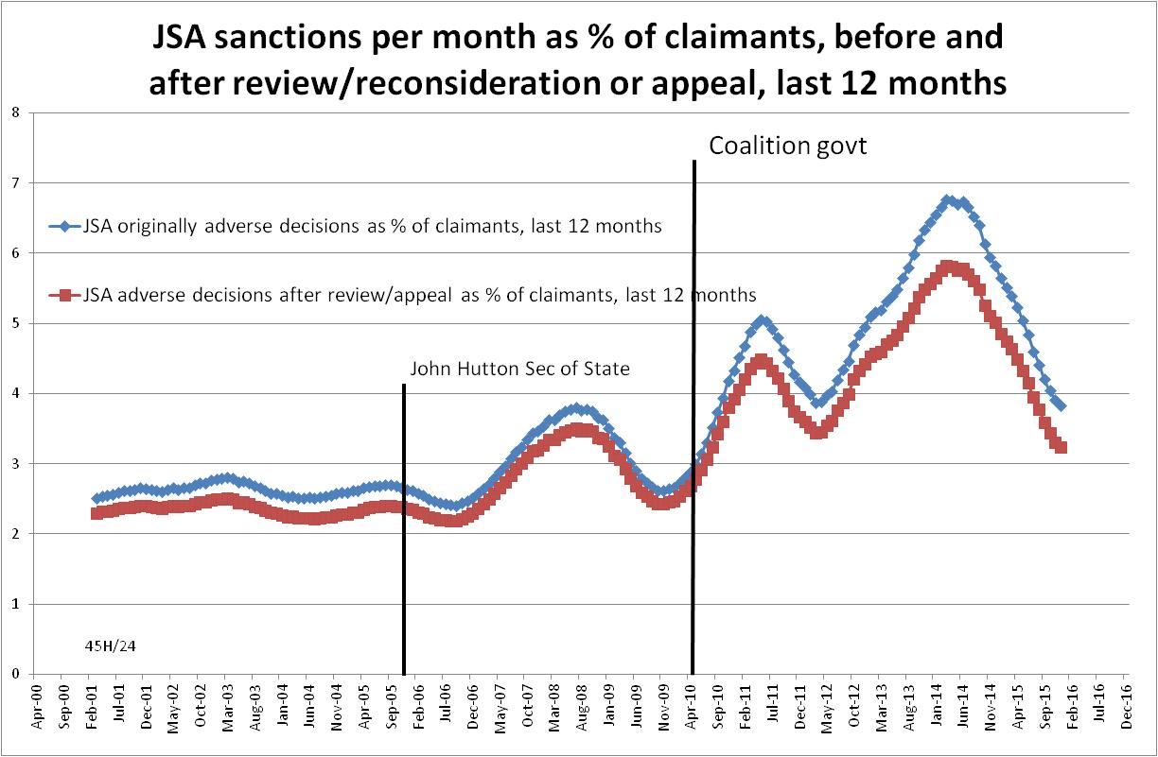

Figure 2
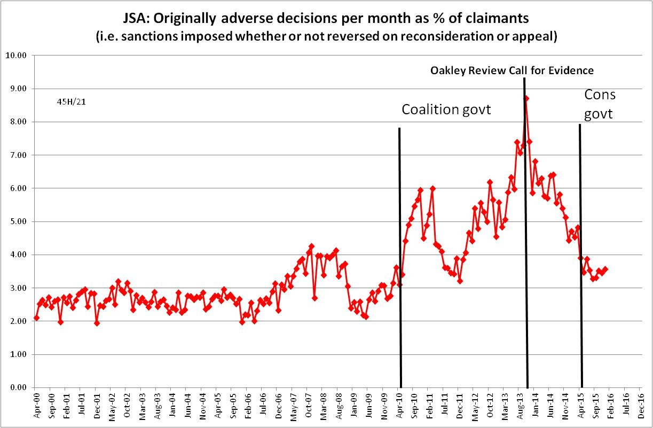
Figure 3 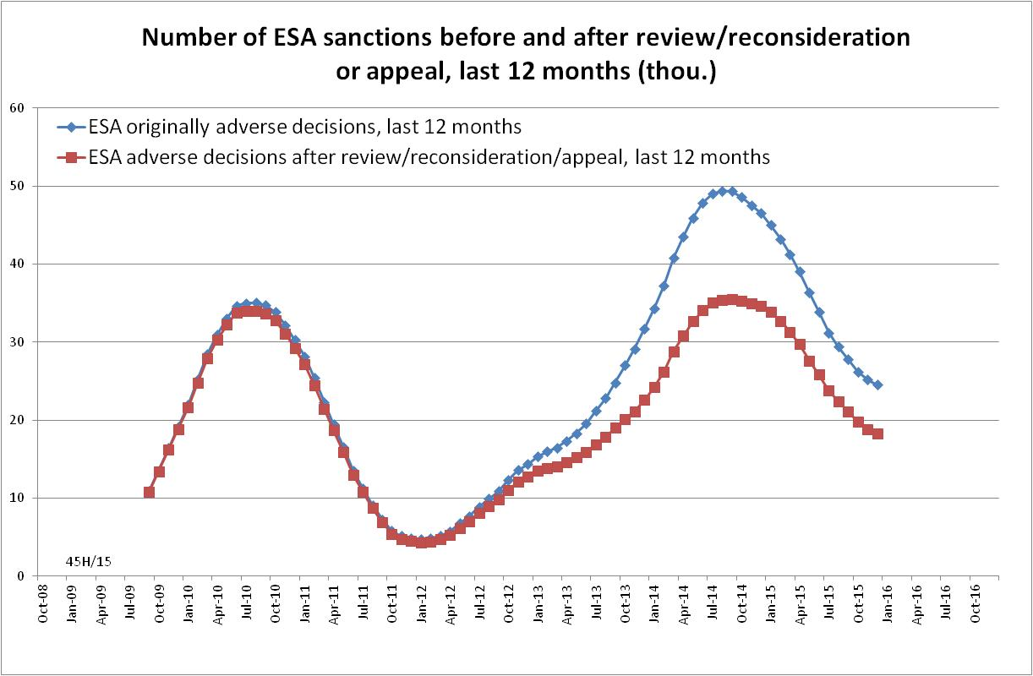

Figure 4
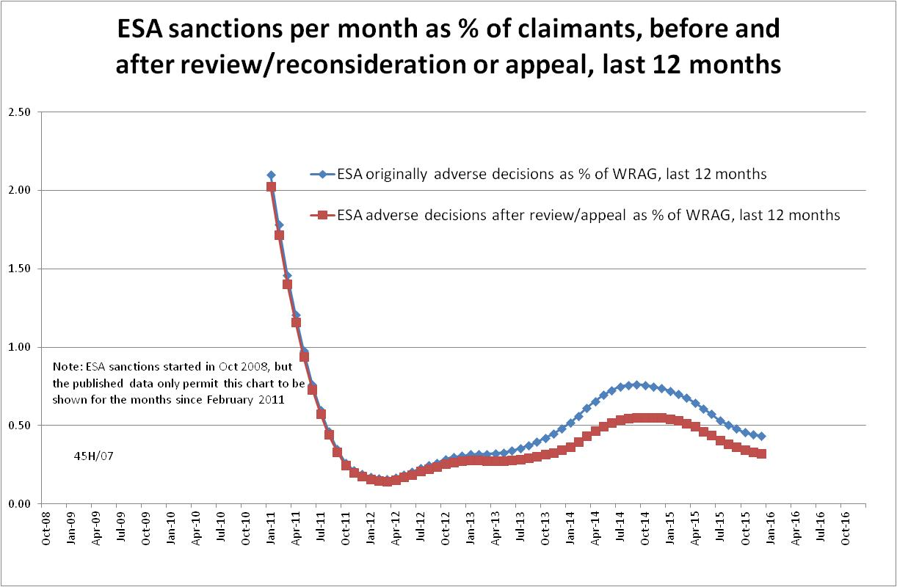

Figure 5
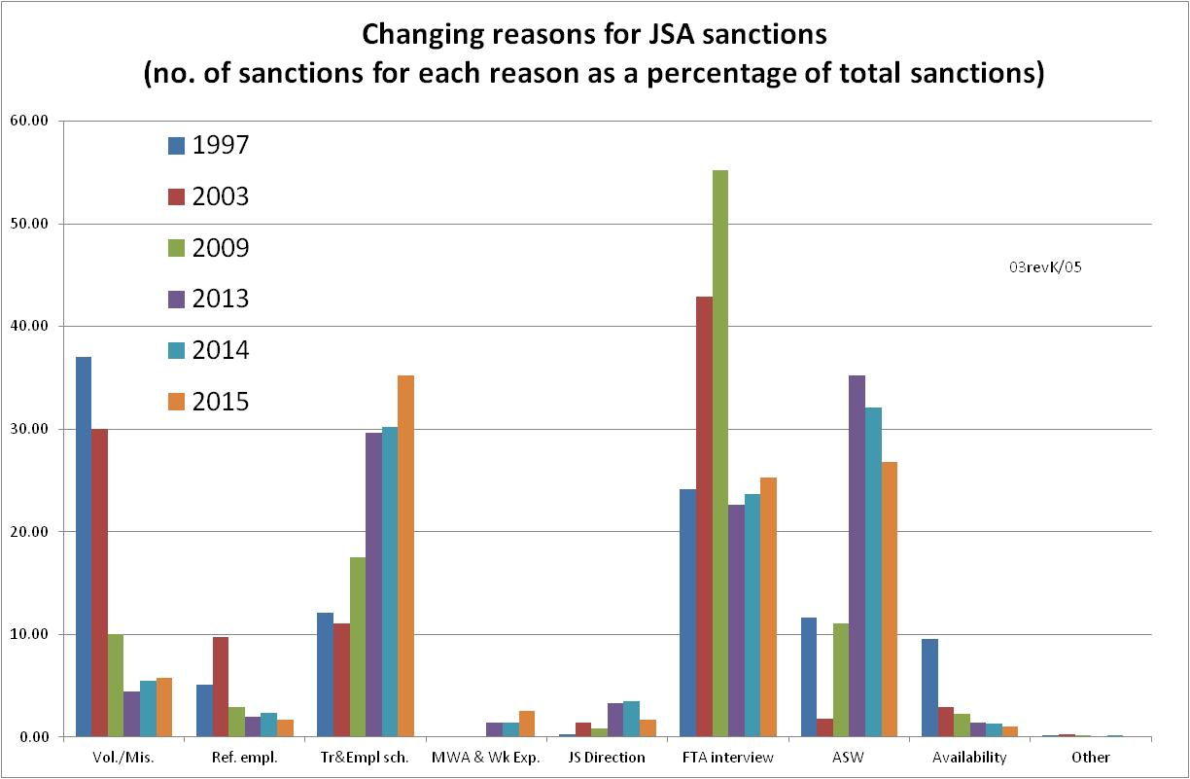

Figure 6
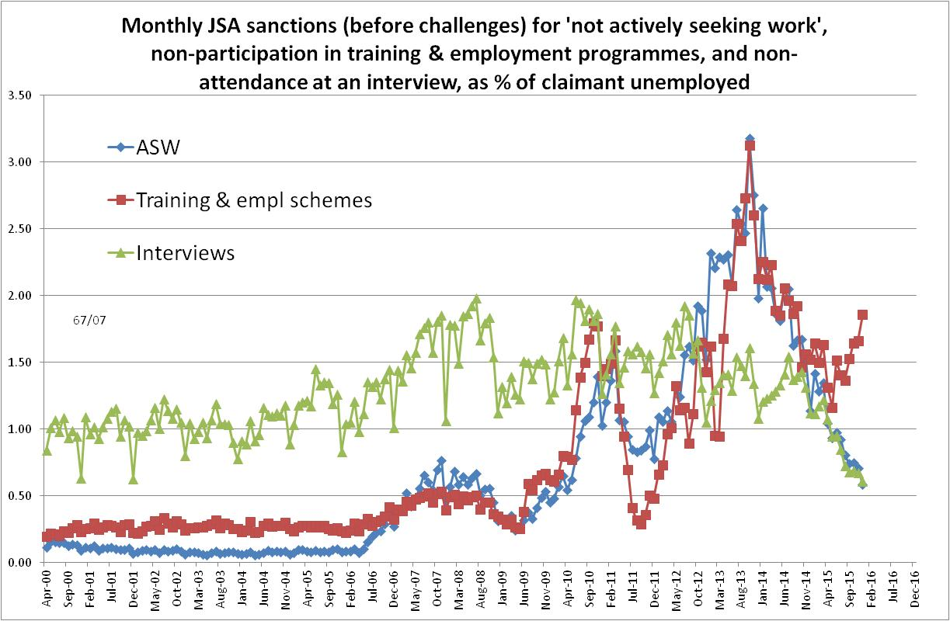

Figure 7
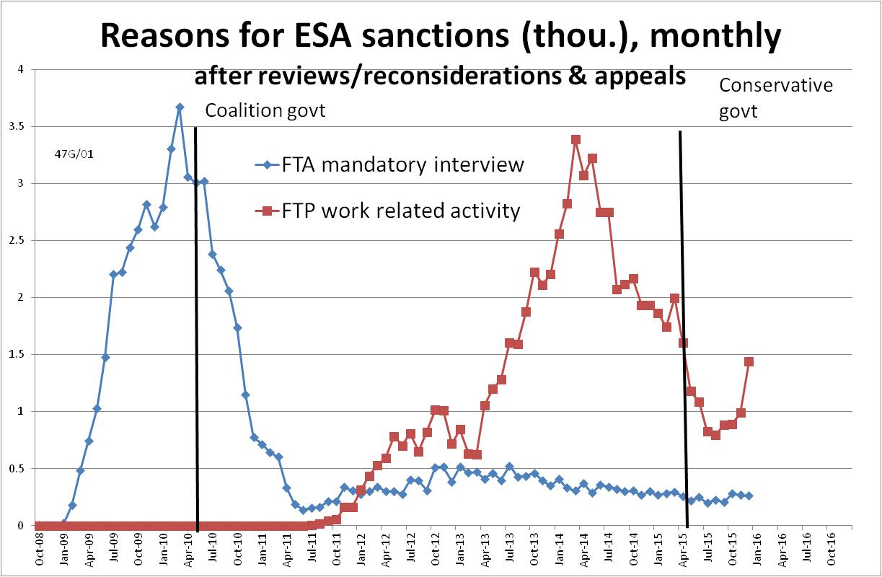

Figure 8
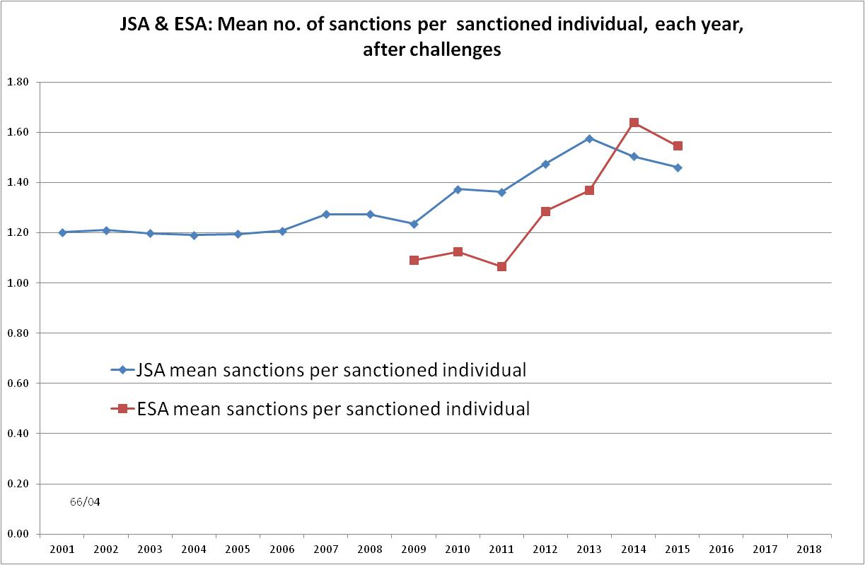

Figure 9
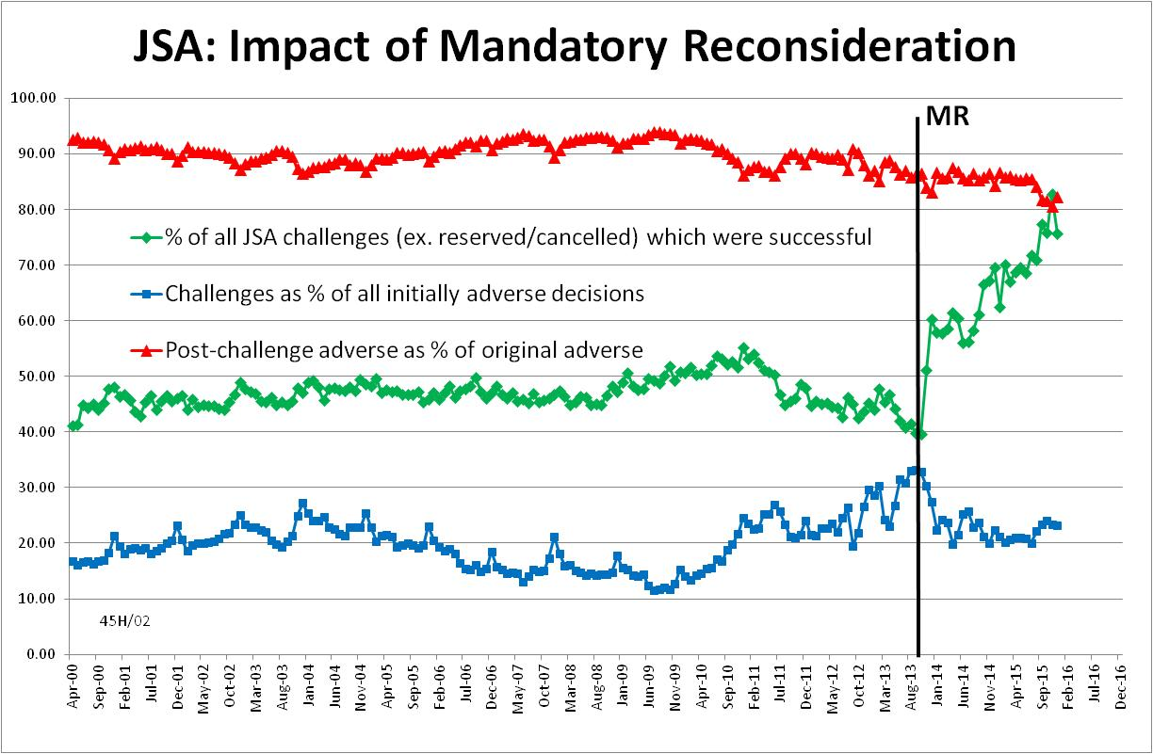

Figure 10
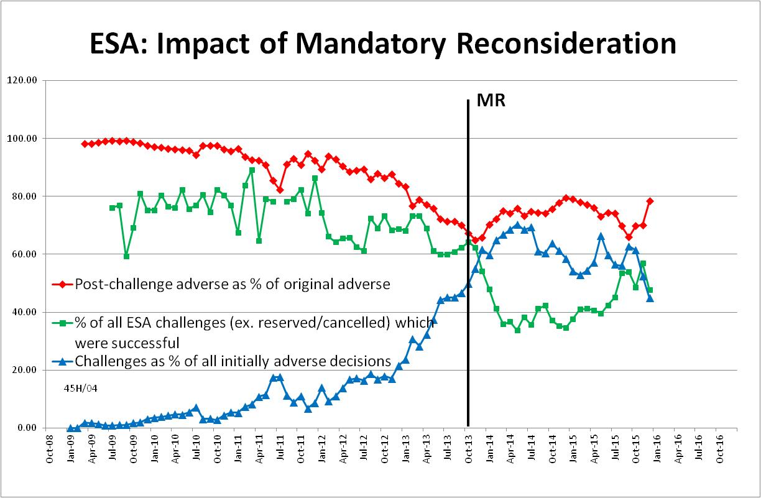

NOTES

This is the eleventh in a series of briefings on the DWP’s statistics on Jobseeker’s Allowance (JSA) and Employment and Support Allowance (ESA) sanctions. All the briefings are available at http://www.cpag.org.uk/david-webster. Earlier briefings should be read in the light of the DWP’s statistical revisions.
Stat-Xplore can now be accessed by registered users using an application programme interface (API).
The basic concept of the DWP’s sanctions database is that each sanction case appears only once, and is given its latest status and attributed to the month of the latest decision on the case. So, for instance, if a decision is made in January 2014 to sanction someone, this decision is reviewed in March 2014 with an outcome unfavourable to the claimant, reconsidered in a ‘mandatory reconsideration’ in May 2014 again with an unfavourable outcome, and is heard on appeal by a Tribunal in October 2014 with a decision favourable to the claimant, then: - it appears in the statistics for the first time in January 2014 as an adverse decision - in March 2014 it changes its status to a reviewed adverse decision and moves month to be with all the other cases where the latest decision has been made in March 2014 - in May 2014 it changes its status to a reconsidered adverse decision and moves month to be with all the other cases where the latest decision has been made in May 2014 - in October 2014 it changes its status again to an appealed non-adverse decision, and moves month again to be with all the other cases where the latest decision has been made in October 2014.
The terms used here in relation to reviews, reconsiderations and appeals are as follows: Mandatory Reconsideration, with initial capitals, and its abbreviation MR, means the whole new appeal system introduced on 28 October 2013 ‘mandatory reconsideration’, without initial capitals, and never abbreviated, means the formal reconsideration of a sanction decision undertaken by the DWP’s Disputes Resolution Team. ‘decision review’ means the informal process of reconsideration now undertaken by the original Decision Maker (but previously undertaken by a different Decision Maker) when a claimant first challenges a sanction ‘internal review’ is a term embracing both ‘decision review’ and ‘mandatory reconsideration’ ‘appeal’ means a formal appeal to a Tribunal ‘challenge’ means any challenge to a sanction decision, i.e. it embraces ‘decision reviews’, ‘mandatory reconsiderations’ and Tribunal appeals.
DWP published an updated version of its UC statistics release strategy on 18 May at https://www.gov.uk/government/publications/universal-credit-statistics-background-information/universal-credit-statistics-background-information It still says nothing about statistics on Universal Credit sanctions. A note on Universal Credit statistics background and methodology is at https://www.gov.uk/government/uploads/system/uploads/attachment_data/file/523595/universal-credit-background-methodology.pdf
The documentation is in correspondence between Jonathan Portes (NIESR) and myself and the UKSA Chair Sir Andrew Dilnot, on the UKSA website at http://www.statisticsauthority.gov.uk/reports---correspondence/correspondence
Universal Credit sanctions have been estimated by assuming that their monthly rate is the same as for JSA, and increasing the resulting number by 37.7% in line with the result of the detailed calculation using age-specific JSA sanction rates reported in the November 2015 Briefing.
The estimate of sanctions before challenges has been derived by adding the monthly total of ‘non-adverse’, ‘reserved’ and ‘cancelled’ decisions shown as being the result of reviews, mandatory reconsiderations and tribunal appeals, to the monthly total of adverse ‘original’ decisions.
‘Non-attendance at training and employment schemes’ is a category created by the author. The schemes comprise refusing or neglecting to avail of an opportunity of a place on a scheme, refusing to attend, voluntarily leaving or losing a place through misconduct; non-participation in the Work Programme; non-participation in Skills Conditionality or other scheme; failure to attend a Back to Work session and failure to participate in supervised job search. This category does not include any work experience or work placements; these are included within MWA (Mandatory Work Activity) & Work Experience.
In FoI response 2015-2187, DWP has supplied a denominator, namely the number of individuals who claimed ESA at any point in the year, which is not quite correct as it is for 1 June 2014 to 31 May 2015. This does not make a significant difference.

