BRIEFING

Benefit Sanctions Statistics

February 2020

12 March 2020

Dr David Webster
Honorary Senior Research Fellow
Urban Studies
University of Glasgow

Email david.webster@glasgow.ac.uk

Webpages: http://www.gla.ac.uk/schools/socialpolitical/staff/davidwebster/
http://www.cpag.org.uk/david-webster
SUMMARY

This Briefing reports on the latest quarterly benefit sanctions statistics, which were released by DWP on 18 February, giving data on sanctions to the end of October 2019 and on numbers of claimants to January 2020.

There has been a sharp falling-off in the rate of increase in the number of claimants on Universal Credit (UC). Nevertheless by January 2020 it was over two and three quarter millions (2.79m). In practice under half of these UC claimants (1,261,894 or 45.2%) were subject to conditionality, and over half (1,530,113 or 54.8%) were not. At January 2020 the number of JSA claimants had fallen to 163,451, but the combined total of unemployed people on UC or JSA had risen to 1,194,645, due to UC imposing work search and availability requirements on hitherto exempt people, raising of the state pension age and other factors. Almost nine out of ten (86.3%) of unemployed claimants are now on UC rather than JSA.

The total number of sanctions continues to fall. In the 12 months to October 2019 there were a total of approximately 193,000 sanctions before challenges on all benefits taken together, comprising 182,500 UC sanctions, 5,500 JSA, 500 ESA and 4,500 IS sanctions. This compares with a total of 197,000 in the 12 months to July 2019, and is far below the peak of 1,113,000 in 2013. The picture remains dominated by UC, which accounts for 94.7% of all sanctions in the latest month. These figures have been affected by further downward revisions to the figures for numbers of UC sanctions, following the substantial revisions published in November 2019. In the last two quarters, the overall monthly rate of UC sanctions before challenges as a proportion of claimants subject to conditionality has stabilised at about 1.4% per month. This ends a very large decline from over 9% in 2015. Unemployed claimants are treated more harshly than other claimants and are at about 1.6%. In November 2019 there were a total of 3,217 claimants in UC no-conditionality groups who were under sanction because they had been sanctioned previously when in a conditionality group.

DWP has provided new data on repeat sanctions within the year to 31 October 2019. Just short of 50,000 UC claimants received more than one sanction during the year. The figures for JSA and ESA were much lower, at 298 and 14 respectively. To put things another way, almost half (86,143 or 47.2%) of UC sanctions given during these 12 months were to claimants who had already been sanctioned during the same 12 months.

DWP has also provided new data on the age and sex of individuals on UC Full Service who have had adverse sanction decisions, before challenges, for the whole period 1 May 2016 to 31 October 2019. Over four out of five of UC claimants subject to conditionality are unemployed, so not surprisingly the age and sex profiles are similar to those seen earlier for JSA. Young people and males are much more likely to be sanctioned than older people and females. The published figures do not show the actual rates of sanction for these groups.

The news section at the end of the Briefing has information on developments affecting sanctions. A notable feature is the number of reports published in the latest quarter which highlight the damaging effects on health, mortality and incomes of the ‘austerity’ policies of which sanctions are a part, and which show the continuing distress of particular parts of the country with weak labour demand resulting from deindustrialisation. Advocates of sanctions generally think that unemployment is primarily due to people’s characteristics and behaviour rather than to weak labour demand.
BRIEFING: Benefit Sanctions Statistics
February 2020

INTRODUCTION

The latest quarterly sanctions statistics were released by DWP on 18 February, giving data on sanctions to the end of October 2019 and on numbers of claimants to January 2020. The new data are summarised by DWP in the publication Benefit Sanctions Statistics, available along with methodological notes at https://www.gov.uk/government/collections/jobseekers-allowance-sanctions together with a spreadsheet with summary tables. The spreadsheet includes new data on UC Full Service sanctions, showing repeats and demography. DWP has changed Benefit Sanctions Statistics from pdf to HTML and invites comments on this to stats-consultation@dwp.gov.uk The full figures for most aspects of the data are on the DWP’s Stat-Xplore database at https://stat-xplore.dwp.gov.uk/webapi/jsf/login.xhtml

All statistics presented here relate to Great Britain.

Corrections to the data

DWP has now found that the data on Universal Credit (UC) Full Service sanction decisions not resulting in a sanction, which have been published in the Benefit Sanctions Statistics spreadsheet (though not in Stat-Xplore) since May 2019, are incomplete. These figures have therefore been withdrawn. The Briefing has never used these figures and therefore no corrections are required here. Data on sanctions themselves are unaffected. However, anyone who has tried to calculate what proportion of UC sanction decisions are adverse will have overestimated it.

A further correction was published in an update of the note Sanctions duration and rate: Background information and methodology on 6 December. It turns out that the DWP’s published estimates of the proportion of claimants serving a sanction at a point in time omit sanctions uncompleted at the time of the calculation. The implications are discussed further below.

Groups of claimants exposed to sanctions:
Universal Credit, JSA, ESA and Income Support

At October 2019, a total of about 1.9m claimants were exposed to the risk of sanctions, with varying frequency and severity. They were split between Universal Credit (UC), Jobseekers Allowance (JSA), Employment and Support Allowance (ESA) and Income Support (IS).

The number of claimants on UC continues to increase. Figure 1 shows that by January 2020 it was over two and three quarter millions (2.79m). However there has been a sharp falling off in the rate of increase in the latest quarter, although it is too early to say whether this is a trend (Figure 2). Figure 1 also shows how the numbers of UC claimants have increased for each conditionality regime. At January 2020 there were 1,033,117 unemployed people in the full conditionality ‘searching for work’ group. There were 145,928 people ‘preparing for work’ and 82,849 ‘planning for work’. The DWP classifies the 403,207 people in the ‘working – with requirements’ group as being subject to conditionality, but since the end of the ‘In-Work Progression Randomised Control Trial’ on 31 March 2018, no conditionality has been applied to them in practice. Therefore in total, under half of UC claimants (1,261,894 or 45.2%) were in practice subject to conditionality at January 2020, and over half (1,530,113 or 54.8%) were not. Unemployed people now account for 81.9% of UC claimants who are in practice subject to conditionality.

Unemployed claimants (i.e. searching for work)

The total of people classified as unemployed in the ‘claimant count’ (i.e. whether on UC or JSA) continues to rise. This is partly due not to a worsening labour market but to UC imposing work search and availability requirements on previously exempt people. The Briefing should have pointed out that it is also due to some extent to the continuing raising of the state pension age, which puts some people who would previously have been pensioners on to working age benefits. Figure 3 shows the relevant part of the timetable for raising the pension age. A further factor, which has been mentioned in the Briefing, is that since 15 May 2019 entitlement to the state pension for both members of a couple has been determined by the age of the younger partner, a change which again has the effect of transferring some people on to working age benefits.

At January 2020 the number of JSA claimants had fallen to 163,451, but the combined total of unemployed people on UC or JSA had risen to 1,194,645. Almost nine out of ten (86.3%) of unemployed claimants are now on UC rather than JSA. A fuller analysis of unemployment was given in the February 2019 Briefing (pp.3-4), and an excellent monthly labour market analysis including UC issues is published by the Learning and Work Institute at https://www.learningandwork.org.uk/our-resources/statistical-analysis/ .

Others subject to conditionality

To establish the number of claimants on grounds of sickness and disability who are subject to sanctions it is necessary to add to the total of claimants in the ESA Work Related Activity Group (WRAG) the number of UC claimants claiming on grounds of sickness or disability and subject to ‘preparing for work’ requirements. The latter figure is not published by DWP. The 145,928 UC claimants ‘preparing for work’ at January 2020 include these people but they also include some people who are not sick or disabled and would previously have claimed IS. The number of ESA WRAG claimants however is known. Their number peaked at 562,620 in August 2013 but has more than halved since then, to an estimated 274,000 in October 2019. Nevertheless ESA still accounts for some two thirds of people subject to conditionality who are claiming out-of-work benefits on account of sickness or disability. This is because the changes of circumstances that would trigger a move on to UC, or a movement off benefit, are relatively unusual for ESA claimants.

The number in the ESA Assessment Phase (which has no conditionality) is falling fast, to 54,415 in August 2019 from a peak of 545,972 in August 2014. This is because new claimants are being put on to UC. UC does not have an assessment phase; the ‘Job Coach’ has discretion on what requirements to impose pending the Work Capability Assessment.

The number of IS claimants is also falling quite fast due to movement of new claimants on to UC. There were an estimated 307,000 claimants on IS and subject to sanctions at October 2019. The largest group among these was an estimated 169,000 lone parents with a youngest child aged between one and five. There were also an estimated 134,000 carers and 4,000 other IS claimants.

The Universal Credit sanctions regime

A full description of the UC sanctions regime was given in the February 2019 issue of the Briefing, pp.5-6.

Sanctions before and after reviews, reconsiderations and appeals

Except for the new UC Full Service data first published in May 2019, the DWP’s Benefit Sanctions Statistics publication and Stat-Xplore database only show sanctions after any reviews, reconsiderations and appeals that have taken place by the time the data are published. But numbers of sanctions before the results of these challenges are important since they show all the cases in which claimants have had their money stopped. Although a successful challenge should result in a refund, this is only paid after weeks or months by which time serious damage is often done. Estimates of sanctions before challenges are therefore given here but although reliable for longer time periods, they are not fully accurate for individual months. For JSA and ESA, figures for sanctions before challenges are typically higher than the ‘after challenge’ figures by very large amounts, namely about 20%. and 40% respectively. For UC Live Service (the only figures currently available for the UC appeal process) and for IS, the proportion of sanctions overturned is much smaller at around 5% and 1% respectively. So for these types of sanction there is much less difference between the pre-and post-challenge figures. Wherever possible, this Briefing shows estimated pre-challenge sanctions figures.

DWP now says that it aims to change this system for Universal Credit sanctions at some point in the future in order to show all decisions at each stage.
MONTHLY NUMBERS AND RATES OF SANCTIONS BEFORE CHALLENGES FOR THE FOUR BENEFITS

On its introduction, Universal Credit was delivered via ‘Live Service’. A programme to transfer Jobcentres to the more sophisticated ‘Full Service’ was started in May 2016 and completed in December 2018. For many months therefore, Live Service and Full Service were operating in parallel. However, 100% of Live Service claimants had transferred to Full Service by April 2019, and the systems used to administer Live Service were shut down at the end of March 2019.

Much more information has been published on Live Service than on Full Service. DWP is still not publishing comprehensive sanctions data on Full Service, but starting in May 2019 it is now publishing some basic data on Full Service sanctions, going back to August 2015. The Briefing can therefore now show figures for all UC sanctions. Separate analysis of Full and Live Service sanctions was given in the May 2019 Briefing but UC sanctions figures in this Briefing are now always for Full and Live Service combined, unless otherwise stated. Unlike all the previously published DWP figures, the new Full Service sanctions figures are on a ‘before challenge’ basis. Here, Live Service figures are put on to this same basis as previously explained.

Total numbers of sanctions

The total number of sanctions continues to fall. In the 12 months to October 2019 there were a total of approximately 193,000 sanctions before challenges on all benefits taken together, comprising 182,500 UC sanctions, 5,500 JSA, 500 ESA and 4,500 IS sanctions. This compares with a total of 197,000 in the 12 months to July 2019, and is far below the peak of 1,113,000 in 2013. The picture remains dominated by UC, which accounts for 94.7% of all sanctions in the latest month.

These figures are affected by revisions which DWP has made to the previously published data for UC Full Service sanctions (Figure 4). A major set of revisions was published in November 2019 (see the November 2019 Briefing), when it was explained that the previously published figures wrongly included data for Northern Ireland and also sanctions which were ‘given in error’. DWP have confirmed to me that the sanctions given in error are unlikely to have resulted in any claimant losing money, even temporarily, although they have not been able completely to exclude the possibility. It is considered therefore that the ‘given in error’ cases should be excluded from the sanctions figures shown in this Briefing. Further revisions have now been published with the February 2020 data. For months up to October 2018 the revisions are trivial, but for the latest few months they are substantial, reaching a reduction of 11.2% in the figure for July 2019.

Monthly rates of sanctions

For UC, the exact number of claimants subject to conditionality is not available for the period April 2015 to March 2018, when a proportion of people in the ‘working – with requirements’ group were enrolled in the In-Work Progression Trial. Here, it has been assumed that everyone in this group was subject to conditionality for the whole period up to March 2018, but no one since then. This will produce an overestimate of the total number of UC claimants subject to conditionality for the period up to March 2018, which will slightly lower the resulting sanction rates for this period.

Taking account of the UC data revisions and the changes affecting the ‘Working – with requirements’ group, Figure 5 shows estimated monthly sanctions before challenges as a percentage of claimants subject to conditionality, for each benefit since August 2015 when UC sanction figures begin.

In the last two quarters, the overall monthly rate of UC sanctions before challenges as a proportion of claimants subject to conditionality has stabilised at about 1.4% per month. This ends a very large decline from over 9% in 2015, which had been steady except for a ‘catch-up’blitz in 2016-17.

The DWP has not broken down its UC Full Service sanctions figures between conditionality groups. However, the estimates of the proportion of claimants under sanction at a point in time (see Figure 7 below) indicate that the rate of UC sanction is much higher for unemployed than for other claimants. On the assumption that the ratios of the monthly rates for the ‘planning for work’ and ‘preparing for work’ groups to the rate for the unemployed group are similar to those for the proportions under sanction at a point in time (see below), it can be crudely estimated that the monthly rate of UC sanctions on unemployed claimants before challenges would be about 1.6% in the latest quarter. This is below the JSA rate seen over most of the period of the Labour government prior to 2010, as shown in the longer period Figure 6, although sanctions are now of course much harsher. The unemployed UC rate is very close to the overall UC rate because unemployed people account for over four-fifths of UC claimants in practice subject to conditionality.

The UC sanction rate remains far above those for the other three benefits, which are at low levels as shown in Figure 5. In the latest quarter the JSA monthly rate of sanctions before challenges was about 0.12%, IS lone parent 0.14%, and ESA and IS non-lone parent 0.01%.

PROPORTION OF CLAIMANTS UNDER SANCTION AT A POINT IN TIME

The DWP’s preferred measure of sanctions ‘rate’ is the proportion of claimants who are serving a sanction at a point in time. Their published figures for this measure have always covered both Live and Full service, but there are various problems with it, which were discussed in the November 2017 Briefing (pp.6-10).

DWP has now (on 6 December) changed the methodological note Sanctions duration and rate: Background information and methodology to say that its calculations omit sanctions which are uncompleted at the time of the calculation. A similar note has been added to Benefit Sanctions Statistics. DWP does not offer any assessment of the quantitative impact of this omission on its estimates of the proportion of claimants under sanction at a point in time. Because the omissions are of sanctions uncompleted at the time of the calculation and not at the time that the estimates refer to, the impact would appear to be limited. In particular, the downward bias will be greatest for the most recent months and will dwindle to nil for the earliest months. However this is a further reason for treating these figures with caution, as has always been advised by the Briefing.

In spite of the limitations, in the current situation where no breakdown of the UC sanction figures is published by conditionality group, the figures are of some value in indicating the comparative harshness with which the different groups are treated.

Figure 7 shows the latest figures. The picture remains unchanged from recent quarters. The proportions for all groups have levelled off. The overall proportion for all UC claimants subject to conditionality is 3.14% in the latest quarter, but the unemployed are treated much more harshly than the other groups, with about 3.40% under sanction, whereas the others are all below 1%.

One of the strongly criticised features of Universal Credit is that sanctions are continued even if the claimant moves into a different group which has no conditionality. The number of people in this position is steadily increasing, no doubt due mainly to the increase in the number of claimants on UC. In November 2019 there were a total of 3,217 claimants in this position, comprising 1,225 in the ‘working – with requirements’ group (which currently has no conditionality), 1,347 ‘no work requirements’ and 645 ‘working – no requirements’.

REPEAT SANCTIONS

Repeat sanctions have previously been considered in the Briefings for November 2014 to May 2016 inclusive, and for May 2017. In the tables accompanying Benefit Sanctions Statistics, DWP has now published figures for UC, JSA and ESA showing the numbers of claimants who have received more than one sanction (before challenges) in the year to 31 October 2019. Just short of 50,000 UC claimants received more than one sanction during the year. The figures for JSA and ESA were much lower: 298 and 14 respectively. To put things another way, almost half (86,143 or 47.2%) of UC sanctions given during these 12 months were to claimants who had already been sanctioned during the same 12 months. This is a far higher proportion than is currently seen for JSA and ESA, where the figures were 8.3% and 4.6% respectively.

Figure 8 shows how the repeat sanctions were distributed by number of sanctions imposed on the same individual. For UC, 17.2% of total sanctions were repeats where the claimant only had one repeat sanction (i.e. two sanctions during the year), while 18.7% (almost one fifth) of total sanctions were repeats where the claimant had four or more sanctions during the year. Repeats occurred much less frequently in JSA and ESA. However the overall sanctions figures for JSA and ESA have fallen so low that this is not a very instructive comparison. Figure 9 compares the figures for UC in the year to 31 October 2019 with those for JSA and ESA for the year to 30 June 2015, which were given in a Freedom of Information response 2015-2187. Because the UC figures are before challenges and the JSA and ESA figures are after challenges, the two sets of figures cannot be straightforwardly compared. But they do show that at the height of the sanctions campaign, repeats accounted for 31.2% of total JSA sanctions and for 40.4% of ESA sanctions, after challenges. These figures are much less different from the recent UC figures, although they do suggest that the concentration of sanctions on a relatively small number of repeatedly sanctioned individuals is particularly strong for UC.

DEMOGRAPHIC BREAKDOWN

For the first time DWP has provided (in the tables to Benefit Sanctions Statistics) some data on the age and sex of individuals on UC Full Service who have had adverse sanction decisions, before challenges, for the whole period 1 May 2016 to 31 October 2019. Figures 10 and 11 present these figures. Alongside them are the corresponding figures for Live Service, which are comparable except that they show individuals with adverse sanction decisions after challenges, so that the two sets of figures cannot be added together to show the picture for all UC claimants. As discussed earlier in this Briefing, over four out of five of the UC claimants subject to conditionality are unemployed, so not surprisingly the age and sex profiles are similar to those seen earlier for JSA. Young people and males are much more likely to be sanctioned than older people and females. Unfortunately it is not possible to say exactly what are the rates of sanction for these groups because DWP has not provided the necessary denominator showing the number of UC claimants over this period.

ANALYSES NOT INCLUDED IN THIS ISSUE

The paucity of data available for UC Full Service sanctions makes it not worthwhile to update many of the analyses at present. Readers are referred to earlier numbers of the Briefing for analyses of matters not discussed in the present issue. Reasons for sanctions were comprehensively analysed in May 2019; durations of sanctions were discussed in detail in November and February 2019; claimants with earnings following a sanction were covered in November 2018; ethnicity and gender in July 2018; benefit destinations in February 2018; challenges to sanctions in February 2018 and May 2017; JSA benefit suspensions not followed by sanction, and ESA sanctions by medical condition in August 2017; and hardship payments for UC in August 2019 and for JSA and ESA in February 2019 and November 2015. Longer period analyses were included in the author’s written evidence to the Work and Pensions Committee (Webster 2018a) and in a presentation to the Welfare Conditionality conference at York in June 2018 (Webster 2018b). These analyses will be updated in future issues.
SANCTIONS - OTHER DEVELOPMENTS

UC rollout – further delay to September 2024

The last phase of the rollout of Universal Credit is the ‘managed migration’ of existing claimants of ‘legacy benefits’ who do not have any change of circumstances which would trigger a UC claim. The government announced on 3 February that this process will not now be completed until September 2024 rather than the previously forecast December 2023. The DWP Parliamentary Under Secretary Will Quince explained to the House of Commons on 4 February (col.175) that previous forecasts assumed that 50,000 households per month would naturally migrate but experience is showing that this is much too high. The current forecast is for only about 31,000 per month, implying that 900,000 fewer households will naturally migrate by December 2023. Because DWP expects to manage about 100,000 households on to UC each month, this means that an additional nine months are needed for the managed migration process. The delay will mean a one-off cost of about £500m but this is not a resource cost. It is a simple transfer of cash from the DWP to claimants, due to the fact that claimants whose migration is ‘managed’ will receive transitional protection to ensure that their total payment is not reduced under UC. A delay in migration means that higher payments will be made for longer.

Thérèse Coffey confirmed in post

Contrary to some media speculation, Thérèse Coffey retained her job as Secretary of State for Work and Pensions in the January reshuffle. Her comments to the Work and Pensions Committee on 16 October, reported in the November Briefing (p.9), probably therefore remain a good guide to current ministerial attitudes.

House of Commons Work and Pensions Committee – New Chair

The very experienced Stephen Timms (Labour, East Ham) has been elected chair of the Work and Pensions Committee in succession to Frank Field. The 11-member Committee itself has been largely reconstituted, with only Neil Coyle (Lab), Steve McCabe (Lab), Nigel Mills (Con) and Chris Stephens (SNP) carried over from the previous Parliament.

DWP study on the effectiveness of sanctions

This potentially very important study was reported in the Commentary on the Government Response to the Work and Pensions Commitee Report on Benefit Sanctions (Feb 2019), pp.1 and 3, available as currently the last item on the webpage www.cpag.org.uk/david-webster , and also in the November 2019 Briefing, pp.9-10. It was originally promised for ‘late Spring’ 2019 and then for ‘by the end of 2019’. A Parliamentary Answer on 2 March stated ‘The Department will look to publish its evaluation in Spring 2020. The evaluation will assess the impact of Universal Credit sanctions on supporting claimants into work. The impact on lone parents will be assessed. The evaluation will not assess the effectiveness of conditionality.’

End of Local Housing Allowance freeze in April 2020

On 13 January the DWP Parliamentary Under Secretary Will Quince announced that the freeze on Local Housing Allowance rates which has been in place since 2016 will be ended from 1 April and thereafter the rates will be uplifted by the Consumer Price Index. LHA was left out of the previous announcement in November that the freeze on working age benefits would be ended. While welcome, this means that there will still be large gaps between the cost of private rented accommodation and the element of benefit which is supposed to pay for it. More details are at
https://www.insidehousing.co.uk/news/news/government-to-end-local-housing-allowance-rate-freeze-after-four-years-64707

BBC2 3-part series ‘Universal Credit: Inside the Welfare State’

This BBC series was broadcast in February, showing real life footage of Jobcentres at Peckham (4 February), Liverpool (11 February) and Bolton (18 February), and also of DWP headquarters. The programmes will remain available to view on the BBC website until February 2021. As explained in the May 2019 Briefing (pp.10-12), the series is the third leg of a DWP campaign to try to improve the public perception of UC, the previous ones being a series of advertisements in the Metro (subsequently banned by the Advertising Standards Authority – see the November 2019 Briefing, p.11) and a promoted series of editorial articles in local media.

SSAC report on the effectiveness of the Universal Credit Claimant Commitment

The Social Security Advisory Committee’s report on the effectiveness of the UC ‘claimant commitment’ was published on 9 September 2019, with little publicity. The report is at
https://www.gov.uk/government/publications/ssac-occasional-paper-21-the-effectiveness-of-the-claimant-commitment-in-universal-credit A public consultation preceding the report is said to have received ‘over 30’ responses. Twenty-two of these were published on 9 October and are at https://www.gov.uk/government/consultations/claimant-commitment
The government’s interim response to the SSAC report is at https://www.gov.uk/government/publications/government-response-ssac-report-on-the-effectiveness-of-the-claimant-commitment-in-universal-credit/dwp-response-to-ssac-report-on-the-effectiveness-of-the-claimant-commitment-in-universal-credit-government-response
(HTML only). It says it will ‘look to respond (substantively) in the autumn of 2019’ but nothing seems to have appeared to date.

The SSAC report is bland and essentially accepts the assumptions on which the claimant commitment is based. It contains two significant recommendations: first, that UC claimant commitments should cease including requirements relating to health, which is in any case against existing policy; and that DWP should collect data to enable analysis of the use of discretion and ‘easements’. The responses to the consultation contain a lot of useful material.

Benefit system fails Thomas Cook staff

Following the collapse of Thomas Cook on 23 September, the BBC on 23 December at
https://www.bbc.co.uk/news/business-50885242 reported on the unsatisfactory experiences many former staff encountered in trying to claim benefits. One particular problem, which has been reported elsewhere, is of staff not advising claimants correctly about contribution-based JSA, which is continuing permanently alongside UC. There has also been inconsistency between Jobcentres in their willingness to pay for retraining. One claimant commented ‘My treatment by the job centre has felt like I've been thrown out again. They made me feel not worthy of benefits.’

Statistics on the Work and Health Programme

Publication of statistics on the Work and Health Programme - the much scaled-down successor in England and Wales to the Work Programme - began in November 2018. The latest statistics were published on 27 February at https://www.gov.uk/government/collections/work-and-health-programme-statistics Between the start of the programme in November 2017 and the end of November 2019, 121,710 people had been referred to the programme, of whom 21,130 were long-term unemployed, for whom participation is mandatory. The other people referred were 89,340 with a disability and 11,240 ‘Early Access’ participants with other disadvantages. Participation is voluntary for both these latter groups.

DWP Abstract of Benefit Rate Statistics

The latest issue of this DWP publication appeared on 18 February (DWP 2020). Its title is new and it has been changed to HTML format, with accompanying Excel tables. It is a very useful reference source, offering:
- DWP benefit uprating history
- rates of benefit time series
- links or pointers to all previously published elements
- supporting tables showing historical figures back to 1948

NAO Briefing on DWP’s information on suicides of benefit claimants

On 7 February the National Audit Office published a Briefing (NAO 2020) on the findings of investigations into the state of the information held by DWP about suicides by benefit claimants. These resulted from queries raised by the former chair of the Work and Pensions Committee, Frank Field, which DWP could not answer. The NAO concluded that the liaison arrangements with coroners have not been adequate to ensure that all cases are known to DWP, and that the DWP does not have robust records of the cases which have been reported or of the investigations carried out, and has only recently adopted a more proactive approach to carrying out Internal Process Reviews into known suicides. The NAO reports that DWP ‘has established a new unit which aims to: improve the Department’s approaches to identifying, investigating and learning lessons from customers’ experiences; and to ensure lessons are fed back into improvement processes’, and is making some other improvements.

Further Gingerbread report on Single parents and In-work progression

Following up their report on the obstacles to in-work progression for lone parents in London, described in the November 2019 Briefing (p.16), Gingerbread has now published a further report giving the national picture on the same subject (Cleary, Dewar & Bivand 2020). The recommendations are similar but this report is twice the length and contains a literature review.

Three new reports from the Resolution Foundation

The Resolution Foundation has published three new reports relevant to benefit sanctions:

- on In-Work Poverty (Judge & Slaughter 2020)
- on the effects of Universal Credit with special reference to Liverpool (Gardiner & Finch 2020)
- on the economic and social characteristics of the ‘Red Wall’ northern and western parliamentary seats which switched from Labour to Conservative at the December 2019 General Election.

Hidden unemployment remains serious – reports from OECD and IZA

In considering the UK’s high numbers of claimants for sickness and disability benefits and other economically inactive people, governments have consistently focused on the motivations of individuals. However two new reports emphasis the importance of varying local labour market conditions. The OECD and Centre for Cities (Barr et al. 2019) find that while the UK has one of the lowest levels of economic inactivity across the OECD, it varies significantly from place to place. If students, retirees, or people looking after family are excluded, there is a clear North/South divide, closely linked to the economic performance of different places. This means that, theoretically, a number of economically-inactive people who, with support, could enter the workforce are not currently counted in official unemployment statistics, which also means they are not targetted by active labour market policies. If those economically inactive people are added to the unemployed, national estimates jump from 4.6 per cent to 13.2 per cent, and.in many Northern cities, such as Liverpool, Sunderland and Dundee, the figure could be approximately one fifth. The report argues there should be a plan for long-term investment in skills for people who have been out of the labour market for a long time, or are at risk of losing their current job due to local economic conditions, with targeted support to help them access new jobs. Public services such as employment, social care, childcare, and physical and mental health services should be better integrated at the local level, and policies should be pursued to make these places more attractive to set up businesses.

Similarly, a new paper from the University of Sheffield (Roberts & Taylor 2020), using up to date longitudinal data from 2009 to 2018, shows that the propensity to claim ESA is still being influenced by local labour market conditions, particularly for lower skilled people and for men, as well as by the intensity of application of the Work Capability Assessment.

Beatty & Fothergill on the labour market in Britain’s older industrial towns

Using a ‘labour market accounts’ approach, a new paper from Sheffield Hallam University (Beatty & Fothergill 2020) concludes that the reduction in recorded unemployment since 2010 paints an overly positive picture of labour market trends in Britain’s older industrial towns. This is because jobs in these towns have been growing only slowly, out-commuting has increased further from an already high base, and the increase in labour force participation has lagged behind the national average. There is scant evidence that London’s spectacular employment growth since 2010 has had a positive impact on the labour market in these towns. While it may have resulted in some indirect fiscal and macroeconomic benefits, its direct benefits have been confined to London and surrounding parts of the South. Effective economic revival of these towns is likely to require a rebalancing of national economic growth towards the sectors, particularly manufacturing, that remain key components of their economy, combined with public spending and financial incentives to make them attractive to potential investors.

Royal Statistical Society’s UK Statistic of the Decade:
Historically low UK productivity growth

The Royal Statistical Society has been nominating a ‘statistic of the year’ since 2017 and has now added UK and international ‘statistics of the decade’ for 2010-19. The judging panel were looking for stand-out statistics that capture the zeitgeist of the last ten years. The UK winner for 2010-19 is the fact that productivity has increased during the decade only by an average of 0.3% per year. The UK has experienced its worst decade for productivity growth since the early 1800s. As this Briefing has several times pointed out, benefit conditionality (central to the zeitgeist) will have contributed to this by pushing claimants into poorly paid, low skilled, undercapitalised jobs for which they are unsuited and/or unmotivated. Details are at https://www.statslife.org.uk/news/4398-rss-announces-statistics-of-the-decade

Impact of In-Work Conditionality on Productivity: Employer perspectives

In November, a team from Manchester Metropolitan University published the results of a pilot study, using 12 semi-structured qualitative interviews with employers, which considered the question: Would the introduction of ‘in-work conditionality’ under UC lead to more productive work? (Jones et al. 2019). It concluded that ‘rigid expectations placed on individuals to increase hours or pay are at odds with the realities of working life in the UK labour market. At a time of low unemployment (and low productivity), the key challenge for policymakers is not moving people into work, but ensuring that, where appropriate, UC claimants are supported into decent and productive work where their skills and capabilities will be developed and used effectively. A “work first, then work more” approach, focused on placing conditions on individual workers fails to consider long-standing issues of poor work quality and management practices, and broader issues relating to the needs of workers outside of the paid labour market. This approach also appears to be at odds with the broader policy agendas focused on improving productivity and the quality of work.’

ONS release on average household income

An Office for National Statistics release on 5 March at https://www.ons.gov.uk/peoplepopulationandcommunity/personalandhouseholdfinances/incomeandwealth/bulletins/householddisposableincomeandinequality/financialyearending2019
shows that over the two years to April 2019, median disposable income for the poorest fifth of people in the UK fell by 4.3% per year. Gains from higher employment have been limited by the slow increase in productivity and have been more than wiped out by benefit cuts, particularly the benefits freeze.

‘Welfare reform’ and worsening mortality

Three recent studies show that recent adverse trends in mortality have disproportionately affected the poor and are therefore likely to be the result of ‘austerity’. An English study (Taylor-Robinson et al. 2019) provides evidence that the unprecedented rise in infant mortality from 2014 to 2017 disproportionately affected the poorest areas of the country, leaving the more affluent areas unaffected. The analysis also suggests that about a third of the increase in infant mortality from 2014 to 2017 may be attributed to rising child poverty. This article is free to access.

A new paper by the Office for National Statistics (ONS 2020) shows that between 2001 and 2018, in the most deprived areas of England, mortality rates for males improved at a slower rate after 2011 compared with the earlier period, while female mortality rates worsened. In the most deprived areas in Wales, mortality rates worsened for both males and females after 2011.

Work by the Scottish Public Health Observatory at
https://www.scotpho.org.uk/population-dynamics/recent-mortality-trends/ concludes that the recent slowing improvement and actual falls in life expectancy are due to austerity and pressure on health and social care services, with influenza also playing a role and some other factors suggested but not yet properly investigated. Further information is at https://www.scotpho.org.uk/media/1886/lynda-fenton-phins-2019.pdf

Health inequality: the Marmot Review ten years on

An update to the Marmot Review of health inequality in England was published on 25 February (Marmot et al. 2020). For the first time in more than 100 years life expectancy has failed to increase across the country, and for the poorest 10% of women it has actually declined. Over the last decade health inequalities have widened overall, and the amount of time people spend in poor health has increased since 2010. The north/south health gap has increased.

Depression cases linked to Universal Credit – Lancet Public Health

A team based at the University of Liverpool have studied the effect of the introduction of UC on mental health, using a sample of 52,187 working age (16-64) people from the UK Household Panel Longitudinal Study (‘Understanding Society’) over the period 2009-18 (Wickham et al. 2020). They compared unemployed people (i.e. those eligible to claim UC) with the rest, after excluding those not working due to a disability. The prevalence of psychological distress increased among the unemployed by 6.57 percentage points after the introduction of UC relative to the comparison group, after accounting for potential confounding factors. The authors estimate that between April 29, 2013, and Dec 31, 2018, an additional 63,674 unemployed people will have experienced clinically significant levels of psychological distress due to the introduction of UC, of whom 21,760 might reach the diagnostic threshold for depression. This study did not look specifically at sanctions, but Williams (2019), reported in the November 2019 Briefing (p.15), did find a quantitative link between sanctions and prescriptions for anti-depressants. These two studies therefore reinforce each other.

Salvation Army report on Universal Credit and Mental Health

On 11 February the Salvation Army published a report highly critical of UC (Salvation Army 2020). The Army surveyed 160 individuals in England and Wales taking part in its Employment Plus support programme about their experience with the benefits system, using a questionnaire which is reprinted in the report, and then followed up with focus groups. The biggest barrier to claiming was mental ill health (for 42.3% of respondents), followed by lack of knowledge of how to claim, computer problems and physical ill health. Most (72.3%) of those with mental ill health also had other barriers, particularly budgeting and computing. These people were not receiving adequate support from Jobcentre Plus, due to lack of identification of their needs and excessive caseloads. Sanctions feature as ‘pushing people down at their lowest point’. The Army concludes: ‘We know people want to work. People want to get on in life. But we’ve created a system that pushes some people down. It prevents them from lifting themselves up, denying them the support they require to tackle the barriers they face.’ It calls for a ‘national rethink’ from the DWP on how it supports people’s mental health when moving on to UC.

New papers from Mo Stewart

Mo Stewart is a former health professional and member of the armed forces who for the past decade has carried out independent research on social security issues for people with disabilities. She has a website at https://www.mostewartresearch.co.uk/ She has recently published three new papers exploring the influence of neoliberal ideology and US corporations on UK policy towards sick and disabled people, and the consequences. Weblinks are in the References below.

GiveDirectly – the benefits of unconditional cash payments

The Financial Times Wealth magazine, March 2020, has reported on a New York-based charity, GiveDirectly, which gives cash directly and unconditionally to people living in poverty, on the basis of evidence which shows that this is the best way to help them (Murray 2020). ‘We believe people living in poverty deserve the dignity to choose for themselves how best to improve their lives — cash enables that choice.....And no, people don’t just blow it on booze......In fact, research finds people use cash in impactful and creative ways. We read the research. We read more research. Then we did our own research. And it turns out, people use cash on medicine; cows and goats and chickens; school fees; water; solar lights; tin roofs; irrigation; motorcycles to jumpstart taxi services; businesses to generate income; and more. If you think about it, doesn’t giving directly make sense? Cash allows individuals to invest in what they need, instead of relying on aid organizations and donors thousands of miles away to choose for them.’ More information is on the charity’s website https://www.givedirectly.org/, on which there are two pages devoted to reviewing and reporting research.

REFERENCES

Barr, Jonathan, Elena Magrini and Michela Meghnagi (2019) Trends in economic inactivity across the OECD: The importance of the local dimension and a spotlight on the United Kingdom, OECD Local Economic and Employment Development (LEED) Working Paper, Paris, October, at
https://www.oecd-ilibrary.org/industry-and-services/trends-in-economic-inactivity-across-the-oecd_cd51acab-en;jsessionid=0FNTvK800rY2QCZqZrTs4x-u.ip-10-240-5-80 and at
https://www.centreforcities.org/publication/hidden-unemployment-in-uk-cities/

Beatty, Christina & Steve Fothergill (2020) Recovery or stagnation?: Britain’s older industrial towns since the recession, Regional Studies, January, at
https://www.tandfonline.com/doi/full/10.1080/00343404.2019.1699651

Cleary, Elizabeth, Laura Dewar and Paul Bivand (2020) Untapped talent: Single parents and in-work progression – the national picture, London, Gingerbread, 11 February, at
https://www.gingerbread.org.uk/policy-campaigns/publications-index/untapped-talent/

DWP (2020) Abstract of DWP Benefit Rate Statistics, at
https://www.gov.uk/government/collections/abstract-of-statistics-for-benefits-national-insurance-contributions-and-indices-of-prices-and-earnings

Gardiner, Laura & David Finch (2020) The long and winding road: The introduction and impact of Universal Credit in Liverpool City Region and the UK, London, Resolution Foundation, January, at
https://www.resolutionfoundation.org/publications/the-long-and-winding-road/

Jones, Katy, Craig Berry, Julia Rouse and Richard Whittle (2019) Universal Credit and In-Work Conditionality – a productive turn?, Productivity Insights Network, at
https://productivityinsightsnetwork.co.uk/app/uploads/2019/10/Project-Report-Universal-Credit-Productivity_Katy-Jones-et-al..pdf
with Briefing Note at
https://productivityinsightsnetwork.co.uk/app/uploads/2019/10/Briefing-Note_Katy-Jones-et-al._Universal-Credit-and-IWC.pdf
and blog at
https://productivityinsightsnetwork.co.uk/2019/10/blog-universal-credit-and-in-work-conditionality-a-productive-turn/

Judge, Lindsay & Hannah Slaughter (2020) Working hard(ship): An exploration of poverty, work and tenure, London, Resolution Foundation, 4 February, at
https://www.resolutionfoundation.org/publications/working-hardship/

McCurdy, Charlie, Laura Gardiner, Maja Gustafsson & Karl Handscomb (2020) Painting the towns blue: Demography, economy and living standards in the political geographies emerging from the 2019 General Election, London, Resolution Foundation, February, at
https://www.resolutionfoundation.org/publications/painting-the-towns-blue/

Marmot, Michael et al. (2020) Health Equity in England: The Marmot Review Ten Years On, Institute for Health Equity, at
http://www.instituteofhealthequity.org/the-marmot-review-10-years-on

Murray, Sarah (2020) ‘Donors still wary of no-strings cash for the poor despite compelling evidence that it works’, FT Wealth Issue 60, March

National Audit Office (2020) Information held by the Department for Work & Pensions on deaths by suicide of benefit claimants, HC 79, 7 February, at
https://www.nao.org.uk/report/information-held-by-the-department-for-work-pensions-on-deaths-by-suicide-of-benefit-claimants/

Office for National Statistics (2020) Changing trends in mortality by national indices of deprivation, England and Wales: 2001 to 2018, 10 March, at
https://www.ons.gov.uk/peoplepopulationandcommunity/birthsdeathsandmarriages/deaths/articles/changingtrendsinmortalitybynationalindicesofdeprivationenglandandwales/2001to2018

Roberts, Jennifer & Karl Taylor (2019) New Evidence on Disability Benefit Claims in the UK: The Role of Health and the Local Labour Market, IZA Discussion Paper No. 12825, Bonn, December, at https://www.iza.org/publications/dp/12825/new-evidence-on-disability-benefit-claims-in-the-uk-the-role-of-health-and-the-local-labour-market

Salvation Army (2020) Understanding Benefits and Mental Health - A national rethink on how government supports vulnerable people moving onto Universal Credit, 11 February, at
https://www.salvationarmy.org.uk/millions-risk-universal-credit-%E2%80%98lock-out%E2%80%99-warns-salvation-army

Stewart, Mo (2019) Influences and Consequences: The Conclusion to the Preventable Harm Project 2009 – 2019, Centre for Welfare Reform, 27 November, at
https://www.centreforwelfarereform.org/library/influences-and-consequences.html

Stewart, Mo (2019) ‘Preventable harm: creating a mental health crisis’, Journal of Public Mental Health 18: 4, 224-230, 5 December, at
https://www.emerald.com/insight/content/doi/10.1108/JPMH-07-2019-0070/full/html?skipTracking=true

Stewart, Mo (2020) ‘The Impact of Neoliberal Politics on the Welfare and Survival of Chronically Ill and Disabled People’, Chapter 1 in The Routledge Handbook of Disability Activism, Routledge, February, at
https://www.researchgate.net/publication/339032153_Chapter_1_the_impact_of_neoliberal_politics_on_the_welfare_and_survival_of_chronically_ill_and_disabled_people

Taylor-Robinson, David, Eric T C Lai, Sophie Wickham, Tanith Rose, Paul Norman, Clare Bambra, Margaret Whitehead and Ben Barr (2019) ‘Assessing the impact of rising child
poverty on the unprecedented rise in infant mortality in England, 2000–2017: time trend analysis’, BMJ Open doi:10.1136/bmjopen-2019-029424, at
https://bmjopen.bmj.com/content/9/10/e029424

Webster, David (2018a) Written evidence to the House of Commons Work and Pensions Committee inquiry into Benefit Sanctions, at
http://data.parliament.uk/writtenevidence/committeeevidence.svc/evidencedocument/work-and-pensions-committee/benefit-sanctions/written/82601.pdf
Webster, David (2018b) The great benefit sanctions drive 2010-16 in historical perspective, presentation to the conference Welfare Conditionality: Principles, Practice and Perspectives, University of York, Wednesday 27 June 2018, at http://eprints.gla.ac.uk/183161/

Wickham, Sophie, Lee Bentley, Tanith Rose, Margaret Whitehead, David Taylor-Robinson and Ben Barr (2020) ‘Effects on mental health of a UK welfare reform, Universal Credit: a longitudinal controlled study’, Lancet Public Health 5: e157–64, March, at
https://www.thelancet.com/action/showPdf?pii=S2468-2667%2820%2930026-8

Figure 1
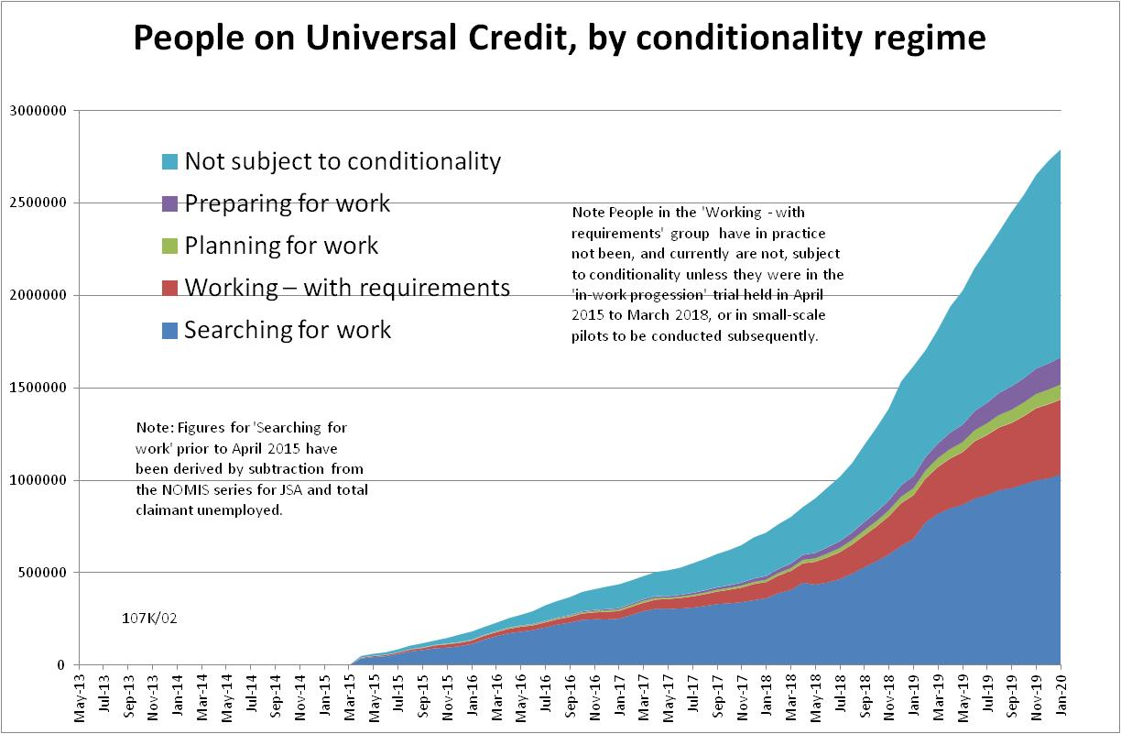

Figure 2
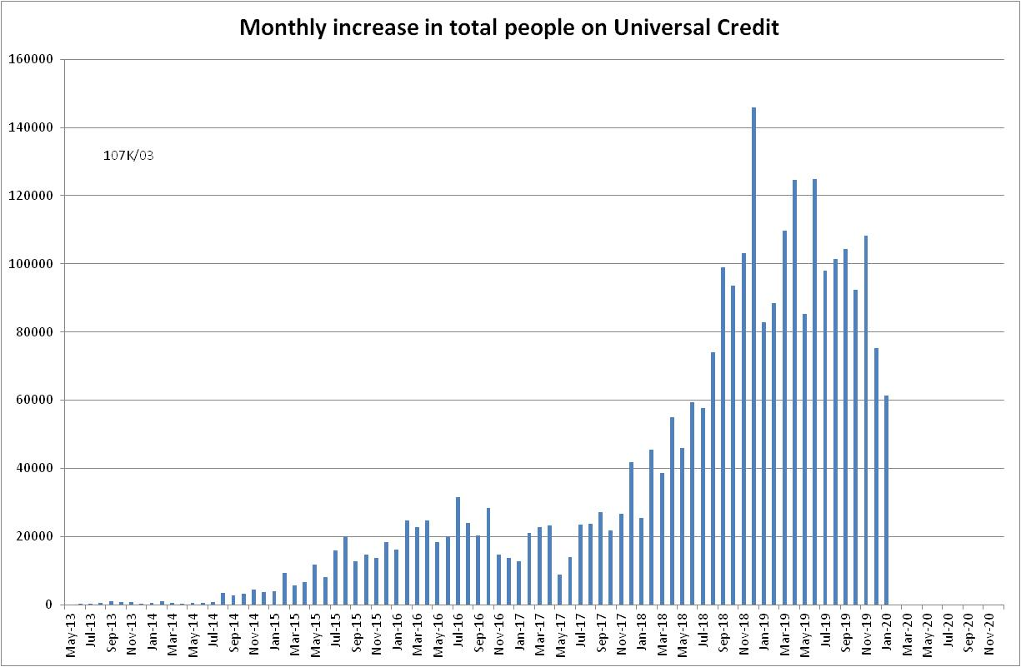

Figure 3
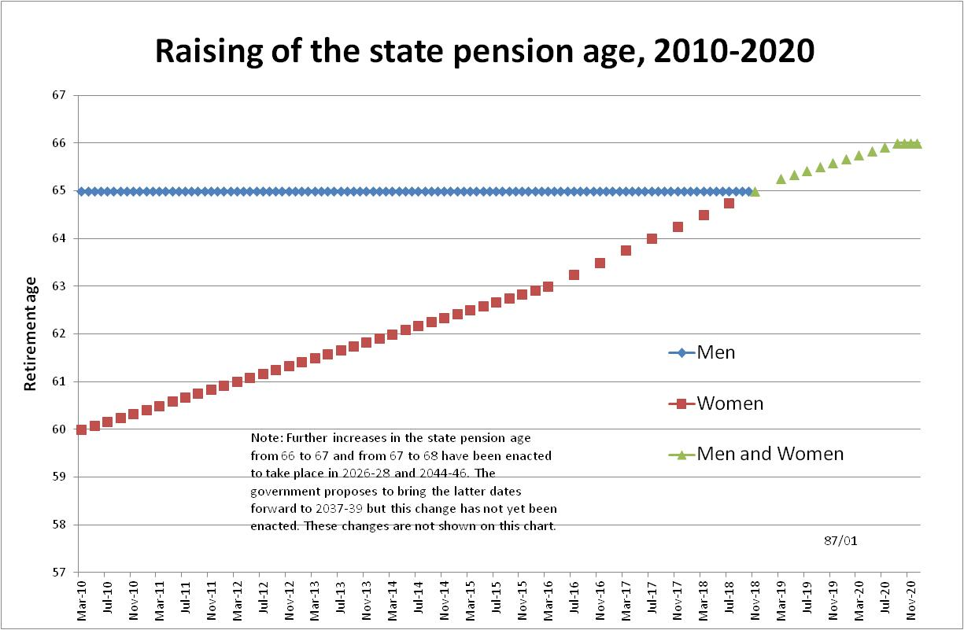

Figure 4
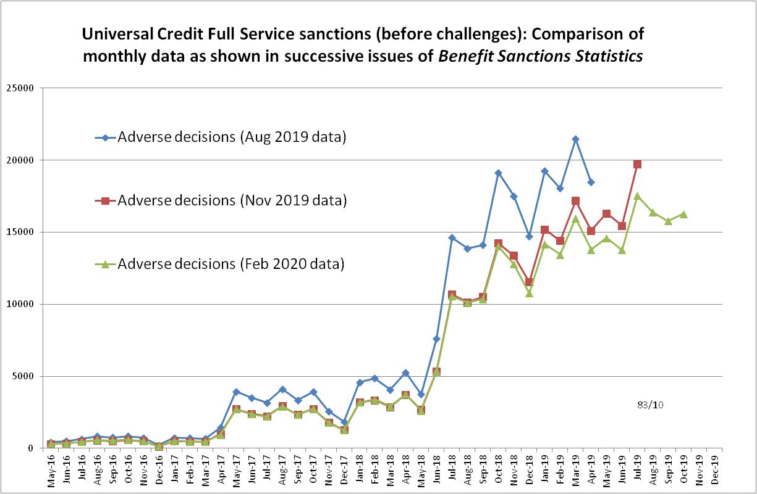

Figure 5
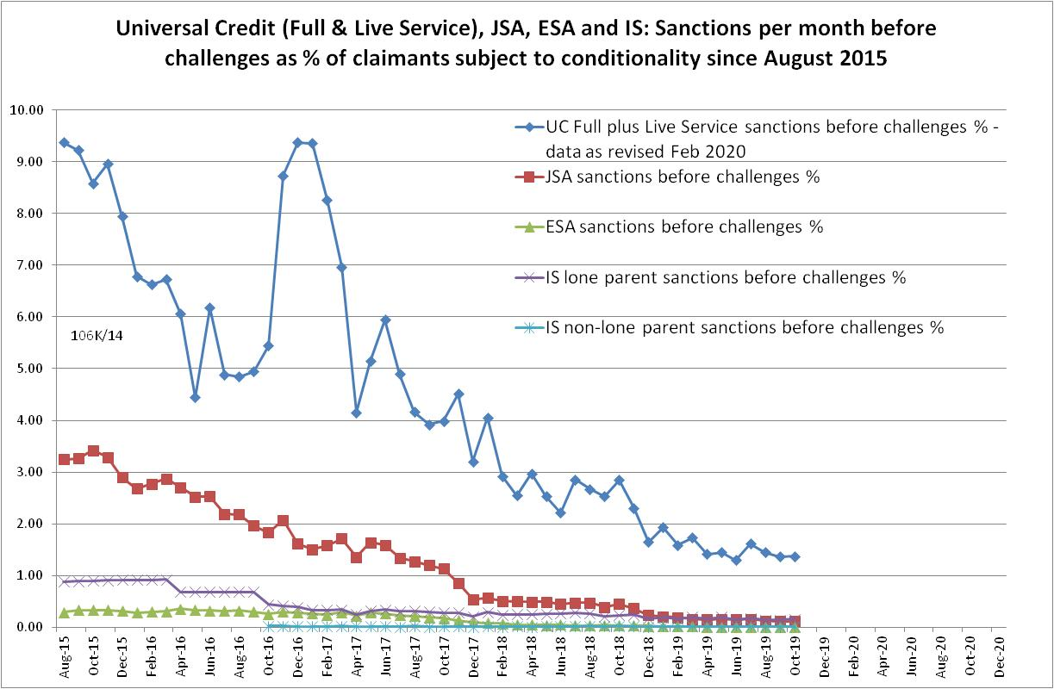
Figure 6
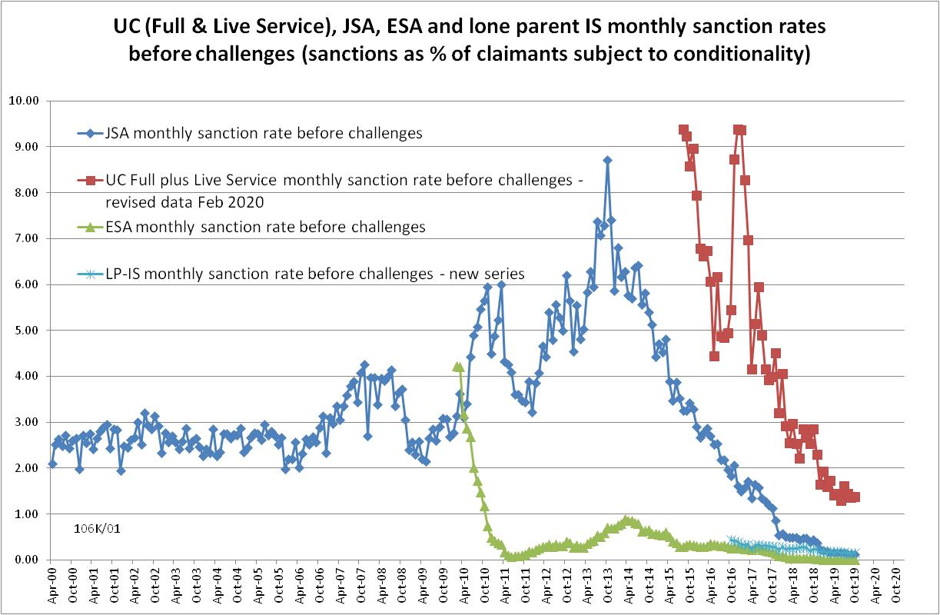
Figure 7
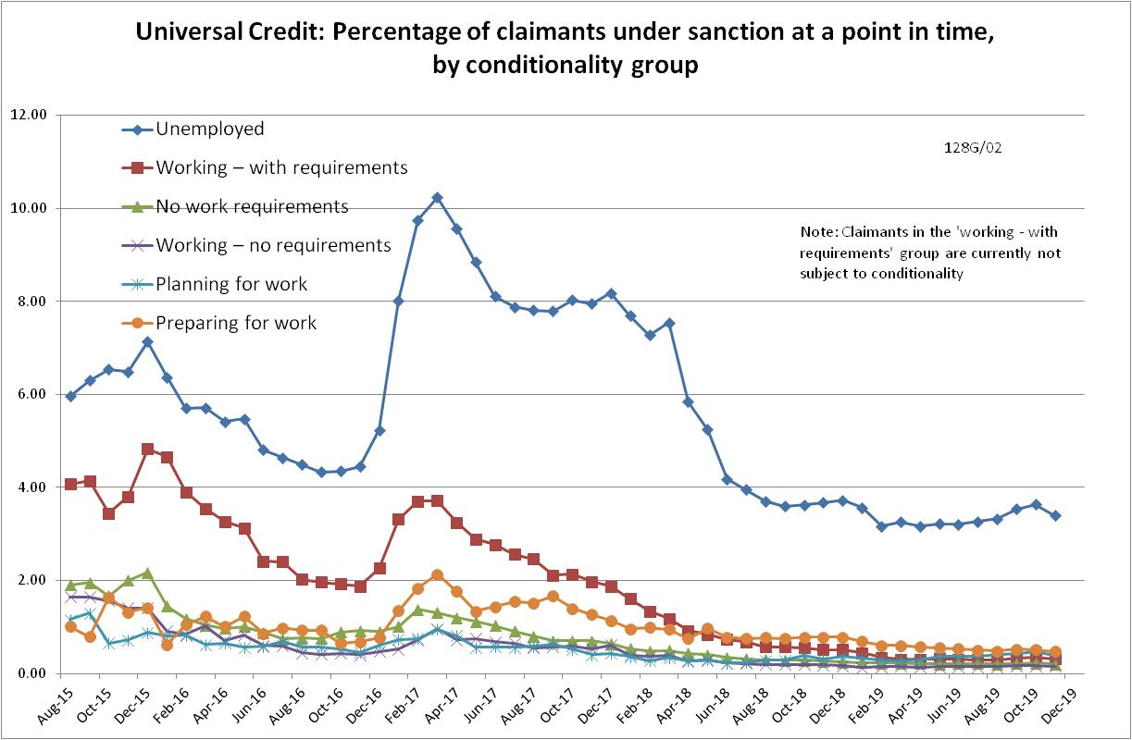

Figure 8
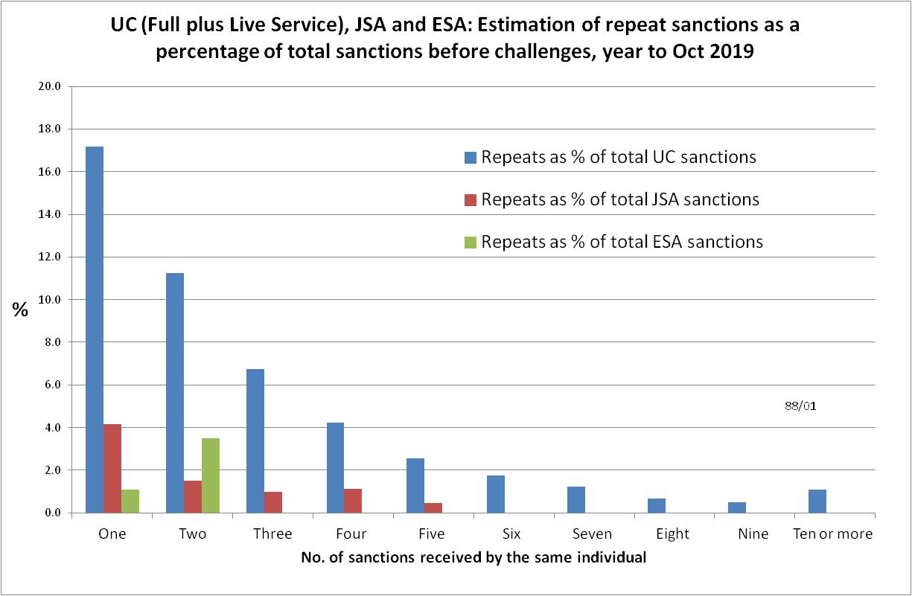

Figure 9
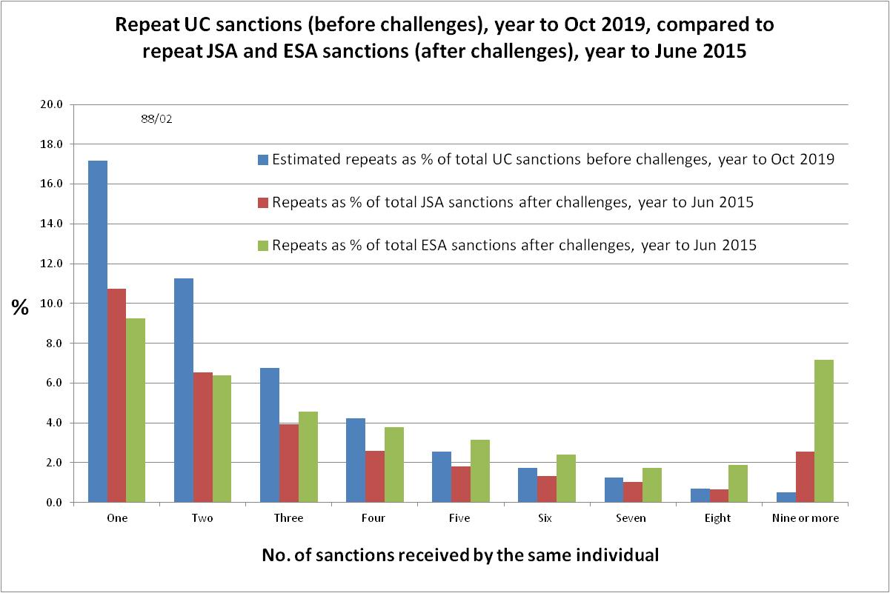

Figure 10
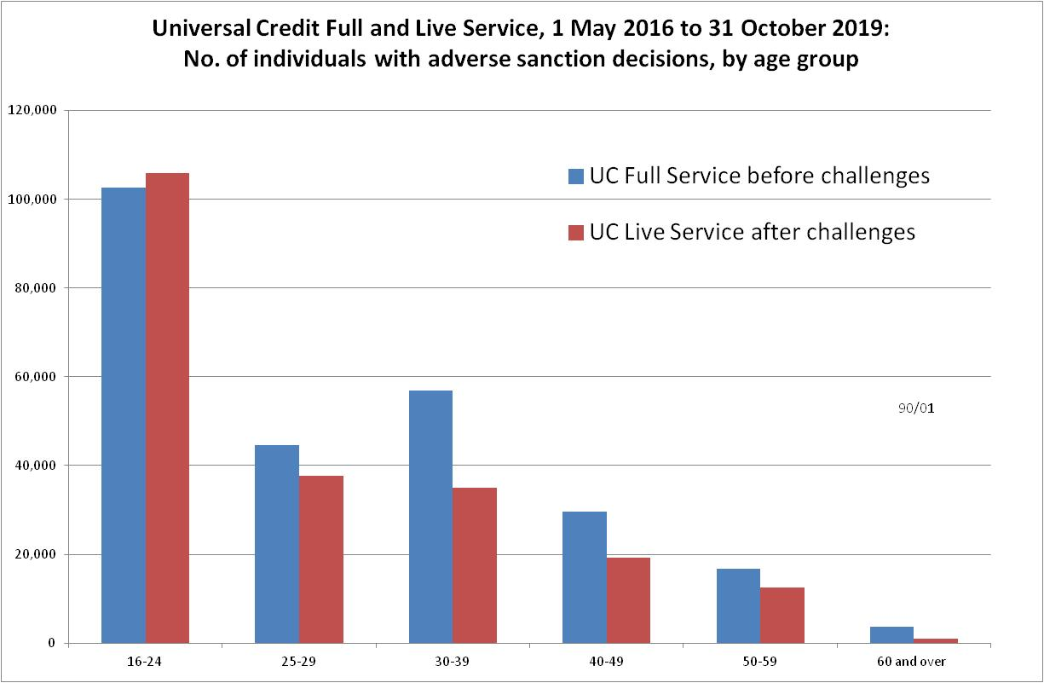

Figure 11
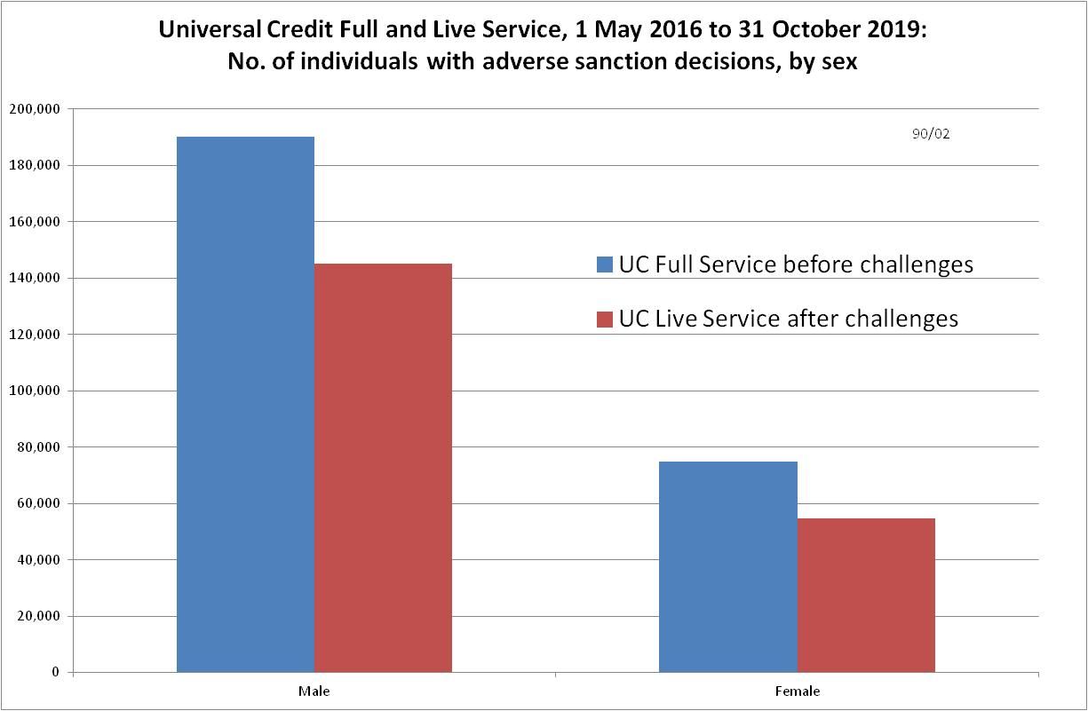
NOTES

Previous briefings are available at http://www.cpag.org.uk/david-webster. They include many analyses that are not repeated here but remain valid. However it should be remembered that the DWP may have made subsequent revisions to the data reported in earlier briefings. These revisions will generally not be major although there are exceptions and there may often be substantial changes in some figures for the most recent few months.
Available at https://www.gov.uk/government/publications/sanctions-durations-and-rate-background-information-and-methodology
The total number of people subject to sanctions cannot be stated exactly, because there are some categories of Income Support claimants other than lone parents with a child under one who are not subject to sanctions, and there are no data on their numbers. However, they are likely to number in the low tens of thousands.
The UC claimants in the ‘working – with requirements’ group are low paid or part-time workers. Those ‘planning for work’ are mainly lone parents with a child aged 1, while those ‘preparing for work’ are people who would have been in the ESA Work Related Activity Group, and lone parents with a child aged 2 but under 5. The statistical categories for conditionality regime used in Stat-Xplore are explained in the ‘i’ feature next to the variable name in Stat-Xplore and also in the Universal Credit Statistics methodology document at https://www.gov.uk/government/publications/universal-credit-statistics-background-information-and-methodology
Lone parents with youngest child aged one to five have been estimated simply as four fifths of the total with youngest child aged 0 to five.
The basic concept of the DWP’s sanctions database(except for the new Full Service data) is that each sanction case appears only once, and is given its latest status and attributed to the month of the latest decision on the case. So, for instance, if a decision is made in January 2014 to sanction someone, this decision is reviewed in March 2014 with an outcome unfavourable to the claimant, reconsidered in a ‘mandatory reconsideration’ in May 2014 again with an unfavourable outcome, and is heard on appeal by a Tribunal in October 2014 with a decision favourable to the claimant, - it appears in the statistics for the first time in January 2014 as an adverse ‘original’ decision - in March 2014 it changes its status to a ‘reviewed’ adverse decision and moves month to be with all the other cases where the latest decision has been made in March 2014 - in May 2014 it changes its status to a ‘reconsidered’ adverse decision and moves month to be with all the other cases where the latest decision has been made in May 2014 - in October 2014 it changes its status again to an appealed non-adverse decision, and moves month again to be with all the other cases where the latest decision has been made in October 2014. DWP now says that it aims to change this system for Universal Credit sanctions at some point in the future in order to show all decisions at each stage.
The estimates of sanctions before challenges have been derived by adding the monthly total of ‘non-adverse’, ‘reserved’ and ‘cancelled’ decisions shown as being the result of reviews, mandatory reconsiderations and tribunal appeals, to the monthly total of adverse ‘original’ decisions. This produces only an approximate estimate for each individual month, since decisions altered following challenge are not attributed to the correct month. It will be particularly unreliable for months affected by a DWP catch-up of a backlog of decisions. But the estimates are reliable for longer periods.
See the updated Universal Credit Sanctions Background Information and Methodology at https://www.gov.uk/government/publications/universal-credit-sanctions-statistics-background-information-and-methodology DWP have subsequently told me the following: ‘These errors occur for reasons such as an incorrect end date (or similar) being entered onto the system at the front-end, and the decision maker immediately realising this and correcting it. The error would be corrected well before it has any chance to impact the claimant’s payment. Although the incorrect sanction appears in our underlying data, it is completely removed from the front-end system used by claimants and work coaches/decision makers. It is not likely that these errors do affect a claimant’s payment; when a sanction decision is input onto the system (which is what provides our data for sanction counts), the claimant’s actual benefit payment doesn’t drop until the next assessment period, which could mean a time gap of several weeks between the date on which the sanction is entered into the system and the change in the claimant’s payment.’ DWP also point out that ‘cancelled’ cases refer to those which are stopped at the referral stage, whereas in the ‘error’ cases the sanction is stopped after an adverse decision has been made.
The In-work Progression conditionality trial started in 10 Jobcentres in April 2015 and began rollout across the whole country in December 2015, in both Full and Live Service. The trial finished on 31 March 2018. 30,709 claimants passed through the trial. About two-thirds ('frequent' & 'moderate' support) were in the trial for at least a year, the other one third for at least 2 months. The total number of people in the ‘working – with requirements’ group rose from 4,000 in April 2015 to 103,000 in March 2018. We therefore know that a substantial proportion of the group were in the trial at any one time, but we do not know how many.
Pre-October 2016 data for lone parents on IS are not comparable with the current data.
The figure given in the Benefit Sanctions Statistics table is 47,877 claimants receiving repeat sanctions for Full Service only. A pro rata adjustment has been made to add estimated numbers for Live Service, by assuming that Live Service was administered in the same way. This results in an estimate of 49,850 for all of UC. Because Live Service now has very few cases, this is not very different from the official figure but will be more accurate.

