BRIEFING

Benefit Sanctions Statistics

August 2023

29 August 2023

Dr David Webster
Honorary Senior Research Fellow
Urban Studies
University of Glasgow

Email david.webster@glasgow.ac.uk

Webpages: http://www.gla.ac.uk/schools/socialpolitical/staff/davidwebster/
http://www.cpag.org.uk/david-webster

SUMMARY

This Briefing reports on the quarterly Universal Credit (UC) sanctions statistics for Great Britain published by DWP on 15 August.

Sanctions continue to run at a high level. A monthly average of 42,186 UC sanctions were imposed in the latest quarter to April 2023 and there were a total of 519,854 UC sanctions in the year to April 2023. The total number of individual UC claimants who were sanctioned during the year was 408,549. Of these, 85,252 (20.9%) received more than one sanction, and 20,021 (4.9%) received more than two. In the last full 12 months before the pandemic, to January 2020, there were 230,720 UC sanctions and 178,476 sanctioned individual claimants. The monthly total of 42,186 sanctions in the latest quarter exceeds that for all periods since the start of the present reporting system in 2000, except for the Coalition government’s sanctions drive of 2010-15. These figures do not include sanctions on JSA, ESA or IS which however seem likely to have been very few.

The number of UC claimants who were serving a sanction at a point in time has continued at around 115,000 – 120,000, or 6.35% of UC claimants subject to conditionality. This is much higher than before the pandemic, when it was around 35,000 (3.1% or less). Of unemployed UC claimants, 7.72% or 1 in 13 were under sanction in May 2023. The average duration of a UC sanction is about 11 or 12 weeks.

The total number of people on UC was a provisional 6.06m in July 2023. Within this there were 1.92m UC claimants subject to conditionality, or 31.65% of all UC claimants.

DWP has begun publication of two new sets of relevant statistics, on Work Capability Assessments (WCAs) for UC claimants and on Moves to UC via ‘managed migration’. It also says it has completed investigative and corrective work on the statistics on the proportion of UC claimants serving a sanction at a point in time prior to April 2019, and on the duration of UC sanctions, and will resume publication, although it has not yet given a date.

In March 2023 there were 1,676,770 people claiming UC on health grounds (‘UC Health’). This caseload is dominated by the LCWRA group (‘Limited Capability for Work or Work-Related Activity’ – no conditionality) at 1.12m. The LCW group (‘Limited Capability for Work’ - requirements to prepare for work but not to look for work) was 0.295m, while the ‘Pre-WCA’ group was 0.259m. Just under two-thirds of WCAs result in a LCWRA classification, and just under one-fifth each in LCW or in refusal to acknowledge any health or disability-related limitation of capacity for work (NLCW).

At March 2023 sick or disabled claimants accounted for well over half (3.30m or 57.8%) of the 5.71m working age claimants of all benefits, while the unemployed accounted for only just over one quarter (1.52m or 26.7%), with carers at 0.88m (15.5%). At April 2023 there were an estimated total of 2.30m claimants on all benefits subject to conditionality.

There is still no improvement in the coverage of the UC sanctions statistics, which have never given any information on the appeal system or on the ‘levels’ of sanction for Full Service (which now covers all UC sanctions).

The news section of the Briefing has more information about the new requirements being imposed on lead carers of children, and about new publications on sanctions.

BRIEFING: Benefit Sanctions Statistics
August 2023

The DWP released its latest quarterly sanctions statistics for Universal Credit on 15 August. The newly published data are summarised by DWP in the online publication Benefit Sanctions Statistics, available along with methodological notes at https://www.gov.uk/government/collections/jobseekers-allowance-sanctions together with a spreadsheet with summary tables. Some data are on Stat-Xplore at https://stat-xplore.dwp.gov.uk/webapi/jsf/login.xhtml . All statistics presented here relate to Great Britain. All previous Briefings are available at http://www.cpag.org.uk/david-webster .

DWP no longer publishes updates to statistics on sanctions for Jobseekers Allowance (JSA), Employment and Support Allowance (ESA) and Income Support (IS). JSA and ESA are not merely ‘legacy’ benefits since there are new claimants of the ‘New Style’ (contribution-based) versions of these benefits. But we will not know about any sanctions on these benefits except via Parliamentary Questions or FoI requests. There are now very few if any JSA claimants other than on New Style.

Since November 2020 two sets of sanctions statistics have been suspended, namely the proportion of UC claimants serving a sanction at a point in time prior to April 2019, and the duration and median length of UC sanctions. There is now good news in that DWP state in the ‘Changes, revisions and known issues’ section of the new edition of Benefit Sanctions Statistics, that investigative and corrective work on these statistics is complete and that following quality assurance exercises publication will be resumed. No date is yet given.

There is still no improvement in the coverage of the UC sanctions statistics, which have never given any information on the appeal system or on the ‘levels’ of sanction for Full Service (which now covers all UC sanctions). However, DWP has commenced publication of two new related sets of statistics:

- On 8 June 2023 DWP published the first set of quarterly statistics on the number of UC claimants undergoing or who have undergone Work Capability Assessments (WCAs) by stage of process, giving monthly decisions and outcomes since April 2019. These can be viewed at https://www.gov.uk/government/collections/universal-credit-work-capability-assessment-statistics
- On 15 August DWP commenced publication of statistics on Moves to Universal Credit via ‘managed migration’. These are at https://www.gov.uk/government/statistics/move-to-universal-credit-statistics-july-2022-to-may-2023 There is also background information at https://www.gov.uk/government/publications/move-to-universal-credit-statistics-background-information and a release strategy at https://www.gov.uk/government/publications/move-to-universal-credit-statistics-release-strategy

Both new sets of statistics are discussed below.

Number of people on Universal Credit (UC) and number of UC claimants subject to conditionality

The total number of people on UC was a provisional 6.06m in July 2023. Within this there were 1.92m UC claimants subject to conditionality in July 2023, or 31.65% of all UC claimants.

The largest group of UC claimants subject to conditionality is those ‘searching for work’, i.e. unemployed. They were 1.44m in July 2023 (Figure 1), accounting for 94.2% of all claimant unemployed; the other 5.8% of the claimant unemployed were the 88,793 claimants on JSA.

The key point arising from the new ‘Move to UC’ statistics is that to date, ‘managed migration’ will have had very little effect on the size or composition of the body of UC claimants. From the start of migration in July 2022 up to the end of May 2023, only 22,190 households (excluding a small number of couple households) had been sent migration notices, of whom only 7,800 had made a claim to UC. The low level of claims is said to be mainly because the vast majority of those sent notices to date were claimants of tax credits, who are less likely than others to have an entitlement to UC. ‘Managed migration’ can be expected to have more effect on UC claimant numbers in the future.

Impact of raising of the Administrative Earnings Threshold (AET)

The UC Administrative Earnings Threshold (AET) determines whether a claimant is in the ‘working – with requirements’ group or the ‘searching for work’ group. If below it, the claimant is in the latter group, and if above it, in the former. It has been raised in two stages, from 9 to 12 hours in September 2022 and from 12 to 15 hours in January 2023. The government’s intention is to push people into working more hours, or raising their earnings, by moving them from the ‘working – with requirements’ group to the ‘searching for work’ group, which involves heavier work search requirements. Prior to the changes, its estimate was of 114,000 claimants moved from ‘working – with requirements’ at the first stage and 120,000 at the second stage, a total of 234,000.

Figure 1 shows the numbers in each conditionality group since January 2022 (longer period charts are available in earlier issues of the Briefing). Since September 2022 there has been a net fall of 200,247 in the ‘working – with requirements’ group. This figure will have been affected by other changes also, so it is not too far off the DWP estimate of 234,000. However, only a net 58,366 have been added to the ‘searching for work’ group, a figure which will also have been affected by other changes. Claimants moved from the ‘working – with requirements’ group by the change in AET might have stopped claiming UC altogether, moved into a sick status or of course have obtained additional work or earnings to take them over the new threshold, enabling them to stay in the ‘Working – with requirements’ group. Only DWP has the data on moves between statuses which would make it possible to establish what has actually happened, and to evaluate the effectiveness of the policy. It is especially important that DWP should evaluate the policy since the Budget on 15 March announced a further planned rise in the AET to 18 hours. Timing for this has not yet been decided, although DWP’s Equality Analysis (DWP 2023b) has stated that it is working on the basis of an autumn 2023 implementation date.

Universal Credit claimants with recognised ill health or disability status

The newly published WCA statistics cast some further light on the make-up of the caseload of UC claimants. In March 2023 there were 1,676,770 people claiming UC on health grounds (‘UC Health’). Figure 2 shows the composition of this caseload for each month since April 2019. The three categories are ‘Limited Capability for Work or Work-Related Activity’ (LCWRA), meaning no conditionality; ‘Limited Capability for Work’ (LCW), meaning requirements to prepare for work but not to look for work (i.e. the equivalent of the ESA Work-Related Activity Group); and ‘Pre-Work Capability Assessment’, meaning that the claimant has produced satisfactory evidence of work-limiting ill-health or disability but has not yet undergone a WCA.

As more and more claimants have transferred across from ESA, or claimed UC who would have claimed ESA, the UC Health caseload has come to be dominated by the LCWRA group, at 1.12m in March 2023. The LCW group, at 0.295m in March 2023, is comparable in size to the old ESA WRAG, which peaked at 0.563m in August 2013 but has now shrunk to 0.162m by April 2023. The ‘Pre-WCA’ group at 0.259m is a measure of the WCA queue, and has not changed much.

Figure 3 shows the outcomes of WCAs for UC. After disruption during the pandemic, the figures have settled down into a fairly stable picture, with just under two-thirds of WCAs resulting in a LCWRA (no conditionality) classification, and just under one-fifth each resulting in LCW or in refusal to acknowledge any health or disability-related limitation of capacity for work (NLCW).

Out-of-work benefit claimants by reason for claiming

UC recognises only three reasons for paying out-of-work benefits to working age claimants: sickness or disability; unemployment; and caring responsibilities, as a parent or otherwise. Figure 4 splits the total of out-of-work UC claimants (3.84m at March 2023) into these three categories, on the assumption that none of the claimants with recognised health/disability status will have been placed in the ‘Searching for work’ regime. In March 2023 there were 1.68m sick or disabled UC claimants, accounting for 43.6% of out-of-work UC claimants. There were 1.43m unemployed UC claimants, accounting for 37.2% of out-of-work UC claimants. By subtraction, there were 0.74m carers, accounting for 19.1% of out-of-work UC claimants.

These figures do not include out-of-work claimants on JSA, ESA or Income Support. When they are included, the position for the total 5.71m working age out-of-work benefit claimants is considerably different (Figure 5). Almost half of all claimants on grounds of sickness or disability were still on ESA at March 2023. Consequently sick or disabled claimants accounted for well over half (3.30m or 57.8%,) of all working age benefit claimants, while the unemployed accounted for only just over one quarter (1.52m or 26.7%), with carers at 0.88m (15.5%).

Total claimants on all benefits subject to conditionality

Reporting on legacy benefits is less up-to-date than on UC. At April 2023 there were still an estimated 388,000 claimants on the legacy benefits subject to conditionality, comprising 162,000 in the ESA Work Related Activity Group, 135,000 on Income Support and 91,000 on JSA. Added to the 1.91m UC claimants subject to conditionality at that date, there were therefore an estimated total of 2.30m claimants on all benefits subject to conditionality.

The monthly number of Universal Credit sanctions has stabilised at a high level

After rising rapidly and continuously following the pandemic, monthly UC sanctions have clearly now stabilised, at least for the time being, both in total numbers and as a percentage of UC claimants subject to sanctions. But they are running at a higher level than before the pandemic (Figures 6 and 7).

Number of UC sanctions being imposed per month

Monthly UC sanctions reached a peak of 58,532 in March 2022 but since then have fallen back, to an average of 42,186 in the latest quarter, to April 2023 (Figure 6). This is almost two-and-a-half times the average in the last full three months before the pandemic (to February 2020), which was 17,293.

Monthly UC sanctions as a percentage of UC claimants subject to conditionality

UC sanctions have also stabilised as a percentage of UC claimants subject to conditionality (Figure 7). The monthly average of 42,186 for the latest quarter to April 2023 equates to 2.25% per month of UC claimants subject to conditionality. In the three months immediately preceding the pandemic, i.e. December 2019 to February 2020, it was 1.4% per month.

As noted in previous Briefings, the overall rate for UC puts together different categories of claimant with very different rates of sanctioning – unemployed, sick/disabled and those with caring responsibilities. The rate for unemployed claimants (‘searching for work’) is much higher than for the other conditionality groups, which have quite low rates of sanctioning. This is the reason for the very high initial rates of UC sanctions shown in Figure 7: when UC live service was launched, it was only available to single people without dependants, and they tend to be young people, who have high rates of sanction.

No. of Universal Credit sanctions and no. of UC claimants sanctioned during the year to 30 April 2023

The DWP’s Benefit Sanctions Statistics spreadsheet has a table showing the numbers of individuals who received two, three, four etc UC sanctions during the year to April 2023.
Since the total number of sanctions imposed is also shown, it is possible to calculate how many individual UC claimants were sanctioned during the year. Of the 519,854 UC sanctions imposed, 111,305 were repeat sanctions on individuals who had already received at least one sanction during the year. Therefore the total number of individual UC claimants who received at least one sanction during the year was 408,549. Of these, 85,252 (20.9%) received more than one sanction, and 20,021 (4.9%) received more than two. In the last full 12 months before the pandemic, to January 2020, there were 230,720 UC sanctions and 178,476 sanctioned individual claimants.

Monthly total sanctions on all benefits

Figure 8 shows the monthly total number of sanctions on all benefits (UC, JSA, ESA and IS) since the start of the current recording system in April 2000. The current level of about 42,000 is higher than at any time other than the coalition government’s sanctions campaign of 2010 to 2015. Figures for May 2022 onwards assume that sanctions on JSA, ESA and IS have continued to be negligible.

Universal Credit claimants serving a sanction at a point in time

Number of UC claimants serving a sanction at a point in time

The number of UC claimants who were serving a sanction at a point in time has continued at around 115,000 – 120,000 (Figure 9). This is much higher than before the pandemic, when it was around 35,000.

Percentage of UC claimants subject to conditionality who were serving a sanction at a point in time

Figure 10 shows the same data as a percentage of UC claimants subject to conditionality. This measure has also stabilised or very slightly fallen, at 6.35%. This percentage is more than double the pre-pandemic peak of 3.1% in October 2019 and equates to one in 16 of UC claimants subject to conditionality.

UC claimants serving a sanction at a point in time by conditionality group

Figure 11 shows the percentage of UC claimants subject to each individual conditionality regime who were serving a sanction at the measurement date in each month. As usual, unemployed (‘searching for work’) claimants were far more likely to be sanctioned than the other two groups subject to conditionality, with 108,411 or 7.72% under sanction in May 2023 compared to 0.64% for both ‘planning for work’ and ‘preparing for work’. One in 13 unemployed UC claimants was under sanction in May 2023.

There are also people in the groups not subject to conditionality who are serving sanctions. That is because under UC, sanctioned claimants are made to serve out the whole of their sanction even if they move into a no-conditionality group, for instance because of illness. There were 5,853 of them in May 2023, almost half (2,853) of these in the ‘working – with requirements’ group. This group are the most likely to have recently been unemployed and therefore to have been sanctioned.

Duration of Universal Credit sanctions

DWP is not currently publishing statistics on the duration of UC sanctions. But the proportion of UC claimants subject to conditionality who were under sanction has been rather stable at an average of around 6.5% since July 2022, and the proportion being given a sanction each month has also been stable at an average of around 2.4% since April 2022. It follows that the average duration of a UC sanction must be around 2.7 months or around 11 or 12 weeks, confirming the estimate given in the previous three Briefings. We may hope soon to have an official DWP figure, but the average will not be significantly different, although DWP will emphasise the median (i.e. the most typical duration), which will be substantially shorter.

Reasons for Universal Credit sanctions

According to DWP, almost all UC sanctions (96.1% in the latest quarter to April 2023) are now for ‘Failure to attend or participate in a Work-Focused Interview’. This contrasts with 87.5% in November 2019-January 2020 (the last full quarter before the pandemic). As mentioned in previous Briefings, it is difficult to credit such a high figure for sanctions for interviews. It seems likely that the reason ‘Failure to attend or participate in a Work-Focused Interview’ is now being used to include cases where claimants have not done the work search or other activities required by their Work Coach. However, as previously noted, categories of reason other than interviews have continued to increase slightly, while remaining very small, with a total of only 4,930 out of 121,630 sanctions imposed in the quarter to April 2023.

SANCTIONS – OTHER DEVELOPMENTS

Commencement of increased conditionality for lead carers of children

A DWP press release on 24 July at https://www.gov.uk/government/news/thousands-of-parents-to-benefit-from-more-work-coach-support announced the start that day of the increased requirements being imposed on the lead carers of children aged 1 or 2 (see the May 2023 Briefing, pp.7-8). There are approximately 98,000 of the former and 84,000 of the latter. The former will have to meet their ‘work coach’ every three months instead of every six months, and the latter every month instead of every three months.

The same press release announced that in the Autumn, DWP will also increase the maximum work-related activity or work availability expected of lead carers of children aged 3 or 4 to 30 hours from the current 16 hours, and for lead carers of children aged from 5 to 12 also to 30 hours, from the current 25 hours. There are approximately 140,000 of the former and 385,000 of the latter.

DWP says that the actual requirements and number of hours will be tailored to a parent’s individual circumstances, including the availability of local childcare.

Additional information on characteristics of the 700,000 lead carers

A DWP Freedom of Information response 2023/58228 dated 11 August 2023 has provided further information on the 700,000 lead carers of children who are affected by the Spring Budget changes (see the May Briefing, pp.7-8). The information is as at June 2023.

Of the 700,000 lead carers:

- 630,000 (90.0%) are women and 70,000 (10%) are men
- 230,000 (one third or 32.9%) have declared a health condition. while 470,000 (two-thirds or 67.1%) have not
- 340,000 (48.6%) had earnings from employment or self-employment or were required to report self-employment earnings; the remaining 360,000 (51.4%) did not.
- Of the 340,000 who had earnings, 310,000 (91.2%) were women and 30,000 (8.8%) were men
- Of the 360,000 who did not have earnings, 320,000 (88.9%) were women and 40,000 (11.1%) were men
- Of the 340,000 who had earnings, 90,000 (26.5%) have declared a health condition
- Of the 360,000 who did not have earnings, 140,000 (38.9%) have declared a health condition.

Work and Pensions Committee – Safeguarding Vulnerable Claimants inquiry

On 21 July the House of Commons Work and Pensions Committtee announced an inquiry into how the DWP supports vulnerable benefit claimants, whether its approach needs to change, the effectiveness of the current Internal Process Review arrangements and whether DWP should be subject to new statutory requirements. The announcement is at https://committees.parliament.uk/work/7866/safeguarding-vulnerable-claimants/ and the Call for Evidence is at https://committees.parliament.uk/call-for-evidence/3210 The closing date for submissions is 13 October.

Westminster Hall debate on Universal Credit deductions - 13 July

On 19 July there was a House of Commons Westminster Hall debate on Universal Credit deductions, led by Chris Stephens MP (SNP Glasgow SW). It did not secure any significant concessions from ministers. The transcript is at https://hansard.parliament.uk/commons/2023-07-19/debates/D0BF8F1F-5161-4A99-AE99-DC6F59A668A2/UniversalCreditDeductions

Citizens Advice report on Universal Credit sanctions

On 18 July Citizens Advice at https://www.citizensadvice.org.uk/about-us/our-work/policy/policy-research-topics/welfare-policy-research-surveys-and-consultation-responses/welfare-policy-research/the-sanctions-spiral-the-unequal-impact-and-hardship-caused-by-sanctions-in-universal-credit/ announced publication of a report on the damage caused by benefit sanctions (Harrison 2023).

The report says people are telling Citizens Advice that they have been sanctioned for missing meetings due to ill health, caring responsibilities or phone or internet issues and that work coaches often apply sanctions without asking claimants why they didn't do the required activity. It found that 94% of people who had been sanctioned in the last 6 months had had to cut back, borrow money, seek crisis support and/or go without essentials. Among CAB debt clients, the median income of people who had been sanctioned was £132 lower than for people on UC in general. The loss of income from sanctions can cause people's mental and/or
physical health to deteriorate if they are faced with a lack of food, heating or electricity, as well as additional anxiety over their finances.

The report recommends that DWP should publish more demographic data on UC claimants, especially those subject to sanctions, and should ensure that staff give people time to explain or submit evidence before a sanction is applied. In the longer term, the report argues that we need a fresh approach and a move away from sanctions that too often penalise people for being on a low income.

Trussell Trust report on Hunger in the UK

On 28 June the Trussell Trust at https://www.trusselltrust.org/what-we-do/research-advocacy/hunger-in-the-uk/ published a major report on food poverty (Bull et al. 2023), expanding previous work to investigate its prevalence and profile in the population at large as well as among users of food banks.

The report finds that the most significant cause of the financial insecurity driving the need for food banks is the design and delivery of the social security system. The research highlights four main benefit issues affecting food bank users: lack of information about entitlements; difficulties claiming and sustaining benefits, particularly Personal Independence Payments (PIP) for people who are affected by a long-term physical or mental health condition or disability; insufficient income from benefits when they are accessed; and further reductions to income from sanctions, caps and debt deductions. In fact the majority (62%) of working-age people in receipt of social security referred to food banks in the Trussell Trust network have
their benefit income capped or reduced, for instance by debt deductions or sanctions. Some participants in the research workshops spoke about being sanctioned for not updating their Universal Credit journal because they were prioritising bills and food instead of paying for
access to the internet.Workshop participants highlighted the importance of the power dynamic between claimants and work coaches. Some believed that this contributed to their interactions feeling unsupportive or dismissive: ‘You’re guilty until proven innocent’.

REFERENCES

Bull, Rachel , Charlotte Miles, Emma Newbury, Adam Nichols, Thomas Weekes and Grace Wyld (2023) Hunger in the UK, Trussell Trust, June, at
https://www.trusselltrust.org/wp-content/uploads/sites/2/2023/08/2023-The-Trussell-Trust-Hunger-in-the-UK-report-web-updated-10Aug23.pdf , with associated reports including the Technical Report at
https://www.trusselltrust.org/what-we-do/research-advocacy/hunger-in-the-uk/

DWP (2023a) Completing the move to Universal Credit: Learning from the Discovery Phase,
at https://www.gov.uk/government/publications/completing-the-move-to-universal-credit-learning-from-the-discovery-phase/completing-the-move-to-universal-credit-learning-from-the-discovery-phase

DWP (2023b) Equality Analysis: Raising the Administrative Earnings Threshold (January 2023 change), 17 April, at https://www.gov.uk/government/publications/changes-relating-to-in-work-progression-equality-analysis/equality-analysis-raising-the-administrative-earnings-threshold-january-2023-change

Harrison, Kate (2023) The Sanctions Spiral: The unequal impact and hardship caused by sanctions in Universal Credit, Citizens Advice, July, at
https://www.citizensadvice.org.uk/Global/CitizensAdvice/welfare%20publications/Sanctions%20report.pdf

Figure 1
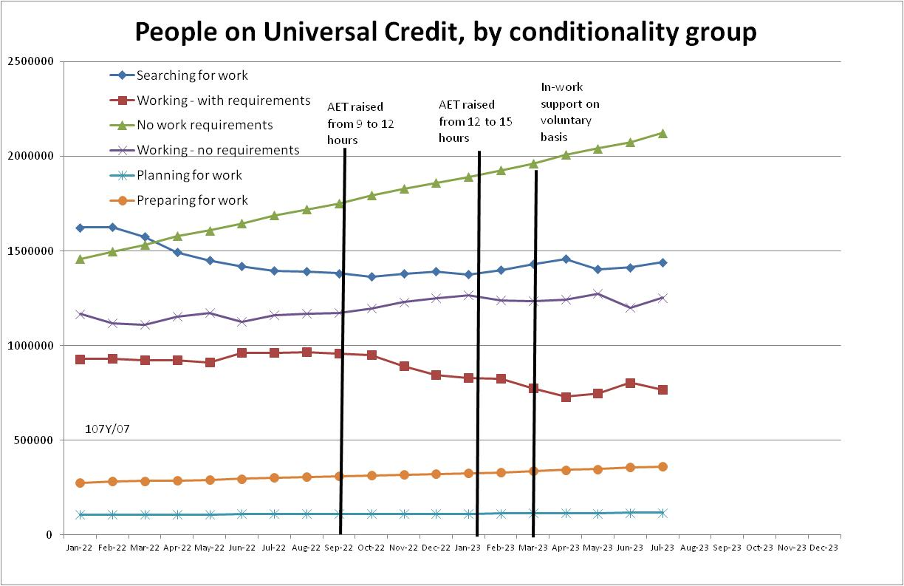

Figure 2
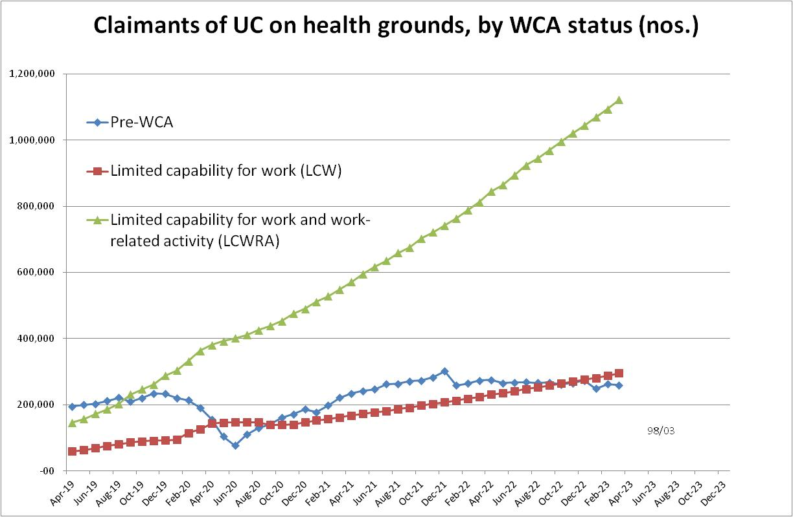

Figure 3
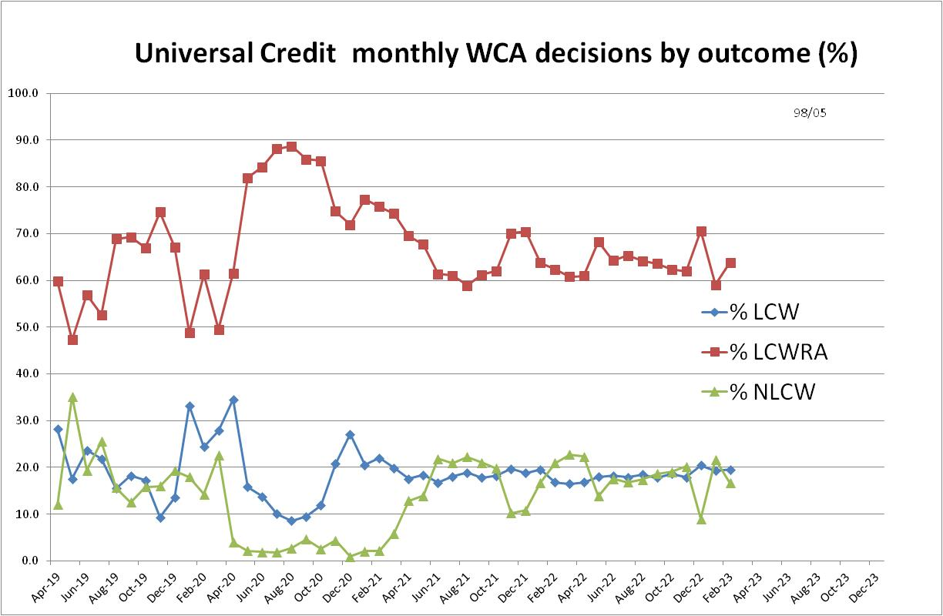

Figure 4
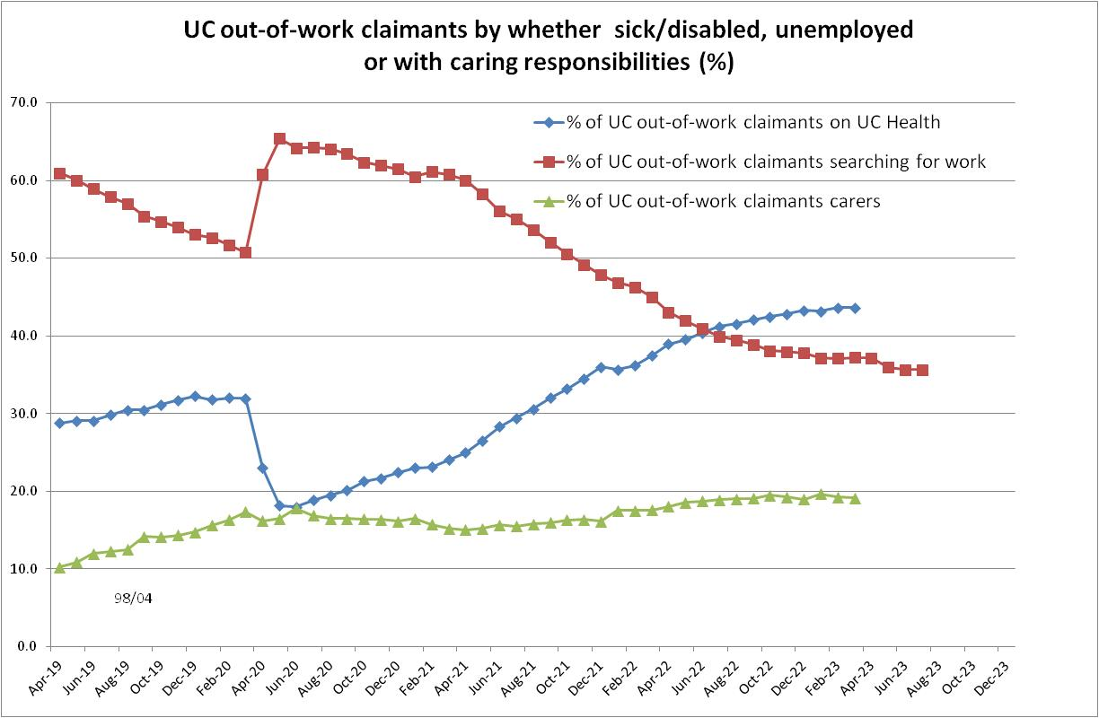

Figure 5
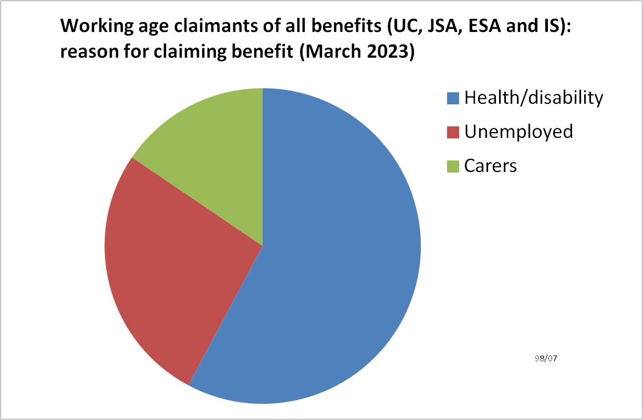
Figure 6
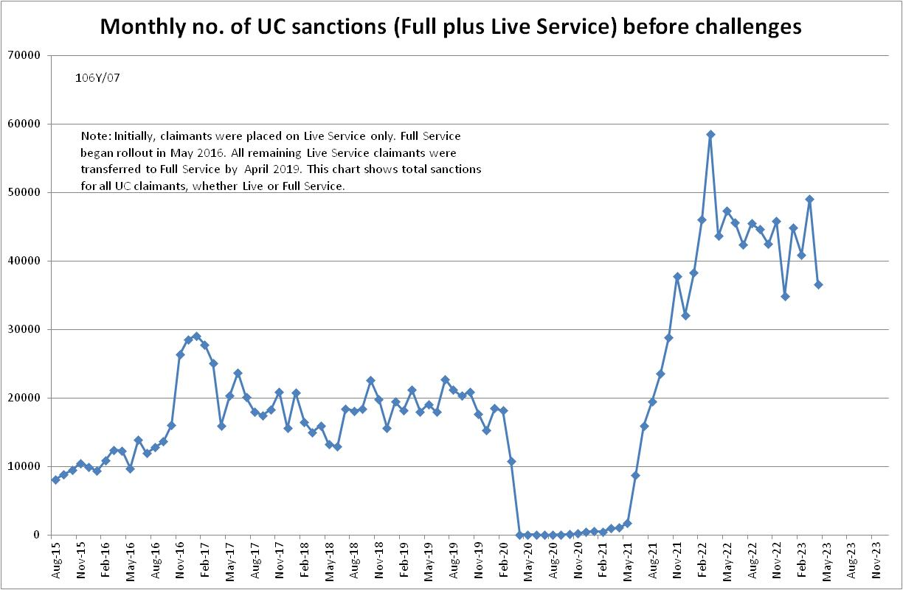

Figure 7
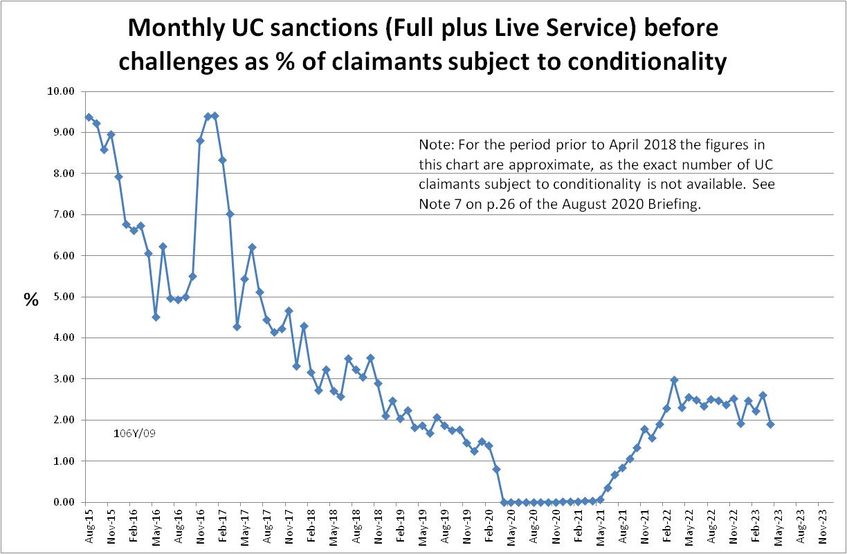

Figure 8
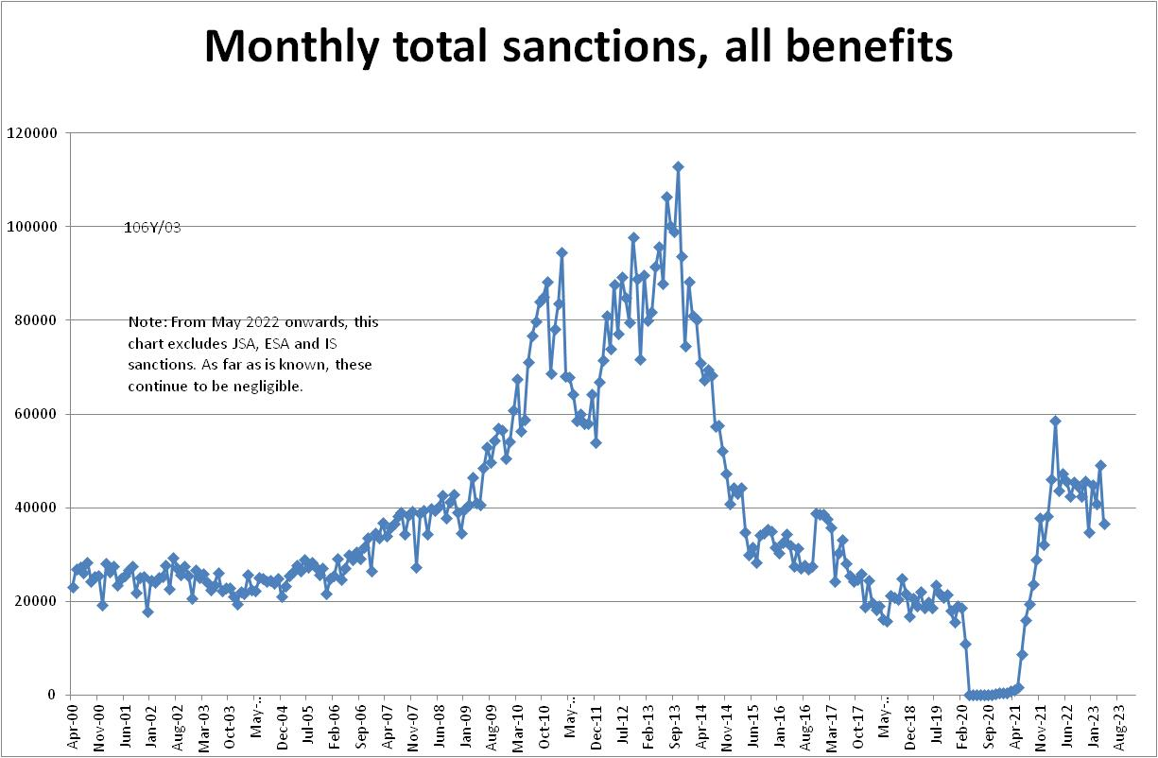

Figure 9
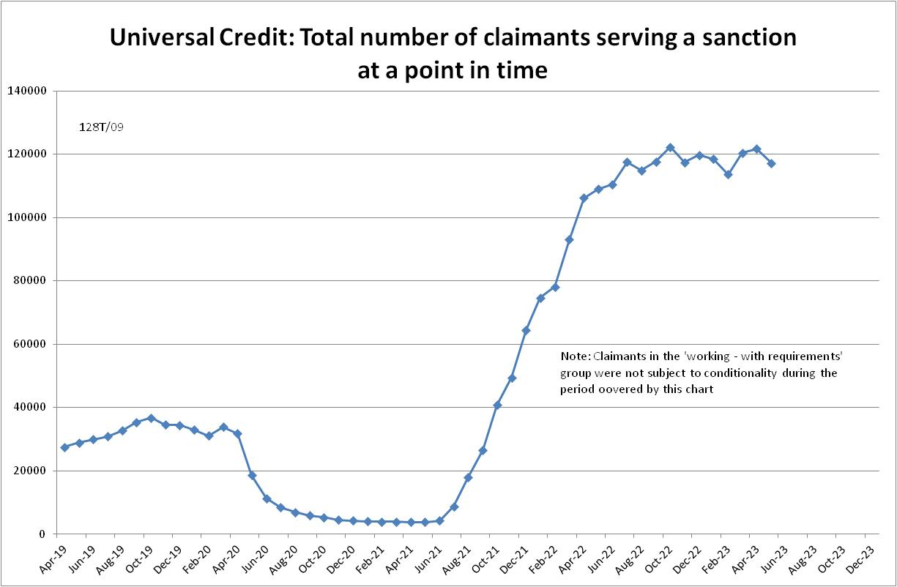

Figure 10
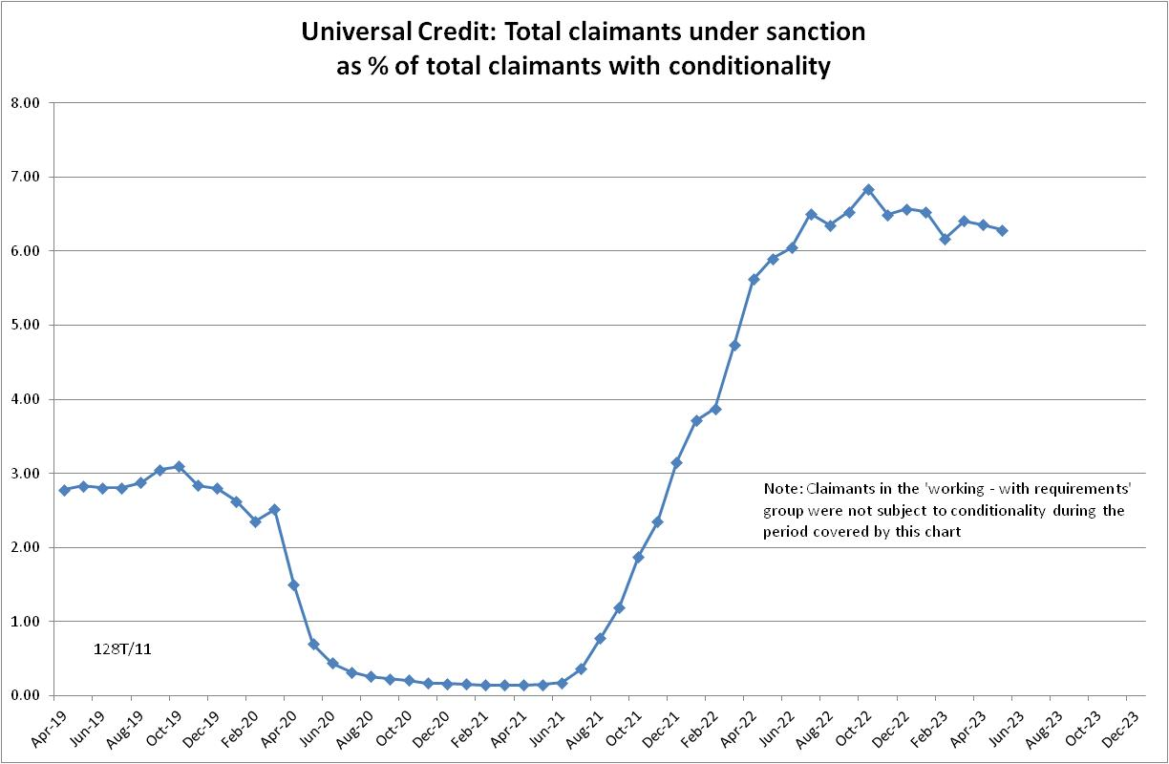

Figure 11
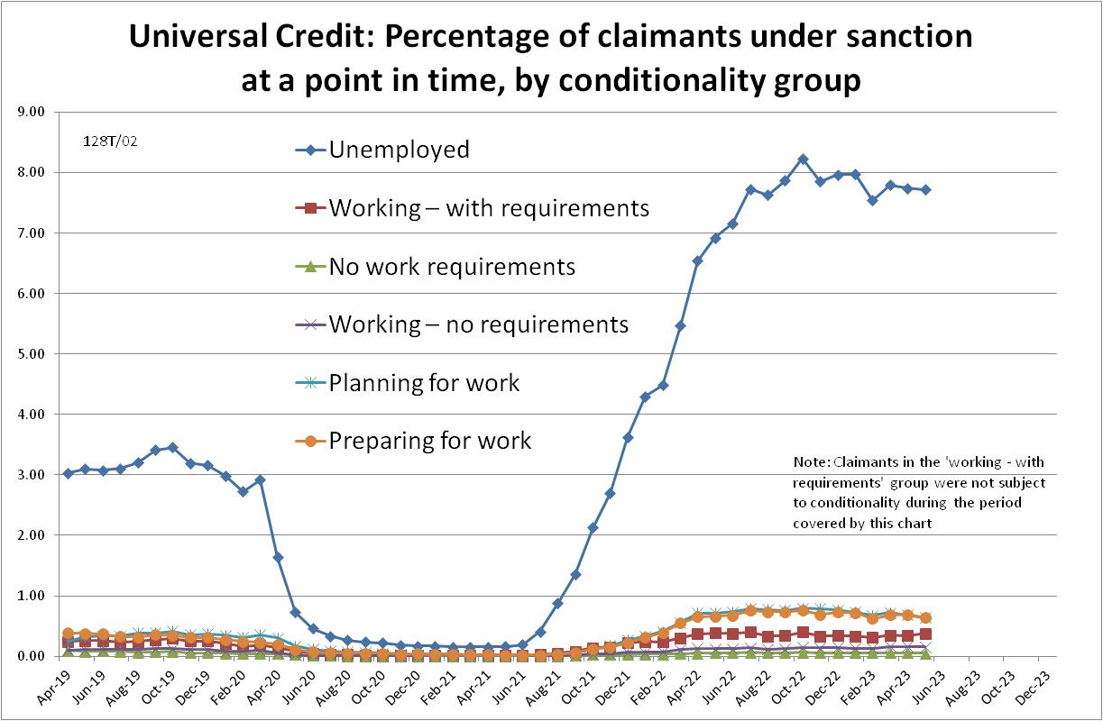

NOTES

Previous Briefings include many analyses that are not repeated here but remain valid. However it should be remembered that the DWP may have made subsequent revisions to the data reported in earlier Briefings. These revisions will generally not be major although there are exceptions. There may also often be substantial changes in some figures for the most recent few months.
A DWP report on the progress of managed migration (DWP 2023a) states that the final migration of claimants from old-style JSA to UC may not be completed before the end of 2024/25. Old-style JSA is already closed to new claimants.
The drawbacks of the ‘claimants under sanction at a point in time’ measure were discussed in the November 2017 issue of the Briefing, pp.6-10. In November 2020, DWP withdrew the UC ‘rate’ data for all months prior to April 2019, pending revision of the figures for the former ‘Live Service’. These figures remain withdrawn. In addition, in the February 2021 release DWP made significant revisions to the figures for April 2019 onwards (which are for Full Service only, there being no one left on the former Live Service). These were fully discussed in the February 2021 Briefing.
Currently available figures for the number of UC claimants under sanction only go back to April 2019 as DWP has withdrawn the figures for earlier dates. But the numbers previously published by DWP for the period before April 2019 are so far below those in 2022 that no conceivable revisions could make them higher than in 2022.

