Benefit Sanctions Statistics:
Special Briefing

DWP STATISTICAL RELEASE ON DISENGAGED SANCTIONED CLAIMANTS, December 2023

22 January 2024

Dr David Webster
Honorary Senior Research Fellow
Urban Studies
University of Glasgow

Email david.webster@glasgow.ac.uk

Webpages: http://www.gla.ac.uk/schools/socialpolitical/staff/davidwebster/
http://www.cpag.org.uk/david-webster

Special Briefing:
DWP STATISTICAL RELEASE ON DISENGAGED SANCTIONED CLAIMANTS,
December 2023

SUMMARY

The government announced in the Autumn Statement on 22 November that it would enable DWP to close the claims of individuals who have been on an open-ended sanction for over six months and who are solely eligible for the Universal Credit (UC) standard allowance. It has since clarified that this will require primary legislation which is unlikely to be passed in the current Parliament. DWP published a statistical release with information about these ‘disengaged’ sanctioned claimants on 12 December, and updated it with a new spreadsheet on 21 December.

The release shows that, had the necessary legislation been put in place at August 2023, there would have been 35,370 claimants (1.9% of sanctionable UC claimants) liable to have their claims closed immediately. This does not tell us how many claimants each month are reaching the 6-month threshold However this can be calculated from the data published by DWP. At the rate of July 2023, about 3,200 claimants per month, or 39,000 per year would have their claims closed under the new proposal.

The government has claimed that there is ‘a rapidly growing group of disengaged (snnctioned) claimants’. However the main reason for this is that the government is imposing more sanctions. You can only become a ‘disengaged’ sanctioned claimant if you are sanctioned in the first place. In fact around a third of sanctioned claimants have been becoming disengaged both before and after the pandemic (about 32% and about 37% respectively). Total UC sanctions in April 2019 to February 2020 were an average of 18,992 per month, whereas in October 2022 to July 2023 they were an average of 43,262 – more than twice as many.

It seems likely that the explanation for the slight increase in the proportion of sanctioned claimants disengaging since the pandemic is the pressure of work on Jobcentre staff, which would mean they are not following up on claimants or having the time to offer worthwhile support. The PCS union has explained that the service is near breakdown, in a dossier at https://www.mypcs.pcs.org.uk/s/article/DWP-boss-receives-devastating-dossier-staff-and-services-at-breaking-point. Claimants are presumably much more likely to disengage if engagement does not deliver value.

The release shows that disengaged sanctioned claimants eligible only for the standard allowance are disproportionately young men. It provides data on claimants reporting earnings to the UC system, but does not consider whether the disengaged sanctioned claimants might actually be in employment or pursuing their own job search.

Conflicting official statements suggest that the government is confused as to whether closing claims would affect claimants’ entitlement to free prescriptions and to legal aid.
Special Briefing:
DWP STATISTICAL RELEASE ON DISENGAGED SANCTIONED CLAIMANTS,
December 2023

Introduction

DWP published an important statistical release just before Christmas: Sanctioned disengaged claimants management information, April 2019 to August 2023, published on 12 December 2023 and re-released on 21 December with additional Excel tables, available at
https://www.gov.uk/government/publications/sanctioned-disengaged-claimants-april-2019-to-august-2023

This information is relevant to the announcement in the Autumn Statement on 22 November that the government will enable DWP to close the claims of individuals who have been on an open-ended (i.e. ‘lowest’ or ‘low’ level) sanction for over six months and who are solely eligible for the Universal Credit (UC) standard allowance. ‘Lowest level’ sanctions are for failure to attend or take part in a work-focused interview (WFI) and ‘Low level’ sanctions are for failing to meet a requirement other than a WFI, such as attendance on a training course. It has since been confirmed that this change will require primary legislation, suggesting that it may never happen. The junior DWP minister Lord Younger told the House of Lords on 30 November (col.1237) ‘(The Bishop of London) also asked about primary legislation and timing. Although I cannot give her any precise information on the timing, I can say that it is very unlikely that we will be able to bring this forward during this Parliament’ (emphasis added).

How many claimants would be liable to have their claims closed?

The statistical release shows that, had the necessary legislation been implemented for the first time at August 2023, there would have been 35,370 claimants liable to have their claims closed immediately. This was 1.9% of sanctionable UC claimants.

However this figure includes large numbers of claimants who had been ‘disengaged’ for much longer than 6 months and who would already have had their claims closed and not appear in this figure had the proposed legislation already been in force. It does not tell us how many claimants each month are reaching the 6-month threshold and therefore what would be the continuing monthly flow of closures. This monthly flow of claimants reaching 6 months of disengagement can be approximately calculated from the data provided by DWP, taking advantage of the fact that by definition people cannot join each monthly cohort of disengaged claimants as it ages, but can only leave it. The result is shown in Figure 1. The calculation method is explained in the Appendix.

This calculation shows that the approximate monthly total number of sanctioned claimants reaching 6 months’ disengagement was about 4,700 in July 2023, after peaking at 6,700 in August 2022. A fairly constant approximately 69% of these people were not entitled to additional UC elements and this means that at the rate of July 2023, about 3,200 claimants per month, or 39,000 per year would have their claims closed.

Is the number of ‘disengaged’ claimants ‘rapidly growing’?

In his House of Lords speech on 30 November, Lord Younger stated that ‘There is a rapidly growing group of disengaged claimants’. The statistical release contains charts which on superficial inspection could appear to support this. I have redrawn the key chart to make its message clearer and the result is shown in Figure 2. (Figure 2 shows monthly stocks of claimants whereas Figure 1 shows flows. In fact both convey the same message.) Figure 2 indicates that the rapid growth is exclusively in the ‘disengaged for 9 months or more’ category. All the shorter duration categories have declined from their earlier peaks. In other words there is a group of claimants who have already been disengaged for 9 months or more, who are neither discontinuing their claims nor re-engaging, and whose numbers are being continuously augmented as further claimants reach the 9 month threshold. But the numbers of newly sanctioned claimants entering the ‘disengaged' category are not increasing, as is also shown by Figure 1.

However what is also evident from Figures 1 and 2 is that the number of claimants entering the disengaged category is much larger than it was before the pandemic, which began in March 2020 when all sanctions were suspended for three months and interviews for more than a year. In the period April 2019 to February 2020, before the pandemic, there were an average of 8,991 disengaged claimants in the 6 weeks to 3 months category, whereas in the period October 2022 to July 2023 there have been an average of 24,223 – three times as many.
.
Why are there more disengaged sanctioned claimants?

A large part of the reason why there are more disengaged sanctioned claimants is simply that there are more sanctions. You can only become a ‘disengaged’ sanctioned claimant if you are sanctioned in the first place. DWP has never published data on the levels (‘low’, ‘lowest’ etc) of sanctions in Full Service Universal Credit (which now covers all UC claimants). However, both before and after the pandemic the predominant reason for sanctions was missing or not participating in an interview, so most (approximately 85% before, 95% after the pandemic) will have been ‘lowest level’. Total UC sanctions in April 2019 to February 2020 were an average of 18,992 per month, whereas in October 2022 to July 2023 they were an average of 43,262 – more than twice as many.

What these figures mean is that during the period April 2019 to February 2020 approximately 32% of sanctioned claimants were becoming disengaged each month, and in the period October 2022 to July 2023, 37% (the calculation method is shown in the Appendix). In other words, around one third of sanctioned claimants disengaged both before and after the pandemic. This is around 6,000 per month before the pandemic and around 16,000 after.

It seems likely that the explanation for the slight increase in the proportion of sanctioned claimants disengaging is the pressure of work on Jobcentre staff, which would mean they are not following up on claimants or having the time to offer worthwhile support. The PCS union says that the service is near breakdown, as explained in a dossier it has compiled from reports from 50 staff, at https://www.mypcs.pcs.org.uk/s/article/DWP-boss-receives-devastating-dossier-staff-and-services-at-breaking-point. Lord Younger said to the House of Lords on 30 November ‘I reassure the House that the quality of job coaches is increasing the whole time’. This may or may not be true but either way it appears that the quality of the service they provide has been falling. I have also had this confirmed to me first hand. Claimants are presumably much more likely to disengage if engagement does not deliver value.

Who are the disengaged sanctioned claimants?

The DWP’s statistical release also contains an analysis of the disengaged sanctioned claimants by age and gender. Disengagement is particularly an issue relating to young men. The statistical release shows that, of the 53,500 claimants disengaged for more than 6 weeks at August 2023 and eligible only for the UC standard allowance, 33,180 or 62.0% were men aged under 35 and only 8,220 or 15.4% were women of any age.

What is happening to the disengaged sanctioned claimants?

The statistical release does not offer any information about the circumstances of the disengaged sanctioned claimants. In his Autumn Statement speech on 22 November, the Chancellor said (col. 336), referring to the disengaged sanctioned claimants, ‘If they choose not to engage with the work search process for six months, we will close their case and stop their benefits.’ This was misleading, because their benefits are of course already stopped by the sanction. But also, precisely because these claimants are disengaged, DWP does not know what work search they are doing. All it knows is that they are not following DWP’s work search prescriptions, which as we know are often criticised, particularly for pressurising people into unsuitable or dead end jobs.

The statistical release has two tables (4.1 and 4.2) showing that around 10% of sanctioned claimants disengaged for over 6 weeks declare some earnings, and giving the amounts of the earnings. Presumably these declarations are by claimants receiving additional UC elements, since there would be little point in those receiving no UC making these declarations. Some of the earnings were significant: 5.1% of sanctioned claimants disengaged for 6 weeks or moe earned more than £500 in August 2023. So ministers have been wrong to suggest that all of these claimants are disconnected from the world of work.

This also raises the question whether some of the disengaged sanctioned claimants are actually in work and no longer eligible for UC. DWP could check this by examining HMRC’s Real Time Information (RTI) data on earnings, but there is no indication in the statistical release that it has done so. The true circumstances of many of the disengaged sanctioned claimants therefore remain a mystery.

Will closing UC claims affect claimants’ ‘passported’ entitlement?

The government appears confused as to whether closing UC claims would affect claimants’ entitlement to free prescriptions and legal aid. In parliamentary answers at

https://www.theyworkforyou.com/wrans/?id=2023-11-24.3677.h&s=universal+credit+sanction#g3677.r0
https://www.theyworkforyou.com/wrans/?id=2023-12-04.5099.h&s=universal+credit+sanction#g5099.r0
and
https://www.theyworkforyou.com/wrans/?id=2023-11-22.3291.h&s=universal+credit+sanction#g3291.r0
and in Lord Younger’s speech in the House of Lords at
https://www.theyworkforyou.com/lords/?id=2023-11-30b.1226.0&s=universal+credit+sanction#g1230.0
the government has stated that closure of claims would end free prescriptions. However, in a parliamentary answer on 17 January at
https://www.theyworkforyou.com/wrans/?id=2024-01-09.8756.h&s=universal+credit+sanction#g8756.q0
and another on 18 January at
https://www.theyworkforyou.com/wrans/?id=2024-01-15.9549.h&s=universal+credit+sanction#g9549.r0
it has now stated that free prescriptions end with imposition of the sanction, and therefore would not be affected by the closure of the claim.

Again, the government previously stated at
https://www.gov.uk/government/news/employment-support-launched-for-over-a-million-people
that closure of claims would end claimants’ entitlement to legal aid. But it has since stated that entitlement to legal aid will not be affected:
https://www.theyworkforyou.com/wrans/?id=2023-12-06.5538.h&s=universal+credit+sanction#g5538.q0

APPENDIX:
Calculating the approximate monthly total number of sanctioned claimants reaching 6 months’ disengagement, and the proportion of sanctioned claimants disengaging each month

The relevant data published by DWP in the spreadsheet accompanying the updated statisticsl release of 21 December were as follows:

Month | Duration 6 weeks to 3 months | Duration 3-5 months | Duration 6-8 months
Apr-19 | 8050 | 5110 | 2220
May-19 | 8210 | 5440 | 2310
Jun-19 | 9070 | 6260 | 2240
Jul-19 | 10310 | 6460 | 2440
Aug-19 | 10850 | 7310 | 2710
Sep-19 | 9920 | 7810 | 3160
Oct-19 | 9270 | 7720 | 3180
Nov-19 | 8700 | 7290 | 3410
etc. etc.

Calculating the approximate monthly total number of sanctioned claimants reaching 6 months’ disengagement

The 7-month monthly cohort at July 2019 is the same as the 4-month monthly cohort at April 2019. This monthly cohort numbers approximately 2440/3 = 813 at July 2019 and 5110/3 = 1703 at April 2019.

The difference between these two figures (i.e. the loss of people from the cohort) is approximately 890 over three months. The one-month loss is therefore approximately 890/3 = 297.

The 6-month monthly cohort at June 2019 is then the 4-month monthly cohort at April 2019 minus twice the monthly loss, i.e. 1703 – (297 x 2) = 1109.

The 6-month monthly cohorts for the remaining months are calculated similarly.

Note that these figures are for all disengaged sanctioned claimants. The disengaged sanctioned claimants not eligible for additional UC elements are taken to be approximately 69% of these figures as Table 2.1 of the DWP spreadsheet shows this to be a fairly constant proportion (range 65% to 74%) with an average of 69%.

Calculating the proportion of sanctioned claimants disengaging each month

There were an average of 18992 UC sanctions per month during the period April 2019 to February 2020 and an average of 43262 during the period October 2022 to July 2023. During the first period there were an average of 8991 claimants in the 6 weeks to 3 months cohort, a period of 1 ½ months, so an average of ( ((8991/1.5) / 18992) x 100 ) or approximately 32% were becoming disengaged each month. Similarly, in the second period an average of (((24223/1.5) / 43262) x 100 ) or 37% were becoming disengaged each month.

Figure 1
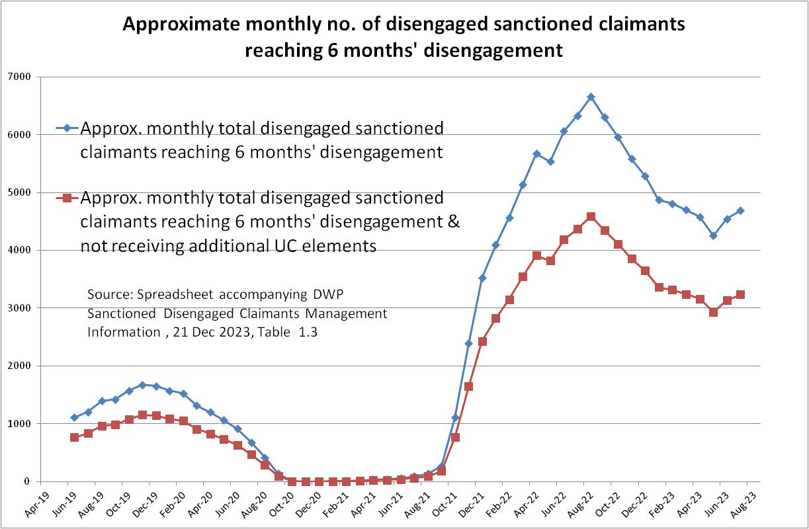

Figure 2 (this chart includes both claimants receiving and not receiving additional elements and therefore both liable and not liable to have their claims closed under the new proposal)

