BRIEFING

Benefit Sanctions Statistics

February 2024

22 February 2024

Dr David Webster
Honorary Senior Research Fellow
Urban Studies
University of Glasgow

Email david.webster@glasgow.ac.uk

Webpages: http://www.gla.ac.uk/schools/socialpolitical/staff/davidwebster/
https://cpag.org.uk/policy-and-research/latest-policy-briefings-and-reports/david-webster-briefings
http://www.cpag.org.uk/david-webster
SUMMARY

This Briefing reports on the quarterly Universal Credit (UC) sanctions statistics for Great Britain published by DWP on 13 February. With this release, DWP has for the first time published statistics on Stat-Xplore showing the ‘levels’ of and reasons for UC sanctions for Full Service (which now covers all UC sanctions). It has also reinstated the two suspended sets of sanctions statistics, namely the proportion of UC claimants serving a sanction at a point in time prior to April 2019, and the duration and median length of UC sanctions. For both these latter sets of statistics, it has introduced new methodologies; these show that the DWP statistics have been understating both numbers under sanction and durations.

The most important remaining gap is figures on the UC appeal system for Full Service, which now covers all UC claimants. Almost eight years on from the start of rollout in May 2016, DWP has still not indicated when these might be published.

There has been a slight uptick in UC sanctions imposed in the latest quarter, both in absolute terms and as a proportion of claimants subject to conditionality, but the general pattern is unchanged. After rising rapidly following the pandemic, monthly UC sanctions have more or less stabilised at a higher level than before the pandemic. They were an average of 49,528 (2.64% of claimants) in the latest quarter, to October 2023, close to three times the average of 17,290 in the last full three months before the pandemic (which was 1.4% of claimants).

A total of 538,842 UC sanctions were imposed in the year to end-October 2023, and 419,219 individual UC claimants received at least one sanction.

The reason ‘Failure to attend or participate in a Work-Focused Interview’ has dominated throughout the period since August 2015 and in recent years sanctions for any other reason have fallen to almost nothing. In the latest quarter there were 140,850 sanctions (94.8%) for missed interviews, and only 7,700 for any other reason. It appears that the explanation is that due to staff shortages, pressured Jobcentre staff opt for this reason as it is less work for them.

Since a missed interview attracts a ‘low’ or occasionally ‘lowest’ level of sanction, it is not surprising that these levels are shown to account for 91.3% of all UC sanctions to date, of which 88.8% were ‘low’ and only 2.6% ‘lowest’.

A problematic feature however is that ‘low’ and ‘lowest’ level sanctions both apply ‘until compliance’, with ‘low’ level having an additional penalty on top. This results in very long sanctions. About half of completed sanctions are lasting between 5 and 13 weeks, and about 10% are lasting each of 14 to 26 weeks, and 27 weeks or more. In the latest quarter the median duration was 44 days or over 6 weeks, and an improved methodology gives an estimated mean of 63 days (9 weeks). Durations have increased, and it appears this may because the understaffing has made it more difficult for claimants to demonstrate compliance. The pandemic also seems to have prevented some claimants from demonstrating compliance.

On the basis of the newly revised figures, the number of UC claimants who were serving a sanction at a point in time was an average of 136,075 in the latest quarter (7.25% of claimants subject to conditionality).

At the end of the Briefing there is a news section reporting significant developments.
BRIEFING: Benefit Sanctions Statistics
February 2024

The DWP released its latest quarterly sanctions statistics for Universal Credit (UC) on 13 February. The newly published data are summarised by DWP in the online publication Benefit Sanctions Statistics, available along with methodological notes at https://www.gov.uk/government/collections/jobseekers-allowance-sanctions together with a spreadsheet with summary tables. Some data are on Stat-Xplore at https://stat-xplore.dwp.gov.uk/webapi/jsf/login.xhtml . All statistics presented here relate to Great Britain. All previous Briefings are available at https://cpag.org.uk/policy-and-research/latest-policy-briefings-and-reports/david-webster-briefings (note the change in URL, although www.cpag.org.uk/david-webster should also work). The Briefings can also be readily found through a web search.

With this release, DWP has for the first time published statistics on Stat-Xplore showing the ‘levels’ of and reasons for UC sanctions for Full Service (which now covers all UC sanctions). It has also reinstated the two suspended sets of sanctions statistics, namely the proportion of UC claimants serving a sanction at a point in time prior to April 2019, and the duration and median length of UC sanctions. For both these latter sets of statistics, it has introduced new methodologies.

DWP no longer publishes updates to statistics on sanctions for Jobseekers Allowance (JSA), Employment and Support Allowance (ESA) and Income Support (IS). JSA and ESA are not merely ‘legacy’ benefits since there are new claimants of the ‘New Style’ (contribution-based) versions of these benefits. But we will not know about any sanctions on these benefits except via Parliamentary Questions or FoI requests. There are now very few if any JSA claimants other than on New Style.

The most important remaining gap is figures on the UC appeal system for Full Service, which now covers all UC claimants. Almost eight years on from the start of rollout in May 2016, DWP has still given no indication of when these might be published.

Number of people on Universal Credit (UC) and number of UC claimants subject to conditionality

The total number of people on UC was a provisional 6.41m in January 2024. Within this there were 1.92m UC claimants subject to conditionality, or 29.9% of all UC claimants.

In the latest quarter there was a further large provisional increase in the number of people on UC, this time of 250,000. This was again partly due to a large increase in the pace of ‘managed migration’, with 363,100 migration notices sent in the quarter ending December 2023. These were almost exclusively to people claiming Tax Credits only, reflected in an increase of 102,000 in working claimants of UC. But there was also an increase of 103,000 in the number of UC claimants with no work requirements.

The largest group of UC claimants subject to conditionality is those ‘searching for work’, i.e. unemployed. They were 1.44m in January 2024, accounting for 94.0% of all claimant unemployed. The other 6.0% of the claimant unemployed were the 92,531 claimants on JSA, almost all of whom will have been claiming the ‘New Style’ contribution based JSA.

Total claimants on all benefits subject to conditionality

Reporting on legacy benefits is less up-to-date than on UC. At October 2023 there were still an estimated 388,000 claimants on the legacy benefits subject to conditionality, comprising 155,000 in the ESA Work Related Activity Group, 123,000 on Income Support and 89,000 on JSA. Added to the 1.87m UC claimants subject to conditionality at that date, there were therefore an estimated total of 2.24m claimants on all benefits subject to conditionality.

Raising of the Administrative Earnings Threshold (AET) and in-work conditionality

Raising of the AET was considered in the May 2023 Briefing, pp.3-4 and Figure 1, and in the August 2023 Briefing, p.4 and Figure 1. There does not seem to have been any date announced for the further planned rise in the AET to 18 hours. Nor has a date been given for the commencement of in-work conditionality, other than that it is intended for some time in 2024 (Parliamentary answer 13 October 2023).

The monthly number of Universal Credit sanctions has stabilised at a high level, with a slight uptick in the latest quarter

The monthly number of sanctions imposed, and this number as a percentage of claimants subject to conditionality, are the most robust measures of the scale of sanctioning.

There has been a slight uptick in UC sanctions imposed in the latest quarter, both in absolute terms and as a proportion of claimants subject to conditionality, but the general pattern is unchanged. After rising rapidly and continuously following the pandemic, monthly UC sanctions have more or less stabilised at a higher level than before the pandemic.

Number of UC sanctions being imposed per month

Monthly UC sanctions reached a peak of 58,515 in March 2022 but since then have fallen back, to an average of 49,528 in the latest quarter, to October 2023 (Figure 1). However this is an increase since the previous quarter (to July 2023), when it was 46,077. The latest average is close to three times the average in the last full three months before the pandemic (to February 2020), which was 17,290.

Monthly UC sanctions as a percentage of UC claimants subject to conditionality

UC sanctions have also more or less stabilised as a percentage of UC claimants subject to conditionality (Figure 2). The monthly average of 49,528 for the latest quarter to October 2023 equates to 2.64% per month of UC claimants subject to conditionality, a slight increase over the previous quarter. In the three months immediately preceding the pandemic, i.e. December 2019 to February 2020, it was 1.4% per month.

The reason for the very high initial rates of UC sanctions shown in Figure 2 is that when UC was launched (as Live Service), it was only available to single people without dependants, and they tend to be young people, who have high rates of sanction.

As noted in previous Briefings, the overall rate for UC puts together different categories of claimant with very different rates of sanctioning – unemployed, sick/disabled and those with caring responsibilities. The rate for unemployed claimants (‘searching for work’) is much higher than for the other conditionality groups, which have quite low rates of sanctioning. This is evident in the figures for claimants serving a sanction at a point in time (see below, Figure 14).

No. of Universal Credit sanctions and no. of UC claimants sanctioned during the year to 31 October 2023

The DWP’s Benefit Sanctions Statistics spreadsheet has a table showing the numbers of individuals who received two, three, four etc UC sanctions during the latest 12 months.
Since the total number of sanctions imposed is also shown, it is possible to calculate how many individual UC claimants were sanctioned during the year. Of the 538,842 UC sanctions imposed in the year to end-October 2023, 119,623 were repeat sanctions on individuals who had already received at least one sanction during the year. Therefore the total number of individual UC claimants who received at least one sanction during the year was 419,219. Of these, 90,429 (21.6%) received more than one sanction, and 21,989 (5.2%) received more than two. These figures are much higher than in the last full 12 months before the pandemic, to January 2020, when there were 230,720 UC sanctions and 178,476 sanctioned individual claimants.

Figure 3 shows the two series for the number of sanctions imposed and the number of claimants sanctioned, for the 12-month periods ending in each quarter since January 2020 (just before the pandemic).

Monthly total sanctions on all benefits since 2000

Figure 4 shows the monthly total number of sanctions on all benefits (UC, JSA, ESA and IS) since the start of the current recording system in April 2000, on the assumption that sanctions on JSA, ESA and IS have continued to be negligible after May 2022, when reporting on the latter three benefits stopped. Even if this assumption is incorrect, the monthly average for latest quarter, almost 50,000, is higher than at any time other than the coalition government’s sanctions campaign of 2010 to 2015.

Reasons for Universal Credit sanctions

Thanks to the new data published by DWP, it is now possible to show in Figure 5 how the reasons for UC sanctions (both Full and Live Service) have varied over the whole period since August 2015. The reason ‘Failure to attend or participate in a Work-Focused Interview’ has been dominant throughout and in recent years sanctions for any other reason have fallen to almost nothing. In the latest quarter there were 140,850 sanctions (94.8%) for missed interviews, and only 7,700 for any other reason. By contrast, in the period 2016-18 there were significant numbers of sanctions for other reasons, sometimes in the low thousands, particularly Availability (peaking at 10,180 in November 2018), non-participation in employment programmes (peak 5,188 in September 2017), and voluntary leaving/misconduct (peak 3,572 in January 2017).

Figure 6 specifically shows the changing share of missed interviews within total sanctions. Between August 2015 and August 2018 there was an upward drift from about two-thirds to about three-quarters. There was then a sharp upward hike in October and November 2018 to a new level of over 90%. Since claimants do not change their behaviour as quickly as that, DWP centrally must have taken some action to cause this, but we do not know what it was. The share of interviews within total sanctions reached almost 100% when face-to-face interviews resumed in April 2021 after the pandemic, but has drifted down a little since then, to 94.2% in October 2023.
Previous issues of the Briefing have suggested that the rise in the share of interviews in total sanctions has been due to the category being used for other ‘failures’. However an informant within DWP has suggested a different interpretation. They say that work coaches avoid the other reasons because they are more complex and take up more time; this is particularly important at present because understaffing is extreme and staff are overstretched, as discussed in the November 2023 Briefing, pp. 9-10, and below (p.11). Whether a claimant attends an interview or not is a simple question for the work coach, even though the offering of ‘good reasons’ by claimants and their assessment by a decision maker will often not be.
Sanction ‘levels’

UC sanctions are imposed at four different levels: Lowest, Low, Medium and High. These are explained in the publication Universal Credit Sanctions Statistics: Background information and methodology, at https://www.gov.uk/government/publications/universal-credit-sanctions-statistics-background-information-and-methodology/a The different levels are attached to different types of ‘failure’. ‘Low’ and ‘lowest’ are misnomers in that they can both last indefinitely, because they apply ‘until compliance’, and in the case of ‘low’ with a penalty on top. They may therefore end up more severe than ‘medium’ or ‘high’.

- ‘Lowest’ level sanctions last until the claimant attends or takes part in an interview, or moves to a no-conditionality group.
- ‘Low’ level sanctions last until the claimant does what they previously ‘failed’ to do or the requirement is no longer appropriate, plus 7, 14 or 28 days for the first, second or third low level sanction in any 12-month period.
- ‘ Medium’ level sanctions last 28 days for the first sanction in any 12 month period, and 91 days (approximately 3 months) for a second or subsequent medium level sanction
- ‘High’ level sanctions last for 91 days (approximately 3 months) for the first sanction in any 12-month period and 182 days (approximately 6 months) for a second high level sanction.

There is a strong relationship between the reason for a sanction and its ‘level’. This is shown in the following table, which includes all Live Service sanctions since August 2015 and all Full Service sanctions since May 2016. Missed interviews attract only ‘low’ or ‘lowest’ level sanctions, and because of their dominance we would expect these levels to account for the great majority of total sanctions, as indeed they do: 91.3% of all UC sanctions to date, of which 88.8% were ‘low’ and only 2.6% ‘lowest’.

LEVEL No. of sanctions
REASON | High | Medium | Low | Lowest
Availability for Work | 8863 | 131410 | 60552 | 0
Employment Programmes | 734 | 0 | 77227 | 0
Reason For Leaving Previous Employment | 68496 | 0 | 0 | 0
Work-Focused interviews | 0 | 0 | 2095103 | 64501
Other | 8824 | 0 | 1738 | 297

Figure 7 shows the monthly number of sanctions by level. Because of the close relationship between reason and ‘level’, Figure 7 looks almost identical to Figure 5. ‘Low level’ sanctions have been dominant throughout, with few sanctions at any other level after Autumn 2018.

Duration of completed sanctions

The duration of a sanction is influenced by its level. But because of the dominance of ‘Low level’ sanctions, which have an ‘until compliance’ component, the relationship is not necessarily close.

There have always been problems with the DWP’s measure of duration and with the closely related measure of the number of claimants serving a sanction at a point in time (see below). These problems were discussed in the November 2017 Briefing, pp.6-10; some of the same points still apply, although others have been addressed in the DWP’s new methodology.

Due to methodological problems, DWP suspended publication of duration figures with effect from the November 2020 release, but it has now reinstated them, with data running from January 2017. The figures include both Live and Full Service. The methodology has been changed in various ways, explained in the updated methodology document at https://www.gov.uk/government/publications/benefit-sanctions-durations-and-sanction-rate-calculation-explanation-of-methodology The most important change is that previously a claimant who served two or more sanctions without a break would have them recorded as a single sanction, whereas now they will be shown as separate sanctions.

Figure 8 compares the revised and previously published total figures for sanction durations, for the whole period which they both cover, i.e. January 2017 to May 2020 inclusive. The shortest sanction duration category, up to 4 weeks, has shrunk, while all the longer categories have increased, in other words the new methodology gives longer estimates for sanction durations. Another way of making the comparison is to compare the median lengths for sanctions completed in each month, as reported by DWP (Figure 9). This shows that in the run-up to the discontinuation of the statistics in 2020, the previous series was failing to capture a steady increase in the median length. This supports DWP’s decision to stop publication. However this chart reveals two causes for concern. During the pandemic there was a huge rise in median length, and although the number of claimants affected was relatively small, this will have been serious for many of them. For 6,559 claimants the median duration rose to 78 days in April 2020 and for 1,906 claimants to 113 days in May 2020. Thereafter the number affected was in the low hundreds, peaking at 338 days for 169 claimants in January 2021. The most likely explanation for these huge lengths appears likely to be that due to the pandemic these claimants were unable to demonstrate ‘compliance’. If this is the case then it will have potentially been a serious injustice. The other issue is that median lengths are substantially greater now than before the pandemic. On the basis of the new figures, up to February 2020 the median averaged 36 days, but since August 2021 it has averaged 45.75 days.

Figures 10 and 11 show the numbers and percentages of completed sanctions falling into each duration category, monthly since January 2017. Each month there are now more than 20,000 claimants completing a sanction after 5 to 13 weeks, and around 4,000 completing sanctions after 14 to 26 weeks and another 4,000 after 27 weeks or more. About half of completed sanctions are lasting between 5 and 13 weeks, and about 10% have lasted each of 14 to 26 weeks, and 27 weeks or more. In the latest quarter the median duration was 44 days or over 6 weeks.

Average (mean) sanction length

DWP does not publish the mean sanction length. However, the more comprehensive data on sanction lengths now published can be used to make a good estimate of the mean using the method explained in the November 2017 Briefing, Note 7. For sanctions completed in the most recent quarter the mean duration is now estimated as approximately 63 days (9 weeks or 2.1 months). This is a substantial reduction from the Briefing’s previous estimate, using a cruder method, which was 11-12 weeks. But it is still strikingly higher than the median of 44 days.

Disengaged sanctioned claimants

In December 2023, at https://www.gov.uk/government/publications/sanctioned-disengaged-claimants-april-2019-to-august-2023, DWP published statistics on ‘disengaged sanctioned claimants’, i.e. those claimants serving open-ended Low or Lowest sanctions who are not in contact with their Jobcentre. These were the subject of a special Briefing which is available at https://cpag.org.uk/policy-and-research/latest-policy-briefings-and-reports/david-webster-briefings

The DWP’s duration statistics relate only to completed sanctions, and therefore the figures on disengaged sanctioned claimants do not fall within them as by definition their sanctions are uncompleted. They are however a significant part of the duration picture. The special Briefing showed that about 3,200 claimants per month are on open-ended sanctions and are reaching the 6-month duration point.

Universal Credit claimants serving a sanction at a point in time

This is DWP’s preferred measure of the scale of sanctioning, first published in November 2017. DWP’s preference appears to be because it produces a low absolute number. But it is subject to assumptions, and understates the potential impact of sanctions; for instance, a 4-week sanction which results in loss of a tenancy or breakdown of a marriage has an impact which lasts far beyond the period of the sanction itself. If the claimant takes a hardship payment, as around half of sanctioned claimants do, repaying it cuts their payments for a long period after the sanction supposedly ends, in effect acting as a further sanction.

This measure is closely related to duration, since once the number of sanctions imposed is known, what then determines the number of claimants serving a sanction at each point in time is the duration of the sanctions. As from November 2020 DWP withdrew this measure for all dates prior to April 2019. It has now reinstated it, back to January 2017. However the methodology has been changed, as explained at https://www.gov.uk/government/publications/benefit-sanctions-durations-and-sanction-rate-calculation-explanation-of-methodology

Impact of the new methodology

Figures 12 and 13 show the impact of the new methodology. The DWP’s previous figures have been understating the number and percentage of claimants serving a sanction. Across most of the series, the new methodology increases the number of those serving a sanction, typically by around 10%. The biggest difference is for November 2021, when the old figure for the percentage under sanction was 1.16 percentage points below the new one. But at the opposite extreme, in April 2020 the old figure was 0.49 percentage points above the new one.

Number of UC claimants serving a sanction at a point in time

On the basis of the revised figures, the number of UC claimants who were serving a sanction at a point in time has seen a sharp increase in the latest quarter, to an average of 136,075, after sitting fairly steadily at between 120,000 and 130,000 for well over a year (Figure 12). This is much higher than in the final quarter before the pandemic, when (again on the new basis) it was around 35,100.

Percentage of UC claimants subject to conditionality who were serving a sanction at a point in time

Figure 13 shows the same data as a percentage of UC claimants subject to conditionality. In the latest quarter this was 7.25%, a slight increase on recent levels. It equates to one in 14 of UC claimants subject to conditionality and is well over double the immediate pre-pandemic level of around 3.0%. Much higher percentages were seen for earlier months, going back to January 2017. As explained in relation to Figure 2 above, this is because when UC was first introduced it was available only to single people without dependants, who tend to be young, and young people have much the highest rates of sanction.

UC claimants serving a sanction at a point in time by conditionality group

Figure 14 shows the percentage of UC claimants subject to each individual conditionality regime who were serving a sanction at the measurement date in each month. As usual, unemployed (‘searching for work’) claimants were far more likely to be sanctioned than the other two groups subject to conditionality, with 123,517 or 8.77% under sanction in November 2023 compared to 0.86% for ‘planning for work’ and 0.71% for ‘preparing for work’. The numbers have increased significantly compared to those previously published. For August 2023, the previous figures had 112,877 unemployed claimants serving a sanction; the revised figure give this as 123,252. One in 11 unemployed UC claimants was under sanction in November 2023.

There are also people in the groups not subject to conditionality who are serving sanctions. That is because under UC, sanctioned claimants are made to serve out the whole of their sanction even if they move into a no-conditionality group, for instance because of illness. There were 7,530 of them in November 2023, almost half (3,534) of these in the ‘working – with requirements’ group. This group are the most likely to have recently been unemployed and therefore to have been sanctioned.

Deductions from Universal Credit

The November 2023 Briefing, p.7, noted a Parliamentary written answer to Sir Stephen Timms on deductions from Universal Credit in 2021-22. A further written answer on 15 January at https://www.theyworkforyou.com/wrans/?id=2024-01-09.8649.h&s=universal+credit+sanction#g8649.r0 has provided similar information for 2022-23. This shows that 3.5m claimants had £1.60 billion deducted from their UC payments in that year. The average amount deducted per month was £62, and on average 43% of this was to repay an advance. The total lost to claimants in Birmingham was £45m and in Manchester and Glasgow £23m each. These figures were all very slightly down on those for 2021-22.

Additional information for 2022-23 was given in a Parliamentary answer on 31 January, at https://www.theyworkforyou.com/wrans/?id=2024-01-17.HL1702.h&s=universal+credit+sanction#gHL1702.q0 This is on the basis of claims rather than claimants It shows the same total and average amounts deducted as above, but in addition gives a full breakdown of deductions by reason, as follows:

2022/23 | Number of distinct UC claims | Proportion of Universal Credit claims subject to deduction | Total amount deducted | Average deduction amount
Claims with deduction for an advance | 2,400,000 | 38% | £690,000,000 | £40
Claims with deduction for third party | 950,000 | 15% | £227,000,000 | £33
Claims with other deductions | 2,200,000 | 34% | £684,000,000 | £49
All UC claims with at least one deduction | 3,500,000 | 55% | £1,601,000,000 | £62
All UC claims | 6,400,000
No. of children in households subject to UC sanctions

Alex Cunningham MP asked why information on the number of children living in households subject to a Universal Credit sanction is not readily available. Jo Churchill, Minister of State, replied on 21 February as follows:

‘The Department records information on the number of children living in Universal Credit households and these are published every three months as part of the official Universal Credit statistics (https://www.gov.uk/government/collections/universal-credit-statistics ). The Department also records information on the number of people who have received a sanction on Universal Credit, and these are published every three months as part of the official Benefit Sanctions Statistics (https://www.gov.uk/government/collections/jobseekers-allowance-sanctions ). These statistics are produced using different methodologies and it is not possible to provide appropriately quality assured statistics within the disproportionate cost limit.’

SANCTIONS – OTHER DEVELOPMENTS

Staffing crisis in Jobcentres

The November 2023 Briefing, pp.9-10, discussed the staffing crisis in Jobcentres and its effects. The PCS union has since published a report (PCS 2023) giving the personal accounts of 50 Jobcentre staff of the ways this has affected them and their customers. It is reported at https://www.mypcs.pcs.org.uk/s/article/DWP-boss-receives-devastating-dossier-staff-and-services-at-breaking-point PCS wrote to the Secretary of State and Permanent Under Secretary in December, as reported at https://www.pcs.org.uk/news-events/news/pcs-calls-urgent-meeting-dwp-over-staffing-crisis It also held a large staff meeting on the issue in January, reported with more details at https://www.pcs.org.uk/news-events/news/dwp-staffing-crisis-meeting-hears-pain-understaffing

PQs explaining procedures on sanctioning vulnerable claimants

Three DWP Parliamentary answers on 30 January (two from Jo Churchill, Minister of State, and one from Mims Davies, Parliamentary Under-Secretary) made the same statement about the treatment of vulnerable claimants in relation to sanctions, as follows:
‘Those found to have limited capability for work and claimants on work-related benefits are expected to take responsibility for meeting the conditionality requirements they have agreed with their work coach. Where a customer has a health condition, illness or disability, work coaches have the discretion to tailor these requirements to what is reasonable and achievable, taking into account the individual's condition. Additionally, in some circumstances a customer’s work-related requirements may be lifted for a period if their ability to carry them out is disrupted due to their personal circumstances. A sanction is only applied where an individual has failed to meet their agreed conditionality requirements without demonstrating good reason for doing so. In cases where vulnerabilities are known or suspected, a pre-referral quality check is undertaken prior to any sanction referral to ensure that it is appropriate in the circumstances.’
This appears to mean that if no vulnerability is known or suspected, no assessment is undertaken before a sanction referral is made. This is contrary to the Sanctions Assurance Framework, which was discussed in the February 2021 Briefing, pp.6-7. It had already seemed that the Framework must have been abandoned in order for DWP to be able to impose the sheer number of sanctions seen since the pandemic. This now appears confirmed.
Sir Stephen Timms on the Autumn Statement

A useful blog (Timms 2023) dissects the Autumn Statement, pointing out that the sanctions changes will have very little effect on the labour market, while the ‘tough talk’ obscured some useful measures to support people suffering mental or physical ill health.

House of Commons Work and Pensions Committee Inquiry – Safeguarding Vulnerable Claimants

This inquiry is continuing, with further oral evidence sessions on 13 December, 24 January and 7 February. Video and transcripts are available on the Committee website.

Health Foundation report on working age ill health and inactivity

This useful analysis (Health Foundation 2023) once again shows that ill health is a bigger problem for the UK labour market than is unemployment. Since the pandemic, 470,000 more people are out of the workforce on ill-health grounds, and 3.7 million working-age people are in work with a health condition that is ‘work-limiting’. The latter figure has increased by 1.4 million over the past decade. The rise in work-limiting conditions is being driven by sharp increases in reported mental ill health, particularly among younger workers. Across the whole workforce, musculoskeletal and cardiovascular conditions remain the most common form of work-limiting health condition. These findings suggest that along with measures to address people leaving the workforce, government and employers need to develop new and better ways to support employees to remain well in work.

The negative impact of benefit conditionality on job quality

Part of the reason for the greater ill health of the workforce is the damaging effects of conditionality and sanctions on the nature of jobs. Conditionality promotes bad, health-damaging jobs. This is shown by an important new paper (Jones, Wright & Scullion 2024).
Drawing upon analysis of unique data from three waves of qualitative longitudinal interviews with 46 UK social security recipients (133 interviews), it establishes that the impact of welfare conditionality is so substantial that it is no longer adequate to discuss job quality without reference to its interconnections to the welfare system. It identifies how conditionality drives welfare recipients’ experience of job quality, disempowering and propelling claimants towards inadequate pay, insecurity and poor employment terms, undermining multiple intrinsic characteristics of work and creating what it terms a new ‘Work–Life–Welfare balance’. Instead of acting as a neutral arbitrator between jobseekers and employers, the welfare system is exposed as complicit in reinforcing one-sided flexibility through one-sided conditionality, by emphasising intensive job-seeking, while leaving poor-quality work provided by employers unchecked.

The paper is being followed up with a conference From Work First to Good Work: Supporting people into good jobs, not just any jobs at Manchester Metropolitan University on 10 April: details are at https://www.eventbrite.co.uk/e/from-work-first-to-good-work-supporting-people-into-good-jobs-tickets-802862341877

DWP research report on the employment impact of UC on lone parents

DWP published this report (DWP 2024) on 22 February. The main finding is that single parents on Universal Credit are 5 percentage points more likely to have been in work within 6 months of making their claim compared to being on legacy benefits. It is too early for any critical appraisals of this work to be available. But the focus of the report is very narrow and it needs to be read in the context of earlier work taking a wider and more critical approach to the benefits and costs of increased employment for lone parents. Recent such studies were noted in the Briefings for February 2023, pp.12-13, and May 2023, p.10.

Women and Welfare Conditionality

A new book (Wright 2023) considers the gendered nature of the conditionality regime, looking at how women and children are disciplined for violating male-defined work norms.

Rowntree on UK Poverty

The latest Rowntree report on poverty in the UK (Joseph Rowntree Foundation 2024) includes the role of benefit sanctions.

Publication of ONS labour market data resumed but ‘transformed’ Labour Force Survey postponed to September

The November 2023 Briefing (p.12) reported on the suspension of labour market statistics derived from the Labour Force Survey, due to its fallen response rates. The Financial Times reported on 13 February (p.2) that publication has resumed following reweighting with new population data, but that reliability is unknown. Publication of data derived from the new ‘transformed’ Labour Force Survey, intended to deal with the difficulties, has been postponed from Spring to September. A further FT article on 21 February, p.3, explained the history of the current problems in some detail.

REFERENCES

DWP (2024) Estimating the Employment Impact of Universal Credit among Single Parents, Research Report No.1048, 22 February, at
https://www.gov.uk/government/publications/estimating-the-employment-impact-of-universal-credit-among-single-parents

Health Foundation (2023) What we know about the UK’s working-age health challenge, 17 November, at https://www.health.org.uk/publications/long-reads/what-we-know-about-the-uk-s-working-age-health-challenge (web only)

HM Treasury (2023) Autumn Statement 2023, CP 977, November, at
https://www.gov.uk/government/organisations/hm-treasury

Jones, K., Wright, S. and Scullion, L. (2024) ‘The Impact of Welfare Conditionality on Experiences of Job Quality’, Work, Employment and Society, at https://doi.org/10.1177/09500170231219677
https://journals.sagepub.com/doi/10.1177/09500170231219677

Joseph Rowntree Foundation (2024) UK Poverty 2024: The essential guide to understanding poverty in the UK, January, at
https://www.jrf.org.uk/uk-poverty-2024-the-essential-guide-to-understanding-poverty-in-the-uk

Public and Commercial Services Union (2023) Staffing Crisis in the DWP: PCS members explain how they are affected, at https://mypcs.my.salesforce.com/sfc/p/#1t000000oksc/a/Sl000001RxI0/bhm_vag0ggsL0cvkItbfXZEbpNh7dQ7cNxqPBj.vOA8

Timms, Stephen (2023) ‘Forcing unready people into ill-suited work is not the answer’, PoliticsHome, 30 November, at
https://www.politicshome.com/thehouse/article/forcing-unready-people-illsuited-work-answer (web only)

Wright, Sharon (2023) Women and Welfare Conditionality: Lived Experiences of Benefit Sanctions, Work and Welfare, Bristol, Policy Press, 30 October

Figure 1
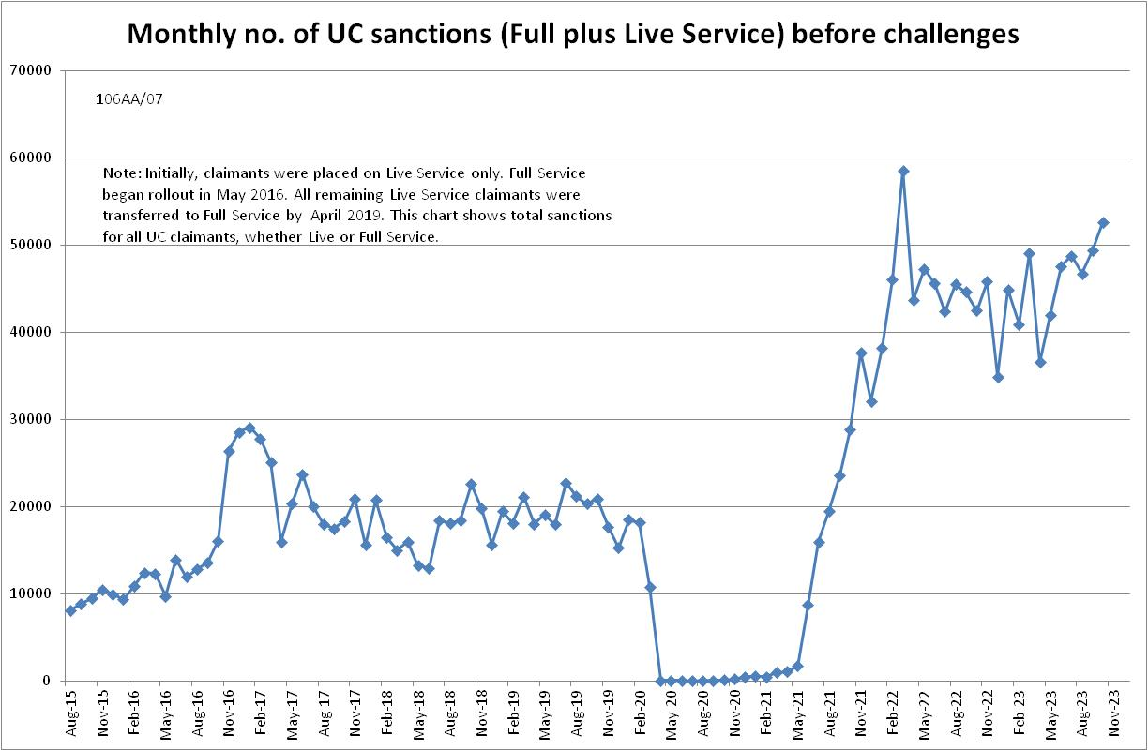

Figure 2
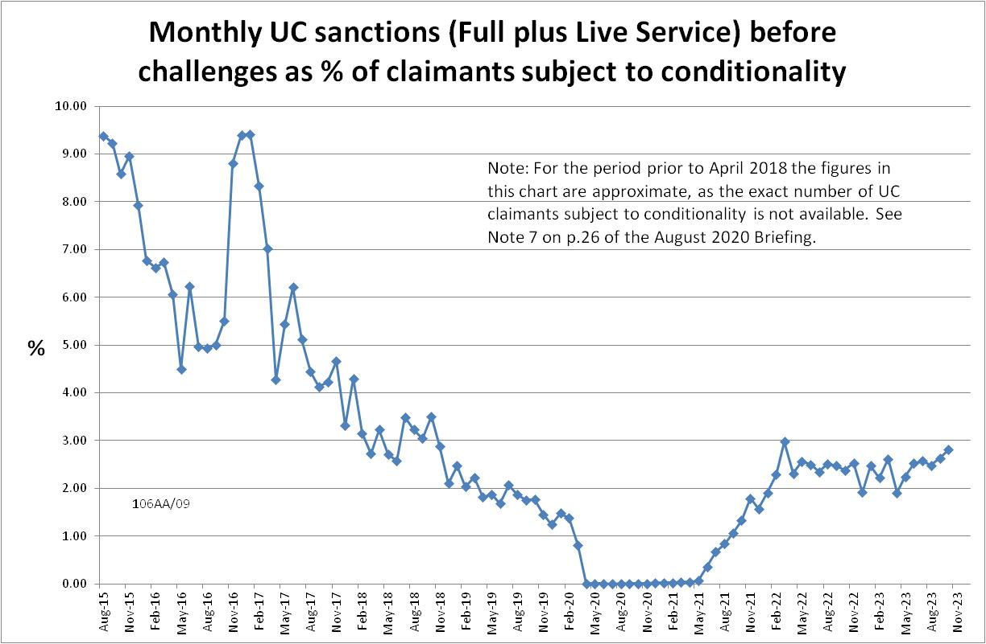

Figure 3
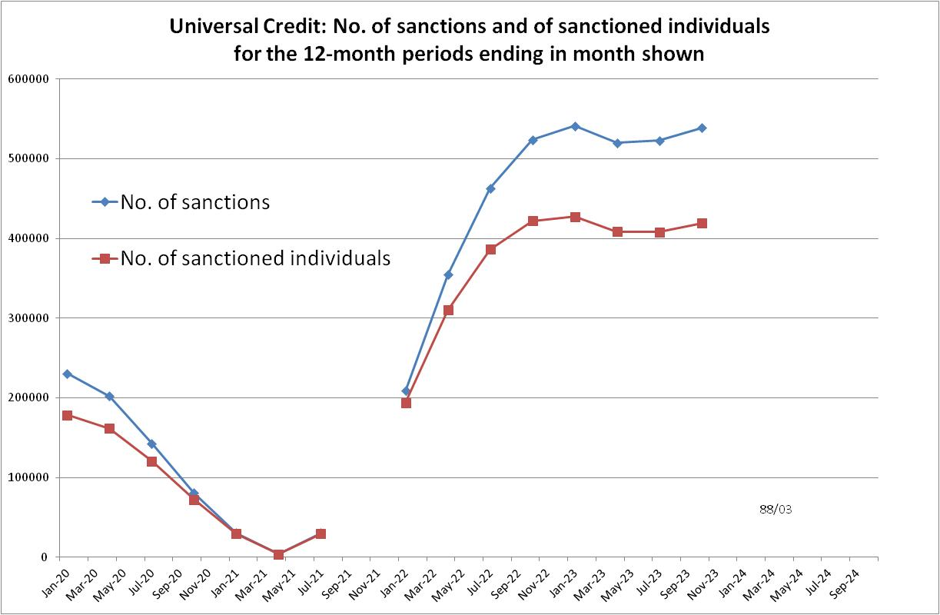

Figure 4
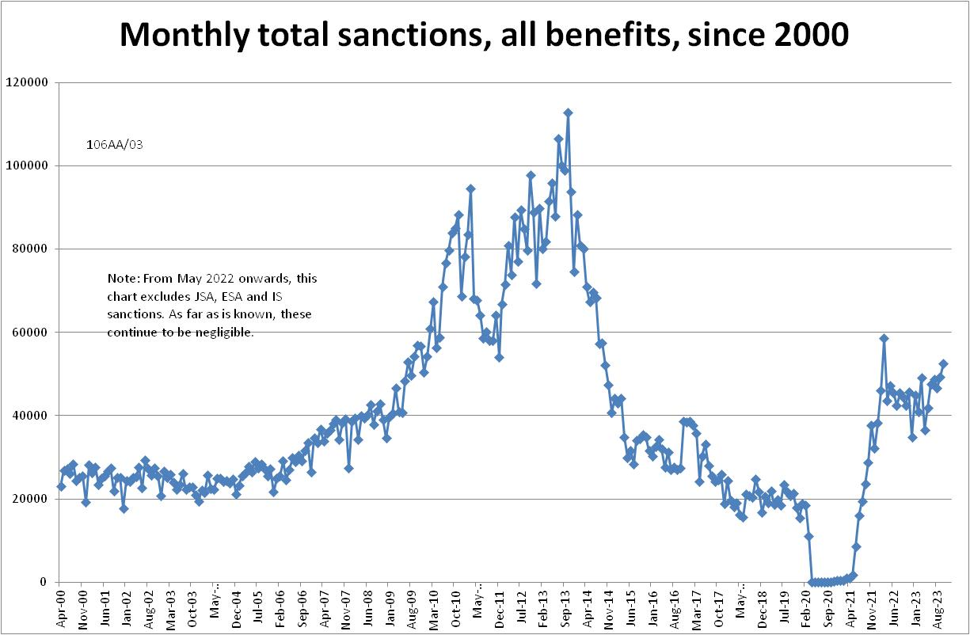

Figure 5
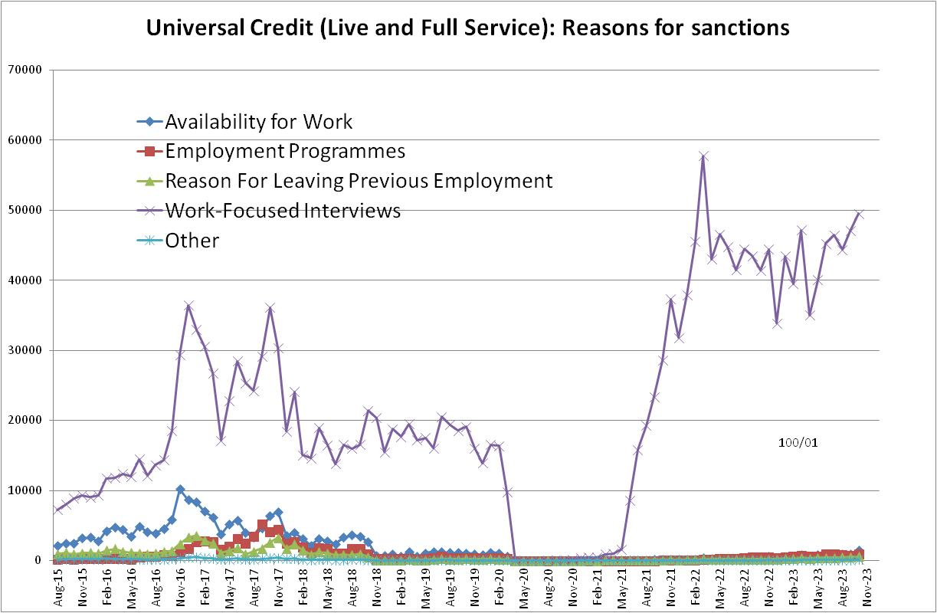

Figure 6
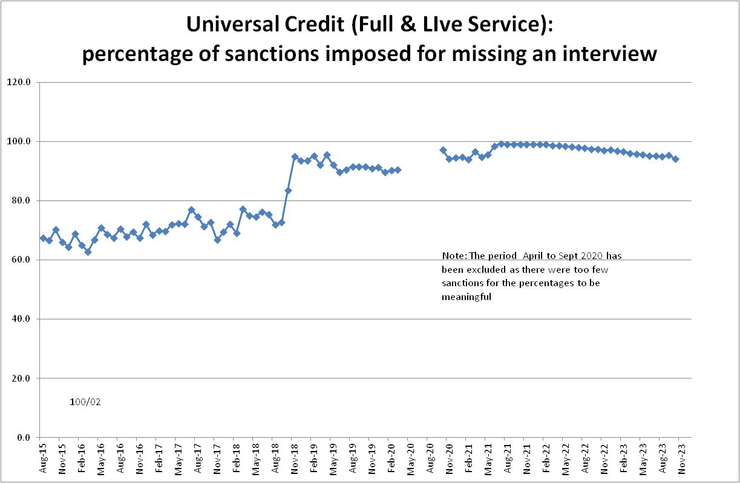

Figure 7
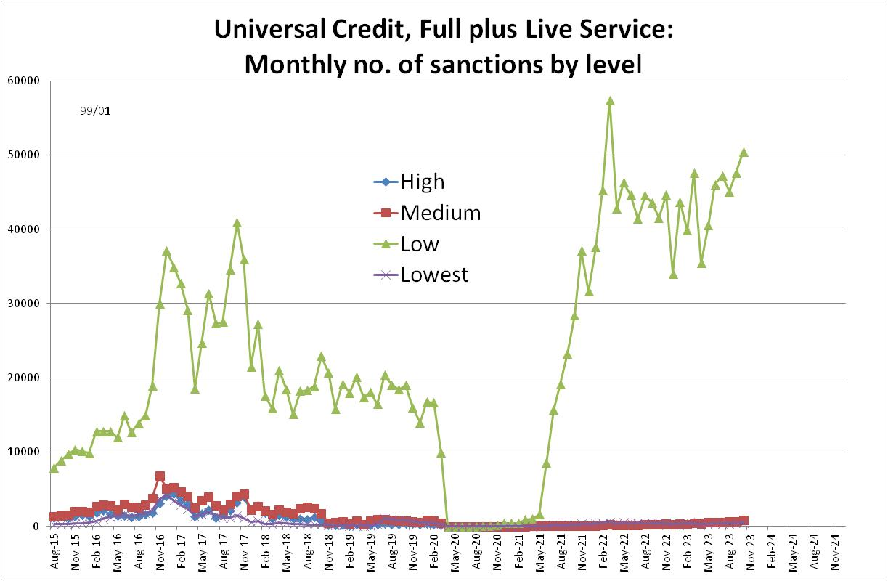

Figure 8
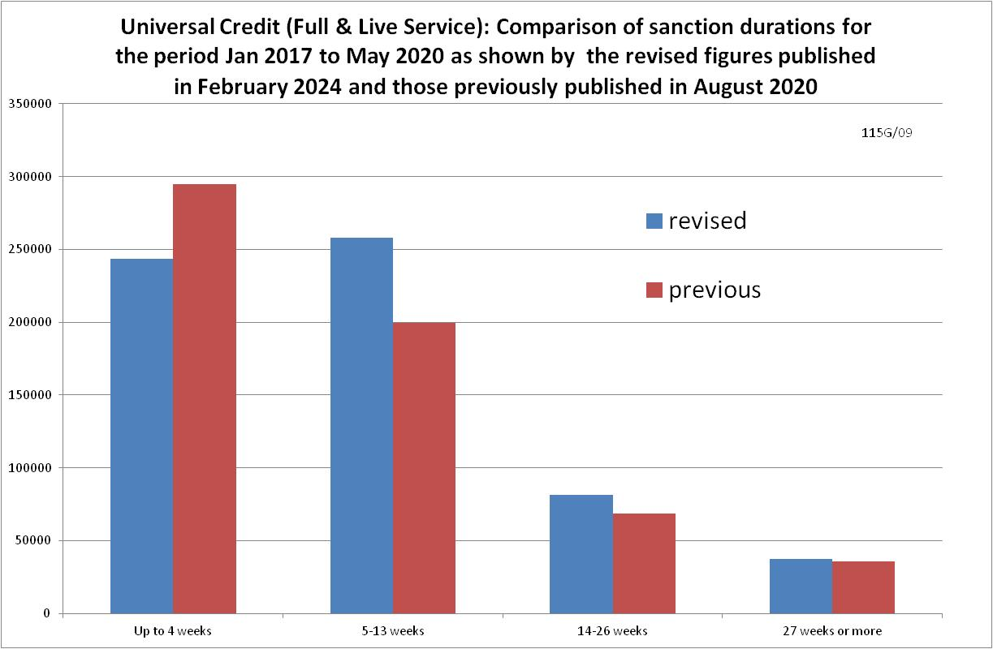

Figure 9
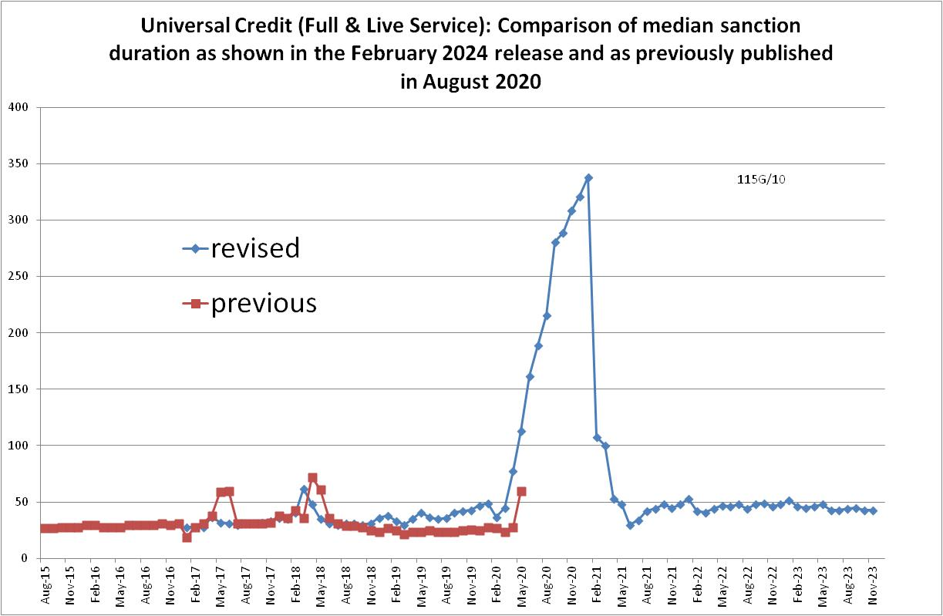

Figure 10
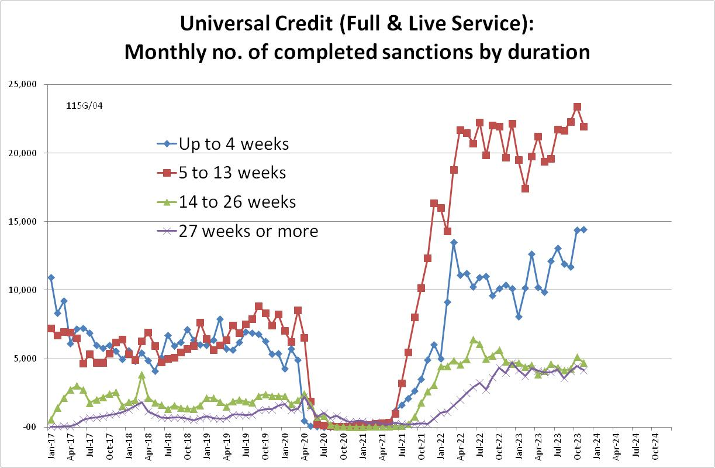

Figure 11
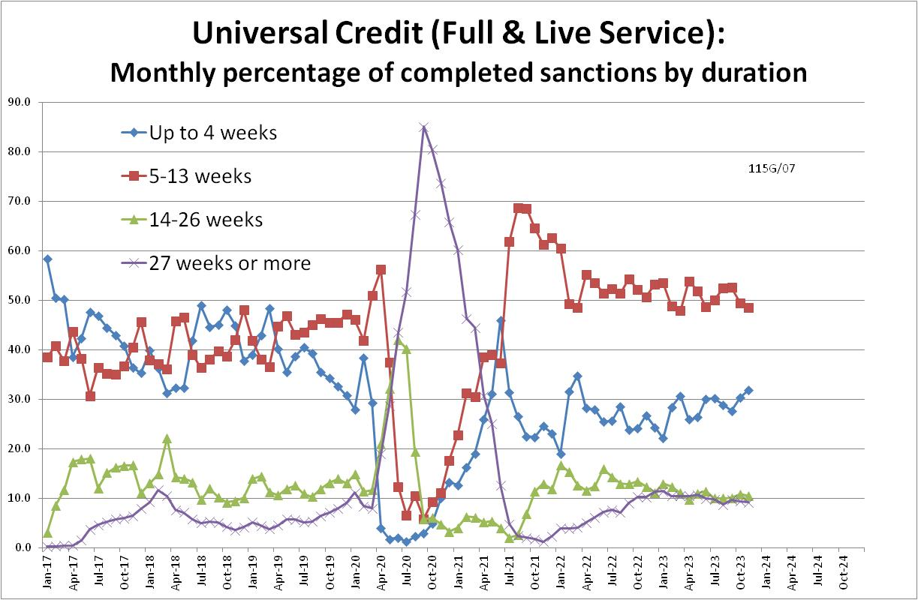

Figure 12
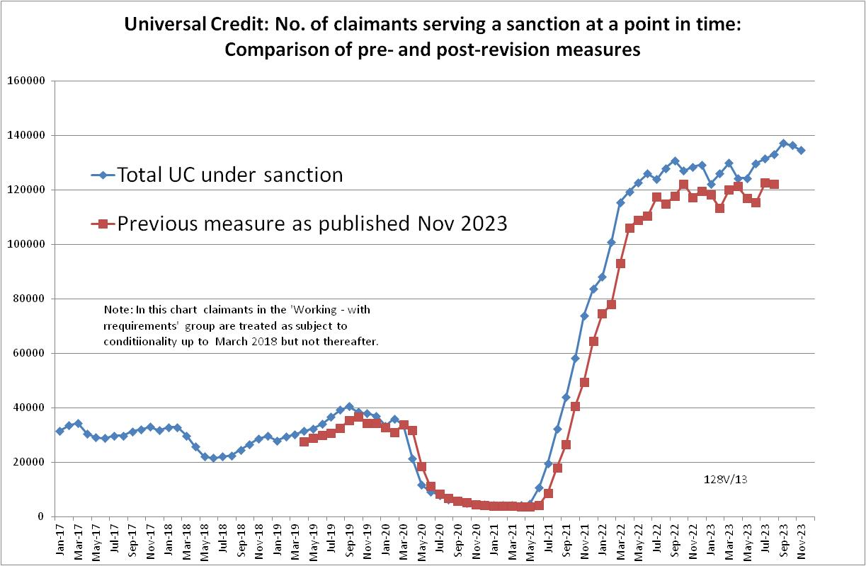
Figure 13
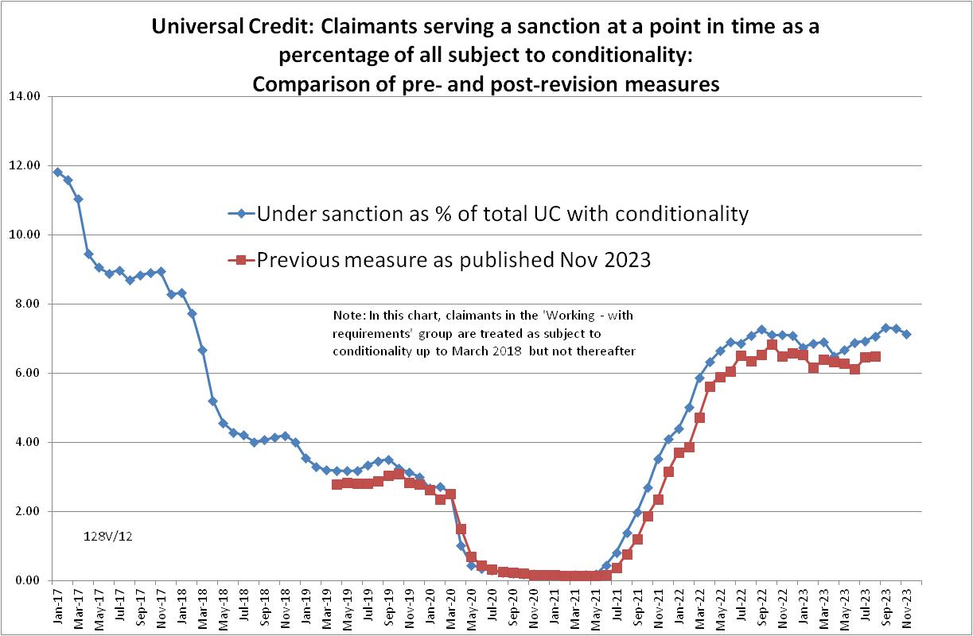

Figure 14
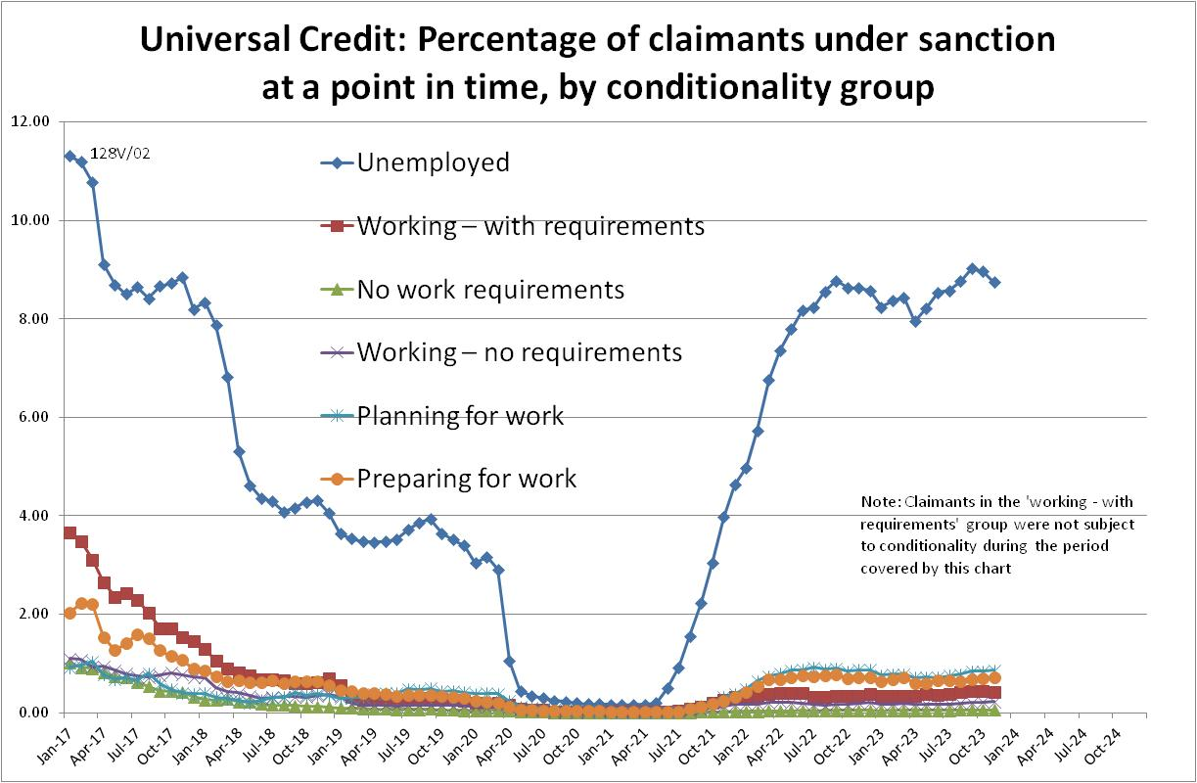

NOTES

Previous Briefings include many analyses that are not repeated here but remain valid. However it should be remembered that the DWP may have made subsequent revisions to the data reported in earlier Briefings. These revisions will generally not be major although there are exceptions. There may also often be substantial changes in some figures for the most recent few months.
A DWP report on the progress of managed migration (DWP 2023a) states that the final migration of claimants from old-style JSA to UC may not be completed before the end of 2024/25. Old-style JSA is already closed to new claimants.
Statistics on ‘managed migration’ to UC can be found at https://www.gov.uk/government/collections/move-to-universal-credit-statistics
The DWP’s Stat-Xplore offers both a detailed and a summary set of reasons for sanctions. Only the latter is used here.
Under the procedure for calculating an approximate mean from a frequency distribution we assume that all the cases in each class interval have the value of its mid-point, and for the top, open class interval we make some reasonable assumption. In this case the mid-point of the top class interval ‘183 days or more’ is assumed to be 200 days. The detailed weekly frequency distributions given in the DWP’s Benefit Sanctions Statistics Table 3.1 are used, not the summary class intervals used in Figures 10 and 11.

