BRIEFING:

The DWP’s JSA/ESA Sanctions Statistics Release, 17 August 2016 - Supplement

Explaining the
rise and fall of JSA and ESA sanctions 2010-16

3 October 2016

Dr David Webster
Honorary Senior Research Fellow
Urban Studies
University of Glasgow

Email david.webster@glasgow.ac.uk

Webpages: http://www.gla.ac.uk/schools/socialpolitical/staff/davidwebster/
http://www.cpag.org.uk/david-webster
SUMMARY

This paper investigates the reasons for the huge rise and fall of JSA sanctions between May 2010 and March 2016, and smaller rise and fall in ESA sanctions. The monthly rate of sanctions as a proportion of JSA claimants rose by approximately 5.6 percentage points between May 2010 and October 2013 and fell by some 5.2 percentage points between October 2013 and March 2016, while ESA sanctions rose by some 2 percentage points from July 2011 to October 2013 before falling by 1 percentage point by April 2015. The effect on claimants was compounded by the increases in penalties from October/December 2012.

The conclusions are that:
- There was an unannounced change of policy by ministers in May 2010 to pressurise DWP staff to make more referrals for JSA sanctions. This was responsible for most of the rise in JSA sanctions, some 3.3 percentage points per month. It is reflected in referrals for every reason for JSA sanction under the control of Jobcentre Plus, but particularly for those for allegedly ‘not actively seeking work’.
- Reductions in the rate of referrals for sanction for all reasons under the control of Jobcentre Plus, except for Workfare, account for most of the fall in JSA sanctions since October 2013, about 4 percentage points. The fact that these reductions all began in about October 2013 suggests a decision by ministers to ease off on JSA sanction referrals under their control. October 2013 marked the beginning of the Claimant Commitment, and this may also have contributed to the fall.
- The increase and then decline in the Work Programme client group from June 2011 accounts for a major part of the rise and fall in JSA sanctions and probably for all of the change in ESA sanctions. Its effect was amplified by the ruling by the DWP, strongly criticised in the Oakley report of July 2014, that contractors must refer claimants for sanction if there is any breach of requirements, even where they know that the claimant is co-operating fully. The group eligible for the Work Programme almost doubled as a proportion of JSA claimants between June 2011 and September 2012, and 1.5m JSA and 0.334m ESA claimants had been referred to the programme by March 2016. The DWP’s ruling ensured that the increase in sanctions was very large: 2.3 percentage points for JSA and 0.8 percentage points for ESA. By March 2016, for JSA, the Work Programme had delivered about 843,000 sanctions and 881,615 cancelled referrals compared to only 483,827 job outcomes. For ESA, it had delivered 36,986 job outcomes and there had been 175,000 sanctions and 162,970 cancelled referrals for ‘work related activity’, although some of the latter sanctions and cancellations may have been originated by Jobcentre Plus.
- Changes in the proportion of referrals for sanction on which there was a decision adverse to the claimant also contributed to the rise in JSA sanctions, and to the rise and fall of ESA sanctions. The increase in the adverse decision rate has been reversed for ESA, but not for JSA, where the adverse proportion is higher now than in April 2010 for every reason for sanction and overall has risen from 60% to 80%. It is unclear whether these changes are due to action by ministers or by officials.
- ‘Workfare’ has made a small contribution to the rise in JSA sanctions.

The great sanctions drive 2010-16 has been a major economic and social policy experiment. It is essential that there should be a full evaluation of this experience, as part of a wider review of benefit sanctions. It is also vital that the Work Programme’s successor, currently in preparation, should not replicate its bias towards sanctions, and that legislation should remove both sanction referrals and decisions on referrals from the control of ministers.
Explaining the rise and fall
of JSA and ESA sanctions 2010-16

The August 2016 sanction statistics Briefing pointed out that the DWP has not satisfactorily explained the huge rise and fall of JSA sanctions between 2010 and 2016. Starting at around 3% of JSA claimants per month before challenges in May 2010, JSA sanctions rose to 2 to 3 times that rate by October 2013 before steadily declining again. Over the whole period May 2010 to March 2016 there were about 1.65m more JSA sanctions than there would have been if the rate inherited from the previous government had continued. During this period there was also a smaller rise and fall in ESA sanctions. The purpose of this paper is to take a more systematic look at the reasons for the rise and fall of these benefit sanctions, and to identify the nature and timing of what appear to be unannounced policy changes by ministers.

Introductory

All of the analysis in this paper shows figures as a percentage of the relevant stock of claimants, either on JSA or in the Work Related Activity Group (WRAG) of ESA. The actual numbers of referrals and sanctions have also been affected by the numbers of claimants, which has changed over the period. These actual numbers are reported in the main Briefing. The present analysis does not consider the effect of reviews, reconsiderations and appeals. Successful challenges against sanctions result in some sanctioned claimants having their money restored. But this does not happen for some weeks or months so that the impact of the sanction is felt anyway.

Figure 1 shows for all JSA sanctions taken together the monthly figures since April 2000 for referrals for sanction as a percentage of JSA claimants; the proportion of referrals which have resulted in sanction; and sanctions before challenges as a percentage of JSA claimants. Figures 2 -3 and 6 -11 do the same for the main reasons for JSA sanctions separately, following the classification used in the main Briefing. Some of the reasons for sanction are much more important numerically than others, and so the charts use different scales. Some numerically small reasons for JSA sanctions have been omitted from most of the analysis. These are Failure to participate in supervised job search, Trade disputes, Jobseeker's Agreement questions, Joint Claim exemption and ‘Other referral reason’. These accounted for less than 0.3% of all sanctions in April 2000 to March 2016, leaving 99.7% of all sanctions fully included in the analysis.

Figures 15 – 17 give the same information for ESA sanctions. In the case of ESA, there are only two reasons for sanction: failure to attend a mandatory interview, and failure to participate in work related activity.

In order to fit all three measures on to each chart, the proportion of referrals resulting in sanction has been divided by 10 or 100. So, for instance, where Figure 2 appears to show the proportion of referrals for ‘not actively seeking work’ resulting in sanction rising from about 8% to about 10%, this actually means a rise from about 80% to about 100%.

Because of the way the DWP maintains its database, the figures shown in the charts are only approximations. However, the trends will be correctly shown and turning points will also be approximately correct.

JSA sanctions are considered first.

The rise and fall of JSA sanctions
Changes in the rate of referrals for sanction, and changes in the proportion of referrals resulting in sanction, have both played a role in the rise and fall of JSA sanctions. It is convenient to consider them separately, starting with the rate of referrals.

The rate of referrals for sanction

It is clear that there was a general toughening of policy under the Tory-Lib Dem coalition which took over in May 2010 (Figure 1). The overall monthly rate of referrals started rising immediately from its level of 6.8% in May 2010, increasing by more than two-thirds within the first seven months. There were then two hiccups, particularly in summer 2011, before the rise was resumed, with a spectacular further increase to a peak at 16.3%, almost two-and-a-half times the starting rate, in October 2013. Since then there has been a rapid and rather steady decline, with a return to the starting level by spring 2015 and a small further decline since then.

Table 1 shows the contribution of each individual reason for sanction to the overall rise in referrals and actual sanctions between April 2010 and October 2013 and to the fall between October 2013 and March 2016, expressed as a percentage of claimants. This table shows that almost all the rise in actual sanctions was accounted for by only two types of sanction: those for ‘not actively seeking work’ and for non-participation in training schemes. Together these increased sanctions by 4.8% of JSA claimants per month up to October 2013. All other reasons together added a further 0.81%, with sanctions for refusing a job or job opportunity actually declining as a percentage of claimants. The fall in sanctions from October 2013 was more evenly spread between reasons. Sanctions for ‘not actively seeking work’ were again the most important, but this time those for training schemes and interviews both contributed more than 1 percentage point to the fall.

‘Not actively seeking work’

‘Not actively seeking work’ (Figure 2) made the largest contribution both to the increase in actual sanctions up to October 2013, 2.47% of claimants per month, and to the fall since then, 2.32%. Referrals for this reason started rising as soon as the Coalition took office, and then showed the same two hiccups as the overall total, with a particular dip in summer 2011, before rising steadily to peak in October 2013. There was no reason other than ministerial direction why referrals should have started rising in May 2010, but October 2013 was the date when the Claimant Commitment started its rollout, which was completed in the spring of 2014. Sanctions relating to the Commitment are classified as ‘not actively seeking work’. Therefore it appears that the Claimant Commitment has been administered in such a way as to reduce the rate of these sanctions compared to the previous system based on the Jobseekers Agreement. This could be due to differences in the way the system works, for instance in giving the claimant clearer expectations at the outset (which the government claims is an aim of the system), or it could be due to a change in policy which coincided with the rollout of the Commitment. The latter is more likely as it will be shown below that the same decline in sanctions occurred for almost all the other reasons under the control of Jobcentre Plus.
Training schemes and the Work Programme

By far the most important contributor to the rise in referrals up to October 2013 was non-participation in training schemes (Figure 3). From July 2011 this was almost exclusively the Work Programme. Prior to the Coalition, referrals for this reason had never reached 2% of claimants per month, but they immediately rose very fast and after falling back in the summer of 2011 they shot up to over 8% of claimants per month in October 2013. The rise in resulting actual sanctions was much smaller, because a high proportion of these referrals ended up being cancelled due to reasons such as flaws in their documentation. Uncancelled Work Programme referrals nevertheless rose to 4%-5%, still a very large increase. Figure 12 shows the proportion of referrals for each reason which have been cancelled. This indicates that cancellations are particularly though not exclusively related to the involvement of outside contractors, in Mandatory Work Activity (MWA) and Work Experience as well as in the Work Programme (where ESA referrals also have a very high rate of cancellations – see Figure 17). Referrals for missed interviews and ‘not actively seeking work’, which are exclusively made by Jobcentre Plus staff, have few cancellations.

Sanctions for non-participation in the Work Programme would have risen even without any change of policy, simply because of the increase in the numbers of people on the programme after its launch in June 2011. The only claimants eligible to join the Work Programme have been those who have been unemployed for between one and three years. Figure 4 shows that the proportion of JSA claimants falling into this category rose rapidly from about 13% in June 2011 to 25% by September 2012, and then stayed at that level until falling from October 2013 onwards to 16% by late 2015. This therefore explains most of the rise and fall in Work Programme sanctions as a proportion of claimants. The latest DWP Quarterly Statistical Summary (DWP 2016, p.8) suggests this: ‘The recent fall in JSA sanction decisions coincides with lower numbers of JSA claimants joining the Work Programme’. A decline in the proportion of Work Programme referrals cancelled (Figure 12) has offset the decline in referrals to some extent.

Figure 5 shows that the proportion of claimants with 1 to 3 year durations on JSA referred for sanction from the Work Programme rose as high as 30% per month in October 2013 on the basis of all referrals, and 18% if only uncancelled referrals are considered. Actual sanctions topped 10% of the eligible group and are still at 7-8%. Up to March 2016 there have been approximately 843,000 Work Programme sanctions before challenges, not far off double the 483,827 Work Programme job outcomes. The Work Programme has been an extraordinary sanction-generating machine. In fact it was set up from the start in such a way as to maximise sanctions. The main reason for its very high rate of sanction referrals is the DWP’s insistence that participants should be referred for sanction in the event of any failure at all to comply with a requirement, even where the contractor knows that there is a good reason and that the claimant is participating fully in the programme. Driving up referrals in this way inevitably increases actual sanctions, simply because if someone is not referred, there is no chance that they will be sanctioned, whereas if they are referred, it is necessary that the system should perform well in order to prevent a sanction if it is unreasonable. No system performs well all the time. Setting up the system in this way was a crass piece of maladministration.

In response to criticism of this ruling by the Oakley report (Oakley 2014, pp. 43-45), DWP (2014, p.15) claimed that its hands are legally tied, but for reasons explained by the present author, this is not credible. Relevant extracts from earlier discussions of this point are reproduced in the Appendix.

Apart from producing large numbers of unjustified sanctions, the DWP’s insistence on maximising referrals from the Work Programme has been responsible for a great deal of waste: up to March 2016 the Programme had produced 881,615 cancelled referrals.

Missed interviews

Sanctions for missed interviews were the next most important contributor to the rise and fall of sanctions. Referrals for this reason (Figure 6) jumped markedly from 2% to 3% as soon as the Coalition came into office, but they started falling off quite quickly, and have contributed significantly to the fall after October 2013, by about 1% of claimants per month. The decline has accelerated somewhat since July 2014 and these sanctions are now at their lowest rate since the current statistical records began in April 2000.

Jobseekers Directions
Jobseekers Direction sanctions (Figure 7) have behaved similarly to those for ‘not actively seeking work’. Referrals began rising immediately in May 2010, and showed a huge increase, from a low base, up to October 2013 before declining back almost to their starting level. They show the same summer 2011 dip as training schemes and ‘not actively seeking work’. Part of the reason for the fall in these sanctions may be replacement of many of the Jobseeker Directions by the Claimant Commitment. Jobseeker Directions are used to give specific instructions to a claimant to do things which are thought likely to improve their prospects of employment, such as taking lessons in English, whereas the Claimant Commitment tends to contain more general instructions for instance on the number of job applications to be made. But there is no real reason why any instruction in a Jobseeker Direction should not be incorporated in the Claimant Commitment instead, and this may be happening.
‘Voluntary leaving’ and Misconduct

Sanctions for ‘voluntary leaving’ and misconduct, for refusing a job or job opportunity, and for non-availability, all show broadly the same pattern as that of interviews, with an initial jump after May 2010 followed by decline.

The decline in referrals for voluntary leaving/misconduct (Figure 8) accelerated after November 2014. This could be at least partly related to the increase which took place then in ‘waiting days’ for payment of benefit, from three to seven. This will have reduced the number of people becoming unemployed who make any JSA claim at all.
Refusing a job or job opportunity

Referrals for refusing a job/job opportunity (Figure 9) showed the same initial increase from May 2010 as other reasons, and the same falling back in summer 2011. But in contrast to the position for other reasons, the increase did not resume and this may be because Jobcentre Plus pulled back from making job proposals after the Work Programme started, seeing it as the responsibility of contractors. There was then a precipitate fall in December 2012 from about 0.8% of claimants per month to 0.2%, before a further gentler decline from early 2014. It is a marked feature of current Conservative attitudes to the role of Jobcentre Plus that offering people actual jobs is not seen as important; the emphasis is on the characteristics of the unemployed person and the effort they make.

Non-availability

After an initial jump from May 2010, referrals for non-availability for work (Figure 10) remained fairly stable until commencing their decline in October 2013. Like sanctions for missed interviews, these sanctions have seen an accelerated decline since 2014, and are now at their lowest level since the current statistics began in April 2000.

Mandatory Work Activity and Work Experience

The ‘workfare’ programmes of Mandatory Work Activity (MWA) and Work Experience were innovations by the Coalition, and they and their associated sanctions did not start until May 2011. Cancelled referrals are very common for this category of sanction, and Figure 11 therefore shows both total and uncancelled referrals. Both had a fast initial build-up to April 2013, and since then uncancelled referrals have fluctuated between 0.1% and 0.3% of claimants per month. In contrast to all the other reasons, sanctions for non-participation in Mandatory Work Activity and Work Experience have gone on rising, and therefore have made no contribution to the overall fall in sanctions since October 2013. MWA and Community Work Placements were to be wound up from Spring 2016, but sanctions for MWA were still being imposed at March 2016.

Explaining the summer 2011 dip in referrals
There appear to be two possible explanations for the summer 2011 dip in referrals for training schemes, not actively seeking work, Jobseekers Directions, and possibly also for voluntary leaving/misconduct and refusing a job/job opportunity. One was indicated by the DWP’s Work Services Director Neil Couling in his report on allegations concerning targets for sanctions (Couling 2014, para. 1.2, 2.1 and 4.3), namely that internal benchmarks for referrals were removed in April 2011, and that this was taken by some staff as a reason to relax pressure on claimants. If this is the case, then pressure on staff to increase sanctions was clearly quickly reapplied. The other possible reason would apply only to training scheme sanctions. This is that there was a hiatus in the run-up to the transfer of responsibility for sanction referrals to Work Programme contractors in June 2011.

The rate of adverse decisions on referrals

Once a referral is made, it goes to a DWP decision maker for determination. The Social Security Act 1998, prepared by the Conservative Peter Lilley but enacted by Labour ministers, specifically Harriet Harman and Frank Field, scrapped the independent adjudication which had always been a central feature of British unemployment insurance since 1911. Since April 2000, all decisions on benefit sanctions and entitlements have legally been made by the Secretary of State. This gives ministers complete control of the decision makers as well as of the staff making referrals.

In the case of every single reason for JSA sanctions, a referral in 2016 was much more likely to result in a sanction than a referral in 2010. Since May 2010, the proportion of total referrals (excluding those reserved and cancelled) resulting in sanction has risen from 60% to 80%, with a first hike to around 70% starting in December 2011 and a second to 80% starting in March 2013 (Figure 1). Figure 13 shows the position for the three most important reasons for sanction individually and Figure 14 does the same for the remaining reasons. The increases in adverse decision rates for Actively Seeking Work, Refusing a Job/Job Opportunity and Jobseekers Directions have been especially spectacular, and these rates are now up to 98%, over 90% and 87% respectively. The increases in rates have occurred at different times. In most cases there was no increase at the outset. It appears that for ‘not actively seeking work’, interviews, Jobseeker Directions, and Refusing a job/opportunity, the increases began at about the same time that Neil Couling said referral benchmarks were removed, in April 2011. But some of the largest increases – for the Work Programme, voluntary leaving/misconduct, refusing job/opportunity, Jobseeker Directions and availability – occurred in mid- to late 2013.

In the case of referrals for not actively seeking work, missing an interview, not complying with a Jobseekers Direction, and refusing a job/opportunity, the increase in the proportion of adverse decisions took place while referrals were rising, prior to October 2013. It would normally be expected that if the rate of referrals is increased, the referrals would on average be less justified and the proportion of adverse decisions would therefore fall. This suggests that there was pressure from ministers on the decision makers to be tougher on claimants. In the case of the remaining sanctionable ‘failures’, the increase in the adverse decision rate only took place after October 2013, when referrals were declining, and hence might not be associated with a toughening of policy. However, even though total referrals have now fallen back to their April 2010 level, the proportion of adverse decisions has remained much higher than in April 2010, indicating a toughening of policy overall.

The increases in the rate of adverse decisions contributed substantially to the rise in actual sanctions up to October 2013, but were not as important as the increases in referrals. Overall, the rate of sanctions rose by 180%. Of this increase, about 20% was due to the increase in the adverse decision rate and the rest was due to the increase in uncancelled referrals.

The rise and fall of ESA sanctions
The rise and fall of ESA sanctions is shown in Figures 15 – 17. These charts make it clear that sanctions for failure to attend a mandatory interview have played no role in the rise and fall. When the Coalition government came into office in May 2010, these were the only sanctions, although the legislation for other sanctions already existed in the Welfare Reform Act 2007. Sanctions for not attending an interview were falling rapidly, having run at a very high initial rate of over 4% of the WRAG when recording began in February 2010. This high level seems likely to have been because of initial lack of realisation by claimants that they had to attend these interviews.

The focus here is therefore on Figure 17, showing the rise and fall of sanctions for non-participation in work related activity.

The rate of referrals for sanction for non-participation in work related activity

ESA sanction referrals for non-participation in work related activity started with the beginning of the Work Programme in June 2011 and rose rapidly to 2% of claimants per month. About half of the referrals were cancelled, leaving a peak of uncancelled referrals of just over 1% of claimants per month. A slight downturn in uncancelled referrals in the winter of 2012-13 was due to an increase in cancellations, not a fall in referrals. After June 2014 there was a rapid fall in referrals until July 2015 when a rise recommenced. The upturn in the latest three months to March 2016 is not significant, as experience shows that the latest few months’ figures are later revised substantially downwards following challenges, which take months to process.

DWP (2016, p.10) states that the downturn since June 2014 is due to a decline in ESA referrals to the Work Programme. Figure 18 shows these referrals. It is not the referrals to the Programme but the stock of claimants on the Programme which would be expected to determine the number of referrals for sanction. With a maximum time on the Programme of two years and a very low rate of outflow into jobs, the stock will have a similar profile to that of referrals to the Programme but will tend to peak later. It therefore seems that the rise and fall in referrals to the Programme is likely to provide a satisfactory explanation for the rise and fall in referrals for sanction, although without firm data on the actual Programme caseload it is impossible to be sure whether it is the only explanation. Stabilisation in referrals to the Programme in summer 2015 and an upturn in early 2016 also appear to be responsible for the upturn in referrals for sanction starting in summer 2015.

As in the case of JSA sanctions, the Work Programme was set up in such a way as to maximise ESA sanctions, by removing discretion from contractors and requiring them to initiate the sanctioning process even when they know it is inappropriate. This issue is discussed further in the Appendix.

The rate of adverse decisions on referrals for non-participation in work related activity

Changes in the rate of adverse decisions on referrals for sanction have amplified the rise and fall of ESA sanctions. Initially the rate was about 50%, but it then rose to peak at over 70% at the same time as the peak in referrals, before declining again to 50%. If the rate of adverse decisions had remained at 50% throughout, the peak of actual ESA sanctions for non-participation in work related activity would have been about one third lower than it was. There is no obvious significance in the turning points for the adverse decision rate.

Conclusions
The monthly rate of sanctions as a proportion of JSA claimants rose by 180% or by approximately 5.6 percentage points between May 2010 and October 2013 and fell by some 5.2 percentage points between October 2013 and March 2016, while ESA sanctions rose by some 2 percentage points from July 2011 to October 2013 before falling by 1 percentage point by April 2015.

The reasons for these changes were as follows:
- There must have been an unannounced change of policy by ministers in May 2010 to pressurise DWP staff to make more referrals for JSA sanctions. This was responsible for most of the rise in JSA sanctions, some 3.3 percentage points per month. It is reflected in referrals for every reason for JSA sanction under the control of Jobcentre Plus, but particularly for those for allegedly ‘not actively seeking work’. They were running at under 0.5% per month prior to the Coalition, but were then pushed up to almost 3%. Because no announcement of this change of policy was made, we do not know exactly who was responsible for it, but presumably all the ministers with relevant portfolios were involved. They were the Secretary of State for Work and Pensions (May 2010-March 2016), Iain Duncan Smith; the Minister of State for Employment (May 2010-Sept 2012), Chris Grayling; and the Parliamentary Under-Secretary (Minister for Welfare Reform) (May 2010-May 2015, subsequently Minister of State May 2015-present), David Freud. The involvement of Chris Grayling in this decision is particularly plausible in the light of his later conduct as Secretary of State for Justice (Sept 2012-May 2015), where he was responsible for the ban on books for prisoners and introduction of the Courts Charge, which were both subsequently scrapped by Michael Gove, and for the abolition of police cautions in some areas to be replaced by more punitive measures.
- Reductions in the rate of referrals for sanction for all reasons under the control of Jobcentre Plus, except for Workfare, account for most of the fall in JSA sanctions since October 2013, about 4 percentage points. The fact that these reductions all began in about October 2013 suggests a decision by ministers to ease off on sanction referrals under the control of Jobcentre Plus. October 2013 marked the beginning of the Claimant Commitment, and the way this is administered may also have contributed to the fall.
- The increase and then decline in the Work Programme client group from June 2011 accounts for a major part of the rise and fall in JSA sanctions and probably for all of the change in ESA sanctions. Its effect was amplified by the ruling by the DWP, strongly criticised in the Oakley report of July 2014, that contractors must refer claimants for sanction in the case of any breach of requirements, even where they know that the claimant is co-operating fully. The group eligible for the Work Programme almost doubled as a proportion of JSA claimants between June 2011 and September 2012, and 1.5m JSA and 0.334m ESA claimants had been referred to the programme by March 2016. The DWP’s ruling ensured that the resulting increase in sanctions was very large: 2.3 percentage points for JSA and 0.8 percentage points for ESA. Once what is essentially a penal process is set in train, it is inevitable that many of these referrals will become actual sanctions, even where unjustified. The Work Programme has been a remarkable sanctioning machine. By March 2016, for JSA, the Work Programme had delivered about 843,000 sanctions and 881,615 cancelled referrals compared to only 483,827 job outcomes. For ESA, it had delivered 36,986 job outcomes and there had been 175,000 sanctions and 162,970 cancelled referrals for ‘work related activity’, although some of these sanctions and cancellations may have been originated by Jobcentre Plus. The fact that the decline in Work Programme sanctions began at the same time as that of other sanctions in October 2013 appears to have been a coincidence.
- Changes in the proportion of referrals for sanction on which there was a decision adverse to the claimant also contributed to the rise in JSA sanctions, and to the rise and fall of ESA sanctions. The increase in the adverse decision rate has been reversed for ESA, but not for JSA, where the adverse proportion is higher now than in April 2010 for every reason for sanction and overall has risen from 60% to 80%. It is unclear whether these changes are due to action by ministers or by officials.
- New sanctions for ‘Workfare’ have been mitigated by a high proportion of cancelled referrals, but nevertheless made a small contribution to the overall rise of JSA sanctions, of 0.1% of claimants per month. They have continued to increase since October 2013.

Implications

The great sanctions drive from May 2010 onwards has constituted a major economic and social policy experiment. While most DWP initiatives are routinely evaluated, there is no sign of an evaluation of the sanctions drive. The House of Commons Work and Pensions Committee (2015) has already commented on the lack of empirical basis for sanctions policy, and called for a comprehensive review. The damage done by sanctions has been extensively documented, particularly by the voluntary sector. It is clearly essential that DWP should now say what they thought they were going to achieve by making the referral and decision-making processes harsher towards claimants, and what they think the consequences of the half decade of escalated sanctions have been. This is all the more important given the proposed extension of sanctions under Universal Credit to an estimated additional 1.3m claimants who are in low paid or part time work.

It is clear that the Work Programme was set up in such a way as to maximise sanctions, by generating a sanction referral in the case of any breach of requirements, however innocent, and then placing the onus on the claimant to show why they should not be sanctioned. This is a reversal of the basic principle of the criminal justice system that it is for the state to prove its case, not for the defendant to prove their innocence. It also structures in an assumption that claimants are not doing their best to get a job, which even advocates of sanctions accept is rarely the case. Contracts will soon be set up for the successor arrangements to the Work Programme, and in Scotland they will be under the control of the Scottish government, not the DWP. It is essential that the new arrangements should not recreate the bias towards sanctions which has been structured into the Work Programme. Indeed, as argued by the Scottish Green Party (Heap 2016) there is a strong case for making the new programme voluntary.

Finally, the fact that DWP ministers could drive up sanctions and drive them down again on the scale shown here, without any public announcement or coherent statement about what they were doing, highlights the lack of accountability in the sanctions system. The system has many problems, which have been discussed exhaustively elsewhere, but one key issue is clearly the need to remove both the referral and the decision process from ministerial control.

REFERENCES

Couling, Neil (2013) Conditionality and Sanctions: Report to the Secretary of State for Work and Pensions, DWP, May, available at https://www.gov.uk/government/publications/conditionality-and-sanctions-a-report-to-the-secretary-of-state-for-work-and-pensions

DWP (2014) Government’s response to the Independent review of the operation of Jobseeker’s Allowance sanctions validated by the Jobseekers Act 2013, Cm 8904, July, available at https://www.gov.uk/government/uploads/system/uploads/attachment_data/file/332137/jsa-sanctions-independent-review-government-response.pdf

DWP (2016) Quarterly Statistical Summary, August, at
https://www.gov.uk/government/statistics/dwp-statistical-summaries-2016

Heap, Dan (2016) Sanction-free Scotland: The case for voluntary employability programmes, A report for the Green MSPs, August, Scottish Green Party, available at https://greens.scot/sites/default/files/Policy/Sanctions%20Report%20for%20Scottish%20Green%20MSPs.pdf

House of Commons Work and Pensions Committee (2015) Benefit sanctions policy beyond the Oakley Review, Fifth Report of Session 2014-15, HC 814, March, available at http://www.publications.parliament.uk/pa/cm201415/cmselect/cmworpen/814/814.pdf

Oakley, Matthew (2014) Independent review of the operation of Jobseeker’s Allowance sanctions validated by the Jobseekers Act 2013, DWP, July, available at
https://www.gov.uk/government/uploads/system/uploads/attachment_data/file/335144/jsa-sanctions-independent-review.pdf

Webster, David (2014) JSA Sanctions: A Guide to the Oakley Report and the Government’s Response, updated 14 September 2014, available at
http://www.cpag.org.uk/sites/default/files/uploads/CPAG-Oakley-Report-Guide-DW-rev-14-Sept-2014.pdf

Webster, David (2015) House of Commons Work and Pensions Committee report: Benefit Sanctions Policy beyond the Oakley Review (24 March 2015): Briefing on the Government’s Response, 4 November, available at
www.cpag.org.uk/david-webster

Table 1
Contributions of Individual Reasons
to the Rise in JSA Referrals for Sanction and Sanctions April 2010 to October 2013
and to the Fall October 2013 to March 2016
(sanctions as % of claimants)
 | Contribution to rise |  | Contribution to fall
 | Referrals | Sanctions | Referrals | Sanctions
ASW | 2.64 | 2.47 | -2.58 | -2.32
Interviews | 0.06 | 0.28 | -1.41 | -1.02
All training schemes | 6.48 | 2.33 | -4.80 | -1.26
MWA & Work Experience | 0.26 | 0.11 | 0.11 | 0.05
Jobseekers Direction | 0.46 | 0.28 | -0.44 | -0.26
Vol. leaving & Misconduct | 0.28 | 0.12 | -0.96 | -0.20
Availability | 0.19 | 0.07 | -0.25 | -0.09
Refuse job/opportunity | -0.26 | -0.06 | -0.22 | -0.13
Other reasons | 0.05 | 0.01 | -0.05 | -0.01
TOTAL | 10.15 | 5.61 | -10.59 | -5.24

Figure 1
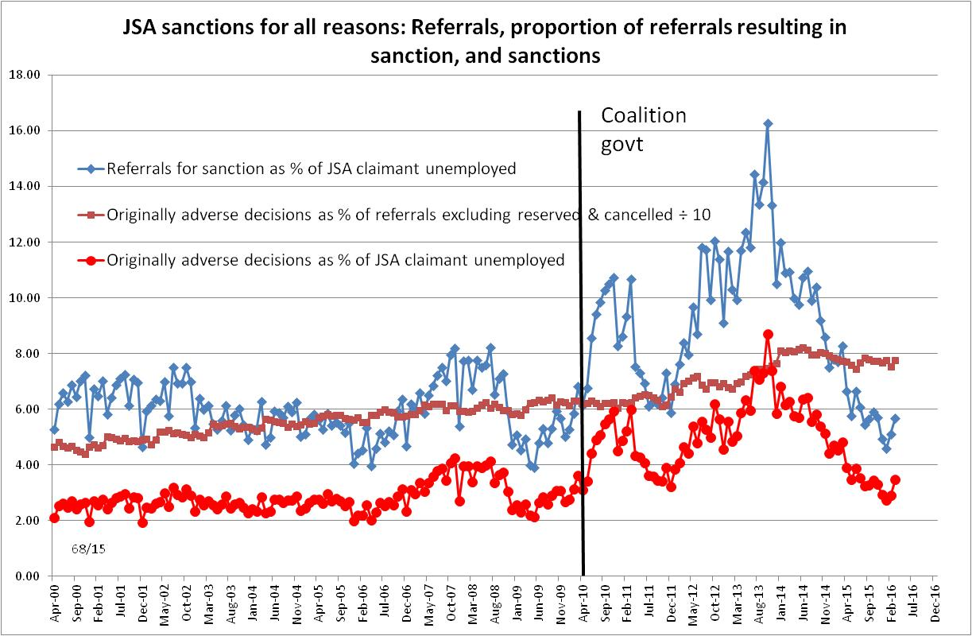
Figure 2
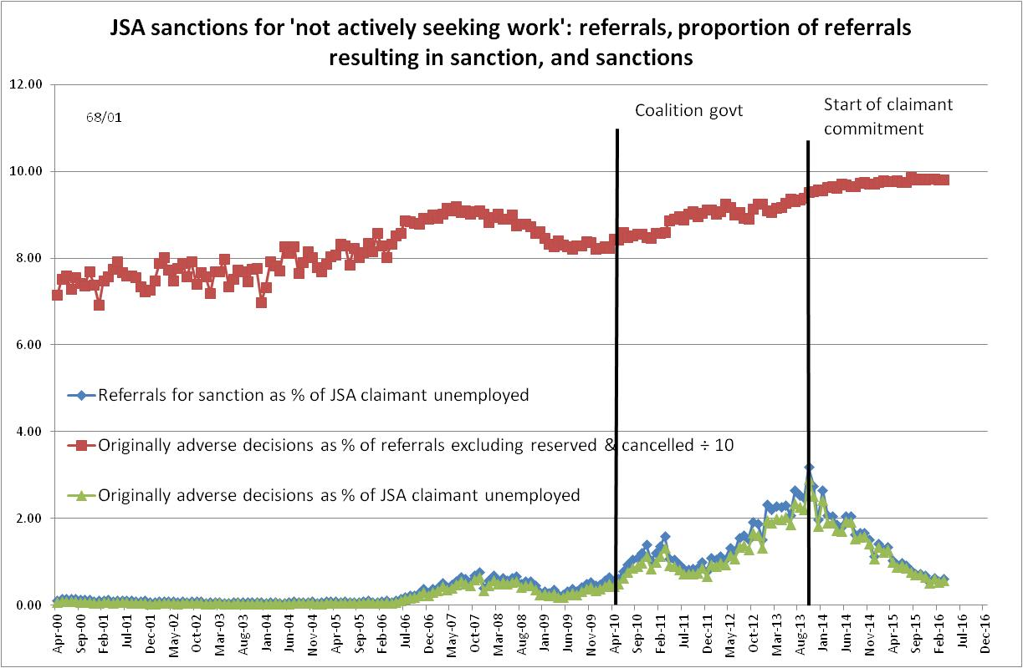
Figure 3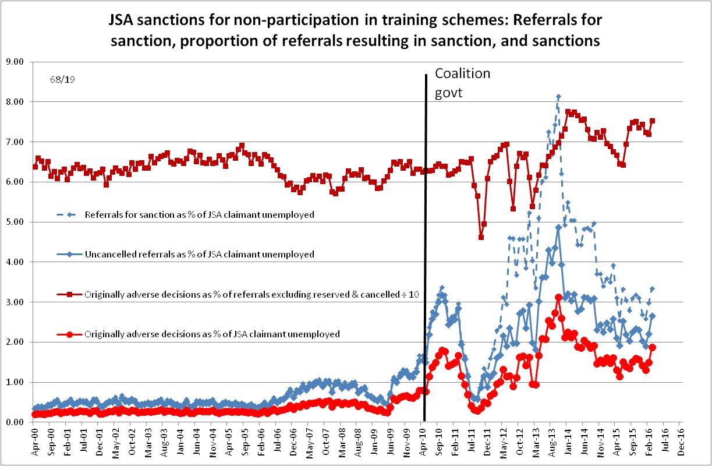
Figure 4
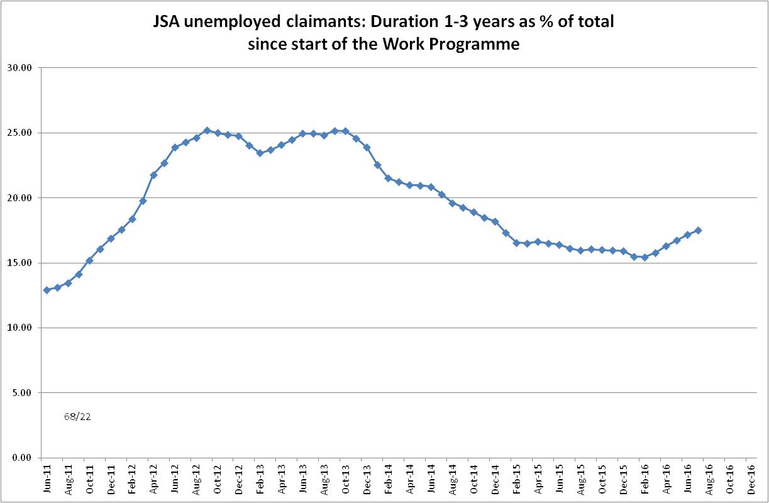
Figure 5
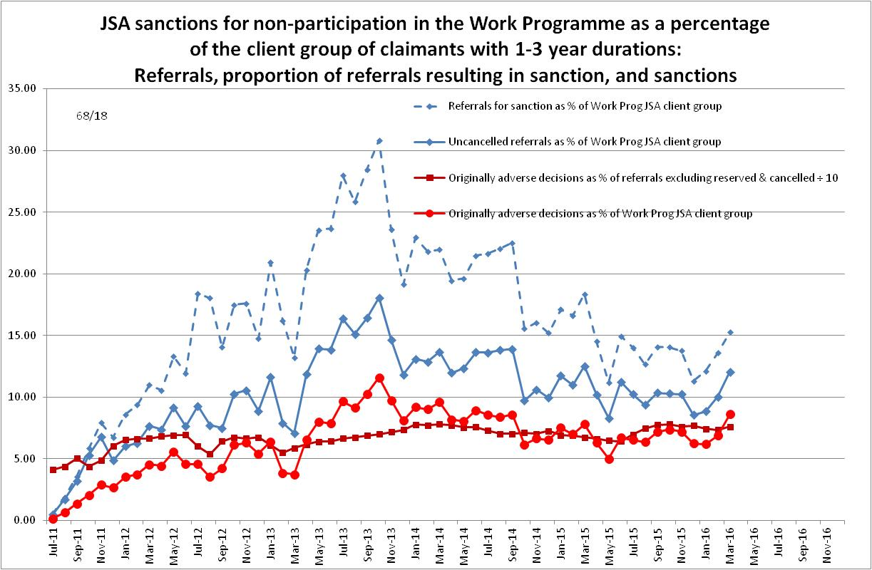
Figure 6
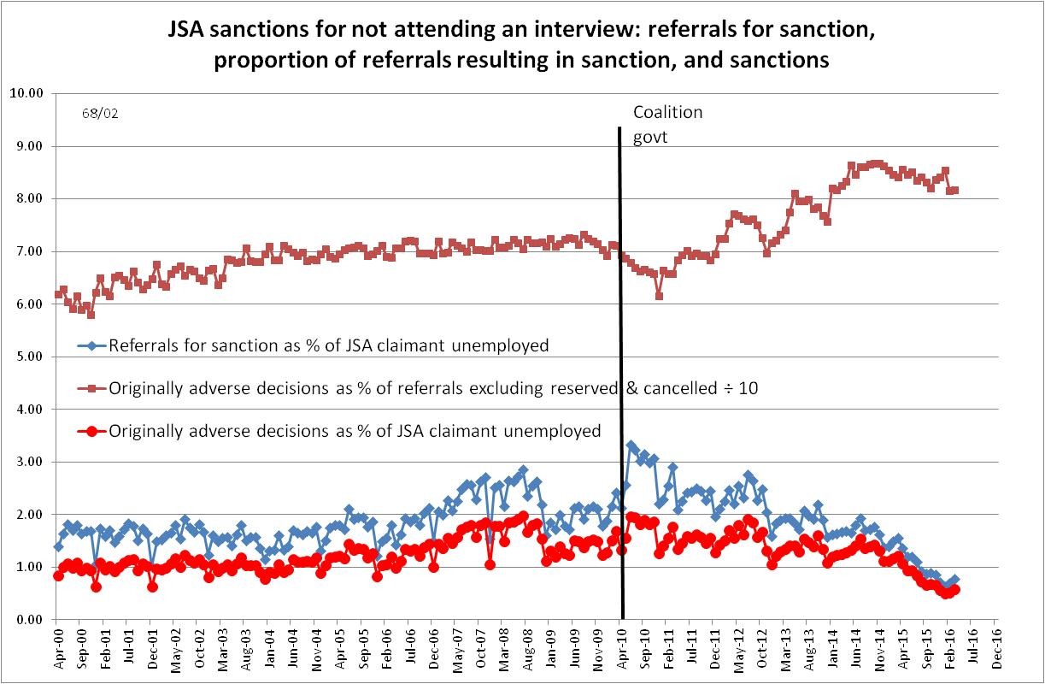
Figure 7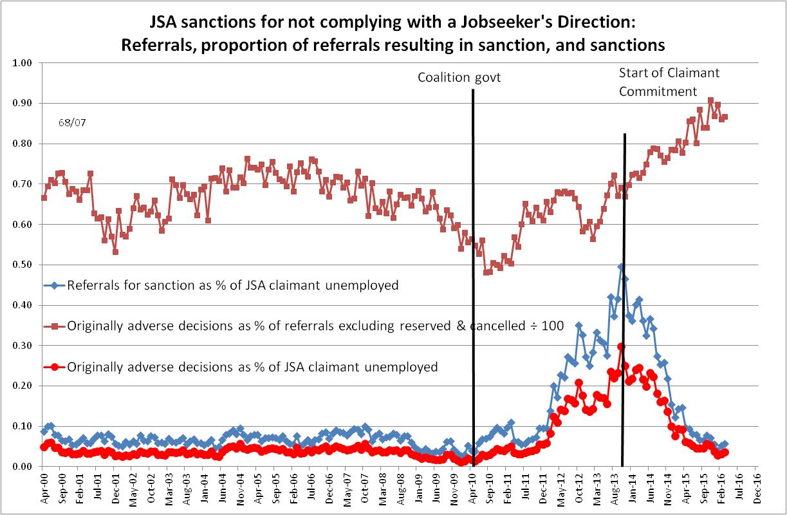
Figure 8
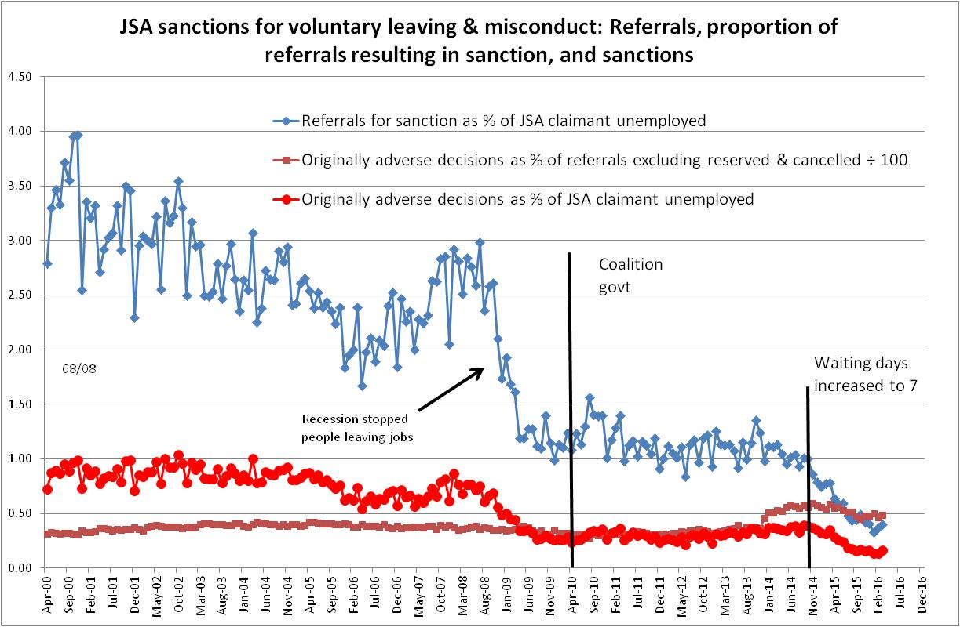
Figure 9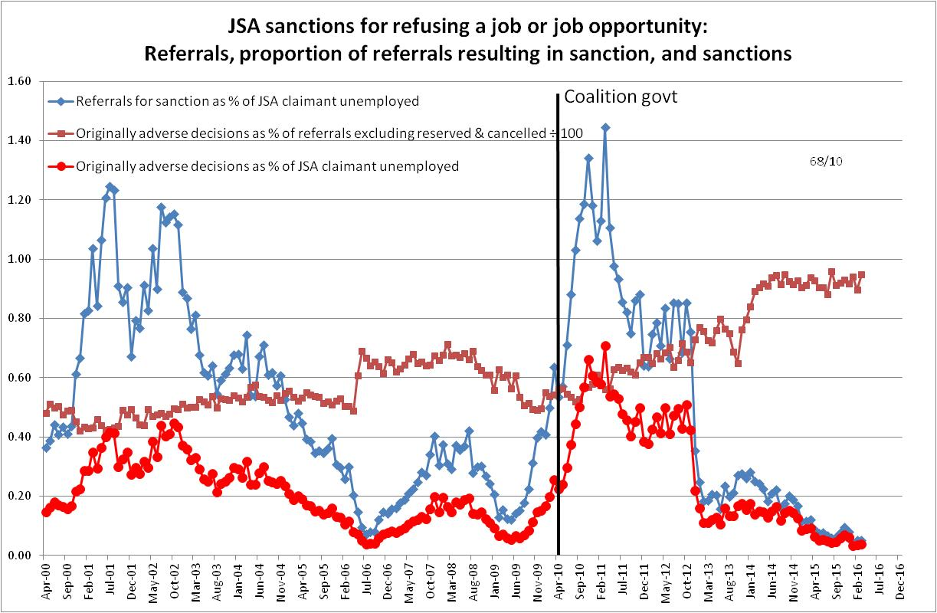
Figure 10
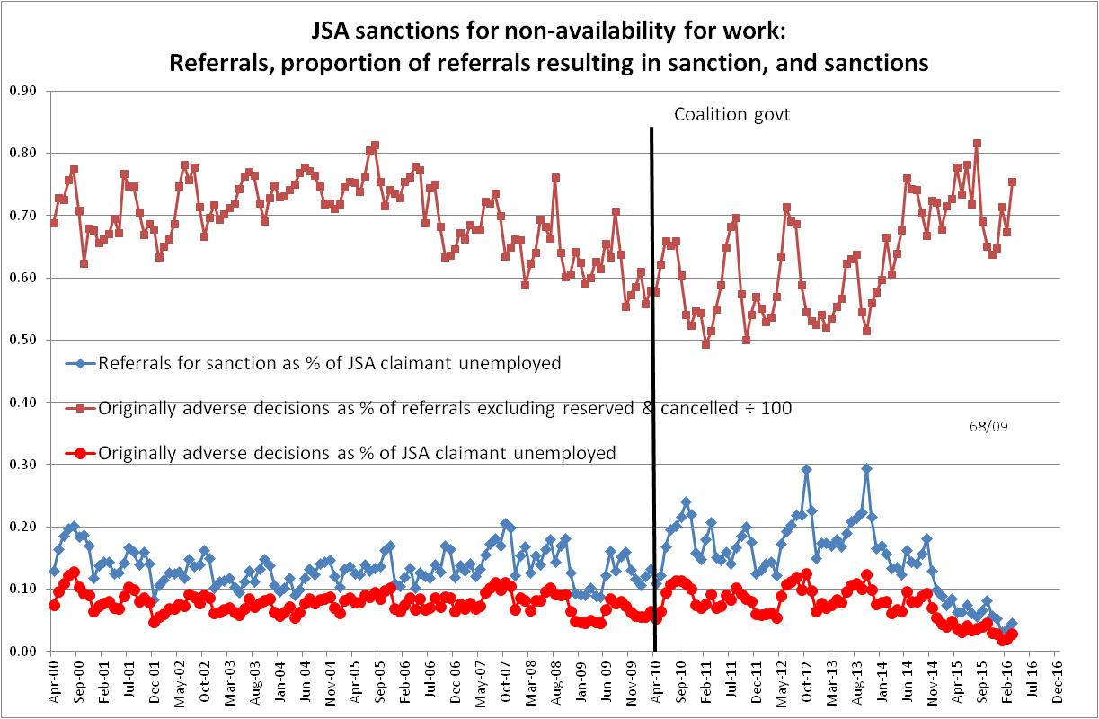
Figure 11
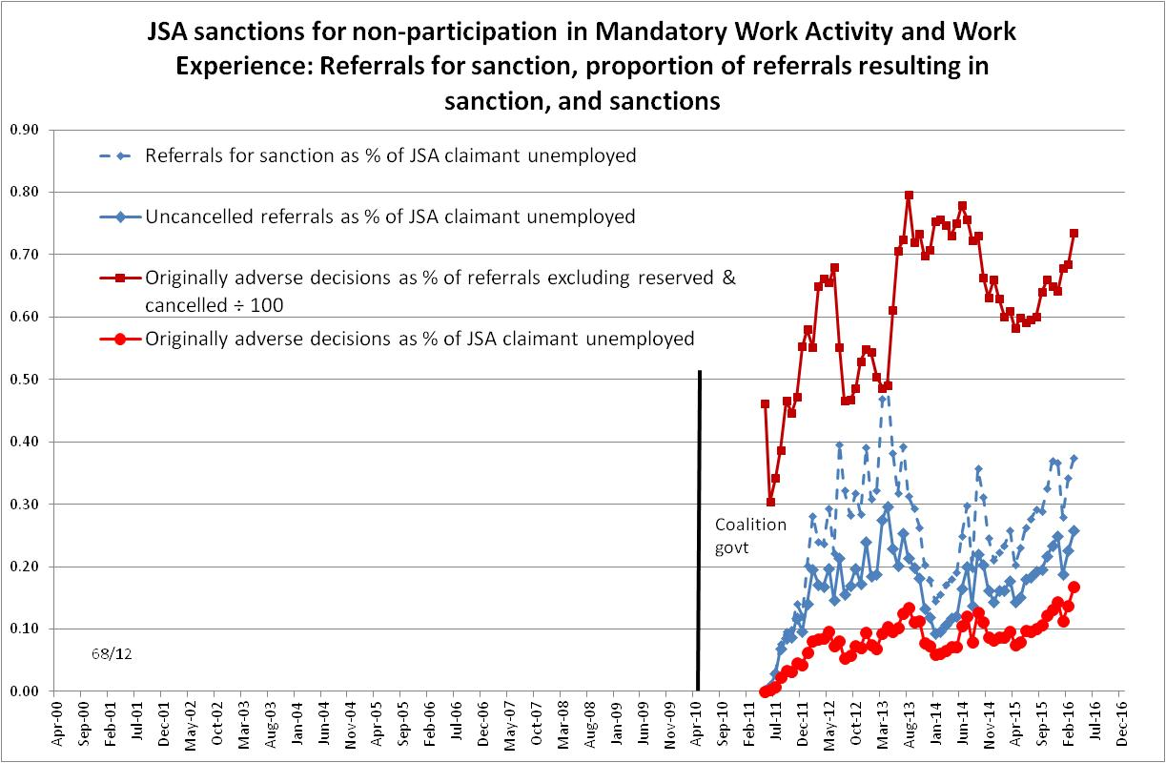
Figure 12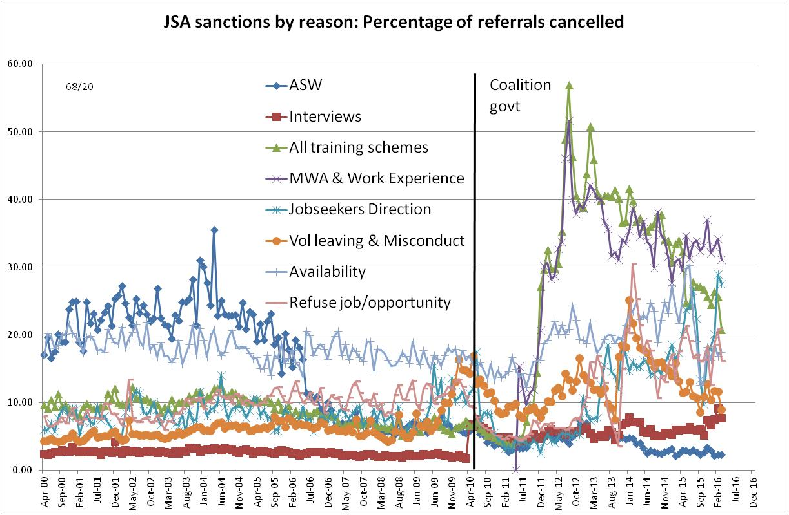
Figure 13
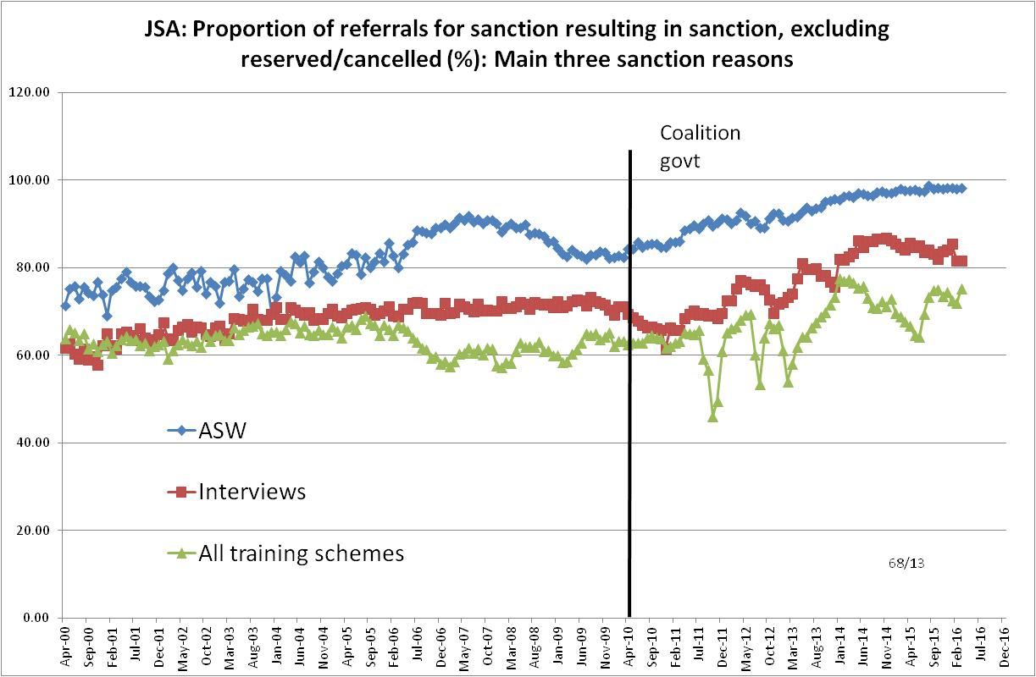

Figure 14
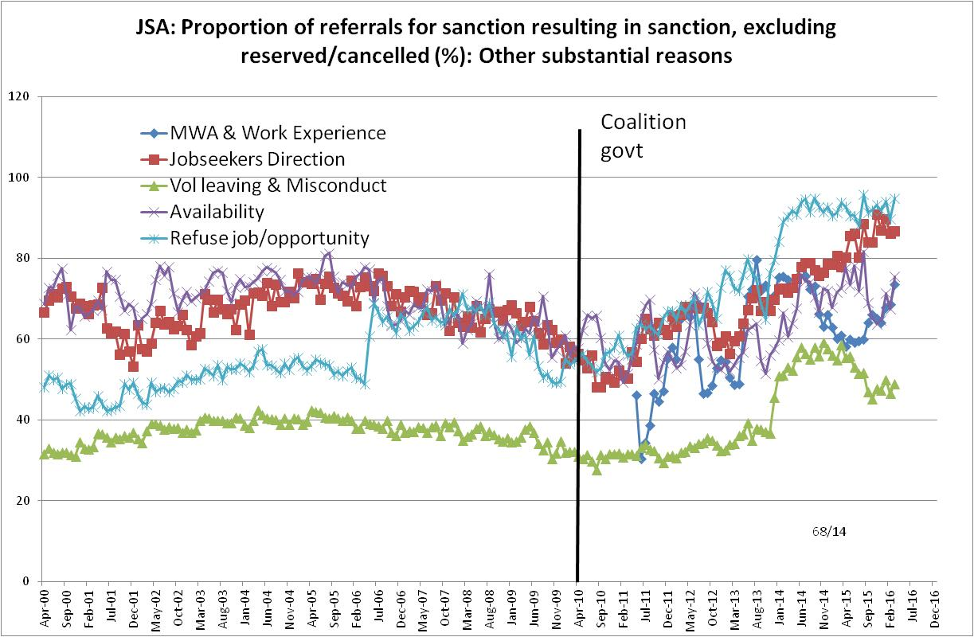
Figure 15
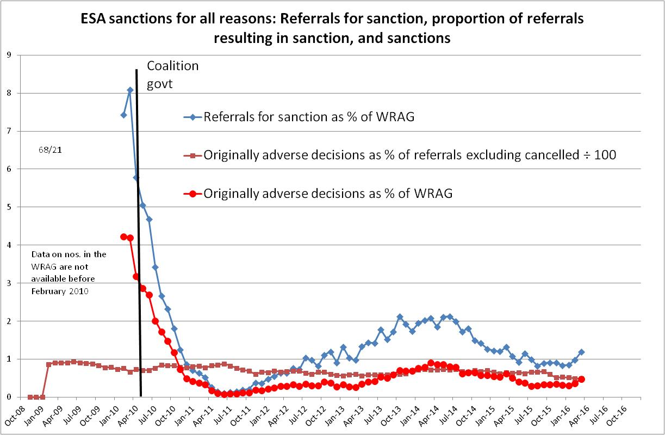
Note: Figures 15-17 show approximate sanctions before challenges, whereas the similar charts in the main Briefing show sanctions after challenges
Figure 16
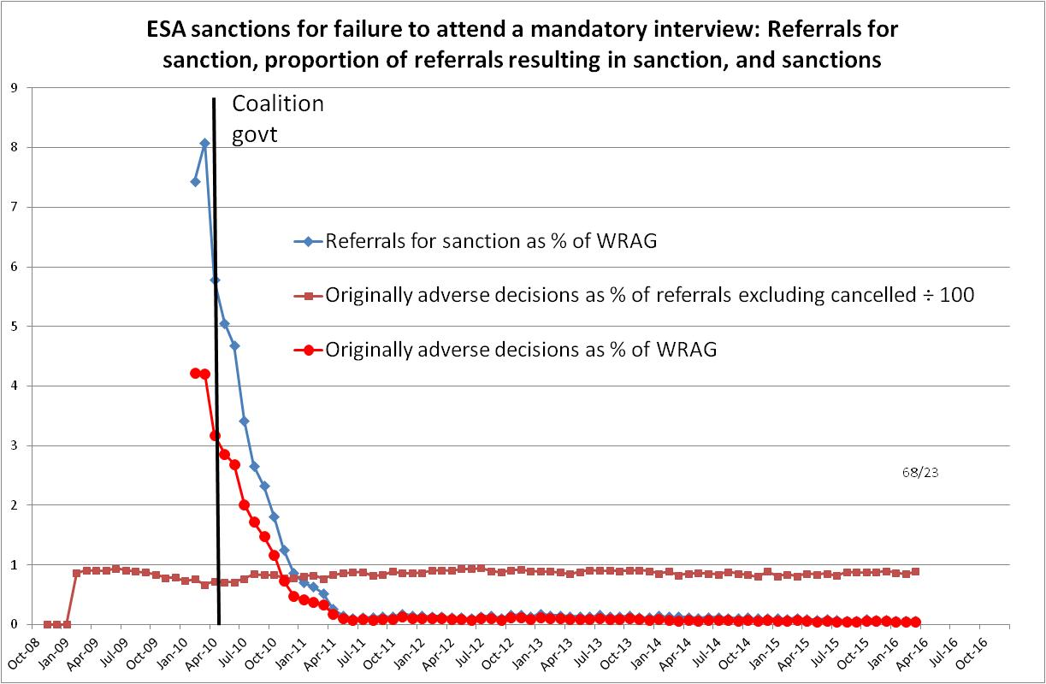
Figure 17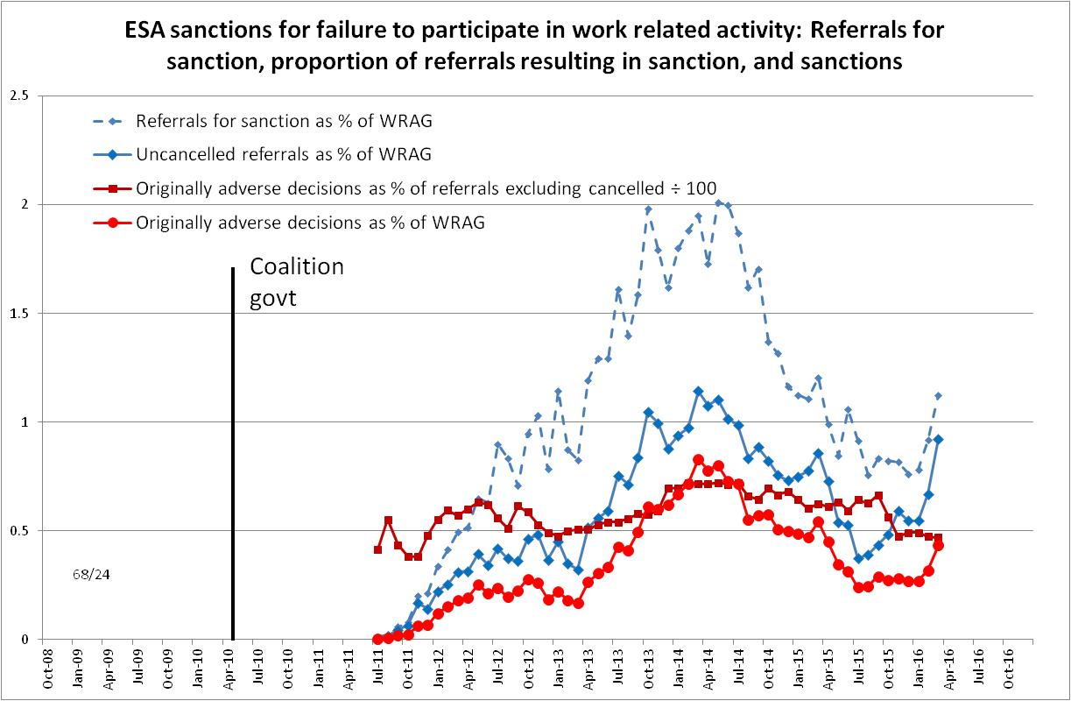
Figure 18
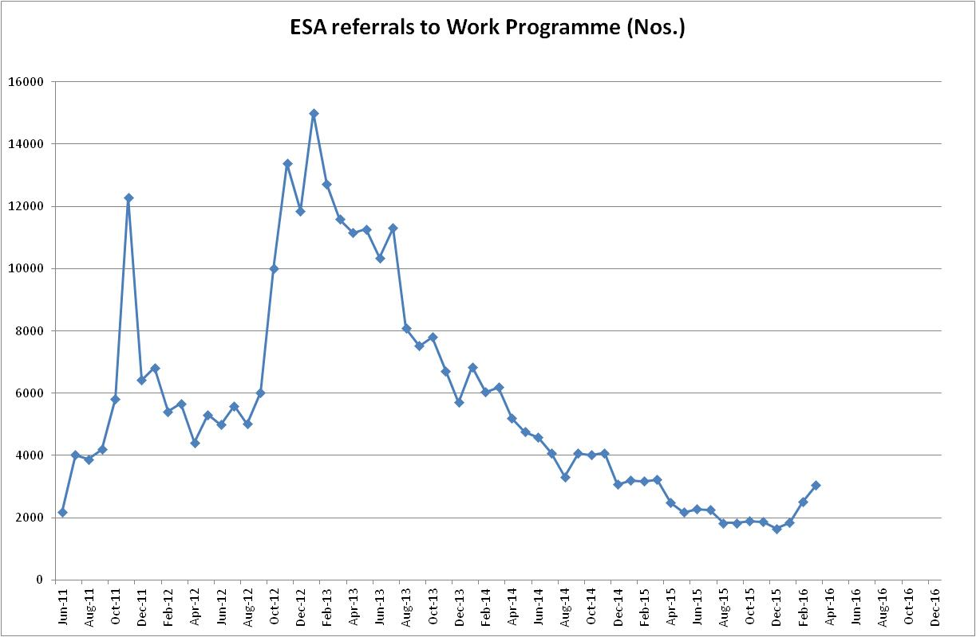

APPENDIX:
The government’s argument that Work Programme contractors must make referrals for sanction even when they know they are inappropriate

EXTRACT from A Guide to the Oakley Report and the Government’s Response, 14 September 2014, pp.20-21 (full text available at www.cpag.org.uk/david-webster )

Recommendation 12 - The Department should revise guidance and/or enabling legislation so that, in some circumstances, providers of mandatory back to work schemes are able to accept good reason from claimants.

Recommendation 14 – Guidance for providers should be revised to require that they have an obligation to take proportional steps to seek good reason from claimants. All subsequent referrals for a sanction should outline the attempts that a provider has made to do this and provide accurate details of any good reason that has been given.

These recommendations highlight an astonishing situation. Oakley (p.43) states that ‘because providers of mandatory schemes are unable to make legal decisions regarding good reason, they have to refer (for sanction) all claimants who fail to attend a mandatory interview to a decision maker. This is the case even if the claimant has provided them with what would ordinarily count as good reason in Jobcentre Plus.’ He quotes evidence that claimants frequently have good reason, and points out the wastefulness of unnecessary referrals. Almost half of all sanctions referrals are made by Work Programme providers, but they only result in one third of all sanctions.

In its response, the government says that it cannot change the situation without primary legislation, and claims that this needs to compete with other legislative priorities. In fact, it is a matter of common knowledge that there is actually a shortage of legislation in the final session of the current parliament. The government already had an opportunity to change the legislation as recently as October 2012, when it made changes to relevant sections of the Jobseekers Act 1995 through the Welfare Reform Act. But there is a more fundamental issue. Most of the sanctions refer to cases where the claimant ‘without good reason....fails to attend....a scheme or programme’ (Jobseekers Act 1995, S.19A (2) (f) as amended). The Act says fails to attend the programme, not fails to attend a single interview or session. But, as the government response confirms, claimants are referred for sanction for missing a single interview even where they have a first-class record of attendance. For instance, a claimant in Glasgow told me that he had attended over 60 interviews with his Work Programme provider, and was then sanctioned for missing a single one. It is puzzling that the term ‘fails to attend’ is being given such a stringent interpretation. It would surely be legally possible to issue guidance that the provision should be interpreted reasonably, in other words a sanction referral would be attracted only by a pattern of non-attendance.

Recommendation 14 relates to a different aspect of the same issue. Oakley points out that the process subsequent to the referral by which Jobcentre Plus asks the claimant whether they had ‘good reason’ often does not work properly; ‘a large proportion of claimants fail to respond’ to the relevant letter, and many do not understand its significance. He therefore proposes that the external provider, who is on the spot, should have an obligation to establish if there is any good reason and make sure that it gets to Jobcentre Plus. The government states that it has accepted this recommendation, but in fact it has rejected it. It says only that it has ‘made it clear that providers can record any good reason offered to them from the claimant’ and that ‘We will continue to encourage providers to take all reasonable steps to record good reason where possible’.

Therefore the human and financial waste exposed by Oakley will continue.

EXTRACTS from
Briefing on the Government’s Response to the House of Commons Work and Pensions
Committee report: Benefit Sanctions Policy beyond the Oakley Review, 4 November 2015, pp.13-14 (full text available at www.cpag.org.uk/david-webster )

44. Another longstanding problem which was highlighted by Oakley (pp. 43-45) is that Work Programme contractors are required to refer every missed appointment to DWP for sanction even where it is obvious that there was a good reason for it, thus generating huge waste. The Committee (Comm 2/Govt 2) reiterated its concern. The government claims that this cannot be changed because of ‘legislative and contractual obligations’. However, there can obviously be no contractual problem in the government unilaterally releasing contractors from what is a financially burdensome duty. In this author’s view, the claim about legislation is also mistaken, for the reasons given in the Guide to Oakley, p.20. The legislation (Jobseekers Act 1995, S.19A (2) (f)) refers to failure to attend ‘a scheme or programme’, not failure to attend a single interview. In common sense terms this means that missing a single appointment, especially if a sensible reason is given, is not normally a sanctionable failure and therefore no referral is required. It is significant that a recent Upper Tribunal case threw out the DWP’s attempt to put an overly strict construction on the similar provision relating to ‘failure or refusal to carry out a Jobseeker Direction’.

51. In line with its refusal of a general review of sanctions, the government has not agreed to a review; indeed its response does not even refer to this part of the Committee’s recommendation. It also claims that in the specific case of ESA, S.16 (3) of the Welfare Reform Act 2007 means that Work Programme contractors must refer any ‘doubt’ to DWP even when it is obvious that the claimant is not at fault. As in the case discussed in para.44 above, this interpretation appears unnecessarily rigid. It is true that S.16 (2)(a) and (3) prevent contracting out of decisions on whether the claimant has failed to comply, shown good cause or should suffer a sanction. But the intention of this section is clearly to reserve to DWP the power to make decisions to a claimant’s disadvantage. It surely leaves it open to a contractor faced with an event that might or might not mean non-compliance simply to postpone any action at all pending further evidence.

52. The government does however say that it has been improving guidance to contractors. Once again, whether this means anything will be shown by whether there is an abatement of the stream of complaints about inappropriate sanctions on ESA claimants.

http://www.cpag.org.uk/david-webster
As in the main Briefing, estimates of sanctions before challenges have been derived by adding the monthly total of ‘non-adverse’, ‘reserved’ and ‘cancelled’ decisions shown as being the result of reviews, mandatory reconsiderations and tribunal appeals, to the monthly total of adverse ‘original’ decisions. Although reliable for longer time periods, they are not fully accurate for individual months.
In this classification, the categories ‘Not actively seeking work’, ‘failure to attend an interview’, ‘non-participation in the Work Programme’, ‘failure to comply with a Jobseekers Direction’ and ‘non-availability for employment’ are as shown in Stat-Xplore. Included in ‘all training and employment schemes’ are ‘voluntarily leaving’, ‘losing through misconduct’, ‘refusing’, ‘neglecting to avail of’ and ‘failing to attend’ a place on a training scheme or employment programme without good reason; ‘failure to participate’ in the Work Programme, Skills Conditionality or other scheme; and failure to attend a Back to Work session. ‘Voluntarily leaving’ and ‘losing through misconduct’ are combined as ‘Voluntary leaving or misconduct’. ‘Refusing a job offer’ and refusing an opportunity of employment are combined as ‘Refuse job/job opportunity’. ‘Other’ includes ‘other referral reason’, Failure to participate in supervised job search, Trade disputes, Jobseeker's Agreement questions and Joint Claim exemption.
In the DWP’s database each sanction case is shown with its latest status and recorded as occurring in the month of the latest decision on the case. This means, for instance, that if a chart shows that 40% of referrals in a given month were cancelled, the true figure will probably be somewhat different. The chart should show, for all the referrals made in a given month, what proportion were cancelled, taking all subsequent months together. Instead, what it shows is cancellations in the given month as a percentage of total decisions in that month, including new sanctions that month as well as revisions to sanctions originally imposed in earlier months.
https://www.theguardian.com/law/2014/nov/01/police-cautions-abolished-staffordshire-west-yorkshire-leicestershire-forces-chris-grayling
Much of their evidence is available at http://www.cpag.org.uk/content/sanctions
http://www.osscsc.gov.uk/Aspx/view.aspx?id=4628

