BRIEFING:

Benefit Sanctions Statistics:
JSA, ESA, Universal Credit and Income Support for Lone Parents

November 2017

13 December 2017

Dr David Webster
Honorary Senior Research Fellow
Urban Studies
University of Glasgow

Email david.webster@glasgow.ac.uk

Webpages: http://www.gla.ac.uk/schools/socialpolitical/staff/davidwebster/
http://www.cpag.org.uk/david-webster

SUMMARY

The rate of sanctions as a percentage of Universal Credit (UC) claimants subject to conditionality remains very high. Over the whole period since August 2015 it has averaged 7.0% per month before challenges and was 5.2% in the quarter to June 2017. We do not know how this rate varies between the different groups on UC (unemployed, in work etc.), although unemployed people accounted for 80.7% of UC claimants subject to conditionality at June 2017. The JSA rate appears to have stabilised at around 1.7% per month before challenges and the ESA WRAG and Income Support lone parent rates are much lower at around 0.3% per month.

The total number of sanctions on the four benefits before challenges is running at a rate of about 400,000 per year and on present trends will not decline further. Although only having 383,000 claimants subject to conditionality at June 2017, compared to 1,180,000 on the other three benefits, UC accounted for over two-thirds (69.5%) of all sanctions in the first half of 2017.

The overall rate of sanction on unemployed people (whether on JSA or UC) can be approximately estimated. It has fallen to about 3.3%, almost double the rate for JSA alone.

DWP has created a new publication, Benefit Sanctions Statistics, and is using it to highlight two new measures, namely the duration of sanctions and the proportion of claimants serving a sanction at a point in time, for UC, ESA and JSA. These measures are very misleading.

The published durations do not show the duration of sanctions of people who stay on benefit and serve their sanction fully; they do not include the periods of reduced income endured by people who remain eligible for benefit but stop claiming it; they do not include the unserved portions of sanctions which those claimants are made to serve if they later reclaim; and they do not reflect the effect of repayment of UC hardship payments. They therefore do not show anything like the full impact of sanctions in lowering claimants’ incomes. Nevertheless it is concerning that even on these definitions, ESA sanctions are often very long, averaging some 9 weeks and with 26% lasting more than 3 months and 16% more than six months.

The published proportions of claimants under sanction at a point in time are derived from the duration figures and are underestimates for the same reasons, but they suffer from other problems as well. The DWP has expressed UC claimants under sanction as a proportion of all UC claimants, rather than of those subject to conditionality. When this is corrected, the proportion under sanction in March 2017 was a remarkable one in ten (9.3%), and this should be raised to around 11% to allow for the other factors. The published ESA and JSA proportions are too low because the DWP has used a database which leaves out large numbers of claimants for various technical reasons, and has then divided this understated number of claimants by the full and unadjusted number of claimants on the benefit. Moreover, in the case of JSA (though not the other benefits), the various figures given by DWP are not compatible with each other, meaning that one or more must be wrong.

The review of other sanctions developments at the end of the Briefing includes a commentary on the government’s response to the Public Accounts Committee’s sanctions report of February 2017.
BRIEFING: Benefit Sanctions Statistics
November 2017

INTRODUCTION

This briefing continues the series of reports dealing with the quarterly benefit sanctions data released by DWP. The latest statistics were released on 15 November on Stat-Xplore at https://stat-xplore.dwp.gov.uk/webapi/jsf/login.xhtml, giving figures to June 2017. All statistics relate to Great Britain.

DWP has changed the presentation of the figures. There is now a separate publication Benefit Sanctions Statistics, available at https://www.gov.uk/government/statistics/benefit-sanctions-statistics-2017 alongside the existing spreadsheet with data tables. Previously, the discussion of sanctions was contained within the quarterly Benefit Statistics Summaries.

In Benefit Sanctions Statistics and in the summary spreadsheet (but not on Stat-Xplore) DWP has now added ‘experimental’ statistics on the duration of completed JSA sanctions and on the number and proportion of JSA claimants subject to sanction at a point in time, running to March 2017. These stand alongside the parallel information for ESA and Universal Credit first published in August. All of these new statistics are subject to severe limitations and it appears that the published figures on the number and proportion of JSA claimants subject to sanction at a point in time are actually incorrect. This Briefing explains why and includes more realistic estimates.

Groups of claimants exposed to sanctions:
JSA, ESA, Universal Credit and Income Support

At May 2017, a total of over 1.7m claimants of JSA, ESA, Income Support or Universal Credit were exposed to sanctions.

Since 2013, DWP has been transferring new unemployed claimants of income-based (but not contribution-based) JSA on to Universal Credit. Until May 2016 this was only of single claimants without dependants. In October 2017 there were 760,300 unemployed claimants, of whom 422,118 (55.5%) were on JSA and 338,182 (44.5%) on UC.

Since May 2016, DWP has been transferring to Universal Credit new claimants of all household types of all the types of benefit which are subsumed into Universal Credit. These are Housing Benefit (not relevant to sanctions), income-based (but not contribution-related) JSA, Working Tax Credit, Child Tax Credit, income-related (but not contribution-related) ESA, and Income Support. This ‘full service’ rollout was initially slow and by June 2017, only 74 out of 714 Jobcentres were operating ‘full service’. This is 10% of the Jobcentres. Because only new claimants are currently transferred, far fewer than 10% of the claimants of each benefit other than JSA have so far been transferred. However, rollout is now accelerating. Under the schedule published in October 2017, rollout would have been completed by the end of September 2018. But following the Budget, DWP has published a new UC rollout schedule, at
https://www.gov.uk/government/uploads/system/uploads/attachment_data/file/662950/universal-credit-transition-rollout-schedule.pdf Under this, rollout will be completed three months later, in December 2018. This still means a rapid acceleration from October 2017 onwards, with 195 Jobcentres operating ‘full service’ by the end of November 2017.

Figure 1 shows how the numbers of claimants on UC have increased, by conditionality regime. Of the 630,000 UC claimants at October 2017, 194,000 were not subject to conditionality. Of the 436,000 UC claimants subject to conditionality, 338,000 were unemployed and 73,000 were working, with 25,000 required to plan or prepare for work.
The in-work UC claimants subject to sanctions are low paid or part-time workers who prior to UC would not have been subject to sanctions at all.

In spite of transfers to UC, the number of claimants in the ESA Work Related Activity Group (WRAG) has started to increase again after almost four years of continuous decline. There were 411,430 of these claimants in May 2017, up from a low of 409,450 in February. Their number peaked at 562,620 in August 2013. The number will decline again as claimants are transferred to UC.

The number of lone parents on Income Support has been falling, to 387,430 in May 2017. Currently, only those with a youngest child aged under 1 are exempt from sanctions. Some other IS claimants, e.g. carers, are also subject to sanctions.

Universal Credit sanctions

Details of the UC sanction regime are given in DWP (2017b). The UC regime has similar lengths of sanction to those of JSA for the various ‘failures’, but there are some critical differences. Sanctions are lengthened by being made consecutive, not concurrent. Hardship payments become repayable. Given that repayments are made at the rate of 40% of benefit – the same as the amount by which a hardship payment is lower than the benefit – this means that for claimants receiving hardship payments, UC sanctions are in effect 2½ times as long as their nominal length. All sanctioned UC claimants must also demonstrate ‘compliance’ for 7 days before applying for hardship payments, and must reapply for each 4-week period. The 80% hardship rate for ‘vulnerable’ claimants is abolished. There is a new ‘lowest’ category of sanction which applies to claimants who would previously have been subject to the milder IS sanction regime and it is equivalent to it.

Sanctions before and after reviews, reconsiderations and appeals

The DWP’s Stat-Xplore database only shows sanctions after any reviews, reconsiderations and appeals that have taken place by the time the data are published. But numbers of sanctions before the results of these challenges are important since they show all the cases in which claimants have had their money stopped. Although a successful challenge should result in a refund, this is only after weeks or months by which time serious damage is often done. Estimates of sanctions before challenges are therefore given here but although reliable for longer time periods, they are not fully accurate for individual months. Figures for sanctions before challenges are currently higher than the ‘after challenge’ figures by about 20% for JSA and 40% for ESA. To date, under 5% of UC sanctions have been overturned following challenge and for lone parent IS sanctions only 1%, so for these types of sanction there is much less difference between the pre-and post-challenge figures. This Briefing has a mixture of pre- and post-challenge sanctions figures.

RATES AND NUMBERS OF SANCTIONS FOR THE FOUR BENEFITS

Rates of sanctions

Figure 2 compares the monthly before-challenge sanction rates for JSA, UC, ESA and IS for lone parents. The UC rate includes all types of claimant, since DWP does not publish separate figures for unemployed, working, sick etc. Rates have been calculated as a percentage of claimants subject to conditionality. For JSA this means all claimants; for UC, it is those ‘searching for work’, ‘working with requirements’, ‘planning for work’ and ‘preparing for work’; for ESA it is those in the Work Related Activity Group; and for lone parents on IS, it is those with youngest child aged over 1 (estimated as four-fifths of the total since all lone parent claimants with a youngest child aged 5+ have been taken off IS and transferred to JSA). UC sanctions have been increased pro rata to adjust for the omission by DWP of sanctions on claimants in ‘full service’ areas, using the published schedule for transfer of Jobcentres to ‘full service’.

The most striking feature is the extremely high rate of sanction under Universal Credit. During 2016 DWP developed backlogs in making decisions on UC sanction referrals, and then mounted a blitz to catch up at the end of 2016. Consequently the rate of UC sanctions has fluctuated wildly, making it difficult to discern the underlying rate. The best guide is the overall average since August 2015. This is 7% per month, similar to the highest level ever seen for JSA (during 2013), but slightly lower than the average for the whole period August 2015 to March 2017 reported in the previous Briefing, which was 7.4% per month. Because DWP has not published the necessary data, we do not know how the rate of sanctions varies between the different groups of UC claimants subject to conditionality. It might, for instance, be higher for unemployed than for employed claimants, or vice versa. We simply do not know.

After peaking at over 8% in 2013, the JSA rate before challenges fell steadily and now appears to have stabilised at around 1.7% of claimants per month. Sanction rates on ESA WRAG claimants and lone parents on IS are much lower, currently both around 0.3% per month before challenges. DWP notes that the new Stat-Xplore series of IS sanctions data is not comparable to the previous one, published in the former Income Support Lone Parents Regime: Official Statistics: Quarterly official statistics bulletin, but it does not offer an explanation of the large discrepancy.

Numbers of sanctions

Actual numbers of sanctions depend on the rate of sanction and on the size of the claimant group subject to them. Table 1 shows the total number of sanctions for each benefit for each calendar year since 2001. This shows how extreme were the years of the Coalition government. The peak year was 2013, with over 1.1m sanctions in total. Since then the number has declined to around 400,000 per year but on present trends will not decline further and may increase. Universal Credit, with its high rate of sanction, has already come to dominate in terms of numbers of sanctions, accounting for over two-thirds (69.5%) of all sanctions in 2017 to date. This is in spite of UC only having 383,000 claimants subject to conditionality at June 2017, compared to about 1,180,000 subject to conditionality on the other three benefits.

Numbers and rates of sanctions against unemployed people (JSA and Universal Credit)

It is unemployed people who are subject to the harshest conditionality regime and who have suffered the largest numbers and highest rates of sanctions. To date, they are also by far the largest group of UC claimants, accounting for 57.9% of all UC claimants, and 80.7% of UC claimants subject to conditionality, at June 2017. It is therefore worth trying to see what has happened to the overall rate of sanctions on unemployed people as more and more have been transferred to Universal Credit.

As already mentioned, DWP gives no breakdown of UC sanctions by type of claimant (unemployed, sick etc.) so that the published figures for UC include sanctions on people other than unemployed. On the other hand, these sanctions figures omit cases in ‘full service’ areas. With unemployed claimants accounting for 80.7% of claimants subject to conditionality at June 2017, and 75 out of 714 Jobcentres offering ‘full service’ at the same date, it can still be reasonably assumed that these two factors approximately cancel each other out. On this basis, in the year to June 2017 there were approximately 348,000 JSA or UC sanctions on unemployed people before challenges. This is about the same as for the year to March 2017 (350,000). Of the 348,000 sanctions to June 2017, 106,000 were JSA and 242,000 UC.

After challenges, in the year to June 2017 there were 86,986 JSA and approximately 232,000 UC sanctions on unemployed people, a total of 319,000.

Figure 3 shows the monthly sanction rates (sanctions as a percentage of claimants) before challenges for JSA alone and for all unemployed claimants (including both JSA and UC unemployed) since April 2000. This shows that the overall sanction rate on unemployed people has not fallen nearly as much as the DWP’s published figures for JSA have suggested. It did apparently fall to just over 3% during 2016. It has fluctuated since then, largely due to backlogs emerging within UC and then being reduced. In the latest quarter the average overall rate on unemployed people was 3.3%, almost double the rate for JSA alone.

The overall rate of sanction on unemployed people is likely to rise simply because of the continuing transfer of claimants to the high-sanctioning UC.

To explain the higher UC sanction rate, the DWP (2017b, p.4) states that under JSA, claimants not attending an interview will normally have their cases closed whereas under UC they are more often sanctioned. The reason for this is that UC claimants may be in receipt of other parts of UC, such as housing benefit and child credits, and therefore cannot have their cases closed. Another part of the explanation why the UC sanction rate is so much higher than JSA is that UC claimants tend to be younger, and younger people have a higher rate of sanction. But a chart in the August 2017 Briefing (Figure 5) showed that the mean monthly UC sanction rate after challenges is much higher than for JSA for every age group.

THE DURATION OF SANCTIONS

In the DWP’s Benefit Sanctions Statistics and the accompanying summary spreadsheet (but not in Stat-Xplore) there are now ‘experimental’ statistics on the duration of ‘ended’ Universal Credit, ESA and JSA (but not IS) sanctions. For UC and ESA there are month-by-month detailed frequency distributions of durations in the spreadsheet but for JSA there is only a single broad frequency distribution for the whole period October 2012 to March 2017, on p.12 of Benefit Sanctions Statistics.

It is important to understand the specific definitions on which these figures have been compiled. They are set out in the DWP’s methodology paper (DWP 2017a). The figures do not directly measure sanctions, but have been obtained by linking observed drops in payments to claimants to apparently associated sanction decisions. The figures show the duration of the payment drop believed to have been due to a sanction believed to have ended in a given month. They include sanctions overturned on reconsideration or appeal. So, for instance, a 13-week sanction which is overturned on reconsideration after 8 weeks, with payment of full benefit restarting after 9 weeks, will be shown as lasting 9 weeks. Some people leave benefit after a sanction is imposed. In some cases this is because they are no longer eligible for benefit because they have got a job or for some other reason, but we know that in many cases they leave as a direct result of the sanction (Loopstra et al. 2015, NAO 2016) and are in effect sanctioning themselves. Claimants who leave benefit immediately upon being sanctioned (‘0 day cases’) are excluded, but if a claimant leaves subsequently before the sanction is completed then their curtailed sanction will be included. In most cases, if a claimant with an uncompleted sanction reclaims benefit later, they will have the unserved part of their sanction reimposed. DWP has confirmed to me that these unserved parts of sanctions are not included in the figures. This means that the term ‘ended’ is inappropriate since these sanctions are not ended at the time used in the figures. The figures also exclude cases where payment and decision data could not be matched (about one fifth of JSA and ESA sanction decisions); JSA ‘non-complex Failure to Attend decisions that are made by a Jobcentre Decision Maker’; and ‘some week-long JSA and ESA sanctions’ (DWP 2017a, p.6). There are also some other minor technical issues. Finally, under UC (but not the other benefits) for those receiving hardship payments, the true length of a UC sanction is two-and-a-half times the stated length, because the hardship payments have to be repaid at a rate which lowers the claimant’s income to the same level (60% of benefit) as during the sanction. A sanction should not be described as ‘ended’ if it is still reducing the claimant’s income, but the duration figures do not include this extra time spent under what is a sanction in all but name.

These duration figures therefore only tell part of the story. All the durations are understated. They do not show the duration of sanctions of people who stay on benefit and serve their sanction fully; they do not include the periods of reduced income endured by people who remain eligible for benefit but stop claiming it; they do not include the unserved portions of sanctions which those claimants are made to serve if they later reclaim; and they do not reflect the effect of repayment of UC hardship payments. They therefore do not show anything like the full impact of sanctions in lowering claimants’ incomes.

In Benefit Sanctions Statistics and the accompanying summary spreadsheet, DWP has presented only the median durations. It is bad practice to publish medians without the corresponding averages or means, because both measures are required to describe the data fully. However, the DWP’s published frequency distributions can be used to calculate approximate mean sanction lengths, using a well-established method.

With these important reservations, Figure 4 shows the median and approximate mean durations of sanctions for ESA, UC and JSA. In calculating the means, the top class interval of ‘27 weeks and over’ is taken to have a mean duration of 30 weeks. This is a fairly conservative assumption given that the durations will not all be clustered at the lower bound of 27 weeks. For JSA, there is only one observation on each of the median and the mean to cover the whole period. This is because DWP has not published more detailed data.

The most striking feature is how much longer are the (unpublished) means than the (published) medians, especially in the case of ESA where the mean is typically about 5 weeks longer than the median. Another feature is that duration generally seems to have risen over time. Finally, it is striking how very long are the mean sanctions on ESA claimants, who are by definition too sick or disabled to work – currently some 9 weeks. The fact that the measured durations for JSA and UC are lower than this will partly be due to the fact that off-flows from benefit are much higher for JSA and UC than for ESA. Another reason why ESA durations are long is that they are all open-ended ‘until compliance’, followed by a fixed period of 1, 2 or 4 weeks. In a badly-administered system such as the UK’s sanctions regime (Oakley 2014), ‘open-ended’ sanctions often last a very long time due to mistakes and communication difficulties. However, even the ESA durations are understated given the estimation procedure which DWP has used.

The frequency distributions themselves show that in the first quarter of 2017, 26% of ‘ended’ ESA sanctions were lasting more than three months and 16% for more than six months. For JSA, the DWP has published only a table covering the whole period. This shows 22.1% of sanctions lasting more than three months and 5.4% for more than six months. The parallel figures for UC are too unstable to be worth quoting. Considering that the figures for ESA and JSA greatly understate the length of sanctions actually served by claimants who do not get them overturned and do not leave benefit prematurely, these estimated sanction lengths are disturbing and indicate how extremely harsh the current UK system has become.

THE PROPORTION OF CLAIMANTS WHO ARE UNDER SANCTION AT A POINT IN TIME

The publication Benefit Sanctions Statistics has introduced a new ‘experimental’ measure, namely the number of claimants receiving less benefit at a point in time because they were being sanctioned. Confusingly, it calls this the ‘rate of sanctions’, and it has been given prominence on the front page of the publication in place of the hitherto primary measure, monthly sanctions as a percentage of claimants. This key measure of monthly sanctions as a percentage of claimants has been suppressed altogether, presumably with the aim of inducing the media to use the new measure.

The new measure has been computed using the same data as the duration analysis. But as explained above, large numbers of cases are missing from the duration analysis for various methodological reasons. These are cases where payment and decision data could not be matched (about one fifth of JSA and ESA sanction decisions); an unknown number of JSA ‘non-complex Failure to Attend decisions that are made by a Jobcentre Decision Maker’; and an unknown number of ‘week-long JSA and ESA sanctions’; (DWP 2017a, p6). As a result, the published ‘rates of sanctions’ for ESA and JSA are underestimates and cannot be used as a measure of the proportion of claimants serving a sanction at a point in time. The DWP’s estimates for UC do not suffer from such serious problems.

The DWP estimates for UC, ESA and JSA are shown in Figure 5. Given DWP’s definitions, the estimates for UC look reasonable, apart from the fact that DWP has expressed them as a percentage of all UC claimants, whether subject to conditionality or not. When they are put on to the more realistic basis of claimants subject to conditionality, as also shown in the chart, it is seen that almost one in ten (9.3%) of these claimants was under sanction in March 2017. This is a temporary high due to a rush of adverse decisions as DWP caught up with the backlog, but it is nevertheless remarkable. The estimates for ESA also look reasonable, again subject to the qualification that this is in relation to the DWP’s definitions.

However, the estimates for JSA look far too low, even given DWP’s definitions. With new JSA sanctions after challenges running at about 0.4% per week (1.6% per month), and a mean JSA sanction duration implied by the DWP table of over 5 weeks, it does not seem plausible that the proportion of JSA claimants under sanction could be as low as the 0.4% stated by DWP, even on the DWP’s restricted definitions.

It is well-known that:

No. of claimants under sanction at a point in time =
(No. of new sanctions per week) x (Mean duration of a sanction in weeks)

Figure 6 shows the results of applying this equation to the DWP’s published figures for new sanctions per week and mean duration of sanctions, for ESA, UC and JSA. For ESA, there is virtually no difference between the DWP’s own estimate of the proportion of claimants under sanction, and the estimate derived from the flow of new ESA sanctions and their duration, using the equation. For UC, the match is not so good, but is still reasonable given the various approximations which are being used. But for JSA, the two estimates are irreconcilable. It might be suggested that this is because people flow off JSA faster than they do from ESA or UC. But this is already taken account of in the DWP’s published frequency distribution of JSA sanction lengths. In any case, with a published median JSA sanction duration of 4 weeks, the mean cannot but be of the order of 5 weeks or more. It might also be suggested that the weekly number of new sanctions after challenges is too high a figure to use given the DWP’s other assumptions. But this is not apparent either. This figure appears to be approximately the correct figure to use: it excludes sanctions overturned following challenge, which should be included, but includes ‘0 day cases’, which should be excluded. These two factors will approximately cancel each other out.

A further cross-check is provided by some survey-based figures released by DWP in 2014 in response to a Freedom of Information request 2014-614. These figures are also shown in Figure 6. They include an unknown number of ‘claimants who lose entitlement because they had earnings or income above prescribed levels’, so are too high. They imply that the numbers under sanction estimated from the equation are also substantially too high. But they also suggest that the figures published by DWP are too low.

To sum up, the conclusions about the DWP’s published figures for the proportion of claimants under sanction at a point in time for each of the three benefits are as follows:

All three benefits –For all three benefits, the figures take no account of people driven off benefit by their sanction, who are in effect sanctioning themselves. Nor do they include people reclaiming a benefit who are made to serve the balance of an uncompleted previous sanction.

Universal Credit – Claimants who receive hardship payments have to repay them at a rate that effectively means that their sanction is two and a half times the stated length. The published figures only show people serving the original sanction, and not those who are having their payments reduced by the same amount because they are repaying the hardship payments. DWP has also presented UC sanctions as a proportion of all UC claimants, rather than just those who are subject to conditionality, although this has been corrected here. Apart from these limitations, the figures published by DWP for the weekly rate of new UC sanctions, the mean duration of UC sanctions, and the proportion of UC claimants serving a sanction at a point in time appear to be reasonably compatible. The DWP’s estimate of 6.9% of claimants serving a sanction at March 2017 should be raised to some 11.0% to allow for the factors mentioned.

ESA - The figures exclude cases where payment and decision data could not be matched (about one fifth of ESA sanction decisions), and ‘some’ week-long ESA sanctions. Apart from these limitations, the figures published by DWP for the weekly rate of new ESA sanctions, the mean duration of ESA sanctions, and the proportion of ESA claimants serving a sanction at a point in time appear to be compatible. The DWP’s estimate of 0.3% of WRAG claimants serving a sanction at March 2017 should be at least 25% higher, i.e. about 0.4% or more.

JSA - The figures exclude cases where payment and decision data could not be matched (about one fifth of JSA sanction decisions), JSA ‘non-complex Failure to Attend decisions that are made by a Jobcentre Decision Maker’, and ‘some’ week-long JSA sanctions. But even on the DWP’s own restrictive definitions, the figures published by DWP for the weekly rate of new ESA sanctions, the mean duration of ESA sanctions, and the proportion of ESA claimants serving a sanction at a point in time appear to be incompatible, and one or more of them must be wrong. It is clear that the DWP’s estimate of 0.4% of JSA claimants serving a sanction at March 2017 is too low. However, DWP has not released sufficient information to enable a better estimate to be produced.

BENEFIT DESTINATIONS OF CLAIMANTS RECEIVING A SANCTION

The new publication Benefit Sanctions Statistics (p.15) (but not Stat-Xplore) contains new ‘experimental’ statistics on the benefit destinations of claimants during the 180 days following a benefit sanction decision. There is an explanation of methodology at https://www.gov.uk/government/publications/benefit-destinations-of-claimants-receiving-a-benefit-sanction-methodology

These figures cover the whole period up to December 2016, starting from the launch of the new regimes for JSA and ESA on 22 October and 3 December 2012 respectively, and from 1 August 2015 for UC ‘live service’. In this case DWP has given means as well as frequency distributions.

The figures do not show whether people who stopped claiming benefits actually went into work. However, they do confirm that JSA claimants are the most likely to leave benefit and ESA the least likely. Only 27% of sanctioned JSA claimants spent the full 180 days ‘in receipt of benefit’, compared to 63% of sanctioned UC claimants and 86% of sanctioned ESA claimants. The publications do not explain what ‘in receipt of benefit’ means. It is not clear whether it includes people who continue their claim for the benefit but receive no money because of the sanction. Clarification is awaited.

ANALYSES NOT INCLUDED IN THIS ISSUE

Readers are referred to earlier numbers of the Briefing for analyses of issues not discussed in the present issue. These analyses will be updated in future numbers.

SANCTIONS - OTHER DEVELOPMENTS

Government response to the Public Accounts Committee Inquiry on benefit sanctions

The government response to the PAC report of February 2017 was published on 12 October as part of a Treasury Minute (HM Treasury 2017) at
https://www.gov.uk/government/publications/treasury-minutes-12-october-2017

The response is quite limited in its scope, because it is a response to the rather brief PAC report rather than to the much harder-hitting National Audit Office report (2016). It seems that in practice the PAC report is functioning as a licence for the DWP to continue ignoring the much more numerous recommendations from the NAO and the House of Commons Work and Pensions Committee, in particular for a comprehensive review of sanctions. Nevertheless the government response does make a couple of potentially useful concessions.

The government states that it agrees with all of the PAC’s recommendations, with a target implementation date of January 2018 for all of them. However, in practice this is misleading. Here is the position on each of the recommendations.

1.Undertake a trial of warnings (rather than sanctions) for first sanctionable offences, as previously recommended by Oakley (2014) and the Work and Pensions Committee (2015). The DWP actually says it will merely assess the feasibility of undertaking a trial. It claims that it will need a legislative change before it can begin a trial. This is incorrect; the system of police cautions used in England since Victorian times never had any statutory basis but was just common sense. A moment’s reflection will show that if the DWP believes that the high rate of JSA sanctions it imposed in 2010-15 was lawful, then in running a lower rate of sanctions since then it must also believe that it must have legal authority not to impose sanctions in cases where it might do. But in any case, they could have put a relevant provision into the Welfare Reform and Work Act 2016 but chose not to. With Brexit consuming parliamentary time there will now be plenty of excuses not to legislate. Incidentally, the use of the language of criminality, referring to ‘first sanctionable offence’ rather than ‘failure’, by both the PAC and DWP, represents an admission that sanctions really have become a parallel penal system.

2a.Monitor and assess the reasons for variations in sanction referrals across jobcentres This is unlikely to prove fruitful. Neither I nor other researchers have found any consistent variations that cannot be simply explained by objective factors, as discussed in Webster (2014). The DWP already monitors variations, as shown by the ‘scorecard’ leaked to the Guardian in 2013, at https://www.theguardian.com/society/2013/mar/28/jobcentre-scorecard-areas-stopping-benefits

2b.Monitor the use and take-up of protections for vulnerable groups The DWP actually says it will explore the feasibility of building a capability to extract data on the application of the protections.

3. The Department should report back to the Committee by the end of 2017 on its progress in
improving data systems, including on linking earnings outcomes to sanctions data, and
addressing recommendations for better information made by the UK Statistics Authority and
NAO The DWP has now published some limited information on start and end dates of sanctions (see the discussion earlier in this Briefing) and has commenced investigations into data sources to link earnings data to sanctions. However, as noted in the August 2017 Briefing (pp.5-6), it is continuing to ignore other recommendations, such as to publish every quarter the proportion of claimants over the past one and five years who have been sanctioned.

4. Work with the rest of Government to estimate the impacts of sanctions on claimants and their wider costs to government The DWP says it will do this and if so, it will be a real step forward.

5a. Work to better understand the relationship between sanctions and the housing-related barriers to employment that some people face The DWP says it will do this. A ‘conditionality easement’ was introduced in the Jobseeker’s Allowance (Homeless Claimants) Amendment Regulations 2014 No. 1623 and DWP says it will look at its application.

5b.The DWP should set out what more it will do to assure itself that Housing Benefit is not being stopped in error due to sanctions The DWP says it has found no evidence that this is occurring. However, at the PAC hearing on 12 December 2016, Qu.11-13, 25, 156-58, both Maeve McGoldrick of Crisis and the PAC Chair herself stated that they were still finding cases where HB was being wrongly stopped due to sanctions. The problem is that in the case of JSA ‘disentitlements’ (mainly for ‘not actively seeking work’ and unavailability) the DWP still tells the local authority that the claimant is no longer entitled to JSA and this may remove the existing basis of the Housing Benefit claim. This problem does not exist in Universal Credit but will remain for JSA claimants unless and until there is primary legislation to remove it.

The DWP says that it will report progress on all these matters in the Treasury Minute Progress Report in January 2018. This should appear at
https://www.gov.uk/government/publications/treasury-minutes-progress-on-implementing-government-accepted-recommendations-of-the-committee-of-public-accounts-january-2018

Early Warning Trial final report – what has happened to it?

The February 2017 Briefing commented on the interim evaluation report of the Early Warning Trial carried out in Scotland, published at
https://www.gov.uk/government/publications/jobseekers-allowance-sanctions-early-warning-trial-evaluation-interim-report
The interim report stated that a final report was to be published in Spring 2017, but it does not seem to have appeared. Nor does there appear to have been any announcement about any administrative changes resulting from it.

Learning and Work Institute/Shaw Trust: Opportunity for all: Essays on transforming employment for disabled people and those with health conditions

This important report was published on 5 September at http://www.learningandwork.org.uk/wp-content/uploads/2017/09/LW-Opp-for-All-FINAL.pdf It is full of ideas for a more constructive regime for sick and disabled people.

Gingerbread reports on lone parents

Gingerbread has recently published two reports on the difficulties that lone parents have with the social security system.

The first, Paying the Price: still ‘just about managing’?, at
https://www.gingerbread.org.uk/policy-campaigns/publications-index/paying-price-still-just-managing/
deals with their financial problems including sanctions. The second, An impossible bind: Requirements to work under Universal Credit, deals in depth with the specific problems for lone parents created by conditionality in the Universal Credit system. It was published on 1 November, at
https://www.gingerbread.org.uk/wp-content/uploads/2017/10/An-impossible-bind-requirements-to-work-under-Universal-Credit.pdf

PCS report on Scottish DWP staff views on the current social security system

A new report from the Public and Commercial Services Union, Social Security in Scotland:
Views from inside the system, undertakes the rare exercise of investigating DWP staff views on the system they are administering. It is based on extensive discussions in focus groups and responses to questionnaires, involving 228 staff in total. Not surprisingly, the views reported are highly unfavourable. They portray a system in chaos which does not work for claimants. The report is available at
https://www.pcs.org.uk/sites/default/files/site_assets/regional_websites/scotland/2017/FSS_Scotland_FINAL.pdf

Social Security Advisory Committee report on In-work Progression and Universal Credit

This report was published on 9 November at
https://www.gov.uk/government/publications/ssac-occasional-paper-19-in-work-progression-and-universal-credit It does not make any startling recommendations but contains useful tables and charts explaining the complicated rules governing different levels of conditionality for in-work claimants and their partners. Many people have not yet realised how intrusive the Universal Credit system is towards the partners of in-work claimants.

Resolution Foundation report on Universal Credit

On 31 October the Resolution Foundation published a report Universal Remedy: Ensuring Universal Credit is fit for purpose, at http://www.resolutionfoundation.org/publications/universal-remedy-ensuring-universal-credit-is-fit-for-purpose/ It makes many of the criticisms of UC which have become standard. About sanctions for in-work claimants, it comments that the method by which they are pressured into increasing their earnings – via discussion with work coaches rather than simple hours rules – ‘is far more complicated and open to error than the tax credit system. Sanctioning people who are already in work, and now expected to find more work ...... will be tough to do on a personal and political level. It also, fundamentally, undermines the aim of UC to ensure people are always better off in work’. The report points out that this discussion only arises because UC reduces the financial incentives to work by comparison with Working Tax Credits, and that providing a greater return to working part-time would mean the DWP has less reason to rely on potentially difficult to deliver sticks, (rather) than much simpler and clearer financial carrots. It would allow the focus of practical support to be ..... on those who need help to overcome barriers to working or earning more and be a far more positive tool, rather than penalising those already in work.’

HMRC sanctions on taxpayers for late submission and late payment

HMRC has been consulting on proposals for altering the system of sanctions for taxpayers who are late in making returns or paying their dues.

A number of important points arise, in particular the willingness actually to have a comprehensive review of the sanctions regime, with consultation, which contrasts with the DWP’s attitude. Sensible comments are made which DWP should take note of in its own policy making, for instance the following:

‘We need to consider:
- whether penalties should be applied for an uncharacteristic failure by an otherwise compliant customer
- our response to those who make a simple mistake when entering a particular tax regime for the first time, or those who need extra help
- whether a customer’s compliance with each of their obligations should be considered separately, or whether penalties should take account of their behaviour as a whole .....
We also want to find a way to reduce or remove the risk of our most vulnerable customers receiving penalties, while still helping them to meet any tax obligations.’ (HMRC 2015, para.5.4-5.5)

A list of the series of HMRC papers on its sanctions regime is in the References at the end of this Briefing.

NHS dental fines in England

The BBC has reported on the difficulties created by a system operated by the NHS in England for automatic £100 fines for patients deemed not eligible for free treatment, at
http://www.bbc.co.uk/news/education-41639456
and at
http://www.bbc.co.uk/news/education-41683011
It is producing similar problems to those reported in the DWP’s sanctions system, in particular wrongly penalising vulnerable patients. This confirms how difficult it is to operate an amateur penal system in an acceptable way.

Beveridge Report available on line

The Socialist Health Association has very helpfully made the entire text of the milestone report of 1942 available on line at
https://www.sochealth.co.uk/national-health-service/public-health-and-wellbeing/beveridge-report/
It can also be accessed in facsimile via Twentieth Century Parliamentary Papers. This is a pay service but it may be accessible via a library membership.

French interest in the UK sanctions system

The Arte TV channel on Saturday 30 September carried a programme on British benefit sanctions, filmed mainly in Glasgow and including a revealing interview with Iain Duncan Smith. It is available to view at
https://www.youtube.com/watch?v=XMCQy4MPq4w

The magazine Alternatives Economiques on 18 October similarly carried an article on British sanctions Assurance chômage : le contre-modèle britannique. It can be read at
https://www.alternatives-economiques.fr//assurance-chomage-contre-modele-britannique/00081143

The article is in French and the TV programme has a French voiceover. But if the article is visited using Google Chrome, a translation (of sorts) will be offered. For the TV programme, YouTube offers a rudimentary English subtitles whatever browser is used.

The reason for this French interest is proposals by Emmanuel Macron to toughen the conditions for claiming unemployment benefit. There is a vague reference in his programme document at
https://storage.googleapis.com/en-marche-fr/COMMUNICATION/Programme-Emmanuel-Macron.pdf

The author of the article, Marion L’Hour, has kindly provided the following explanation of the Macron proposals:

Macron has said that he wants unemployment benefit to be run mostly by the government, as in the UK rather than by the unions and the employers, as it has been until today (and was, to a substantial extent, in Britain before the second world war). He has said that he wants to make the jobseeker's allowance broader (for example self employed people and some people who quit their jobs could benefit from it, which is not the case today) but in exchange there would be more control and sanctions, and people who refuse two job offers would lose the allowance. There already is a ‘two job offers’ rule (created by Nicolas Sarkozy), but at present it is the work coaches who are supposed to make sure people accept the job offers. Jobseekers usually stay with the same work coach, who knows them and therefore doesn't really want to sanction them if they refuse an offer because they feel it is not a good one. Macron wants to create a new team of ‘checkers’ (much like the decision makers in the DWP) who don't know the jobseekers and would find it easier to decide on a sanction.

REFERENCES

Brewer, Mike, David Finch & Daniel Tomlinson (2017) Universal Remedy: Ensuring Universal Credit is fit for purpose, Resolution Foundation, 31 October, available at
http://www.resolutionfoundation.org/publications/universal-remedy-ensuring-universal-credit-is-fit-for-purpose/

DWP (2017a) Benefit Sanctions Durations and Sanction rate calculation: Explanation of methodology, August, at https://www.gov.uk/government/publications/sanctions-durations-and-rate-background-information-and-methodology

DWP (2017b) Universal Credit Sanctions Experimental Official Statistics: Background information and methodology, November, at
https://www.gov.uk/government/uploads/system/uploads/attachment_data/file/637862/universal-credit-sanctions-statistics-background-information-and-methodology.pdf

Dewar, Laura & Dalia Ben-Galim (2017) An impossible bind: Requirements to work under Universal Credit, London, Gingerbread, November, at
https://www.gingerbread.org.uk/wp-content/uploads/2017/10/An-impossible-bind-requirements-to-work-under-Universal-Credit.pdf

HM Treasury (2017) Treasury Minutes: Government responses to the Committee of
Public Accounts on the Forty Second to the Forty Fourth and the Forty Sixth to the Sixty
Fourth reports from Session 2016-17, Cm 9505, October, at
https://www.gov.uk/government/publications/treasury-minutes-12-october-2017

HMRC (2015) HMRC Penalties: a Discussion Document, 2 February, at
https://www.gov.uk/government/uploads/system/uploads/attachment_data/file/400211/150130_HMRC_Penalties_a_Discussion_Document_FINAL_FOR_PUBLICATION__2_.pdf

HMRC (2016) Making Tax Digital: Tax administration, Consultation Document, 15 August, at https://www.gov.uk/government/uploads/system/uploads/attachment_data/file/546001/Making_Tax_Digital-Tax_administration-consultation.pdf

HMRC (2017) Making Tax Digital - Sanctions for late submission and late payment, Consultation document, 20 March 2017, at
https://www.gov.uk/government/uploads/system/uploads/attachment_data/file/601136/Making_Tax_Digital_-_sanctions_for_late_submission_and_late_payment.pdf

HMRC (2017) Making Tax Digital – sanctions for late submission and late payment: Summary of responses, December, at
https://www.gov.uk/government/uploads/system/uploads/attachment_data/file/664165/Making_Tax_Digital_-_sanctions_for_late_submission_and_late_payment-responses.pdf

HMRC (2017) Making Tax Digital: interest harmonisation and sanctions for late payment:
Consultation document, 1 December, at
https://www.gov.uk/government/uploads/system/uploads/attachment_data/file/663930/Making_Tax_Digital_-_interest_harmonisation_and_sanctions_for_late_payment_-_consultation.pdf

House of Commons Public Accounts Committee (2017) Benefit sanctions, Forty-second Report of Session 2016–17, HC 775, 21 February, at
https://publications.parliament.uk/pa/cm201617/cmselect/cmpubacc/775/775.pdf

House of Commons Work and Pensions Committee (2015) Benefit sanctions policy beyond the Oakley Review, Fifth Report of Session 2014-15, HC 814, March, available at http://www.publications.parliament.uk/pa/cm201415/cmselect/cmworpen/814/814.pdf

Learning and Work Institute/Shaw Trust (2017) Opportunity for all: Essays on transforming employment for disabled people and those with health conditions, Leicester, September, at
http://www.learningandwork.org.uk/wp-content/uploads/2017/09/LW-Opp-for-All-FINAL.pdf

Loopstra, Rachel, Aaron Reeves, Martin McKee & David Stuckler (2015) Do punitive approaches to unemployment benefit recipients increase welfare exit and employment? A cross-area analysis of UK sanctioning reforms, Oxford University Department of Sociology,
Sociology Working Paper No. 2015-01, January, available at
http://www.sociology.ox.ac.uk/materials/papers/sanction120115-2.pdf

National Audit Office (2016) Benefit Sanctions, HC 628, 30 November, at
https://www.nao.org.uk/wp-content/uploads/2016/11/Benefit-sanctions.pdf

Oakley, Matthew (2014) Independent review of the operation of Jobseeker’s Allowance sanctions validated by the Jobseekers Act 2013, DWP, July, available at
https://www.gov.uk/government/uploads/system/uploads/attachment_data/file/335144/jsa-sanctions-independent-review.pdf

PCS (Public and Commercial Services Union) (2017) The Future of Social Security in Scotland: Views from inside the system, October, at
https://www.pcs.org.uk/sites/default/files/site_assets/regional_websites/scotland/2017/FSS_Scotland_FINAL.pdf

Rabindrakumar, Sumi (2017) Paying the Price: still ‘just about managing’?, London, Gingerbread, September, at
https://www.gingerbread.org.uk/wp-content/uploads/2017/09/Paying-the-price-still-just-about-managing.pdf

Social Security Advisory Committee (2017) In-work Progression and Universal Credit: A study by the Social Security Advisory Committee, Occasional Paper No. 19, November, available at
https://www.gov.uk/government/publications/ssac-occasional-paper-19-in-work-progression-and-universal-credit

Webster, David (2014) 'Geographical Variations in JSA Sanctions and Disallowances', Supplementary evidence submitted to the House of Commons Work and Pensions Committee Inquiry into The Role of Jobcentre Plus in the reformed welfare system, Second Report of Session 2013-14, HC 479, Vol. II, pp. Ev w101-w111, available at http://eprints.gla.ac.uk/90148/

TABLE 1: Annual no. of adverse sanction decisions before challenges
 | UC | JSA | ESA | LP-IS | Total
2001 |  | 300,000 |  |  | 300,000
2002 |  | 305,000 |  |  | 305,000
2003 |  | 282,000 |  |  | 282,000
2004 |  | 259,000 |  | 24,000 | 283,000
2005 |  | 267,000 |  | 48,000 | 315,000
2006 |  | 279,000 |  | 62,000 | 341,000
2007 |  | 351,000 |  | 76,000 | 427,000
2008 |  | 380,000 |  | 90,000 | 470,000
2009 |  | 471,000 | 19,000 | 87,000 | 577,000
2010 |  | 742,000 | 30,000 | 79,000 | 851,000
2011 |  | 739,000 | 5,000 | 65,000 | 809,000
2012 |  | 905,000 | 14,000 | 51,000 | 970,000
2013 |  | 1,041,000 | 32,000 | 44,000 | 1,117,000
2014 |  | 691,000 | 46,000 | 44,000 | 781,000
2015 | 47,000 | 318,000 | 23,000 | 39,000 | 427,000
2016 | 173,000 | 154,000 | 16,000 | n.a. | n.a.
2017  (Jan to June) | 137,000 | 47,000 | 7,000 | 6,000 | 197,000
Note: These figures are rounded because they are estimates, as explained in the text.

Figure 1
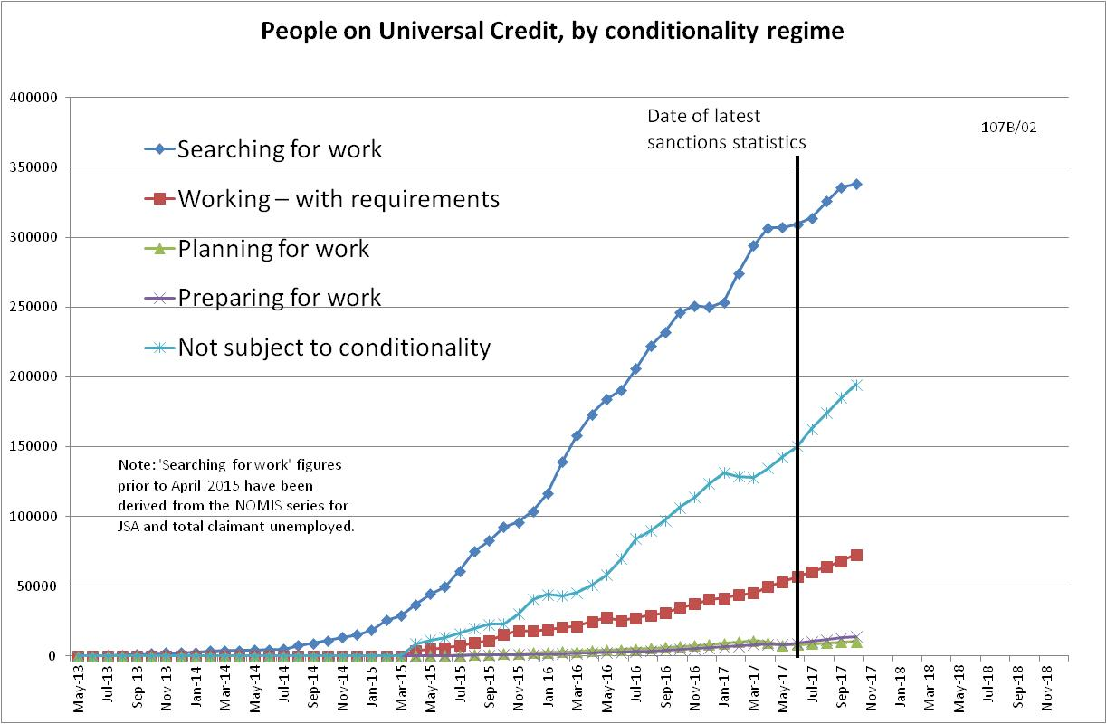

Figure 2
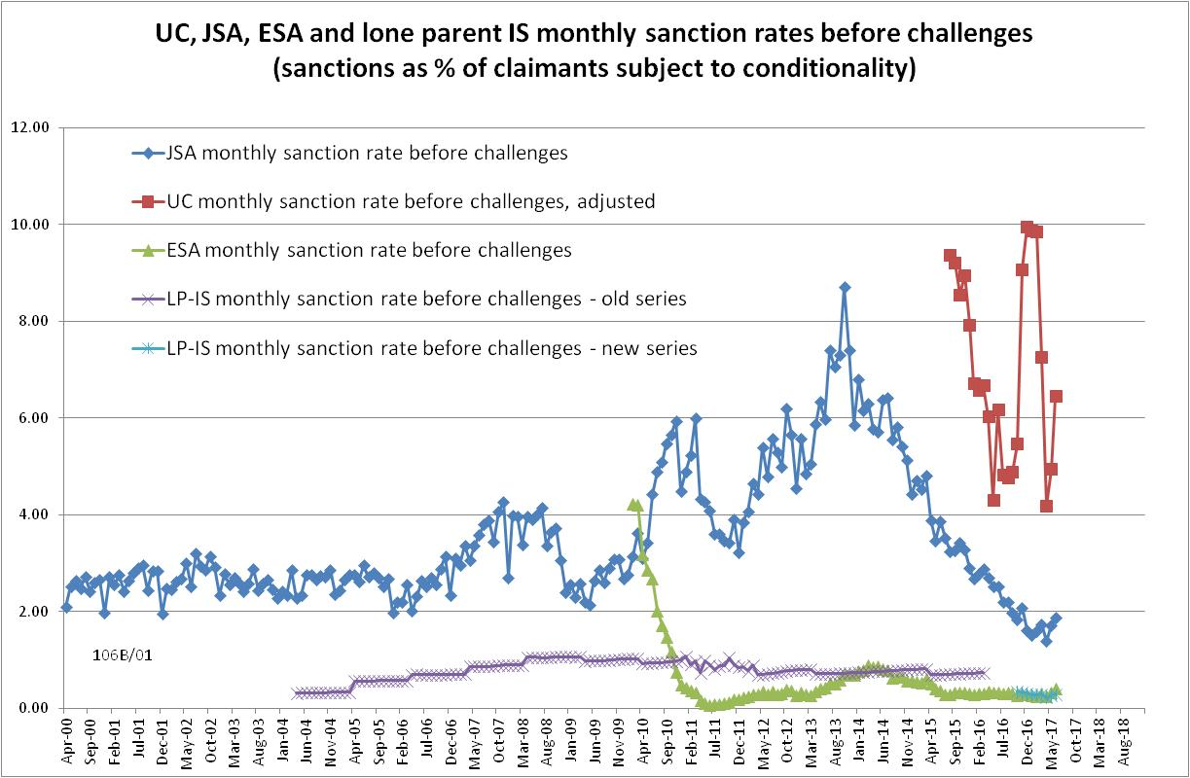

Figure 3
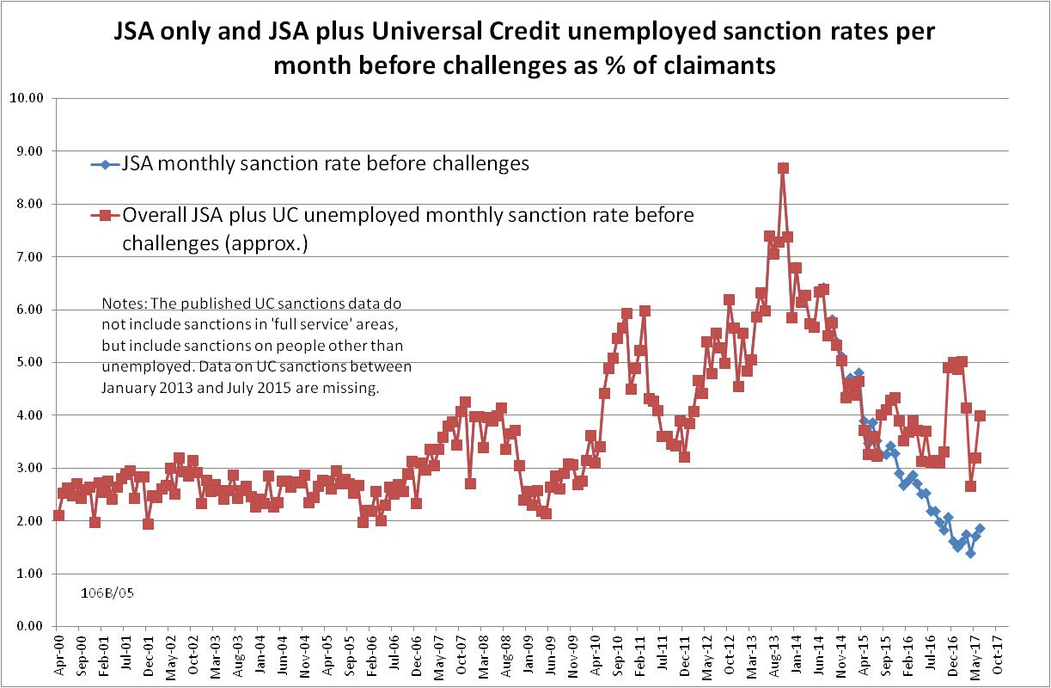
Figure 4
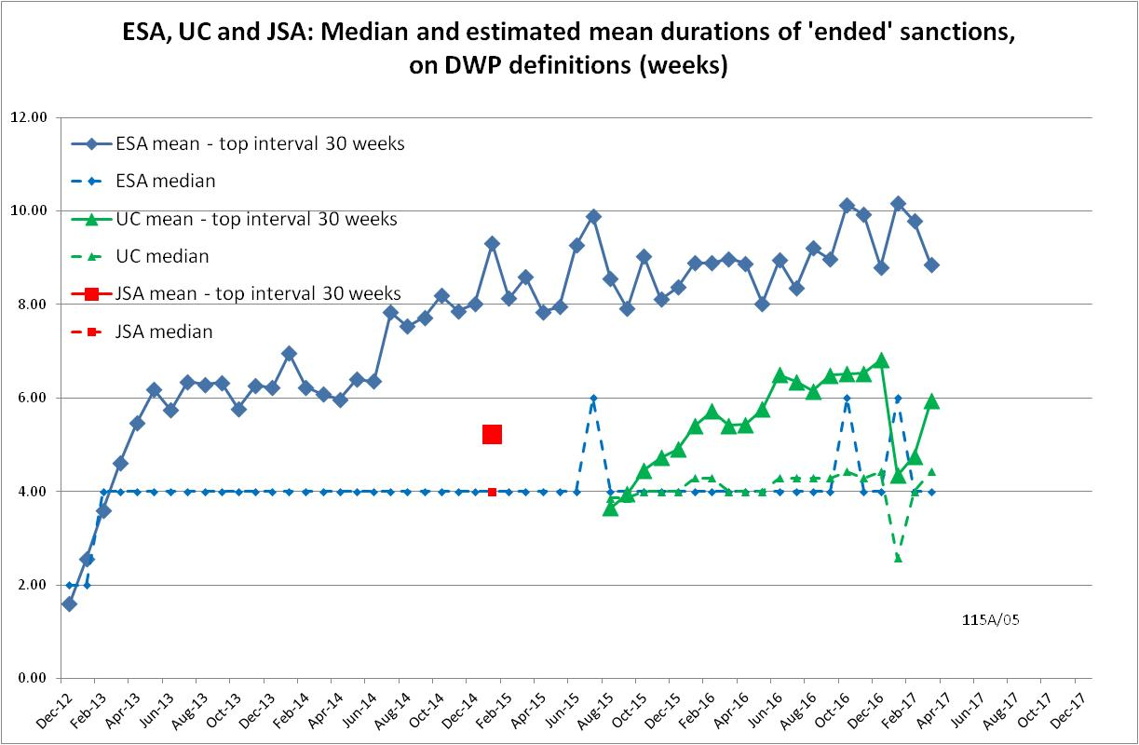
Figure 5
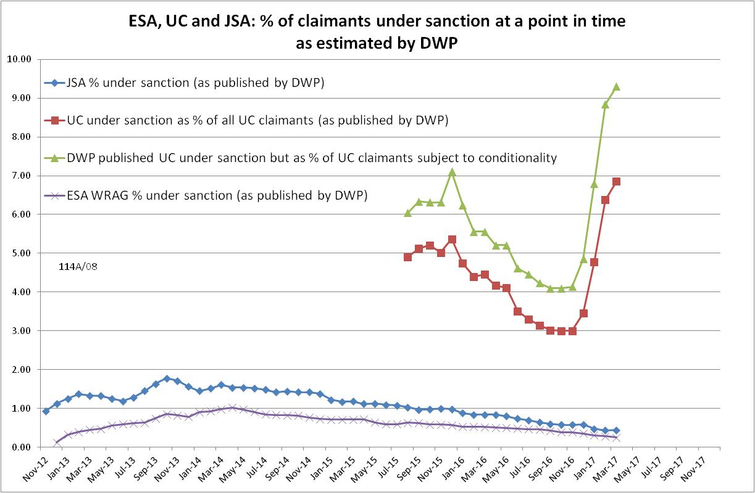

Figure 6
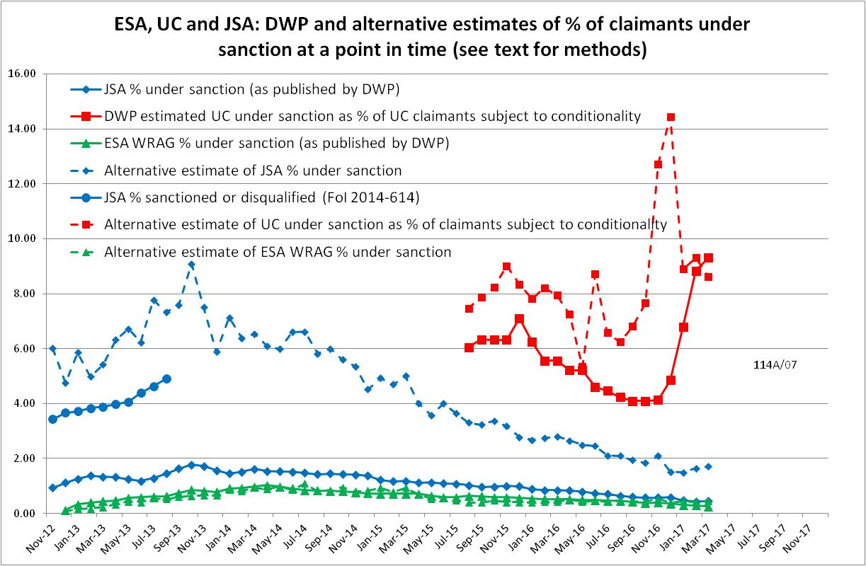

NOTES

Previous briefings are available at http://www.cpag.org.uk/david-webster. They include many analyses that remain valid. However it should be remembered that the DWP may have made subsequent revisions to the data reported in earlier briefings.
DWP does not offer an explanation of how the statistical categories for conditionality regime used in Stat-Xplore relate to the legislation or to its Methodology document. It is assumed here that ‘Planning for work’ refers to people who are required only to attend work-focused interviews, and that ‘Preparing for work’ refers to people who are required to undertake work-related activity. ‘In-work’ conditionality has been taken to apply to claimants in the statistical category 'working - with requirements'.
Repayment is suspended for any month when the claimant earns more than their threshold, and any remaining debt is written off if the earnings threshold has been met for 26 weeks, whether continuous or not.
The basic concept of the DWP’s sanctions database is that each sanction case appears only once, and is given its latest status and attributed to the month of the latest decision on the case. So, for instance, if a decision is made in January 2014 to sanction someone, this decision is reviewed in March 2014 with an outcome unfavourable to the claimant, reconsidered in a ‘mandatory reconsideration’ in May 2014 again with an unfavourable outcome, and is heard on appeal by a Tribunal in October 2014 with a decision favourable to the claimant, then: - it appears in the statistics for the first time in January 2014 as an adverse ‘original’ decision - in March 2014 it changes its status to a ‘reviewed’ adverse decision and moves month to be with all the other cases where the latest decision has been made in March 2014 - in May 2014 it changes its status to a ‘reconsidered’ adverse decision and moves month to be with all the other cases where the latest decision has been made in May 2014 - in October 2014 it changes its status again to an appealed non-adverse decision, and moves month again to be with all the other cases where the latest decision has been made in October 2014.
The estimates of sanctions before challenges have been derived by adding the monthly total of ‘non-adverse’, ‘reserved’ and ‘cancelled’ decisions shown as being the result of reviews, mandatory reconsiderations and tribunal appeals, to the monthly total of adverse ‘original’ decisions. This produces only an approximate estimate for each individual month, since decisions altered following challenge are not attributed to the correct month. But the estimates are reliable for longer periods.
The frequency distributions for ESA and UC were discussed in the August 2017 Briefing.
Under the procedure for calculating an approximate mean from a frequency distribution we assume that all the cases in each class interval have the value of its mid-point, and for the top, open class interval we make some reasonable assumption as stated here. For UC and ESA the detailed frequency distributions given in the DWP’s spreadsheet are used, while for JSA it has been necessary to use the much less detailed frequency distribution on p.12 of Benefit Sanctions Statistics.
DWP also excludes claimants who leave benefit immediately upon being sanctioned (‘0 day cases’). Whether this is correct or not depends on why they leave. If it is to go to a job then it is appropriate, but if it is simply to escape the conditionality regime without a job to go to then it is not.
For instance, see the article ‘Duration of unemployment’ in the Department of Employment Gazette, September 1978, particularly the footnote on p.1053 which gives the formula used here. This relates to unemployment spells rather than sanctions, but the relationships between inflows, outflows, stocks and durations are the same for both unemployment spells and sanctions. The equation can be understood using the following example. Let us assume that 4000 JSA claimants are sanctioned every 4 weeks, at a rate of exactly 1000 per week, and that all have an identical sanction length of 4 weeks. Then at the end of Week 1 there will be 1000 claimants under sanction. At the end of Week 2 there will be 2000 claimants under sanction. This is because 1000 more claimants have been added to the number of those under sanction, while Week 1's 1000 sanctioned claimants are still under sanction. At the end of Week 3 there will be 3000 claimants under sanction, by the same reasoning. At the end of Week 4 there will be 4000 claimants under sanction. However at the end of Week 5 there will still be 4000 claimants under sanction. This is because although 1000 have been added as in previous weeks, Week 1's intake have now dropped out. The same will be true at the end of Week 6, when there will still be 4000 claimants under sanction. In fact there will always be 4000 claimants under sanction if the intake is 4000 per 4 week period and the duration of a sanction is 4 weeks. The calculation will not be affected if the assumption that all claimants have a 4-week duration is relaxed, so long as the mean duration stays at 4 weeks.

