BRIEFING

Benefit Sanctions Statistics

November 2018

13 December 2018

Dr David Webster
Honorary Senior Research Fellow
Urban Studies
University of Glasgow

Email david.webster@glasgow.ac.uk

Webpages: http://www.gla.ac.uk/schools/socialpolitical/staff/davidwebster/
http://www.cpag.org.uk/david-webster

SUMMARY

This Briefing reports on the quarterly benefit sanctions statistics published by DWP on 13 November, giving figures to July or August 2018. The number of claimants on Universal Credit (UC) has been increasing by 100,000 a month and by October 2018 had reached 1.3m, of whom 64.5% were subject to conditionality. Of the total of 919,075 unemployed claimants at October 2018, 63.1% were on UC rather than JSA. Altogether about 1.9m people are subject to conditionality.

DWP has still not published any statistics for sanctions on claimants using its UC ‘full service’, even though by July 2018 an estimated 86% of UC claimants were on ‘full service’. This makes it difficult to estimate total UC sanction numbers and rates. For UC ‘live service’ claimants subject to conditionality, the estimated sanction rate over the latest 12 months has averaged 6.4% per month before challenges. This is far above the rates for the ‘legacy’ benefits: JSA about 0.5%, ESA 0.05%, lone parents on Income Support (IS) 0.25% and other IS claimants 0.01%. DWP argues that comparisons of rates of sanction between UC and legacy benefits are invalid because of policy differences. Appendix 1 explains the reasons for rejecting this argument.

A very rough estimate of the total number of sanctions imposed in the 12 months to July 2018, before challenges, is 350,000, comprising 300,000 on UC ‘live’ and ‘full’ service, 37,000 on JSA, 5,000 on ESA and 9,000 on IS. This is much less than the peak of over 1.1m in 2013, but is an increase over the estimated figure of 318,000 in the 12 months to April 2018. Sanctions are rising as more claimants are transferred to the high-sanctioning UC.

An update of the figures for the numbers of people under sanction at a point in time confirms the much harsher treatment by UC of unemployed claimants compared to those in other conditionality categories.

For JSA and UC live service, DWP has published new data on earnings in the 6 months following a sanction. However it is impossible to extract any meaning from them, because the periods covered for JSA and UC are very different; the starting split between employed, unemployed and other statuses is different; and no detail is given on the amount of earnings. Superficially, the figures might appear to suggest that UC is better than JSA at getting people into work. However, no such conclusion can be drawn.

DWP has also published some basic statistics on the first nine months of the new Work and Health programme. These show 38,060 referrals and 24,720 starts, both mainly by people who are sick or disabled.

UC has been producing major problems relating to debt reclaims, which can interact with sanctions to deprive claimants of part or all of their housing and child elements, leading to evictions and damage to children. Appendix 2 explains the rules relating to debt reclaims within UC and how they compare with their treatment within the ‘legacy’ benefits.

Appendix 3 gives an update on the position in Northern Ireland, showing that this country did not join in the great GB sanctions drive of 2010-15 and that sanction rates there remain lower. The past quarter has been very eventful in terms of sanctions policy and research, and the news section has a digest covering in particular the visit of the UN Special Rapporteur on Extreme Poverty and Human Rights and the reports of House of Commons committees.
BRIEFING: Benefit Sanctions Statistics
November 2018

INTRODUCTION

The latest quarterly benefit sanctions statistics were released by DWP on 13 November, giving data to the end of July or August 2018. The new data are summarised by DWP in the publication Benefit Sanctions Statistics, available at https://www.gov.uk/government/statistics/benefit-sanctions-statistics-to-july-2018 with an associated spreadsheet with summary tables. The full figures for most aspects of the data are on the DWP’s Stat-Xplore database at https://stat-xplore.dwp.gov.uk/webapi/jsf/login.xhtml

On 29 November DWP also made the first publication of statistics on the Work and Health Programme, at https://www.gov.uk/government/statistics/work-and-health-programme-statistics-to-august-2018, with papers on methodology and publication plans at https://www.gov.uk/government/collections/work-and-health-programme-statistics

All statistics presented here relate to Great Britain except those in Appendix 3 which gives an update on the situation in Northern Ireland.

Groups of claimants exposed to sanctions:
Universal Credit, JSA, ESA and Income Support

At July 2018, a total of some 1.94m claimants of UC, JSA, ESA and IS were exposed to the risk of sanctions, with varying frequency and severity.

The number of claimants on UC has been increasing by 100,000 a month and by October 2018 had reached 1.3m. Figure 1 shows how the numbers of claimants on UC have increased, by conditionality regime. Of the 1,317,985 UC claimants (provisional) at October 2018, 467,504 (just over one third or 35.5%) were not subject to conditionality. Of the 850,287 UC claimants subject to conditionality, 580,491 were unemployed and 190,376 were working, with 79,420 neither working nor unemployed but required to plan or prepare for work.

At October 2018 the number of JSA claimants had fallen to 339,379. The combined total of unemployed people on UC or JSA in October 2018 was 919,075, so that almost two-thirds (63.1%) of unemployed claimants are now on UC. UC defines groups such as non-working Housing Benefit claimants, previously not regarded as unemployed, as now being unemployed and subject to conditionality. The rollout of UC is therefore increasing the unemployed claimant count. The DWP has held a consultation on how to deal with the resulting discontinuity in the statistics. Its decision (DWP 2018d) is to publish a new series which will lift the historic claimant count to what it would have been under a ‘Universal Credit world’, defined by excluding UC cases awaiting a Work Capability Assessment but including JSA ‘credits only’ cases (these are people who do not qualify for means-tested JSA and have exhausted their entitlement to contributory JSA but who by registering as unemployed are credited with National Insurance contributions). The new series has yet to start. This Briefing uses the counts of UC and JSA claimant unemployed published by NOMIS.

The number of claimants on grounds of sickness and disability who are subject to sanctions can no longer be stated with complete certainty. This is because to the total of claimants in the ESA Work Related Activity Group (WRAG) there needs to be added the number of UC claimants claiming on grounds of sickness or disability. This is not published by DWP. The 49,081 UC claimants ‘preparing for work’ at October 2018 include these people but they also include some people who are not sick or disabled and would previously have claimed IS. The number of ESA WRAG claimants however is known. Their number peaked at 562,620 in August 2013 and has fallen since. After a pause the decline has resumed with the number at 395,060 at May 2018. The number in the ESA Assessment Phase (which has no conditionality) continues to fall, to 188,170 in May 2018 from a peak of 546,030 in August 2014. UC does not have an assessment phase; the ‘Job Coach’ has discretion on what conditions to impose pending the Work Capability Assessment. This provision has been criticised by the Work and Pensions Committee (2018b, Ch.3).

There were an estimated 460,000 claimants on IS and subject to sanctions at July 2018. The largest group among these was an estimated 273,000 lone parents with a youngest child aged between one and five. DWP reports sanctions for these separately. There were also an estimated 170,000 carers and 18,000 other IS claimants. DWP only reports sanctions for the whole of this latter group of 188,000 claimants.

Universal Credit sanctions

Details of the UC sanction regime are given in the DWP’s Sanctions Statistics methodology document (DWP 2018b), in the claimant’s guide at https://www.gov.uk/government/publications/universal-credit-and-you/universal-credit-and-you-a and by OBR (2018, Chapter 3). The UC regime has similar lengths of sanction to those of the previous benefits for the various ‘failures’, but there are some critical differences. Sanctions are lengthened by being made consecutive, not concurrent. Hardship payments become repayable. Given that repayments are made at the rate of 40% of benefit – the same as the amount by which a hardship payment is lower than the benefit – this means that for claimants receiving hardship payments, UC sanctions are in effect 2½ times as long as their nominal length. All sanctioned UC claimants must also demonstrate ‘compliance’ for 7 days before applying for hardship payments, and must reapply for each 4-week period. The 80% hardship rate for ‘vulnerable’ claimants is abolished. There is a new ‘lowest’ category of sanction which applies to claimants who would previously have been subject to the milder IS sanction regime. But now lone parents with a child aged between 2 and 5 lose their whole Standard Allowance, and those with a child aged 1 lose 40% of it, whereas previously both groups would have lost 20%.

Under UC, the sanction is applied to the amount of the Standard Allowance which is calculated to be due. In the case of in-work UC sanctions, the calculated amount may be less than the full amount, in which case the sanction may also be less. But conversely, where there are deductions from the Standard Allowance for various types of debt, UC sanctions are deducted from the Housing and Child elements to the extent necessary to ensure that the full amount of the sanction is exacted (usually 100% of the Standard Allowance) – making children suffer and creating the risk of eviction. This could not happen under the previous regime of entirely separate benefits. This provision has been criticised by the Work and Pensions Committee in its new report (2018b, pp.41-42). A recent National Audit Office report (NAO 2018) has also criticised public sector approaches to problem debt. Appendix 2 summarises the rules on deductions from Universal Credit and how they interact with sanctions.

Under UC, a sanction imposed on a claimant in a particular conditionality group remains in place even if the claimant moves to a different group with no conditionality. Under the previous benefit regime the sanction would have ceased. This feature has also been criticised by the Work and Pensions Committee (2018b, pp. 40-41).

Sanctions before and after reviews, reconsiderations and appeals

The DWP’s Benefit Sanctions Statistics publication and Stat-Xplore database only show sanctions after any reviews, reconsiderations and appeals that have taken place by the time the data are published. But numbers of sanctions before the results of these challenges are important since they show all the cases in which claimants have had their money stopped. Although a successful challenge should result in a refund, this is only paid after weeks or months by which time serious damage is often done. Estimates of sanctions before challenges are therefore given here but although reliable for longer time periods, they are not fully accurate for individual months. For JSA and ESA, figures for sanctions before challenges are currently higher than the ‘after challenge’ figures by very large amounts, namely about 20%. and 40% respectively. But to date, under 5% of UC sanctions have been overturned following challenge and for IS sanctions only 1%, so for these types of sanction there is much less difference between the pre-and post-challenge figures. This Briefing has a mixture of pre- and post-challenge sanctions figures.

NUMBERS AND MONTHLY RATES OF SANCTIONS
FOR THE FOUR BENEFITS

DWP has two delivery mechanisms for Universal Credit: ‘live service’ and ‘full service’. Full service is taking over from live service and by the end of 2018 all Jobcentres will be offering only full service. By July 2018, 419 out of 642 JCP offices (65%) had transferred to ‘full service’. The proportion of UC claimants subject to conditionality who were on full service has risen even more (this is because full service covers a wider range of claimants). Figure 2 shows that by July 2018, an estimated 86% of UC claimants subject to conditionality were on live service, and by October 2018, 94%. Yet for UC sanctions, DWP is still publishing only figures for ‘live service’, and even for them gives no breakdown by conditionality group. This makes it impossible to make an accurate estimate of the total numbers of UC sanctions being imposed.

This Briefing has been attempting to produce estimates of total UC sanctions by inference from the figures for live service (see earlier issues). But with live service having shrunk so much, this can no longer be done with any precision. All that is possible is to present the figures for live service and to provide a very crude indication of what the overall UC figures might be.

Rates of sanction on the four benefits, before challenges

In recent months, for instance on the front page of Benefit Sanctions Statistics, DWP has been arguing that comparisons between sanction rates on UC and on ‘legacy’ benefits cannot be validly made because of differences in policy. This argument is considered in Appendix 1, which shows why such comparisons are in fact perfectly valid and that any inaccuracies are trivial.

Figure 3 gives the monthly rates of sanction before challenges for all four benefits. For UC it shows only the rate for live service claimants subject to conditionality. This rate has fluctuated, partly because of backlogs, cancellations and catch-ups by DWP, but for the latest 12 months has averaged 6.4%. This is way above the rates for the other benefits. The JSA sanction rate has bottomed out at about 0.5% per month and the ESA rate at 0.05%. The rate for lone parents on Income Support is about 0.25% and that for other IS claimants about 0.01%.

The estimate of the UC live service sanction rate has been revised upwards since the August 2018 Briefing (Figure 3 of that Briefing), typically by about 1 to 2 percentage points. This is because the previous estimate inadvertently used as denominator the total of claimants on live service, rather than just those subject to conditionality. This has now been corrected and the denominator used here is the total of claimants on live service who are subject to conditionality. It should be borne in mind that the result is still only an estimate. A key assumption is that existing UC claimants in Jobcentres transferring from live to full service will on average have transferred to full service in the middle of the following month. It may be that this process takes longer, in which case the sanction rate estimate shown here will be too high.

The UC live service sanction rate does not appear to have any trend. It has been around 6% since the end of 2015, except for the administrative catch-up period of December 2016 to February 2017. DWP has stated that there are missing data on live service for January to April 2018 (which will remain permanently uncorrected). However, it can be seen that this has not created any obvious disturbance in the figures.

The House of Commons Library (Keen 2018) has separately compared the sanction rates on UC live service and on JSA and agrees, on the basis of a slightly different approach, that the UC rate is much higher.

The high monthly rate of UC live service sanctions is the product of a consistently high referral rate, at between 10% and 20% of claimants subject to conditionality per month, and a consistently high proportion of referrals which result in sanction, at about 80% when reserved and cancelled decisions are excluded (Figure 4).

Number of sanctions on all benefits before challenges
in the year to 31 July 2018

For the reasons discussed, estimates of the total number of sanctions on all benefits before challenges can currently only be approximate. The biggest problem is making an estimate of the number of UC full service sanctions. The estimated number of UC live service sanctions before challenges in the 12 months to July 2018 was 150,000. During this period, on average 56% of UC claimants subject to conditionality were on full service. Very roughly therefore, the total of UC sanctions in both live and full service could be estimated at 300,000 (to allow for the fact that full service has a higher – though unknown - proportion of claimants in conditionality groups with low rates of sanction). Adding in the approximately 37,000 JSA, 5,000 ESA and 9,000 IS sanctions gives a total of approximately 350,000 sanctions on all the four benefits before challenges in these 12 months. This compares with over 1.1m sanctions before challenges in the peak year 2013, but it is an increase over the 318,000 estimated for the 12 months to April 2018 in the previous Briefing. On current trends, the total number of sanctions will rise further as more and more claimants are moved on to the high-sanctioning Universal Credit.

PROPORTION OF CLAIMANTS UNDER SANCTION AT A POINT IN TIME

The DWP’s preferred measure of sanctions ‘rate’ is the number and proportion of claimants who are serving a sanction at a point in time. There are various problems with this measure, which were discussed in the November 2017 Briefing (pp.6-10). In particular, it does not show people who stop claiming because of the sanction, or people who resume a sanction on returning to benefit, or those on UC who still have reduced benefits as a result of repaying hardship payments. DWP has yet to publish any data on UC hardship payments. This measure also gives no idea of the total number of people who have been subjected to sanctions over a given period such as a year, which is a serious weakness given that the effects of a sanction often last a long time. There are also particular problems with the JSA estimates, which do not appear credible at all. However, the figures do have the advantage that in respect of UC, they show the differing prevalence of sanctions for the different conditionality groups.

Figures allowing calculation of the percentage of UC claimants under sanction at a point in time by conditionality group were first published by DWP in May 2018. Figure 5 updates these figures. There is currently a downward trend in all the groups. They are all back to the level of just before the DWP’s catch-up blitz of December 2016-February 2017. The unemployed are clearly treated much more harshly than the other groups, with about 4% under sanction in the latest quarter, whereas the others are all below 1%.

As noted earlier, under UC a claimant must serve out their sanction even if they move into a no-conditionality group. At August 2018 there were 1,064 claimants in this position, of whom 511 were working and 553 not working but not subject to conditionality. Some such split would be expected as studies show that after a sanction, some people move into work but others move into inactivity.

At August 2018 there were 969 people under sanction who were ‘working with requirements’. The DWP’s trial of in-work conditionality ended in March 2018 and Neil Couling confirmed to the Work and Pensions Committee on 2 June (Q.740-42) that there is currently no in-work conditionality except for ‘some other piloting activity’. Presumably these 969 people were either in these pilots, or were still serving long sanctions imposed earlier, or had brought a sanction with them from other conditionality groups. DWP have confirmed to me that people earning below the ‘Administrative Earnings Threshold’ of £338 per month will generally be included in the ‘searching for work’ group, not the ‘working with requirements’ group. They are the equivalent of JSA claimants unemployed but doing small amounts of work; UC allows them to keep more of such earnings. The ‘working with requirements’ group also includes people who are not working themselves but have a partner with low earnings.

CLAIMANTS WITH EARNINGS IN THE SIX MONTHS FOLLOWING A SANCTION DECISION

DWP has added a new item to its already published statistics on ‘Destinations of claimants receiving a benefit sanction’, namely the number of claimants on JSA or UC with a period of earnings during the 180 days after the sanction decision. This is not available in Stat-Xplore but only in Benefit Sanctions Statistics. This shows that about 53% of UC live service claimants sanctioned between 1 August 2015 and 30 September 2017 had some earnings in these 180 days, with an average (including those with no earnings) of 53 days with some earnings. About 31% of JSA claimants sanctioned between 22 October 2012 and 30 September 2017 had some earnings during the 180 days after sanction, with an average (again including those with no earnings) of 28 days with some earnings. Unfortunately it is impossible to extract any meaning from these figures, because the periods covered for JSA and UC are very different; the starting split between employed, unemployed and other statuses is different; and no detail is given on the amount of earnings. Superficially, the figures might appear to suggest that UC is better than JSA at getting people into work. However, no such conclusion can be drawn.

The think tank Policy in Practice has published (19 November) a more useful though tentative analysis, reported at http://policyinpractice.co.uk/is-universal-credit-getting-more-people-into-work/ This was based on data from three local authorities, and confined to households claiming Council Tax Reduction. It concludes that Universal Credit does not appear to have a statistically significant impact on employment rates, although there is more evidence that any significant impact is likely to be positive rather than negative.

THE WORK AND HEALTH PROGRAMME

The Work and Health Programme (WHP) was rolled out in England and Wales between November 2017 and March 2018. It targets people who have a disability or health condition, as well as the long-term (over 2 years) unemployed, and certain priority groups (known as ‘early access’ groups). It is mandatory for the long-term unemployed and voluntary for the rest. The programme lasts for 15 months for each participant, extendable to 21 months.

The new statistics published on 29 November give basic information about programme participation. Up to 31 August 2018 there had been a total of 38,060 referrals to the Work and Health Programme and 24,720 starts. Of these, 1,870 referrals and 1,270 starts were of long-term unemployed people for whom participation is compulsory. There were 3,710 referrals and 2,270 starts for the ‘early access’ group. The great majority of participants (32,490 referrals and 21,190 starts) are therefore people who are sick or disabled. Other information is limited at present but it will be expanded and in due course will be added to Stat-Xplore.

The Work and Health Programme does not apply in Scotland, which has its own programmes, entirely voluntary and aimed only at those with disabilities and health conditions. Statistics on the two initial Scottish programmes applying in 2017/18, Work First Scotland and Work Able Scotland, are available at https://www.gov.scot/publications/scotlands-devolved-employment-services-work-first-scotland-work-scotland-2017-9781788519236/pages/2/
Information about the successor programme for 2018 onwards, Fair Start Scotland, is at http://www.employabilityinscotland.com/devolved-employment-services/fair-start-scotland/-about-fair-start-scotland/

ANALYSES NOT INCLUDED IN THIS ISSUE

Readers are referred to earlier numbers of the Briefing for analyses of issues not discussed in the present issue. Durations of sanctions were covered in the August 2018 issue; ethnicity and gender in July 2018; benefit destinations in February 2018; challenges to sanctions in February 2018 and May 2017; JSA benefit suspensions not followed by sanction, and ESA sanctions by medical condition in August 2017; and reasons for sanctions in May 2017. Longer period analyses were included in the author’s written evidence to the Work and Pensions Committee (Webster 2018). These analyses will be updated in future numbers. Obviously it is to be hoped that it will soon be possible to produce a full range of analyses for UC covering ‘full’ as well as ‘live’ service.
SANCTIONS - OTHER DEVELOPMENTS

UK Visit by the UN Special Rapporteur on Extreme Poverty and Human Rights

The UN Special Rapporteur Philip Alston visited the UK from 5 to 16 November. He had already received nearly 300 written submissions, more than he had received for any previous country visit. These are at
https://www.ohchr.org/EN/Issues/Poverty/Pages/UKVisitSubmissions.aspx
During the visit he attended a large number of meetings and events; his programme is at
https://www.ohchr.org/EN/Issues/Poverty/Pages/VisitUK516November.aspx
His initial statement of findings, issued on 16 November, is at
https://www.ohchr.org/EN/NewsEvents/Pages/DisplayNews.aspx?NewsID=23881&LangID=E It will be followed by a fuller report.

Professor Alston’s statement is very critical of the sanctions regime and of the ‘welfare reform’ system in which it is embedded. ‘.....many claimants ..... feel that they are forced to jump through hoops for the sake of it, fill out pointless job applications for positions that do not match their qualifications, and take inappropriate low-paid, temporary work just to avoid debilitating sanctions. One Conservative Party MP with whom I spoke criticized DWP for adopting a military-style command and control approach rather than seeking to empower their clients and instill confidence. ..... One of the key features of Universal Credit involves the imposition of draconian sanctions, even for infringements that seem minor. Endless anecdotal evidence was presented to the Special Rapporteur to illustrate the harsh and arbitrary nature of some of the sanctions, as well as the devastating effects that resulted from being completely shut out of the benefits system for weeks or months at a time. .... Many detailed studies have been undertaken which give substance to the harsh consequences that ensue for vulnerable claimants who are sanctioned. Departmental and Ministerial insistence notwithstanding, there is no clear evidence that recent high employment rates in the UK are due to sanctions, or that blunt and harsh sanctions are superior to far less harmful methods to encourage compliance with conditionality. .....What is clear from those with whom the Special Rapporteur has spoken, is that sanctions succeed in instilling a fear and loathing of the system in many claimants’.

Professor Alston recommends that ‘The Department of Work and Pensions should conduct an independent review of the effectiveness of reforms to welfare conditionality and sanctions introduced since 2012, and should immediately instruct its staff to explore more constructive and less punitive approaches to encouraging compliance.’

Work and Pensions Committee report on Benefit Sanctions

This important report was published on 6 November. It is essential reading for its analysis of the destructive character of the sanctions system, although it does not challenge its basic assumptions. Its recommendations are not particularly radical, although it does call for the complete abolition of sanctions on people with a Work Capability Assessment or medical certificate saying they are unfit for work.

Apart from the report itself, the website has useful lists of mandatory and discretionary conditionality easements, and of ‘good reasons’, in a letter from the minister Alok Sharma dated 23 August 2018 at
https://www.parliament.uk/documents/commons-committees/work-and-pensions/Correspondence/180823%20MfE%20-%20Rt%20Hon%20Frank%20Field%20MP%20-%20Update%20following%20Benefit%20Sanctions%20Enquiry_Redacted.pdf
It is notable that ordinary public transport failure is not mentioned as a ‘good reason’. This is a frequent source of grievance for claimants.

Also, Annexes 4 & 5 of Alok Sharma’s letter to Frank Field of 25 June at
https://www.parliament.uk/business/committees/committees-a-z/commons-select/work-and-pensions-committee/news-parliament-2017/benefit-sanctions-chairs-comments-17-19/
reproduce the hardship payment award letter sent to claimants and the instructions on management of hardship payment repayments given to DWP staff.

A further letter from Alok Sharma dated 4 September at https://www.parliament.uk/documents/commons-committees/work-and-pensions/Benefit-sanctions/180904%20MfE%20-%20Rt%20Hon%20Frank%20Field%20MP.PDF
contains the following statement in response to the Committee’s request for him to consider exempting people who are sick or disabled from any form of conditionality and sanctions:
‘Evidence shows that when provision or support is voluntary the take up is extremely low and has had limited success. For example, the ESA Support Group has no mandatory conditionality and less than 1% move off the benefit and into work every month. As such, we believe that to impose a blanket policy which exempts all disabled people from any form of conditionality would be doing this group a great disservice.’ The Support Group are people who have been found by a WCA to be unfit for work either now or in the foreseeable future. No inference at all can be drawn from their experience about the relevance of conditionality to people who are currently unfit but may be in the future. This response also raises the question why the government has made the Work and Health Programme voluntary for all except long-term unemployed. Given this response it is not surprising that the Committee went ahead and recommended scrapping conditionality for sick and disabled people.

Professor Michael Adler of the University of Edinburgh has published a summary and critique of the Work and Pensions Committee report at
https://ukaji.org/2018/11/21/making-the-totally-unacceptable-slightly-more-palatable/

Reports on Universal Credit

There have recently been two highly critical reports on Universal Credit, considering various aspects which are relevant to sanctions: a general report by the Public Accounts Committee (2018) and a report specifically on ‘Universal Support’ for UC claimants by the Work and Pensions Committee (2018a). The Work and Pensions Committee has also published a report on managed migration to UC (22 November) and on 5 November DWP published its revised draft Regulations on managed migration together with the Social Security Advisory Committee’s report on the first draft. The Budget 2018 also made various changes to UC which are set out at https://www.gov.uk/government/publications/budget-2018-documents
p.77.

Findings of the In-work Progression randomised control trial

On 12 September DWP published three reports on this trial: a Findings report, an Impact Assessment and a Summary (DWP 2018c). The Impact Assessment provides more clear-cut findings than the Findings report. The trial did not find much difference in changes in earnings after a year between the groups given Frequent, Moderate and Minimal Support – about £5 per week between the former two and the latter. The former two groups were sanctioned more. Qualitative research with employers found that an employer belief that low staff turnover was good for the business favourably influenced the availability of progression opportunities for low-wage, low-skilled workers, although these opportunities were unlikely to be available to employees on temporary or zero-hours contracts or agency workers. The report does not draw the obvious conclusion that rather than using sanctions to push people into bad jobs and then subjecting them to ‘in-work conditionality’ to attempt to promote earnings progression, DWP could be putting pressure on employers to provide better jobs with career progression in the first place.

Labour Party position on sanctions reaffirmed

John McDonnell has reaffirmed the Labour Party’s position on sanctions in a list of demands in relation to Universal Credit, No.3 of which is ‘End counter-productive sanctions (e.g. requiring people to demonstrate in an online journal that they are spending 35 hours a week looking for work)’. See
https://labourlist.org/2018/10/watch-vote-down-budget-if-universal-credit-roll-out-not-halted-says-mcdonnell/

Young people’s experience of Jobcentre services

4 in 10 and the Young Women’s Trust have published a study on young people’s experience of Jobcentre services (Elliott & Dulieu 2018), based on extensive interviews with a variety of stakeholders. Only one third of young women jobseekers (33%) and two fifths of men (44%) felt they were getting personalised support from their Work Coach. ‘Instead of being a centre of support, jobcentres are increasingly a place of enforcement. This is evident in the way the
system assesses a young person’s needs and vulnerabilities..... The initial meeting between a young person and their Work Coach is crucial to establishing each young person’s starting point. Meetings typically last for 10 minutes, during which a Work Coach must verify a young person’s identity, assess their vulnerability status and decide on and agree with the young person the plan for going forward – the “claimant commitment”. DWP teams told us that, while training is given to staff, it can be difficult to establish a relationship in which claimants feel safe enough to disclose their issues within the 10 minute window that is allowed for initial appointments.’ Just over half of Jobcentre Plus users (56%) reported feeling they were treated with respect by Jobcentre Plus staff, while three in 20 described their treatment as “unfair”.

The impact of sanctions on low income private tenants – University of York report

Rhodes & Rugg (2018), in a study funded by the Nationwide Foundation, find that benefit sanctions, along with other features of ‘welfare reform’, have left low income private tenants increasingly unable to pay their rent and that a ‘slum tenure’ at the bottom end of the housing market is the likely result.

Update study on local welfare assistance schemes in England

Church Action on Poverty (Aitchison 2018) has carried out an update study on the state of the local welfare assistance schemes (LWAS) that in England since 2013 have taken over from the emergency assistance previously provided by DWP. This follows the 2017 study by the Centre for Responsible Credit, at www.responsible-credit.org.uk/decline-local-welfare-schemes The new study finds that at least 28 local authorities have wound up their schemes completely and that Councils that responded have cut their LWAS budget by an average of 72.5% since 2013–14.

Statistics on the Scottish Welfare Fund, which remains a mandatory service run by the Scottish Government and delivered by local authorities, are at
https://www2.gov.scot/Topics/Statistics/Browse/Social-Welfare/swf

Scottish Social Security Committee inquiry into Social Security and In-Work Poverty

Sanctions have been discussed frequently during the course of this inquiry. Details are at
http://www.parliament.scot/parliamentarybusiness/CurrentCommittees/108877.aspx

Food insecurity - Scottish Health Survey 2017

The 2017 Scottish Health Survey has for the first time investigated food security. It found that in the space of a year, one in ten adults living in the most deprived quintile of Scottish areas ran out of food due to lack of money or other resources. Details are at
https://www.gov.scot/publications/scottish-health-survey-2017-volume-1-main-report/pages/85/

Impact of conditionality on lone parents

An important paper by Avram et al. (2018) on the impact of the UK Lone Parent Obligation finds that it did increase the flow of single parents into work, and seems to have had larger effects than comparable interventions in the past. However, it also caused a large proportion of single mothers to move on to health-related benefits or into non-claimant unemployment. In fact, the flow towards either of the two states with no work search requirements attached is generally larger than that into work. These findings are consistent with those of other studies.

Snapshot versus lifetime receipt of means tested benefits

An important new paper by Roantree & Shaw (2018), using data from the British Household Panel Survey, 1991-2008, has found that the treatment of recipients of means-tested benefits (including tax credits) affects a far higher proportion of the population than appears from the usually published statistics. Whereas the proportion of individuals receiving a means-tested benefit at any one time was only 20.5%, over the full 17 years this rose to 54.4%. The figures for unemployment benefit were 1.6% and 16.4%.

Police Scotland on the impact of welfare reform

The Police Scotland performance report for July-September 2018 at
http://www.spa.police.uk/assets/126884/441011/441165/511339/item9
stated ‘anecdotal evidence from intelligence suggests that a combination of increased drug prices due to police enforcement, and changes to welfare systems, may have contributed to an increase in crimes of dishonesty and robbery’.

Skills & Employment Survey 2017 shows intensification of work

The Financial Times (‘Exhausted staff work harder’, 1 October) reported findings from the government-funded Skills and Employment Survey that Britons are under more pressure at work than at any time over the past 25 years. Almost a third of respondents said they had to work at very high speeds ‘all’ or ‘almost all’ of the time. More than 45% said the same for the requirement to work very hard and meet tight deadlines. These metrics were substantially higher than in 1992. About 55% of women and 47% of men ‘always’ or ‘often’ went home exhausted from work. The proportion of people who have a lot of discretion over how they do their jobs has declined massively, from 62% in 1992 to 38% in 2017. About 20% of women and 15% of men had jobs where they were required to work hard while also having little control, compared to 15% for both sexes in 2012. It has been established that this combination is damaging to health. The sanctions system will have played a role in creating these conditions, since it aims to drive people into bad jobs that undermine their health and wellbeing, against their better judgment.

Britain’s productivity crisis

There continues to be major concern over the UK’s poor productivity performance over the last decade. The Financial Times reported on 13 August that a large part of the explanation is that employment growth over the past two years has been concentrated in low-wage jobs Sanctions are designed to push people into low paid jobs.

Role of benefit conditionality in the decline of the German SPD

Many people will be aware of the dire electoral position of the German Social Democratic Party, whose vote has now fallen to between 10% and 20% of the electorate, behind the Greens and the far right Alternative für Deutschland. Less well known is the role that adoption of British-style benefit conditionality policies has played in the decline. The Financial Times magazine carried a lengthy analysis on 20 October (Bastian 2018). ‘In any discussion about the SPD’s decline, one term keeps resurfacing: Hartz IV. It refers to a reform of welfare and unemployment regulations pushed through by an SPD government under chancellor Schröder in 2003. Named after Peter Hartz, the head of a commission advising the government at the time, the regime involved deep cuts to unemployment benefits, and made payment conditional on tighter rules for job search and acceptance. Hartz IV was part of a bold reform package widely credited with restoring German competitiveness and laying the groundwork for the sustained economic boom that followed. For many SPD voters in Ruhr cities like Bochum, Dortmund and Gelsenkirchen, however, it was an act of betrayal. It hit the jobless struggling to build a new life after the collapse of local industries. They felt abandoned at their moment of greatest need, by the very party they trusted to take care of them. The anger stoked by Hartz IV helped shatter the SPD’s already weakening hold over leftwing politics in Germany.......’

APPENDIX 1

WHY DWP IS WRONG TO SAY THAT COMPARISONS SHOULD NOT BE MADE BETWEEN SANCTION RATES ON UNIVERSAL CREDIT
AND ON ‘LEGACY’ BENEFITS

1. In recent months DWP has been saying that sanction rates should not be compared between UC and ‘legacy’ benefits because policies are different. The clearest statement came in the DWP’s written evidence to the Work & Pensions Committee (May 2018), at http://data.parliament.uk/writtenevidence/committeeevidence.svc/evidencedocument/work-and-pensions-committee/benefit-sanctions/written/84015.pdf , para.22-23:

‘There are differences between sanctions policy in UC and other benefits which means that a comparative assessment cannot be made. For instance, a JSA claimant would have their claim closed if they fail to attend a Work Coach meeting and do not make contact within five days. This does not register as a sanction. Under UC, these same claimants would be referred for a sanction, but to ensure that they continue to receive other elements to which they may be entitled, such as payment for children and housing costs, their claims are not closed. Likewise, in JSA, when a claimant is determined to be ‘not actively seeking work’ this will end their entitlement to benefit and their claim will be closed and this will again not be counted as a sanction. In UC, for the same reasons above, the claim is kept open and this action would be recorded as a sanction. This does not reflect a tougher approach on sanctions, rather that UC is designed to provide continuous support to our claimants and to ensure that all payment is not stopped while we investigate the reasons for the loss of contact with the claimant, and work to re-establish our relationship with them.’

2. This statement mentions two categories of sanction, for missed interviews and for ‘not actively seeking work’ and they need to be considered separately.

Missed interviews

3.Almost three-quarters of UC sanctions are for missed interviews, so this is the most important issue. The key to understanding it lies in the words ‘and do not make contact within five days’.

4.Irrespective of whether they are on JSA or UC, claimants who miss an interview and do make contact within 5 days have their reason for missing it considered and if it is judged unsatisfactory they are referred for sanction. There is no difference in treatment between JSA and UC. Therefore in these cases there is no basis for saying that straightforward comparisons cannot be made between UC and JSA.

5.This leaves the claimants who miss an interview and do not make contact within 5 days. The DWP’s argument in relation to them depends on establishing that having their claim closed, an event which is not recorded in the statistics, is equivalent to a sanction. But is it? Whether it is or not depends on which of four groups the claimant belongs to..

- Claimants who miss an interview, do not make contact within 5 days, but move into work. These people are clearly treated much worse under UC if their earnings are such that they remain eligible for it (as most people’s will be as most moves are into entry-level jobs). Under JSA their claim would be closed but they will not be bothered because they no longer need it. But under UC they will be sanctioned for 1, 2 or 4 weeks depending on whether it is a first, second or subsequent ‘failure’ and even if they do not get enough UC standard allowance to meet the full sanction, they will find their housing or child elements raided if they have them. Therefore in these cases it is entirely appropriate to make a straightforward comparison of sanction rates between UC and JSA. It is likely that this is the major reason why people miss an interview and do not make contact within 5 days. It will not seem a priority to them when they will already be at work, or have many other things to do to prepare for their job start.

Even the people who move into a job which pays enough to escape from UC will not avoid penalty unless they maintain their above-conditionality-threshold earnings for at least the 6 months for which their UC claim will be kept open. Otherwise they will find that a ‘reserved’ sanction decision has been reactivated.

- Claimants who miss an interview, do not make contact within 5 days, but remain unemployed and need to reopen a JSA claim or continue a UC claim. If this is the first missed interview, such a person will be treated approximately the same in immediate financial terms, whether on JSA or UC. Under JSA their claim will be closed. They will be able to re-apply but they will lose the money for the 7 ‘waiting days’. Under UC they will be sanctioned for 1 week. However, if it is a second or subsequent ‘failure’, they will be worse off under UC through being sanctioned for 2 or 4 weeks. In addition, everyone will be worse off under UC in that they will be one ‘strike’ closer to an escalated sanction if they later have another ‘failure’; and they will be subject to the psychological and social damage of being sanctioned rather than simply subject to an administrative adjustment.

- Claimants who miss an interview, do not make contact within 5 days, but move to another benefit such as ESA or Income Support. These people are clearly worse off under UC. Under the legacy benefit system, they would move to the new benefit without any penalty, whereas under UC they will carry a 1, 2 or 4 week sanction into their new UC status.

- Claimants who miss an interview, do not make contact within 5 days, and no longer want or need any benefit (e.g. because they are going on a round-the-world trip). These people are clearly worse off under UC. Under JSA they will simply drop out of the system whereas under UC they will incur a 1, 2 or 4 week sanction which will be reactivated should they reclaim at a later date.

6. The conclusion of this analysis is that there is only one, probably very small group of JSA claimants missing an interview and not making contact within 5 days who are not seriously worse off under the UC sanction system, namely those who leap straight into a job paying above their conditionality threshold and stay there.

7. In response to DWP’s claim, the House of Commons Library (Kean 2018, section 5), and relying on its analysis, the Work and Pensions Committee (2018b, para.21-22), have tried to compare UC and JSA sanction rates by excluding all interview-related sanctions from both benefits. However, this is clearly excluding far too many cases from the comparison and has the effect of narrowing the gap between JSA and UC sanction rates far too much.

‘Not actively seeking work’

8. ‘Not actively seeking work’ is a much less frequent reason for sanction: 14% of all UC sanctions to date. So differences in policy between JSA and UC would not have a major effect on comparisons of sanction rates. But in any case it is unclear what is DWP’s argument.

9. Ever since it was introduced by the Social Security Act 1989, 'actively seeking work' has always been an 'entitlement' condition, i.e. if a claimant is judged not to be fulfilling it then they will indeed have their case closed. However, such cases always have been recorded in the sanctions statistics. For instance, the old DWP Tabtool used to divide its tables into three categories: 'fixed sanctions', 'variable sanctions' and 'disentitlements'. But all the cases where people had their cases closed for this reason were recorded in the sanctions statistics, and indeed they are still there in Stat-Xplore, peaking at 32,387 in October 2013. The Regulations implemented on 22 October 2012 created the concept of an 'intermediate level' sanction and in the case of actively seeking work added to the existing ‘disentitlement’ a period of sanction such that the total duration of benefit withdrawal would be 4 weeks for the first time. However my understanding is that this did not make any difference to the way the penalties were recorded.

10. There does not therefore appear to be any substance to DWP’s argument in relation to ‘not actively seeking work’. I have asked for clarification from DWP and will report the response.

Conclusion

11. The conclusion of the above analysis is that at most very minor adjustments would be needed to ensure that comparisons between sanction rates on JSA and UC are entirely accurate. DWP could make these itself if it chose to do so. But the difference in rates as shown by the published statistics is so large that no one will be misled by the simple comparisons made in this Briefing. They are certainly more accurate than the comparisons made by the House of Commons Library and Work & Pensions Committee after removing all interview-related sanctions.

APPENDIX 2

RULES FOR DEDUCTIONS FROM BENEFIT:
UNIVERSAL CREDIT COMPARED TO ‘LEGACY’ BENEFITS

1.This note aims to set out concisely how much money can be deducted by DWP from people’s Universal Credit payments to settle debts and compare this with the situation under the ‘legacy’ benefits.

2. Deductions can be made from most DWP benefits, but the concern here is with Universal Credit, JSA, ESA and IS, which provide basic means-tested support. Some complications (e.g. nursing home rates, recovery from disregards, in-work UC) are ignored here.

3. Most of the information is in the DWP’s recently published Benefit overpayment recovery guide (DWP 2018a). This is not easy to use but it does have full lists of types of reclaim, orders of priority for deductions, and the legislative basis for reclaims. Two new reports from the House of Commons Work and Pensions Committee also discuss the issue: Benefit Sanctions (2018b, para.83-85 and 128-132) and Universal Support (2018a, para.32-43).

4. Deductions from benefit can include previous overpayments of benefit, third party debts such as fuel or rent arrears or court fines, Social Fund loans (for legacy benefits) and advances or repayment of repayable sanction hardship payments (for UC).

Legacy Benefits For means-tested legacy benefits, there is a ceiling on all deductions of 15% of standard allowance (including 5% for each of up to three third party deductions) except in cases of overpayment due to fraud where 40% applies. Claimant consent is required for total deductions to exceed 25% (presumably this would apply where there are Social Fund repayments etc. applying on top of third party deductions). Third party deductions apply only to claimants aged 25+. For non-means-tested benefits there is a deduction ceiling of one third.

Universal Credit For UC, there is a ceiling of 40% of standard allowance on all deductions (including 5%-20% for third party deductions and 40% for hardship payments), but this does not apply if there is a sanction or penalty, or if an advance is being recovered. Third party deductions apply to all claimants, whether aged 25+ or not. The recovery rate for advances is decided at the time the advance is granted (DWP 2018a p.66). 60% of UC claimants have been receiving repayable advances. These were initially up to 50%, repayable within 6 months; from Nov 2017 they have been up to 100%, repayable within 12 months; Budget 2018 announced a further increase to 16 months from Oct 2021. Sanctions are usually 100% of the standard allowance and this sum is deducted even if the presence of other deductions means that the housing and child elements of UC are being raided (Work & Pensions Committee 2018b, para.83-85). The amount of UC paid can be reduced to 1p per month.

The November 2018 Budget reduced the 40% ceiling to 30% as from October 2019, but this ceiling can still be breached in the case of sanctions, penalties or advances.

The Work & Pensions Committee (2018b) has recommended that where a UC sanction is imposed, all other deductions should be postponed so that elements other than the standard allowance are not affected. It has also recommended (2018a) that DWP should review its deduction caps and include UC advances within the caps.

Applying to both legacy benefits and UC Under both legacy benefits and UC, utilities can take third party arrears via pre-payment meters; and any creditors, including local authorities pursuing council tax arrears, can pursue debtors through the courts and collect via bailiffs etc. (Fitzpatrick et al. 2018, pp.31-2)

Claimants can apply to DWP for mitigation of deductions on account of hardship. This is entirely discretionary and cannot be claimed in cases of fraud. Procedures are in DWP (2018a, para.5.68-5.82).

Conclusion

5. To sum up, Universal Credit produces far greater problems relating to debt reclaims than do the legacy benefits for three reasons:

- UC raises the ceiling on total reclaims from a normal 15% (with claimant’s consent, 25%) to 40% (30% from October 2019). Previously only overpayments due to fraud could be reclaimed at 40%. Elision of the distinction between treatment of actual criminality and other issues is yet another illustration of the way social security is being transmuted into a penal system.
- UC makes deductions above the 40% (30%) ceiling in the case of advances (where there is no limit on the extra which can be deducted) and sanctions (where the amount of any third-party deductions or advances being repaid will be deducted from elements of the UC award other than the standard allowance if, as is usual, this is already taking up 100% of the standard allowance).
- UC creates more debt which is then reclaimed. This is due to the 5-week minimum wait for first payment (applying to all claimants), lack of or limitation on run-on for previous benefits during this period, and making sanction hardship payments repayable.

APPENDIX 3

BENEFIT SANCTIONS IN NORTHERN IRELAND

1.In relation to benefit conditionality, Northern Ireland has followed a different trajectory from the rest of the UK. Administration of social security is a devolved matter, subject to the maintenance of ‘parity’ with UK provisions. This gives considerable flexibility. The harsher sanctions regime (in terms of length of sanctions) introduced in October and December 2012 in Great Britain was not introduced until April 2016 in Northern Ireland. Mandatory Reconsideration was introduced in October 2013 in GB, but May 2016 in Northern Ireland. Universal Credit rollout began in 2013 in GB, with ‘full service’ beginning in November 2015, and there are statistics on UC in GB starting from August 2015. Rollout of UC in Northern Ireland started only on 27 September 2017, and no statistics are yet available.

2. Northern Ireland has also had a much milder regime in terms of rates of sanctions. Statistics on numbers of sanctions in Northern Ireland have been published annually since 2017-18 in the Welfare Supplementary Payments Annual Reports (Department for Communities 2017, 2018). Prior to that, there is only a Northern Ireland Assembly Written Answer AQW 46136/11-15, 2 June 2015, covering 2012 to 2015, for JSA only. Figure A.1 puts together a comparison of JSA sanction rates in Northern Ireland and GB from these sources. It will be seen that Northern Ireland entirely avoided the great GB sanctions drive of 2010-15. For the latest two years, 2016 to 2018, the rates are very similar.

3. Figure A.2 shows the figures for ESA for 2016 to 2018. In this case the rates remain very much lower in Northern Ireland, with GB around 100 times higher. For Income Support, figures for Northern Ireland are available only for 2017/18. In that year, the monthly average of sanctions as a percentage of claimants was 0.015%. The comparable figure for GB was 0.17%, around 10 times higher.

4. From 2018/19 onwards, Northern Ireland, unlike DWP, will be reporting the lengths of sanctions imposed (Dept for Communities 2018, p.24).

5. At the time of implementation of welfare reform in Northern Ireland in 2016, and following the report of a Working Group (NI Executive 2016), the Northern Ireland Executive agreed to provide £585m from its budget over the four financial years from 2016 to 2020 to fund various mitigations.

6. Currently there is no functioning Executive and the Northern Ireland Secretary of State has not taken over its functions. The whole system is being operated by Northern Ireland civil servants on the basis of existing legislation and previous ministerial decisions.

REFERENCES

Aitchison, Gavin (2018) Compassion in Crisis: How do people in poverty stay afloat in times of emergency?, Church Action on Poverty, October, at
http://www.church-poverty.org.uk/compassion

Avram, Silvia, Mike Brewer & Andrea Salvatori (2018) ‘Can’t work or won’t work: Quasi-experimental evidence on work search requirements for single parents’, Labour Economics, 51: 63-85

Bastian, Jasper (2018) ‘Is Social Democracy dead? A report from Germany’, Financial Times magazine, 20/21 October

Department for Communities (2017) Welfare Supplementary Payments, Sanctions, the Operation of Discretionary Support, and Standards of Advice and Assistance Provided,
Belfast, December

Department for Communities (2018) Welfare Supplementary Payments, Discretionary Support, Standards of Advice and Assistance, Sanctions: Annual Report, Belfast, November
Both of the above at https://www.communities-ni.gov.uk/publications/welfare-supplementary-payments-discretionary-support-standards-advice-assistance-and-sanctions

DWP (2018a) Benefit overpayment recovery guide: A reference guide to the recovery of overpaid DWP administered Social Security benefits and penalties, including recovery of advances and hardship payments, Version 2.20, February, at
https://assets.publishing.service.gov.uk/government/uploads/system/uploads/attachment_data/file/683470/benefit-overpayment-recovery-guide.pdf

DWP (2018b) Universal Credit Sanctions Experimental Official Statistics: Background information and methodology, May, at
https://www.gov.uk/government/uploads/system/uploads/attachment_data/file/637862/universal-credit-sanctions-statistics-background-information-and-methodology.pdf

DWP (2018c) Universal Credit: In-Work Progression Randomised Controlled Trial Findings from quantitative survey and qualitative research, September, and Universal Credit: In-Work Progression Randomised Controlled Trial: Impact assessment, September, both at
https://www.gov.uk/government/publications/universal-credit-in-work-progression-randomised-controlled-trial

DWP (2018d) Response to consultation on proposals for a new statistical series to count the number of unemployed claimants, 16 October, at
https://www.gov.uk/government/consultations/proposals-for-a-new-statistical-series-to-count-unemployed-claimants

Elliott, Sian & Nicole Dulieu Working well? Young people’s experiences of Jobcentre services, Young Women’s Trust, October, at
https://www.youngwomenstrust.org/assets/0001/0106/YWT_4in10_Report_v04.pdf

Fitzpatrick, Suzanne, Glen Bramley et al. (2018) Destitution in the UK 2018, Joseph Rowntree Foundation, June, at https://www.jrf.org.uk/report/destitution-uk-2018
House of Commons Committee of Public Accounts (2018) Universal Credit, Sixty-Fourth Report of Session 2017–19, HC 1183, 26 October, at
https://publications.parliament.uk/pa/cm201719/cmselect/cmpubacc/1183/1183.pdf

House of Commons Work and Pensions Committee (2018a) Universal Support, Eighteenth Report of Session 2017-19, HC 1667, 28 October, at
https://publications.parliament.uk/pa/cm201719/cmselect/cmworpen/1667/1667.pdf

House of Commons Work and Pensions Committee (2018b) Benefit Sanctions, Nineteenth Report of Session 2017-19, HC 955, 6 November, at
https://publications.parliament.uk/pa/cm201719/cmselect/cmworpen/955/955.pdf

Keen, Richard (2018) Universal Credit: Why are sanction rates higher? House of Commons Library Briefing Paper CBP 8410, 27 September, at
file:///C:/Users/WebsterDavid/Downloads/CBP-8410.pdf

National Audit Office (2018) Tackling problem debt, HC 1499, 6 September, at
https://www.nao.org.uk/report/tackling-problem-debt/

Northern Ireland Executive (2016) Welfare Reform Mitigations Working Group Report,
19 January, at
https://www.executiveoffice-ni.gov.uk/publications/welfare-reform-mitigations-working-group-report

Office for Budget Responsibility (2018) Welfare trends report, Cm 9562, January 2018, at
http://obr.uk/docs/dlm_uploads/WelfareTrends2018cm9562.pdf

Rhodes, David & Julie Rugg (2018) Vulnerability amongst Low-Income Households in the Private Rented Sector in England, University of York Centre for Housing Policy, Sept, at
http://www.nationwidefoundation.org.uk/wp-content/uploads/2018/09/Vulnerability-report.pdf

Roantree, Barra & Jonathan Shaw (2018) What a difference a day makes: inequality and the tax and benefit system from a long-run perspective, Journal of Economic Inequality, 16:23-40, at
https://link.springer.com/content/pdf/10.1007%2Fs10888-017-9362-x.pdf

Webster, David (2018) Written evidence to the House of Commons Work and Pensions Committee inquiry into Benefit Sanctions, at
http://data.parliament.uk/writtenevidence/committeeevidence.svc/evidencedocument/work-and-pensions-committee/benefit-sanctions/written/82601.pdf

Figure 1
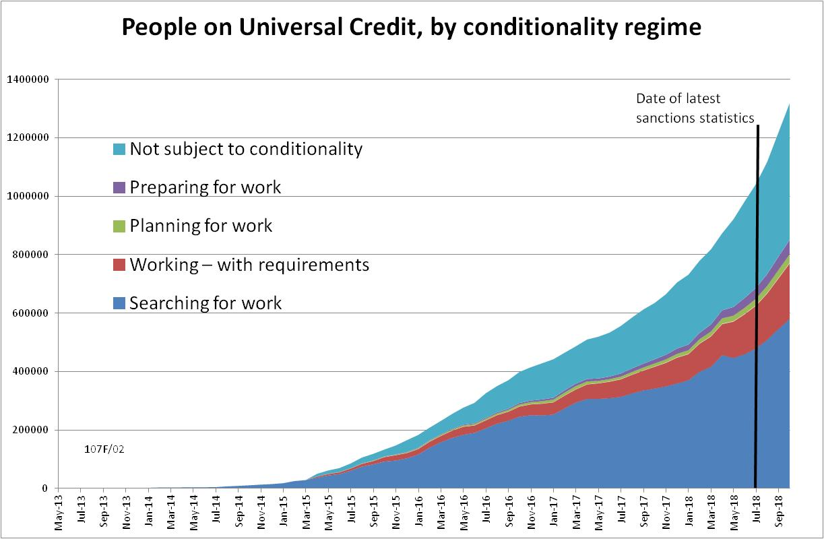

Figure 2
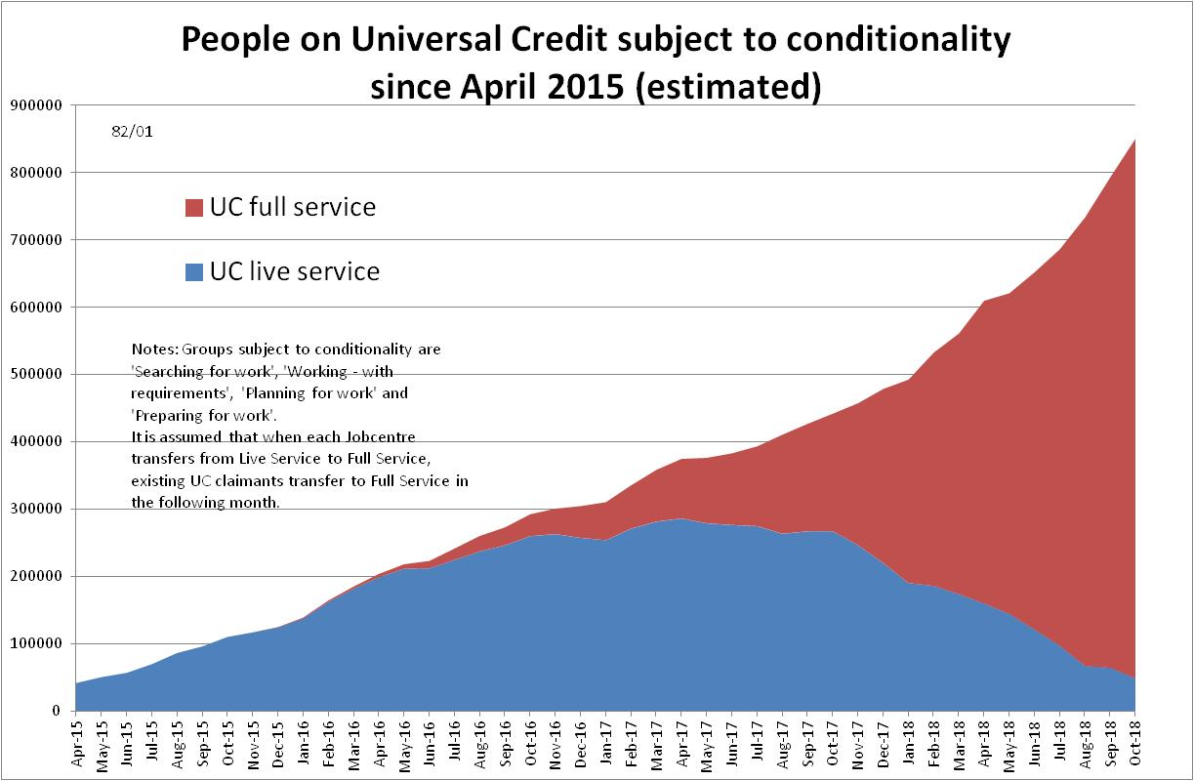

Figure 3
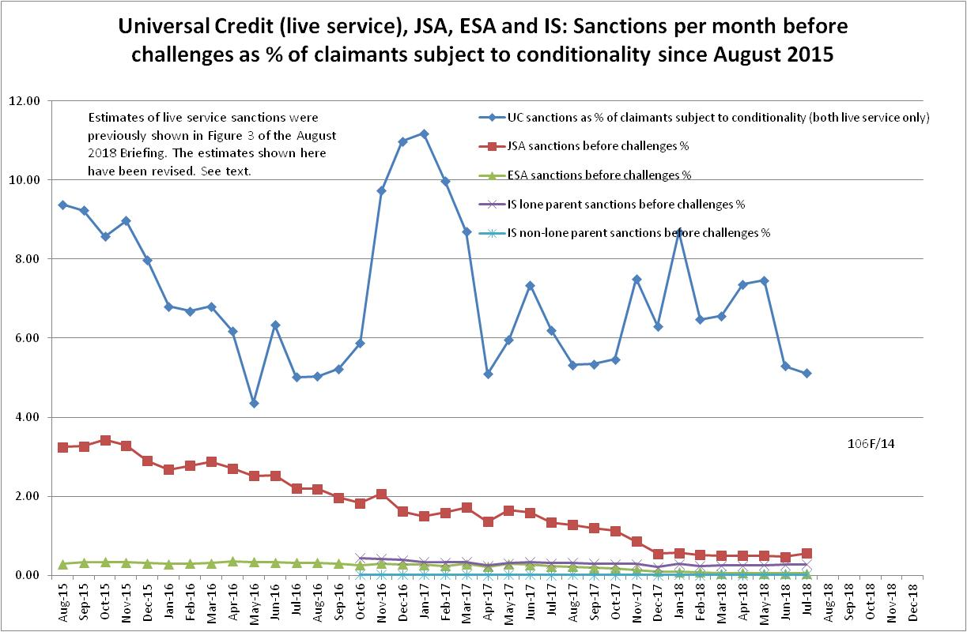

Figure 4
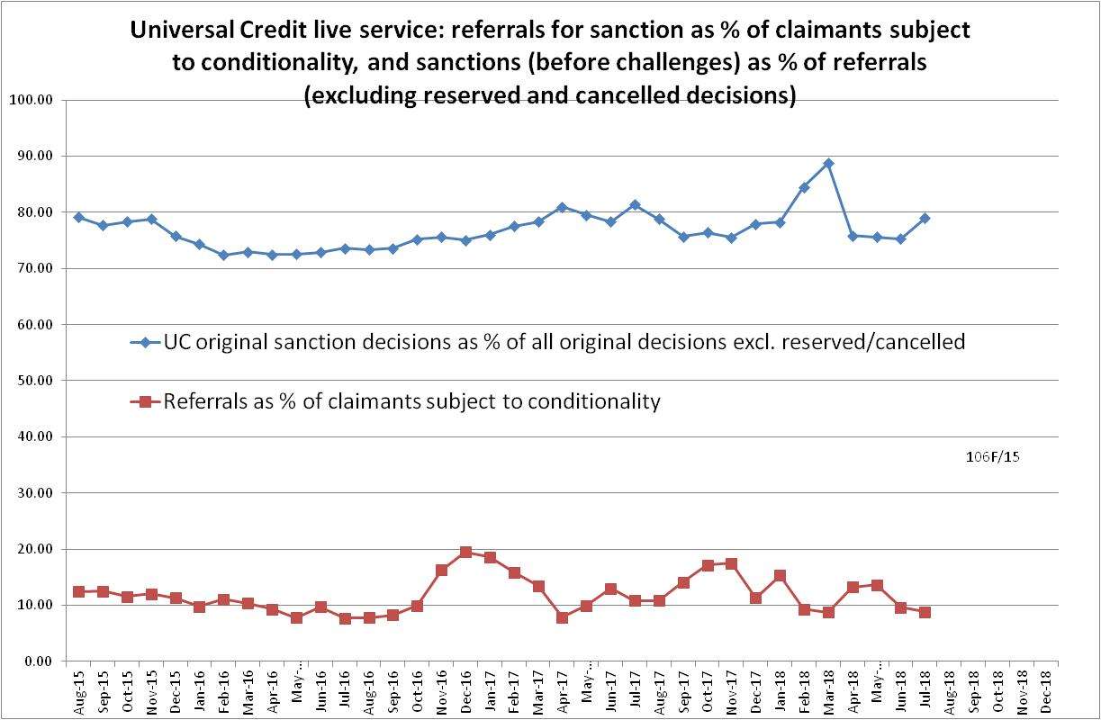
Figure 5
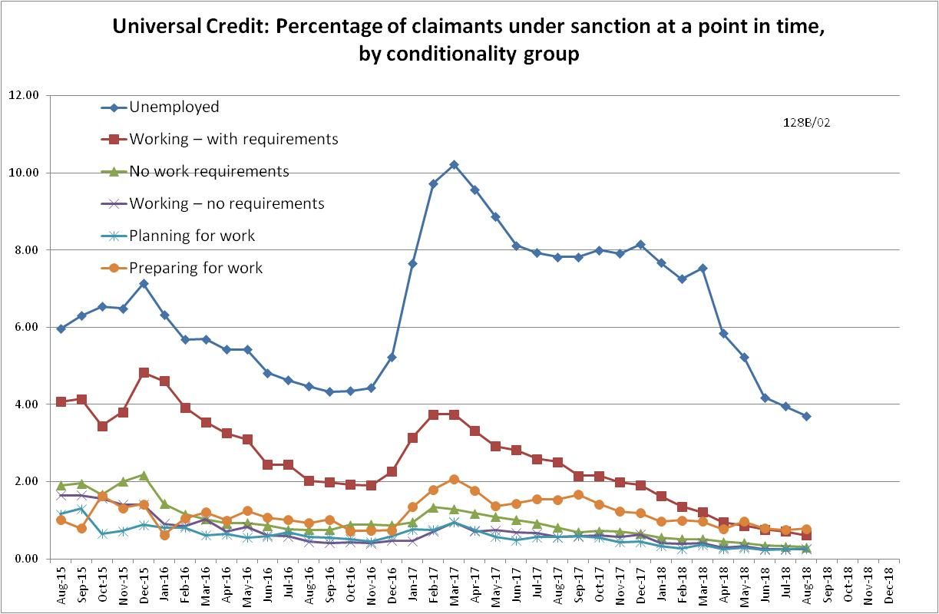

Figure A.1
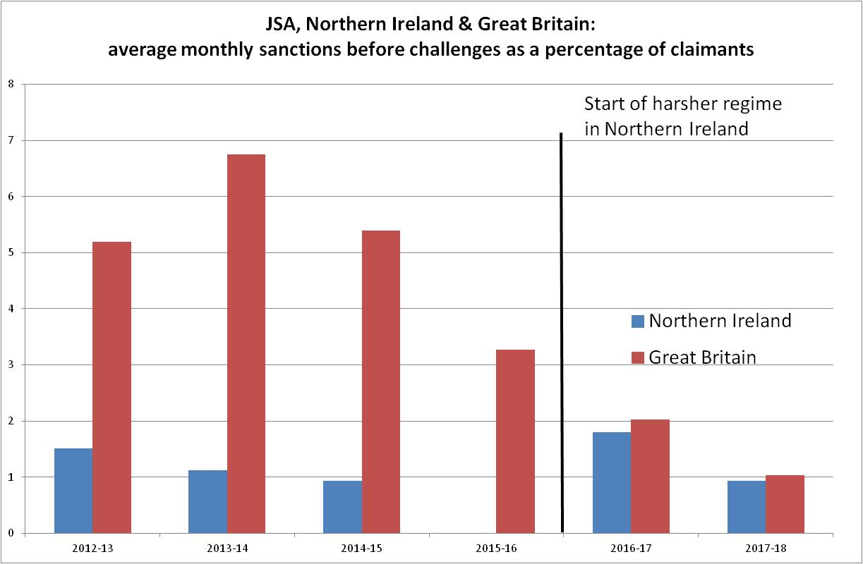

Figure A.2
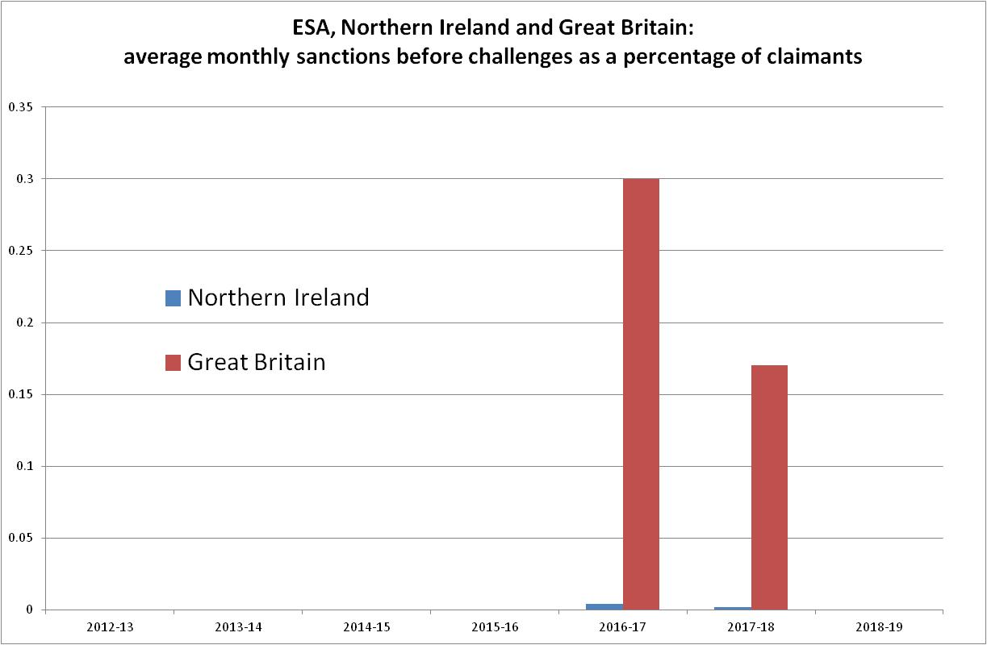

NOTES

Previous briefings are available at http://www.cpag.org.uk/david-webster. They include many analyses that remain valid. However it should be remembered that the DWP may have made subsequent revisions to the data reported in earlier briefings.
The total number of people subject to sanctions cannot be stated exactly, because there are some categories of Income Support claimants other than lone parents with a child under one who are not subject to sanctions, and there are no data on their numbers. However, they are likely to number in the low tens of thousands.
The in-work UC claimants subject to conditionality are low paid or part-time workers who prior to UC would not have been subject to sanctions at all. Those ‘planning for work’ are mainly lone parents with a child aged 1, while those ‘preparing for work’ are people who would have been in the ESA Work Related Activity Group, and lone parents with a child aged 2 but under 5. The statistical categories for conditionality regime used in Stat-Xplore are explained in the ‘i’ feature next to the variable name in Stat-Xplore and also in the Universal Credit Statistics methodology document at https://www.gov.uk/government/publications/universal-credit-statistics-background-information-and-methodology
Lone parents with youngest child aged one to five have been estimated simply as one fifth of the total with youngest child aged 0 to five.
The new Work and Pensions Committee report (p.59) has a useful chart showing the effect of repayable hardship payments on the effective length of sanctions. A qualification is that repayment is suspended for any month when the claimant earns more than their threshold, and any remaining debt is written off if the earnings threshold has been met for 26 weeks, whether continuous or not. This is only of any use to someone who has a realistic chance of earning.
The Standard Allowance is the basic living amount for a single adult, before the addition of other amounts for housing costs, children etc.
The basic concept of the DWP’s sanctions database is that each sanction case appears only once, and is given its latest status and attributed to the month of the latest decision on the case. So, for instance, if a decision is made in January 2014 to sanction someone, this decision is reviewed in March 2014 with an outcome unfavourable to the claimant, reconsidered in a ‘mandatory reconsideration’ in May 2014 again with an unfavourable outcome, and is heard on appeal by a Tribunal in October 2014 with a decision favourable to the claimant, then: - it appears in the statistics for the first time in January 2014 as an adverse ‘original’ decision - in March 2014 it changes its status to a ‘reviewed’ adverse decision and moves month to be with all the other cases where the latest decision has been made in March 2014 - in May 2014 it changes its status to a ‘reconsidered’ adverse decision and moves month to be with all the other cases where the latest decision has been made in May 2014 - in October 2014 it changes its status again to an appealed non-adverse decision, and moves month again to be with all the other cases where the latest decision has been made in October 2014.
The estimates of sanctions before challenges have been derived by adding the monthly total of ‘non-adverse’, ‘reserved’ and ‘cancelled’ decisions shown as being the result of reviews, mandatory reconsiderations and tribunal appeals, to the monthly total of adverse ‘original’ decisions. This produces only an approximate estimate for each individual month, since decisions altered following challenge are not attributed to the correct month. It will be particularly unreliable for months affected by a DWP catch-up of a backlog of decisions. But the estimates are reliable for longer periods.
As shown in the March 2018 edition of the DWP’s Universal Credit Transition Rollout Schedule.
The 2014-15 sanctions figure for Northern Ireland is for April to January and has been grossed up pro rata to a full year. The Department for Communities have confirmed to me that all Northern Ireland sanctions figures are shown before challenges.

