BRIEFING

Benefit Sanctions Statistics

June 2020

1 July 2020

Dr David Webster
Honorary Senior Research Fellow
Urban Studies
University of Glasgow

Email david.webster@glasgow.ac.uk

Webpages: http://www.gla.ac.uk/schools/socialpolitical/staff/davidwebster/
http://www.cpag.org.uk/david-webster
SUMMARY

Almost all new benefit sanctions (though not those already in place) were suspended during the coronavirus lockdown, for three months to 30 June, but the Secretary of State has decided not to renew the suspension, despite having the power to do so. This is not simply a return to the position before the lockdown. It means a huge increase in the number of people exposed to benefit sanctions, from just under 2.0m in January 2020 to a likely 3.0m to 3.5m now. The increase is almost entirely due to unemployment, with an increase of 1.373m unemployed claimants on Universal Credit (UC) or Jobseeker’s Allowance (JSA) between March and May. Of this increase, about 130,000 or 10% will have been claimants of ‘New Style’, i.e. non-means tested contribution-based JSA, the remainder being on UC. Altogether, claimants on UC increased by 2.3m, from 3.0m in March to 5.3m in May. Over half (1.25m) of this increase was due to unemployment and 0.828m to working claimants. Increases in the other categories of claimants (sick and disabled people and those with caring responsibilities) were only a little above trend, so that the large recruitment of claimants to UC will have done little to change the projected timetable for migration from ‘legacy’ benefits.

Prior to the lockdown, sanctions on all benefits had fallen to the lowest annual level since the current statistical system began in 2000, with an estimated 239,000 sanctions in 2019, the same as in 2018. Of these, about 89% were for missed interviews, and 87% were UC sanctions for missed interviews. DWP does not publish figures for the length of these specific sanctions, but because they account for such a high proportion of total sanctions their lengths must be similar to the published figures for all sanctions. In the latest quarter 45% of all completed UC sanctions lasted more than 4 weeks, 19.1% more than three months, and 7% more than 6 months. The loss of all income for these periods is a very severe penalty for a ‘failure’ (a missed appointment) which until April 2010 did not lead to a ‘sanction’ at all. There must be concern about the extension of such penalties to a further 1.0m to 1.5m people, particularly in the face of the evidence produced by the Resolution Foundation, Institute for Fiscal Studies and Step Change that many people’s financial resilience has been severely undermined by loss of income, running down of savings, and accumulation of debt during the lockdown. They will be less able to cope with the impact of any sanctions.

DWP argues that it cannot avoid the large numbers of UC sanctions for missed interviews because the alternative of closing the case is not available where claimants are entitled to other elements of UC, such as for housing or child care. This problem has been created by the design of UC, which could obviously be changed. There must be a suspicion that the failure to make this change is due to a reluctance to admit that UC has design faults that need to be corrected, as has been seen in the case of the ‘banking days’ issue on which DWP recently lost a case in the Court of Appeal.

DWP has published further corrections to the figures for the monthly number of UC sanctions. The figures now published in June 2020 are almost identical to those published in August 2019, before the previous round of corrections. The figures published in November 2019 and February 2020 understated the number of UC Full Service sanctions by around one quarter to one third, equating to some 5,000 sanctions per month.

A news section at the end of the Briefing reports particularly on recent research on sanctions.
BRIEFING: Benefit Sanctions Statistics
June 2020

INTRODUCTION

The latest quarterly DWP benefit sanctions statistics were due to be released on 19 May but were delayed while DWP investigated problems with the data. They were eventually published on 11 June. They give data on sanctions usually to January 2020. The new data are summarised by DWP in the publication Benefit Sanctions Statistics, available along with methodological notes at https://www.gov.uk/government/collections/jobseekers-allowance-sanctions together with a spreadsheet with summary tables. The full figures for most aspects of the data are on the DWP’s Stat-Xplore database at https://stat-xplore.dwp.gov.uk/webapi/jsf/login.xhtml

DWP suspended almost all sanctions and all Jobcentre interviews for approximately 3 months from March because of the coronavirus emergency. This suspension has now ended. The effects of the suspension will not begin to show up in the statistics until the August release. However data on unemployment and benefit claims are available up to 14 May. These do reflect the coronavirus emergency and are considered here.

All statistics presented here relate to Great Britain.

Further corrections to the sanctions data

Corrections to the sanctions data were noted in the February 2020 Briefing. The new release highlights two further issues.

The most important is that UC sanctions (‘adverse decisions’) were undercounted in the data published in November 2019 and February 2020. The resulting undercount was substantial, equating to some 5,000 sanctions per month, or between around one quarter and one third of all UC sanctions. The implications of the revisions are considered below.

DWP has also found that there was a significant change in trend in JSA sanction decisions in January 2020, which it cannot currently explain. It has therefore only published these figures up to December 2019. It cannot be assumed that the January 2020 figures are the ones that are incorrect; the change in trend might be a sign that the earlier figures, or both sets of figures, are wrong. JSA sanctions have of course now become only a relatively small part of the total sanctions picture, because of the transfer of most unemployed people to UC.

Groups of claimants exposed to sanctions:
Universal Credit, JSA, ESA and Income Support

During the coronavirus emergency, almost all sanctions have been suspended. But the sanctions regime is being reinstated as of 1 July. At January 2020, a total of almost 2m (1.98m) claimants were exposed to the risk of sanctions, with varying frequency and severity. They were split between Universal Credit (UC), Jobseekers Allowance (JSA), Employment and Support Allowance (ESA) and Income Support (IS). These numbers have now increased dramatically, particularly for UC and to a lesser extent JSA. As result, the total now exposed to sanctions as at the beginning of July seems likely to be between 3.0m and 3.5m.
Numbers of claimants of the four benefits

Until the coronavirus emergency the number of claimants on UC continued to increase at a modest rate, typically around 100,000 per month. By January 2020 it had reached over two and three quarter millions (2.77m). The coronavirus lockdown came on 23 March, too late to affect the figures for March, which relate to the second Thursday (12 March). However there was a huge increase of almost 1.2m (1.198m) by the second Thursday of April (9th), and a further increase of over one million (1.065m) by 14 May, taking the total to over five and a quarter millions (5.275m) (Figure 1). Figure 2 shows how the numbers of UC claimants have increased for each ‘conditionality regime’. The biggest increase between March and May has been in the unemployed, i.e. those ‘searching for work’. They increased by 1.25m. The other large increase was in working claimants, whether earning above or below the conditionality threshold. They increased by 0.828m. By contrast, the increase in those with ‘no work requirements’, i.e. sick or disabled, was simply on trend, and the increases in those ‘planning for work’ and ‘preparing for work’ were only a little above trend. This means that little of the total increase of 181,477 between March and May in these latter three groups was attributable to the impacts of the coronavirus. This in turn means that the large recruitment of UC claimants due to coronavirus will probably not have much effect on the DWP’s timetable for ‘managed migration’ of existing ‘legacy’ claimants to UC (see the February 2020 Briefing, p. 10).

Unemployed claimants

The UC count of those ‘searching for work’ does not contain everyone claiming benefits as a result of unemployment, because there are also people claiming ‘legacy’ Jobseeker’s Allowance (JSA) (i.e. unemployed claimants who have not had a change of circumstances which would have made them transfer to UC), and people who are claiming ‘New Style JSA’, i.e. the non-means tested benefit available for 6 months to newly unemployed people with a qualifying National Insurance contribution record. Separate figures for income-based and contribution-based JSA are no longer regularly published by DWP, but at February 2019, out of a total of 318,200 JSA claimants, 30,400 (9.6%) were receiving contribution-based JSA and a further 15,800 (5.0%) were claiming National Insurance credits only, with the remainder receiving income-based JSA only.

Prior to the coronavirus emergency, the total of unemployed claimants (the ‘claimant count’) was rising gently, but within the total, JSA claimants were falling as UC took over (Figure 3). But between March and May the claimant count more than doubled, increasing by 1.373m to reach 2.611m, and far surpassing the peak of the 2008 recession (Figure 4). Of the increase of 1.373m, 126,410 was an increase in JSA. Since the total of JSA claimants had been falling by a few thousand per month in previous months, it can safely be stated that there were almost 130,000 new claimants of New Style JSA between March and May. In other words, of the new unemployed claimants between those two months, about 10% claimed New Style JSA. Overall, in spite of the increase in JSA claimants, by 14 May UC accounted for 89% of all unemployed claimants.

Further analysis of the labour market under coronavirus is published by the Learning and Work Institute at https://learningandwork.org.uk/what-we-do/employment-and-social-security/labour-market-analysis/ and by the Institute for Employment Studies at https://www.employment-studies.co.uk/resource/labour-market-statistics-june-2020-ies-analysis The latter body has also published a report on the policy issues involved in labour market recovery from coronavirus (Wilson et al. 2020).

Sickness and disability

The number of people claiming UC on grounds of sickness or disability and in normal times subject to conditionality is not published by DWP. UC claimants ‘preparing for work’ (145,425 at January 2020 and 218,827 at May 2020) include these people but they also include some people who are not sick or disabled and would previously have claimed IS. The number of ESA claimants subject to conditionality, i.e. those in the Work Related Activity Group (WRAG) however is known. They are all subject to conditionality. Their number peaked at 562,620 in August 2013 but has more than halved since then, to an estimated 249,700 in January 2020.

As well as ‘legacy’ ESA, there is a ‘New Style’ ESA, which like ‘New Style’ JSA is a non-means tested, time limited benefit available to people with qualifying National Insurance contributions. As for JSA, there are also people who do not qualify for ESA on either income or contribution grounds but claim only to obtain National Insurance credits. At November 2019, of the total in the WRAG, 3.8% were receiving contribution-based ESA and 13.9% were claiming ‘credits only’, the remainder being on income-based ESA alone. During the coronavirus emergency, New Style ESA is available to additional groups such as people who are self-isolating due to vulnerability or are in quarantine. This will lead to a slowing or reversal of the declining trend in ESA WRAG claims. However, data reflecting this will not be published until November 2020.

Income Support

The number of IS claimants is falling quite fast due to movement of new claimants on to UC. There were an estimated 281,000 claimants on IS and subject to sanctions at January 2020. The largest group among these was an estimated 151,000 lone parents with a youngest child aged between one and five. There were also an estimated 127,000 carers and 4,000 other IS claimants.

The Universal Credit sanctions regime

A full description of the UC sanctions regime was given in the February 2019 issue of the Briefing, pp.5-6.

Universal Credit ‘Full Service’ and ‘Live Service’

On its introduction, Universal Credit was delivered via ‘Live Service’. A programme to transfer Jobcentres to the more sophisticated ‘Full Service’ was started in May 2016 and completed in December 2018. For many months therefore, Live Service and Full Service were operating in parallel. However, 100% of Live Service claimants had transferred to Full Service by April 2019, and the systems used to administer Live Service were shut down at the end of March 2019.

DWP is still not publishing comprehensive sanctions data on Full Service. Most data on Stat-Xplore still relate only to Live Service. Within Stat-Xplore, the only topic covered for Full Service is the number and proportion of claimants under sanction at a point in time. Benefit Sanctions Statistics and the accompanying spreadsheet add the number of adverse sanction decisions, duration of completed sanctions, repeat adverse sanction decisions in the past year, reasons for sanctions, and demographics, though not necessarily all of them in every release.

Sanctions before and after reviews, reconsiderations and appeals

Except for the new UC Full Service data first published in May 2019, the DWP’s Benefit Sanctions Statistics publication and Stat-Xplore database only show sanctions after any reviews, reconsiderations and appeals that have taken place by the time the data are published. But numbers of sanctions before the results of these challenges are important since they show all the cases in which claimants have had their money stopped. Although a successful challenge should result in a refund, this is only paid after weeks or months by which time serious damage is often done. Estimates of sanctions before challenges are therefore given here but although reliable for longer time periods, they are not fully accurate for individual months. For JSA and ESA, figures for sanctions before challenges have typically been higher than the ‘after challenge’ figures by very large amounts, namely about 20%. and 40% respectively. For UC Live Service (the only figures currently available for the UC appeal process) and for IS, the proportion of sanctions overturned has been much smaller at around 5% and 1% respectively. So for these types of sanction there is much less difference between the pre-and post-challenge figures. Wherever possible, this Briefing shows estimated pre-challenge sanctions figures. DWP now says that it aims to change this system for Universal Credit sanctions at some point in the future in order to show all decisions at each stage.

CORONAVIRUS AND BENEFIT CONDITIONALITY

In response to the coronavirus emergency, the Social Security (Coronavirus) (Further Measures) Regulations 2020 No.371 suspended all new UC and JSA sanctions relating to work search or availability for work for 3 months from 30 March. This period could be extended up to 13 November at the Secretary of State’s discretion (para.10(2)). The Regulations are at https://www.legislation.gov.uk/uksi/2020/371/contents

In addition, the Secretary of State made an administrative decision to suspend all face-to face interviews for claimants of UC, JSA, ESA and IS for at least 3 months from 19 March. This was explained in a letter from the Secretary of State to the chair of the House of Commons Work and Pensions Committee on 25 March, at https://committees.parliament.uk/publications/467/documents/1841/default/

These two measures taken together mean that there has been a 3-month moratorium on almost all new sanctions, from March to the end of June, but not including UC and JSA sanctions for voluntary leaving or misconduct. The latest figures for reasons for sanctions (considered further below) indicate that the suspension will have covered about 99% of all sanctions. But sanctions already in place were not suspended. All health and disability assessments were also stopped for at least 3 months. The OECD, which has long been an advocate of benefit sanctions, itself advises relaxed job search monitoring during the epidemic and cites many other countries as having taken this course (OECD 2020 p.5)

The Secretary of State has announced that she is not extending the moratorium on sanctions. In June, a group of 20 NGOs including Rethink and the Royal College of Psychiatrists called for the suspension of work-related benefit sanctions to be extended for a further 6 months. Details are at
https://www.rethink.org/news-and-stories/news/2020/06/joint-statement-on-work-related-conditionality-and-sanctions/ In addition, at oral questions on 29 June, the Labour Work and Pensions spokesman, Jonathan Reynolds said to the Secretary of State ‘At a time when unemployment has risen sharply, the number of vacancies has dropped, people are shielding and schools have not yet gone back, threatening people with reducing their financial support if they do not look for jobs is surely untenable, so will the Secretary of State announce an immediate extension?’ However, Dr Coffey replied ‘It is important that as the jobcentres fully reopen this week we reinstate the need for a claimant commitment. It is an essential part of the contract to help people start to reconsider what vacancies there are, but I know that I can trust the work coaches and jobcentre managers, who are empowered to act proactively with people. There will be some people right now who have not had to look for a job for the last 20 to 30 years, and they will need careful support, tailored to make sure they can start to look for the jobs that are available and which I hope will soon become available.’

There remains some ambiguity about the exact scope of the moratorium, which no doubt will be resolved when the relevant statistics are published. At https://www.understandinguniversalcredit.gov.uk/employment-and-benefits-support/faqs/#jobcentreappointments the DWP stated ‘You will not be penalised or sanctioned for not attending the jobcentre, but if you have an appointment that will be conducted online or by telephone you should attend it.’ This implies the possibility that people could be sanctioned for not taking part in a telephone interview, though this seems more likely to be recorded as closure of the case. The formal announcements also raise the possibility that UC sanctions might have continued in relation to work planning and preparation (no ESA sanctions other than for missed interviews have been applied since February 2019). But the same DWP webpage appeared to rule this out by stating ‘All requirements to attend appointments, undertake work preparation, undertake work search and be available for work have been temporarily suspended in response to the coronavirus outbreak.’

Third party deductions and repayments of advances and ‘hardship payments’

The DWP also suspended UC third party deductions, both new deductions and those already in place, for one month only, to 10 May. An email from DWP dated 29 April makes it clear that this was simply to relieve pressure on staff resources, not on claimant finances. ‘An unprecedented number of Universal Credit applications have been made since March. The Department has rightly prioritised the processing of these claims to ensure people get the support they need during the coronavirus outbreak. This means prioritising our resources and as a result of this we’ve made a decision to pause deductions from existing UC claimants, on behalf of third parties. This includes deductions taken on behalf of landlords relating to rent arrears and service charge arrears. This activity has been paused for one month only, while we work through the huge number of new claims. All deductions will resume on 10 May as normal.’ It also appears that repayments of advances and hardship payments have continued without interruption.

The outlook for sanctions

It remains to be seen how vigorously DWP will enforce the reinstated sanctions regime. The statistics show that sanctions were being de-emphasised even before coronavirus. Also, DWP still needs to publish its study on the effectiveness of sanctions, originally promised for ‘late Spring’ 2019 (Briefing, February 2020 p.10), and this will very likely prompt public debate.
However, there must be two particular concerns. One is that following the coronavirus lockdown there are large numbers of people whose financial resilience has been severely undermined by the loss of income, running down of savings, and accumulation of debt. They will be less able to cope with the impact of any sanctions, which in the UK since 2012 are very extreme, involving for many people the loss of all income for prolonged periods. This weakened financial resilience has been analysed in reports by the Resolution Foundation (Bangham & Leslie 2020), Institute for Fiscal Studies (Bourquin et al. 2020) and Step Change (Step Change 2020). The other concern is that the historical record going back to the 1920s (Webster 2018b) suggests that harsh conditionality is most likely to be imposed on unemployed people not in the immediate aftermath of a big recession, but in the later stages of recovery, when politicians get impatient that unemployment (and its benefit cost) is not falling faster, and the body of unemployed people becomes smaller, more disadvantaged and less able to defend itself. So even if sanctions were to resume at a relatively low level, they may well rise later in the recovery. The question of reform of the 2012 regime therefore remains vital.

Later in the Briefing it is shown that Universal Credit sanctions for failure to attend an interview now account for almost nine out of ten (86.7%) of all sanctions. DWP say that previously the claimant’s case would simply have been closed, usually with lesser financial consequences, but that the structuring of UC makes it impossible to close a case where a claimant has an entitlement to other elements of UC, such as for housing or childcare. But it would clearly be possible to restructure UC to avoid this issue. Unfortunately, DWP ministers have shown a reluctance to admit that UC has design faults that need to be corrected, as for instance in relation to the ‘banking days’ issue. This problem, arising from the rigidity of UC assessment periods, has led to loss of money and huge fluctuations in some claimants’ incomes. The Court of Appeal (Secretary of State for Work and Pensions v Johnson & Others [2020] EWCA Civ 778 (22 June 2020), at https://www.bailii.org/ew/cases/EWCA/Civ/2020/778.pdf ) recently found that the refusal to correct the problem was so irrational as to be unlawful, and DWP has now capitulated. With the resumption of sanctions following the lockdown, applicable to a hugely increased number of claimants, there is clearly a need for an urgent review of the policy on sanctions for interviews.

MONTHLY NUMBERS AND RATES OF SANCTIONS BEFORE CHALLENGES FOR THE FOUR BENEFITS

UC sanctions figures in this Briefing are now always for Full and Live Service combined, unless otherwise stated. Unlike all the previously published DWP figures, the new Full Service sanctions figures are on a ‘before challenge’ basis. Here, historic Live Service figures are put on to this same basis as previously explained.

As mentioned above, DWP has once again revised the figures for Full Service adverse sanction decisions. DWP says this is because cases were only included in these figures if the decision date fell within the period when a service centre was active, and it has subsequently been found that some valid adverse decisions occurred outside this date range. Figure 5 shows the figures which have been published in the last four quarterly releases, since August 2019. It will be seen that the figures now published in June 2020 are almost identical to those published in August 2019, before the previous round of corrections. The figures published in November 2019 and February 2020 understated the number of UC Full Service sanctions by around one quarter to one third, equating to some 5,000 sanctions per month.

Total numbers of sanctions

The revised figures mean that before the coronavirus outbreak the total number of sanctions was no longer falling significantly. The total of sanctions on all benefits before challenges in 2019 was almost identical to that in 2018: 239,000 in both years (Figure 6). This remains the lowest since the present recording system began, and much lower than the peak of 1.113m in 2013. The 238,000 sanctions imposed in the 12 months up to and including the end of January 2020 comprised 231,000 UC sanctions, 3,000 JSA, 250 ESA and 3,700 IS sanctions. UC accounted for 97% of all sanctions in the latest 12 months.

Monthly rates of sanctions

Figure 7 shows estimated monthly sanctions before challenges as a percentage of claimants subject to conditionality, for each benefit since August 2015 when UC sanction figures begin.

The overall picture is one of a lengthy decline for all the benefits. The overall monthly rate of UC sanctions before challenges as a proportion of claimants subject to conditionality has fallen from over 9% in 2015 to about 1.4% in the three months to January 2020, with the decline interrupted only by the ‘catch-up’blitz in 2016-17.

The UC sanction rate remains far above those for JSA, ESA and IS, which are at low levels as shown in Figure 7. In the latest quarter the JSA monthly rate of sanctions before challenges was about 0.04%, ESA 0.005%, IS lone parent 0.14%, and IS non-lone parent 0.01%.

The DWP has not yet given a breakdown of its UC Full Service sanctions figures between conditionality groups. However, the estimates of the proportion of claimants under sanction at a point in time (see below) indicate that the rate of UC sanction is much higher for unemployed than for other claimants. On the assumption that the ratios of the monthly sanction rates for the ‘planning for work’ and ‘preparing for work’ groups to the rate for the unemployed group are similar to those for the proportions under sanction at a point in time (see below), it can be crudely estimated that the monthly rate of UC sanctions on unemployed claimants before challenges would be about 1.65% in the latest quarter.

PROPORTION OF CLAIMANTS UNDER SANCTION AT A POINT IN TIME

The DWP’s preferred measure of sanctions ‘rate’ is the proportion of claimants who are serving a sanction at a point in time. There are various methodological problems with this measure, which were discussed in the November 2017 Briefing (pp.6-10). A further issue was discussed in the February 2020 Briefing, p.7. This measure also understates the impact of sanctions, since the number of people experiencing a sanction over a period such as a year is much greater than the number actually serving one at a point in time, and the effects of a sanction often last a long time. But in spite of the limitations, in the current situation where no breakdown of the monthly UC sanction figures is published by conditionality group, the figures are of some value in indicating the comparative harshness with which the different groups are treated within UC. The figures for JSA and ESA (published in the Benefit Sanctions Statistics spreadsheet, not Stat-Xplore) are less valuable.

Figure 8 shows the latest figures for UC. There is a big contrast between the unemployed and the other groups. For the former, the proportion under sanction has been approximately static at about 3.25% since February 2019. The other two groups subject to conditionality, ‘planning for work’ and ‘preparing for work’, are much lower at around 0.4%. Both of these groups contain sick and disabled people, and although the proportions under sanction are low, they are much higher than for ESA. This is shown in Figure 9.

The groups not subject to conditionality would be at zero but for the fact that under UC there is a much-criticised rule that sanctions that are in place continue even if the claimant moves into a no-conditionality group. For the ‘working - with requirements’ group the proportion is about 0.25%, for the ‘no work requirements’ group 0.20%, and for the ‘working - no requirements’ group about 0.14%. In terms of absolute numbers, at January 2020 there were a total of 2,861 claimants in this position, comprising 933 in the ‘working – with requirements’ group, 1,392 ‘no work requirements’ and 536 ‘working – no requirements’.

REASONS FOR SANCTIONS

The Briefing last looked at the reasons for sanction in May 2019 (pp.6-7), when DWP released figures enabling an analysis for the 12 months to end-January 2019. Figures 10 and 11 update this analysis for the further 12 months to end-January 2020, with the earlier figures shown for comparison.

In terms of total numbers of sanctions (Figure 10), the picture for the latest 12 months is similar to that of the year before, but it has become even more dominated by sanctions for failure to attend an interview. There were 210,800 of these sanctions, equating to 88.7% of all sanctions compared to 76.9% the year before. These sanctions were spread across all the benefits, although 206,000 of them were on UC. Next came 20,000 sanctions for non-availability for work, all either UC or JSA, accounting for 8.4% of all sanctions, compared to 13.5% the year before. There were about 4,200 sanctions for non-participation in employment programmes or work preparation activity, or 1.8% of all sanctions, compared to 6.4% the year before. Voluntary leaving and misconduct accounted for about 2,200 sanctions, all either UC or JSA, equating to 0.9% of all sanctions, compared to 3.0% the year before.

Figure 11 shows the relative importance of each sanction reason within each benefit. JSA shows a big shift away from employment programmes and towards non-availability, while ESA shows a big shift from work-related activity to missed interviews. But JSA and ESA sanctions are now quite few in number, so the changes are of less interest than they would have been earlier. In numerical terms, the most important change is the shift within UC towards missed interviews, away from availability, employment programmes and voluntary leaving/misconduct.

Under UC, the sanction for missing an interview is either ‘low level’ or ‘lowest level’. ‘Low level’ applies to people who have both an interview requirement and other requirements. They receive a sanction of 100% of their standard allowance which lasts until they attend an interview, followed by a further period of one, two or four weeks for a first, second or subsequent ‘failure’ respectively. ‘Lowest level’ applies to people with only an interview requirement. Their sanction lasts until they attend an interview, and is also of 100% of the standard allowance, except for claimants in the ‘Planning for Work’ regime or the ‘No Work requirements regime’ on the grounds of childcare responsibilities, adoption or pregnancy, when it is 40%. These rules are often producing long sanctions. In the latest reported quarter (December 2019 to February 2020) DWP’s estimates indicate that 45% of all completed UC sanctions lasted more than 4 weeks, 19.1% more than three months, and 7% more than 6 months. Since interview sanctions now account for 89% of all UC sanctions, the durations of UC interview sanctions must be close to these figures for all UC sanctions.

Up to April 2010, missing an interview was not a cause for sanction as such; if the claimant did not get in touch, the claim would be closed, and the claimant then had the option of renewing the claim, having suffered the loss only of the number of days’ delay in reclaiming plus the then three ‘waiting days’. DWP say that the structuring of UC makes it impossible to close a case where a claimant has an entitlement to other elements of UC, such as for childcare. But it would clearly be possible to restructure UC to avoid this issue.

Given their now overwhelming numerical predominance, we clearly need to know more about how the open-ended sanctions for interviews have been working.

ANALYSES NOT INCLUDED IN THIS ISSUE

The paucity of data available for UC Full Service sanctions makes it not worthwhile to update many of the analyses at present. Readers are referred to earlier numbers of the Briefing for analyses of matters not discussed in the present issue. Durations of sanctions were discussed in detail in November and February 2019; repeat sanctions on the same individuals in February 2020, May 2017 and November 2014 to May 2016 inclusive; demographic breakdown in February 2020; claimants with earnings following a sanction were covered in November 2018; ethnicity and gender in July 2018; benefit destinations in February 2018; challenges to sanctions in February 2018 and May 2017; JSA benefit suspensions not followed by sanction, and ESA sanctions by medical condition in August 2017; and hardship payments for UC in August 2019 and for JSA and ESA in February 2019 and November 2015. Longer period analyses were included in the author’s written evidence to the Work and Pensions Committee (Webster 2018a) and in a presentation to the Welfare Conditionality conference at York in June 2018 (Webster 2018b). These analyses will be updated in future issues.
SANCTIONS - OTHER DEVELOPMENTS

Stephen Timms interview

The Guardian on 22 June carried an interview with the chair of the House of Commons Work and Pensions Committee, Stephen Timms. Among other things, he said that one of the lessons DWP ministers might learn from the pandemic is how much of the architecture of the benefits system temporarily suspended during the pandemic might be permanently jettisoned. He would not scrap conditionality, but the ‘needlessly punitive’ sanctions regime ..... should be looked at. One of the problems is that claimants feel the system is there to catch them out, rather than support them. ‘That’s a very poisonous relationship that people have sometimes got into with jobcentres. That’s not how it ought to be. The system should treat people a lot better than that. Sanctions are a reason why too many people have found it such an unpleasant experience.’ The interview is at
https://www.theguardian.com/society/2020/jun/22/stephen-timms-universal-credits-five-week-delay-is-indefensible

Link between sanctions and anxiety and depression

A further paper from Evan Williams of the University of Glasgow provides more evidence of the link between sanctions and anxiety or depression (Williams 2020). It is similar to the same author’s previous article, reported in the November 2019 Briefing, p.15, but uses survey estimates on anxiety/depression from the Annual Population Survey. The central finding is that, following the increase in the severity of JSA sanctions in October 2012, every 10 additional sanctions applied per 100,000 working age population per quarter are associated with approximately eight additional people reporting that they suffer from anxiety and/or depression. This headline result overestimates the relationship between sanctions and anxiety/depression, which may need to be scaled down by up to a fifth. This is an open access article, free to view.

Bright Blue Scotland report on Scottish attitudes to social security

On 13 April the Conservative think tank Bright Blue Scotland published the results of a survey by Opinium Research of 3,002 Scottish adults jointly commissioned with the Joseph Rowntree Foundation and carried out during the general election campaign in December 2019. This type of survey is relatively rare and therefore valuable, although the results are very much influenced by the precise wording of the questions. Among the findings of this survey are that 64% of Scots agree that any further cuts to social security will be damaging; 74% support the rent direct facility and 62% the fortnightly payment flexibility introduced under the Universal Credit Scottish Choices scheme; and Scots support the Scottish Government’s decision to introduce the Scottish Child Payment, with 72% thinking the payment is set at the right amount or should be higher. A majority of Scots believe that social security spending should be increased for particular claimant groups, especially carers (72%) and disabled people (67%), but also low-income working parents (61%) and those who have previously paid income tax and national insurance for a number of years (50%). However 45% thought that spending on unemployed people should stay the same, with slightly more (27%) thinking that spending on them should be increased than that it should be reduced (22%). Respondents were divided on whether the advance payment given to help claimants deal with the five-week wait for UC should be a loan or a grant, with the former (43%) being preferred to the latter (39%) by a small margin.

In relation to conditionality and sanctions, a majority thought that social security should be conditional on strict requirements (58%) and that those who have paid income tax and NI for a greater number of years should receive greater help (64%). In relation to particular groups:

Unemployed: 71% v. 9% thought that unemployed people should be required to search for work and 52% v. 23% that they should be sanctioned if they turned down a job.
Low income working benefit claimants: Scots do not support requiring them to look for more or better paid work (37% v. 48%), but they do support sanctioning them if they refuse such work (46% v. 26%).
Low-income parents of a child aged between three and four: Scots do not think that they should be required to work at least 16 hours a week to receive benefit (38% v. 32%).
Self-employed benefit claimants: Scots agreed that they should be required to look for new or additional work if they do not earn a salary equal to working full-time at the minimum wage rate (40% v. 23%).

A summary of the findings, with a link to the detailed tables, is at https://brightblue.org.uk/scots-support-more-generous-and-devolved/
and there is also a printed report (Sarygulov & Arslanagić-Wakefield 2020).

Impact of Universal Credit on couples

A new report from the University of Bath Institute for Policy Research and Oxford University Department of Social Policy and Intervention (Griffiths et al. 2020) considers the relatively little-discussed issue of the treatment of couples under UC. UC makes demands on partners who would previously not have been claimants themselves. The analysis draws on the experiences and views of 90 interviewees to identify issues relevant to couples, especially in accessing benefit and managing and negotiating their finances. It discusses sanctions among other issues. Participants will be interviewed again in 2020 about how life has changed and how well the system has responded.

Destruction of DWP records of claimants’ suicides

The Glasgow Herald reported on 23 March that in response to a Freedom of Information request, the DWP has stated that reviews of deaths of benefit claimants, including suicides or alleged suicides, prior to 2015/16 have been ‘destroyed or are incomplete in line with General Data Protection Regulation/data retention policies’. Debbie Abrahams MP, who appears to have made the FoI request, commented ‘With the DWP’s destruction of “peer reviews” records into claimants’ deaths prior to 2015, and their failure to supply coroners’ reports that they held to the independent reviewers of the Work Capability Assessment process, I’m afraid the time has passed for the DWP to be marking its own homework. Nothing more than a fully independent review into social security claimants’ deaths will do’.

REFERENCES

Bangham, George & Jack Leslie (2020) Rainy days: An audit of household wealth and the initial effects of the coronavirus crisis on saving and spending in Great Britain, Resolution Foundation, June, at https://www.resolutionfoundation.org/publications/rainy-days/

Bourquin, Pascale, Isaac Delestre, Robert Joyce, Imran Rasul and Tom Waters (2020) Briefing Note: The effects of coronavirus on household finances and financial distress, Institute for Fiscal Studies, June, at https://www.ifs.org.uk/publications/14908

Griffiths, Rita, Marsha Wood, Fran Bennett and Jane Millar (2020) Uncharted Territory: Universal Credit, Couples and Money, University of Bath Institute for Policy Research, June, at https://www.bath.ac.uk/publications/uncharted-territory-universal-credit-couples-and-money/attachments/Uncharted-Territory-Universal-Credit.pdf

Organization for Economic Co-operation and Development (2020) Public employment services in the frontline for jobseekers, workers and employers, updated 20 April, at
https://read.oecd-ilibrary.org/view/?ref=131_131935-qg47t7rrfi&title=Public-employment-services-in-the-frontline-for-jobseekers-workers-and-employers

Sarygulov, Anvar & Phoebe Arslanagić-Wakefield (2020) Separate support? Attitudes to social security in Scotland, Bright Blue Campaign, at
https://brightblue.org.uk/research/social-reform/

Step Change (2020) Coronavirus and personal debt: a financial recovery strategy for households, June, at
https://www.stepchange.org/policy-and-research/debt-research/post-covid-personal-debt.aspx

Webster, David (2018a) Written evidence to the House of Commons Work and Pensions Committee inquiry into Benefit Sanctions, at
http://data.parliament.uk/writtenevidence/committeeevidence.svc/evidencedocument/work-and-pensions-committee/benefit-sanctions/written/82601.pdf
Webster, David (2018b) The great benefit sanctions drive 2010-16 in historical perspective, presentation to the conference Welfare Conditionality: Principles, Practice and Perspectives, University of York, Wednesday 27 June 2018, at http://eprints.gla.ac.uk/183161/

Williams, Evan (2020) ‘Punitive welfare reform and claimant mental health: The impact of benefit sanctions on anxiety and depression, Social Policy and Administration, DOI: 10.1111/spol.12628, at https://onlinelibrary.wiley.com/doi/full/10.1111/spol.12628

Wilson, Tony, James Cockett, Dafni Papoutsaki and Helena Takala (2020) Getting Back to Work: Dealing with the labour market impacts of the Covid-19 recession, Institute for Employment Studies, Brighton, 8 April, at https://www.employment-studies.co.uk/system/files/resources/files/541.1.pdf

Figure 1
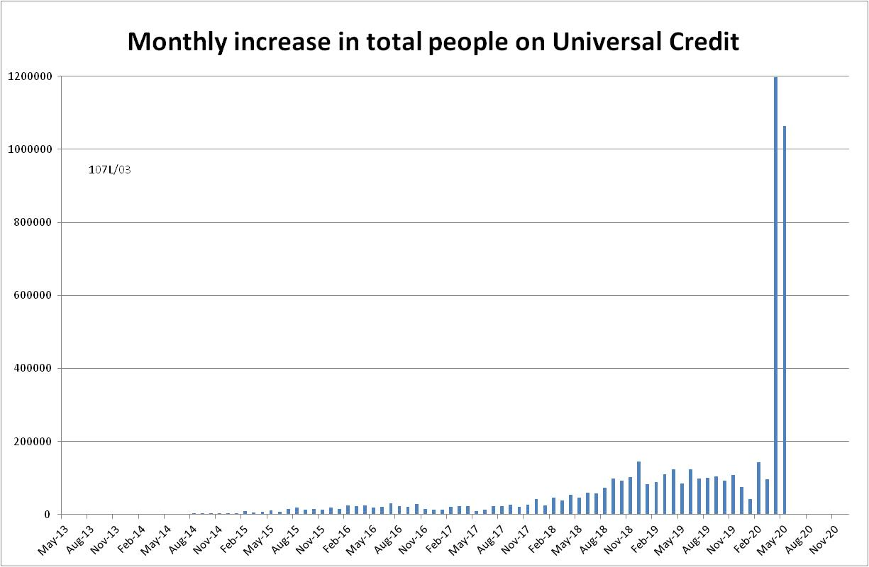

Figure 2
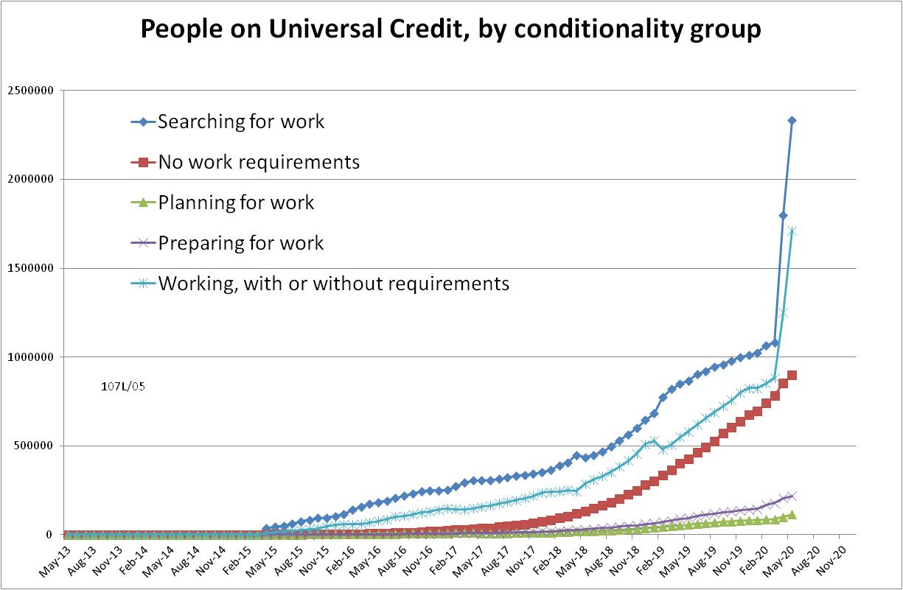

Figure 3
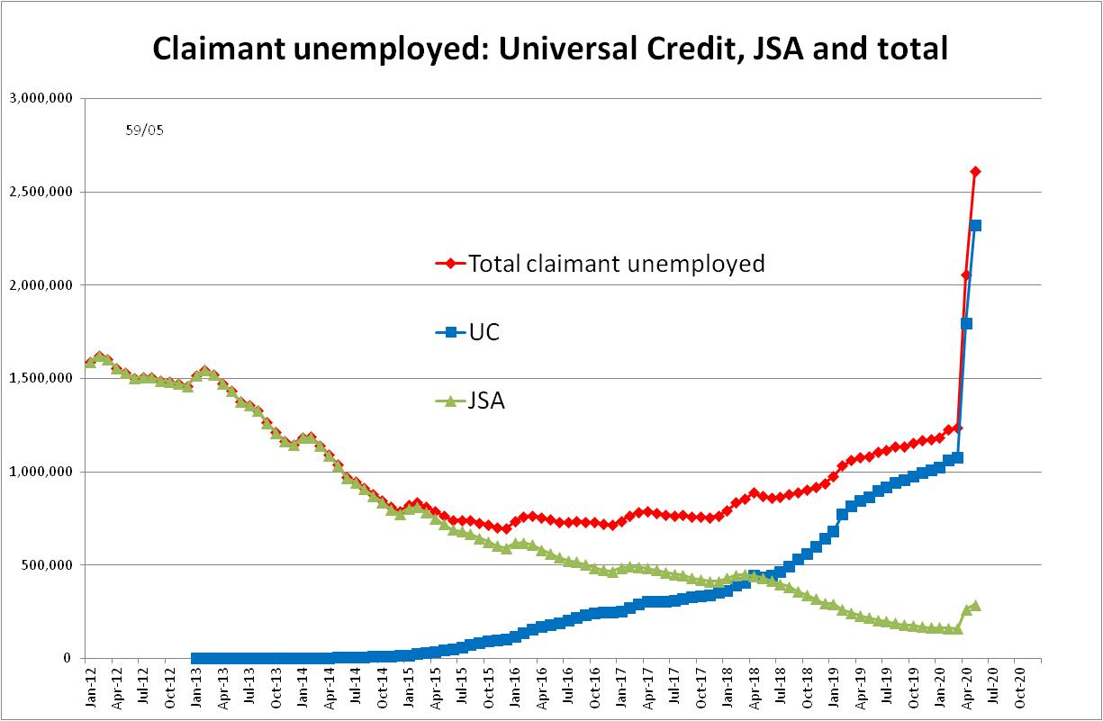

Figure 4
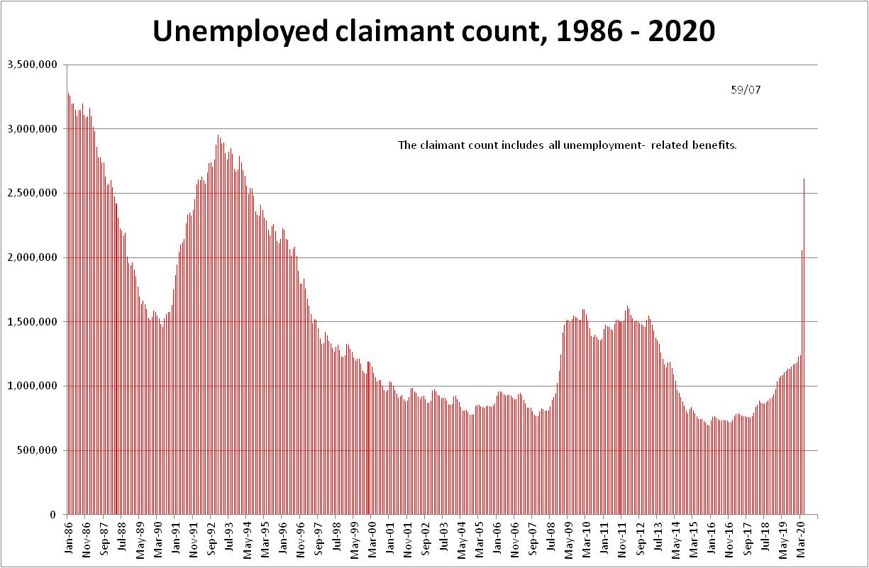

Figure 5
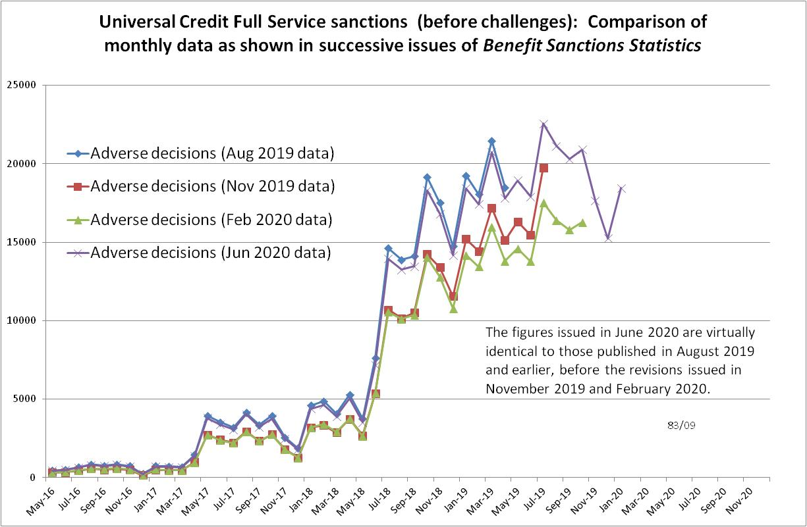

Figure 6
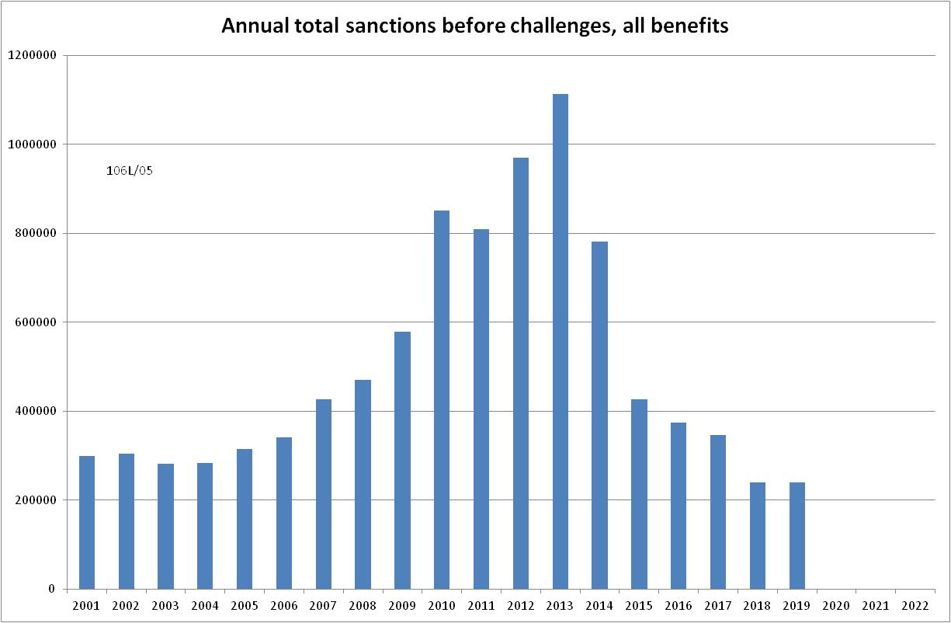

Figure 7
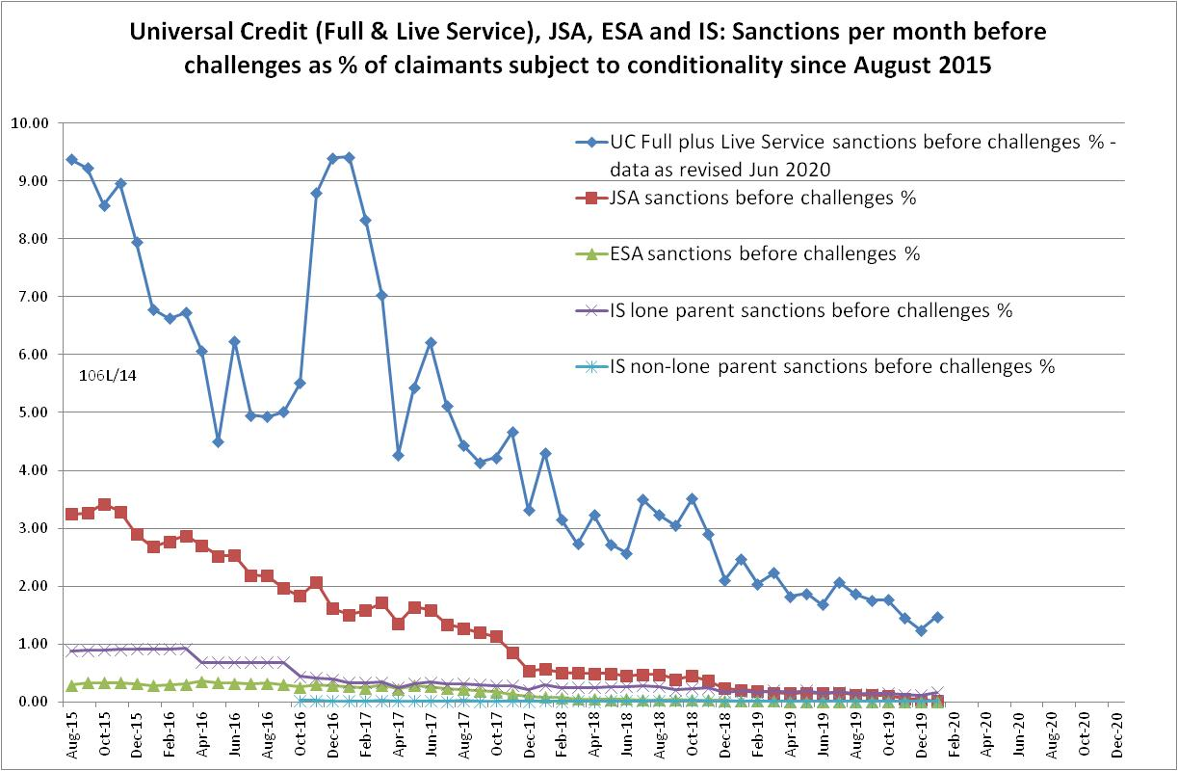
Figure 8
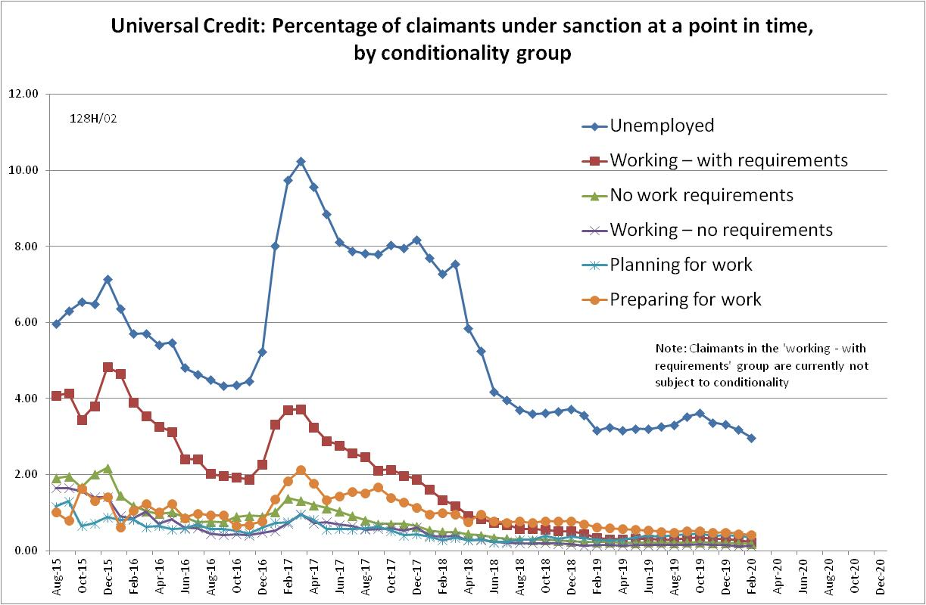

Figure 9
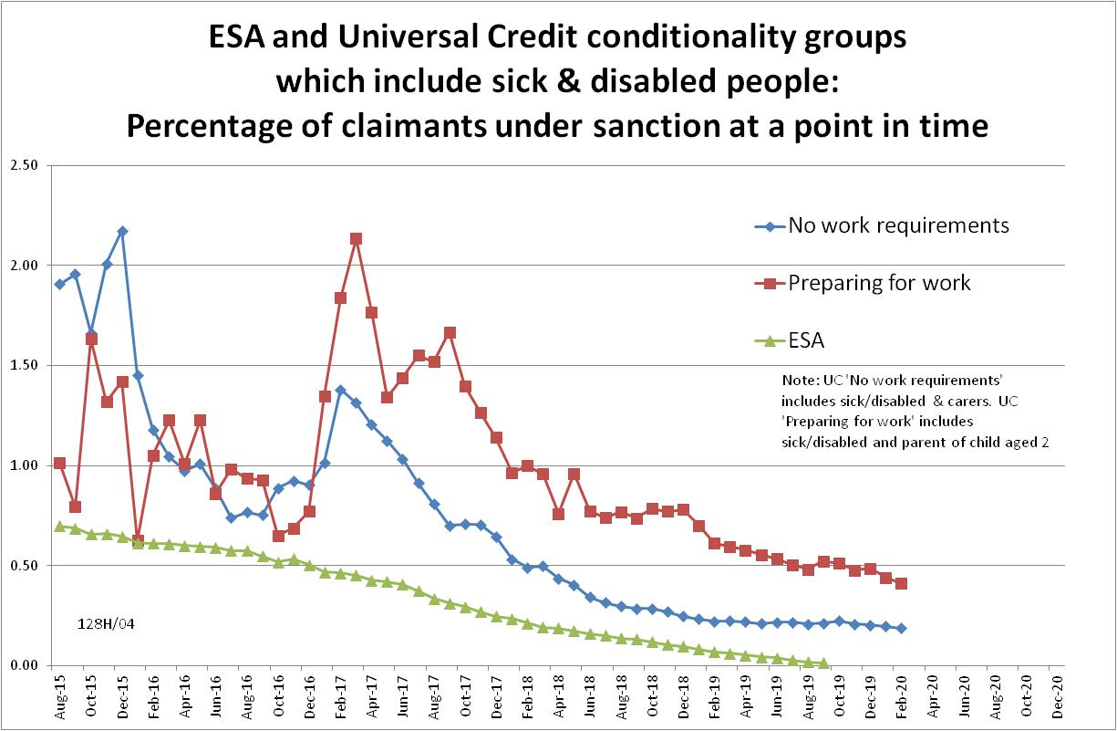

Figure 10
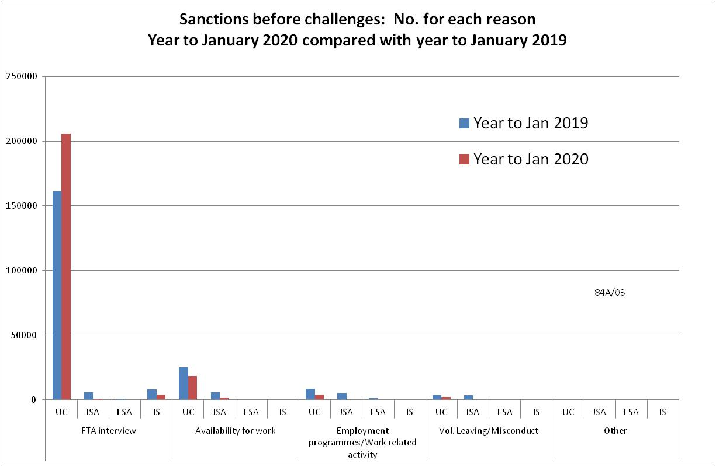

Figure 11
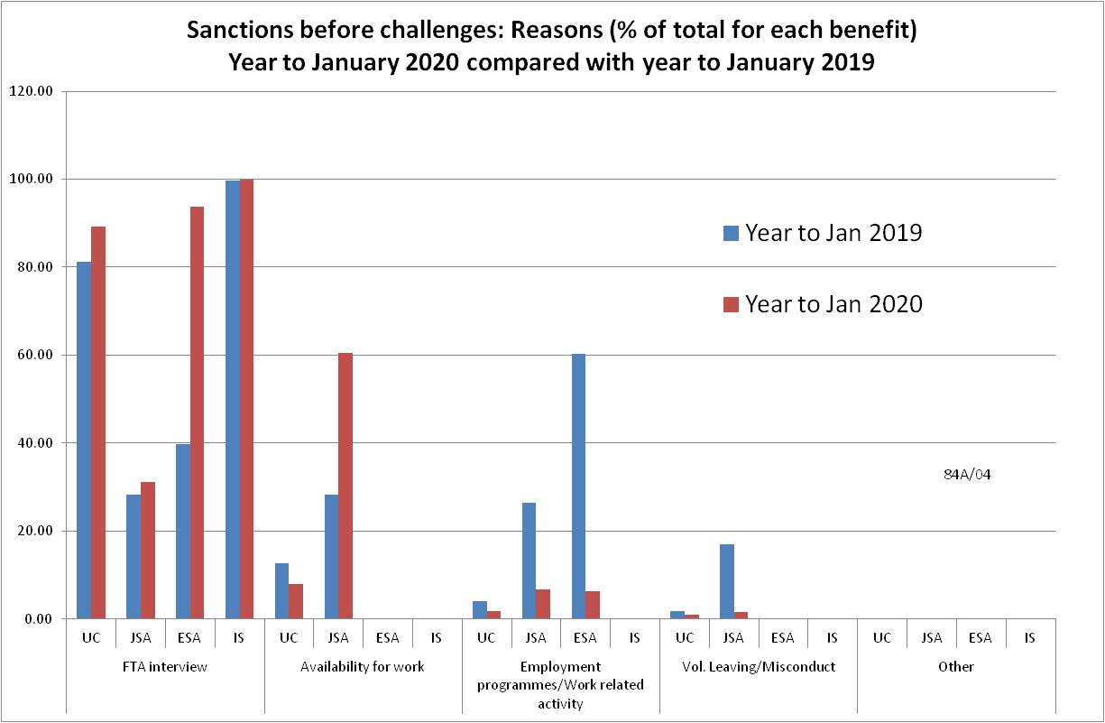

NOTES

Previous briefings are available at http://www.cpag.org.uk/david-webster. They include many analyses that are not repeated here but remain valid. However it should be remembered that the DWP may have made subsequent revisions to the data reported in earlier briefings. These revisions will generally not be major although there are exceptions and there may often be substantial changes in some figures for the most recent few months.
The total number of people subject to sanctions cannot be stated exactly, because there are some categories of Income Support claimants other than lone parents with a child under one who are not subject to sanctions, and there are no data on their numbers. However, they are likely to number in the low tens of thousands.
The UC claimants in the ‘working – with requirements’ group are low paid or part-time workers. Those ‘planning for work’ are mainly lone parents with a child aged 1, while those ‘preparing for work’ are people who would have been in the ESA Work Related Activity Group, and lone parents with a child aged 2 but under 5. The statistical categories for conditionality regime used in Stat-Xplore are explained in the ‘i’ feature next to the variable name in Stat-Xplore and also in the Universal Credit Statistics methodology document at https://www.gov.uk/government/publications/universal-credit-statistics-background-information-and-methodology
Lone parents with youngest child aged one to five have been estimated simply as four fifths of the total with youngest child aged 0 to five.
The basic concept of the DWP’s sanctions database (except for the new Full Service data) is that each sanction case appears only once, and is given its latest status and attributed to the month of the latest decision on the case. So, for instance, if a decision is made in January 2014 to sanction someone, this decision is reviewed in March 2014 with an outcome unfavourable to the claimant, reconsidered in a ‘mandatory reconsideration’ in May 2014 again with an unfavourable outcome, and is heard on appeal by a Tribunal in October 2014 with a decision favourable to the claimant, - it appears in the statistics for the first time in January 2014 as an adverse ‘original’ decision - in March 2014 it changes its status to a ‘reviewed’ adverse decision and moves month to be with all the other cases where the latest decision has been made in March 2014 - in May 2014 it changes its status to a ‘reconsidered’ adverse decision and moves month to be with all the other cases where the latest decision has been made in May 2014 - in October 2014 it changes its status again to an appealed non-adverse decision, and moves month again to be with all the other cases where the latest decision has been made in October 2014. DWP now says that it aims to change this system for Universal Credit sanctions at some point in the future in order to show all decisions at each stage.
The estimates of sanctions before challenges have been derived by adding the monthly total of ‘non-adverse’, ‘reserved’ and ‘cancelled’ decisions shown as being the result of reviews, mandatory reconsiderations and tribunal appeals, to the monthly total of adverse ‘original’ decisions. This produces only an approximate estimate for each individual month, since decisions altered following challenge are not attributed to the correct month. It will be particularly unreliable for months affected by a DWP catch-up of a backlog of decisions. But the estimates are reliable for longer periods.
JSA sanctions before challenges had fallen so much by December 2019 (65 cases) that the absence of a figure for January 2020 makes no difference to the reporting.
For UC, the exact number of claimants subject to conditionality is not available for the period April 2015 to March 2018, when a proportion of people in the ‘working – with requirements’ group were enrolled in the In-Work Progression conditionality trial. This started in 10 Jobcentres in April 2015 and began rollout across the whole country in December 2015, in both Full and Live Service. The trial finished on 31 March 2018. 30,709 claimants passed through the trial. About two-thirds ('frequent' & 'moderate' support) were in the trial for at least a year, the other one third for at least 2 months. The total number of people in the ‘working – with requirements’ group rose from 4,000 in April 2015 to 103,000 in March 2018. We therefore know that a substantial proportion of the group were in the trial at any one time, but we do not know how many. Here, it has been assumed that everyone in this group was subject to conditionality for the whole period up to March 2018, but no one since then. This will produce an overestimate of the total number of UC claimants subject to conditionality for the period up to March 2018, which will slightly lower the resulting sanction rates for this period.
Pre-October 2016 data for lone parents on IS are not comparable with the current data.
The DWP’s method of estimating sanction durations is not able to identify reasons for sanctions and indeed, because UC sanctions are consecutive, what appears as a single sanction in the data might in fact be two or more sanctions imposed for different reasons. Nevertheless the statement in the text here is correct.

