BRIEFING

Benefit Sanctions Statistics

August 2020

27 August 2020

Dr David Webster
Honorary Senior Research Fellow
Urban Studies
University of Glasgow

Email david.webster@glasgow.ac.uk

Webpages: http://www.gla.ac.uk/schools/socialpolitical/staff/davidwebster/
http://www.cpag.org.uk/david-webster
SUMMARY
This Briefing covers the statistics released by DWP on 11 August, giving sanction decisions up to the end of April 2020, with other data for various dates.
The newly published figures show, as expected, that sanction decisions fell almost to nil in April, when the suspension of new sanctions due to the coronavirus was in force throughout the month. The suspension took effect on two different dates in March, with interviews suspended on 19th and work search and availability requirements on 30th. Reflecting this, the figures for March are intermediate between those for February and April. Prior to the coronavirus suspension, the overall picture was of a lengthy decline in sanctions for all the benefits.
However, despite the coronavirus suspension of new sanctions, DWP estimates that there were 36,277 Universal Credit (UC) claimants still under sanction at 9 April, and 25,460 at 14 May. These numbers are not far below the peak for this figure which was 39,715 at October 2019. The reasons why the UC numbers under sanction have remained high during the coronavirus suspension are that many sanctions are very lengthy; UC sanctions are now served consecutively rather than concurrently as was the case with ‘legacy’ benefits; and sanctions continue even if the claimant moves into another UC regime where they are not liable to any new sanction.

The figures for repeat sanctions which were reported in the February 2020 Briefing were affected by an undercount of UC Full Service sanctions and have been withdrawn by DWP. However we do now have corrected figures for UC repeat sanctions for the two 12-month periods ending 31 January and 31 April 2020. For the twelve months ending 31 April 2020, out of 202,473 UC sanctions, approximately 142,000 (69.9%) were second or subsequent sanctions imposed on the same individuals, and between a quarter and one third (28.9%) were repeat sanctions imposed on individuals who incurred four or more sanctions during the year. Almost 50,000 UC claimants received two sanctions, 16,827 received three sanctions, 6,926 received four sanctions, and 7,083 received five or more sanctions. Since UC sanctions are served consecutively, and repeat sanctions are generally much longer than first sanctions, this means that substantial numbers of people are going without benefits for very long periods. Amber Rudd’s well-publicised abolition of sanctions longer than 6 months from 28 November 2019 does not mean that no one now spends longer than six months under sanction. On the DWP’s estimates, in the months running up to the coronavirus suspension, typically more than 40% of the periods spent under UC sanction were longer than 4 weeks, and some 15% were longer than 3 months. In the six months since the abolition of sanctions longer than 6 months, an average of 1,284 UC claimants per month have been ending sanction periods lasting longer than 6 months. This figure rose to 1,705 in May.

As a result of the recession caused by the coronavirus emergency there has been a large increase in the number of claimants normally subject to conditionality, from approximately 2.0m in March to approximately 2.87m in April. Sanctions will have restarted from 1 July, by which time the number of claimants subject to conditionality will have increased to over 3m. Total UC claimants reached five and a half million (5.55m) by mid-July.

The news section at the end of the Briefing reports on sanctions developments including the very critical report on UC by the House of Lords Economic Affairs Committee.
BRIEFING: Benefit Sanctions Statistics
August 2020

INTRODUCTION

This Briefing discusses the latest quarterly DWP benefit sanctions statistics which were released on 11 August. The new data are summarised by DWP in the publication Benefit Sanctions Statistics, available along with methodological notes at https://www.gov.uk/government/collections/jobseekers-allowance-sanctions together with a spreadsheet with summary tables. The full figures for most aspects of the data are on the DWP’s Stat-Xplore database at https://stat-xplore.dwp.gov.uk/webapi/jsf/login.xhtml

The new release shows what happened to sanction decisions up to and including April, which was the first full month of the almost complete coronavirus sanctions suspension which began in late March and ended on 1 July. Some other figures are more up-to-date, and others less. Full details of the sanctions suspension, including exact dates, legal basis etc. were given in the June Briefing, pp.7-8. All previous Briefings are available at http://www.cpag.org.uk/david-webster . All statistics presented here relate to Great Britain.

Groups of claimants exposed to sanctions:
Universal Credit, JSA, ESA and Income Support

As a result of the recession caused by the coronavirus emergency there has been a large increase in the number of claimants normally subject to conditionality, from approximately 2.0m in March to approximately 2.87m in April and even more since then. This is almost entirely due to the increase of 818,715 in the number of unemployed claimants of UC or JSA between March and April. Very few of them will have been exposed to the risk of sanctions during the suspension from late March until the end of June. But sanctions will have restarted from 1 July, by which time the number of claimants subject to conditionality will have increased to over 3m. Claimants subject to sanctions are split between Universal Credit (UC), Jobseekers Allowance (JSA), Employment and Support Allowance (ESA) and Income Support (IS).

Numbers of claimants of the four benefits

There were huge increases in the number of claimants of Universal Credit (UC) in April and May, but the increases in June and July have been at a more normal level (Figure 1), although still above recent trends. The UC caseload increased by 171,008 in June and 120,614 in July, compared to an average of 101,000 per month in the year to February 2020. Total UC claimants reached five and a half million (5.55m) by mid-July.

An analysis by the BBC at https://www.bbc.co.uk/news/uk-53697256 has shown that the largest percentage increases in UC claims between March and June have been in mainly prosperous commuter towns around London: Guildford (148%), Harrow (142%), Kingston-upon-Thames (138%), Hemel Hempstead (129%), Redhill (128%), Stevenage (127%), Luton (126%), Bromley (124%) and Ilford (120%). In this respect the current recession is somewhat like that of 1990, which started in the south (Green et al. 1994).

Figure 2 shows that there was no further material increase in unemployed UC claimants between May and July, while the increases in non-working UC claimants were more or less in line with established trends. But there was a substantial increase of 250,813 in working UC claimants, most (174,798) of whom were ‘working – no requirements’, i.e. earning above the equivalent of the national minimum wage for a full week, and therefore would not be subject to conditionality. A possible explanation for the timing of this increase in working UC claimants is that after lockdown, some potential claimants of what used to be Working Tax Credits may have taken some time to become aware that they were eligible.

Unemployed claimants

The UC count of those ‘searching for work’ does not contain everyone claiming benefits as a result of unemployment, because there are also people claiming ‘legacy’ Jobseeker’s Allowance (JSA) (i.e. unemployed claimants who have not had a change of circumstances which would have made them transfer to UC), and people who are claiming ‘New Style JSA’, i.e. the non-means tested benefit available for 6 months to newly unemployed people with a qualifying National Insurance contribution record.

Between March and May the total unemployed claimant count more than doubled, increasing by 1.373m to reach 2.611m (Figure 3), far surpassing the peak of the 2008 recession. But the further increase in the two months to July was under 20,000 (19,565). Slightly more than all of this increase (20,918) was due to claims for JSA. As explained in the June Briefing (p.4), because claims for legacy JSA have been declining, this means that there are now more than 21,000 additional claimants of New Style JSA, on top of the almost 130,000 increase in New Style JSA claimants between March and May. Overall, in spite of the increase in JSA claimants, by mid-July UC accounted for 88.2% of all unemployed claimants.

Further analysis of the labour market under coronavirus is published by the Learning and Work Institute at https://learningandwork.org.uk/what-we-do/employment-and-social-security/labour-market-analysis/ and by the Institute for Employment Studies at https://www.employment-studies.co.uk/resource/labour-market-statistics-august-2020

Sickness and disability

The number of people claiming UC on grounds of sickness or disability and in normal times subject to conditionality is not published by DWP. UC claimants ‘preparing for work’ (221,920 at July 2020) include these people but they also include some people who are not sick or disabled and would previously have claimed IS. The number of ESA claimants subject to conditionality, i.e. those in the Work Related Activity Group (WRAG) however is known. They are all subject to conditionality. Their number peaked at 562,620 in August 2013 but had declined to an estimated 235,000 in April 2020.

As well as ‘legacy’ ESA, there is a ‘New Style’ ESA, which like ‘New Style’ JSA is a non-means tested, time limited benefit available to people with qualifying National Insurance contributions. As for JSA, there are also people who do not qualify for ESA on either income or contribution grounds but claim only to obtain National Insurance credits. At February 2020, of the total in the WRAG, 3.6% were receiving contribution-based ESA and 14.9% were claiming ‘credits only’, the remainder being on income-based ESA alone. During the coronavirus emergency, New Style ESA is available to additional groups such as people who are self-isolating due to vulnerability or are in quarantine. This will lead to a slowing or reversal of the declining trend in ESA WRAG claims. However, data reflecting this will not be published until November 2020.

Income Support

The number of IS claimants is falling quite fast due to movement of new claimants on to UC. There were an estimated 268,000 claimants on IS who would have been subject to sanctions at April 2020 but for the suspension. The largest group among these was an estimated 142,000 lone parents with a youngest child aged between one and five. There were also an estimated 123,000 carers and 4,000 other IS claimants.

The Universal Credit sanctions regime

A full description of the UC sanctions regime was given in the February 2019 issue of the Briefing, pp.5-6.

Universal Credit ‘Full Service’ and ‘Live Service’

On its introduction, Universal Credit was delivered via ‘Live Service’. A programme to transfer Jobcentres to the more sophisticated ‘Full Service’ was started in May 2016 and completed in December 2018. For many months therefore, Live Service and Full Service were operating in parallel. However, all Live Service claimants had transferred to Full Service by April 2019, and the systems used to administer Live Service were shut down at the end of March 2019. DWP is still not publishing comprehensive sanctions data on Full Service. Most data on Stat-Xplore still relate only to Live Service. Within Stat-Xplore, the only topic covered for Full Service sanctions is the number and proportion of claimants under sanction at a point in time. Benefit Sanctions Statistics and the accompanying spreadsheet add the number of adverse sanction decisions, duration of completed sanctions, repeat adverse sanction decisions in the past year, reasons for sanctions, and demographics, though not necessarily all of them in every release.

Sanctions before and after reviews, reconsiderations and appeals

Except for the new UC Full Service data first published in May 2019, the DWP’s Benefit Sanctions Statistics publication and Stat-Xplore database only show sanctions after any reviews, reconsiderations and appeals that have taken place by the time the data are published. But numbers of sanctions before the results of these challenges are important since they show all the cases in which claimants have had their money stopped. Although a successful challenge should result in a refund, this is only paid after weeks or months by which time serious damage is often done. Estimates of sanctions before challenges are therefore given here but although reliable for longer time periods, they are not fully accurate for individual months. For JSA and ESA, figures for sanctions before challenges have typically been higher than the ‘after challenge’ figures by very large amounts, namely about 20%. and 40% respectively. For UC Live Service (the only figures currently available for the UC appeal process) and for IS, the proportion of sanctions overturned has been much smaller at around 5% and 1% respectively. So for these types of sanction there is much less difference between the pre-and post-challenge figures. Wherever possible, this Briefing shows estimated pre-challenge sanctions figures. DWP now says that it aims to change this system for Universal Credit sanctions at some point in the future in order to show all decisions at each stage.
MONTHLY NUMBERS AND RATES OF SANCTIONS BEFORE CHALLENGES FOR THE FOUR BENEFITS

Monthly rates of sanctions

Figure 4 shows estimated monthly sanctions before challenges as a percentage of claimants subject to conditionality, for each benefit since August 2015 when UC sanction figures begin.
The newly published figures show, as expected, that sanction decisions fell almost to nil in April, when the coronavirus suspension was in force throughout the month (Figure 4). The suspension came into force on two different dates in March, with interviews (now the main source of sanctions) suspended on 19th and work search and availability requirements on 30th. Reflecting this, the figures for March are intermediate between those for February and April. Prior to the coronavirus suspension, the overall picture was of a lengthy decline in sanctions for all the benefits.
Benefit Sanctions Statistics states that there were in fact 20 UC sanctions in April. It says that these ‘were due to failures to attend work-focused interviews that occurred prior to the decision to suspend the requirement to attend face-to-face appointments’. No JSA, ESA or IS sanctions were imposed in April.
In the previous release, DWP withheld figures for JSA sanctions in January because of an unexplained change of trend. These figures have now been published, together with the later figures up to April. There was in fact a slight uptick in JSA sanctions in January and February, which took sanctions as a percentage of claimants to 0.12% and 0.10% respectively compared to 0.04% in both December 2019 and February 2020. This increase took the rate only back to the level of August 2019, and involved less than 250 claimants. Benefit Sanctions Statistics explains the uptick as follows: ‘Over the course of 2019, some decisions were put on hold for (JSA) sanction referrals made under the reason of “failure to attend a place on a training scheme or employment programme without good reason”. This was to allow for changes to handling procedures to be developed. After developments had been implemented, these outstanding JSA sanction referrals were processed. This resulted in a temporary increase in JSA sanction decisions in the early months of 2020.’ This begs the question whether there can be any point at all in imposing penalties many months after the alleged ‘failure’, when the claimed object of sanctions is to influence behaviour. This is to deploy an inappropriate penal system model. DWP followed this model in the winter of 2016/17, as can be seen in Figure 4, which shows a huge surge of ‘catch-up’ sanctions in the winter of 2016-17 after a backlog of decisions had built up. It appeared that they had thought better of it when they waived a similar backlog of UC sanctions in the second half of 2017 (see Briefing, July 2018 p.7). It is disappointing to see this reversion to the penal model.
Total numbers of sanctions

The previous Briefing noted that the total of sanctions on all benefits before challenges in 2018 and 2019 was 239,000 in both years, which was the lowest since the present recording system began.There will be little point in updating these figures on the total numbers of sanctions until we have a full quarter’s figures following the end of the coronavirus suspension. These figures will not be available until February 2021.
UNIVERSAL CREDIT: PROPORTION OF CLAIMANTS UNDER SANCTION AT A POINT IN TIME

The DWP’s preferred measure of sanctions ‘rate’ is the proportion of claimants who are serving a sanction at a point in time. There are various methodological problems with this measure, which were discussed in the November 2017 Briefing (pp.6-10). A further issue was discussed in the February 2020 Briefing, p.7. This measure also understates the impact of sanctions, since the number of people experiencing a sanction over a period such as a year is much greater than the number actually serving one at a point in time, and the effects of a sanction often last a long time. This is evidently why DWP likes this measure, and prioritised its development; it is constantly used to understate the impact of sanctions, as it was recently for instance in the House of Lords oral evidence session on 2 June (Q.136), at https://committees.parliament.uk/work/31/the-economics-of-universal-credit/publications/
But in spite of the limitations the figures can be of some value.

The figures for JSA and ESA published in the Benefit Sanctions Statistics spreadsheet run only to December 2019. But for UC we have data up to May 2020. The huge increase in the number of UC claimants in April and May obviously means that the proportion of claimants under sanction would have fallen precipitately even without any change in the number under sanction. Therefore there is no point in showing proportions. Figures 5 and 6 show the absolute number of UC claimants under sanction, separately for the unemployed (Figure 5) and the other conditionality regimes (Figure 6). They show the position on the second Thursday of the month, which for April and May was 9th and 14th respectively.

The numbers are vastly higher for the unemployed than for the other groups – reaching a peak of 35,405 in October 2019 compared to a peak for all other groups combined of 4,376 in April 2020. But the most striking feature of the charts is how limited have been the falls during the coronavirus suspension, given that there have been virtually no new sanctions since it started. The unemployed actually had the biggest fall, from around 33,000 to under 22,000. But the falls for the other groups have been trivial, and the number in the ‘working with requirements’ group has risen slightly. Altogether there were 36,277 UC claimants still under sanction at 9 April, and 25,460 at 14 May. These numbers are not far below the peak for this figure which was 39,715 at October 2019.

The reasons why the UC numbers under sanction have remained high during the coronavirus suspension are that many sanctions are very lengthy; repeat UC sanctions are now served consecutively rather than concurrently as was the case with ‘legacy’ benefits; and they continue even if the claimant moves into another UC regime where they are not liable to any new sanction. UC repeat sanctions and sanction lengths are considered next.

UNIVERSAL CREDIT: REPEAT SANCTIONS

Figures for the number of UC sanctions which were repeat sanctions imposed on the same individuals were first published by DWP in February 2020, relating to the twelve months ending 31 October 2019. They were discussed in the February 2019 Briefing. It now transpires that these figures were incorrect and DWP has withdrawn them. DWP is unable to replace them with corrected figures. The reason why the figures were incorrect is because they were affected by the undercount of UC Full Service sanctions which was reported in the June 2020 Briefing.

However we do now have corrected figures for UC repeat sanctions for the two 12 month periods ending 31 January and 31 April 2020. Figure 7 shows these figures. The numbers are very large. For the twelve months ending 31 April 2020, out of 202,473 UC sanctions, approximately 142,000 (69.9%) were second or subsequent sanctions imposed on the same individuals, and between a quarter and one third (28.9%) were repeat sanctions imposed on individuals who incurred four or more sanctions during the year. DWP does not publish the number of individuals who received just one UC sanction during the twelve months. But 49,420 UC claimants received two sanctions, 16,827 received three sanctions, 6,926 received four sanctions, and 7,083 received five or more sanctions. Since UC sanctions are served consecutively, and repeat sanctions are generally much longer than first sanctions, this means that substantial numbers of people are going without benefits for very long periods. As discussed in the November 2019 Briefing, p.7, Amber Rudd’s abolition of sanctions longer than 6 months does not mean that no one now spends longer than six months under sanction.

Comparing the figures for May 2019 to April 2020 with those for February 2019 to January 2020 shows that the concentration of more sanctions on fewer individuals was increasing.

DURATION OF SANCTIONS

The DWP’s figures on actually served durations of sanctions are derived indirectly from payment records. They show not the length of individual sanctions but the length of periods served under sanction, which will often be comprised of two or more sanctions served consecutively. Making sanctions consecutive rather than, as previously, concurrent, has been one of the harshest of the changes under UC.

Figure 8 shows the number of UC sanction periods ending in each month, by length of period, and Figure 9 shows the equivalent percentages. The sharp declines in the percentage of short periods, and rises in the percentage of long periods, in April and May are due to the coronavirus suspension of new sanctions. This is because a majority of UC sanction lengths are normally ‘short’, i.e. up to 4 weeks, so that if all new sanctions are stopped, those still terminating must be long. Otherwise the most conspicuous feature of Figure 9 is the surge in long sanction periods, and corresponding fall in shorter periods, from Spring 2017. This was a consequence of the catch-up in sanction decisions following the build-up of a backlog.
The other striking feature of the data is the high proportion of sanction periods which are very long. In the months running up to the coronavirus suspension, typically more than 40% of UC sanction periods were longer than 4 weeks, and some 15% were longer than 3 months. In spite of Amber Rudd’s abolition of sanctions longer than 6 months, effective from 28 November 2019, an average of 1,284 UC claimants per month since then have been ending sanction periods lasting longer than 6 months. This figure rose to 1,705 in May, the second full month of the sanctions suspension. This is due to sanctions being made consecutive under UC.

REASONS FOR SANCTIONS – slight correction

The June Briefing (pp. 11-12) noted that sanctions for failure to attend an interview accounted for 88.7% of all sanctions in the 12 months to January 2020. There is no point at present in updating these figures beyond January. However, Benefit Sanctions Statistics (Figure 3, Note 4) carries a correction. It states that ‘A small proportion of (UC Full Service) sanctions (around 2%) have previously been categorised under the “Availability for Work’ reason group, where they should have been attributed to the “Work Focused Interviews” reason group’. Since there are now very few sanctions other than within UC Full Service, this means that the percentage of all sanctions due to missed interviews is actually about 91%, rather than 88.7%.

ANALYSES NOT INCLUDED IN THIS ISSUE

The coronavirus suspension and the paucity of data available for UC Full Service sanctions make it not worthwhile to update many of the analyses at present. Readers are referred to earlier numbers of the Briefing for analyses of matters not discussed in the present issue. Reasons for sanctions were discussed in June 2020; demographics in February 2020; claimants with earnings following a sanction were covered in November 2018; ethnicity and gender in July 2018; benefit destinations in February 2018; challenges to sanctions in February 2018 and May 2017; JSA benefit suspensions not followed by sanction, and ESA sanctions by medical condition in August 2017; and hardship payments for UC in August 2019 and for JSA and ESA in February 2019 and November 2015. Longer period analyses were included in the author’s written evidence to the Work and Pensions Committee (Webster 2018a) and in a presentation to the Welfare Conditionality conference at York in June 2018 (Webster 2018b). These analyses will be updated in future issues.
SANCTIONS - OTHER DEVELOPMENTS

The DWP’s study on the efficacy of sanctions: ‘coming as soon as we can’

The DWP study on the effectiveness of sanctions, first announced to the House of Commons Work and Pensions Committee in February 2019 with a proposed publication date of Spring 2019, has still not been published at the time of writing. The following exchange took place at the House of Lords Economic Affairs Committee on 2 June:

Neil Couling (DWP Change Director General and Senior Responsible Owner for Universal Credit): ‘......We are a bit late on our promise to the Work and Pensions Committee, which we have every intention of fulfilling. I was talking to the Secretary of State about this in one of our briefing sessions before the hearing, and we hope to bring that forward soon. One or two events since we made that promise have got in the way of some of that, but we are keen to get that evidence out there, and I will send you a copy.
The Chair (Lord Forsyth): How soon is soon? It would be quite useful to us, because we are about to start reaching our conclusions.
Neil Couling: ‘.....I doubt that I can get the evaluation to you by the end of this week, but it will be coming as soon as we can.’

The study had not appeared by the time the Committee published its report on 31 July. In the meantime, in written evidence to the Committee dated 5 June Neil Couling submitted five pieces of evidence which he said were relevant to conditionality and sanctions. In fact three of them (DWP 2018a and similar earlier studies) have nothing to say about sanctions. The fourth simply has the often-quoted fact that claimants think sanctions will make them do more work search, not that they actually get people into work, while the fifth is the important Arni et al. study (2012) which is one of the important pieces of evidence against the sanctions regime.

House of Lords Economic Affairs Committee report on Universal Credit

The House of Lords Economic Affairs Committee’s report Universal Credit isn’t working: proposals for reform (House of Lords 2020) is a remarkable document which has surely become one of the best guides to its failings and a key reference in the sanctions debate. The written and oral evidence submitted to the inquiry is also an important resource. The report and evidence are available at https://committees.parliament.uk/work/31/the-economics-of-universal-credit/publications/ .

On conditionality and sanctions, the report’s Summary states:

‘The conditionality requirements on claimants who can look for, or prepare for work should be rebalanced. The extent of conditionality has been increased significantly over recent years and too often to the detriment of claimants. Less emphasis should be placed on obligations and sanctions. Instead, there should be more support to help coach and train claimants to find jobs or to progress in their current roles. We believe that a more balanced combination of responsibilities and entitlements would better reflect the relationship between employer and employee that the DWP wishes to emulate. In addition, conditionality should be adapted so that it is able to accommodate dynamically changing labour market conditions, including at the local level, particularly in the light of the economic impact of the COVID-19 pandemic.

‘The UK has some of the most punitive sanctions in the world, but there is limited evidence that they have a positive effect. Removing people’s main source of support for extended periods risks pushing them into extreme poverty, indebtedness and reliance on foodbanks. Furthermore, there is a great deal of evidence that sanctions, and the threat of sanctions, are harmful to claimants’ mental health. We recommend that the Government publish an evaluation of the impact of conditionality and sanctions on mental health and wellbeing.
Furthermore, we recommend that the DWP evaluate how the current length and level of sanctions facilitate positive behaviour change and how they lead to sustainable work outcomes. The DWP should also expedite its work on introducing a written warning system before the application of a sanction. Sanctions must be a last resort.

‘We note that conditionality and sanctions were suspended briefly in response to the COVID-19 pandemic. We regret that the suspension was lifted so soon. Threatening claimants with long and severe sanctions at this stage, so far from a labour market recovery, is unfair and counterproductive.’

During an oral evidence session on 2 June, at Q.132, Neil Couling made two statements which are not true. He said ‘The amount sanctioned is only the personal allowance; it
is never more than that. The housing and children elements, childcare and so on, are not subject to a sanction.’ This is contradicted by the Work and Pensions Committee report of 2018 (House of Commons 2018), para.83-85. He also said ‘most people who are
sanctioned go for a hardship payment’. This is contradicted by the analysis in the Briefing, August 2019, which showed that by August 2018 only about 17% of sanctioned UC claimants were getting a hardship payment, far below the proportion for JSA of around 45%.

Neil Couling also stated (Q.133) ‘I think the Secretary of State has just launched a
commission to advise on in-work conditionality’. This appears to be an important development, but other information about it does not seem to be available.

DWP Weekly Work Search Review Trial

This report (DWP 2018a) was published in July 2018 but does not appear to have been widely noticed at the time. It presents the results of a Randomised Control Trial investigating the impact of making JSA claimants attend for weekly, rather than the present fortnightly, Work Search Reviews. The conclusion was that those on the weekly regime spent on average (6.4 ± 2.6) days fewer on benefit and (7.3 ± 2.7) days more in employment over the year following claim. Identifying groups more influenced by weekly reviews and confining the increased frequency to them did not improve this by a statistically significant amount in spite of the large sample. The report does not attempt a cost benefit analysis but given the staff and overhead costs of doubling the number of interviews, not to mention the extra costs for claimants, it seems very unlikely that fortnightly reviews could justify their expense.

IPPR: The Great Risk Shift: How did we get here, and where do we go next?

On 29 July the IPPR think tank ran a webinar on the issue of the huge redistribution of economic risk which has taken place from the state and employers to individuals and their families, and what to do about it. The webinar is described at https://www.ippr.org/event/webinar-the-disruption-decades-what-future-for-the-welfare-state and at the time of writing is still available to view at
https://en-gb.facebook.com/ipprUK/videos/310516703639512/

Responding on the idea of universal basic income, Danny Kruger, Conservative MP for Devizes, made the following interesting comment at 1h05m: ‘I’m not opposed, as many of my colleagues are, to just the very principle of paying people unconditionally....... Anything’s better than the terribly bureaucratic, coercive, prescriptive, disempowering, distrusting, system that we’ve got, and I echo all the calls for change on that’. Another speaker, Johnna Montgomerie of King’s College London, made the point that the function of safety net which used to be performed by the social security system has now been taken over by debt. Driving people into debt is of course a fundamental feature of the sanctions regime. A list of Dr Montgomerie’s papers on this topic is at https://www.kcl.ac.uk/people/dr-johnna-montgomerie

Joseph Rowntree Foundation reports on the experience of UC
in Glasgow and Northern Ireland

JRF in June published two reports on the experience of UC in Glasgow and Northern Ireland, drawing on the perspectives of claimants and staff through interviews, focus groups and workshops (Robertson et al. 2020; Patrick et al. 2020). Sanctioning rates are of course low in Northern Ireland. Jobcentre staff in the Glasgow study did not think that sanctions were effective in influencing claimants to move towards work.

Lawfulness of requirement to seek Mandatory Reconsideration before tribunal appeal – ESA

The High Court on 24 July at https://www.bailii.org/ew/cases/EWHC/Admin/2020/1999.html
has ruled that in the absence of payment equivalent to payment pending appeal, the requirement for ESA claimants to obtain a Mandatory Reconsideration decision before appealing to a Tribunal is unlawful because it is an unjustified impediment to the right of access to court guaranteed by the European Convention on Human Rights, Article 6. However this judgment does not seem to have any direct application to the treatment of sanctions.

Social Security Advisory Committee report:
Young People Living Independently – May 2018

Publication of this important report (SSAC 2018) and the government response to it (DWP 2018b) should have been noted in an earlier Briefing but it was overlooked. The report was critical of the impact of the sanctions regime on these vulnerable young people, and is a useful source of information on this group. It made several recommendations, which received a mixed response from the government in its reply.

National Audit Office on first payment of Universal Credit

On 10 July the NAO published its fourth major report on UC (NAO 2020). This one is focused on the 5-week wait for first payment. Among the key findings are: In the six months to February 2020, 57% of households making a new claim received a UC advance payment; one fifth of claimants (22%) did not claim as soon as they became eligible because, for example, they did not know what to do, thought they would get another job quickly, or were afraid to apply, having heard about bad experiences from friends, family or through the media; disabled claimants and people on low incomes are more likely to claim advances and have other debts to repay from their UC; 61% of claimants have a deduction applied to their first payment, rising to 70% by their fourth payment; DWP has improved the proportion of claims paid on time from 55% in January 2017 to 90% in February 2020, but despite this, the number of people paid late has increased, from 113,000 in 2017 to 226,000 in 2018 and 312,000 in 2019; claimants with claims due for payment in 2019, who were not paid on time faced average delays of three weeks in addition to the five-week wait, and some 6% of households (105,000 new claims) waited around 11 weeks or more; and DWP does not have all the information it needs to track vulnerable claimants and ensure its support is effective.

Welfare at a (Social) Distance research project

This is a major national research project investigating the benefits system during the Covid-19 pandemic, funded by the Economic and Social Research Council as part of UK Research and Innovation’s rapid response to Covid-19. It draws upon a new survey of 2,364 new Universal Credit (UC)/Jobseekers’ Allowance (JSA) claimants carried out between 25th May and 3rd June to look at how far benefit claimants are connected to the world of work.

The research challenges some of the prevailing assumptions surrounding conditionality. Despite the suspension of mandatory job-search requirements and an extraordinary drop in job vacancies, it found that the majority of new UC claimants (54%) and new JSA claimants (81%) who did not currently have a job were looking for work. This supports overwhelming evidence that, despite political rhetoric, benefit claimants do not lack the motivation to work.
For those not looking for work, there are clear obstacles that preclude them from fulfilling work-related requirements and job search. For many, these obstacles relate to the realities of social distancing and its impact on the wider economy. For others, there are longer-standing obstacles that will extend through and beyond this pandemic. But this is not to say that claimants do not want support. The survey identified a number of areas where benefit claimants would like additional assistance to help them engage with the labour market. This flags up the importance of genuinely personalised support for benefit claimants that accounts for personal circumstances and fluctuating labour market conditions. The researchers suggest that the Covid-19 crisis could be a watershed in how we think about conditionality. There is an opportunity to reconceive the social security system in a way that responds dynamically to the needs of those already looking for work, and accounts for the short-term obstacles and longer-standing challenges for those unable to do so.

Details of the findings are available at
https://blogs.lse.ac.uk/politicsandpolicy/conditionality-covid19/
and
http://hub.salford.ac.uk/welfare-at-a-social-distance/claiming-but-connected-to-work/
and there is a printed report (Geiger et al. 2020).

Spatial ‘creaming’ and ‘parking’ in employment programmes

British employment programmes have persistently been based on the assumption that there are no relevant differences in employment opportunities between different parts of the country. A new paper (Whitworth 2020), using the example of the Work Programme launched in 2011, demonstrates systematic spatial inequality in outcomes and financial resource that are at the expense of already more deprived areas. In other words there is in effect spatial as well as social ‘creaming’ (i.e. deliberate prioritisation) and ‘parking’ (i.e. deliberate neglect) by providers of differently placed service users within employment programmes.

Ellen Clifford: The War on Disabled People

A new book (Clifford 2020) published on 18 June mounts a radical attack on British policy towards disabled people, focusing on the period since 2010. It takes a historical materialist approach.

Channel 4 TV series The Yorkshire Jobcentre

Channel 4 has made a series of six programmes giving an intimate view of claimants and work coaches at the Southern House Jobcentre in Leeds, which are showing on Mondays and Tuesdays starting on 10 August, and available to view at https://www.channel4.com/programmes/the-yorkshire-jobcentre Filming took place between September 2019 and March 2020. Unlike the BBC2 series Universal Credit: Inside the Welfare State shown in February (Briefing February 2020 p.11), this series has not been sponsored by DWP and in fact the makers say that they spent five years convincing DWP to let them make the series. Channel 4’s Commissioning Editor Rita Daniels says: ‘Lots of series have been made about benefits, mostly focusing on the extreme end of the spectrum and the long-term unemployed. This will be the first series placing equal emphasis on the human stories on both sides of the desk – challenging preconceptions about staff and claimants.......’ It aims to present a more positive picture of claimants than the Channel 4 series Benefits Street, and this aim was explained to the featured claimants to help persuade them to permit filming of what would normally be very private episodes.
The first programme included a revealing episode dating from some time in 2019 showing the impact of sanctions in promoting violence. Kenny, a single man of 32 living on his own, with a notably sunny personality, had been out of work for two years at the time of filming in late 2019. He finds computers difficult. He had had the traumatic experience on 6 February 2019, with an 11-year-old nephew, of searching for his missing sister and finding her taking her own life by hanging. He had attempted unsuccessfully to resuscitate her. His father had an accident and died in March 2019, a month after his sister. Another sister had died 10 years previously. Being a new claimant for UC, Kenny had applied for and received an advance of £914.09 on 23 January 2019 and was repaying it at the rate of £84 per month. At the time of filming, rent, arrears, repayment and other prior charges were leaving him with £50 per month to live on.
The exact date of the alleged incident was not given in the programme, but as it was still under investigation at the time of filming it seems that it must have been some time between March and September. Kenny had already been sanctioned and the trigger for the incident was his being told that he was being referred for a second sanction, which would presumably be for longer. He was alleged to have leapt up and banged his chair back, used some abusive language to the work coach, and threatened to rip the door off its hinges. As a result he had been allocated to a special interview area.
The programme presenter made no comment on the episode, but it seems obvious that it would be asking for trouble to threaten with destitution someone already under the degree of stress which was affecting Kenny.
In June 2016, Mhairi Black MP (Paisley & Renfrewshire S., SNP) introduced a Benefit Claimants Sanctions (Required Assessment) Bill which should have headed off this episode. It would have prevented a claimant from being sanctioned unless two requirements have been met. First, the claimantʹs circumstances have to be assessed. Second, a number of conditions have to be met. These focus on the claimant’s situation, in particular any caring responsibilities, mental and physical health and well‐being and housing position and whether, in the light of the circumstances, the imposition of the sanction is justified. Where, following the assessment, a claimant is sanctioned, they must be assessed for hardship payments. (see Briefing, February 2017, pp. 15-16; the Bill is still available at https://services.parliament.uk/bills/2016-17/benefitclaimantssanctionsrequiredassessment.html ) Unfortunately, like almost all the reforms to the sanctions system which have been proposed, this was not taken up by ministers.

REFERENCES

Arni, Patrick, Lalivea, Rafael and Van Ours, Jan (2012) ‘How effective are unemployment benefit sanctions? Looking Beyond Unemployment Exit’, Journal of Applied Econometrics,
doi: 10.1002/jae.2289

Clifford, Ellen (2020) The War on Disabled People: Capitalism, welfare and the making of a human catastrophe, London, Zed Books, details at
https://www.zedbooks.net/shop/book/the-war-on-disabled-people/

DWP (2018a) Weekly Work Search Review Trial, Ad hoc Research Report No.59, July, at
https://assets.publishing.service.gov.uk/government/uploads/system/uploads/attachment_data/file/721910/weekly-work-search-review-trial.pdf

DWP (2018b) Government response: SSAC report on young people living independently, 30 July, HTML only at
https://www.gov.uk/government/publications/government-response-ssac-report-on-young-people-living-independently

Geiger, Ben Baumberg, Eleni Karagiannaki, Daniel Edmiston, Lisa Scullion,
Kate Summers, Jo Ingold, David Robertshaw and Andrea Gibbons (2020) Claiming but connected to work, Rapid Report 1, June, at
http://hub.salford.ac.uk/welfare-at-a-social-distance/wp-content/uploads/sites/120/2020/06/WaSD-Rapid-Report-1-Work.pdf

Green, A. E., D. W. Owen and C. M. Winnett (1994) ‘The Changing Geography of Recession: Analyses of Local Unemployment Time Series’, Transactions of the Institute of British Geographers, Vol. 19, No. 2, pp. 142-162

House of Commons Work and Pensions Committee (2018) Benefit Sanctions, Nineteenth Report of Session 2017-19, HC 955, 6 November, at
https://publications.parliament.uk/pa/cm201719/cmselect/cmworpen/955/955.pdf

House of Lords Economic Affairs Committee (2020) Universal Credit isn’t working: proposals for reform, 2nd Report of Session 2019–21, HL Paper 105, 31 July, at
https://committees.parliament.uk/work/31/the-economics-of-universal-credit/publications/

National Audit Office (2020) Universal Credit: getting to first payment, Report by the Comptroller and Auditor General, HC 376 Session 2019–2021 10 July, at
https://www.nao.org.uk/report/universal-credit-getting-to-first-payment/

Patrick, Ruth and Mark Simpson, with UC:Us (2020) Universal Credit could be a lifeline in Northern Ireland, but it must be designed with people who use it, Joseph Rowntree Foundation, June, at
https://www.jrf.org.uk/report/universal-credit-could-be-lifeline-northern-ireland-it-must-be-designed-people-who-use-it

Robertson, Laura, Sharon Wright and Alasdair B. R. Stewart (2020) How well is Universal Credit supporting people in Glasgow?, Joseph Rowntree Foundation, June, at
https://www.jrf.org.uk/report/how-well-universal-credit-supporting-people-glasgow

Social Security Advisory Committee (2018) Young People Living Independently, Occasional Paper No. 20, May, at
https://www.gov.uk/government/publications/ssac-occasional-paper-20-young-people-living-independently

Webster, David (2018a) Written evidence to the House of Commons Work and Pensions Committee inquiry into Benefit Sanctions, at
http://data.parliament.uk/writtenevidence/committeeevidence.svc/evidencedocument/work-and-pensions-committee/benefit-sanctions/written/82601.pdf
Webster, David (2018b) The great benefit sanctions drive 2010-16 in historical perspective, presentation to the conference Welfare Conditionality: Principles, Practice and Perspectives, University of York, Wednesday 27 June 2018, at http://eprints.gla.ac.uk/183161/

Whitworth, A. (2020) ‘Spatial Creaming and Parking?: the Case of the UK Work Programme’, Applied Spatial Analysis and Policy, online 14 July, at
https://link-springer-com.ezproxy.lib.gla.ac.uk/content/pdf/10.1007/s12061-020-09349-0.pdf
or https://doi.org/10.1007/s12061-020-09349-0

Figure 1
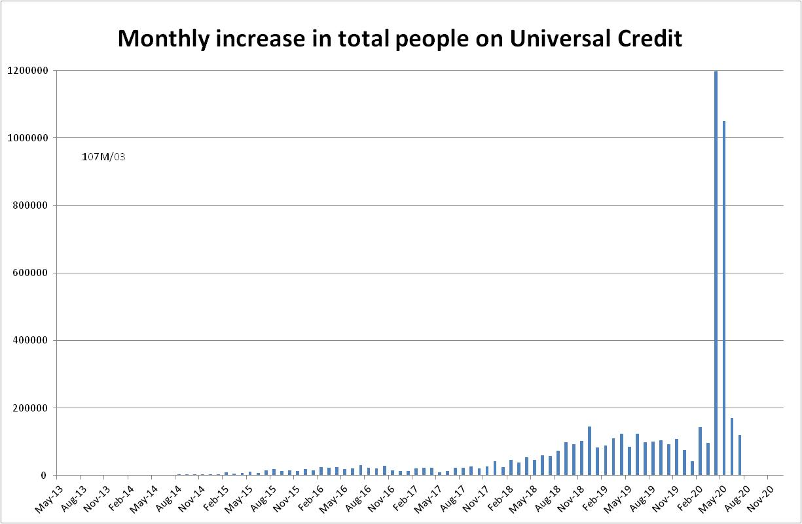

Figure 2
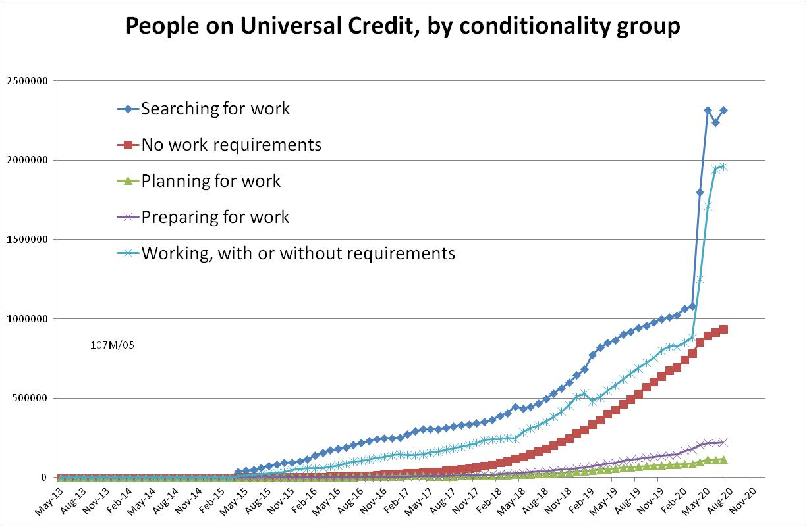

Figure 3
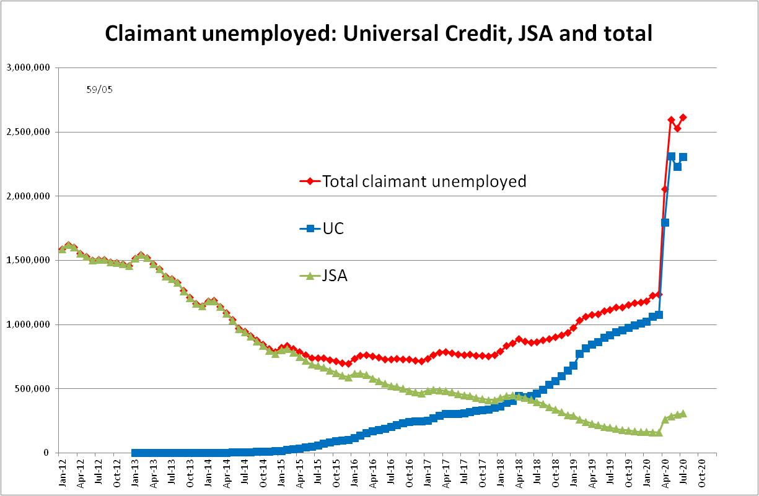

Figure 4
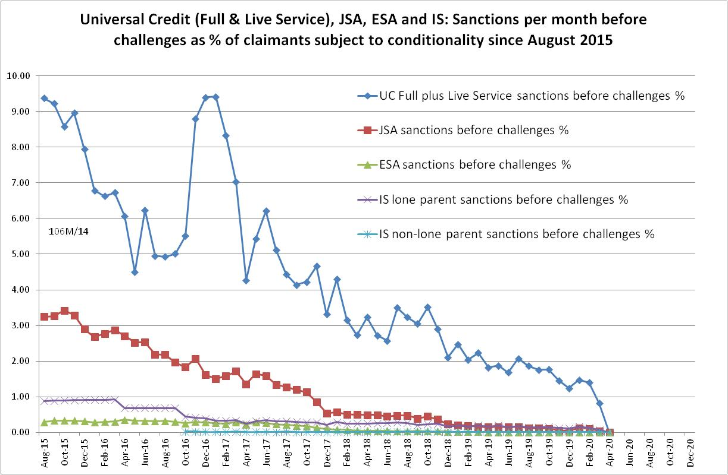

Figure 5
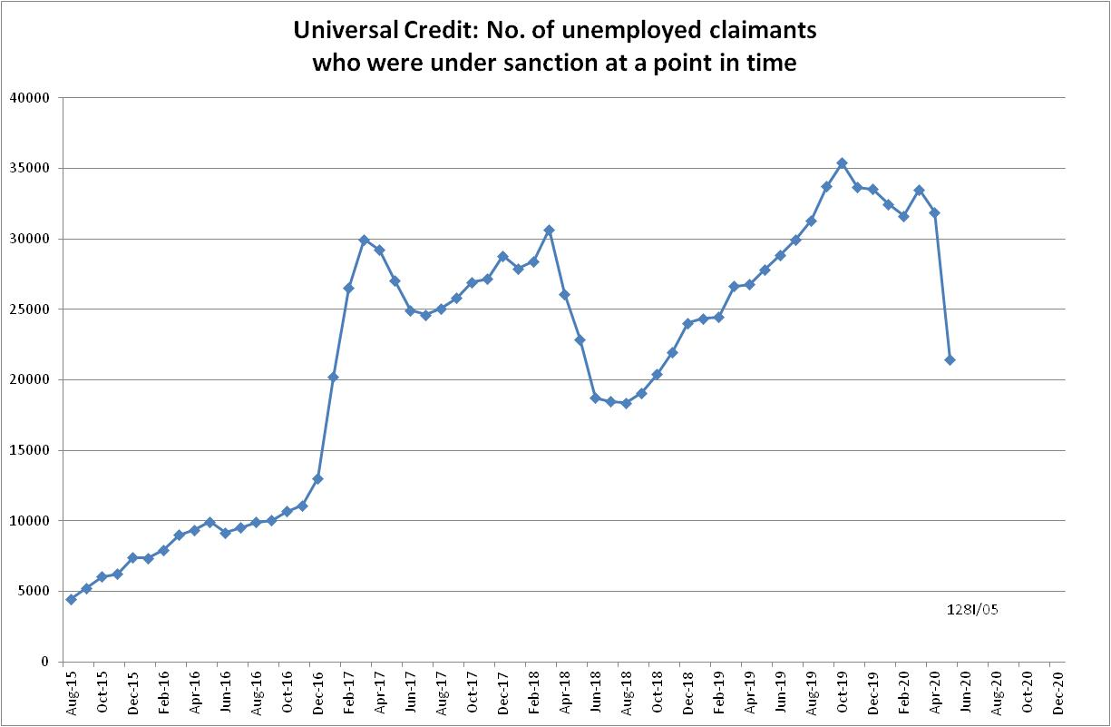

Figure 6
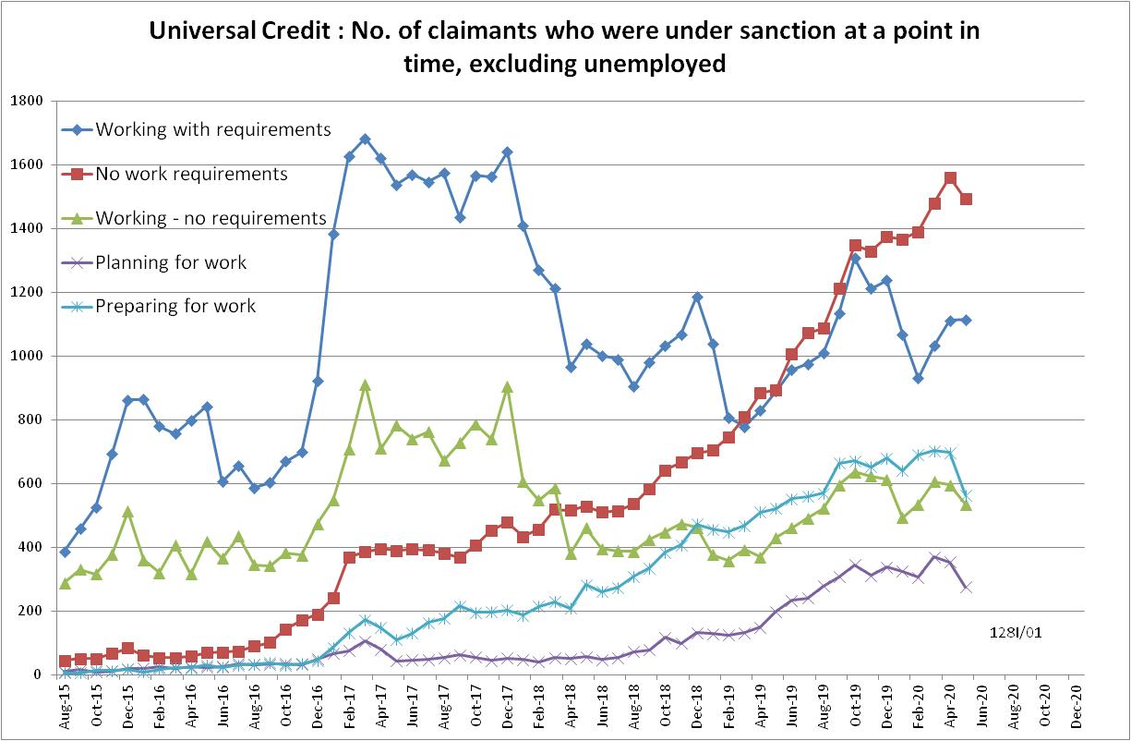

Figure 7
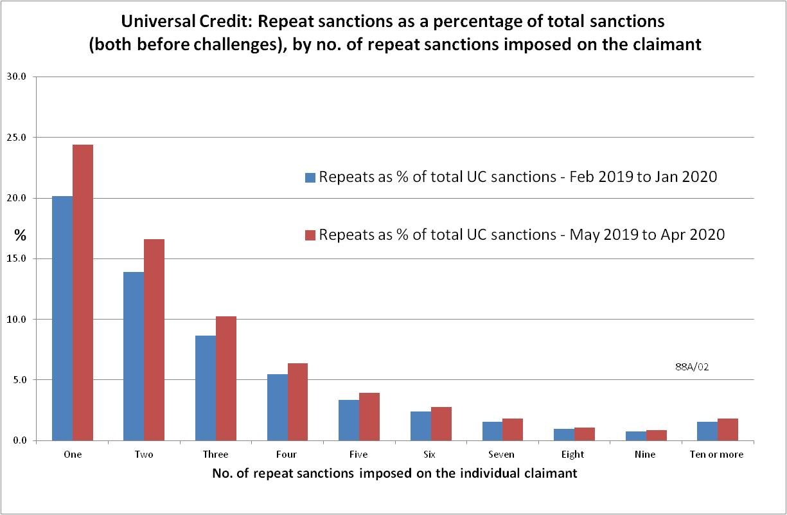

Figure 8
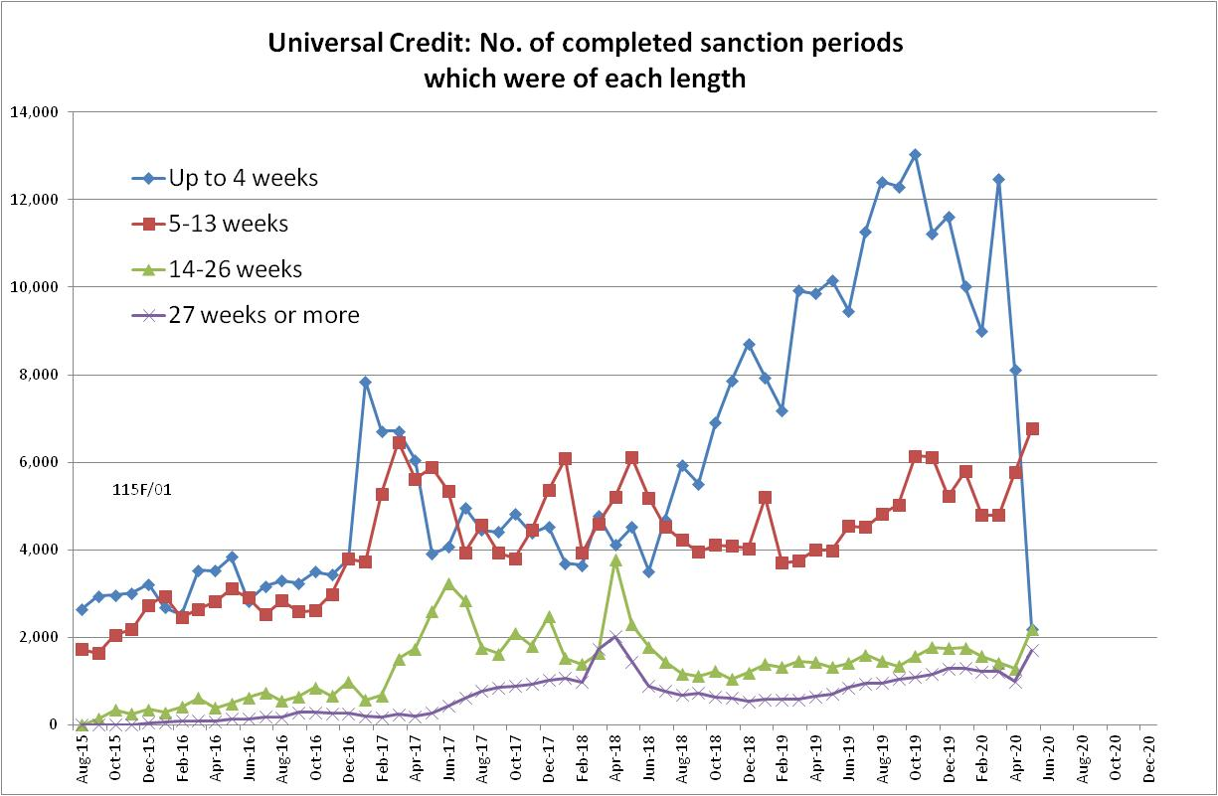

Figure 9
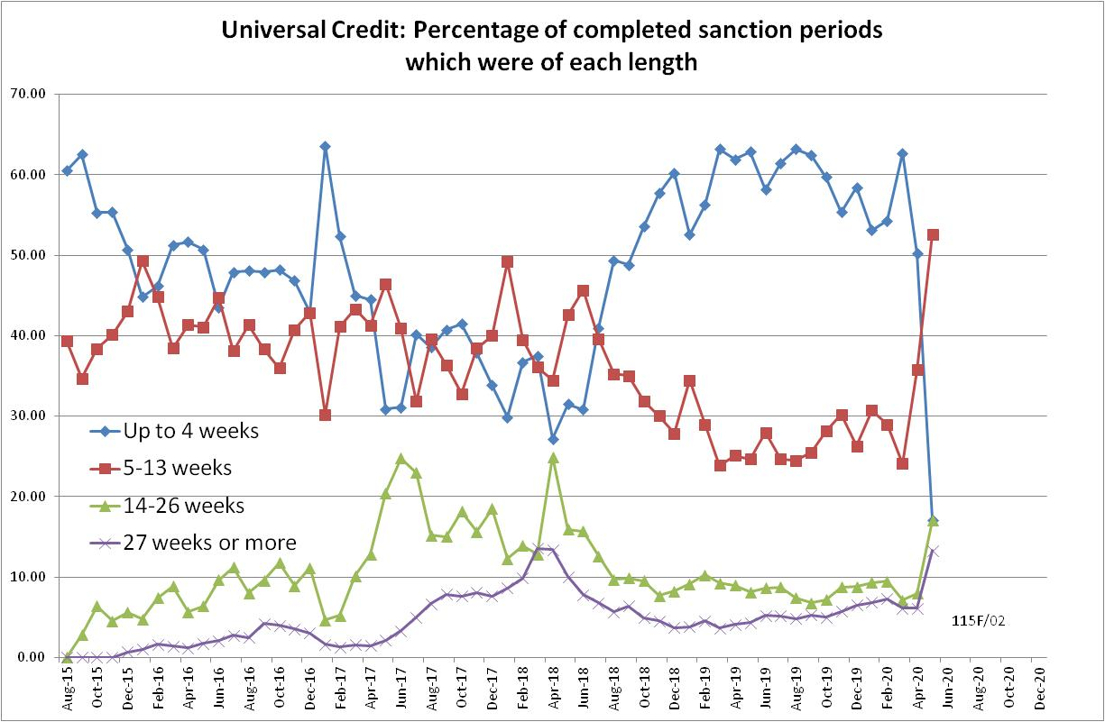

NOTES

Previous briefings include many analyses that are not repeated here but remain valid. However it should be remembered that the DWP may have made subsequent revisions to the data reported in earlier briefings. These revisions will generally not be major although there are exceptions and there may often be substantial changes in some figures for the most recent few months.
The total number of people subject to sanctions cannot be stated exactly, because there are some categories of Income Support claimants other than lone parents with a child under one who are not subject to sanctions, and there are no data on their numbers. However, they are likely to number in the low tens of thousands.
The UC claimants in the ‘working – with requirements’ group are low paid or part-time workers. Those ‘planning for work’ are mainly lone parents with a child aged 1, while those ‘preparing for work’ are people who would have been in the ESA Work Related Activity Group, and lone parents with a child aged 2 but under 5. The statistical categories for conditionality regime used in Stat-Xplore are explained in the ‘i’ feature next to the variable name in Stat-Xplore and also in the Universal Credit Statistics methodology document at https://www.gov.uk/government/publications/universal-credit-statistics-background-information-and-methodology
Lone parents with youngest child aged one to five have been estimated simply as four fifths of the total with youngest child aged 0 to five.
The basic concept of the DWP’s sanctions database (except for the new Full Service data) is that each sanction case appears only once, and is given its latest status and attributed to the month of the latest decision on the case. So, for instance, if a decision is made in January 2014 to sanction someone, this decision is reviewed in March 2014 with an outcome unfavourable to the claimant, reconsidered in a ‘mandatory reconsideration’ in May 2014 again with an unfavourable outcome, and is heard on appeal by a Tribunal in October 2014 with a decision favourable to the claimant, - it appears in the statistics for the first time in January 2014 as an adverse ‘original’ decision - in March 2014 it changes its status to a ‘reviewed’ adverse decision and moves month to be with all the other cases where the latest decision has been made in March 2014 - in May 2014 it changes its status to a ‘reconsidered’ adverse decision and moves month to be with all the other cases where the latest decision has been made in May 2014 - in October 2014 it changes its status again to an appealed non-adverse decision, and moves month again to be with all the other cases where the latest decision has been made in October 2014. DWP now says that it aims to change this system for Universal Credit sanctions at some point in the future in order to show all decisions at each stage.
The estimates of sanctions before challenges have been derived by adding the monthly total of ‘non-adverse’, ‘reserved’ and ‘cancelled’ decisions shown as being the result of reviews, mandatory reconsiderations and tribunal appeals, to the monthly total of adverse ‘original’ decisions. This produces only an approximate estimate for each individual month, since decisions altered following challenge are not attributed to the correct month. It will be particularly unreliable for months affected by a DWP catch-up of a backlog of decisions. But the estimates are reliable for longer periods.
For UC, the exact number of claimants subject to conditionality is not available for the period April 2015 to March 2018, when a proportion of people in the ‘working – with requirements’ group were enrolled in the In-Work Progression conditionality trial. This started in 10 Jobcentres in April 2015 and began rollout across the whole country in December 2015, in both Full and Live Service. The trial finished on 31 March 2018. 30,709 claimants passed through the trial. About two-thirds ('frequent' & 'moderate' support) were in the trial for at least a year, the other one third for at least 2 months. The total number of people in the ‘working – with requirements’ group rose from 4,000 in April 2015 to 103,000 in March 2018. We therefore know that a substantial proportion of the group were in the trial at any one time, but we do not know how many. Here, it has been assumed that everyone in this group was subject to conditionality for the whole period up to March 2018, but no one since then. This will produce an overestimate of the total number of UC claimants subject to conditionality for the period up to March 2018, which will slightly lower the resulting sanction rates for this period.
Shown as 17, not 20, in Stat-Xplore, presumably owing to the statistical disclosure control that is applied.
It is assumed that on average those individuals receiving ten or more repeat sanctions each received twelve sanctions in total. Small corrections have been applied to the figures for the 12 months ending 31 January 2020 to account for the less than 1% of sanctions during this period which were on Live Service.
Information about the series has been put together from various news stories readily available on the web.
Kenny’s story was presented disjointedly. This account has been put together from the sequences at 10, 27, 38 and 47 minutes into the programme.

