BRIEFING

Benefit Sanctions Statistics

November 2021

24 November 2021

Dr David Webster
Honorary Senior Research Fellow
Urban Studies
University of Glasgow

Email david.webster@glasgow.ac.uk

Webpages: http://www.gla.ac.uk/schools/socialpolitical/staff/davidwebster/
http://www.cpag.org.uk/david-webster

SUMMARY

This Briefing deals with the quarterly benefit sanctions statistics released by DWP on 16 November, taking sanctions data up to the end of July 2021.

There was a big rise in Universal Credit (UC) sanctions in June and July 2021. Up to the end of May there had only been 5,490 UC sanctions, for any reason, since the moratorium officially ended on 1 July 2020. But there were 8,687 in June alone and 15,929 in July. The latter figure equates to an annual rate of 191,000. This is not very far short of the 231,717 issued in 2019, the last complete calendar year before the pandemic, though still well below the levels reached under the Coalition. The DWP’s figures on UC claimants under sanction at a point in time indicate that the rise continued in August, and that it has taken place all over the country except in a very few areas.

The rise in UC sanctions has largely been confined to the ‘searching for work’ group, i.e. the unemployed, and is almost completely due to sanctions for missed interviews. It is explained by the resumption of face-to-face interviews following on the return to full opening hours for Jobcentres, which took place on 12 April. Of the approximately 29,600 UC claimants newly sanctioned since the end of the moratorium, 79% were male, and half (51.5%) were aged 18-24, with almost nine in ten (85.9%) aged 18-39.

It appears that to date there has been no decision by DWP to resume sanctions on any significant scale for reasons other than missed interviews.

There continue to be no new Employment and Support Allowance (ESA) or Income Support (IS) sanctions since the pandemic moratorium, but Jobseeker’s Allowance (JSA) sanctions have now restarted, albeit at a very low level (approximately 25 in the latest quarter).

The rise in sanctions is concerning, though without more information it is difficult to properly assess its likely effects. Earlier analysis and anecdotal evidence indicate that sanctions for missed interviews can result in claimants spending very long periods under sanction. The exceptionally harsh Duncan Smith/Grayling/Freud sanctions regime introduced in 2012 remains almost completely unreformed. And many studies are showing that the combination of loss of earnings in the pandemic, the withdrawal of the £20 per week UC uplift, the benefits freeze, the two child policy, the benefit ceiling and the sharp rise in the cost of living are already leaving very many households in a desperate financial position, with the added burden of mental health worsened by the pandemic.

There has a been a significant fall in the number of claimants of UC from a peak of 5.972m in March 2021 to 5.776m in October 2021. Of the latter figure, 2.210m or 38.3% were subject to conditionality. The overall total of claimant unemployed (whether on JSA or UC) has fallen from 2.618m in March to 1.950m in October, and by October 2021, almost half of the increase in unemployment produced by the pandemic had been reversed. By October, JSA accounted for only 6.5% of unemployed claimants, the remainder being on UC.

The news section at the end of the Briefing reports in particular on DWP’s acceptance that it has discretion to waive repayment of sanction hardship payments, and on several new reports dealing with the falling rewards of work and the problems of debt and hunger.

BRIEFING: Benefit Sanctions Statistics
November 2021

The DWP released its latest quarterly benefit sanctions statistics on 16 November, taking sanctions data up to the end of July 2021.The new data are summarised by DWP in the online publication Benefit Sanctions Statistics, available along with methodological notes at https://www.gov.uk/government/collections/jobseekers-allowance-sanctions together with a spreadsheet with summary tables. The full figures for many aspects of the data are on the DWP’s Stat-Xplore database at https://stat-xplore.dwp.gov.uk/webapi/jsf/login.xhtml All statistics presented here relate to Great Britain.

All previous Briefings are available at http://www.cpag.org.uk/david-webster .

There was a big rise in Universal Credit (UC) sanctions in June and July 2021

Up to the end of May there had only been 5,490 UC sanctions, for any reason, since the moratorium officially ended on 1 July 2020. But there were 8,687 in June alone and 15,929 in July. The latter figure equates to an annual rate of 191,000. This is not very far short of the 231,717 issued in 2019, the last complete calendar year before the pandemic, though still well below the levels reached under the Coalition. Figure 1 compares the July 2021 annual rate with the totals for earlier years. The number of UC sanction referrals will be higher, but DWP is not currently reporting it, so we do not know how many UC sanction proceedings have been initiated since the end of the suspension.

The DWP also publishes figures on the number and proportion of UC claimants under sanction at a point in time (as opposed to the number of sanctions issued during a period of time). These take us up to the end of August instead of July. In spite of their limitations, they can therefore be used to give a slightly more up-to-date measure of the rise in sanctions. Figure 2, showing the percentage of UC claimants under sanction by ‘conditionality group’, indicates that the rise has largely been confined to the ‘searching for work’ group, i.e. the unemployed. It also shows that it continued in August; if it had not done so then the increase in claimants under sanction in August would have been similar to that in July, whereas it is clearly greater. However, it has a long way to go before it reaches the immediate pre-pandemic level of March 2020, when for the unemployed it was 2.9% compared to 0.78% in August 2021.

Figures 3 and 4 show the numbers of UC claimants under sanction, separately for the unemployed and for the other conditionality groups. Numbers have risen faster in relation to the pre-pandemic position than have proportions. This is because there are now far more UC claimants subject to conditionality: 2.2m in July 2021 compared to 1.3m in March 2020.

Figure 5 gives an analysis of the total increase in UC claimants under sanction by Jobcentre Plus District for the four months May to August 2021, standardised using a ‘per 100,000 claimants’ measure. This indicates that the rise has taken place right across Great Britain, although there are a few areas – South London, Northern Scotland and Birmingham/Solihull – which have yet to see much rise.

Sanctions – Other benefits

Up to the end of July 2021, there have still been no new sanctions on Employment and Support Allowance (ESA) or Income Support (IS) since the beginning of the pandemic. However, Jobseeker’s Allowance (JSA) sanctions have now restarted, with approximately 6 in May, 7 in June and 12 in July. These are very small numbers, although there are now relatively few JSA claimants: 164,266 in July 2021.

Reasons for sanctions

In the latest quarter, May-July, the proportion of UC sanctions accounted for by non-attendance at interviews has risen even higher than before, to 98.8% (26,000), leaving only 1.2% (310) for any other reason. In the previous quarter, missed interviews accounted for 95.7% (2,390), with 4.3% (120) for any other reason. The rise in sanctions is therefore almost entirely due to sanctions for missed interviews. It can be explained by the resumption of face-to-face interviews following on the return to full opening hours for Jobcentres, which took place on 12 April as noted on p.4 of the August 2021 Briefing. This is mentioned by DWP in section 3.1 of Benefit Sanctions Statistics, November 2021 issue. The more interviews that are scheduled, the more that are missed. However, although there has been a very small rise in UC sanctions for reasons other than missed interviews, it appears that there has been no decision by DWP to resume these other sanctions on any significant scale.

There are currently too few JSA sanctions to make an analysis of the reasons worthwhile.

What is the significance of the rise in sanctions on unemployed UC claimants for missed interviews?

Under UC, the sanction for missing an interview is either ‘low level’ or ‘lowest level’. My understanding is that ‘low level’ applies to people who have both an interview requirement and other requirements (including the unemployed). They receive a sanction of 100% of their standard allowance which lasts until they attend an interview, followed by a further period of one, two or four weeks for a first, second or subsequent ‘failure’ respectively. ‘Lowest level’ applies to people with only an interview requirement. Their sanction lasts until they attend an interview, and is also of 100% of the standard allowance, except for claimants in the ‘Planning for Work’ regime or the ‘No Work requirements regime’ on the grounds of childcare responsibilities, adoption or pregnancy, when it is 40%.

DWP has currently suspended its statistics on the duration of sanctions while it addresses problems with the methodology, but the analysis of the quarter December 2019 to February 2020 in the June 2020 Briefing (p.12) showed that these rules on sanctioning for missed interviews were often producing long periods under sanction. An estimated 45% of all completed UC sanction periods (which might have comprised more than one sanction, one following another) lasted more than 4 weeks, 19.1% more than three months, and 7% more than 6 months. Since interview sanctions then accounted for 89% of all UC sanctions, the durations of UC interview sanctions had to be similar to these durations for all UC sanctions. These figures may of course be revised by DWP but they are currently the best we have.

DWP has never published any information on the split of missed interview UC sanctions between 'low level' and 'lowest level' or between 1st, 2nd and subsequent 'low level' sanctions. This missing information has now become quite important.

Up to April 2010, missing an interview was not a cause for sanction as such. If the claimant did not get in touch, the claim would be closed, and the claimant then had the option of renewing the claim, having suffered the loss only of the number of days’ delay in reclaiming plus the then three ‘waiting days’. DWP has stated that this practice has been reinstated since then for JSA, although it is not clear exactly when. DWP says that the structuring of UC makes it impossible to close a case where a claimant has an entitlement to other elements of UC, such as for housing or childcare. But it would clearly be possible to restructure UC to avoid this issue, and it would certainly be possible to reduce the lengths of the sanctions.

While it is difficult without more information properly to assess its effects, the rise in sanctions is concerning for two reasons. First, the exceptionally harsh Duncan Smith/Grayling/Freud sanctions regime introduced in 2012 remains almost completely unreformed; as the November 2019 Briefing (p.7) pointed out, the abolition of three-year sanctions by Amber Rudd was in practice a minor change. We do also know from real life cases that missed interview sanctions have often been unreasonable and can cause very severe hardship (see for instance the case history discussed in the report ‘Discretionary waiver of repayment of hardship payments’ on p.7 below). Second, many studies are showing that the combination of loss of earnings in the pandemic, the withdrawal of the £20 per week UC uplift, the benefits freeze, the two child policy, the benefit ceiling and the sharp rise in the cost of living are already leaving very many households in a desperate financial position, with the added burden of mental health worsened by the pandemic.

The rise in sanctions also raises the question of what has happened to the DWP’s study of their effectiveness, which was originally to be published in ‘late spring 2019’ but has not appeared. This was discussed in the February 2020 issue of the Briefing, p.10.

Gender and age breakdown of those newly sanctioned since the moratorium

Each issue of Benefit Sanctions Statistics shows the cumulative number of UC claimants sanctioned since 1 May 2016. By comparing successive issues, it is possible to derive the approximate number of UC claimants of each gender and age group who have been sanctioned for the first time since that date during each quarter. This analysis for the approximately 29,600 claimants newly sanctioned since the end of the moratorium shows that 79% were male, and half (51.5%) were aged 18-24, with almost nine in ten (85.9%) aged 18-39. For age, this is a very similar pattern to that shown in the analysis for the period before the moratorium reported in the February 2020 Briefing (p.9 and Figures 10 and 11), except that the proportion aged 18-24 is now higher. For gender, there appears now to be a stronger concentration of sanctions on males than before the moratorium (79% compared to 72%), but not by such a wide margin as in the data to April 2021 (when it was 83% compared to 72%).

Repeat Universal Credit sanctions

Benefit Sanctions Statistics has figures for the numbers of individuals receiving repeat sanctions during the year to end-July 2021: 573 people received one repeat sanction, 22 received two repeat sanctions, and 7 received three. However, these figures are of little interest since until June and July 2021 there were very few sanctions at all, and if there are few sanctions there obviously cannot be many repeats. For more useful analysis the reader is referred to the May 2021 Briefing (pp.4-5 and Figure 1), which presented an analysis of repeat UC sanctions for the period May 2016 to October 2020, and to the August 2021 Briefing (p.4 and Figure 1), which gave an analysis for the last complete 12 months before the moratorium, i.e. February 2019 to January 2020 inclusive. These analyses showed that over the four and a half year period, one third (32.9%) of sanctions were second or subsequent sanctions on the same individuals, compared to between one quarter and one fifth (22.6%) over the one-year period.

Groups of claimants exposed to sanctions:
Universal Credit, JSA, ESA and Income Support

At October 2021 there were 5.776m claimants of UC. This is a significant fall from the peak of 5.972m of March 2021. Of the 5.776m claimants in October, 2.210m or 38.3% were subject to conditionality (counting the ‘working – with requirements’ group as not subject to conditionality, as the DWP itself now does). This is a fall from 45.6% in March and is entirely due to a fall in the ‘searching for work’ group. JSA claimants have also fallen sharply from 268,000 in March 2021 to 126,000 in October. The overall total of claimant unemployed (whether on JSA or UC) has fallen from 2.618m in March to 1.950m in October, and indeed by October 2021, almost half of the increase in unemployment produced by the pandemic had been reversed (Figure 6). By October, JSA accounted for only 6.5% of unemployed claimants, the remainder being on UC.

For claimants in the Work Related Activity Group (WRAG) of ESA, and of IS, the latest available figures are for May 2021. In that month there were 200,000 in the ESA WRAG and 206,000 claimants of IS normally subject to conditionality.

SANCTIONS - OTHER DEVELOPMENTS

Discretionary waiver of repayment of hardship payments

One of the harshest features of the UC sanction regime is that the discretionary hardship payments which may be made to a sanctioned claimant have been made repayable. Previously, hardship payments were grants.

Following a judicial review, DWP has now confirmed that it does in fact have discretion to waive repayment of hardship payments and has changed the guidance issued to work coaches and other DWP staff. The DWP has written an open letter to the Public Law Project (PLP), who pursued the judicial review, explaining how claimants can apply for recoverable hardship payments after a UC sanction, and the process by which claimants can request that repayments of hardship payments are waived. Full details are at https://publiclawproject.org.uk/latest/dwp-publishes-letter-on-universal-credit-hardship-payments/

The case history of the claimant whose experience sparked the judicial review is worth reading in its own right, showing how the UC rules can easily result in claimants spending very long periods of time under sanction even though the maximum individual sanction is now 6 months. It is at https://twitter.com/publiclawprojct/status/1321100888673521665
PLP provides a commentary on the case at
https://www.lag.org.uk/article/210983/the-problems-with-benefit-sanctions which explains that DWP’s previous policy was directly contrary to an undertaking given to the House of Commons by the then Employment Minister Chris Grayling.

DWP Restart scheme guidelines

The Restart scheme aims to give UC claimants who have been out of work for at least 12 months enhanced support to find jobs in their local area. The webpage https://mrfrankzola.wordpress.com/restart/ provides weblinks to the various documents describing the scheme and its operation.

Noteworthy is for instance the advice to Restart providers in the ‘Restart bidder Q & A log’, row 29, that ‘(DWP) would like to encourage alternative approaches to mandation being explored where relevant’.

Benefit Sanctions (Warnings) Bill

A private member’s Bill promoted by Chris Stephens (SNP, Glasgow SW), to make provision for warnings to be given to benefit claimants before they are given sanctions, is scheduled for second reading in the House of Commons on 10 December.

Free TalkTalk broadband for jobseekers
A joint national programme has been launched by the telecoms company TalkTalk and DWP to give jobseekers a voucher for six months’ free use of TalkTalk’s Fibre 35 broadband, which normally costs £23 a month. Usage is uncapped, meaning there are no data limits aside from the usual “fair usage” rules. Users will get wifi connectivity via a home router, though they are unable to add optional extras such as TV services, and voice calls are not part of the package. Details are at https://www.theguardian.com/society/2021/sep/27/uk-jobseekers-are-offered-six-months-of-free-broadband This is not the only such deal. For example, Vodafone’s Voxi brand offers UK jobseekers unlimited 5G data, calls and texts for £10 a month for up to six months.
New claimant-led guide to Universal Credit
The Northern Ireland claimant organization UC:Us has published a claimant-led online guide to Universal Credit, which is available at https://www.ucus.org.uk/ . The same webpage also has a recording of the launch at Belfast City Hall on 29 September. The work of UC:Us has been funded by the Joseph Rowntree Foundation and the Economic and Social Research Council. Although the guide has been designed in Northern Ireland, it is intended to be a valuable resource for people claiming UC anywhere in the UK and contains specific guidance for each of the four countries where appropriate.
Deterioration of work experience for lower earners

On 20 September the Resolution Foundation published a report on people’s subjective experience of work (Shah & Tomlinson 2021), available at https://economy2030.resolutionfoundation.org/reports/work-experiences/ Overall, the report did not find that job quality has deteriorated significantly or that employees are trapped in jobs they consider worthless. The majority of employees remain satisfied with their job and falls in job satisfaction have been relatively modest over time. However, the picture for lower earners is more concerning. Across a range of indicators – from job satisfaction, to workplace stress, to feeling used up at the end of the day – the experience of work for low-earners has deteriorated at a faster rate than for those who earn more. In doing so, the experience of low earners is beginning to catch up on the experience of higher earners, who report the worst absolute level.

New Policy Institute: Work no longer the route out of poverty
On 31 August the New Policy Institute published a report analysing the ways in which the problem of poverty has changed over the last 20 years (Kenway & Holden 2021), available at https://www.npi.org.uk/publications/income-and-poverty/modern-poverty-whats-changed-20-years-and-why-work-no-longer-route-out-poverty-uk/ The report points out that the number of children in poverty in the UK when the Covid-19 pandemic struck had returned to where it was in 1999. But it shows that the conditions associated with poverty now are different. Nearly 1 in 5 children in households where all adults are working, and approaching 1 in 2 where some are working, are now in poverty. These in-work ‘poverty rates’ are at record highs. Three quarters of children in poverty are in working households. More than 4 in 10 of all working adults in poverty have a family member who is either disabled or suffering from an illness which limits their day-to-day activities. Two thirds of working-age adults in poverty have either a dependent child in their family or someone who is disabled or ill. Almost 3 in 10 of all those in poverty have a household income less than half what they would need even to be at the poverty line, up over the last 20 years from just under 2 in 10. Housing costs for lower-income households have risen over 20 years compared with costs for those on middle incomes. The poorest fifth face the highest average costs, while the second-poorest fifth now face the second highest. These high average costs reflect the large number of lower-income households living in the private- or social-rented sectors. Taken together, these facts paint a picture of modern poverty as a condition likely to be experienced by working households, with family responsibilities that limit paid work, high housing costs and an income that may be far below the poverty line. The report concludes that the claim that work is the route out of poverty must be rejected because its premise – that poverty is due to worklessness – is no longer true.
Huge increase in scale of low income household debt following the pandemic

On 21 October the Joseph Rowntree Foundation published a Briefing on the extent of household debt following on the pandemic. It is available at https://www.jrf.org.uk/report/dragged-down-debt-millions-low-income-households-pulled-under-arrears-while-living-costs-rise

The briefing gives the findings from a survey by Savanta ComRes of 4,193 adults aged 18+ in households in the lowest 40% of equivalised household income, conducted between 25 September and 5 October 2021. Prior to the pandemic, in 2019/20, the Family Resources Survey showed 11% of low-income households were behind on at least one household bill or credit commitment. This new study is not perfectly comparable, but it found that an estimated 3.8 million low-income households (33%) are in some form of household arrears, and 4.4 million low-income households (38%) have taken on new borrowing or increased their existing borrowing during the pandemic. There is significant overlap between these two groups – over two thirds (69%) of households who have taken on new or increased lending during the pandemic are also in arrears. A large majority (87%) of low-income households now behind with their bills report that before the pandemic they were always or often able to pay all their bills in full and on time, underlining the impact of the pandemic. The study estimates that arrears currently stand at £5.2 billion across the UK, with £3.4 billion coming from household bills like rent, council tax and utilities, and £1.8 billion from personal borrowing arrears. Breaking arrears down into four broad categories of housing, utilities, state debt and personal borrowing, seven in ten low-income households in arrears (2.7 million households) are in more than one type of arrears, and 35% (1.3 million households) are in three or more types. Debts owed to the state feature heavily for those in multiple kinds of debt, with council tax arrears making up half of the estimated £1.5 billion owed to the state.

Low-income UC recipients are one of the hardest-hit groups, with 7 in 10 in arrears even before the removal of the £20 per week UC uplift. Half of UC recipients said they did not feel confident they could find a job or work more hours. A large minority of them were not confident they would be able to pay their bills in full and on time in future (40%), and not confident they will be able to avoid taking on more debt (35%). Around half were planning to manage their budgets by cutting back on essentials like food.

Public attitudes to welfare during Covid-19

On 2 September the Welfare at a Social Distance project published a report on attitudes to welfare during Covid-19 (de Vries et al. 2021), available at https://distantwelfare.co.uk/attitudes The report found that Covid-19 prompted little change in public attitudes to welfare. The public believes Covid-19 claimants are considerably more deserving of benefits than pre-pandemic claimants, but general welfare attitudes are much more closely tied to perceptions of pre-pandemic claimants than to perceptions of Covid-19 claimants. However, before the pandemic, attitudes had already become more pro-welfare than the UK has seen in 20-30 years.
Hunger and the Welfare State

On 4 October the Welfare at a Social Distance project published a report on food insecurity in the UK (Geiger et al. 2021). The report uses YouGov surveys of the general public (n=2,600) and of claimants (n=6,300), conducted in May/June 2021. Among its findings are that of working-age people who are food insecure, 52.9% are claiming income or work-related benefits; and among people who are severely food insecure, 62.1% are claiming benefits. While keeping the £20 per week UC uplift would help, a significant fall in food insecurity would require a broader increase in the level of benefits. Even with the uplift, half of UC claimants were food insecure, and around one-quarter were severely food insecure. The report found that direct deductions from benefits are strongly associated with food insecurity and severe food insecurity. Claimants repaying debts were 20 percentage points more likely to be food insecure and 10 percentage points more likely to be severely food insecure. If benefits are to provide an adequate income, then claimant debt must be taken into account – e.g. by better providing or signposting to debt advice, and making claimants aware of the (England & Wales) ‘Breathing Space’ scheme (see Conway 2021). To reduce food insecurity, policymakers also need to make sure that disabled people receive adequate benefits. Disabled people are much more likely to be food insecure or severely food insecure. ESA claimants did not receive the £20 per week uplift, and probably as a result, the report found that their levels of food insecurity sharply increased during Covid-19 relative to UC claimants. Disabled people’s levels of food insecurity only fall close to the level of non-disabled people if they receive both the extra disability-related payments in UC/ESA and the separate extra benefits PIP/DLA.

REFERENCES

Conway, Lorraine (2021) Debt Respite Scheme – a breathing space for those in debt, Research Briefing, House of Commons Library, 9 June, at
https://commonslibrary.parliament.uk/research-briefings/cbp-9256/

Geiger, Ben Baumberg, Daniel Edmiston, Lisa Scullion, Kate Summers, Robert de Vries, Jo Ingold, David Robertshaw and David Young (2021) Hunger and the welfare state: Food insecurity among benefit claimants in the UK, Welfare at a Social Distance Project Report, October, at https://www.distantwelfare.co.uk/food-insecurity-report

Kenway, Peter and Josh Holden (2021) Modern Poverty: What’s changed in 20 years and why work is no longer the route out of poverty in the UK, New Policy Institute, September, at
https://www.npi.org.uk/files/4916/3041/0468/Modern_Poverty.pdf

Shah, Krishan & Daniel Tomlinson (2021) Work Experiences: Changes in the subjective experience of work, Resolution Foundation, September, at https://economy2030.resolutionfoundation.org/wp-content/uploads/2021/09/Work-experiences.pdf

de Vries, Robert, Ben Baumberg Geiger, Lisa Scullion, Kate Summers, Daniel Edmiston, Jo Ingold, David Robertshaw and David Young (2021) Solidarity in a crisis? Trends in attitudes to benefits during COVID-19, Welfare at a Social Distance Project Report, September, at https://distantwelfare.co.uk/attitudes

Figure 1
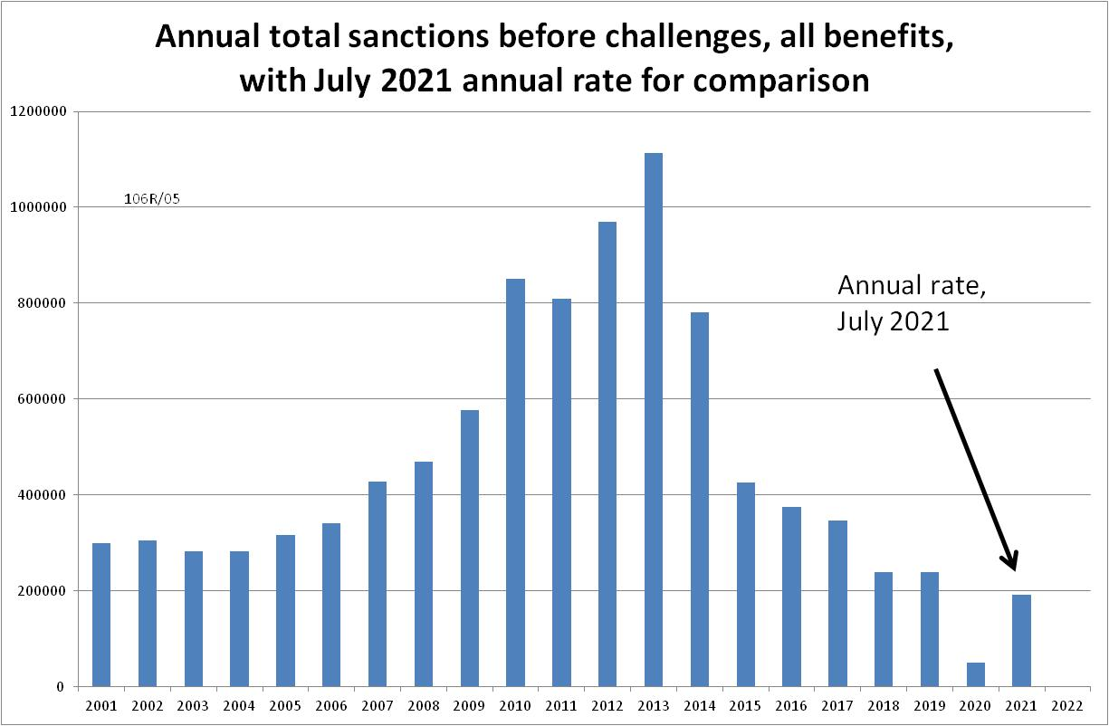
Figure 2
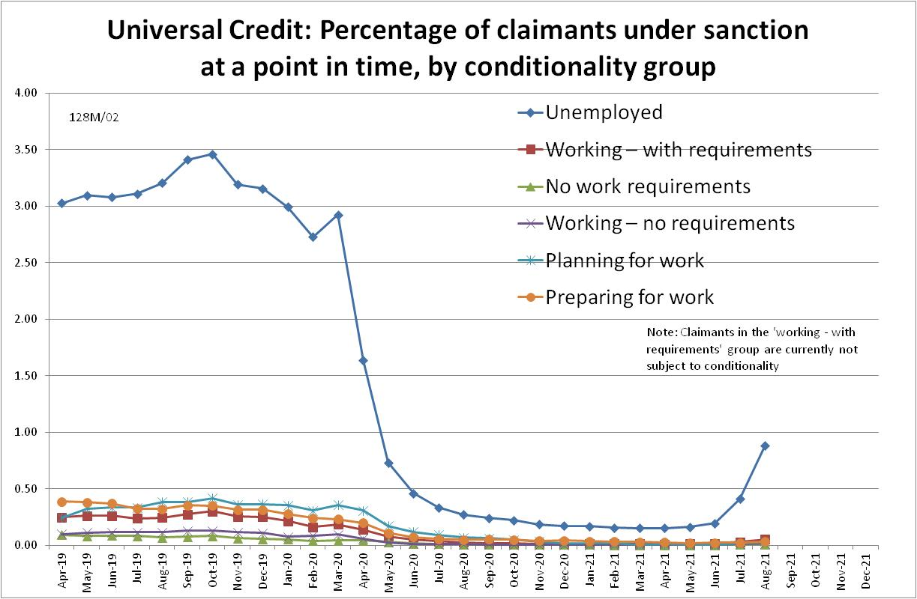

Figure 3
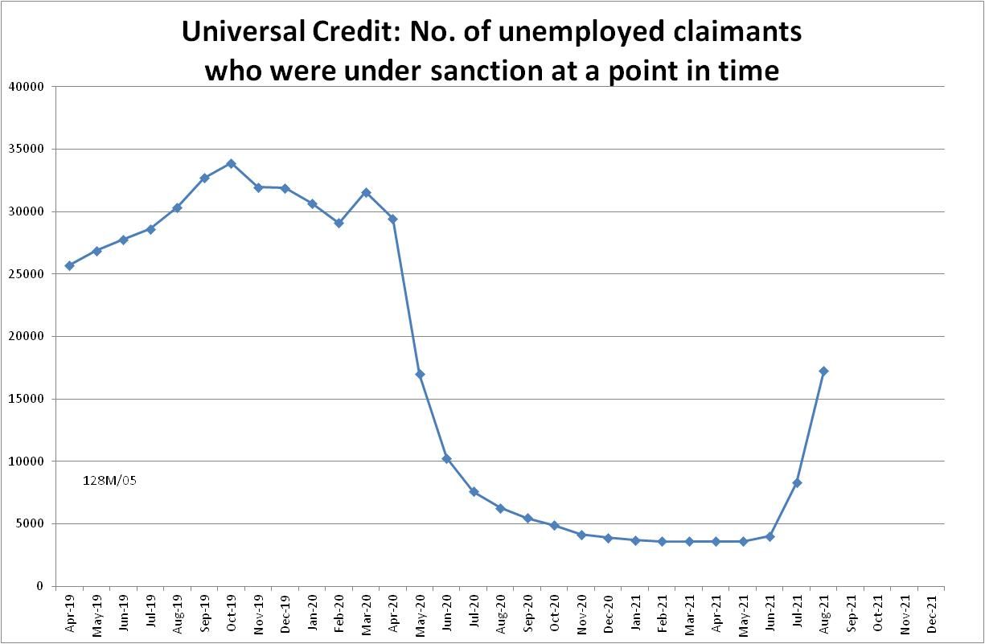

Figure 4
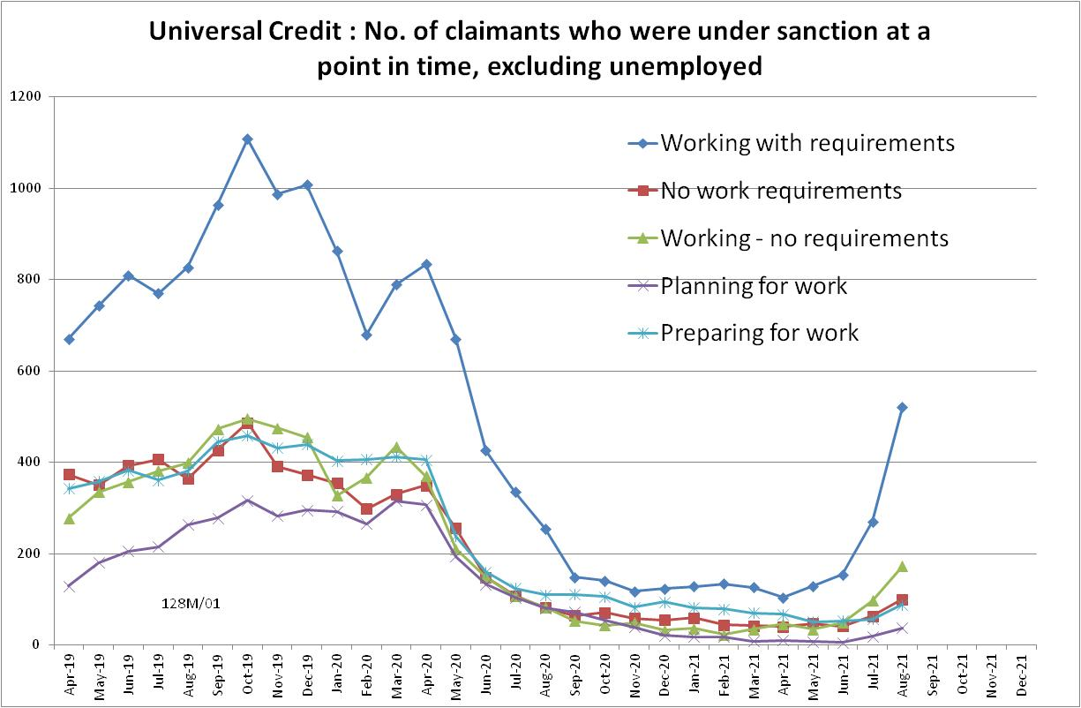

Figure 5
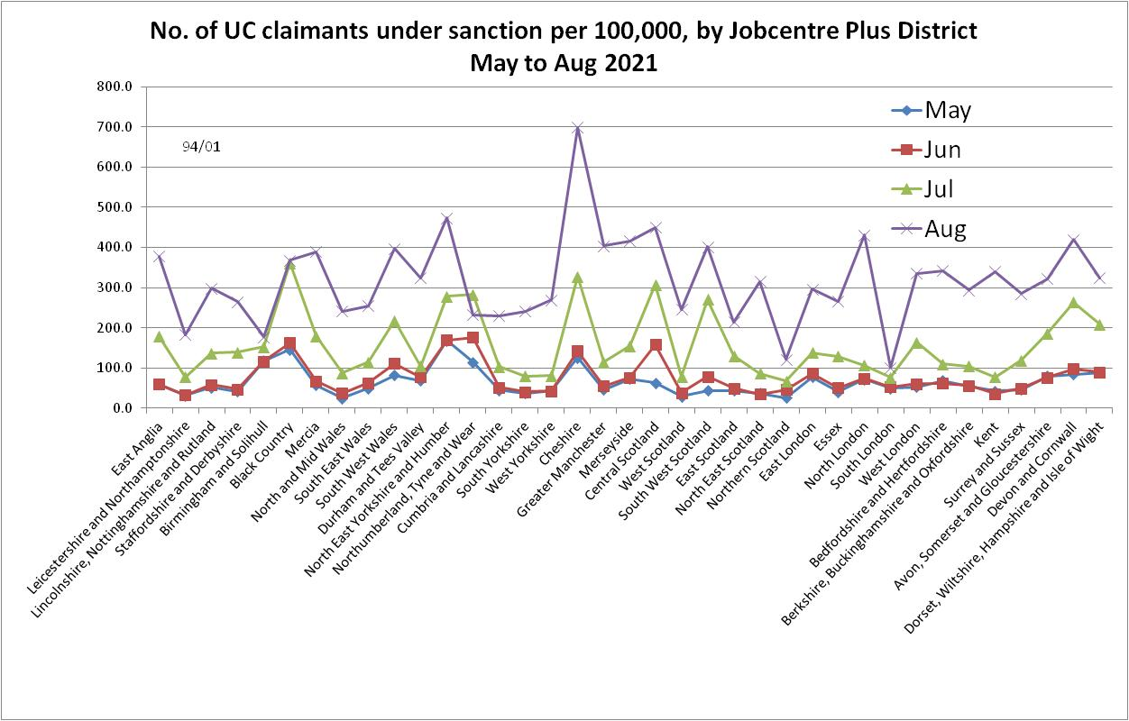
Figure 6
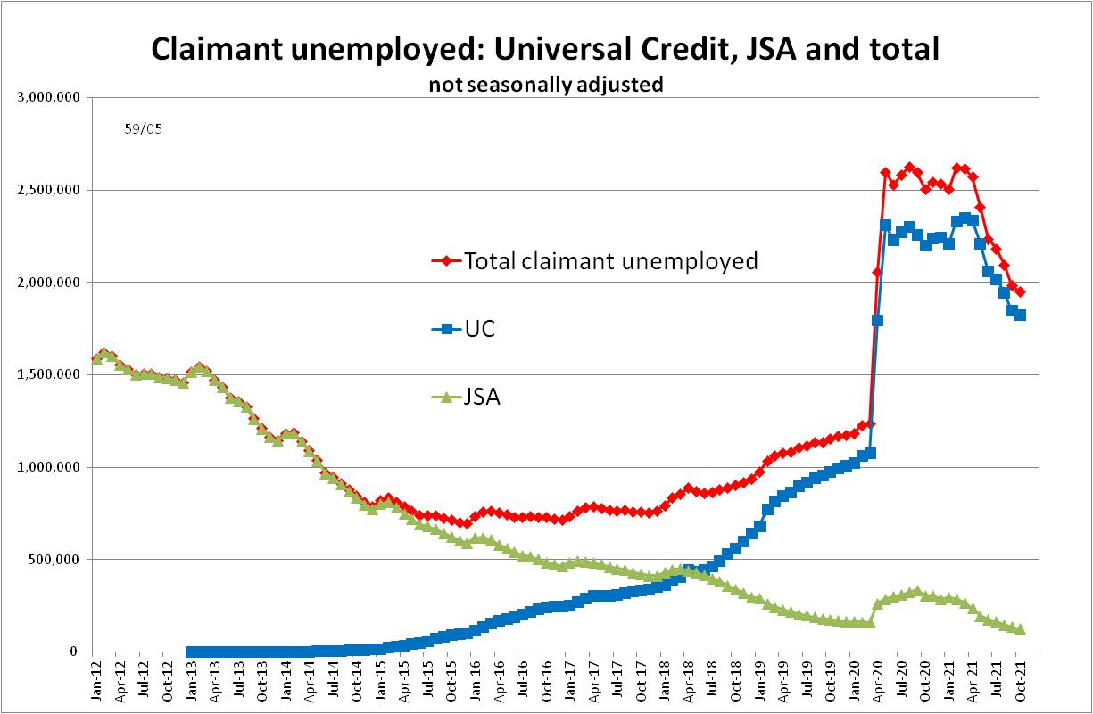

NOTES

Previous Briefings include many analyses that are not repeated here but remain valid. However it should be remembered that the DWP may have made subsequent revisions to the data reported in earlier Briefings. These revisions will generally not be major although there are exceptions. There may also often be substantial changes in some figures for the most recent few months.
Details of the sanctions moratorium/suspension, including exact dates, legal basis etc. were given in the June 2020 Briefing, pp.7-8. DWP guidance on the resumption of sanctions was reported in the November 2020 Briefing, pp.3-4, and details of new sanctions procedures and staff guidance in the February 2021 Briefing, Appendix, pp.6-7.
The drawbacks of the ‘claimants under sanction at a point in time’ measure were discussed in the November 2017 issue of the Briefing, pp.6-10. In November 2020, DWP withdrew the UC ‘rate’ data for all months prior to April 2019, pending revision of the figures for the former ‘Live Service’. These figures remain withdrawn. In addition, in the February 2021 release DWP made significant revisions to the figures for April 2019 onwards (which are for Full Service only, there being no one left on the former Live Service). These were fully discussed in the February 2021 Briefing.
It should be borne in mind that under UC, a sanctioned claimant continues to serve their sanction even if they move into a no-conditionality group. This is why Figure 4 shows people under sanction who are in no-conditionality groups. In addition, as discussed in the August 2021 Briefing, p.5, from the November 2021 statistics release, DWP has changed its treatment of the ‘working – with requirements’ UC group to reflect the reality that in practice this group is not subject to conditionality. This does not affect any of the statistics in this or earlier issues of the Briefing, which has followed this treatment ever since the large-scale pilot of in-work conditionality ended in March 2018.

