BRIEFING

Benefit Sanctions Statistics

November 2023

29 November 2023

Dr David Webster
Honorary Senior Research Fellow
Urban Studies
University of Glasgow

Email david.webster@glasgow.ac.uk

Webpages: http://www.gla.ac.uk/schools/socialpolitical/staff/davidwebster/
http://www.cpag.org.uk/david-webster

SUMMARY

This Briefing reports on the quarterly Universal Credit (UC) sanctions statistics for Great Britain published by DWP on 14 November.

There have been important policy announcements, in the Autumn Statement and elsewhere. They are reported in the news section of the Briefing. These involve further increases in conditionality, in particular reintroduction of compulsory job placement and termination of claims in some circumstances, and extension of conditionality by 2028/29 to around 370,000 sick or disabled people who would currently be exempt. There are also increases in employment support. But there has been little change in the statistics, apart from a slight uptick in sanctioning rates in the latest quarter. It is too early to assess whether this is the start of a trend. The suspended statistics on the proportion of UC claimants serving a sanction at a point in time prior to April 2019, and on the duration of UC sanctions, have not yet been resumed. There is still no improvement in the coverage of the UC ‘full service’ sanctions statistics, which have never given any information on the appeal system or on the ‘levels’ of sanction. Full Service now covers all UC claims.

Sanctions continue to run at a high level. A monthly average of 46,068 UC sanctions were imposed in the latest quarter to end-July 2023 and there were a total of 522,659 UC sanctions in the year to July 2023. The total number of individual UC claimants who were sanctioned during the year was 408,251. Of these, 86,863 (21.3%) received more than one sanction, and 20,944 (5.1%) received more than two. For comparison, in the last full 12 months before the pandemic, to January 2020, there were 230,720 UC sanctions and 178,476 sanctioned individual claimants. The monthly average of 46,068 sanctions in the latest quarter exceeds that for all periods since the start of the present reporting system in 2000, except for the Coalition government’s sanctions drive of 2010-15. These figures do not include sanctions on JSA, ESA or IS which however seem likely to have been very few.

The number of UC claimants who were serving a sanction at a point in time averaged just over 120,000 in the latest quarter, or 6.36% of claimants subjcct to conditionality. This is much higher than before the pandemic, when it was around 35,000 (3.1% or less). Of unemployed UC claimants, 112,877 or 8.03% (1 in 12) were under sanction in August 2023 compared to 0.68% for ‘planning for work’ and 0.64% for ‘preparing for work’. The average duration of a UC sanction is 11 to 12 weeks.

The total number of people on UC was a provisional 6.21m in October 2023. Within this there were 1.89m UC claimants subject to conditionality, or 30.5% of all UC claimants.
At July 2023 there were still an estimated 388,000 claimants on the legacy benefits subject to conditionality, comprising 158,000 in the ESA Work Related Activity Group, 128,000 on Income Support and 89,000 on JSA. Added to the 1.89m UC claimants subject to conditionality at that date, there were therefore an estimated total of 2.26m claimants on all benefits subject to conditionality.

As well as reviewing the further increases in conditionality announced in the Autumn Statement and elsewhere, the news section of the Briefing notes several new campaigns and policy report, all of them critical of the sanctions regime.
BRIEFING: Benefit Sanctions Statistics
November 2023

The DWP released its latest quarterly sanctions statistics for Universal Credit on 14 November. The newly published data are summarised by DWP in the online publication Benefit Sanctions Statistics, available along with methodological notes at https://www.gov.uk/government/collections/jobseekers-allowance-sanctions together with a spreadsheet with summary tables. Some data are on Stat-Xplore at https://stat-xplore.dwp.gov.uk/webapi/jsf/login.xhtml . All statistics presented here relate to Great Britain. All previous Briefings are available at http://www.cpag.org.uk/david-webster .

DWP no longer publishes updates to statistics on sanctions for Jobseekers Allowance (JSA), Employment and Support Allowance (ESA) and Income Support (IS). JSA and ESA are not merely ‘legacy’ benefits since there are new claimants of the ‘New Style’ (contribution-based) versions of these benefits. But we will not know about any sanctions on these benefits except via Parliamentary Questions or FoI requests. There are now very few if any JSA claimants other than on New Style.

Since November 2020 two sets of sanctions statistics have been suspended, namely the proportion of UC claimants serving a sanction at a point in time prior to April 2019, and the duration and median length of UC sanctions. In August DWP stated in the ‘Changes, revisions and known issues’ section of Benefit Sanctions Statistics that investigative and corrective work on these statistics is complete and that following quality assurance exercises publication will be resumed. But it did not give a date and publication of these statistics has still not been resumed.

There is still no improvement in the coverage of the UC sanctions statistics, which have never given any information on the appeal system or on the ‘levels’ of sanction for Full Service (which now covers all UC sanctions).

Number of people on Universal Credit (UC) and number of UC claimants subject to conditionality

The total number of people on UC was a provisional 6.21m in October 2023. Within this there were 1.89m UC claimants subject to conditionality, or 30.5% of all UC claimants.

In the latest quarter there was a particularly large provisional increase of 197,000 in the number of people on UC, the largest for any quarter since the pandemic. This was due in part to an increase in the pace of ‘managed migration’. Up to May 2023, only 22,040 households (excluding a small number of couple households) had been sent migration notices, of whom only 7,800 had made a claim for UC. But in the quarter June to August 2023, a further 94,330 notices were sent. Claims lodged to the end of August were 61,130. Almost everyone sent a migration notice to date has been claiming only Tax Credits, without any DWP benefits. This is reflected in an increaase of 76,000 in the number of working UC claimants.

The largest group of UC claimants subject to conditionality is those ‘searching for work’, i.e. unemployed. They were 1.42m in October 2023, accounting for 94.1% of all claimant unemployed; the other 5.9% of the claimant unemployed were the 88,739 claimants on JSA.

Total claimants on all benefits subject to conditionality

Reporting on legacy benefits is less up-to-date than on UC. At July 2023 there were still an estimated 388,000 claimants on the legacy benefits subject to conditionality, comprising 158,000 in the ESA Work Related Activity Group, 128,000 on Income Support and 89,000 on JSA. Added to the 1.89m UC claimants subject to conditionality at that date, there were therefore an estimated total of 2.26m claimants on all benefits subject to conditionality.

Impact of raising of the Administrative Earnings Threshold (AET)

This was considered in the May 2023 Briefing, pp.3-4 and Figure 1, and in the August 2023 Briefing, p.4 and Figure 1. In the latest figures there is no obvious further effect on the sizes of the UC conditionality groups.

The Budget on 15 March announced a further planned rise in the AET to 18 hours. DWP’s Equality Analysis (DWP 2023a) stated that it is working on the basis of an autumn 2023 implementation date. But it appears that no date has yet been announced. This could be due to the staffing difficulties discussed in the News section below.

Work Capability Assessment statistics

DWP is now publishing its new WCA statistics each quarter, throwing light on the health and disability status of UC claimants. The first release with data to March 2023 was discussed in the August 2023 Briefing, p.5 and Figures 2 and 3. Data to June 2023 were released in September, together with updated methodological notes and release strategy. There will be updates in later Briefings, either annually or as additional analyses become available.

The monthly number of Universal Credit sanctions has stabilised at a high level, with a slight uptick in the latest quarter

After rising rapidly and continuously following the pandemic, monthly UC sanctions have more or less stabilised, both in total numbers and as a percentage of UC claimants subject to sanctions, although they increased in the latest quarter. They are running at a higher level than before the pandemic (Figures 1 and 2).

Number of UC sanctions being imposed per month

Monthly UC sanctions reached a peak of 58,532 in March 2022 but since then have fallen back, to an average of 46,068 in the latest quarter, to July 2023 (Figure 1). However this is an increase since the previous quarter (to April 2023), when it was 42,186. The latest average is more than two-and-a-half times the average in the last full three months before the pandemic (to February 2020), which was 17,293.

Monthly UC sanctions as a percentage of UC claimants subject to conditionality

UC sanctions have also more or less stabilised as a percentage of UC claimants subject to conditionality (Figure 2). The monthly average of 46,068 for the latest quarter to July 2023 equates to 2.45% per month of UC claimants subject to conditionality, a slight increase over the previous quarter. In the three months immediately preceding the pandemic, i.e. December 2019 to February 2020, it was 1.4% per month.

As noted in previous Briefings, the overall rate for UC puts together different categories of claimant with very different rates of sanctioning – unemployed, sick/disabled and those with caring responsibilities. The rate for unemployed claimants (‘searching for work’) is much higher than for the other conditionality groups, which have quite low rates of sanctioning. This is the reason for the very high initial rates of UC sanctions shown in Figure 2: when UC live service was launched, it was only available to single people without dependants, and they tend to be young people, who have high rates of sanction.

No. of Universal Credit sanctions and no. of UC claimants sanctioned during the year to 31 July 2023

The DWP’s Benefit Sanctions Statistics spreadsheet has a table showing the numbers of individuals who received two, three, four etc UC sanctions during the latest 12 months.
Since the total number of sanctions imposed is also shown, it is possible to calculate how many individual UC claimants were sanctioned during the year. Of the 522,659 UC sanctions imposed in the year to end-July 2023, 114,408 were repeat sanctions on individuals who had already received at least one sanction during the year. Therefore the total number of individual UC claimants who received at least one sanction during the year was 408,251. Of these, 86,863 (21.3%) received more than one sanction, and 20,944 (5.1%) received more than two. These figures are much higher than in the last full 12 months before the pandemic, to January 2020, when there were 230,720 UC sanctions and 178,476 sanctioned individual claimants.

Monthly total sanctions on all benefits

Figure 3 shows the monthly total number of sanctions on all benefits (UC, JSA, ESA and IS) since the start of the current recording system in April 2000, on the assumption that sanctions on JSA, ESA and IS have continued to be negligible for May 2022 onwards. Even if this assumption is incorrect, the current level of about 42,000 is higher than at any time other than the coalition government’s sanctions campaign of 2010 to 2015.

Universal Credit claimants serving a sanction at a point in time

Number of UC claimants serving a sanction at a point in time

The number of UC claimants who were serving a sanction at a point in time averaged just over 120,000 in the latest quarter (Figure 4). This is much higher than before the pandemic, when it was around 35,000.

Percentage of UC claimants subject to conditionality who were serving a sanction at a point in time

Figure 5 shows the same data as a percentage of UC claimants subject to conditionality. This measure has more or less stabilised, at 6.36%. This percentage is more than double the pre-pandemic peak of 3.1% in October 2019 and equates to one in 16 of UC claimants subject to conditionality.

UC claimants serving a sanction at a point in time by conditionality group

Figure 6 shows the percentage of UC claimants subject to each individual conditionality regime who were serving a sanction at the measurement date in each month. As usual, unemployed (‘searching for work’) claimants were far more likely to be sanctioned than the other two groups subject to conditionality, with 112,877 or 8.03% under sanction in August 2023 compared to 0.68% for ‘planning for work’ and 0.64% for ‘preparing for work’. One in 12 unemployed UC claimants was under sanction in August 2023.

There are also people in the groups not subject to conditionality who are serving sanctions. That is because under UC, sanctioned claimants are made to serve out the whole of their sanction even if they move into a no-conditionality group, for instance because of illness. There were 6,294 of them in August 2023, almost half (3,059) of these in the ‘working – with requirements’ group. This group are the most likely to have recently been unemployed and therefore to have been sanctioned.

Duration of Universal Credit sanctions

DWP is not currently publishing statistics on the duration of UC sanctions. But as discussed in earlier Briefings, because the proportion of UC claimants subject to conditionality who were under sanction, and the proportion being given a sanction each month, have both been rather stable, the average duration can easily be calculated as around 2.6 months or 11 to 12 weeks. The typical or ‘median’ duration will be shorter, but cannot be calculated in the same way.

Reasons for Universal Credit sanctions

According to DWP, almost all UC sanctions (95.3% in the latest quarter to July 2023) are now for ‘Failure to attend or participate in a Work-Focused Interview’. This contrasts with 87.5% in November 2019-January 2020 (the last full quarter before the pandemic). As mentioned in previous Briefings, it is difficult to credit such a high figure for sanctions for interviews. It seems likely that the reason ‘Failure to attend or participate in a Work-Focused Interview’ is now being used to include cases where claimants have not done the work search or other activities required by their Work Coach. However, the figures may be becoming slightly more realistic, because as previously noted, categories of reason other than interviews have continued to increase slightly, while remaining very small, with a total of only 6,500 out of 138,220 sanctions imposed in the quarter to July 2023.

Deductions from Universal Credit

Deductions from UC payments – to repay advances, repay overpayments by DWP, meet third party debts and repay sanction Hardship Payments – matter greatly, reducing claimants’ ability to recover from a sanction. Information about deductions has been included in previous Briefings: May 2019 pp.8-9 (deductions other than third party debts and sanctions) and May 2022 p.6 (repayments of Hardship Payments). Amounts deducted through sanctions themselves were in the February 2023 Briefing, p.6.

A written answer to Sir Stephen Timms on 23 November (PQ 2055) has provided comprehensive information about deductions from UC in 2021-22, in a spreadsheet, which can be downloaded from https://www.theyworkforyou.com/wrans/?id=2023-11-15.2055.h&s=universal+credit+sanction#g2055.r0. The figures are for every local authority and include all deductions other than sanctions and fraud penalties.

The figures show that in 2021-22, 3.6m claimants had no less than £1.72 billion deducted from their UC payments. The average amount deducted per month was £68, and of the total deducted, on average 44% was to repay an advance ("advances" include all four UC advance types: New Claim, Benefit Transfer, Budgeting and Change of Circumstances). As examples, the total lost in the year to claimants in Birmingham was £48m, and in Manchester and Glasgow £24m each.

Children in households subject to UC sanctions

In September Alex Cunningham MP asked a parliamentary question (UIN198769, tabled on 11 September) attempting to find out how many children were living in households subject to UC sanctions in each Parliamentary constituency the most recent month for which data are available. The written answer on 14 September stated that this information is not readily available and to provide it would incur disproportionate cost.

SANCTIONS – OTHER DEVELOPMENTS

THE AUTUMN STATEMENT:
yet further tightening of conditionality but also more support

The Autumn Statement on 22 November (HM Treasury 2023, Chapter 3) contained two major announcements on UC conditionality for unemployed claimants:
- Compulsory job placement after 18 months
- In some circumstances, termination of claims
It is important to read the exact wording of these two measures as they have been widely misreported in the media, partly no doubt due to what DWP has said about them.

Compulsory job placement Claimants in England and Wales who are still unemployed after
12 months on Restart (i.e. after 18 months of unemployment, since Restart begins after 6 months) will take part in a ‘claimant review point’ to determine what further work search conditions or employment pathways would best support them into work. If no suitable local
job is available immediately, claimants will be required to accept a time-limited mandatory work placement (‘workfare’) or take part in other intensive activity, designed to increase their skills and improve their employability. If a claimant refuses to accept these new conditions without good reason, their Universal Credit claim will be closed. This model will be rolled out gradually from 2024. This provision will not apply in Scotland, because of the devolution of employment support. Mandatory work placement has been tried before, in 2006-08 and in 2011-15 but was not very successful. One of the main issues is employer resistance. Employers tend not to like forced labour and to fear the stigma of participating in it; for this reason in 2011-15 DWP fought a long but ultimately unsuccessful legal battle to avoid revealing the names of participating firms. The Treasury statement also appears to imply that claimants will be required to take an unsuitable job.

Termination of claims - DWP will close the claims of individuals who have been on an open-ended sanction for over six months and who are solely eligible for the Universal Credit standard allowance. This will also end their access to benefits such as free prescriptions, sight tests, dentistry and legal aid which are ‘passported’ by UC in varying parts of the UK. (italics added) DWP does not offer any estimate of the number of claimants who will be affected, and probably does not know. It is clear however that only a small minority of sanctioned UC claimants will be affected. Only ‘lowest level’ and ‘low level’ sanctions are open-ended. ‘Lowest level’ sanctions are for failure to attend or take part in a work-focused interview (WFI) and apply until the claimant either takes part in one, or moves to the ‘No work requirements’ (i.e. sick or disabled) or ‘Working – no requirements’ (i.e. in a job and earning more than the minimum wage) conditionality groups. ‘Low level’ sanctions are for failing to meet a requirement other than a WFI, such as attendance on a training course, and apply until the requirement is met or removed, or replaced by another requirement. Exclusion of claimants getting the housing, child, childcare, disability or carer’s elements means that this provision should generally not affect children or sick or disabled claimants, or cause eviction. It is not in fact new that claims should be terminated if people do not attend the Jobcentre when required. This has applied at various times. What is different now is the 5-week wait before UC becomes payable on a new claim, compared with the traditional 3 ‘waiting days’. Also, the government has been silent on the question whether there will be any bar on re-applying and if so for how long. Jayanetti (2023) reported that a 3-month period has been floated.

This new penalty looks likely to cause a lot of trouble for a relatively small number of mentally ill or chaotic claimants, who will need to be rescued by the already overstretched voluntary sector. There will presumably be damage to health, on top of the damage already being done by underfunding of the NHS.

The Autumn Statement presents these measures as part of a ‘Back to Work Plan’ stated to cost a planned £2.5 bn over the next 5 years, of which £1.2bn will be spent on the unemployed. Other elements include extending ‘Additional Jobcentre Support’ (daily attendance for 2 weeks – see February 2023 Briefing, p.8), ‘strengthening Restart’, tracking claimants’ attendance at job fairs and interviews organised by Jobcentres, further integration of employers into Jobcentre processes, and increased surveillance of claimants’ work search activities. There are also measures aimed at sick and disabled claimants, which will cost £1.3bn. Against this of course is the scrapping of the Work Capability Assessment, which will remove large sums from people who do not meet the criteria for PIP. Changing the WCA activities and descriptors will also extend conditionality to large numbers of additional sick and disabled claimants. Details of this are at https://www.gov.uk/government/news/government-announces-new-welfare-reforms-to-help-thousands-into-work and there is a consultation paper (DWP 2023b). DWP estimates that this will mean around 370,000 people (all new claimants) by 2028/29 will be moved out of the Limited Capability for Work Related Activity (LCWRA) group. An excellent guide to the WCA is available at https://wcainfo.net/

The government has also announced a ‘Chance to Work Guarantee’, under which claimants will be able to try work with no fear of losing their benefits, including health top-ups, with the prospect of re-assessments removed entirely for most claimants. Long-term sick and disabled UC claimants will also have increased Work Allowances meaning that they can keep £404 of earnings every month (presumably instead of the current £379 for those receiving the housing element) without this affecting their welfare payments. https://www.gov.uk/government/news/new-chance-to-work-guarantee-will-remove-barriers-to-work-for-millions

‘Universal Support’, aimed at sick and disabled people, was launched on 13 September https://www.gov.uk/government/news/25-000-people-to-be-helped-into-work-as-government-ramps-up-roll-out-of-flagship-universal-support-scheme and the Youth Offer was extended to economically inactive young people, previously ineligible, on 25 September https://www.gov.uk/government/news/government-announces-employment-support-boost-for-over-30-000-economically-inactive-young-people Both of these programmes were already announced in the Spring Budget.

How far will these measures be delivered? – DWP ‘easements’

There is a serious question about how far the various measures will actually be delivered. The PCS union, which represents most Jobcentre staff, has pointed out that shortages of staff will limit what can be done. Its analysis dated 4 October is at https://www.pcs.org.uk/news-events/news/staffing-chaos-dwp .

PCS notes that the following ‘easements’ have been agreed at national level:
- Delaying the introduction of the in-work progression conditionality offer for claimants in Light Touch
- Reduce the work coach impact of the lead carer conditionality measure to increase work-focused interviews for lead carers of children aged one and two
- Reduce work coach contact for WHP (Work and Health Programme) and IPES (Intensive Personalised Employment Support) participants from fortnightly to once every four weeks, in line with the change to Restart.
Should they be necessary, authority has also been given for the following ‘easements’ to be introduced locally, in order of priority:
- Shorten initial Claimant Commitment meeting from 50 minutes to 30 minutes
- Seeing all Intensive Work Search claimants that are currently in PAYE work monthly.
- Reduce labour market support for the gainfully self-employed in a 12-month start-up period from four to two 30-minute interventions (one at 6 months, one at 12 months).
- Pause proactive AWCT (Access to Work) Health enrolment for people claiming ESA.
- All claimants receiving fortnightly Work Search Reviews after 13 weeks (instead of 50% weekly, 50% fortnightly).
John McDonnell MP raised this issue in the House of Commons on 23 November, at col.502. He said ‘I met the Public and Commercial Services Union last week, and the chronic staffing crisis in the DWP means that the implementation of last year’s sanctions policy is floundering because of the massive casework backlogs. Individual members of DWP staff have case loads of 2,000 cases, and obviously the system is collapsing. Loading more work on those workers will intensify the delays and will result—let us be honest—in more stress for the disabled, the sick and those with mental health problems.’

The Office for Budget Responsibility estimates (OBR 2023b, para.1.9) that the Autumn Statement’s package of welfare and other measures targeting the inactive and long-term
unemployed will raise employment by 50,000 and hours worked by 28,000 in full-time equivalent (FTE) terms by 2028-29. In other words they will have only a very modest effect (though it is not clear exactly what the OBR’s estimate includes).

The Office for Budget Responsibility suggests that sanctions have been contributing to the rise in economic inactivity

In a little-noticed report in July (OBR 2023a, Chapter 2), the OBR suggested that conditionality and sanctions have actually been contributing to the increase in economic inactivity. It states: ‘There is more evidence to support the idea that changes in conditionality and sanctions in non-health-related parts of the means-tested welfare system have contributed to rising health-related inactivity....... The expansion of conditionality and rising rates of sanctioning in the non-incapacity parts of the means-tested, working-age welfare system may have made applying for (largely unconditional and often-more-generous) incapacity benefits more attractive. Academic evaluations suggest that tightening conditionality in other parts of the system can lead to rising claims for unconditional incapacity benefits......... It is also possible that cost-of-living concerns related to the pandemic and energy crisis – coming on top of a decade in which real incomes were squeezed by weak productivity growth and, for some people, real-terms cuts to benefits – may have incentivised claimants to seek out those parts of the system that are more generous and subject to less stringent conditionality (and therefore leave them less at risk of facing sanctions and loss of income)...... We explore this in more detail below in relation to the volume of health-related claims submitted for a WCA.’ It has long been accepted that in the 1980s and 1990s, tightened conditionality for unemployment benefits contributed to the big move on to incapacity benefits which took place then.

Commencement of increased conditionality for parents of 3 to 12 year olds

The previously announced increase in conditionality for parents took effect on 25 October. This increases the maximum work-related activity or work availability expected of lead carers of children aged 3 or 4 to 30 hours from the current 16 hours, and for lead carers of children aged from 5 to 12 also to 30 hours, from the current 25 hours. There are approximately 140,000 of the former and 385,000 of the latter. DWP says that the actual requirements and number of hours will be tailored to a parent’s individual circumstances, including the availability of local childcare. The DWP announcement, which also has details of childcare changes, is at https://www.gov.uk/government/news/employment-boost-for-thousands-of-parents-on-universal-credit Further relevant information for families with children is at https://www.gov.uk/government/publications/universal-credit-and-your-family-quick-guide

Unite the Union campaign ‘Cut sanctions, not incomes’

Unite the Union is campaigning against the intensification of conditionality and sanctions, particularly in relation to in-work conditionality. Its criticisms, campaign and support materials and a campaign video are at https://www.unitetheunion.org/cutsanctions

Unite offers a Model Agreement between the union and employers designed to mitigate the inpact of in-work conditionality, for instance by securing agreement on how to manage clashes caused by DWP requiring the claimant to attend the Jobcentre during their working hours.

Single Parent Rights campaign against increased conditionality

The organization Single Parent Rights, launched in 2020, has started a campaign against the increased conditionality for parents announced in the Spring Budget 2023 (which in turn built on announcements in September and November 2022). Details are at https://www.singleparentrights.org/current-campaign-action

IPPR on a new public employment service, with reduced conditionality

A report from IPPR (Wilkes et al. 2023) points out that the assumption that people have no intrinsic motivation to find work has led to an increasing use of the threat of financial penalties to drive engagement, despite evidence that this is counter-productive; that the ‘any job’ model limits a focus on sustainable, long term goals; and that there are 150,000
economically inactive disabled people who want to work but are missing out on support (recent government announcements may have met this last criticism, at least to some exten).
The report proposes a wide range of reforms, in particular that conditionality should be limited in order to facilitate person-centred support, that people with health conditions, single parents and parents of young children should be exempt from requirements or financial penalties under any circumstances, and that for all other groups, a sanction should only be applied as a last resort, where attempts at engagement have broken down.

New Economics Foundation report on rethinking conditionality in social security

A new paper from the New Economics Foundation (Pollard 2023) mounts a challenge to the assumptions behind the sanctions system. It argues that conditionality fundamentally compromises the quality of people’s relationship with employment support, driving compliance when what is needed is genuine engagement. This leads to poor experiences and poor outcomes. The paper sets out how an alternative approach could be better not only for people’s financial security and wellbeing but also their prospects of finding well-paid, secure and fulfilling employment.

Work and Pensions Committee – Safeguarding Vulnerable Claimants inquiry

The first oral evidence session for this inquiry was held on 15 November. Th transcript is at https://committees.parliament.uk/event/19669/formal-meeting-oral-evidence-session/ Prof. Ben Geiger of King’s College,London, drew attention to as yet unpublished survey findings that among people with health conditions or care barriers, 52% say their work coach is not taking everything into account in setting their level of conditionality. About 45% of people agree that the conditionality requirements are reasonable for them, but 25% actively disagree.

Destitution in the UK – Joseph Rowntree Foundation report

This fourth study in Rowntree’s series on destitution in the UK (Fitzpatrick et al. 2023), published on 24 October, reveals that about 3.8 million people experienced destitution in 2022, including around one million children. This is almost two-and-a-half times the number of people found by the 2017 study, and nearly triple the number of children. The report calls for an ‘Essentials Guarantee’ and for reform of sanctions so that people are not left with zero or extremely low income. It notes that the substantial fall in levels of benefit sanctioning after 2015 contributed to an estimated 25% reduction in destitution levels between 2015 and 2017. It notes that sanctions have long been a core driver of destitution and, after a period of much-reduced levels, have climbed rapidly in the post-COVID period. While there was only a small number of interviewees directly affected by sanctions in this year’s qualitative sample, several others (including main carers for children) had been repeatedly threatened. Sanctions case histories are on p.64 of the report.

ONS labour market data have become too unreliable to publish

The severity of the crisis in UK official statistics became obvious when ONS was unable to publish key labour market data in October or November because it has become too unreliable, with the result that policy is being made in the dark. The response rate to the Labour Force Survey has fallen to a disastrous 14.6%, from an already low 49% in 2013. Response rates to surveys have been falling generally, but there is a fundamental problem of cuts in funding for ONS (30% in real terms between 2008/09 and 2015), together probably with continuing after-effects of the move from London to Newport in 2006, which resulted in the loss of about 90% of London-based staff together with their collective experience and work culture, meaning in effect the need to rebuild the organization almost from scratch. An account of the problems has been published by the House of Commons Library (Francis-Devine 2023). ONS is working on a ‘transformed’ LFS, to be published from Spring 2024. ONS currently expects the response rate for the new survey to be in the range 40%-50%.

Citizens Advice on In-Work Conditionality

In March Citizens Advice published a report (Miller and Rose 2023) outlining the problems caused by conditionality which are being encountered by its advisers in their work with clients. For instance, a quarter (24%) of advisers said they help an in-work Universal Credit claimant experiencing an inappropriate claimant commitment, work coach request or other conditionality problem at least once a week and 43% help someone in these circumstances at least once a month. In the short term, the report calls for improved work coach training to ensure better understanding of each individual’s support and communication needs, and for replacement of the first sanction with a warning (‘yellow card’). In the longer term it calls for a complete rethink of conditionality.

How DWP’s IT systems affect claimants’ ability to exercise their rights

A major report from the Child Poverty Action Group and the Legal Education Foundation (Mears and Howes 2023) examines how claimants’ exercise of their rights, for instance in challenging sanctions through Mandatory Reconsideration, are affected, in many cases inadvertently, by the design of the DWP’s digital systems.

REFERENCES

DWP (2023a) Equality Analysis: Raising the Administrative Earnings Threshold (January 2023 change), 17 April, at https://www.gov.uk/government/publications/changes-relating-to-in-work-progression-equality-analysis/equality-analysis-raising-the-administrative-earnings-threshold-january-2023-change

DWP (2023b) Work Capability Assessment: Activities and Descriptors Consultation: Consultation Paper, CP 930, September, at
https://assets.publishing.service.gov.uk/government/uploads/system/uploads/attachment_data/file/1182410/work-capability-assessment-activities-and-descriptors-consultation.pdf

Fitgzpatrick, Suzanne, Glen Bramley, Morag Treanor, Janice Blenkinsopp, Jill McIntyre, Sarah Johnsen and Lynne McMordie (2023) Destitution in the UK 2023, Joseph Rowntree Foundation, October, at
https://www.jrf.org.uk/report/destitution-uk-2023

Francis-Devine, Brigid (2023) Has labour market data become less reliable?, House of Commons Library Insight, 30 October, at https://commonslibrary.parliament.uk/has-labour-market-data-become-less-reliable/

HM Treasury (2023) Autumn Statement 2023, CP 977, November, at
https://www.gov.uk/government/organisations/hm-treasury

Jayanetti, Chaminda (2023) New Universal Credit Sanctions Could Include Losing Free NHS Prescriptions and Dental Care, PoliticsHome, 5 October, at
https://www.politicshome.com/news/article/new-universal-credit-sanctions-include-losing-free-nhs-prescriptions-dental-care

Mears. Rosie and Sophie Howes (2023) You Reap What You Code: Universal credit, digitalisation and the rule of law, Child Poverty Action Group and Legal Education Foundation, June, at
https://cpag.org.uk/sites/default/files/files/policypost/You_Reap_What_You_Code.pdf

Miller, Elizabeth and Maddy Rose (2023) Is in-work conditionality working? The impact of changing conditionality requirements on in-work Universal Credit claimants, March, at
https://www.citizensadvice.org.uk/Global/CitizensAdvice/welfare%20publications/Is%20in-work%20conditionality%20working.pdf

Office for Budget Responsibility (2023a) Fiscal risks and sustainability, CP870, July, at
https://obr.uk/frs/fiscal-risks-and-sustainability-july-2023/

Office for Budget Responsibility (2023b) Economic and fiscal outlook, November

Pollard, Tom (2023) From compliance to engagement: Rethinking the use of conditionality in our social security system, Policy Briefing, New Economics Foundation, 23 August, at
https://neweconomics.org/2023/08/from-compliance-to-engagement

Wilkes, Melanie, Henry Parkes, Ruth Patrick and Uisce Jordan, with contributions
from Changing Realities participants (2023) Working Together: Towards a new public employment service, Institute for Public Policy Research, September , at
https://www.ippr.org/files/2023-09/working-together-sept23.pdf

Figure 1
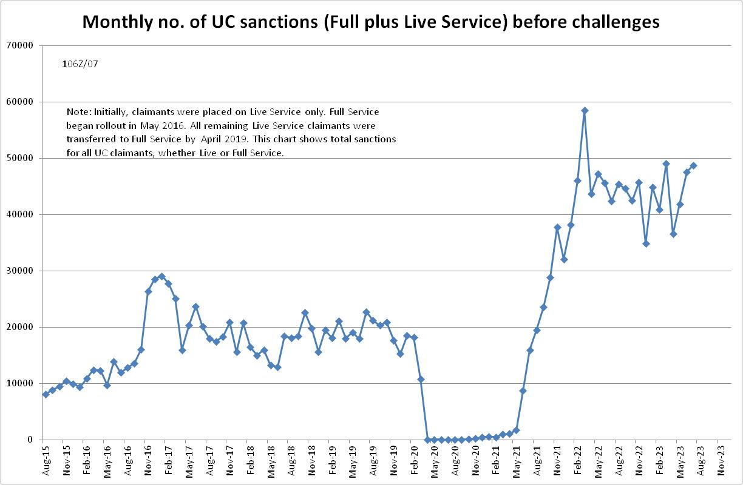

Figure 2
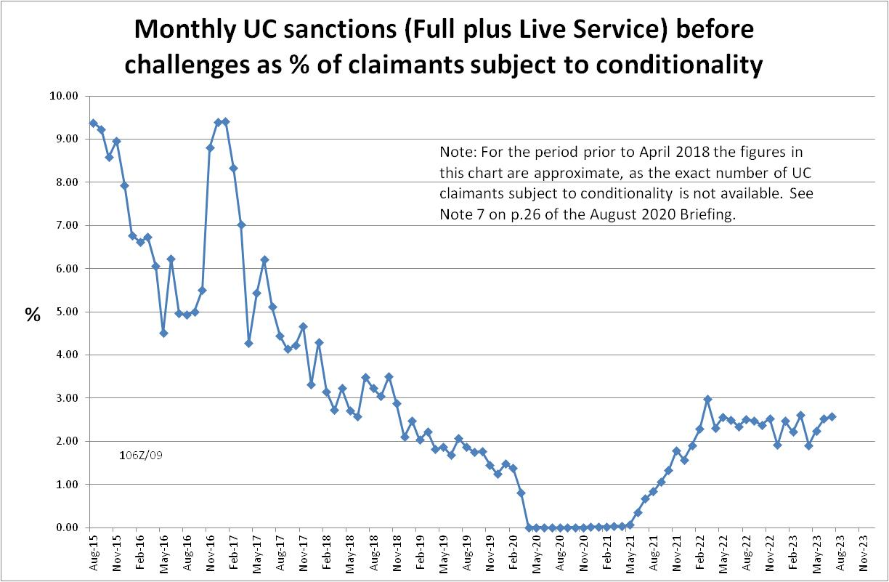

Figure 3
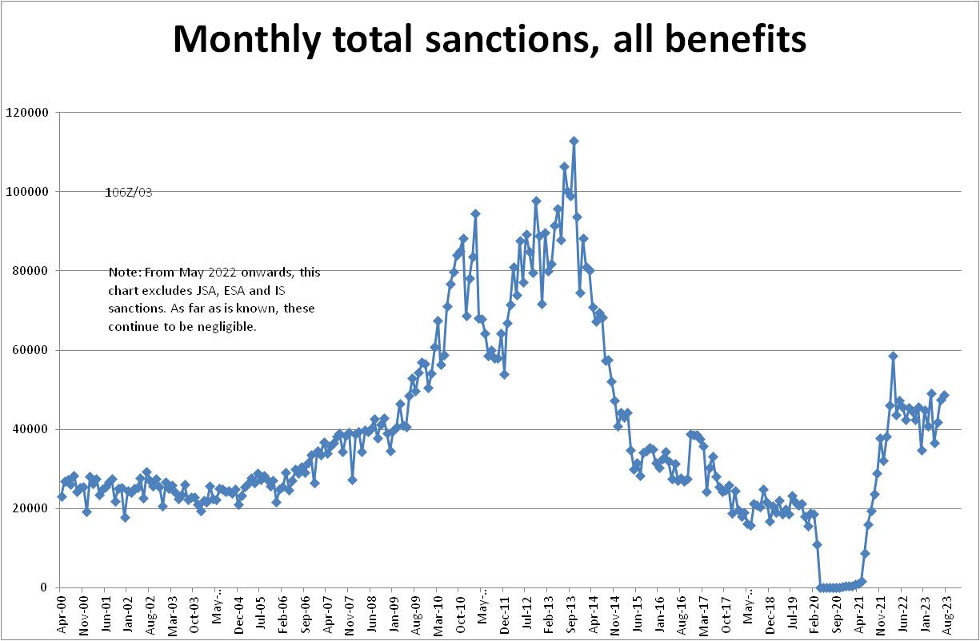

Figure 4
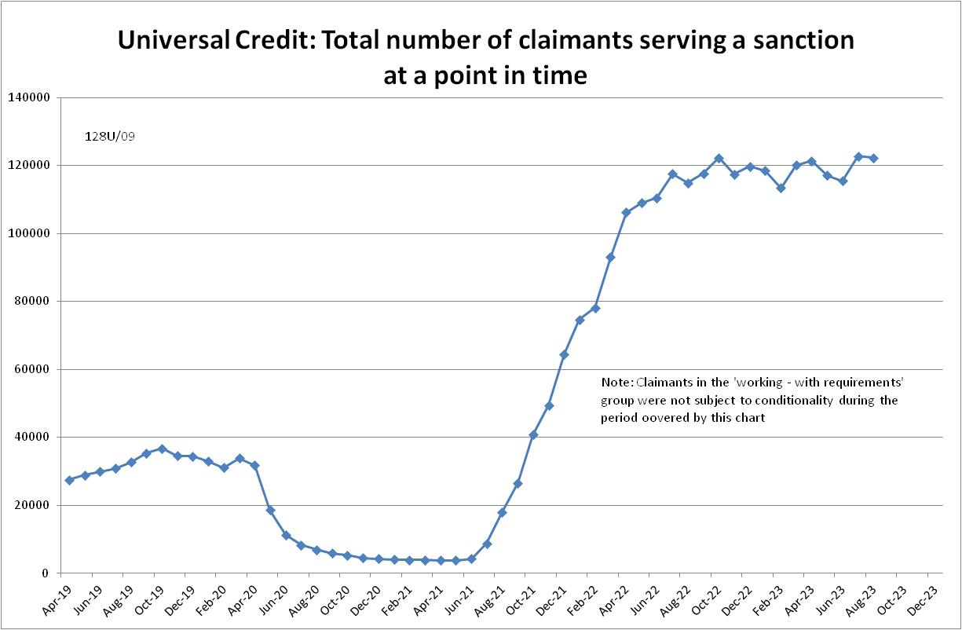

Figure 5
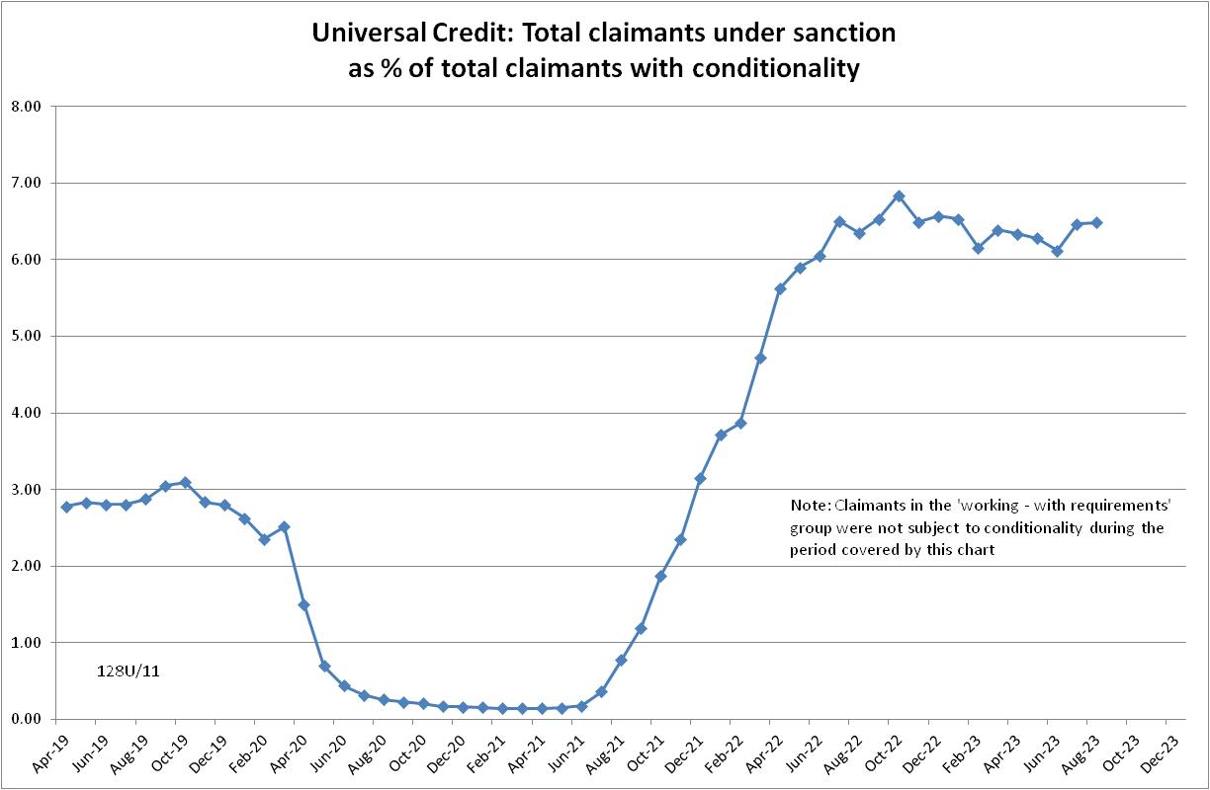
Figure 6
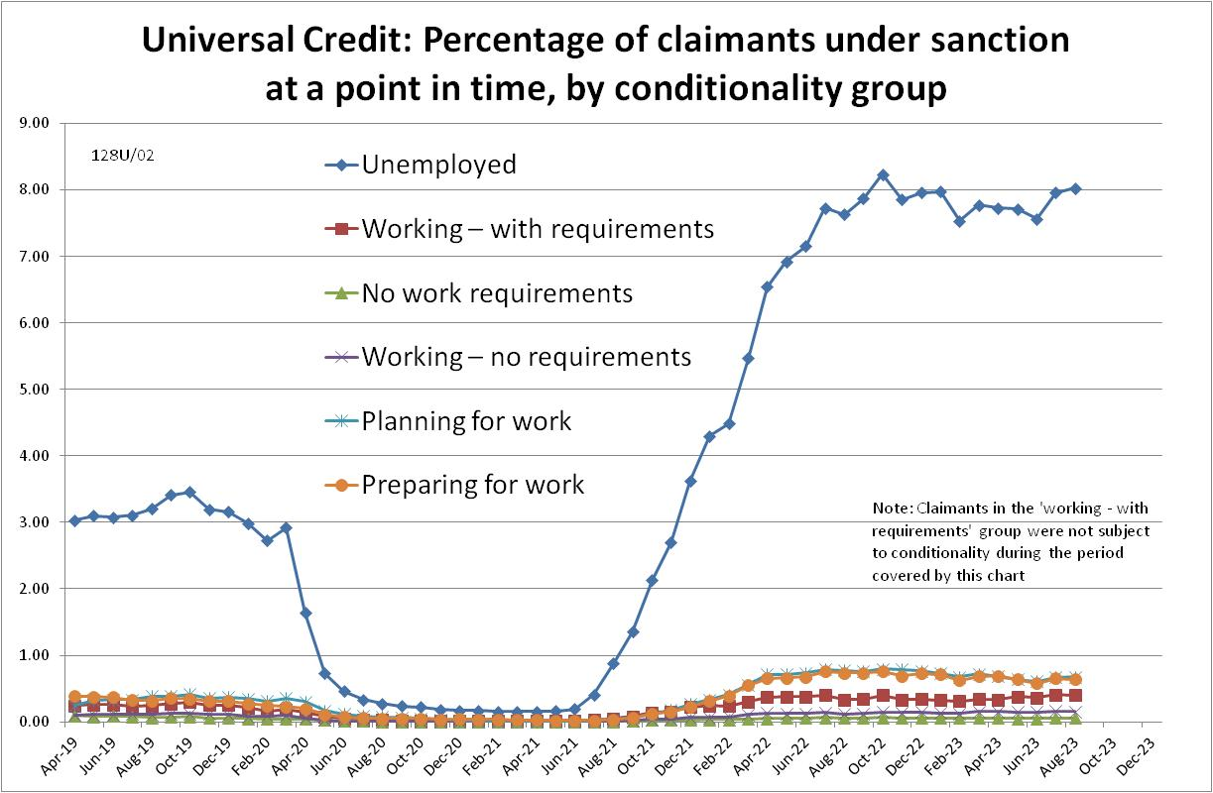

NOTES

Previous Briefings include many analyses that are not repeated here but remain valid. However it should be remembered that the DWP may have made subsequent revisions to the data reported in earlier Briefings. These revisions will generally not be major although there are exceptions. There may also often be substantial changes in some figures for the most recent few months.
A DWP report on the progress of managed migration (DWP 2023a) states that the final migration of claimants from old-style JSA to UC may not be completed before the end of 2024/25. Old-style JSA is already closed to new claimants.
The drawbacks of the ‘claimants under sanction at a point in time’ measure were discussed in the November 2017 issue of the Briefing, pp.6-10. In November 2020, DWP withdrew the UC ‘rate’ data for all months prior to April 2019, pending revision of the figures for the former ‘Live Service’. These figures remain withdrawn. In addition, in the February 2021 release DWP made significant revisions to the figures for April 2019 onwards (which are for Full Service only, there being no one left on the former Live Service). These were fully discussed in the February 2021 Briefing.
Currently available figures for the number of UC claimants under sanction only go back to April 2019 as DWP has withdrawn the figures for earlier dates. But the numbers previously published by DWP for the period before April 2019 are so far below those in 2023 that no conceivable revisions could make them higher than in 2023.

